Feasibility Study Presentation on a Sustainable Global Innovation Summit Event

Student Name: Rafique Ullah
Student ID:2118398
Tutor Name: Philippa Fitzgerald

Presentation link: https://uowtsd-my.sharepoint.com/:v:/g/personal/2118398_student_uwtsd_ac_uk/EacdI01cGM5Ll-QLrvbsaVYBpwokx3tRN5dIZdv6ogVo0w?referrer=Teams.TEAMS-ELECTRON&referrerScenario=MeetingChicletGetLink.view.view

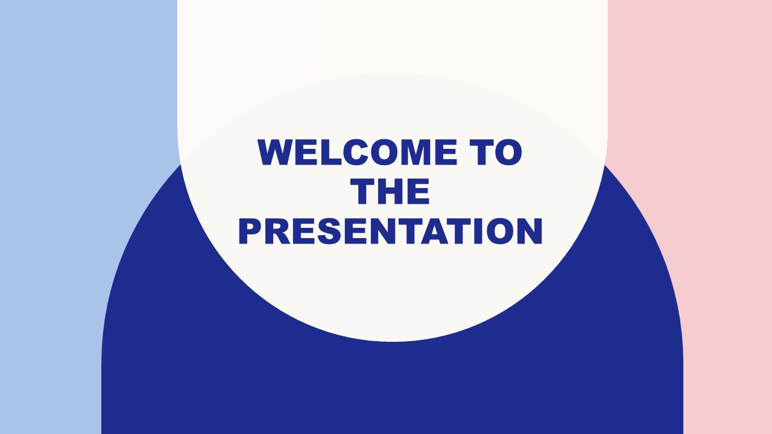

Introduction Slide
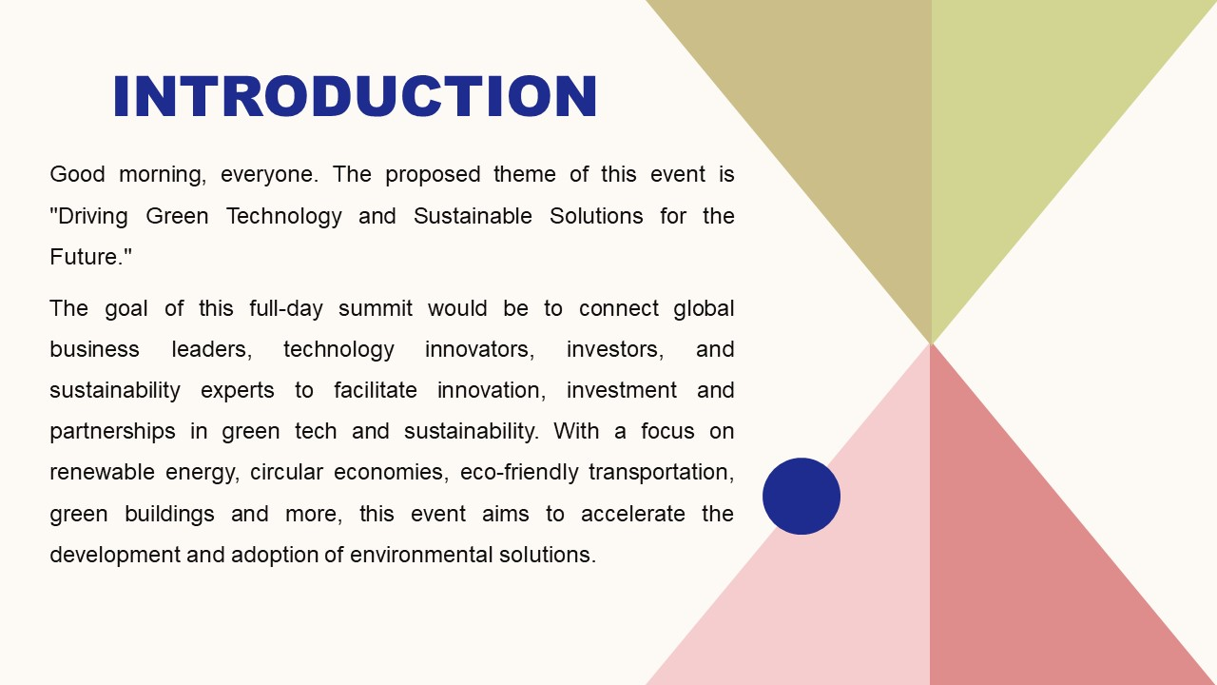
Situational Analysis
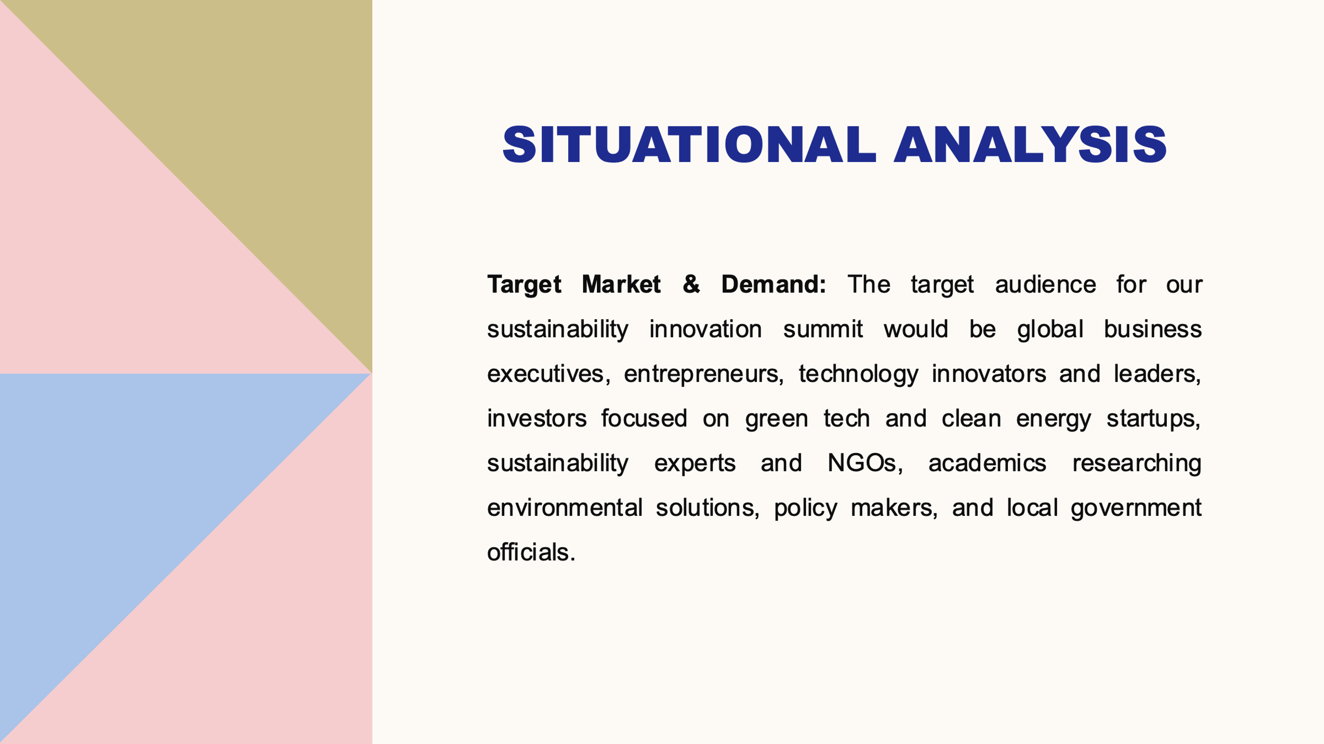
.
Operational Factors
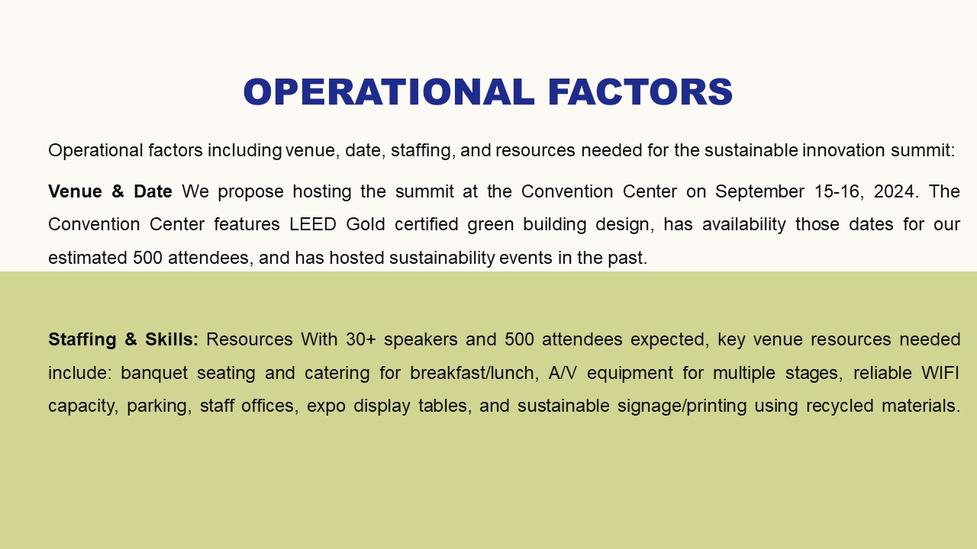
Financial Factors
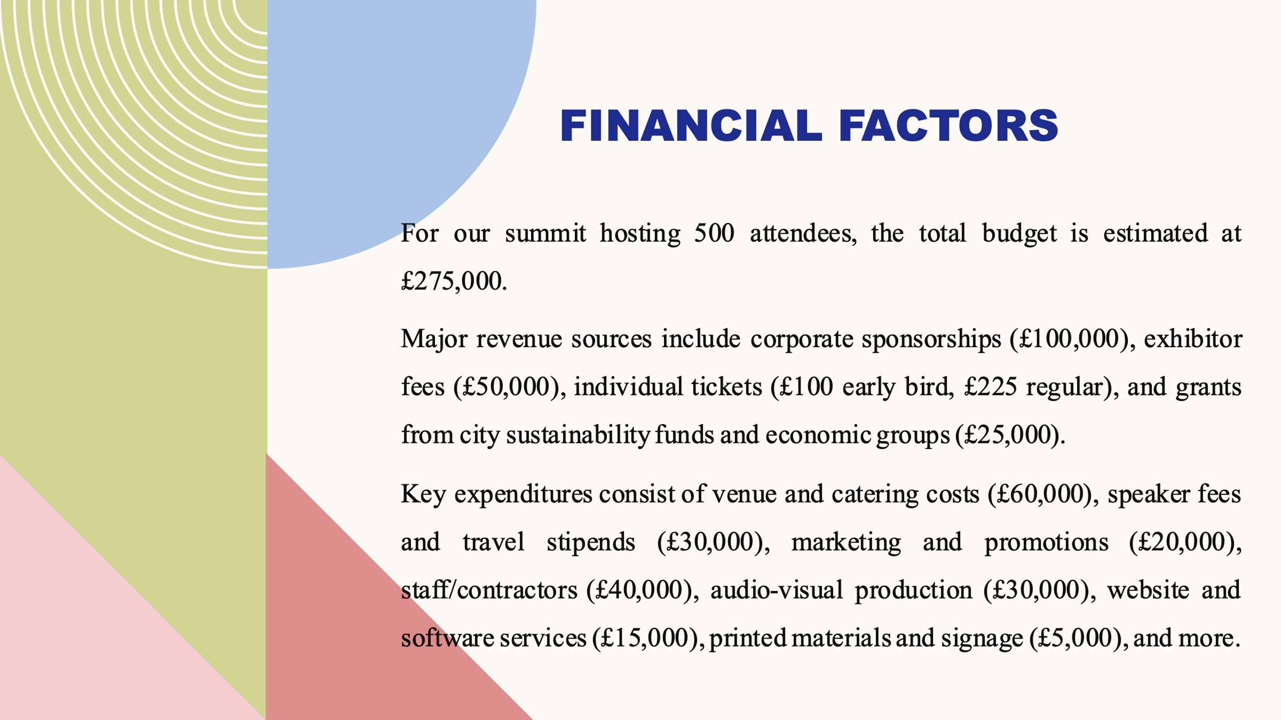

SWOT Analysis
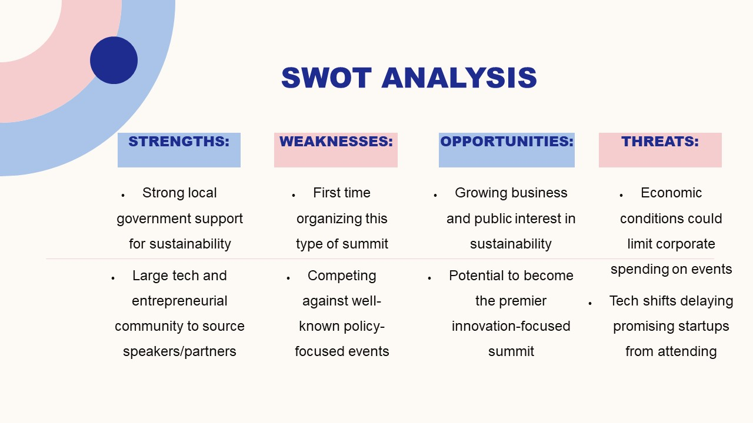PESTLE Factors
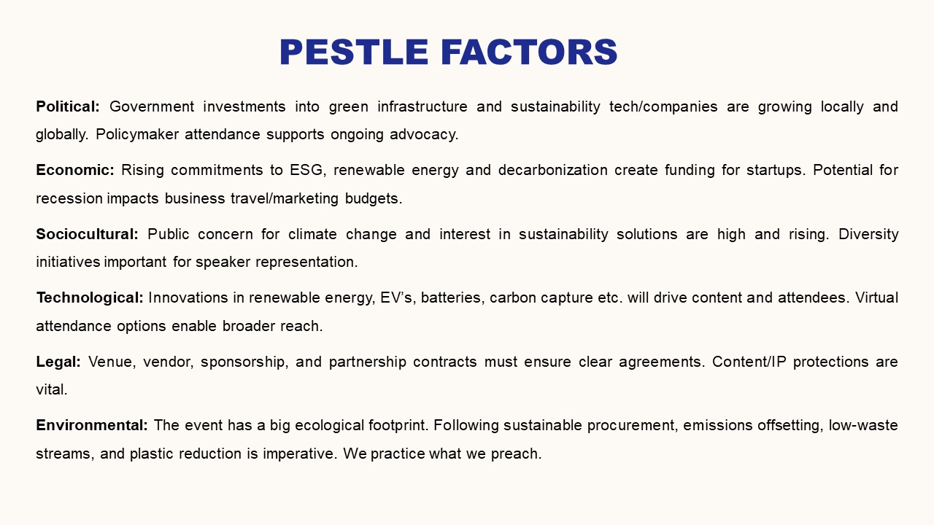
Conclusion
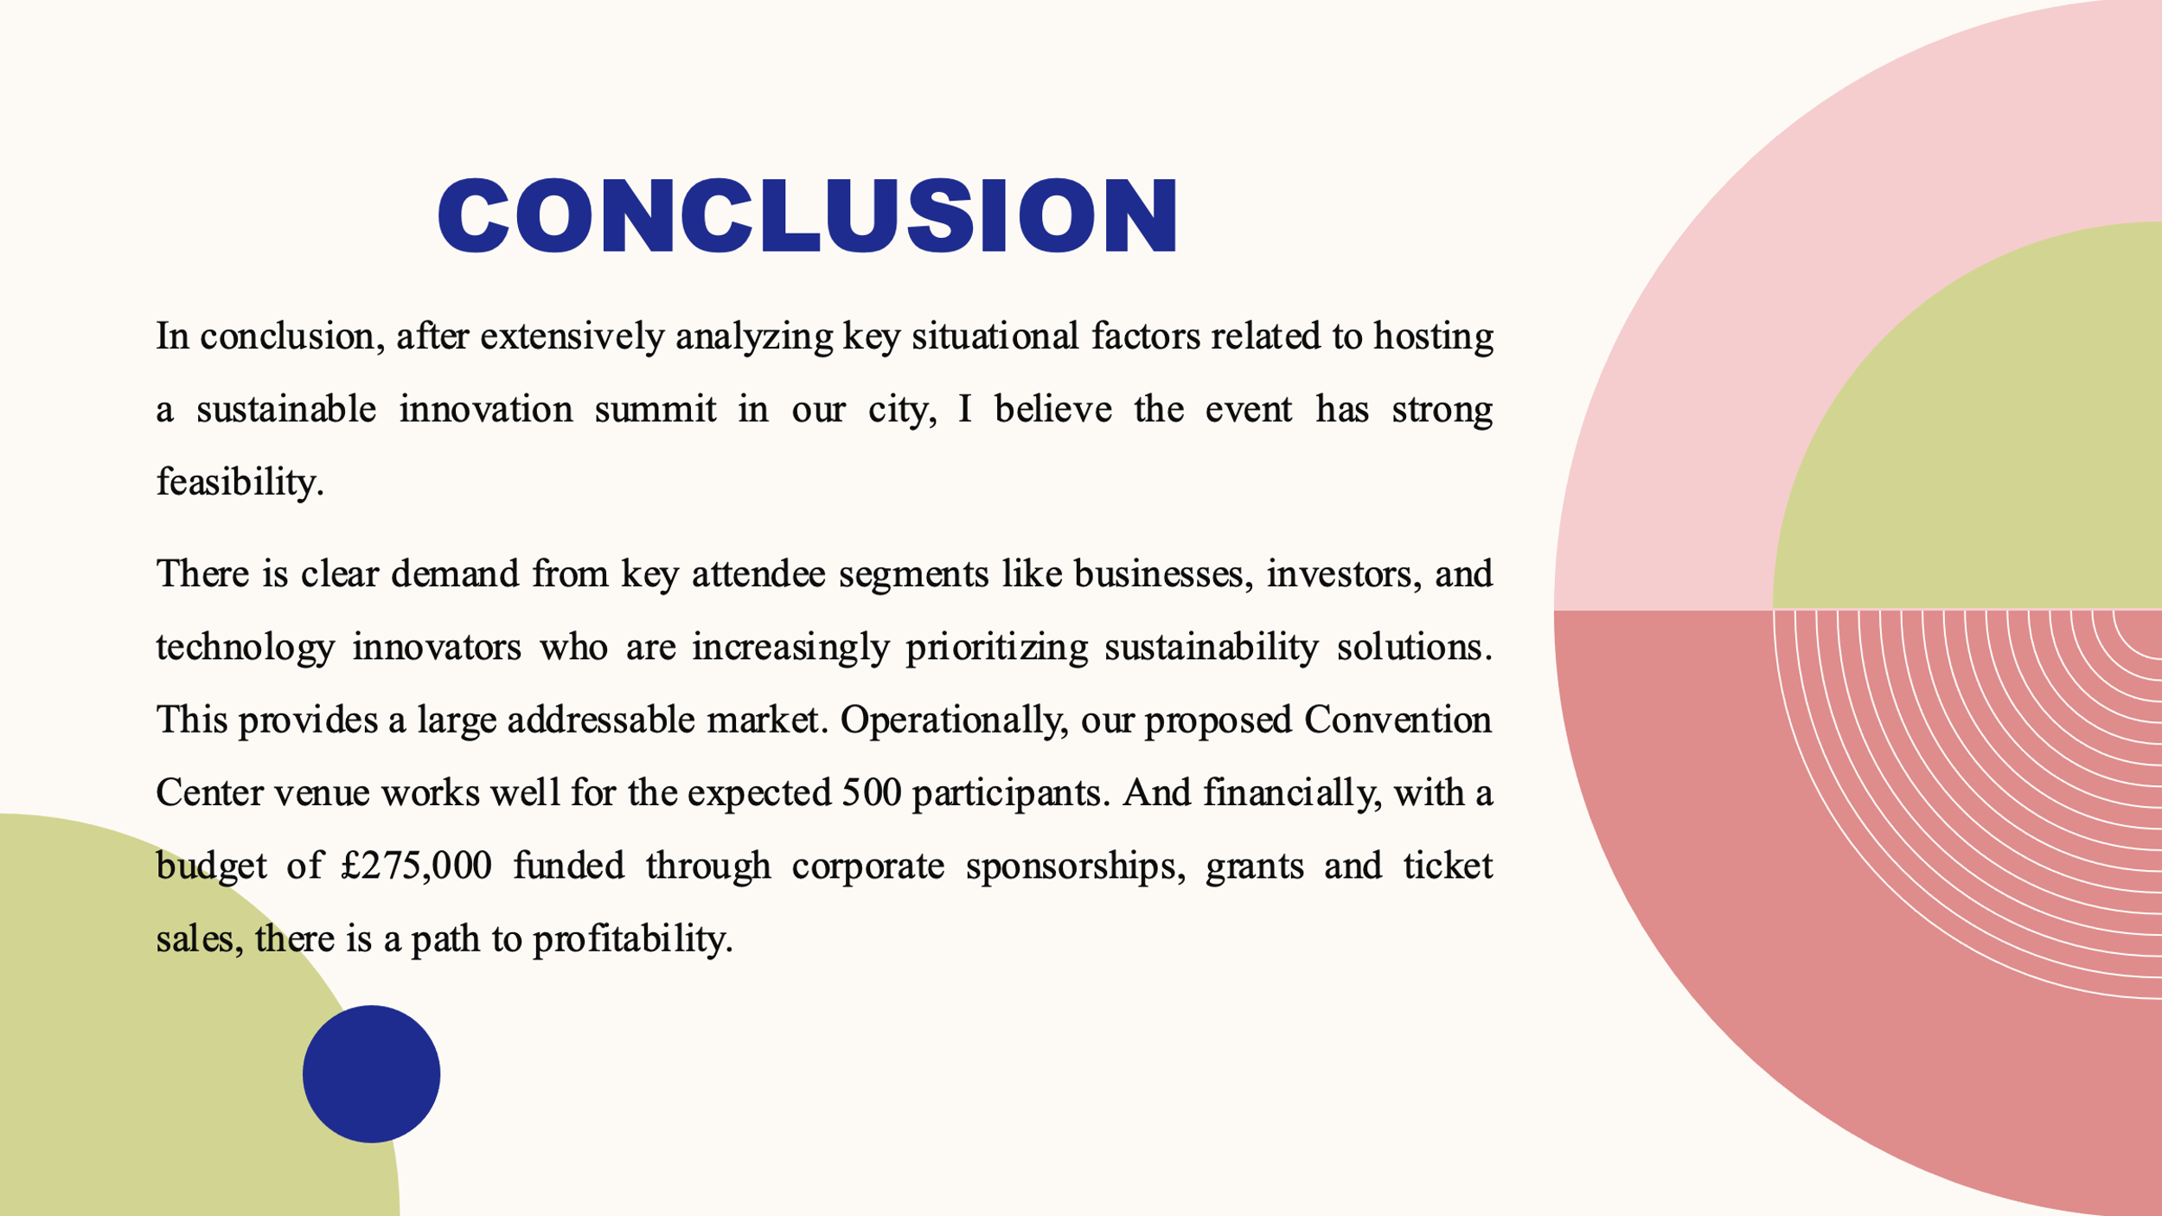

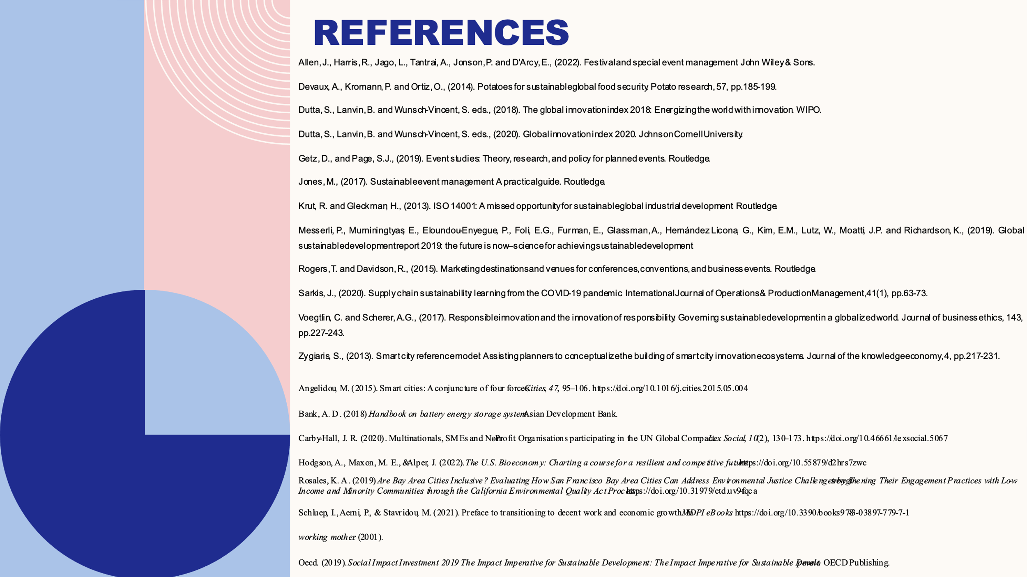
References
Allen, J., Harris, R., Jago, L., Tantrai, A., Jonson, P. and D'Arcy, E., (2022). Festival and special event management. John Wiley & Sons.
Devaux, A., Kromann, P. and Ortiz, O., (2014). Potatoes for sustainable global food security. Potato research, 57, pp.185-199.
Dutta, S., Lanvin, B. and Wunsch-Vincent, S. eds., (2018). The global innovation index 2018: Energizing the world with innovation. WIPO.
Dutta, S., Lanvin, B. and Wunsch-Vincent, S. eds., (2020). Global innovation index 2020. Johnson Cornell University.
Getz, D., and Page, S.J., (2019). Event studies: Theory, research, and policy for planned events. Routledge.
Jones, M., (2017). Sustainable event management: A practical guide. Routledge.
Krut, R. and Gleckman, H., (2013). ISO 14001: A missed opportunity for sustainable global industrial development. Routledge.
Messerli, P., Murniningtyas, E., Eloundou-Enyegue, P., Foli, E.G., Furman, E., Glassman, A., Hernández Licona, G., Kim, E.M., Lutz, W., Moatti, J.P. and Richardson, K., (2019). Global sustainable development report 2019: the future is now–science for achieving sustainable development.
Rogers, T. and Davidson, R., (2015). Marketing destinations and venues for conferences, conventions, and business events. Routledge.
Sarkis, J., (2020). Supply chain sustainability: learning from the COVID-19 pandemic. International Journal of Operations & Production Management, 41(1), pp.63-73.
Voegtlin, C. and Scherer, A.G., (2017). Responsible innovation and the innovation of responsibility: Governing sustainable development in a globalized world. Journal of business ethics, 143, pp.227-243.
Zygiaris, S., (2013). Smart city reference model: Assisting planners to conceptualize the building of smart city innovation ecosystems. Journal of the knowledge economy, 4, pp.217-231.
Angelidou, M. (2015). Smart cities: A conjuncture of four forces. Cities, 47,
95–106. https://doi.org/10.1016/j.cities.2015.05.004
Bank, A. D. (2018). Handbook on battery energy storage system. Asian Development Bank.
Carby-Hall, J. R. (2020). Multinationals, SMEs and Non-Profit Organisations participating in
the UN Global Compact. Lex Social, 10(2), 130–173. https://doi.org/10.46661/lexsocial.5067
Hodgson, A., Maxon, M. E., & Alper, J. (2022). The U.S. Bioeconomy: Charting a course for
a resilient and competitive future. https://doi.org/10.55879/d2hrs7zwc
Rosales, K. A. (2019). Are Bay Area Cities Inclusive? Evaluating How San Francisco Bay
Area Cities Can Address Environmental Justice Challenges by Strengthening Their
Engagement Practices with Low-Income and Minority Communities through the
California Environmental Quality Act Process. https://doi.org/10.31979/etd.uv9f-tqca
Schluep, I., Aerni, P., & Stavridou, M. (2021). Preface to transitioning to decent work
and economic growth. In MDPI eBooks. https://doi.org/10.3390/books978-3-03897-779-7-1
Working mother. (2001).
Oecd. (2019). Social Impact Investment 2019 The Impact Imperative for
Sustainable Development: The Impact Imperative for Sustainable Development. OECD Publishing.


