Population health and digital health promotion
BLOGS AND POSTURE
Student Name: Khushi Patel
Student Id: 2334075
Module Name: Population Health and Digital Health Promotion.
Module Code:LCHS7007
Program: M.Sc. Public Health and Social care in Practice

BLOG 1
Hear the Difference: Managing Hearing Loss with Petralex Hearing Aid App
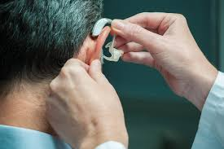
Understanding Hearing Loss
(Penn Medicine Becker ENT, 2024)
Hearing loss, a condition affecting the ability to perceive sounds ranges from mild to profound. It can occur due to ageing, exposure to loud noises, infections, or genetic factors. People with hearing loss often face communication difficulties, affecting their quality of life (Lieu et al, 2020). Approximately 11 million people in the UK experience hearing loss, equating to 1 in 6 adults (British Academic of Audiologist, 2024).
Petralex Hearing Aid App: A Technological Solution
Petralex Hearing Aid is a mobile application designed to assist individuals with hearing loss. It leverages smartphone capabilities to amplify sound, offering an accessible alternative to traditional hearing aids (Koo et al, 2022).
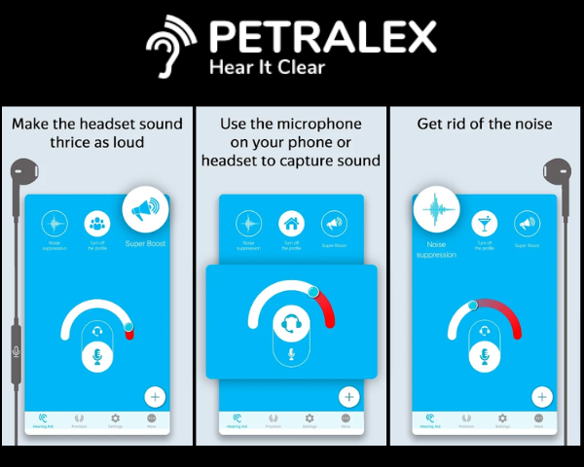
(News Hook, 2022)
Key Features of the Petralex Hearing Aid App
- Custom Sound Profiles: Adapts to individual hearing levels through a quick hearing test (Nguyen et al, 2022).
- Real-Time Sound Amplification: Enhances environmental sounds to improve clarity (Koo et al, 2022).
- Noise Reduction: Filters background noise for clear conversations in noisy settings (Koo et al, 2022).
- Bluetooth Connectivity: Supports wireless devices for seamless audio streaming (Koo et al, 2022).
- Hearing Aid Mode: Converts your smartphone into a virtual hearing aid (Nguyen et al, 2022).
Advantages of Petralex Hearing Aid
- Cost-Effective: A budget-friendly option compared to traditional hearing aids (Jo et al, 2023).
- User-Friendly Interface: Simple navigation suitable for all age groups (Jo et al, 2023).
- Accessibility: Available on iOS and Android devices (Al-Khafaji et al, 2023).
- Customisable: Personalized settings ensure a tailored hearing experience (Jo et al., 2023).
Limitations of the App
- Dependent on Smartphone Quality: Requires a device with a good microphone and speaker (Al-Khafaji et al, 2023).
- Battery Drain: Prolonged use can quickly deplete a phone battery (Al-Khafaji et al, 2023).
- Limited Professional Oversight: May not address complex hearing issues (Jo et al, 2023).

Overcoming Challenges: Suggested Solutions
- External Microphone Support: Adding compatibility with high-quality external mics can improve sound input (Al-Khafaji et al, 2023).
- Battery Optimisation: Incorporate power-saving modes to extend device usage (Al-Khafaji et al., 2023).
- Integration with Audiologists: Allow app data sharing with hearing care professionals for better diagnosis (Jo et al., 2023).

BLOG 2
Empowering Lives: HIV Management Simplified with MyHIVCare App in the UK

HIV (Human Immunodeficiency Virus) remains a critical global health issue (Assefa and Gilks, 2020). By leveraging technology, innovative apps like myHIVCare are transforming how people manage their health, providing accessible, personalised, and empowering solutions. Here's a closer look at HIV, its prevalence in the UK, and how myHIVCare is making a difference.
(Zekerie Redzheb, 2024)
What is HIV?
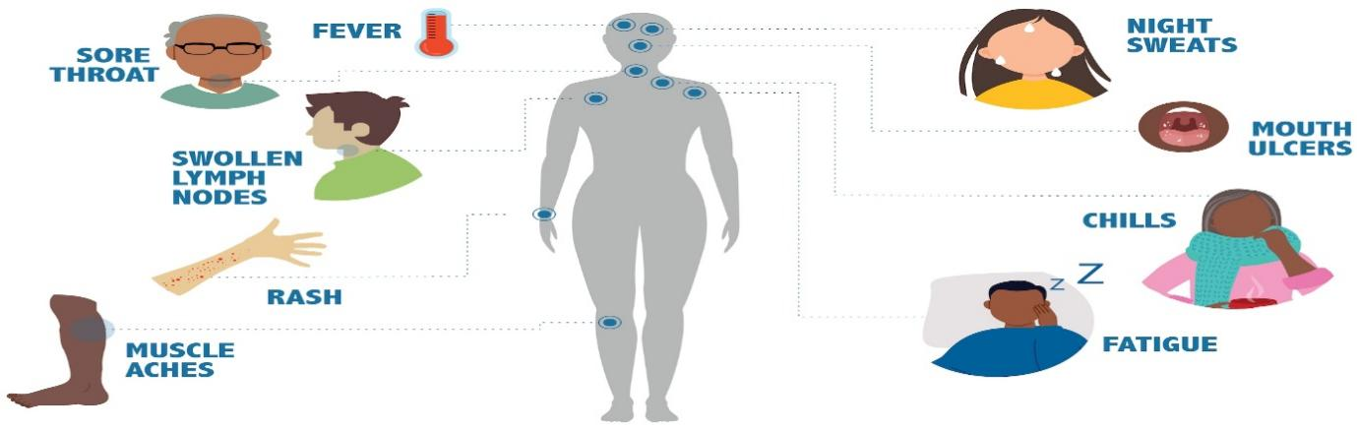
(CDC, 2024)
HIV is a virus that attacks the immune system, specifically targeting CD4 cells (T cells), which are crucial for fighting infections. Untreated, it can lead to AIDS (acquired immunodeficiency syndrome) (Assefa and Gilks, 2020). Around 38,680 people in the UK were living with HIV in 2022 (Gov.UK, 2024). Early diagnosis and regular monitoring remain essential in reducing transmission and improving quality of life (Assefa and Gilks, 2020).
MyHIVCare App
Developed to support people living with HIV, MyHIVCare is a new mobile app designed to improve disease management and streamline communication with healthcare providers.

Features of MyHIVCare App
- Health Record Management: Track appointments, medication schedules, and test results in one place (Mehraeen et al, 2022).
- Medication Reminders: Timely alerts to ensure adherence to ART medication (Mehraeen et al, 2022).
- Symptom Tracker: Long symptoms to provide healthcare providers with accurate insights (Hightow-Weidman et al, 2022).
- Secure Messaging: Direct communication with doctors for personalised advice (Hightow-Weidman et al, 2022).
- Educational Resources: Access reliable HIV-related information tailored to the user’s condition (Hightow-Weidman et al, 2022).
Advantages of the App
- Enhances treatment adherence, a critical factor for viral suppression (Mehraeen et al, 2022).
- Promotes patient empowerment through education and self-management tools (Mehraeen et al, 2022).
- Reduces healthcare system burden by enabling remote monitoring (Mumtaz et al, 2022).
- Supports stigma-free communication via private, secure channels (Hightow-Weidman et al, 2022).
Limitations and Challenges
- Limited availability of internet access among some users (Mehraeen et al, 2022).
- Digital literacy gaps could hinder usage among older populations (Mehraeen et al, 2022).
- Potential concerns about data privacy (Hightow-Weidman et al, 2022).
Solutions to Overcome Challenges
- Offline Access: Develop features to allow offline data logging (Mumtaz et al, 2022).
- User-Friendly Design: Simplify the interface for diverse age groups and skill levels (Mumtaz et al, 2022).
- Transparent Data Policies: Reinforce trust by adhering to strict privacy regulations (Mumtaz et al, 2022).

References:
Abdelk Al-Khafaji, A. and Jaber Hashim Al-Jawfi, A., (2023). Problems of People with Hearing Disabilities from Their Teachers’ Point of View. Sustainability Education Globe, 1(1), pp.100-117.
Assefa, Y. and Gilks, C.F., (2020). Ending the epidemic of HIV/AIDS by 2030: Will there be an endgame to HIV, or an endemic HIV requiring an integrated health systems response in many countries?. International Journal of Infectious Diseases, 100, pp.273-277.
British Academic of Audiologist, (2024), Facts about hearing loss and deafness, https://www.baaudiology.org/about/media-centre/facts-about-hearing-loss-and-deafness/
Gov. UK (2024), Annual epidemiological spotlight on HIV London: 2022 data, https://www.gov.uk/government/publications/hiv-london-annual-data-spotlight/annual-epidemiological-spotlight-on-hiv-in-london-2022-data
Hightow-Weidman, L.B., Muessig, K., Soberano, Z., Rosso, M.T., Currie, A., Larsen, M.A., Knudtson, K. and Vecchio, A., (2022). Tough talks virtual simulation HIV disclosure intervention for young men who have sex with men: development and usability testing. JMIR Formative Research, 6(9), p.e38354.
Jo, S., Park, M.K., Seo, J.H., Lee, K.E., Han, J.S., Lim, J.H., Lee, J.H. and Oh, S.H., (2023). Feasibility of a Smartphone-Based Hearing Aid App for Mild-to-Moderate Hearing Loss: Prospective Multicenter Randomized Controlled Trial. JMIR mHealth and uHealth, 11, p.e46911.
Koo, M., Nguyen, W., Lee, J.H., Oh, S.H. and Park, M.K., (2022). Behavioral evaluation of 3 smartphone-based hearing aid apps for patients with mild hearing loss: an exploratory pilot study. The Journal of International Advanced Otology, 18(5), p.399.
Lieu, J.E., Kenna, M., Anne, S. and Davidson, L., (2020). Hearing loss in children: a review. Jama, 324(21), pp.2195-2205.
Mehraeen, E., SeyedAlinaghi, S., Pashaei, Z., Mirzapour, P., Barzegary, A., Vahedi, F., Qaderi, K., TANTUOYIR, M., Nazeri, Z., Karimi, A. and Mehrtak, M., (2022). Mobile applications in HIV self-management: a systematic review of scientific literature. AIDS Rev, 24(1), pp.24-31.
Mumtaz, H., Riaz, M.H., Wajid, H., Saqib, M., Zeeshan, M.H., Khan, S.E., Chauhan, Y.R., Sohail, H. and Vohra, L.I., (2023). Current challenges and potential solutions to the use of digital health technologies in evidence generation: a narrative review. Frontiers in Digital Health, 5, p.1203945.
Nguyen, W., Koo, M., Lee, J.H., Oh, S.H. and Park, M.K., (2022). Electroacoustic evaluation of smartphone-based hearing aid applications. Clinical and Experimental Otorhinolaryngology, 15(2), pp.135-143.

Posture:


