

Module Code: LCBB5000
Module Title: Data Handling & Business Intelligence
Student name: Andra-Maria Daniliuc
Student ID: 2030171
University name: University of Wales Trinity Saint David
Executive Summary
Business Intelligence refers to the software that collects business data and presents them in a user-friendly format. It also provides proper insights into the business achieved through an array of practices and technologies. The report has identified the current trends in business intelligence that includes artificial intelligence, data security, data governance, collaborative BI and data automation. Eventually, the report has depicted implementing BI trends could help organisations to understand their customers better, boosting their visibility and increasing their business efficiency.

Table of Contents
1. Introduction 4
2. Current trends in Business Intelligence 4
3. Reasons behind the businesses required to implement BI trends 6
4. Conclusion 9
References 10

1. Introduction
Business Intelligence refers to the software that collects business data and presents them in a user-friendly format. According to IBM (2023), the revolution in the field of Business Intelligence has impacted the way of doing business in recent years. It also provides proper insights into the business achieved through an array of practices and technologies. This report will identify the current trends in Business Intelligence along with analysing the reason behind the requirement of implementing BI trends by businesses.

2. Current trends in Business Intelligence
Artificial intelligence: According to Božič and Dimovski (2019), Artificial intelligence (AI) allows machines to execute the same thing that could be done by human intelligence. Thus, business data is being managed by AI in a revolutionised way. Businesses could get real-time alerts about possible security risks and attack points which are vulnerable through AI. The integration of BI and AI will help businesses to get a comprehensive solution without any human efforts. According to IBM (2023), AI will help businesses to get instant access to business growth reports and forecast trends. Additionally, finding any kind of anomalies is also possible for businesses.
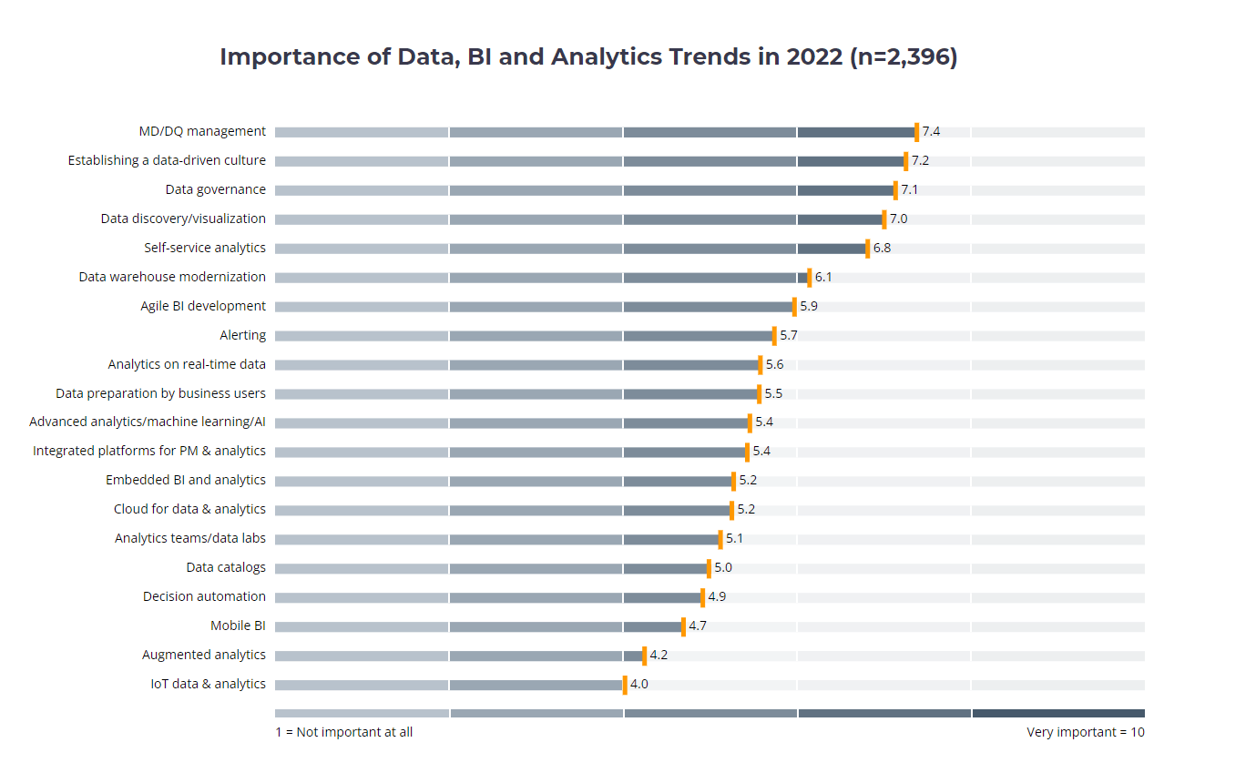
Figure 1: Importance of data, BI and analytic trends in 2022
(Source: Calzon, 2022)
Data security: Providing updated and accurate data is important for the success of BI. It ensures no data breaching is being done by the business companies because cyber-attacks steal customer data and leave them exposed. Thus, data security is important to protect customer data from any kind of misuse or using them for a long purpose. According to Calzon (2022), it could drop the brand value and share of the company as well. The GDPR Act in the EU, California Consumer Privacy Act in the USA and General Personal Data Protection Law in Brazil were introduced to create building blocks for data management and security.
Data governance: Data governance is the process of providing and way for managing data assets, architecture and infrastructure. Different business companies have successfully used the power of technology, people and process through data governance. According to ‌Zuci Systems (2021), the market for data governance is expected to grow from USD 2.62 billion in 2021 to USD 10.93 billion by 2030. This has helped the companies to deliver understandable, secure and trustworthy data. These companies have also been in compliance with the General Data Protection and Regulation (GDPR) since 2018. The modern tools for BI have supported the procedure of data governance to increase the value of analytics for businesses.
Collaborative BI: The requirement for collaborative BI is increasing in the complex and competitive business environment by combining some online BI tools. It includes social media and other 2.0 technologies which could help to track the business fast. The online BI tools could help to generate automated reports and find unique challenges at specific times for particular people. BI Is also helpful to share public dashboards to flexibly interact with the customers. Thus, the connection between data and analytics is reducing the barrier and connecting the users at every stage. According to Calzon (2022), around 75% of the executives have reported having comparative business functions rather than collaborative ones.
Data automation: The importance of data automation has increased because the business has produced, collected and evaluated huge amounts of data. This massive volume of data could not be handled by the human being henceforth, business intelligence provides the technique for discovering, measuring, analysing, monitoring and evaluating this large-scale data. Hyper automation is one of the trends where multiple tools and technologies including machine learning, low-code and no-code tools are used. According to ‌Zuci Systems (2021), around 80% of business executives think that automation could be applied to any kind of business decision as well.

3. Reasons behind the businesses required to implement BI trends
Understanding customers: Strategies of business intelligence could effectively understand the customers and analyse their patterns of buying. The inclusion of artificial intelligence also helps businesses to create customer persona and profiles (‌Stjepić et al., 2021). Additionally, the businesses could develop better products and enrich the experience of the customers. Business intelligence could successfully segment their customers and create distinct groups with high accuracy. As an example, Lotte.com, a shopping site in Korea wanted to understand the reason behind the abandoning of shopping cards by their customers. Business intelligence has helped them to analyse the behavioural data of their customers and implement an effective marketing strategy.
Boosting the visibility of business operation: Business intelligence helps organisations to control their visibility over their business processes better. It helps in the identification and rectification of inefficiencies and errors within the existing business process as well. Thus, the organisations could get an insight into the unforeseen challenges and act according to the problem. As an example, the logistics companies could know if there is a delay in delivery and date and can take necessary steps to improve their services. Cementos Argos, an American cement company has enhanced its competitive advantage and better decision-making by boosting its visibility with the help of business intelligence (Vugec et al., 2021).
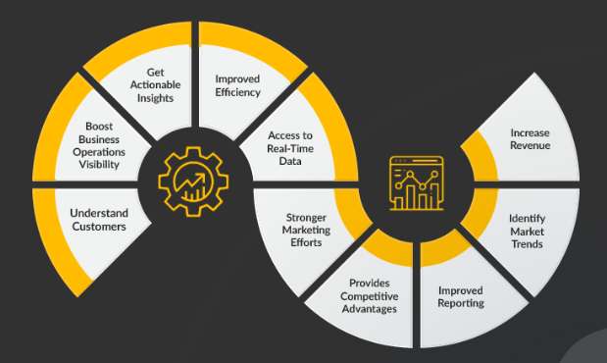
Figure 2: Reasons behind the businesses required to implement BI trends
(Source: ‌Zuci Systems, 2021)
Getting proper insights: A proper business decision could only be made on the basis of sufficient data. BI provides a business with access to enormous information which eventually helps them to gain valuable insights about the business and make better business decisions. The business organisations get mattresses including the percentage of customers abandoning their cards. This provides an idea about the reason behind the customers dropping off the cart. As an example, Baylis & Harding, a UK company distributing world-class class gift sets and toiletries has created ad-hoc and standard reports to make better business decisions and expand their business as well (Božič. and Dimovski, 2019).
Improved efficiency for the business: A robust solution through business intelligence in powers organisations to boost their overall efficiency along with increasing their revenue and performance. BI helps all the departments to get sufficient data which reduces the waiting time for the reports as well. Thus, the employees become efficient in self-service and these availabilities also help the organisations to make data-driven decisions. New York Shipping Exchange (NYSHEX) has introduced a centralised data system through BI which has helped them to triple the volume of shipping between the US and Asia (Strohmeier, 2021).
Access to real-time data: Business intelligence could also provide organisations to get access to real-time data which reduces the threats of potential risks. Additionally, the organisations could prepare critical reports based on data and it will also help the organisations to monitor the overall health of the company as well. Machine learning and artificial intelligence are the two most important trends that have helped companies to get access to real-time data as well. Expedia had moved visibility to the voice of the customers along with having little time for data analysis (Božič. and Dimovski, 2019). Business intelligence has helped them to analyse customer data and enhanced their satisfaction.

4. Conclusion
The report has identified the current trends in business intelligence that includes artificial intelligence, data security, data governance, collaborative BI and data automation. These current trends need to be followed by businesses to get the proper advantage of business intelligence. Different tools and strategies of business intelligence have helped organisations to grow and get valuable insights for their business as well. Eventually, the report has depicted implementing BI trends could help organisations to understand their customers better, boosting their visibility and increasing their business efficiency.

References
Božič, K. and Dimovski, V., (2019). Business intelligence and analytics use, innovation ambidexterity, and firm performance: A dynamic capabilities perspective. The Journal of Strategic Information Systems, 28(4), p.101578.
Božič, K. and Dimovski, V., (2019). Business intelligence and analytics for value creation: The role of absorptive capacity. International journal of information management, 46, pp.93-103.
Calzon, B., (2022). See Top 10 Analytics & Business Intelligence Trends For 2023. Available at: https://www.datapine.com/blog/business-intelligence-trends/ [Accessed 3 August 2023]
IBM, (2023). What is Business Intelligence and How Does it Work?. Available at: https://www.ibm.com/topics/business-intelligence [Accessed 3 August 2023]
‌Stjepić, A.M., Pejić Bach, M. and Bosilj Vukšić, V., (2021). Exploring risks in the adoption of business intelligence in SMEs using the TOE framework. Journal of Risk and Financial Management, 14(2), p.58.
Strohmeier, L., (2021). Central business intelligence: A lean development process for SMEs. In B2B Marketing: A Guidebook for the Classroom to the Boardroom (pp. 685-698). Cham: Springer International Publishing.
Vugec, D.S., Vukšić, V.B., Bach, M.P., Jaklič, J. and Štemberger, M.I., (2020). Business intelligence and organizational performance. Business process management journal, 26(6), pp.1709-1730.
‌Zuci Systems, (2021). Top 8 Business Intelligence Trends in 2023. Available at: https://www.zucisystems.com/blog/top-8-trends-in-business-intelligence-in-2022/#1 [Accessed 3 August 2023]

