

University of Wales Trinity Saint David
School of Engineering
Calum McGowan-Franklin
1803213
Motorcycle Engineering BEng.
Date 06/11/2021
Module code: ACHA6012
Automotive Materials & Sustainability
Vehicle to Grid Technology

Contents
List of figures 3
Introduction 4
Aims 4
Interconnectivity- a lateral shift 4
Electric vehicle mass adoption 5
The Impact of PEV`s on the current grid 6
The Smart Grid and Micro Grid Setup 6
The Role of PEV Within the Smart Grid 7
Standardisation 8
Batteries 9
Battery Life and Recycling 10
Battery Raw Materials 10
Conclusion 11
References 13

List of figures

Figure 1. Projected annual global electric vehicle sales (Bloomberg Electric vehicle outlook, 2021)
Figure 2. Countries proposition of ICE production ban (thomsonreuters.com, 2020)
Figure 3. Impact of PEV penetration in a microgrid (Hossain et al, 2015)
Figure 4 EV current plug connectors (Dalroad.com,2021)
Figure 5. Metals demand in a 100% EV world (Thomsonreuters.com, 2021)

Introduction

As the looming effects of climate change become ever more present and forthcoming, fossil fuel based industrial activity well and truly has its writing on the wall and the need for a new economic narrative driven by sustainable energy is paramount. As government incentive and technological advances lay way for the mass adoption of electric vehicles powered by renewable energy sources, the need for a flexible distributed energy system becomes prominent. Vehicle to grid technology endeavours to facilitate this integration, this report will be examining the feasibility of such a system, investigating current procedures and the effects of implementation.

Aims
Analyse the feasibility for widespread employment of vehicle-to-grid technology as a solution to peak energy demands in the UK.

Interconnectivity- a lateral shift

Traditional energy supplies such as coal, oil, and natural gas make use of the familiar centralised top-down command and control system, as has been the driving model for modern capitalism (Rifkin, 2011). This model was intuitive for traditional energy supplies as the raw produce was in exclusive locations and took significant capital investment, careful geopolitical policies, and negotiations to ensure production and accessibility (Rifkin, 2011).
In contrast renewable energies are found everywhere and following initial installation are free save from maintenance work. This energy is collected at numerous local sites, aggregated, shared, and distributed across intelligent power networks aiming to achieve, optimal performing sustainable energy (Rifkin, 2011). As we shift into a new paradigm of energy harvesting and distribution, the traditional business and production model becomes burdensome and uncooperative when applied to new initiatives. Such is the case with renewable energy and the mass adoption of electric vehicles where to remain utilitarian and successful the top-down model is abandoned and instead a lateral distributive model is assumed. This distributive model requires the synergy of technological agendas and as energy demand and production increases, the groundwork for each facet needs to be laid down concurrently to be successful. These elements are the scaling up of; renewable energy sources, the utilisation of energy storage technologies within micro grids to enable stabilisation, smart grids, micro grids to enable energy sharing, and electric vehicles that can interact with the grid, providing a spinning reserve, allowing users the opportunity to optimise peak shaving and valley filling, providing a cost saving to the user whilst simultaneously providing a service to the grid.

Electric vehicle mass adoption

Unlike previous automotive breakthroughs wherein progression has been dictated by technological feats alone, EV technology has been propelled to the forefront of the consumer market through a concerted effort from government incentives and legislation, technological advances, social equity and a strong media and marketing stance.
This barrage of motivation paired with many countries proposing the ban of internal combustion engines within the next 10-15 years leaves the electric vehicle rollout poised for mass adoption.
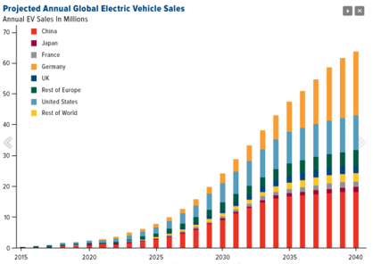

Figure 1. Projected annual global electric vehicle sales (Bloomberg Electric vehicle outlook, 2021)


Figure 2. Countries proposition of ICE production ban (thomsonreuters.com, 2020)

The Impact of PEV`s on the current grid

This however raises questions surrounding the impact of a mass adoption of electric vehicles primarily in electric demand. As it stands, the current utility grid operates at near capacity whilst sourcing the majority of power from fossil fuel-based generators. As the demand for electric vehicles grows as will the demand on the grid (Hossain et al, 2015). One approach to resolution, following the top-down control system, would be to scale up current production and distribution, however this approach quickly diminishes in utilitarianism as cost will go up and energy cost will be prohibitive. Also, grid network investment would be substantial and the fluctuating nature of renewable energy sources would remain an issue (Nuvve holding corporation, 2021).
In plain terms, the EV industry paired with the power industry creates volatility and the unchecked integration of EV`s into the current grid would increase peak demand and compound existing load demand issues. However, this is wherein V2G technology could provide the necessary resolutions.
By using vehicle batteries as storage and a source for energy within the smart grid, this provides the opportunity of stabilising renewable energy resources and increasing the reliability of the grid whilst reducing demand at peak times. This technology endeavours to facilitate the narrative of clean energy and the termination of fossil fuel-based transportation whilst providing a solution to grid demand and EV consumer issues (Hossain et al, 2015).

The Smart Grid and Micro Grid Setup

Smart grids aim to combine intelligent technologies such as information and communication tools with the current electric grid to create a stable, controllable and reliable electric system from utility grids through delivery and storage systems to end users. Thus, aiming to make low voltage network behaviour accessible to end users as to adjust their usage with an informed view of peak and trough times, encouraging customer participation in the operation of the smart grid, namely by means of smart meters, smart homes and vehicle to grid (v2G) PEV`s (Hossain et al, 2015).
Micro grids can be considered as a subset of the smart grid, a small-scale power supply providing power to a small community that enables local power generation to sustain local loads. The system is as such that it can operate as a standalone island or in parallel to the main grid (Hossain et al, 2015). With the power distribution controlled from small substations using microprocessor based automatic load shedding controllers (El shimmy, 2021), the application of which allows selected loads to be shed due to a system disturbance preventing a large-scale voltage collapse (Cao et al, 2016).
Under voltage load shedding can be applied in either a distributed method, wherein relay protection equipment is present at each load to be shed; sensing voltage drop in the area and shedding loads to the affected area, or a centralised load shedding scheme, that measures critical buses in an area and sends various trip signals to the voltage drop area to shed load (Cao et al, 2016). A centralised systems reliability depends solely on a small number of relays or indicator equipment within the system to monitor voltage instability, whereas a distributed systems reliability increases as it expands, and disruption in one area does not affect another (Cao et al, 2016).

The Role of PEV Within the Smart Grid

The role of PEV`s within the sustainable energy model is paramount, it is also seemingly fragile and the rate of implementation of both the smart grid and the production of PEV`s needs to grow in unison to remain utilitarian.
The unpredictable charging behaviour of EV owners creates uncertain loads on the system at random times, creating difficulty in system control and stability. As the sale of EV`s grow, the charging patterns will have a significant impact on the electric systems and power supply will have to be balanced as not to overwhelm the system (Cao et al, 2016).
The advancement of communication and information technology within the grid, primarily load demand management and the distribution of electricity enables the integration of EV`s. To facilitate this integration the smart grids must adjust their stance on EV`s from a load- following to a load shaping strategy therefore allowing electricity to be bidirectional and thus vehicles can serve as distributed storage devices (Hossain et al, 2015).
V2G technology facilitates this, making use of EV batteries that act as a spinning reserve, stabilising the grid whilst also enabling peak shaving and valley filling by adapting the charging load to off peak periods enabling reductions in consumer costs, power generation and network investment (Hossain et al, 2015).

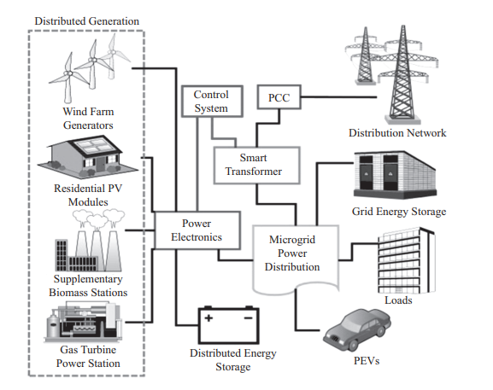
Figure 3. Impact of PEV penetration in a microgrid (Hossain et al, 2015)

Standardisation

To ensure the success of the rapid rollout of EV`s and its integration into the grid via V2G it is vital that common standards are established (euroelectric, 2021). This is applicable to both the hardware (connector and cables) as well as the software (communication protocols, remote operability, and payment systems). Currently, as with many technological advances, the mechanisation lays in the hands of the manufacturers creating varying standards, often lead by geographic location and company preference.
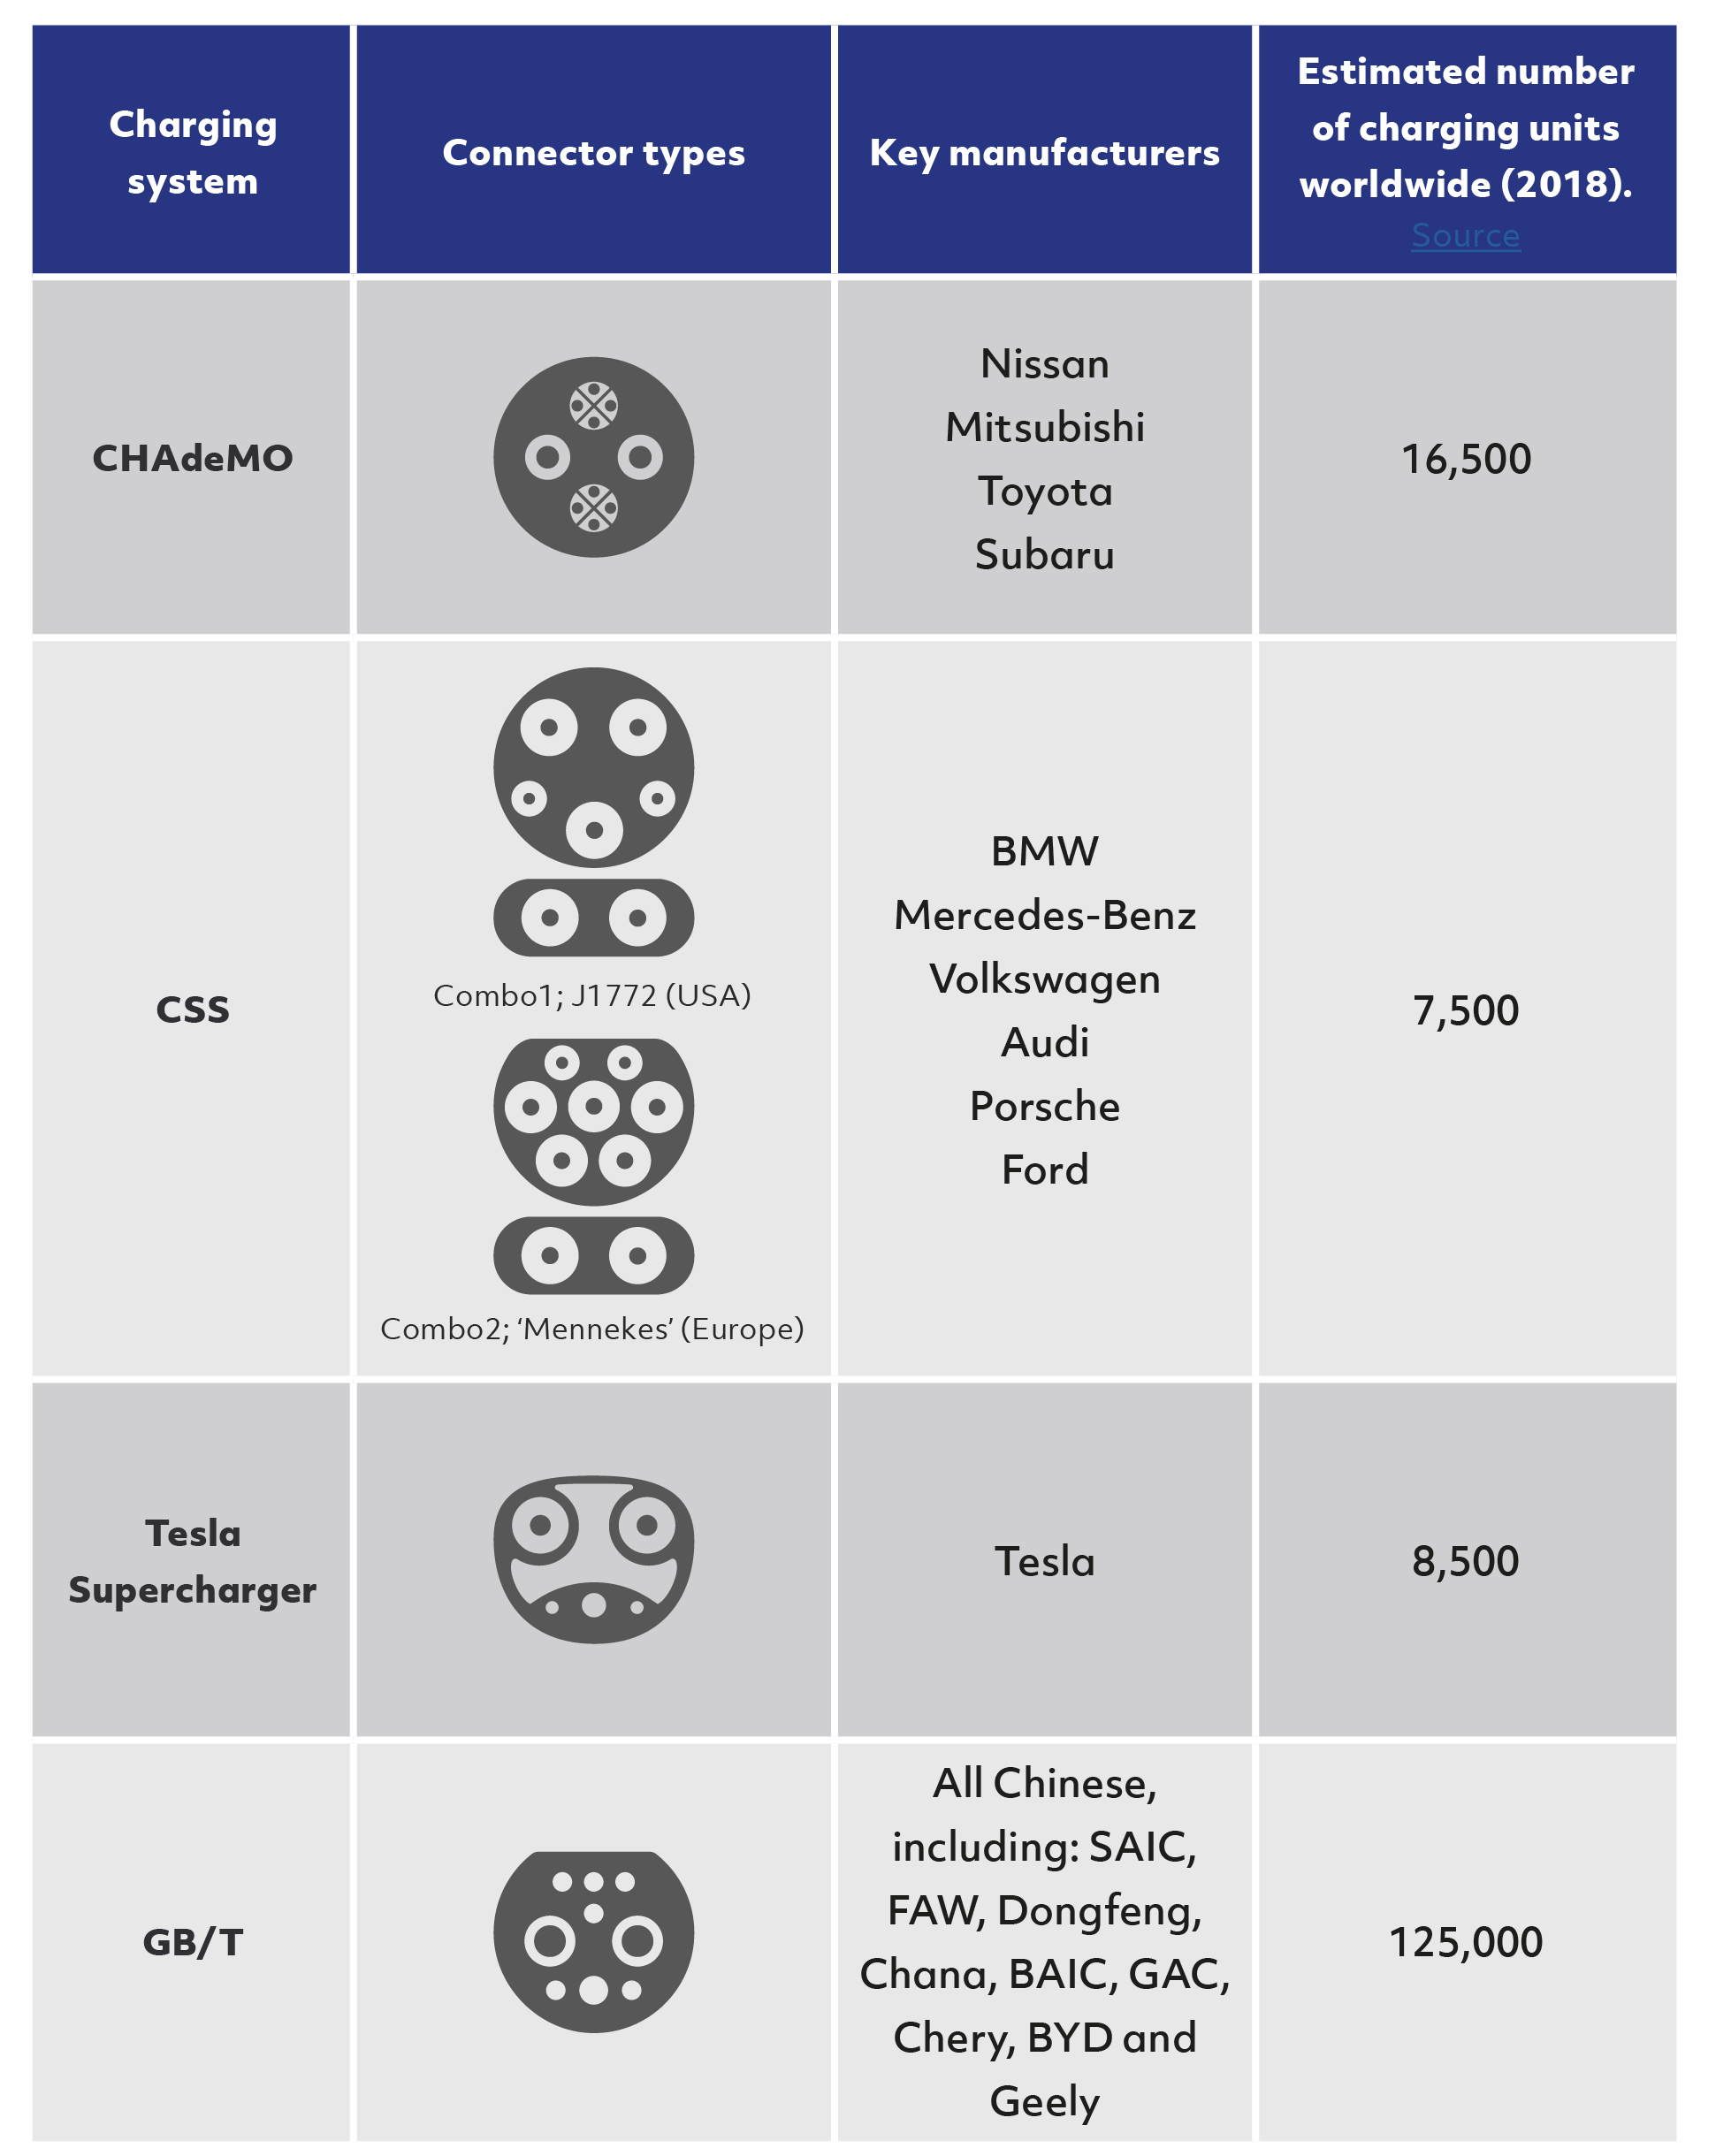
Often this varying technology will naturally bottle neck and public adoption will dictate a standard, as was seen with CD`s, mini discs, VHS, and Betamax. However, as government legislation tightens and climate change becomes ever more prominent, the market penetration of electric vehicles becomes immutable and failure to adopt a standard will slow consumer uptake, halter funding and development, and create volatility for stakeholders (euroelectric, 2021).
Figure 4 EV current plug connectors (Dalroad.com,2021)
This topic is further complicated as the technology pairs both automotive and electrical technologies in which standards are treated by international bodies both with very different cultural approaches to harmonisation. Which, up until now has operated within boundaries of standardisation dependent of where the technology fell, vehicle centric being undertaken by the International organization of standards (ISO) and infrastructure focused being undertaken by the international electrotechnical commission (IEC) (Al-Majeed and chamberlain, 2021)
As a result, each country and manufacturer employed different charge station connector types in accordance with local regulatory bodies and grid design (Al-Majeed and chamberlain, 2021). Such an example of this is the Nissan leaf which uses a controller area network (CAN) communication device primarily used by Japanese manufacturers in line with their connector standard. Whilst in contrast, BMW, Tesla and Jaguar adopted the powerline communication as their protocol, neither of which are interchangeable (Al-Majeed and chamberlain, 2021); thus creating a complex myriad of factors subjected to the end user such as varying connector hardware, charge times and compatibility. Alongside consumer dissatisfaction this creates discord with the communication protocol software layer between the EV and its host charger which is vital for its functionality and overall success being responsible for the exchange of information such as “Authentication state - Battery capacity - Charge time - Correct voltage output - Maximum charging current available - Instructions to bypass the vehicles on-board AC-DC charger if utilising a DC fast charger - State of charge” (Al-Majeed and chamberlain, 2021).

This varying technology is also further convoluted by differing payment methods such as subscription and pay as you go, the former being exclusive to contract based mobile phone apps and the latter being accessible to all via a credit card. Some charging stations operate exclusively with the manufacturers vehicles such as tesla and utilise a radio frequency identification system (RFID) limiting users to charging stations owned by the companies of which their registered (electric standardisation, p9). Although superior ergonomically speaking, the pay as you go method is still rare, likely caused by a window of monopolisation by manufacturers of EV`s and communication software. However the UK government is pushing charge point operators to adopt a dual payment system (Gov.uk, 2019), creating open access to all EV owners, subject to connector compatibility. Hence, by employing standardisation, manufacturers can collaborate, and innovation can thrive, creating industry momentum towards the clean energy narrative.

Batteries

A critical pillar of the new green initiative is the use of batteries. Used to store energy, they offer a method to produce reliable energy when the renewable sources such as wind and solar are unavailable, and in the focus of this report their use in EV`s and application as a spinning reserve when applied to V2G technologies.
Technological advancements of battery’s have continued to move forward and will persist to develop as demand increases. As a determining factor of EV`s success and in turn V2G technology the impact of a global switch to battery powered vehicles must not be taken likely. The changing geopolitical dynamic between energy producers and consumers is significant when electric overtakes oil and oil demand reduces whilst electric and battery demand increases (Weforum.org, 2019).
Alongside this the effects of significantly ramped up production in all stages of battery construction from mining to manufacturing will have to be carefully managed and consideration must be given to avoid issues such as worker exploitation, unethical mining and extraction methods and the degradation of local communities to raw materials.
Currently lithium-ion batteries are most commonly used in EV`s due to their performance characteristics, offering high power and energy density as well as high cyclic charge and discharge life. Whilst batteries will continue to develop it seems likely that lithium ion will be at the forefront of the EV reform (UNCTAD, 2020) and the demand for cobalt, manganese, lithium, and nickel being critical raw materials in lithium-ion batteries will be vast (Sunriseem, 2021).

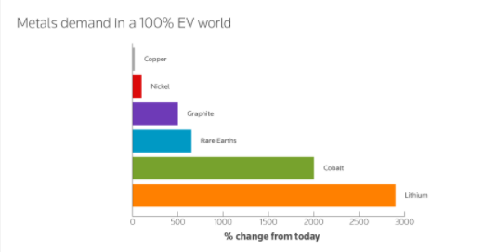
Figure 5. Metals demand in a 100% EV world (Thomsonreuters.com, 2021)

Battery Life and Recycling

As previously stated, batteries are of exceptional importance in the adoption of EV`s and the production of which is destined to boom. As an emerging technology, consumers have trepidations to what they can expect in battery degradation as many manufacturers advertise expected reduction in range after 8 years and with replacements costing between $10 000-$30000 (Gayton B, 2021) consumers have reason to be wary.
The degradation of batteries is largely down to the charge control, ensuring charge set rate and depth of discharge being critical to battery longevity as well as customer satisfaction (Hossain et al, 2015) as failure to implement charge control will lead to drained batteries or unusable range. However, even with correct procedure current battery technology is limited in its lifespan, expensive to replace and are difficult to recycle, compounding to create further complications in the shift to EV.
Battery recycling is of major importance towards the endeavour of a sustainable transportation system. Although the recycling of materials in lithium ion batteries is being explored, currently only 68% of cobalt and 58% of manganese is being recycled (UNCTAD, 2020) whilst currently no lithium recycling technology exists despite its capability to be recycled unlimitedly (UNCTAD, 2020). With demand increase, battery waste will continue to rise and without robust recycling procedures as well as information and protocol for second life use, some elements will end up contributing to landfill, falling far beyond the green image the sustainable narrative wishes to pursue.

Battery Raw Materials

Cobalt resources are estimated at 25 million tons which is predominantly located in the Democratic Republic of the Congo and Zambia (UNCTAD, 2020). Moreover, 75% of the worlds raw supply of manganese is sourced in South Africa, whilst lithium resources are concentrated in Chile, Bolivia and Argentina making up the” lithium triangle” hosting half of the worlds 62 million tons of lithium (UNCTAD, 2020).
Due to the geographic locations of the raw materials and each locations political state and production capability, increase in demand will present unique and varied ripple effects. One example of this is within the Democratic Republic of the Congo where cobalt production employs approximately 100,000 miners many of whom are children working in dangerous conditions (UNCTAD, 2020). Although the Democratic Republic of the Congo has acknowledged the issue and tried to adopt policies and procedures to prevent it, it currently remains an issue.
Further concerns present themselves in the mining of lithium. Within Chilies Salar de Atacama, mining reportedly consumed 65% of the regions water, having a detrimental effect on local farmers and communities who are already relying on external water supplies to sustain themselves (UNCTAD, 2020). Likewise, acid mine drainage, which is the dissolution of metal elements, often present in exploited copper-cobalt mines causes the contamination of rivers and drinking water leading to degradation of local land and communities (UNCTAD, 2020).
Alongside mining production, due to the laborious extraction process of ores to minerals, the countries which host the raw produce often do not have the capability to refine the product, meaning some of the production activities span several countries which reduces the efficiency of the process in energy demand. Furthermore, as demand increases refineries will also expand to avoid supply chain interruption such as cobalt chemical refineries in China. This too will be cause to geopolitical tensions and will require careful strategizing and negotiation to satisfy all interests.

Conclusion

The pursuit of zero emissions has laid way for EV`s to become the standard in transportation, and whilst Hydrogen and synthetic fuels are being explored, it seems that current technology and government patronage facilitates EV`s to become widely adopted. Following consumer trajectories, production will soon reach a topple point wherein demand and production will surge. To serve this narrative energy demand will have to be addressed and the scaling up of the current grid would simply inflate peak demand leading to increased production of fossil fuel-based energy. Alongside this, the current grid would quickly be overwhelmed resorting in huge network investment in outdated technology and ultimately result in diminished utilitarianism the whole way from supplier to consumer.
The application of V2G technology facilitates the implementation of EV`s and offers a solution to inconsistent renewable energy sources and peak grid demand, as well as the engagement of consumer participation whilst generating cost savings, ultimately creating a reliable distributed energy network.
However, V2G operates as one critical pillar within in a distributed network and therefore its effectiveness to contribute successfully relies on the rate and quality in which its dependent facets are deployed. Major contributing components being; the implementation of smart grids and grid power storage facilities, V2G infrastructure, V2G communication and hardware standardisation and geopolitical bilateral agreements regarding critical battery raw material supply and trade. Failure to synchronously develop all avenues will result in deficits within the foundations of this prevailing green initiative and thwart progress.
Overall V2G technology offers a solution to the volatile relationship between renewable energies and EV`s but must be considered as one tool amongst many that are necessary to reach long term sustainability goals, all of which need refinement and holistic consideration to harmonisation.

References

Al-Majeed S and Chamberlain K. (2021). standardisation of UK Electric vehicle charging protocol, payment and charge point connection. World electric vehicle journal. 1 (12)
Bloomberg enf. (2021). electric vehicle outlook 2021. Available: https://about.bnef.com/electric-vehicle-outlook/. Last accessed 06/11/2021.
Cao, y et al (2016). influences of electric vehicles on power systems and key technologies of vehicle to grid. Beijing: science press. 14, 37, 38, 49.
Clean Teq. (2021). Lithium ion batteries. Available: https://www.sunriseem.com/wp-content/uploads/2016/12/9772_Clean-Teq-LITHIUM-ION-BATTERIES_17-1-17.pdf. Last accessed 06/11/2021.
Dalroad.com. (2021). an introduction to electric vehicle rapid charging stations. Available: https://www.dalroad.com/resources/an-introduction-to-electric-vehicle-rapid-charging-standards/. Last accessed 15/11/2021.
El-shimy, M. (2021). the art of load shedding and online applications in a power system. Available: https://electrical-engineering-portal.com/load-shedding-online-applications-power-system-emergency-state. Last accessed 06/11/2021.
euroelectric. (2021). standardisation of electric vehicle charging infrastructure. Available: https://www3.eurelectric.org/evdeclaration/declaration.html. Last accessed 06/11/2021.
Gayton, B. (2021). How much does it cost to replace batteries in electric vehicles. Available: https://thedriven.io/2021/07/23/how-much-are-replacement-batteries-for-electric-vehicles-in-australia/. Last accessed 06/11/2021.
Gov.uk. (2019). All new rapid chargepoints should offer card payment by 2020. Available: https://www.gov.uk/government/news/all-new-rapid-chargepoints-should-offer-card-payment-by-2020. Last accessed 06/11/2021.
Nuvve holding corporation (2021) Explaining vehicle to grid technology from Nuvve. Available at https://www.youtube.com/watch?v=DbyceAkPiAU, accessed 06/11/2021
Rifkin, J (2011). the third industrial revolution. New york: PALGRAVE MACMILLAN. p 107, 115.
Thomson Reuters. (2020). will electric vehicles really create a cleaner planet. Available: https://www.thomsonreuters.com/en/reports/ele
United nations conference on trade and development. (2020). commodities at a glance, special issue on strategic battery raw materials. United nations conference on trade and development.
Weforum.org. (2019). How electric vehicles will redefine geopolitics. Available: https://www.weforum.org/agenda/2019/07/how-electric-vehicles-will-redefine-geopolitics/. Last accessed 06/11/2021.

