Research project proposal

Impact of current challenges on the human resources department relating to recruitment and retention

Student name: Mihaela Buzdugan 2121942
Tutor: Lisa Knight
Table of Content
INTRODUCTION AND BACKGROUND 4
DISCUSSION/LITERATURE 4
Literature review 4
Evaluation of the external and internal factors 5
Examples of current affairs 7
Potential solutions with example 8
EVALUATION and CONCLUSION 9
REFERENCES 11

Table of Figures
Figure 1: Growth of GDP of UK 6
Figure 2: Increased rate of inflation in the UK 8

INTRODUCTION AND BACKGROUND
The proposal for the research is the process of creating the report and evaluating the various solutions and methods which can help in solving the problems which have been faced by the organisation (Boon et al., 2019). The research project proposal is based on the evaluation of the various issues which have been faced by the company in terms of managing the individuals of the organisation and facing the challenges of ineffective employee retention in the organisation. The Premier Inn is a British hotel company which is situated in Dunstable, United Kingdom. The hotel was founded in the year 1987 and is currently operated and managed by Dominic Paul, who is the group CEO of the company (Premier Inn, 2023). The research project proposal consists of the evaluation of the external factors which can affect the performance of the organisation and the capabilities of retaining the employees to the organisation. Premier Inn is facing the issue of employee retention, which is due to the various external factors that are affecting the effective management of the staff in the organisation. The project will evaluate and include examples of other organisations which were able to retain employees to the organisation and manage the various challenges which have faced by the organisation.
The proposal will describe the reasons behind the challenges which have been faced by the Premier Inn and are affecting the performance of the organisation. The challenges consist of the various external factors which are affecting the performance of the business and the effective management of the staff which is working in the organisation. The current issue of ineffective employee retention in the Premier Inn will be discussed, and the solutions which can be used for solving the issues that have been faced by the company in the effective management of the business and the staff. The proposal will evaluate the external factors with the help of the PESTLE analysis and the internal factors of the company with the help of the SWOT analysis so that the various internal and external aspects of the organisation can be evaluated. The proposal will consist of the various techniques which have been used by the competitors of the company so that the ease of evaluating the various solutions can be achieved. The proposal will consider the various issues which have been faced by the employees, which are affecting the employee retention of the Premier Inn.

DISCUSSION/LITERATURE

Literature review
According to Gigauri (2020), employee retention in the organisation is based on the management of the various internal factors that can affect the mindset of the individuals. The employees are required to be considered as the key entities of the organisation so that the staff can be valued and respected in the company. Internal factors such as the environment and the culture of the organisation can affect the employee retaining capabilities of the organisation, which can affect the performance of the business (Aguinis and Burgi-Tian, 2021). Internal factors such as the low amount of payment and the lack of appreciation can reduce the employee retention capabilities of the business. However, in contrast to this Malik et al. (2020), said that employee retention in the organisation can be affected by external factors of the organisation. The political and economic factors of the country can affect the performance of the company in terms of retaining employees. The increased inflation in the country and the various political decisions can affect the efficiency of the business in terms of managing and retaining the staff in the organisation. The ineffective management of external factors can affect employee retention in the organisation (Wang et al., 2020).

Evaluation of the external and internal factors
The internal and external factors can be evaluated to understand the various challenges which increase the issues in employee retention (AlKahtani et al., 2021).
Internal analysis
The SWOT analysis can be used for the internal analysis of Premier Inn.
- Strengths- The Premier Inn can perform in various regions of the world as the company can operate in UK and UAE. The company can increase the number of hotels as there are more than 800 hotels in the UK and various countries of the world (Premier Inn, 2023).
- Weaknesses- The company is not able to effectively manage the employees as the international teams and employee management is challenging for the company. There are more than 35,000 local and global employees of the company who are not managed by the company in an effective manner (Premier Inn, 2023).
- Opportunities- The organisation can increase the sales of the business by targeting customers from the various countries in which the business is located. The increased sales can provide the ease of improving the brand image and invest in improving the quality of services (Paillé, Valéau and Renwick, 2020).
- Threats- Premier Inn can face issues in retaining employees as the ineffective management of the staff can affect the performance of the company, which is important for the growth of the business.
External analysis200
The external analysis of the business can be done with the help of the PESTEL analysis, which can help in evaluating the various external factors of the business.
- Political- The political factors of the country are supportive of the business as the government of the UK collaborates in the improvement of the hospitality sector for creating effective solutions for the organisations which are working in the hospitality industry of the United Kingdom (Gov, 2023).
- Economical- The economic factors of the country are supportive of the growth of the business, as the GDP of the country in the year 2021 was more than £2.2 trillion (Statista, 2023). The GDP of the country is expected to grow at a rate of 2.15% by the year 2027.
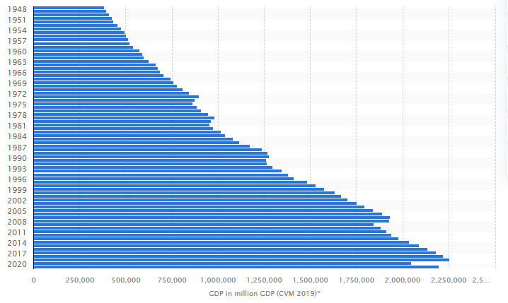
Figure 1: Growth of GDP of the UK
(Source: Statista, 2023)
The bar graph describes that the GDP of the UK is fluctuating since 2017 as in the year 2018 the GDP was less than £2.2 trillion which hiked up to be more than £2.2 trillion by the year 2021 (Statista, 2023).
- Social- The social factors of the country consist of the trends in the hotel industry, which can affect employee retention. The trends such as the demand for vaccinated staff can affect the retention of employees.
- Technological- Technological factors such as the smart rooms and the robot butlers can affect the retention of employees in the organisation, which can be affected by the reduced needs of the human forces in the company (Pak et al., 2019).
- Legal- legal factors such as the various contracts and working hours of the employees and the Equality Act 2010 can affect the efficiency of retaining the employees in the organisation, which is important for the company (Citation.co.uk, 2023).
- Environmental- Economic factors such as air pollution and deforestation due to the need to increase the property of the hotel company can affect employee retention as they are required to perform illegal activities for the business (Benevene and Buonomo, 2020).

Examples of the current affairs
There are various current affairs which affect employee retention in the organisation.
- Covid-19- Covid-19 affected employee retention during the covid-19 pandemic; the company was required to fire the employees so that the business could be managed. During the covid pandemic, the Premier Inn announced cutting more than 6,500 jobs in the hotels of the company (Theguardian, 2023). This affected the employee retention capabilities of the company as the job cuts reduced the number of staff members who were working in the Premier Inn. The COVID-19 pandemic affected employee retention in the company.
- Inflation- The inflation affected employee retention in the company as the increased inflation made the employees demand increased salaries. In the year 2022, the rate of inflation in the United Kingdom was 11.1%, which increased the cost of living for employees (Commonslibrary, 2023). The increased rate of inflation increased the need for higher compensation from the Premier Inn, which was not provided to the employees. The low amount of salary reduced the interest of the staff in working in the Premier Inn, which increased the risk of ineffective employee retention.
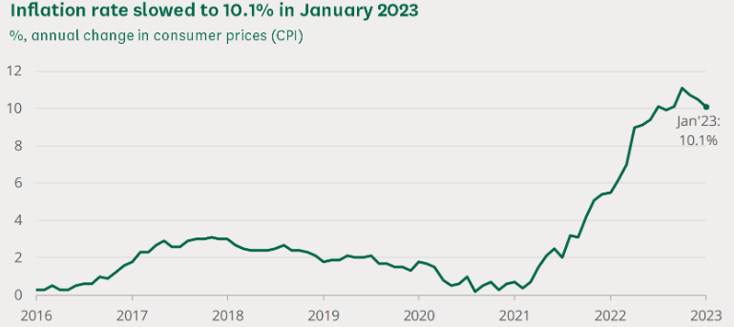
Figure 2: Increased rate of inflation in the UK
(Source: Commonslibrary, 2023)
The bar graph demonstrates that the rate of inflation is increasing in the UK since 2021 as of January 2023 the rate was 10.1% (Commonslibrary, 2023).
- Brexit- Brexit affected employee retention in the organisation as the decision to close the sources of labour by the UK can increase the wages of the employees (Yin, Wang and Lu, 2019). The increased wages of the staff can affect the profit management of the Premier Inn, which can affect employee retention in the organisation. The increased rates of wages due to the Brexit affected employee management as the organisation is required to increase revenue and profit, which can be done by reducing the number of employees in the organisation (Baum et al., 2020). The increased wages due to the Brexit can reduce the number of employees in the Premier Inn as the company is required to fire the employees so that the wages and profits can be managed.

Potential solutions with example
- Increasing the wages- Increasing the wages of staff can help in retaining the employees in the organisation as increased wages can motivate the staff to stay in the organisation. For example, Marriott increases the wages of the employees at the rate of 4% of the cost of living every year so that the staff can be retained in the business (Indeed, 2023). The increased wages of the staff can help the company in overcoming the challenge of ineffective employee retention and increase the rate of retention in the organisation. The increased wages are beneficial for motivating the staff so that the employees can work in an effective manner (Iqbal, 2019).
- Providing growth opportunities- The company can provide opportunities for growth to the employees so that the staff can be retained in the company. The development of the staff can motivate them in terms of staying in the organisation and contributing to the major operations of the business. For example, the Radisson provides the staff with growth opportunities and focuses on employee development in the company (Radissonhotels, 2023). This helps in retaining the staff and supporting the team so that the domestic and global employees can be managed and retained effectively.

EVALUATION and CONCLUSION
The use of the PESTLE analysis is beneficial for evaluating the external forces that can affect the organisation and its performance in terms of retaining employees. Technological trends such as smart rooms and robot butlers in hotels can reduce the efficiency in terms of retaining the staff as the employees will be of the opinion that they are not being valued in the organisation by the employer. The SWOT analysis is beneficial for evaluating the internal factors of the business that can affect the performance of the company and its capabilities of retaining the staff of the organisation. The Premier Inn can operate its business on an international level as there are more than 800 hotels of the company in the UK, and it can operate in various regions such as the UK and UAE. The various events, such as the covid-19 pandemic, affected the employee retention capabilities of the Premier Inn as the company announced to cut off more than 6500 employees during the period of the pandemic. The increased rate of inflation in the UK in 2022 affected employee retention in the company as the staff thought that wages should be increased so that the cost of living could be managed.
There are various recommendations which can be given to the company as the solutions for solving the problems which are faced by the company.
- Appreciating the good work- The company is recommended to appreciate the good work which is done by the employees in the company. Premier Inn can motivate the staff and retain them in the organisation by appreciating the hard work and the creative operations which are performed by the staff so that the employees can be motivated and retained in the organisation. This can help the company in improving its performance and effectively retaining the staff.
- Promoting the deserving employee- The company must provide promotions to employees who are hard-working and can work effectively. The promotions can motivate the staff, which can increase employee retention capabilities, which are necessary for the effective performance of the business. This can improve employee performance and capabilities of managing the major operations of the business. The promotions can create a positive image of the organisation in the minds of employees, which is important for retaining the staff.

REFERENCES
Aguinis, H. and Burgi-Tian, J., 2021. Talent management challenges during COVID-19 and beyond: Performance management to the rescue. BRQ Business Research Quarterly, 24(3), pp.233-240.
AlKahtani, N., Iqbal, S., Sohail, M., Sheraz, F., Jahan, S., Anwar, B. and Haider, S., 2021. Impact of employee empowerment on organizational commitment through job satisfaction in four- and five-stars hotel industry. Management Science Letters, 11(3), pp.813-822.
Baum, T., Mooney, S.K., Robinson, R.N. and Solnet, D., 2020. COVID-19’s impact on the hospitality workforce–new crisis or amplification of the norm? International Journal of Contemporary Hospitality Management, 32(9), pp.2813-2829.
Benevene, P. and Buonomo, I., 2020. Green human resource management: An evidence-based systematic literature review. Sustainability, 12(15), p.5974.
Boon, C., Den Hartog, D.N. and Lepak, D.P., 2019. A systematic review of human resource management systems and their measurement. Journal of management, 45(6), pp.2498-2537.
Citation.co.uk, 2023. Equality Act 2010 [Online] Available Through <https://www.citation.co.uk/news/hr-and-employment-law/uk-employment-laws-explained/> [Accessed on 28 February 2023]
Commonslibrary, 2023. Increased rate of inflation in the UK [Online] Available Through <https://commonslibrary.parliament.uk/research-briefings/cbp-9428/#:~:text=The%20cost%20of%20living%20increased,goods%20and%20services%20for%20households.> [Accessed on 28 February 2023]
Gigauri, I., 2020. Effects of Covid-19 on Human Resource Management from the Perspective of Digitalization and Work-life-balance. International Journal of Innovative Technologies in Economy, (4 (31)).
Gov, 2023. Support of government to the hospitality sector [Online] Available Through <https://www.gov.uk/government/groups/hospitality-sector-council> [Accessed on 28 February 2023]
Indeed, 2023. Increase in wages at the Marriott [Online] Available Through <https://www.indeed.com/cmp/Marriott-International/faq/how-often-do-raises-occur-at-marriott-international?quid=1au0grngm1agn0t0#:~:text=Yearly%2C%20with%20a%20maximum%20of%204%25%20COST%20OF%20LIVING%20INCREASE.> [Accessed on 28 February 2023]
Iqbal, A., 2019. The strategic human resource management approaches and organisational performance: The mediating role of creative climate. Journal of Advances in Management Research, 16(2), pp.181-193.
Malik, S.Y., Cao, Y., Mughal, Y.H., Kundi, G.M., Mughal, M.H. and Ramayah, T., 2020. Pathways towards sustainability in organizations: Empirical evidence on the role of green human resource management practices and green intellectual capital. Sustainability, 12(8), p.3228.
Paillé, P., Valéau, P. and Renwick, D.W., 2020. Leveraging green human resource practices to achieve environmental sustainability. Journal of Cleaner Production, 260, p.121137.
Pak, K., Kooij, D.T., De Lange, A.H. and Van Veldhoven, M.J., 2019. Human Resource Management and the ability, motivation and opportunity to continue working: A review of quantitative studies. Human Resource Management Review, 29(3), pp.336-352.
Premierinn, 2023. About us [Online] Available Through <https://www.premierinn.com/gb/en/why.html> [Accessed on 28 February 2023]
Radissonhotels, 2023. Employee development at the Radisson [Online] Available Through <https://www.radissonhotels.com/en-us/corporate/responsible-business/people> [Accessed on 28 February 2023]
Statista, 2023. Growth of GDP of UK [Online] Available Through <https://www.statista.com/statistics/281744/gdp-of-the-united-kingdom/> [Accessed on 28 February 2023]
Theguardian, 2023. Job cuts in Premier Inn [Online] Available Through <https://www.theguardian.com/business/2020/sep/22/premier-inn-whitbread-cut-jobs-covid-beefeater-lockdown> [Accessed on 28 February 2023]
Wang, Y., Kim, S., Rafferty, A. and Sanders, K., 2020. Employee perceptions of HR practices: A critical review and future directions. The International Journal of Human Resource Management, 31(1), pp.128-173.
Yin, Y., Wang, Y. and Lu, Y., 2019. Antecedents and outcomes of employee empowerment practices: A theoretical extension with empirical evidence. Human Resource Management Journal, 29(4), pp.564-584.

