2118883
Concrete sustainability and Experimental work.
Concrete sustability & experimental work
Materials Engineering – Semester 2

Table of Contents
Introduction 2
How can improve concrete quality play an important role in reducing environmental impacts and contribute to sustainable development. 2
Reducing CO2 emissions – 2
Durability 2
Managing waste 2
Life Cycle Assessments (LCA) 2
Mix Design 3
Regulatory Certification 3
Material usage 3
Discuss if the production of recycled aggregate concrete from old concrete structures can have a major environmental impact in the future programs for sustainable development. 3
Benefits of using recycled concrete for the environment 4
Resource Conservation 4
Reduction of Landfill waste 4
Support for Sustainable Development Goals (SDG) – 4
Carbon Footprint – 4
Cons of using recycled concrete for the environments 4
Contamination concerns 4
Durability 4
Availability 4
Compliance checks 4
Discuss the development of a new form of concrete that, as scientists at a British concrete manufacturer claim, absorbs carbon dioxide as it hardens. 5
Overview 5
Experimental Task 6
Procedure for Compressive Test 6
Sieve Analysis 6
Compressive Test 6
Experiment 1 – Standard concrete mix. 7
Experiment 2 – 2% fibres mixed with concrete design. 9
Experiment 3 – 5% fibres mixed with concrete design. 10
Conclusion 11
References 12

Introduction
The construction industry consumes a large amount of natural resource and energy and is one the main sources of waste generation and greenhouse gases (GHG) in the world. The preparation and utilisation of concrete has a massive impact on climate change and environmental pollution. It is generally accepted that concrete is the worlds most used man-made material due to durability and cost as well as achieving excellent properties of workability. However, concrete production is well known for being a significant contributor towards global warming and has caused major environmental impacts. This research study is going to investigate the findings of the use of concrete globally and its effects on the world, after an article was written titled ‘Concrete: the most destructive material on Earth’. Through this research analysis, information will be gathered as to how concrete quality can be play a significant role in reducing environmental impacts as well as look into different factors that could reduce this outlook of the use of concrete worldwide as there are different methods that are being produced to prevent the amount of greenhouses gases (GHG) such as the use of recycling old concrete by remixing with fresh concrete and British scientist have developed a new concrete that absorbs carbon dioxide as the concrete properties harden. In this case study it will investigate these ideas that globally we are depending on being an efficient factor we could use and have a better understanding on the positive impacts that they could bring to the world. A comparison on all three different ideas will take place to provide a conclusion to which idea could be the most efficient method in different aspects such as productivity, durability, and efficiency. (Nature, 2021)

How can improve concrete quality play an important role in reducing environmental impacts and contribute to sustainable development.
Reducing CO2 emissions – The production of cement, is a significant source of carbon dioxide emissions when producing concrete. If the concrete quality is to be enhanced, this can reduce the amount of cement required per unit of concrete, thereby lowering CO2 emissions that are associated with cement production. (Nnamdi Ezimako, 2023)
Durability – High-quality concrete formulas and more advanced construction techniques can lead to more durable structures. This will reduce the amount of maintenance requirements and minimise the environmental impacts that are associated with the need to repairs or replacements. This also includes any impacts that involve transportation, material extraction and processing.
Managing waste – Proper quality measure can reduce material waste during construction work phases, as well as advancements in concrete technology such as self-healing concrete can extend the lifespan of concrete structures by reducing the amount of waste generated over time. (Nnamdi Ezimako, 2023)
Life Cycle Assessments (LCA) – Conducting LCA’s help identify environmental hotspots that are associated with the use of concrete production as it will quantify the environmental impacts across the life cycle of concrete structures and stakeholders can make informed decisions to minimise the environmental burdens and provide maximum sustainability. (Manjunatha, 2021).
Mix Design – Advanced research into the correct mix design can lead to the most suitable concrete strength being used for the correct job. For example, the formula for the concrete strength will vary depending on the mix design used. Not all structures require the same mix design as it will be dependent on the loads it will be carrying. This not only ensure the structural integrity of buildings but also reduced the material usage and waste generation. High quality concrete typically required less raw materials such as cement, aggregate and water so by optimising the mix design it is possible to produce concrete that maintains its strength and durability while reducing resources.
Regulatory Certification – Many countries and regions have started implementing stricter environmental regulations related to the use of construction materials. This implementation will ensure concrete manufacturers can ensure compliance with materials and demonstrate commitment to sustainability with stakeholders.
Material usage - By improving the concrete quality, it becomes possible to use supplementary cementitious materials (SCMs) such as slag, silica fume and fly ash which are waste products from other industries (such as steel production industry). Incorporating these material not only reduce the demand for cement but also helps in recycling industrial waste and reduced environmental burdens.

Discuss if the production of recycled aggregate concrete from old concrete structures can have a major environmental impact in the future programs for sustainable development.

As the construction industry increasingly prioritises sustainability, the recycling of construction and demolition waste has emerged as a critical focus. Furthermore, the development of new construction materials derived from recycling concrete and demolition waste has advanced these sustainable initiatives. Utilising recycled aggregate has been extensively studied as a pathway towards sustainable future offering an alternative to natural concrete. Studies have demonstrated that concrete made with recycled aggregate reduces the strength when compared to concrete with natural aggregate. (Senaratne, 2017)
Utilising recycled aggregate in concrete has proven to offer a sustainable and cost-effective substitute for natural aggregates, particularly in non-structural components where strength is less crucial. Historically, recycled aggregates have found application in pavement construction, offering a sustainable alternative to natural aggregates. In China, for instance, there are instances where concrete mixtures incorporating approximately 50% recycled aggregates have met the same standards as those utilising solely natural aggregates for pavement construction. (Senaratne, 2017)

Benefits of using recycled concrete for the environment
Resource Conservation – Recycling old concrete reduced the demand for virgin aggregates, which are obtained through quarrying natural resources. By conserving these natural resourced, the environmental impacts with mining, transportation are reduced significantly.
Reduction of Landfill waste – Recycling concrete diverts large quantities of construction waste from landfills and reduces harmful pollutants, greenhouse gases into the environment. Contributing to better waste management practices and reducing the need for additional landfill space.
Support for Sustainable Development Goals (SDG) – The United Nation have targets to achieve related to consumption, sustainability and life on land and the use of recycling concrete aligns with providing these goals, including Goal 12 ‘Responsible Consumption and Production) by encouraging more sustainable and production patterns. (United Nations, 2024).
Carbon Footprint – Recycling concrete generates fewer gas emissions compared to producing fresh concrete which is a significant source of CO2 emissions. Recycled concrete contributes to mitigating climate change.

Cons of using recycled concrete for the environments
Contamination concerns – Recycled concrete may contain contaminants such as chemicals, paints, and other materials from the original structure. If not properly treated, these contaminants could provide environmental risk when the concrete is recycled into new projects. For instance, Gypsum presented in large quantities in concrete can affect the durability of reinforcement as it has a high sulphate concentration. (Khalaf and DeVenny, 2004)
Durability – Recycled concrete may exhibit different characteristic in its durability in comparison to fresh concrete, particularly if has not been properly processed. Also, if too much recycled aggregate is used, then this is going to affect the structural strength of the material. Both could then lead to concerns about the performance and lifespan of structure built with the recycled concrete leading to more maintenance and repair issues in the future. (Nick, 2020)
Availability – The availability of recycled concrete can vary depending on factors such as the condition and age of the original structure and the method of demolition. Inconsistent quality of concrete may affect the structural performance of the new projects. (Katerusha, 2021)
Compliance checks – Meeting set standard whilst using recycled material for construction projects can be very complex and can lead to uncertainty regarding quality assurances and environmental compliance that could have the potential to hinder broader adoption of recycled concrete.
When considering the utilisation of recycled concrete in new construction endeavours, comprehending both its advantages and potential drawbacks is imperative. In essence, recycled concrete presents notable environmental benefits, and any concerns can be mitigated through thorough evaluations, rigorous quality control, and adherence to regulatory standards, thereby ensuring its continued environmental sustainability.

Discuss the development of a new form of concrete that, as scientists at a British concrete manufacturer claim, absorbs carbon dioxide as it hardens.
An article published by The Guardian in 2008 titled "The cement that eats carbon dioxide" discusses a journal related to Novacem's cement, which is based on magnesium silicate. This innovative cement not only requires less heating during production but also absorbs significant amounts of CO2 as it hardens, rendering it carbon negative. Jonathan Essex, a civil engineer engaged in the environment and sustainability panel for the ICE (Institution of Civil Engineers), expressed approval of Novacem's concept, provided that Novacem can manufacture their cement at a competitive price (The Guardian, 2008).
According to a Totalconcrete article, Novacem concrete is reported to have the capacity to absorb up to 0.6 tonnes of CO2 per tonne. Additional research highlighted in the article explores efforts at several UK universities aimed at reducing global carbon dioxide levels using concrete as a mitigation strategy. At the University of Exeter, researchers have been investigating the incorporation of graphene into concrete, asserting that this could halve the amount of material required for concrete production and result in a reduction of 446kg of carbon emissions per tonne. Moreover, it is claimed that concrete enhanced with graphene exhibits double the strength and four times the water resistance compared to traditional concrete. Meanwhile, scientists from the University of Bradford are developing environmentally friendly, reusable concrete blocks termed 'demountable' blocks. These interlocking blocks are designed to prevent the release of CO2 into the atmosphere by eliminating the need for destruction after use. (Total Concrete, 2021)

Overview
After examining two distinct methods currently undergoing experimentation worldwide to enhance concrete sustainability, it is encouraging to note that each of these approaches offers unique advantages suitable for diverse structural applications. The research underscores a notable focus on repurposing waste concrete in new constructions, which holds significant potential for widespread sustainability across various industries. However, concerns regarding its integrity arise, particularly in infrastructure projects. The analysis suggests that this method may be more suitable for structures with lower bearing capacity, such as pavements and roadworks. Additionally, the development of carbon dioxide-absorbing concrete represents a groundbreaking design with global potential if extensively implemented. Nonetheless, the scarcity of research and experimentation in this area, particularly beyond the UK, poses a significant obstacle. Expanding global investigations and experiments could revolutionise concrete production methods and their environmental impact.

Experimental Task
The objective of this experimental investigation is to explore the impact of integrating plastic fibres into a concrete mix design across three distinct experimental parameters. Initially, a standard concrete mix design was employed as a reference to establish fundamental properties. Subsequently, in the following experimental phase, a portion of the aggregate was substituted with 2% plastic fibres, which was further increased to 5% in the subsequent experiment. This range of fibre concentrations within the aggregate matrix allows for a comprehensive analysis of the effects of fibre inclusion compared to a conventional concrete mix design.
Before commencing the mixing process, several parameters were predetermined to ensure adherence to appropriate concrete standards. The targeted characteristic strength was set at 25N/mm² at 28 days. Additionally, the desired slump test value was specified to be 100mm, with a maximum aggregate size of 20mm and a free water content of 195kg/m³. The total aggregate content for the experiment was established at 1750kg/m³, with a proportion of fine aggregate set at 40%, resulting in 700kg/m³ of fine aggregate and 1050kg/m³ of coarse aggregate content. These predefined parameters provide a standardised framework for the mixing process, facilitating accurate comparison and analysis of the experimental results.

Procedure for Compressive Test

Sieve Analysis
Prior to starting the experiment, the aggregate was separated using the sieve analysis test. This is performed by using a set of sieves with that have mesh inside that gets progressively smaller and will separate the coarse to fine aggregate. The sample was placed in the top sieve in the stack and the stack was then shaken mechanically which causes the particles to be arranged into their sizes with larger particles remaining on the top sieve and smallest at the bottom. This provided the experiment with more accurate results when mixing the coarse and fine aggregate together to get the correct mix design. See below the results of the sieve test.
Sieve Size (mm) | Weight (kg) – Mix 1 | Weight (kg) – Mix 2 | Total
16 | 1.26 | 6.72 | 7.98
8 | 1.5 | 1.76 | 3.26
4 | 1.34 | 0.96 | 2.3
2 | 0.84 | 0.36 | 3.5
1.6 | 0.045 | 0.025 | 0.07
1 | 0.054 | 0.033 | 0.087
0.5 | 1.76 | 0.46 | 2.22
0.25 | 0.76 | 0.62 | 1.38
0.125 | 0.073 | 0.071 | 0.144
0.08 | 0.0035 | 0.005 | 0.0085
Table 1: Showing sieve sizes and weight in each sieve size.

Compressive Test
When performing the cube compression test, the machine must be set at the correct test type and the machine will automatically calculate the area of the cube. The machine test rate is set at 0.6MPa/sec as this is commended for most concrete. Once the machine is set the start, the load recommended is 50KN. As the machine starts pressuring load onto the concrete block you will see the load amount increase. Once it reaches its peak amount, you will see the amount of force start to decrease and the peak amount of force is what will be tracked for each cube tested.
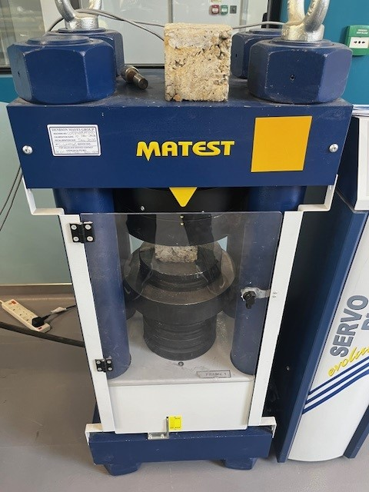
Figure 1: Showing compressive test machine.

Experiment 1 – Standard concrete mix.
In the first experiment, a standard concrete mix was prepared according to established guidelines and served as the control group to compare against the modified mixes. This standard mix consists of 7.1kg cement, total of 21kg aggregate (7kg 10mm coarse and 14kg 20mm coarse) and 3.9litre of water. This was set out prior to starting the mix.

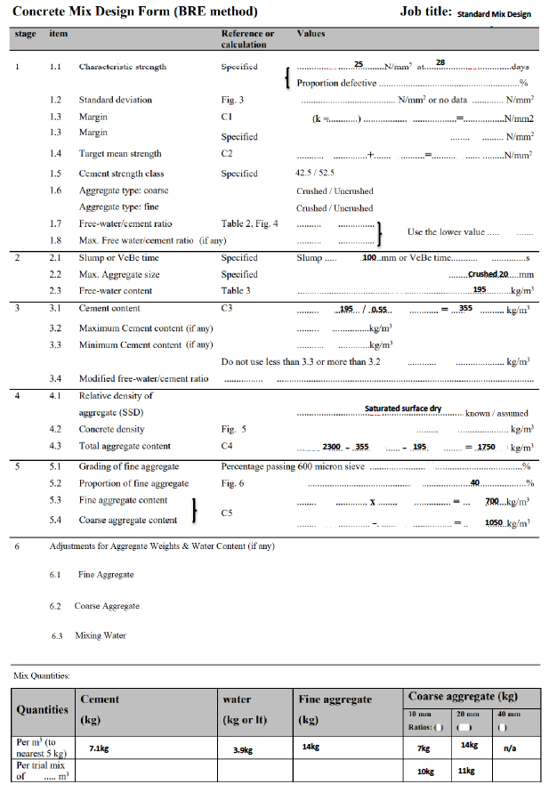
Figure 2: Showing the concrete mix design – Standard mix.
Experiment 1 was carried out twice as the 1st time it was performed the slump test failed. In the 2nd attempt the slump test measured at 110mm which is 10mm more than the targeted amount of 100mm. The concrete was then poured in 6no 0.1m3 cubes and set to dry to perform the compression test after seven days.
The results for the compression test after seven days are below:
SAMPLE | Compressive Test Results (KN)
A | 202.267
B | 246.587
C | 249.093
D | 231.623
E | 121.217
F | 230.043
Table 2: Showing results of Compressive test on Experiment 1.
As it can be seen from the results, the compressive strength ranged from the lowest result being 121.217 to the strongest result reaching 249.093, but an average compressive strength of 213.471.

Experiment 2 – 2% fibres mixed with concrete design.
In the second experiment, the standard mix design was altered to compensate 2% plastic fibres to be added to the concrete mix. This 2% mix replaced the fine aggregate of the mix design that varied the ratio to 38% fine aggregate, 2% plastic fibres and 58% coarse aggregate (10mm and 20mm coarse aggregate). See below.
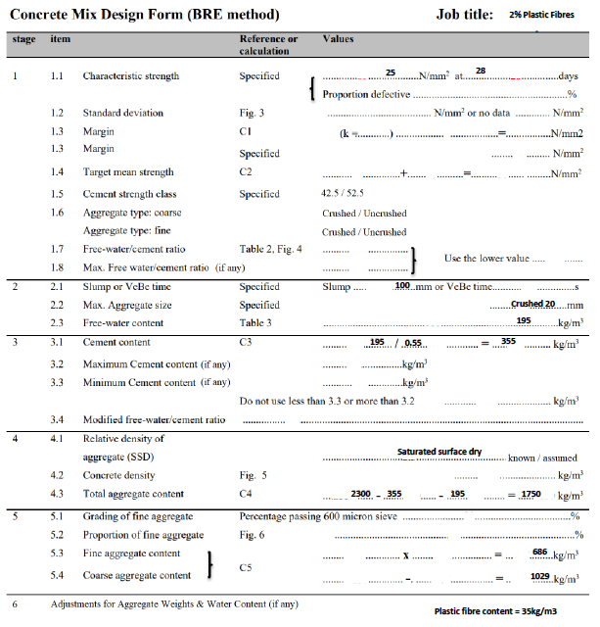
Figure 3: Showing the concrete mix design – 2% Plastic fibres.
After the mix, the slump test measured at 95mm, and the concrete mix was separated into 4no concrete blocks at 0.1m3. The results are below:
SAMPLE | Compressive Test Results (KN)
A | 160.324
B | 211.432
C | 136.253
D | 215.155
Table 3: Showing results of Compressive test on Experiment 2.
As it can be seen from the results, the compressive strength ranged from 160.324 to 215.155KN, and an average compressive strength of 180.791.

Experiment 3 – 5% fibres mixed with concrete design.
In the third experiment, the standard mix design was altered to compensate 5% plastic fibres replacing the standard mix design of 40% fine aggregate and 60% coarse aggregate to then be 35% fine aggregate and 55% coarse aggregate. See below.
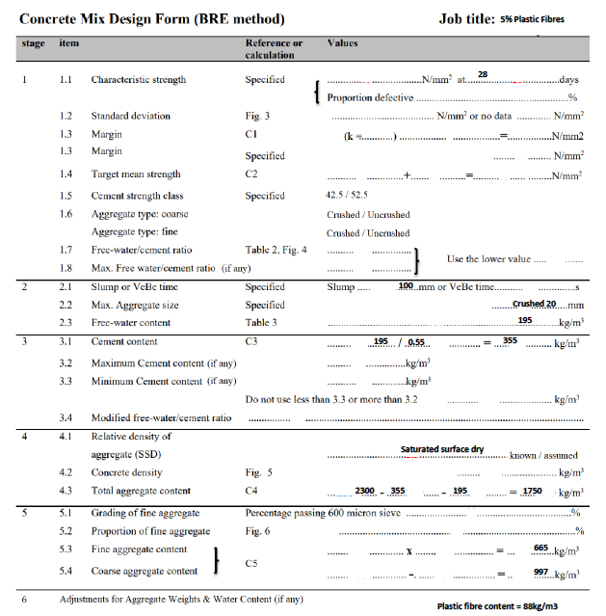
Figure 3: Showing concrete mix design – 5% Plastic fibres.
Once the mix was completed, the slump test was performed, and this measured at 92mm. The concrete mix was separated into 6no different 0.1m3 concrete cubes to be dried and tested after 7 days of strength. The results are below.
SAMPLE | Compressive Test Results (KN)
A | 147.279
B | 177.279
C | 144.845
D | 148.067
E | 163.747
F | 161.671
Table 4: Showing results of Compressive test on Experiment 3.
The results identified that the compressive strength of the 6no cubes ranged from 144.845Kn to 177.279 providing the results with an average of 157.148.

Conclusion
The analysis of this experiment revealed that the standard mix design exhibited the highest compressive strength, averaging 213Kn, compared to 2% plastic fibres at 180Kn and 5% plastic fibres at 157Kn. These findings suggest a correlation between increasing plastic fibres in the concrete mix and a decrease in compressive strength. Unlike a previous study by Al-Tulaian, which showed an 84% increase in flexural strength, this investigation yielded contrasting results, indicating a negative impact on compressive strength. (Al-Tulaian, 2016). There is also a correlation from the results of the slump test height decreasing as we increased the number of plastic fibres into the concrete design. Reasoning for this show that as the plastic fibres were introduced, the mix of aggregate and water/cement ratio got worse and therefore provided a less workability concrete mix.
Improvements could enhance the accuracy of the investigation. Increasing the number of samples per test, from the current range of 4-6 to a minimum of 10-15, could yield more precise results. Conducting separate sieve analysis tests for each experiment would ensure proper division of fine and coarse aggregates, potentially leading to varied outcomes. Furthermore, it was observed post-compression test that the concrete blocks with 5% plastic fibres exhibited poor mixing, evidenced by increased cracking and breakage. This could be attributed to insufficient curing time; extending the curing period from 7 to 28 days may result in stronger concrete bonds and improved overall strength.
This experiment provided good anaylsis and experience when dealing with concrete mixes design and brought intail on the significance important in the dicussion about the introduction of plastic fibres into concrete mixes. Although, there was improvements that could be made in the experiment for better accurate results, this was a great start to showing the effects that plastic fibres can cause to compressive strength and workability of concrete.
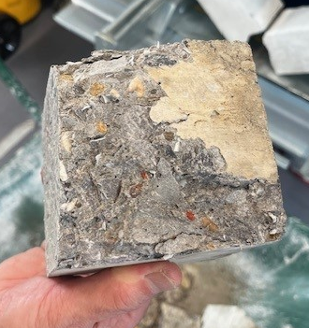
Figure 2: Showing the breakage of 1 sample of 5% concrete cube.

References
Al-Tulaian (2016) Recycled plastic waste fibres for reinforcing Portland cement mortar.
Katerusha, D. (2021). Barriers to the use of recycled concrete from the perspective of executing companies and possible solution approaches - case study Germany and Switzerland. Oct.
Khalaf F M and Devenny A S. (2004) “Recycling of Demolished Masonry Rubble as Coarse Aggregate in Concrete: Review.” Journal of Materials in Civil Engineering. ASCE. July/August. 331340.
Manjunatha (2021). Life cycle assessment (LCA) of concrete prepared with sustainable cement-based materials. Materials Today: Proceedings. doi:https://doi.org/10.1016/j.matpr.2021.01.248.
Nature (2021). Concrete needs to lose its colossal carbon footprint. Nature, [online] 597(7878), pp.593–594. doi:https://doi.org/10.1038/d41586-021-02612-5.
Nick (2020). An Overview of Recycled Concrete Aggregate. [online] ETM Recycling. Available at: https://www.recyclingbristol.com/an-overview-of-recycled-concrete-aggregate/.
Nnamdi Ezimako. (2023). The Advantages of Using Sustainable Building Materials. [online] Available at: https://www.linkedin.com/pulse/advantages-using-sustainable-building-materials-nnamdi-ezimako/.
Senaratne, S. (2017). Recycled Concrete in Structural Applications for Sustainable Construction Practices in Australia.
The Guardian. (2008). Revealed: The cement that eats carbon dioxide. [online] 31 Dec. Available at: https://www.theguardian.com/environment/2008/dec/31/cement-carbon-emissions#:~:text=Novacem [Accessed 2 Apr. 2024].
Total Concrete. (2021). Is Green Concrete Eco-Friendly? [online] Available at: https://www.totalconcrete.co.uk/news/is-green-concrete-eco-friendly/ [Accessed 2 Apr. 2024].
United Nations (2024). Goal 12 | Ensure Sustainable Consumption and Production Patterns. [online] United Nations. Available at: https://sdgs.un.org/goals/goal12.
‌

