Matthew Macpherson
1804910
Bsc Civil Engineering and Environmental Management
Construction Technology Assignment 2

Contents
- Foundations………………………………………………………………..3
  - – Type of foundation suitable for the construction (why?)…3
  - - Sketches of the chosen foundation…………………………………4
- Construction Details…………………………………………………….4
  - – Ground floor construction details…………………………………….5
  - – First Floor construction details………………………………………….5
  - – Eaves detailing/Covering……………………………………………………6
  - – The main roof structure construction details……………………..7
- Roof Design…………………………………………………………………..8
  - – Advantages and Disadvantages of the specified design……..8
  - - Alternative roof design (advantages and disadvantages)……10
- Condensation and Ventilation………………………………………...11
  - – Condensation……………………………………………………………………… 11
  - - Methods of Ventilation that will reduce condensation…………13
4.2.1 – Sketches……………………………………………………………………………………….14
  - – Measures that can be taken to reduce the risk of condensation in the proposed building……………………………………………………………..15
- Reference Page…………………………………………………………………17
- Bibliography …………………………………………………………………….20
- Appendix (All Hand Drawings to be present) ……………………21

- Foundations
1.1
For the construction of the house in question the foundation type I have chosen would be a raft foundation, more specifically it would be raft on soil. This would be better than raft on piles due to fact that with the plot being above the water table you would be unable to dig to the required depth to allow the piles to do their job. Also, the fact that the subsoil is firm also suggests that the regular raft foundation that sits straight on the soil would be a sufficient form of foundation for this project. Furthermore, as it’s only a single building it wouldn’t need the reinforcement that the piles as they are primarily utilised for far larger structures such as sky scrapers and large towers (Heaton Products LTD, N.D), hence the choice of raft on soil as the chosen foundation type (Foundation, Concrete and Earthquake Engineering, N.D). Further factors that I looked at when making the decision and these will be discussed below.
Due to the sub structure of the ground having clay contents present (even with it being low) it means that the ground can shrink and expand when certain conditions are met. The ground would shrink in high temperatures and would expand when heavy rainfall occurs (K–State Research and Extension, 2018). This would be problematic when it comes to a building as with the wrong foundation type the ground movement could cause defects in the building (cracks in the building etc.) and ultimately could cause the foundations to fail as a result. A raft foundation would stop the ground movement becoming a factor on the house, one reason for this is that it is a continuous reinforced slab that spreads the load of the building across it meaning that the raft takes the force of the ground movement and making the building stable when the ground might not be that stable (Home Building & Renovating, 2016). Since it protects the building that it’s underneath it’s perfect for the sub structure that is present for this project.
Raft foundations also are very economic compared to other types of foundations since it combines both the foundation and the floor slab, so requires less work than other methods as it’s all done in the same process (Civil Engineers Forum, 2014). It also improves the water proofing of the property and with the construction taking place above a water table this will be a further benefit and makes the use of this type of foundation a no brainer at this point (Define Civil, 2018). Less Excavation is also required as a result of choosing the raft foundation, this is since the concrete slab being able to do its job no matter the conditions and the depth of the dig as a result of this (DIY Doctor, N.D). The fact that it’s a house build there might be limited access to the bigger excavators that would be able to carry out more complexed and deeper foundations therefore again the raft foundation id the ideal type of foundation for this project (Heaton Products LTD, N.D).
Also, raft foundations are extremely versatile when it comes to design with several designs that might be suitable to choose from as a result, they can also be specifically designed for specific soil types so would be ideal for the site in question as the design would be specific to this project (Heaton Products LTD, N.D).
Annotated drawings of what the raft foundation would look like will be shown in 1.2, with the full drawing being present in the appendix at the rear of the paper.
1.2
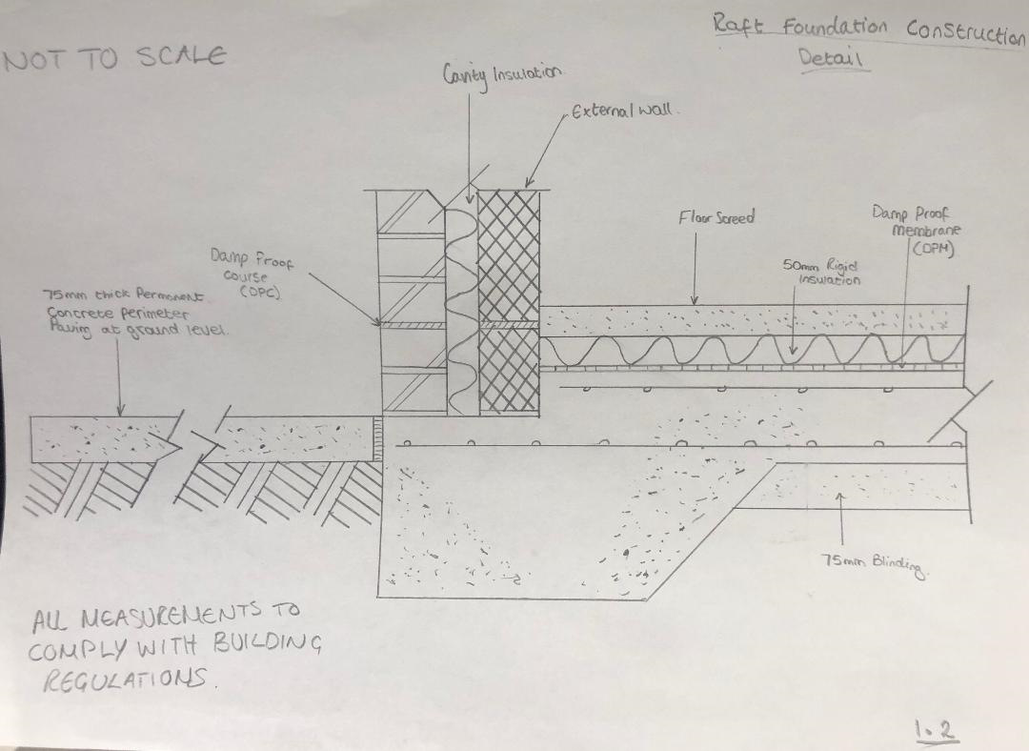

- Construction Details (Begins on page 5)
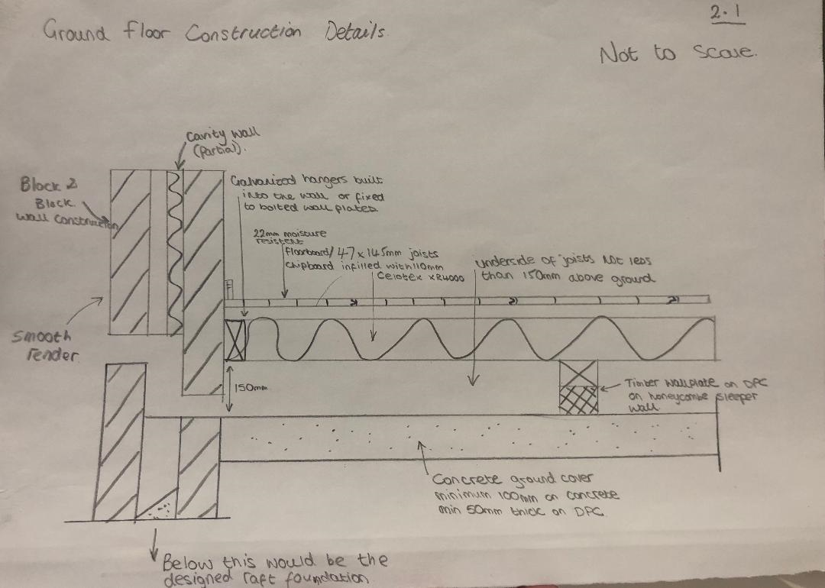
2.1

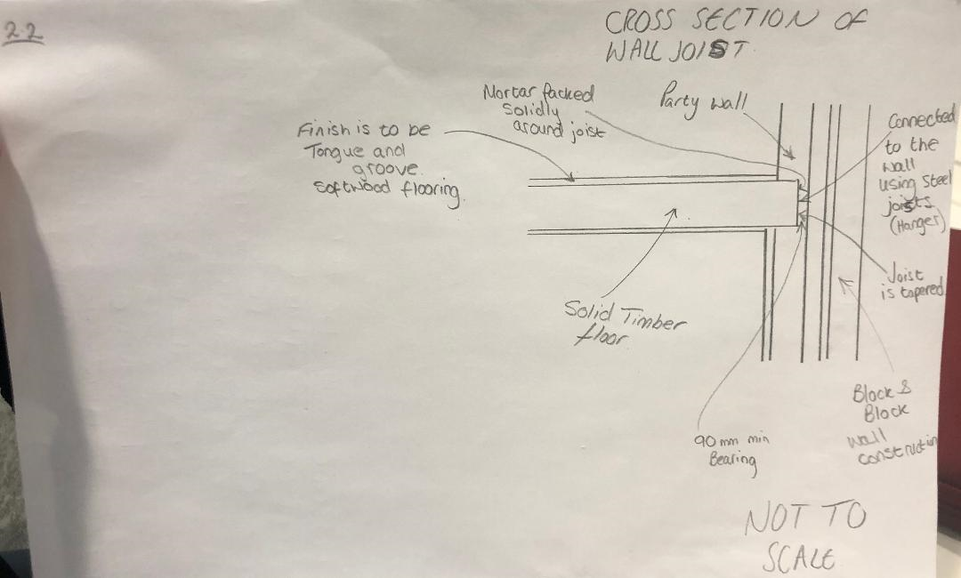
2.2
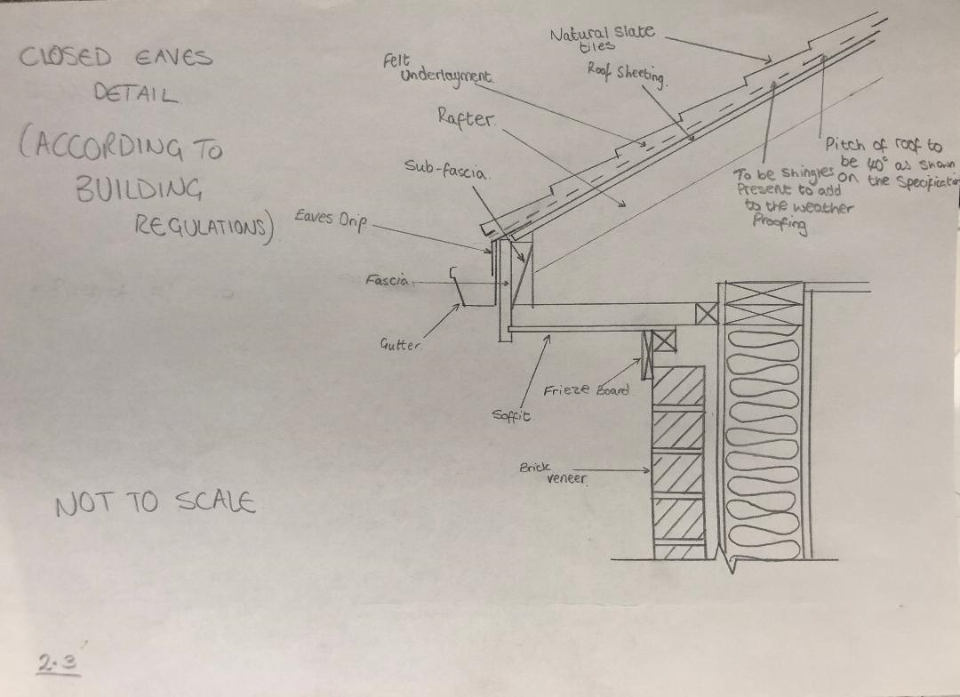
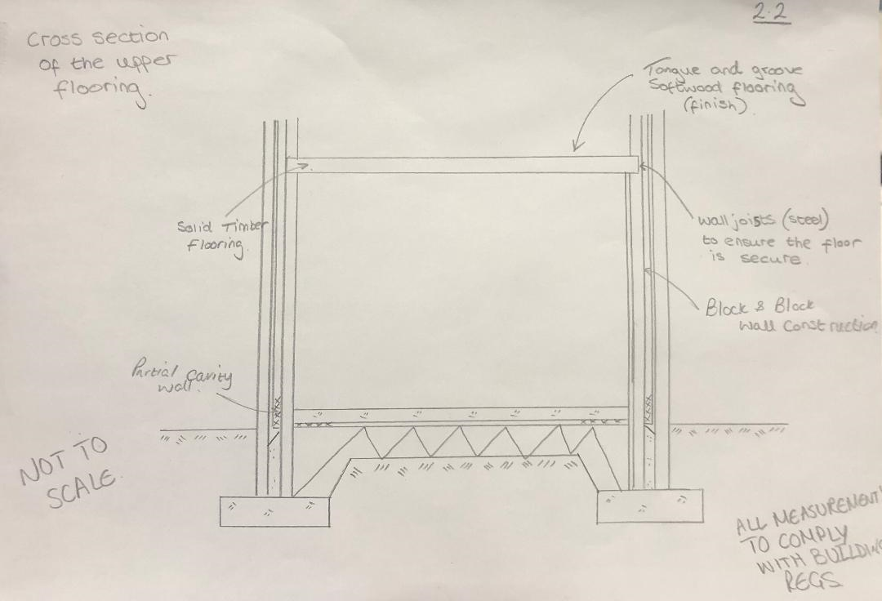
2.3

2.4
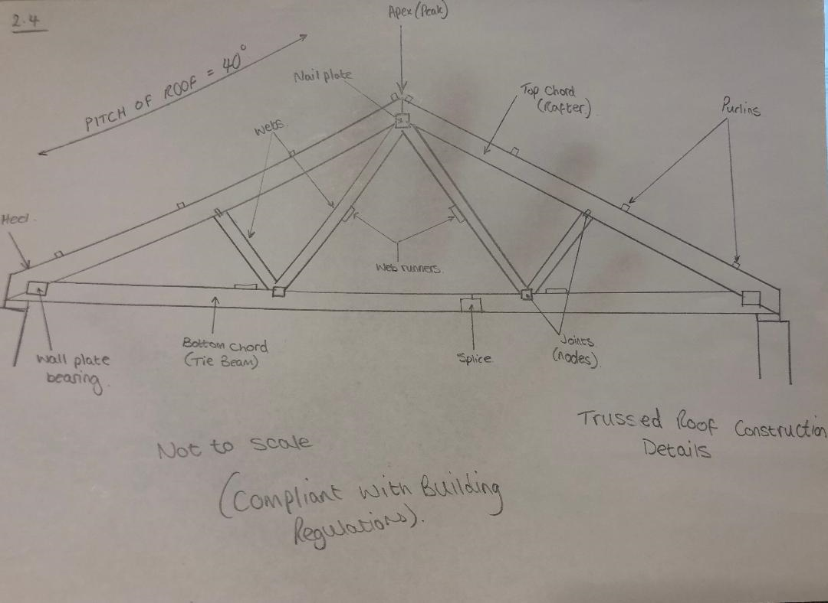

(Part 3 begins on page 8)

- Roof Design and Details
3.1
Advantages of a Trussed Roof (Timber)
- They are flexible and versatile meaning that they can be used alongside other trusses or combined with other parts to make the roof better, they can be used for large spans as well as much shorter spans so are ideal for house construction in general. Also, the trusses can be moved when required and it wouldn’t compromise the structure in question (The Constructer Civil Engineering Home, N.D).
- Is also an eco-friendly construction process, this is due to the timber storing high amounts of carbon from carbon dioxide meaning it leaves the oxygen to stay in the atmosphere reducing the pollution levels in not only the air but any nearby water supplies. Timber is also one of the only renewable construction materials and therefore helps the sustainability levels of modern buildings which is something that is looked at a lot more nowadays (The Constructer Civil Engineering Home, N.D).
- They are also economically beneficial to companies that use them as often they don’t require the use of heavy machinery to install them and can be installed by hand as long as the correct regulations and legislation is followed throughout the process. Timber Trusses also don’t add to the sites waste as they are made with a sustainable material so it means that it is cheaper to clear any excess that may be present after the job is complaint (The Constructer Civil Engineering Home, N.D).
- Timber Trussed roofs are also durable and have high levels of strength. The quality control that is present throughout a project ensure that the structure and shape is correct throughout the construction and also therefore means that the roof is key to the structural integrity of the building (The Constructer Civil Engineering Home, N.D).
- They are energy efficient also, they hold really god thermal properties which is extremely beneficial for a house construction and more importantly a roof due to the fact that it means that the whole build will be warmer as a result. Also, they create large spaces that can be used for things such as insulation which again increases not only the energy efficiency but also increases the thermal capacity of the building which in times like winter will benefit the home owner greatly (The Constructer Civil Engineering Home, N.D).
- There is also plenty of scope for different designs with a trussed roof and this variety means that there is a lot less limitations when it comes to the roof design, as shown in the specification for the task (The Constructer Civil Engineering Home, N.D)
- Timber is a material that is readily available to collect from suppliers so makes it easier to use than other materials which may take more planning to use throughout the project (Landmark, 2019).
Disadvantages of a Trussed Roof (Timber)
- Timber is a natural resource therefore its properties that make it so great to build with can alter given a change in the climatic conditions (Landmark, 2019). Timber can do things such as shrink, swell and crack if the conditions change, meaning that measures must be taking to ensure that the chances of these things occurring are reduced as the structural integrity of the building will be compromised if these properties are altered (Landmark, 2019).
- Timbers are also prone to rotting due to being a natural material over time it could become an issue to the building if this occurs and as a result must be treated in the correct manor to reduce the chances of this occurring (Landmark, 2019). Timber can also mould and can be attacked by fungi and insects such as white ants (Landmark, 2019).
- If using a cheaper form of timber, it might lead to issues in years to come due to the fact that they will need to be maintained more than a more expensive timber, so when designing the trussed roof this should be investigated before the design is finalised (Landmark, 2019).

Advantages of a Pitched Roof
- A pitched roof often gives a more homely feel compared to other designs as its traditional, hence why in the given project it would be ideal as it’s a single domestic build (Pioneer Roofers, 2014).
- It’s an effective roof type to deal with the elements and is ideal for excessive weather to ensure that the building stays watertight and removes the water etc away from the building, leaving no standing water where that might be an issue with other methods (Pioneer Roofers, 2014).
- The pitched roof also offers a large space that can be used as a loft area which is often extremely desirable for people in modern times as it adds more room for storage or residents, therefore a pitched roof offers flexibility when it comes to design stage of the building in question (Morgan Asphalte Co., 2013).
- A pitched roof also has a far longer lifespan than other designs when constructed correctly, this is due to the materials that are used tend to be more durable (Timber) than those that are used for example on a flat roof. The house will be more insulated as a result of the excess space in the loft area and won’t suffer from the extreme temperature that usually effect the rooms of a building with a flat roof (Morgan Asphalte Co., 2013).
- The maintenance of these roofs is far simpler than with other designs as the defects can often be easily spotted (such as damp etc) and then can notify the relevant parties so that the problems can be fixed (Home Logic, 2018)
Disadvantages of a Pitched Roof
- Pitched Roofs tend to be more expensive to construct since the design is far more complexed in comparison to other methods. This means that there may be the need for additional building materials (Morgan Asphalte Co., 2013).
- They can also have a larger bearing on the foundations of the house, not relevant in this design but if someone wanted to change the building from one roof to the pitch roof it may not be possible because of the excess force provide by the pitched roof (Morgan Asphalte Co., 2013).
3.2
A Flat roof Is another popular roof design that is increasing in popularity on buildings and in many modern days builds they are being used instead of the pitched roof, they do have their benefits but also have negatives and will discuss those below. In recent times green and blue flat roofs are becoming popular to give the flat roof a purpose and to make it a more viable option (Homebulding & Renovations, 2018).
A green roof is when the roof is used for the purpose of a garden. It is becoming more popular in city builds as often there is limited space, so people are unable to enjoy things such as a garden but with this it gives the feel of a proper home (Homebulding & Renovations, 2018). It can be heavy however so may be a bearing on the foundation and therefore has to be incorporated before the build takes place. A blue roof is similar to a green roof, but it holds water and reduces the amount of run off from the roof and stores the water, this is also a benefit as it lessens the chance of localised flooding (Homebulding & Renovations, 2018).
Advantages of a Flat Roof
- Accessibility is much better to a flat roof compared to other types of roof, meaning that it can be used for things such as rooftop gardens or a roof terrace, which as stated above is becoming far more popular and a thing that modern families are looking for when going into the housing market (RG Leverett LTD, 2013).
- They are also cost effective as they take far less materials than some other methods, this is because it takes far less materials to construct then say the pitched roof but also takes less labour then other methods also (Morgan Asphalte Co., 2013).
- In recent times the materials that have been used to construct the flat roof has been improved to give it a far greater lifespan to previous designs. The use of EPDM (a 3mm thick rubber membrane) has increased the lifespan from 20 years to 40 years which is an extreme positive when it comes to housebuilding (Morgan Asphalte Co., 2013).
- Flat roofs are often overlooked because of the stigma that suggests there is no run off capacity, but they are often constructed with a very shallow pitch of only a few degrees to allow any rainwater to run into the gutter and safely away from the roof (Morgan Asphalte Co., 2013).
- They are easy to carry out maintenance on also, due to the flatness of the roof and the access as previously stated is improved so that things like cleaning gutters or patching any defects that may be present without the constant threat of slipping of the roof which is far more common in a pitched roof (Professional Roofers.com, N.D).

Disadvantages of a Flat Roof
- Flat roofs are not considered to be stylish as a roof design and often tends not to blend in with the surrounding areas due to fact that most communities are built with pitched roofs and therefore flat roofs would look out of place within these areas (Professional Roofers.com, N.D).
- Buildings that are constructed with a flat roof tend not to have much space for insulation and as a result can be effected by severe temperature change, leaving the building much more colder when in these extreme conditions leaving the homeowner requiring to spend more money on things such as heating as the house wouldn’t be warm enough without the extra heat (Professional Roofers.com, N.D).
- Flat roofs on buildings also tend to reduce the stability of the building and reduce the amount of weight that can be applied also. So, when designing/constructing contractors must bare this in mind take the appropriate actions where appropriate and follow the set building regulations and legislations where applicable (Professional Roofers.com, N.D).
- If the flat roof is constructed with materials such as felt the lifespan would not be as good as previously stated so would require more work over time and would need to be replaced a lot faster than other methods (Morgan Asphalte Co., 2013).

- Condensation and Ventilation
4.1
Condensation in a building occurs when water vapour that’s in the air condenses due to the temperature falls below what is referred to as the ‘dew point’ (myglazing.com, N.D), this then causes the vapour to condense and turn into droplets on the surrounding surfaces.
This ‘dew point’ is varied depending on certain factors these are:
- Air temperature (can also be referred to as relative humidity)
- How much water is in the atmosphere.
(myglazing.com, N.D)
In humid conditions the process of condensation occurs at higher temperatures, also in cooler conditions the process of condensation happens even though there is relatively low humidity (myglazing.com, N.D). In windows and doors condensation occurs due to the difference in temperatures from the outside to inside, also it factors in the glass too. All these factors cause the condensation to form (myglazing.com, N.D).
Causes of Condensation
‘The average household produces around 14 litres or 24 pints of water vapour every day.’ (JRHT, N.D). There are many sources of water vapour that can lead to condensation in the house these include:
- Drying clothes, this produces condensation because the clothes are damp/wet and therefore produces high levels of water vapour that if in an unventilated house can turn into droplets on the surrounding surfaces (Windows, walls, furniture etc.). This can lead to things such as mould in the house which can be detrimental for the residents if left for long enough (JRHT, N.D).
- Using utilities such as a tumble dryer could also cause high levels of condensation if there isn’t the correct ventilation to the outside, this is because a tumble dryer effectively takes the moisture off the clothes then if installed correctly will remove the vapour out the building but will cause condensation if this is wrong (Homebuilding & Renovating, 2017)
- It is critical that when doing things such as taking a shower that if doing so with the door shut that a ventilation system is in place to ensure that the moisture that is being given out. If there is no ventilation system there will be high levels of condensation that is present as the water is really warm with a shower therefore the moisture will be a lot warmer than the cooler surrounding walls (AXA, 2018)
- Through regular activities such as breathing and sleeping can cause high amounts of condensation also, two sleeping adults can produce approximately 1 litre of moisture in a regular 8-hour sleep (myglazing.com, N.D).
- Cooking utilities such as saucepans and kettles can also be a cause of condensation in the home as often water is boiled in these and therefore produces high amount of warm air with water vapour (steam) and therefore when it hits the cooler surfaces of the walls/windows/doors of the surrounding area, it condenses and causes condensation (myglazing.com, N.D)
- If a house is heated intermittently it can also be a cause of condensation because the surfaces go from warm to cooler, and when the house is in the cool stage it is susceptible to condensation at this stage as the warm moist air comes into contact with the now cool surfaces therefore creating condensation as a result (NHBC, 2016).
Overall there are many causes/potential causes of condensation in the home and there are plenty of ways that the causes of condensation can be mitigated and managed through methods that all homes should be able to do. If condensation is left it can have severe detrimental effects on the house and these will be discussed below.
Detrimental effects of condensation
- Black Mould is the main concern when it comes to condensation. It can grow from even a small level of condensation if not dealt with and therefore allowed to get worse as a result (JRHT, N.D), it can form in various places such as the walls, surfaces and even personal possessions.
- ‘It’s almost exclusively caused by condensation’ (JRHT, N.D)
- The mould tends to be found in places such as ceilings, cold surfaces, the corners of walls etc (JRHT, N.D). The cold surfaces that are being referred to include tiles, window sills and sometimes even behind furniture due to the air flow being restricted making mould more liable to grow due to the lack of ventilation (JRHT, N.D).
- Black mould can be dealt with in terms of detergents or specific mould removers however it is recommended that the best way to deal with such problem is to reduce the condensation levels before they get to a dangerous level and therefore will stop the mould growing in the first place (JRHT, N.D).
- Black mould can be extremely detrimental to people’s health and is recommended that if there are any signs of mould present in a house that is to be dealt with as soon as possible and that the room to b avoided in the mean time to reduce the risk of illness as a result of the mould. (NHS, 2018)
- If in the property there is wooden window frames present condensation might have a negative impact on such a structure by rotting them if they are left untreated. This could cause major issues with the building and will require various amount of work to happen as a result (Mould & Mildew.co.uk, N.D).
- Dust mites might also become a problem when it comes to excess condensation in the home, this is because they thrive in the moist conditions that is provided by the vapour and then condensation. This is extremely problematic for people who suffer form asthma but can affect everyone in a negative way (Rega Vent, N.D)

4.2
Methods of Ventilation to reduce condensation
- Natural Ventilation is one of the most common and easiest forms of ventilation that is possible in the house even if it’s not always the best form as it can be quite a slow process depending on the external conditions (wind etc.) (HomeTips Contributor, 2015).
- Opening windows and doors is the main type of natural ventilation that people use and this will reduce the levels of condensation as it will cool the vapour in the air and will therefore make it less likely to come into contact with the walls and form droplets. The warm air then slowly cools and escapes out through the door and windows meaning the condensation goes with it even if it’s at a slow speed (HomeTips Contributor, 2015).
- Small cracks in also add to the natural ventilation but is on an even slower rate compared to that of the doors and windows and would therefore make no real difference in the short term to aid the ventilation of the vapour but does help even if it is a small amount (HomeTips Contributor, 2015).
- Although this method does help, it is often seen as inadequate to reduce the growing levels of household condensation, further adding to this point a lot of modern families are opening doors and windows as often due to central heating and now cooling systems (HomeTips Contributor, 2015).
- Mechanical ventilation comes in the shape of mechanical fans and can be installed directly on the walls of the home or even in some modern cases on the windows too (World Health Organisations, 2009).
- It works by sucking in the air that contains the vapour (whether that be from a shower or washing machine) and removing it from the building to the outside so that it can’t turn into condensation as a result (World Health Organisations, 2009).
- This method of ventilation is probably one of the most used methods in the home as they can be used in all areas of the house in different forms, but all offer the same properties and have the same aim when it comes to condensation, it is crucial that this method is used as it’s a quick and efficient way that removes the vapour directly out of the house through the system (World Health Organisations, 2009).
- Positive Input Ventilation (PIV) is one of the most effective method when it comes to dealing with condensation and the issues that come alongside it (nuaire, N.D). It’s a modern method that is growing and has been developed since the 1970s, it has been ‘installed in over 1 million homes’ (nuaire, N.D).
- The method of this system is to give the house a constant flow of air to ensure that the vapour present in the air doesn’t turn into condensation as a result (nuaire, N.D). This is the process of lowering the humidity levels in the house and therefore preventing the growth of things such as black mould etc.
- Is a method that is popular in new builds and complies with the building regulations.
- Is installed in the loft areas of buildings so that it can be the most effective in terms of removing the vapour ridden air out of the home (nuaire, N.D)
4.2.1
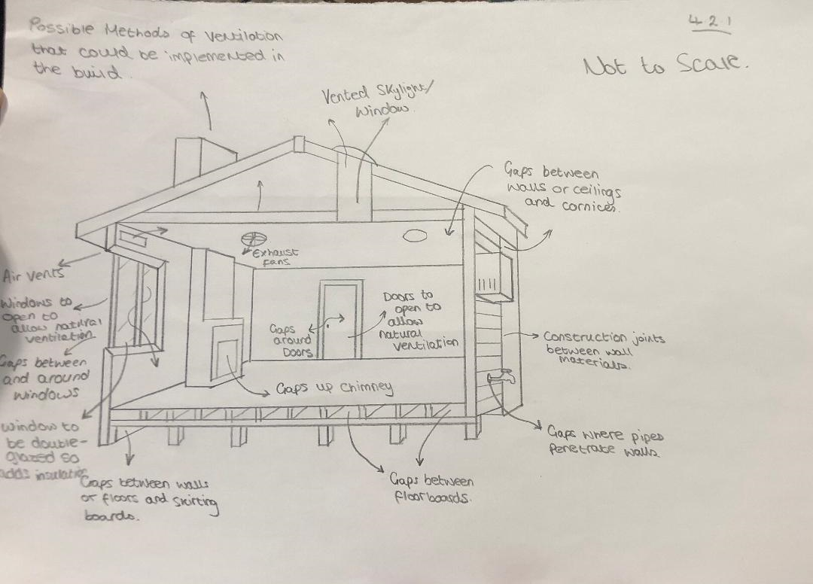

4.3
Measures that can be taken to reduce the risk of condensation in the proposed building
In terms of condensation there are a number of methods that can be useful when it comes to being able to reduce the potential condensation in the home. Some can be permanent solutions to the issue but often there is short term fixes which will certainly help reduce the amount of condensation that is present in the house. These will be discussed below and how the impacts of condensation are reduced (EnviroVent, 2014)
- One of the most common ways that condensation is produced is when you dry clothes indoors, to reduce the effect of this it’s recommended that when possible that clothe are too be dried outside to ensure that the excess moisture in the clothes fails to build up in the proposed home (Wise Property Care, N.D). If the external conditions are not suitable to dry your clothes to limit the chance of condensation to begin to build up it is suggested that the bathroom is used, with the door shut and the windows open to ensure that there is a natural ventilation present (EnviroVent, 2014).
- Cooking using pots and pans also creates excess moisture, to prevent this the majority of units in kitchens are now fitted with extractor fans to ensure that the said excess moisture is extracted from the building and therefore doesn’t become an issue with regards to the possible build-up of condensation in the home (Wise Property Care, N.D). However, to ensure that all moisture is removed after cooking it is suggested that the extractor fan is to be left on for 10-15 minutes after so that all the humid air is removed and therefore taking out the risk of condensation (EnviroVent, 2014). Also, if possible when cooking it is also recommended to open any kitchen windows or doors (External) to add to the extraction process (Wise Property Care, N.D). Any internal kitchen doors should be closed also so to ensure any moisture in the air doesn’t go into the cooler areas of the house and therefore fail to begin the condensation process (Timbawood, 2016).
- Similar to cooking it is essential that an extractor is used when either having a shower/bath therefore removing the steam and moisture that is created when warm water is present in a colder environment, this will reduce the levels of condensation that appears in the bathroom after these tasks (EnviroVent, 2014).
- Overfilling things like wardrobes and kitchen cupboards can also be a source of condensation since there is a lack of ventilation and air moisture trapped in warm cupboards is the perfect breeding ground for the black mould to begin to grow (EnviroVent, 2014). Therefore, it is recommended that you keep on top of what’s in the cupboard and make sure that there is ventilation room (EnviroVent, 2014).
- For the same reason as not overfilling wardrobes and cupboards it is essential that furniture is at least 50mm away from the wall to allow the air to move and circulate around the property to make the chance of condensation less likely. Wardrobes should be placed against internal walls in the house because they are less cold than the external wall so the chances of damp and condensation occurring are far less (EnviroVent, N.D).
- The type of window that is installed in the property can also impact the likelihood of condensation occurring, for example single glazed has a much lower internal surface temperature and therefore it would be recommended to install thicker windows such as double or triple glazed windows. This works because the inner pane will be more insulated and a higher temperature as a result (Timbawood, 2016).
- As shown in the spec the building will have double glazed, meaning that the house will have a high amount of insulation reducing the chance of condensation straight away.
- When the building is constructed ensure that the property has adequate heating so that it will mean that the temperature of surfaces in the home and therefore reduce the chances of condensation in the home. Having additions such as insulated walls and double-glazed windows as described above will also add to the ability of the house to trap warmer air inside and therefore limit the chances of cold surfaces being about to allow condensation to form (EnviroVent, 2014).
- It could be useful upon building the house to include something like a moisture meter for the residents to ensure that they can monitor any moisture that will be present in the building and be able to act on it if the levels get to high (EnviroVent, 2014).
The majority of methods that can be used to reduce the risk of condensation will be applicable after the building is built and by the residents but as contractors all possible methods that can be mechanically reduce the risk (Ventilation) or different building materials such as double/ triple glazed windows and insulation to ensure that the building is as warm as possible to begin with as described above.

5. Reference Page
K-State Research and Extension (2018) Clay Soil: it shrinks and swells. Available at: https://www.johnson.k-state.edu/lawn-garden/agent-articles/miscellaneous/shrink-swell-clay-soils.html (Accessed: 08/03/2019)
Home Building & Renovating (2016) Foundations for Difficult sites. Available at: https://www.homebuilding.co.uk/foundations-for-difficult-sites/ (Accessed: 08/03/2019)
Civil Engineers Forum (2014) Advantages and Disadvantages of Raft Foundation. Available at: https://civilengineersforum.com/raft-foundation-advantages-disadvantages/ (Accessed: 09/03/2019)
Define Civil (2018) Advantages and Disadvantages of Raft Foundation. Available at: https://definecivil.com/advantages-of-raft-foundation-disadvantages/ (Accessed: 09/03/2019)
DIY Doctor (N.D) Concrete Raft Foundations – How They are Constructed, When they Should be Used and the Advantages and Disadvantages of Raft Foundations. Available at: https://www.diydoctor.org.uk/projects/rafts.htm (Accessed: 10/03/2019)
Foundation, Concrete and Earthquake Engineering (N.D) What is Raft Foundation? Difference between Raft Foundations and Mat Foundation. Available at: https://www.civil-engg-world.com/2012/06/what-is-raft-foundation-difference.html (Accessed: 10/03/2019)
Heaton Products LTD (N.D) Raft Foundations. Available at: https://www.heatonproducts.co.uk/news-information/raft-foundation-construction-uses-types-and-cost/ (Accessed: 11/03/2019)
The Constructer Civil Engineering Home (N.D) Advantages of Timber roof trusses in building construction. Available at: https://theconstructor.org/structural-engg/timber-roof-trusses-advantages/13875/ (Accessed: 13/03/2019)
Landmark (2019) Timber Disadvantages become Positives. Available at: https://www.landmarkpro.com.au/timber-disadvantages-become-advantages/ (Accessed: 14/03/2019)
Pioneer Roofers (2014) Advantages and Disadvantages of a Pitched Roof. Available at: https://www.pioneerroofers.net/blog/advantages-and-disadvantages-of-a-pitched-roof/ (Accessed: 14/03/2019)
Morgan Asphalte Co. (2013) Advantages & Disadvantages of Pitched & Flat Roofing. Available at: http://www.morganasphalte.co.uk/news/advantages-disadvantages-pitched-flat-roofing/# (Accessed: 15/03/2019)
Home Logic (2018) Pitched Roof Advantages and Disadvantages: An Overview. Available at: https://www.homelogic.co.uk/pitched-roof-advantages-and-disadvantages-an-overview (Accessed: 15/03/2019)
Home Building & Renovating (2018) Flat Roofs: A Handy Guide. Available at: https://www.homebuilding.co.uk/flat-roofs/ (Accessed: 15/03/2019)
RG Leverett LTD (2013) Why choose a flat roof over pitched alternatives? Available at: https://www.roofsuk.co.uk/blog/Why-choose-a-flat-roof-over-pitched-alternatives (Accessed: 15/03/2019)
Professional Roofers.com (N.D) The advantages and disadvantages of flat roofs. Available at: https://www.professionalroofers.com/advantages-disadvantages-flat-roofs/ (Accessed: 15/03/2019)
Myglazing.com (N.D) Condensation and the Causes of Condensation. Available at: https://www.myglazing.com/be-informed/condensation-causes-of-condensation/ (Accessed: 16/03/2019)
JRHT (N.D) Condensation and Black Mould. Available at: https://www.jrht.org.uk/resources-residents/home-garden-and-estate-maintenance/condensation-black-mould (Accessed: 16/03/2019)
Homebuilding & Renovating (2017) How to solve condensation. Available at: https://www.homebuilding.co.uk/how-to-solve-condensation/ (Accessed: 16/03/2019)
AXA (2018) What causes condensation and how to stop it. Available at: https://www.axa.co.uk/home-insurance/tips-and-guides/what-causes-condensation-and-how-to-stop-it/ (Accessed 16/03/2019)
myglazing.com (N.D) Window condensation – where the water vapour comes from. Available at: https://www.myglazing.com/be-informed/window-condensation-water-vapour-sources/ (Accessed: 17/03/2019)
NHBC (2016) About condensation in your home. Available at: https://www.nhbc.co.uk/nhbcpublications/literaturelibrary/homeownerdocuments/filedownload,31929,en.pdf (Accessed: 17/03/2019)
Mould & Mildew.co.uk (N.D) Condensation on windows. Available at: https://www.mouldandmildew.co.uk/condensation-on-windows/ (Accessed: 18/03/2019)
NHS (2018) How do I get rid of damp and mould? Available at: https://www.nhs.uk/common-health-questions/lifestyle/how-do-i-get-rid-of-damp-and-mould/ (Accessed: 18/03/2019)
Rega Vent (N.D) The effects of condensation. Available at: www.heatrecoveryventillationsystems.co.uk/the-effects-of-condensation.php (Accessed: 19/03/2019)
HomeTips Contributor (2015) Types of Ventilation Systems. Available at: https://www.hometips.com/how-it-works/ventilation-systems-exhaust.html (Accessed: 19/03/2019)
World Health Organisation (2009) Natural Ventilation for infection control in health-care settings. Available at: https://www.ncbi.nlm.nih.gov/books/NBK143277/ (Accessed: 19/03/2019)
Nuaire (N.D) Positive Input Ventilation PIV. Available at: http://nuaire.co.uk/residential/positive-input-ventilation (Accessed: 19/03/2019)
EnviroVent (2014) 14 Ways To Help Reduce Condensation In Your Property. Available at: https://www.envirovent.com/blog/14-ways-to-help-reduce-condensation-in-your-property/ (Accessed: 19/03/2019)
Wise Property Care (N.D) Top Ten Tips to Beat Condensation. Available at: https://www.wisepropertycare.com/news/condensation/how-stop-condensation-10-steps/ (Accessed: 19/03/2019)
Timbawood (2016) 3 ways to reduce condensation on the inside of windows. Available at: https://www.timbawood.co.uk/advice/3-ways-reduce-condensation-inside-windows/ (Accessed: 20/03/2019)

6. Bibliography
Construction Tuts (2018) Roof Truss – Types, Components, Advantages. Available at: https://www.constructiontuts.com/roof-truss/ (Accessed: 14/03/2019)
The wow decor (2019) Advantages and Disadvantages of Pitched Roofs. Available at: http://www.thewowdecor.com/advantages-and-disadvantages-of-pitched-roofs/ (Accessed: 16/03/2019)

APPENDIX

