  Component One:  What are the key skills required when working in the housekeeping team? | Student No: | 2133167
 | Module Title: | Operating Hotel Facilities
 | Module Code: | 4006
 | Lecturer: | Lola Villard
In this fascinating and continually evolving sector, as a student of hotel management, I continue to grow in my knowledge and discover new things. Thanks to my studies, in particular marketing, managing operations, customer support and running hotels, I have learned a lot of things. In this diary, I am going to take a look at my educational experiences so far and how I plan on using those theoretical skills in the workplace (Alnawas and Hemsley-Brown, 2019).
Customer service is one area which is very important and based on this course on hotel management I have developed my understanding of its importance. I have learned that in the Hotel sector success is directly or indirectly associated with the satisfaction of customers. It is noted that success or survival for a long period will not be possible for hotels without increasing the satisfaction of customers. So, I have realized that the development of a better understanding of the expectations and needs of customers is one key aspect that should need to be focused on (Kang and Jang, 2019). I have been involved in the management of some of these aspects by working as a front desk receptionist at the hotel. Learning about effective ways of interacting with customers was one key area of my learning and I have also learned about the problem-solving and providing suggestions on how we can improve the experience for them. In addition, I have learned how to make the services offered in this hotel even better by using guests' input (Sonnenschein, Barker and Hibbins, 2019).
Another important idea I have learned is that marketing plays a role in the hotel industry. There can be no business without a marketing campaign, but the hotel sector needs it in particular because of intense competition with its clients. Throughout my course, I have studied a wide range of techniques in the field of marketing, such as email communications, social media and loyalty schemes. Furthermore, I'm beginning to understand the value of branding and how it should be used by a hotel or restaurant to differentiate itself from its competitors. I will use that expertise in this area to design and execute effective marketing strategies for attracting new clients and keeping existing ones (Burak, 2020).
I've also studied management of operations, which is an important subject. This sector has a responsibility to ensure that resources, procedures and systems are effectively and efficiently administered to provide consumers with quality services. Throughout my training, I have learnt a wide range of operating principles such as capacity planning, inventory management and quality control (Tong-On, Siripipatthanakul and Phayaphrom, 2021).
The use of technology in terms of management of all processes of working was another key area of my learning as I have improved my understanding regarding processes including point of sale system, CRM, and management of revenue. I have developed my understanding that effective processes of operations are important for the effective use of available resources (Leung, Lyu and Bai, 2020).
The success of the hotel industry is based on clients' satisfaction. In such an extremely competitive market, customers have great expectations from the services they receive. It is therefore essential that firms in the sector offer top-quality customer service and have effective marketing plans, as well as efficient operating procedures. In these areas, I intend to draw upon my expertise in the field of theory (Chung and Byrom, 2021). Businesses that offer good customer service can differentiate themselves from the competition, gain repeat clients and increase their client base. With the assistance of efficient marketing techniques, companies can strengthen their brands and gain a better understanding of their target market. To maximize resource utilization and provide customers with the highest quality of services, efficient operating procedures can be beneficial for companies (Kim, Barber and Kim, 2019).
Lastly, it was my experience during the training process in hotel management that made me happy and fulfilled. With my training, I'm better able to comprehend a lot of concepts that are crucial for success in the field. I have been able to take some of that knowledge into my present part-time work, and it has provided me with a great deal of experience (Yu, 2020). I want to keep growing and developing my theoretical knowledge in this field to provide top-quality service, practice powerful marketing plans as well as create efficient operational procedures. These are the key factors that a successful hotel sector must have to succeed, and my knowledge and experience should be capable of making an impact on all organizations I work for (Mehta, Kumar and Ramkumar, 2023).

Word Count | 750

Component Two:
Problem | Why did it happen? | What are you going to do? | How will you prevent this from happening in the future? | What measures would you introduce to improve team effectiveness?
The guest Room was not clean | A failure in tracking and prioritizing cleaning requests properly could be resulted because of a breakdown in the  process of communication between the front desk team and housekeeping staff. | In case of facing inconvenience from the customers, it is important of expressing empathy and apologize to the guest.  For verifying issues and identifying some other important areas, it is important to visit the room of the guest. | It is important of ensuring that proper training is provided to the team of housekeeping on the protocols, procedures, and cleaning standards. | It is important of ensuring that proper training should be received by staff of housekeeping in respect of the protocols, procedures, and cleaning standards. This includes giving appropriate attention to detail, appropriate use of equipment for cleaning and understanding the expectations of guests.  Feedback from members of the team and open communication should need to be encouraged and the creation of a well-organized and comfortable working environment.
 | Insufficient training is provided to members and staff of housekeeping on the cleaning procedures and standards of cleaning. | Assigning a member and contacting the team housekeeping for a clean room of guests in a complete way. | A process of inspection and establishing a checklist for verifying the cleanliness of all rooms. | Review of performance: conduction of reviews of performance regularly so that proper feedback could be provided, and areas could be identified where improvement could be made.
 | A lacking proper supplies and equipment that are needed in the process of cleaning and leading towards substandard outcomes. | For ensuring that the satisfaction need of guests is followed and for a certain level of additional help is provided. | Encouragement should need to be increased among team members so that they can focus on communicating any kind of concerns or issues with each other and the leaders of the team. This will help in ensuring proper solutions for leaders. | Recognition of achievement: All those members who are showing better performance should need to be recognized and a reward should be given to them.
 | Incomplete or rushed cleaning could be resulted because of understaffed or overworked housekeeping. | Documenting the issues and taking steps for addressing them for better performance. | Establishment of clear goals of performance and expectations for each member of the team. These should need to be communicated to members properly. Members will be motivated in this way for achieving a high level of accountability and performance. | Implementation of inspection and checklists: this is very important for verifying the cleanliness of all rooms before the arrival of guests. It will also help in ensuring that no room has been missed in cleaning and every person is accountable.

Component Three:
Contribution to Overall Module Assessment: 50%

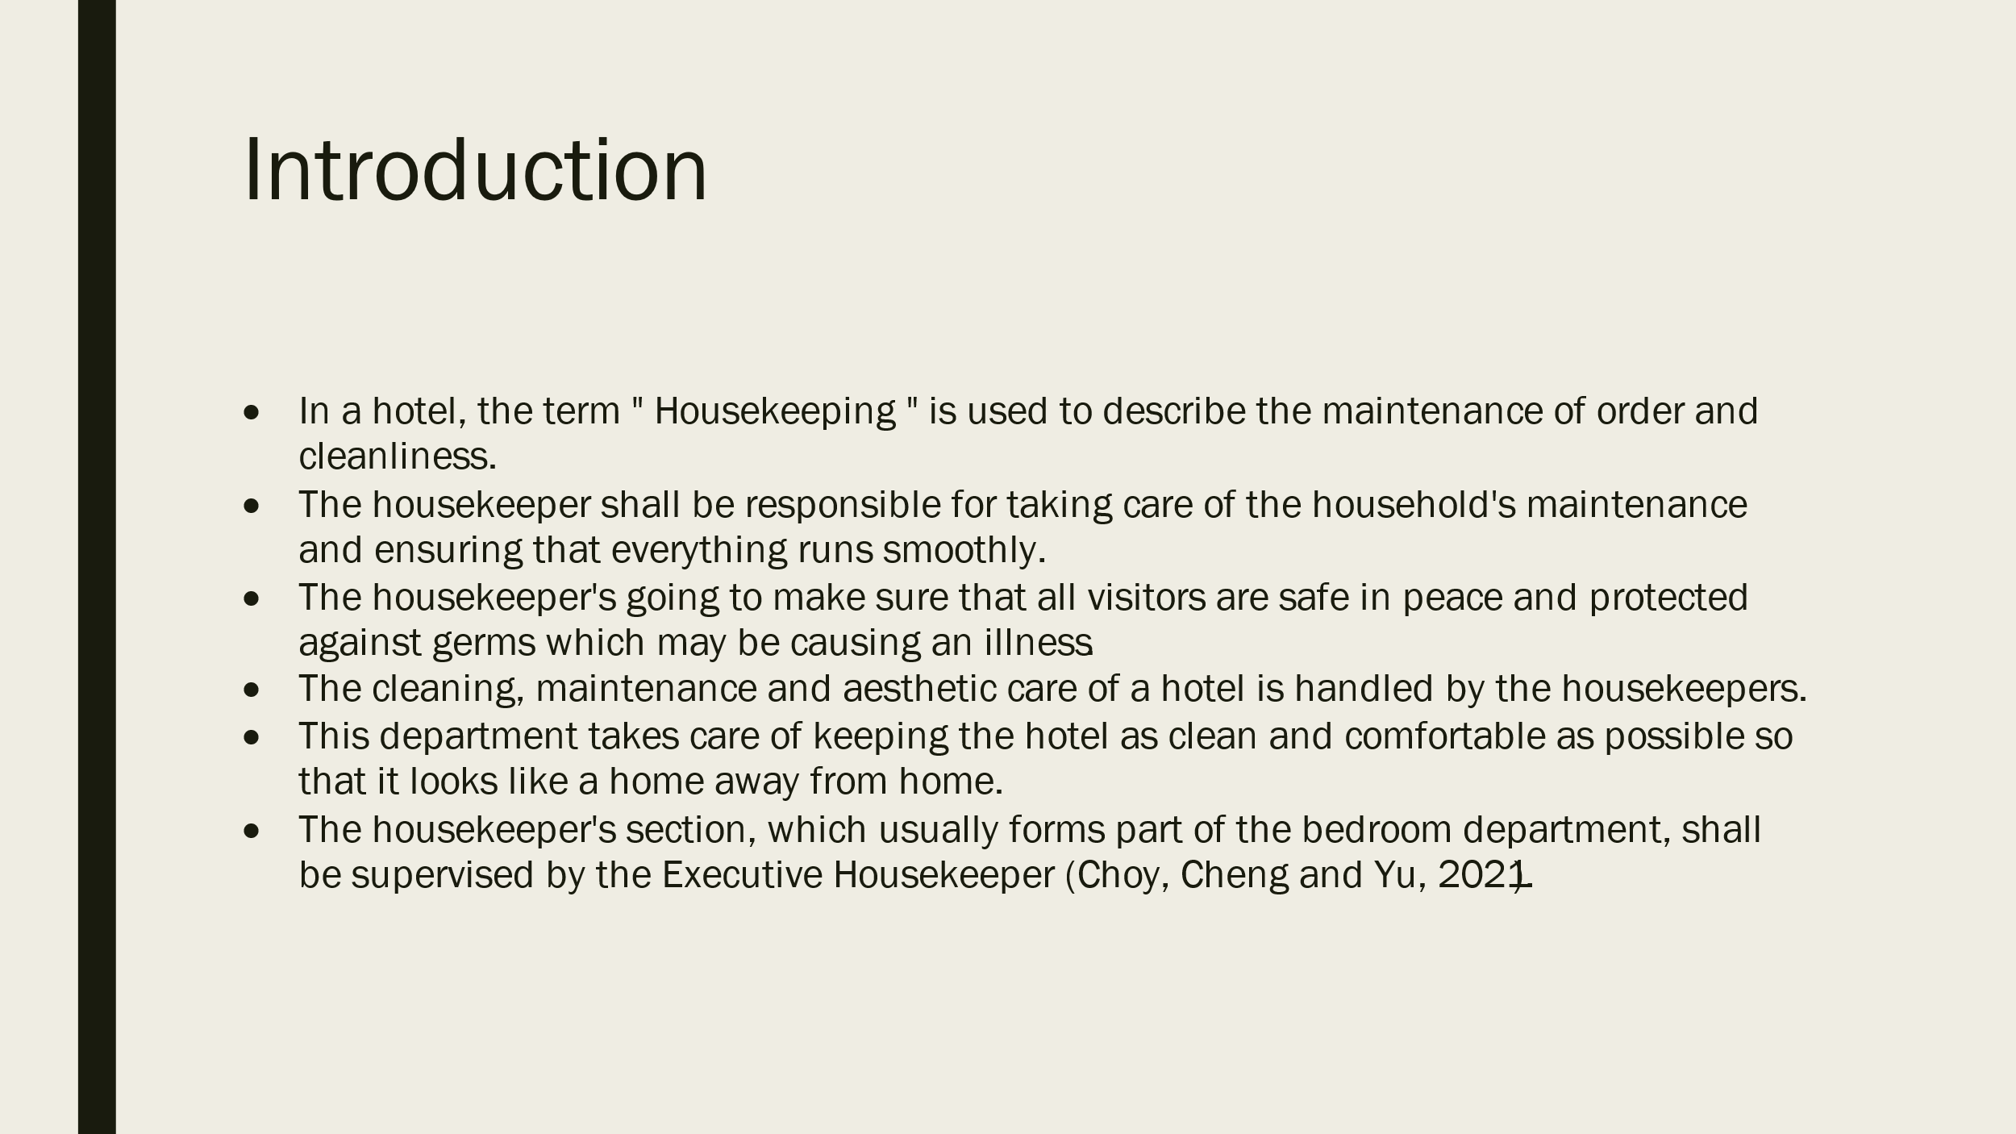
Training Notes: Housekeeping shall consist of any duties relating to cleaning, polishing, vacuuming, preserving order, waste removal from the hotel or other premises and ensuring that they are protected against all types of fire hazards.
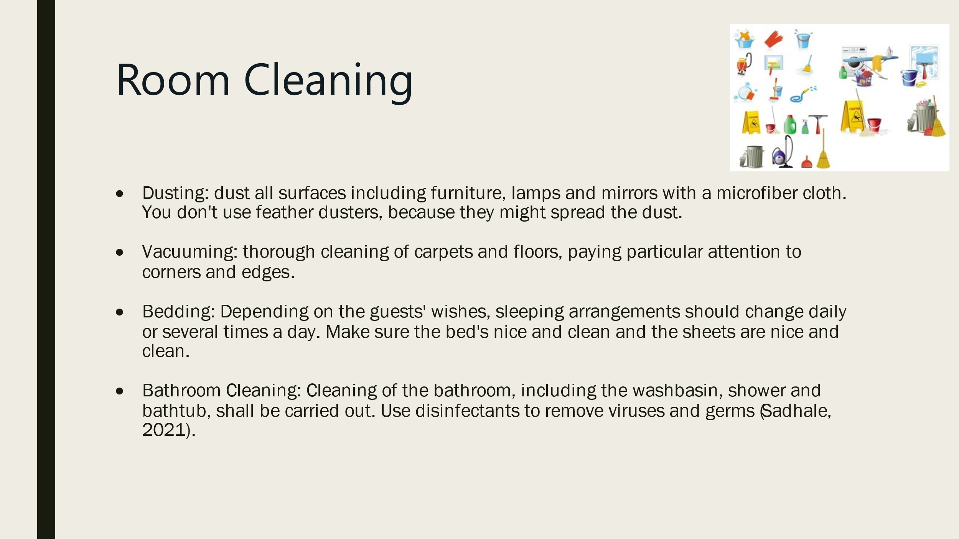

Training Notes: The room staff plays a crucial role in the hotel because of their visibility, interactions with guests and responsibilities to ensure that rooms are clean, hygienically maintained, and comfortable. The visitors will receive a key message from all of them.

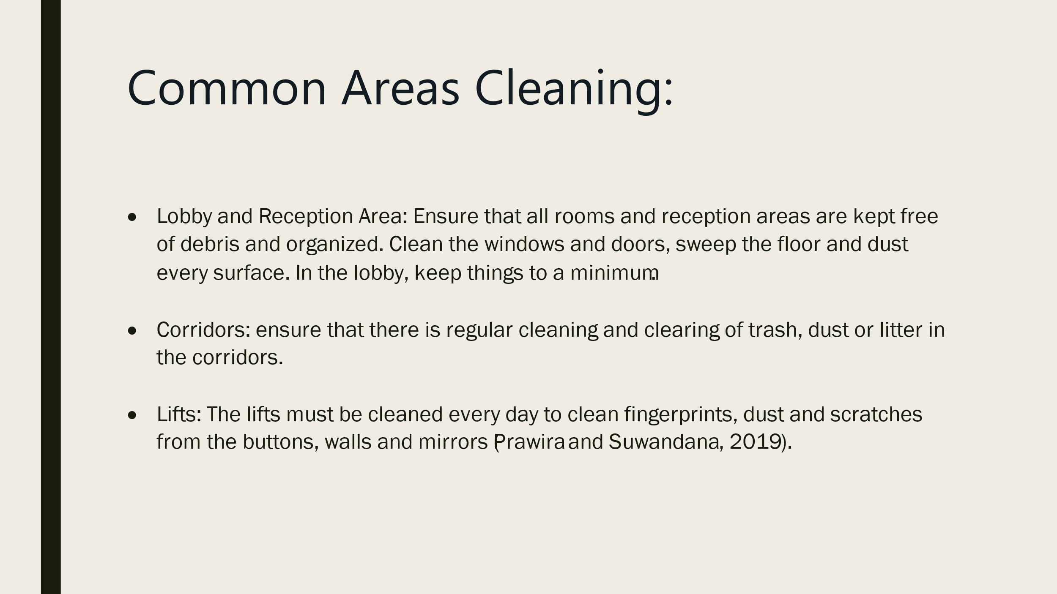
Training Notes: The lobby must be organized properly in addition to the cleaning. Put a front desk and some of the other desks there. Establish a direct route for traffic to move through the lobby. To identify the areas in which guests should be allowed to enter or leave, use clear signs. It's a way of easing things and keeping the roads free.
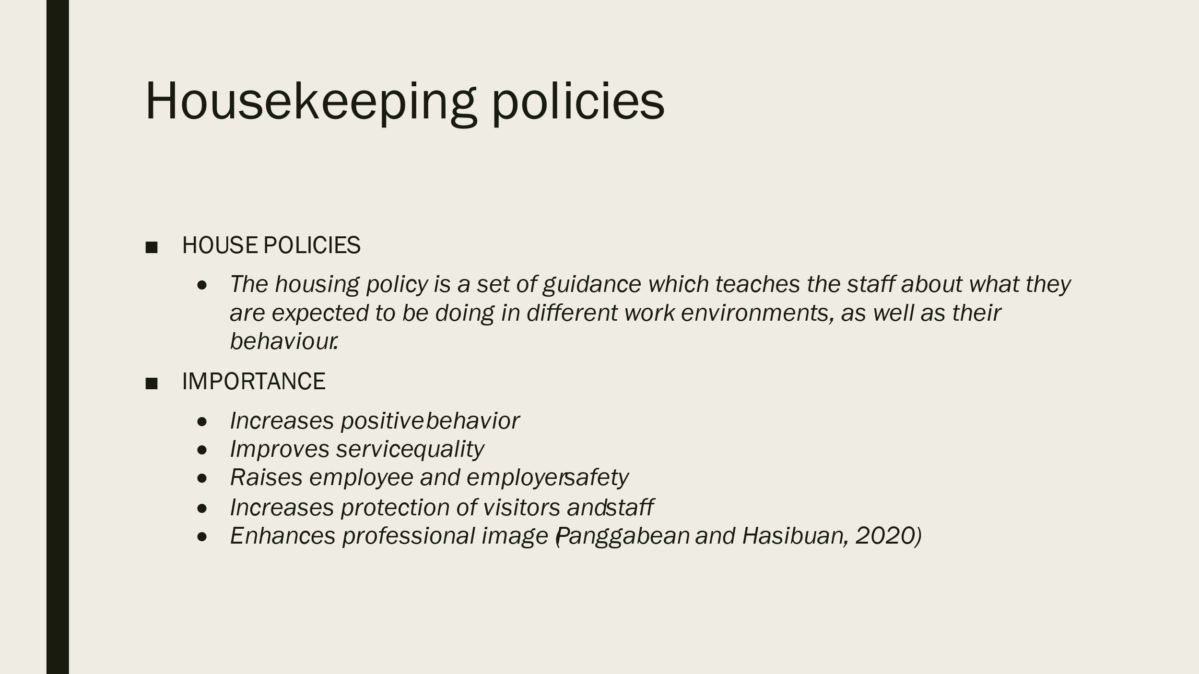
Training Notes: Guidelines for employee behavior, such as those on eating, drinking and using cell phones to make personal calls.
Unlawful activities such as stealing or destroying property.
Benefits for the company can be discounts, meals and the use of specialised services.
Clothing or uniform
It shall be authorised to use the facilities for work or personal purposes, including parking spaces, employee platforms, restaurants, and swimming pools.

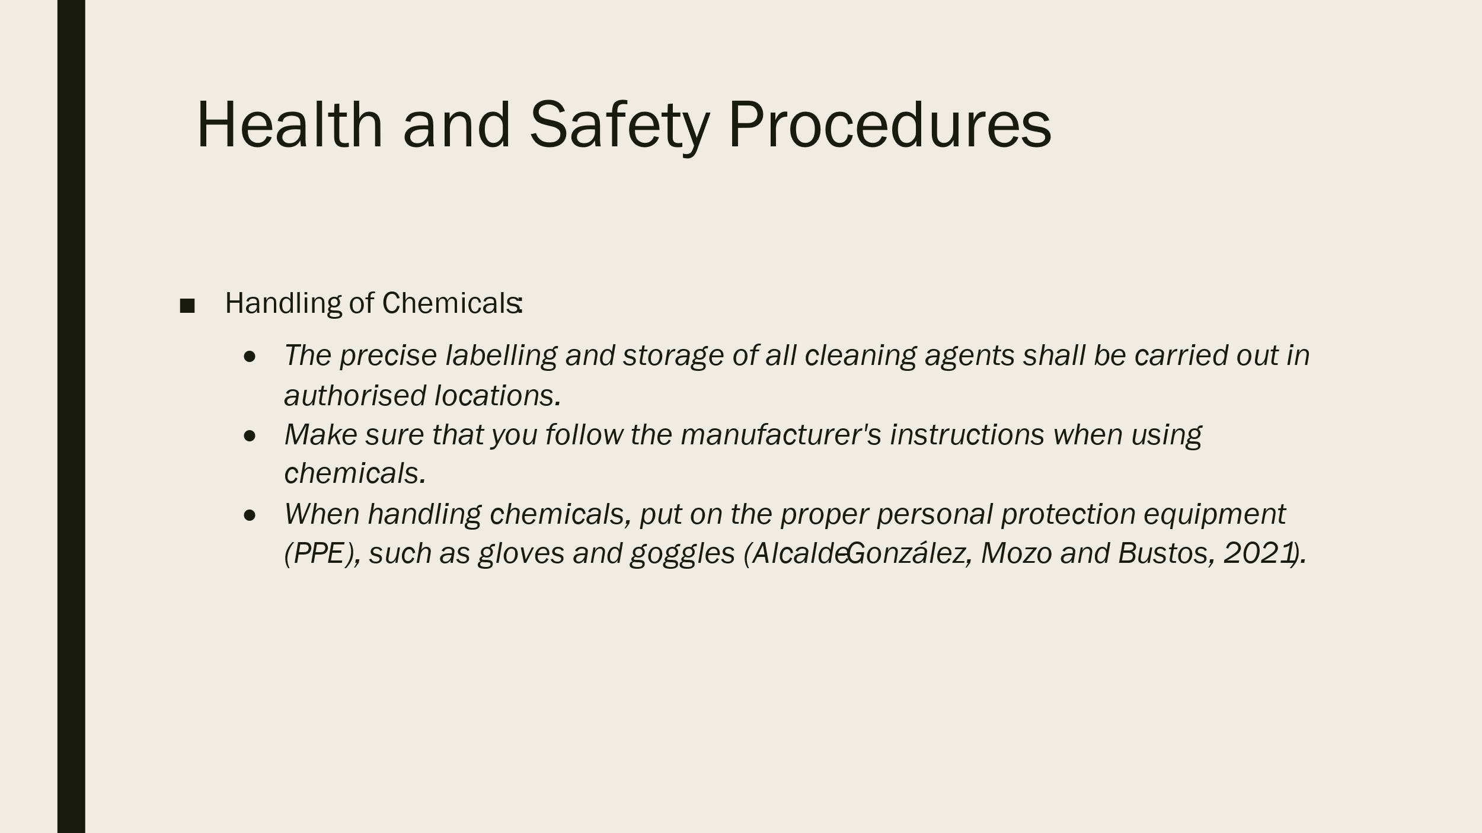
- Training Notes: Make sure that the hotel is not exposed to significant and clear risks.
- Ensure that working conditions in your country, as a minimum, are compliant with national law.
- Staff should be provided with tools and equipment which are safe to use in the course of their work and, where appropriate, have been adequately maintained. Every single time.

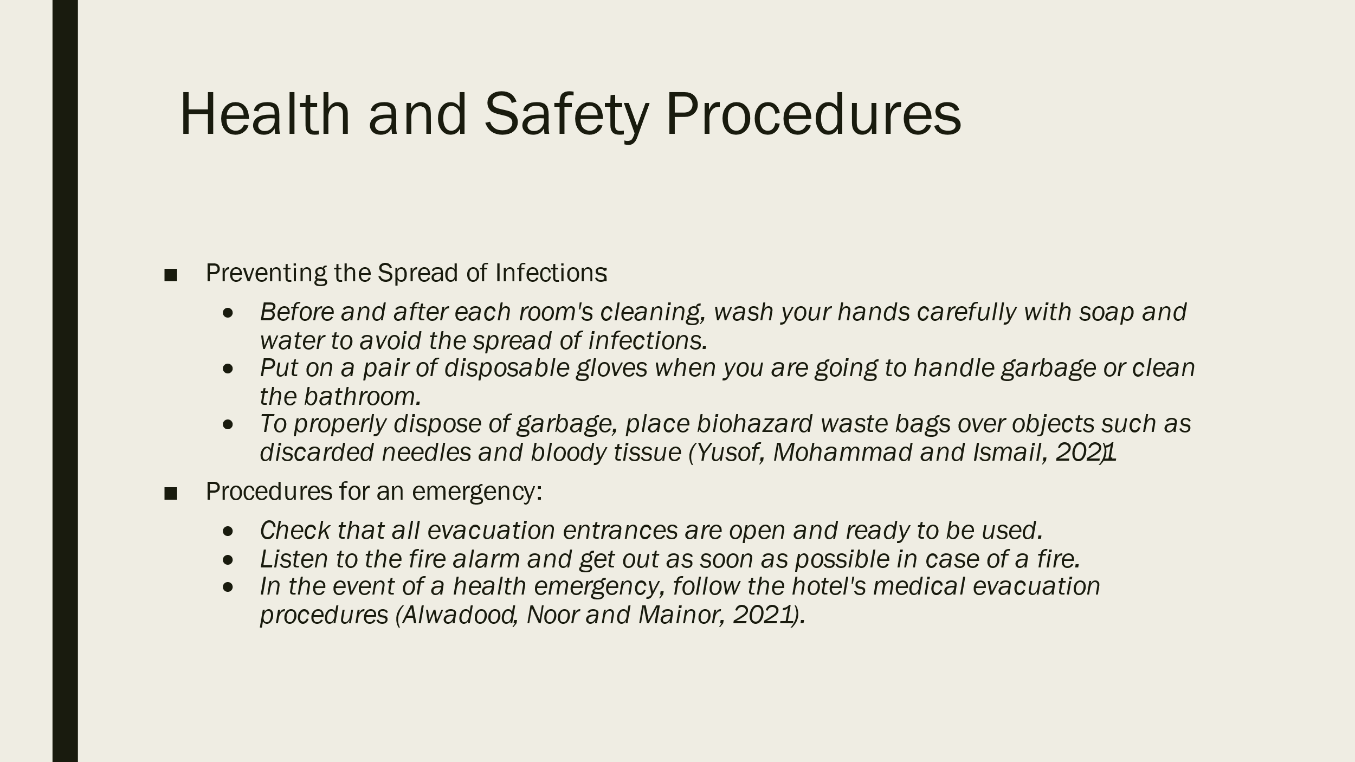
Training Notes: Risk assessments are a simple way of ensuring the safety of persons in your buildings. This will allow you to take a significant step in ensuring the protection of your staff and compliance with all applicable legislation. Risk assessments will allow you, as an owner of a company, to focus on the risks associated with your property and for you to spot something very dangerous which is likely to seriously harm someone. In particular, when the main staff members have been out of service for a longer time, their injury may affect how easily an organization operates.
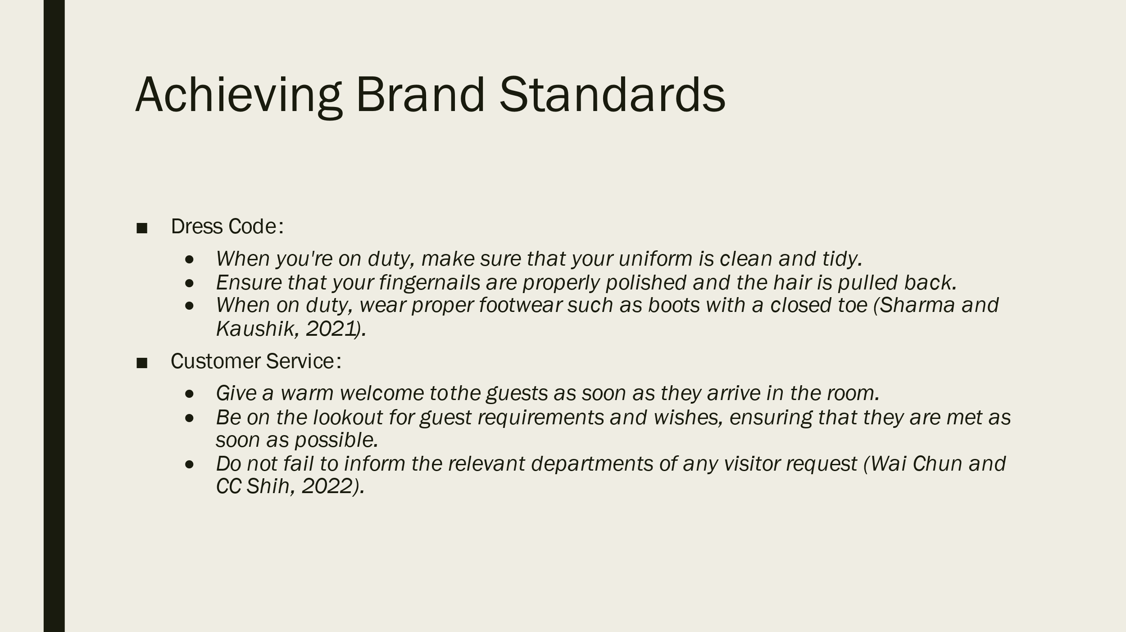
Training Notes: Every successful company begins with a customer-centric mindset, and Experience mapping is an excellent tool to identify and launch global brand touchpoints. A hotel service should make lasting memories, strengthen the client experience and be part of their life story.

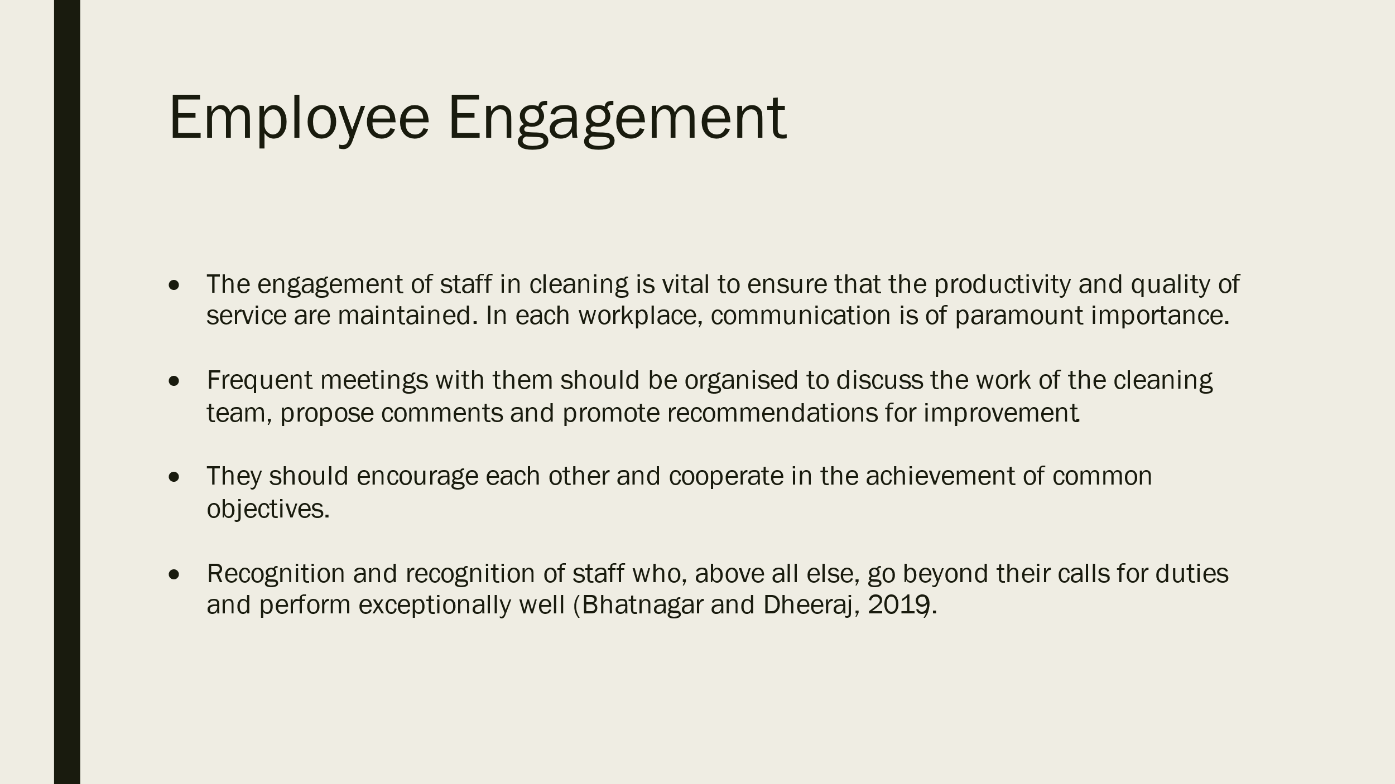
Training Notes: Creating a motivated, committed workforce that can provide clients with high-quality service will be facilitated by the engagement of your cleaning staff.

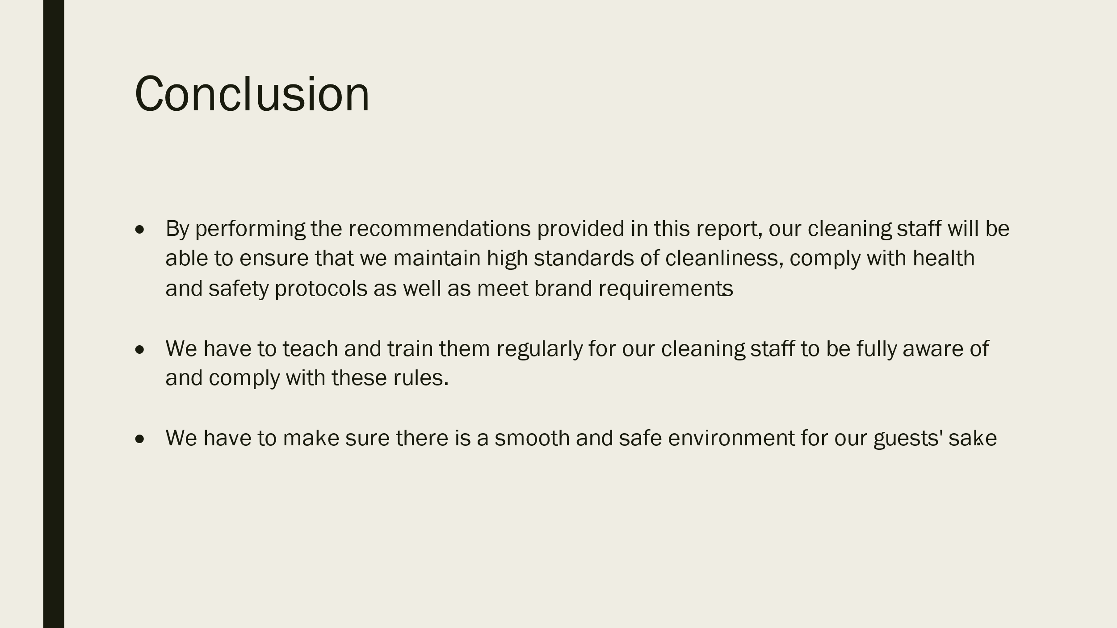

Training Notes: Finally, to ensure that our visitors are given the best possible service while adhering to brand standards and health & safety regulations, it is our duty as housekeepers. Under the guidance given in this seminar, we may cooperate to ensure a pleasant and secure environment for our visitors. Thank you for working with us, and we will continue to work together to improve our services.

References
Alcalde-González, V., Mozo, A.G. and Bustos, A.V., 2021. No clean rooms, no hotel business: Subversion tactics in Las Kellys’ struggle for dignity in hotel housekeeping. Annals of Tourism Research, 91, p.103315.
Alnawas, I. and Hemsley-Brown, J., 2019. Examining the key dimensions of customer experience quality in the hotel industry. Journal of Hotel Marketing & Management, 28(7), pp.833-861.
Alwadood, Z., Noor, N.M. and Mainor, N.A., 2021. An optimization model for hotel housekeeping personnel scheduling in pandemic outbreak. Menemui Matematik (Discovering Mathematics), 43(2), pp.83-92.
Bhatnagar, E. and Dheeraj, N., 2019. Impact of housekeeping services and practices on customer satisfaction and repeat business. Prabandhan: Indian Journal of Management, 12(8), pp.46-57.
Burak, V., 2020. Training of future specialists in the hotel and restaurant industry in higher educational establishments in the conditions of distance learning. ScienceRise: Pedagogical Education, 6(39).
Choy, M., Cheng, J. and Yu, K., 2021. Evaluating the environmental sustainability strategies of the housekeeping department: the case of an international hotel chain in Hong Kong, China. Tourism Critiques: Practice and Theory, 2(1), pp.115-132.
Chung, S.Y. and Byrom, J., 2021. Co-creating consistent brand identity with employees in the hotel industry. Journal of Product & Brand Management, 30(1), pp.74-89.
Kang, J. and Jang, J., 2019. What do employees perceive as hindrance or challenge stressors in the hotel industry? The role that hope plays. Journal of Human Resources in Hotel & Tourism, 18(3), pp.299-322.
Kim, Y.H., Barber, N. and Kim, D.K., 2019. Sustainability research in the hotel industry: Past, present, and future. Journal of Hotel Marketing & Management, 28(5), pp.576-620.
Leung, X.Y., Lyu, J. and Bai, B., 2020. A fad or the future? Examining the effectiveness of virtual reality advertising in the hotel industry. International Journal of Hotel Management, 88, p.102391.
Mehta, M.P., Kumar, G. and Ramkumar, M., 2023. Customer expectations in the hotel industry during the COVID-19 pandemic: a global perspective using sentiment analysis. Tourism Recreation Research, 48(1), pp.110-127.
Panggabean, R. and Hasibuan, N.A., 2020. Penerapan Preference Selection Index (PSI) Dalam Sistem Pendukung Keputusan Pengangkatan Supervisor Housekeeping. Resolusi: Rekayasa Teknik Informatika dan Informasi, 1(2), pp.85-93.
Prawira, I.G.A.G.Y. and Suwandana, I.G.M., 2019. Peran Kepuasan Kerja Memediasi Pengaruh Stres Kerja Terhadap Kinerja Karyawan Housekeeping Department Fave Hotel (Doctoral dissertation, Udayana University).
Sadhale, M., 2021. The Changing Role of Housekeeping Department in Hotels Post COVID-19 Pandemic. Eureka Publications.
Sharma, S. and Kaushik, T., 2021. Aesthetically clean to clinically clean–A study on new housekeeping practices in Delhi hotels beyond COVID-19 pandemic. Worldwide Hotel and Tourism Themes, 13(5), pp.646-659.
Sonnenschein, K., Barker, M. and Hibbins, R., 2019. Benefits of work-integrated learning: Perceptions held by Chinese international students enrolled in an Australian university and managers in the Chinese hotel industry. Journal of Hotel & Tourism Education, 31(3), pp.139-148.
Tong-On, P., Siripipatthanakul, S. and Phayaphrom, B., 2021. The implementation of business intelligence using data analytics and its effects towards on performance in the hotel industry in Thailand. International Journal of Behavioral Analytics, 1(2).
Wai Chun, M.C. and CC Shih, C., 2022. The effect of employee uniform on job Satisfaction: A case of the housekeeping department in A luxury five-star hotel in Hong kong, china. Tourism and hotel management, 28(3), pp.559-574.
Yu, C.E., 2020. Humanlike robots as employees in the hotel industry: Thematic content analysis of online reviews. Journal of Hotel Marketing & Management, 29(1), pp.22-38.
Yusof, M.F.M., Mohammad, R. and Ismail, S.H., 2021. Work-Related Low Back Pain among Hotel Housekeeping Workers at Kuala Lumpur. Journal of Advanced Research in Applied Sciences and Engineering Technology, 25(1), pp.80-93.

