Health Industry Internship Essay

My employment goals and possible routes for progression.
Before I started studying Nursing Studies and health at UWTSD my aspiration was to become a Paediatric Nurse, however since learning about nursing, skills needed to become a nurse and complications within the NHS I have decided that a nursing career is not one I want to take. I have decided this through my studies of the way the NHS is currently being run, the amount of pressure that is being put on to nurses and health care workers. By being educated on these topics through my time in university I have realised nursing is not the pathway for me. I have previously had experience with working with children and young people which is the sector I want to go in but for my placement I wanted to try something new and different , I chose dementia. I am now currently volunteering for Alzheimer’s society as a side by side volunteer. I have developed my knowledge and understanding of well-being and safeguarding as service user and making sure they have their needs and care are met. This has given me the aspiration to become a Social Worker for child protection. To reach my aspiration to become a social worker I am going to stay on a third year at UWTSD and study Health and Social Care. While I continue my studying, I want to gain experience working with vulnerable children and families, I will be looking to volunteer a child and family support service such as the NSPCC or Childline. After I have successfully completed my degree at UWTSD I will follow to go on to Cardiff University to study a Maters in Social Work and hopefully qualify as a Social Worker after two years. My ambition is to work within child protection or with fostering and adoption, I feel this would be rewarding as your protecting children or helping children look for families.

Mentoring and Coaching in Health and Social Care
Mentoring focuses on what skills we need for the future and career development (Skills You Need 2019). A mentor is more experienced than the mentee , they may be in there last year of training or already qualified in the career (Business Directory 2019). The mentor needs provide wisdom, teaching and support. The mentor does this by observing and advising the mentee (The Balance Careers 2019). Coaching provides individuals the ability to reflect and gain awareness of who they are, coaching also reflects the individual’s strengths challenges, and what options that are open to them which could be jobs, education , volunteering work and activities (Personal Coaching Information 2019). According to Foster (2016) mentoring and coaching has a positive affect on workers within the NHS and health and social care. Ashwood (2017) agrees with Foster-Turner (2016) that mentoring has a is affective. Ashwood (2017) makes the point that mentoring and coaching maintains public safety as nurses and midwives have to accept reasonability for the patients and others within the healthcare setting. Mentoring and coaching helps maintain safety as the mentor has a role as a gatekeeper within this process. Mentoring is also used in health and social care within management roles. It helps with development, learning, performance, goal setting, listening, questioning, constructive challenges and feedback. Not only does mentoring help the mentee it improves the mentor’s skill set (HSJ 2011). In 2017 Towers Hamlets Together (TVT) awarded funding to deliver coaching to support frontline staff, clinical leads and senior managers that work in integrated and person-centred care. This program included coaching and training for leads and managers and trainees. A health and wellbeing coaching programme were also offered to help improve the wellbeing and health of the workers. The benefits of this training was the increase in patient activation, improve behaviours, self-management, communication, partnership, job ratification, cost reductions and improved service.
CLip Module of Mentoring Background, Research, Success and Issues
CLip is known as Collaborative Learning in Practice, it is a coaching module where students or highly qualified staff are encouraged to take lead of a group and support them through their daily learning and development. Students are also coached but my register staff which could be a lecturer or supervisor in the workplace (Crowle 2019). According to South West Leadership NHS (2019) CLip module has huge personal benefits going through training and development. It reduces stress fir the mentee and helps improve their academic and personal skills. It gives both the mentee and mentor motivation, morale and enthusiasm. CLip module is being used more now especially in medical schools and NHS. It gives students an understanding of the culture and structure of the organisation, provides them with necessary support and information.
Rylance et al (2017) identify that there is a shortage of NHS mentors within nursing and it is worrying as mentors play a crucial role in a student nurses placement and learning as it participates in shaping a future nurse It also increases their knowledge about the organisation and everything around it. It helps the mentee progress their learning and development and gives them the ability to move forward within their career (BMA 2012). Experienced students regularly meet up with their mentees for assessments to see how they are progressing during their studies. Assignments, placement and university life is topics to be assessed, the mentee will then report to a member of staff after sessions (University of Plymouth 2019). CLip tests student’s knowledge and promotes critical thinking and basic skills. CLip enhances students experience and satisfaction as they are being supported by another student or staff member which makes their experience more pleasant (Academy of Fabulous Stuff 2018) .
The skills and the expertise of the mentor benefits the mentee as it provides with solutions for any problems that may occur within training, advice for avenues and contacts that they may need. It can give the mentee motivation and confidence to grow within their skills and career (University of Cambridge 2019). Mentoring is popular within the NHS in order to support others, advice on the mentees performance, share learning, encourage independence and create leadership (Leadership Academy NHS 2019).The department of Health Public Health Policy & Strategy Unit (2014) believe that mentoring within health and social care has positive outcomes for health and social care organisations, practitioners and service users. In health and social care there is a lot of crucial decisions workers need to make, making big decisions can put a lot of pressure on the Social Worker as its someone else’s life they are organising. By having a mentor who has made similar decisions in the past or has the critical thinking skills gives the mentee confidence and reassurance when it comes to critical decision making (National Children Bureau 2019).
According to Ashwood (2017) mentoring is a crucial part during any training especially nursing as it contributes to a positive environment for learning and for personal and professional development. For example, if a student nurse was learning in university about injections, they may not of had a practical session but in a hospital setting they will be able to learn from the mentees as they can show them how to carry out a injection and assist them. This will give them confidence personally as they may have faced a fear of hurting a patient or the injection and they have also gained a skill. Mentees my find it easier to ask questions to their mentor as there with them all the time during training they feel they can open up more. If you were to task the manager or course leader it can sometimes feel uncomfortable and awkward but If you got someone who is only a position higher than you it can be much easier (Small Business 2019).
Joseph (2019) argues that mentoring can feel forced in health and social care environment, as the manager puts to people together and expects them to get on and learn from the mentor. This can feel unwelcoming and uncomfortable for both the mentor and mentee. When mentoring you sometimes have to arrange a day and time when you meet, you’re not always round each other when training. This can sometimes be difficult as the mentee and mentor have other commitments and responsibilities which means that they will not have regular contact to improve skills and training which could lead the mentee to have poor development through training. It can also leave the mentee having an increase of emotional issues as they have no one to talk to about how they feel and where they can go for advice (Management Mentors 2018).

My Own Experience of Clip Module Mentoring
During my time at university I have gained experience with mentoring as I have previously been a mentor and a mentee. I mentored a fellow peer within my class and she also mentored me. We met for a coffee every Tuesday afternoon to talk about our week in university which included what we have found hard and what we found easy. To describe, analyse and evaluate my experience I will relate to Johns Module of reflection.
My mentee and I would discuss lectures, assignments and placements. During the mentee sessions we would reflect on previous lectures. The reflection included what we learnt what needs to be looked over and what we did not get. After the reflection was completed, we went over lectures together to help one another understand what has been discussed within the lectures. This resulted in both of us feeling more confident and motivated as we understood more and knew we had each other for support. This helped us understand lectures more as we knew what our lecture was talking about and discussing. By having a support of a mentor, it makes you feel more at ease as you know you got someone to talk to and ask for advice. I could point my mentee in the right direction, I could recommend a good book or website to read to help understand lectures or which lecturer the best is to speak to for a certain area of support. Me and my mentee came to the agreement that we can contact each other throughout the week if we are struggling, confused, upset and stressed, we exchanged numbers and email. This enabled my mentee to contact me in the week if it was urgent and they could not wait till the next meeting. This resulted in pressure being taken away from my mentee as she knew if the needed to make an enquiry or to be put into a certain direction, they were able to contact me. It was crucial that we maintain a professional relationship in order to maintain my well-being as it could lead to my mentee being to reliant on me which can be do much pressure as I am still a student and have other commitments, I became more relaxed as I knew I could speak to someone who is going through the same thing as me. To improve the mentoring sessions we could of gone through PowerPoints on Moodle and go through the lecture together which would of given me more detail of where my mentee is struggling which means I would have been able to give her better support and point her in better directions as I would have had better knowledge of my mentees understanding. I have learnt to support someone, use my knowledge and understand to help others and to analyse an individual’s strengths and weaknesses.
From my personal experience of completing assignments, it can be very stressful, and you have many questions you need to ask. Most of the time other peers are able to answer your questions and guide you in the right directions when completing assignments. Not only does this give you quick answers it can take pressure off lectures as the do not need to answer small enquiry’s as students can support themselves. I did this when supporting my mentee and if it an inquiry or situation was out of my knowledge it would advice my mentee with the best lecture to speak to or member of staff. To improve this I could of provided my mentee with a list of contacts before we started the sessions, maybe given more of a range of people to speak to rather than just one person. I could have given my mentee more of a range of resources such as books, websites and journal articles. This has developed my skills as well as my mentee as we have developed our communicating and team work skills as we are asking and providing advice and support for one another.
I provided my mentee with advice on time management as she struggled to fit time in to complete them. Together we made a study timetable to help fit in her placement, lectures, assignments and social life, I always emphasised how important it is to have time for yourself and friends. By making a timetable my mentee developed her time management skills as she can know manage her time keeping and daily jobs and activities, it has also given her confidence as she feels she will successfully complete her assignments on time. This is because my mentee has a day by day planner which includes what assignments to fit in, time to go the library to get resources and appointments to see lecturers for advice. I never checked with my mentee if she was sticking to the timetable, my mentee told me it took a lot of weight of her shoulders, but I did not see proof of this. If I monitored the timetable weekly, I would have been able to see if she needs to more support with time management. This developed my time management skills as I was supporting someone else and their time management. I had to use my communication skills to see what my mentee has in her weekly schedule and what needs to be done.
Placement can be harder than completing assignments as I can be emotional and mentally challenging. My mentee found it easier to speak to me about issues they have felt within placement than people who she works alongside. My placement is one to one with Dementia, I have been dementia trained but my mentee has not. My mentee would open up about situations she’s been in and she did not know what to do. It would listen and give advice and talk about what similar situations I have been in, this gave my mentee confidence as she has been given guidance on what do to in a certain situation. If placement has been very upsetting such as someone had died or got detreated dramatically my mentee just wanted someone that could listen, I did this by showing active listening which is a skill I learnt and developed in my first year of university. I could of given my mentee the dementia training pack I received and given her some basic training using my dementia portal. This would have meant that my mentee would of received much better quality training as it would have been from the learning modules and not myself. I developed my communication skills, knowledge and understanding of dementia. I also development my counselling and active listening skills as my mentee did struggle emotionally though placement and I was able to support her and help her come to terms with what is going on.
I feel that it is crucial to have a mentor throughout studies in education and within the workplace, it makes you more confidence, puts you at ease, it gives you a basis of skills and advice to perform in a certain situation. I feel if this was used more mental health rates will reduce as students and staff have someone they can talk to about their feelings and what they found difficult that week, day or month. I did not only develop my mentee skills but mine too, I had the confidence to put out my opinions and advice. I developed my active listening skills as I had to be understanding, respectful and supportive towards my mentee in order for our sessions to work. Even though the mentoring was successful and we both developed and improve our skill sets there were ways in which I could have improved. For example, I could have kept a target and goal sheet as we could monitored my mentees progress throughout university. The targets would have been to read a certain journal article by the following week in order to complete an assignment or to understand a lecture. I did use my active listening skills when my mentee was opening up about the struggles of her placements as she had seen things that had emotional affected her as well as the situations, she has found herself in. We could have worked together to create solutions to improve her mental health while being on placement, so when she did witness something horrible, she could have away to deal with it such as meditating. The mentoring could have been more successful if my mentee explained what she wanted to achieve from the mentoring sessions, what she expects from me as a mentee and from the sessions. This way I would know what we should discuss each session and how I can improve my mentees progress.

What lessons could the NHS use from my ideas, experience and research
The NHS can take lessons from my experience from mentoring. I felt it was comforting that I had someone to talk to that was going through the same thing as me, and my mentee felt the same. I think each nurse. social worker or any worker that works in a health and social care area should be partnered up to a mentor. All NHS mentors should be trained in counselling, Hughes (2013) suggests that counselling within the workplace is part of an employee’s duty of care, it is much more convenient that private counsellors and the NHS counselling service as there is already a long waiting list. Counselling is a support approach to improve an individual’s mental health, it highlights the emotional and intellectual experience of a client (Skills you need 2019). Counselling will help with individuals to come to terms with their problems and overcoming them (Counselling Directory 2019). Counselling and mental support is used in workplaces such as the armed forces. This is counselling s provided for people within the armed forces, their families and veterans (Relate 2019). The MOD and Defence medical services have worked to improve mental health to help those serving in the armed forces. Government UK(2016) have seen an improvement within the armed forces mental health. This is because Personnel have gained the ability to manage their stress and have mental health awareness. Training is also provided to Personnel such as mental health awareness ,leadership and management skills so they can support each other. The NHS should include counselling within their mentoring. According to the Daily Mail (2018) nearly 100,000 member of NHS staff were off work due to stress in 2018. If counselling was provided within mentoring sessions NHS staff would gain the ability to come to terms of their stress and enable themselves to deal with it. This will be a positive outcome for the NHS as there will not be so many staff of work due to stress. Nursing Times (2009) recognised that nearly half of NHS staff felt that they did not receive enough support and felt that they cannot carry out they jobs because of this. If NHS staff had mentors to talk to and for support the NHS would not have so many workers feeling, they have no support and they do not have the ability to carry out their roles. This can cause NHS staff to lack confidence and self-belief which can lead to serious mental health issues. An important part of mentoring is setting targets to reach goals which should be used within the NHS. Mentroloop (2019) suggest that individuals that set targets to reach goals are more successful than those that do not. By setting targets and goals it improves the mentee and mentor’s development and performance within their career as they are learning skills and improving them my reaching their goals (Time Bank 2018). In retail businesses set targets in order to reach their goals for example they have to make so much money and sell so many units of the product to make their profits. Their targets may be to create advertisements, making the most of every customer, going above and beyond for customer. They may even train their staff, so they become better with their jobs. The NHS can use this technique with their staff. For example, if a nurse wants to be promoted as a senior nurse they can set targets on how to reach their goal. They can be basic targets such as speak to management or more ambitious targets such as developing skills by attending a specific course. If the nurse has a mentor which is a senior nurse they would of already been in that position and gone through a certain pathway to get there. By the senior nurse giving advice and putting them in the right direction it can boost the confidence of the nurse as they know someone has already been in their position. I felt more confidence through my mentoring experience knowing that me and my mentee were in the same position It put us both at ease. Setting targets and goals creates positivity for NHS as it highlights your strengths which can be used to overcome obstacles and help staff find solutions for them. It will make NHS staff be aware of their weaknesses which enables them to improve them (The Happy Manager 2019). If NHS staff have an assigned mentor that works with them to create targets and goals to improve their performance and knowledge all NHS staff will be giving their best within their work. This creates a positive workforce as everyone is putting 100% to improve themselves, it will also improve the quality of patient’s care being delivered. Another lesson the NHS can learn from my experience is learning about different scenarios. During my time mentoring I found that my mentee found it beneficial when I provided scenarios for her and what way was the best way to deal with them. During the time my mentee was on placement she experienced a lot of things and found herself in certain situations which she did not know how to deal with them. For example, she had a patient with dementia that was having a bad day, the patient was confused and being aggressive. My mentee had never had dementia training and was upset, confused, scared and felt she was the only one who did not know what to in that situation. I have had training on dementia and have been in a similar situation. I used my expertise and dementia knowledge to advice my mentee on what do if that sort of situation occurred again. This made my mentee understand dementia better and how people with dementia make the best of what they got, it also gave my mentee the confidence to deal with a similar situation again. If the NHS took a lesson from this the mentee and mentor would be able to support each other if they come across situations that they do not really know how to deal with them. For example if a student doctor dealt with his first death and they did not know how to act around the family and support the family they could speak to their mentor , the mentor can tell them their experiences and the best way to act around them and how to support them. This would give the student doctor the knowledge, confidence and skills to deal with the situation the best they can. By NHS mentors and mentees working on scenarios and the skills sets need to be used for the scenario’s, NHS staff would have the ability to provide the best care that they can. It would also impact NHS staff mental health as they would have more confidence and self-belief when dealing with difficult situations as they have more positivity.

Conclusion
From my research and experience I have realised how mentoring is crucial in any job role especially within health and social care. Mentoring helps with performance, development and skills. It improves your knowledge and understanding of yourself such as your skills, strengths and weaknesses. It also improves your understanding of the environment around you such as your university or workplace. You also have a wider understanding of what is going on around you and what possible routes there are to take which can be what happens after university or a job promotion. Not only does mentoring impact your development and progression it supports your well-being and mental health, this is because you have someone there to talk to and that has been through something similar to you. Through my experience of mentoring I found that my mentee had much more confidence as she knew she had someone to talk to and someone to go to for advice. The NHS should provide mentoring for every staff member as nearly 100,000 of their staff were of sick due to stress in 2018. If staff had someone to talk to and have support from them they would not need time off work and patients would have better care being provided to them. from my finding I feel it is crucial that all NHS should have some basic counselling training to enable them to support others and recognise when someone is struggling mentally. Even though mentoring is a positive thing within university and workplace it can be negative. For example, the mentee may rely on the mentor too much and get attached, trying to arrange to meet up with your mentor or mentee can be difficult as everyone has families, jobs and other commitments which means they may struggle to make time for the sessions. By not attending the sessions consequently mentees and mentors may struggle to develop their skills, performance and improve their mental health and well-being as these sessions are important. From my research and experience I have gained it has enabled me to carry this through my education and my career. As a professional I will have the skills to support other social workers. I have the ability to improve others well-being and mental health from my experience of counselling and active listening. I can also point others in the right direction and provide contacts and avenues to go down to. As I will gain experience becoming a professional social worker, I can use this to advise other social workers and students. I will have the ability to provide scenarios and the recommended way to overcome them. as a professional I can support students as I have been in the same boat as them before, I understand the emotions and hallenges of being a student.

Referencing

Skills you need (2019) What is mentoring. Available at: https://www.skillsyouneed.com/learn/mentoring.html [Accessed 11/04/19]
Business Directory (2019) Mentoring. Available at: http://www.businessdictionary.com/definition/mentoring.html [Accessed 11/04/19]
The Balance Careers (2019) A guide to understanding the role of a mentor. Available at: https://www.thebalancecareers.com/a-guide-to-understanding-the-role-of-a-mentor-2275318 [Accessed 11/04/19]
Personal Coaching Information (2019) What Is coaching. Available at: https://www.personal-coaching-information.com/what-is-coaching.html [Accessed 28/04/19]
Ashwood.H (2017) The Importance of Effective Mentorship in Healthcare. Available at: https://blogs.staffs.ac.uk/health/2017/06/20/the-importance-of-effective-mentorship-in-healthcare/ [Accessed 25/04/19]
Foster-Tuner . J (2006) ‘Coaching and Mentoring in Health and Social Care: the essentials of practice for professionals and organisations’ Career Focus. 1. pp152
HSJ (2011) Exploring the benefits of coaching for clinician and patients. https://www.hsj.co.uk/workforce/exploring-the-benefits-of-coaching-for-clinicians-and-patients/5035414.article [Accessed 25/04/19]
Crowle.S (2019) ‘The journey of collaborative learning in practice (CLip) at JPUH. James Paget University Hospitals NHS. Online : https://www.hee.nhs.uk/sites/default/files/documents/JPUH%20Conference%20Presentations.pdf [Accessed 02/05/19]
University of Plymouth (2019) Collaborative Learning in Placement Practice (CLiPP). Available at: https://www.plymouth.ac.uk/student-life/your-studies/academic-services/placements-and-workbased-learning/poppi/poppi-health/collaborative-learning-in-placement-practice [Accessed 13/04/19]
Academy of Fabulous (2018) Collaborative Learning in Practice (CLiP). Available at: https://fabnhsstuff.net/fab-stuff/collaborative-learning-practice-clip [Accessed 13/04/19]
BMA (2018) Mentoring. Available at: https://www.bma.org.uk/advice/career/progress-your-career/mentoring [Accessed 13/04/19]
Barrett. JE, Rylance. R, Sixsmith. P Ward. D (2017) ‘Student nurse mentoring : an evaluative study of the mentor's perspective’ University of Salford Manchester. Pp 1-19
University of Cambridge (2019) Personal and Professional Development. Available at: https://www.ppd.admin.cam.ac.uk/professional-development/mentoring-university-cambridge/what-mentoring [Accessed 11/04/19]
Leadership Academy NHS (2019) Coaching and Mentoring. Available at: https://www.leadershipacademy.nhs.uk/resources/coaching-register/ [Accessed 12/04/19]
Department of Health Public Health Policy & Strategy Unit (2014) coaching and mentoring in social work. Available at: https://www.basw.co.uk/resources/coaching-and-mentoring-social-work [Accessed 02/05/19]
National Children’s Bureau (2019) Reflective supervision, coaching and mentoring for social care leaders. Available at: https://www.ncb.org.uk/what-we-do/our-priorities/vulnerable-children/training-social-care/reflective-supervision-coaching [Accessed 12/04/19]
H. Ashwood (2017) Stafford University, School of Health and Social Care. Available at: https://blogs.staffs.ac.uk/health/2017/06/20/the-importance-of-effective-mentorship-in-healthcare/ [Accessed 12/04/19]
Small Business (2019) Advantages and Disadvantages of Mentoring. https://smallbusiness.chron.com/advantages-disadvantages-mentoring-10888.html
C. Joseph (2019) Chron, Advantages and Disadvantages of Mentoring. Available at: https://smallbusiness.chron.com/advantages-disadvantages-mentoring-10888.html [Accessed 13/04/19]
Management and Mentors (2018) Business Mentoring Matters. Available at: https://www.management-mentors.com/about/corporate-mentoring-matters-blog/7-common-challenges-in-mentoring-relationships [Accessed 13/04/19]
Hughes.R (2015) Occupational health and well-being, workplace counselling helps employees and employers. Available at: https://www.personneltoday.com/hr/workplace-counselling-helps-employees-employers/ [Accessed 25/04/19]
Skills you need (2019) What is counselling? Available at: https://www.skillsyouneed.com/learn/counselling.html [Accessed 27/05/19]
Counselling Directory (2019) What is Counselling? Available at: https://www.counselling-directory.org.uk/what-is-counselling.html [Accessed 27/04/19]
Relate (2019) Support to armed forces. Available at: https://www.relate.org.uk/dorset-south-wiltshire/support-armed-forces [Accessed 27/04/19]
Government UK (2016) Mental health support for UK Armed forces. Avaialble at: https://www.gov.uk/guidance/mental-health-support-for-the-uk-armed-forces [Accessed 27/04/19]
Daily Mail (2018) Almost 100,000 NHS staff have taken at least a MONTH off work to deal with emotional stress in the last three years, 'unsurprising' figures show. Available at: https://www.dailymail.co.uk/health/article-5228567/Nearly-100-000-NHS-staff-MONTH-work.html [Accessed 27/04/19]
Mentorloop (2019) Powerful Goal Setting. Available at: https://mentorloop.com/goal-setting/ [Accessed 27/04/19].
Time Bank (2018) Mentoring. Available at: http://timebank.org.uk/leaders-together/mentoring-tools [Accessed 27/04/19]
The Happy Manager (2019) 8 Benefits of Goal Setting. Available at: https://the-happy-manager.com/tips/benefits-of-goal-setting/ [Accessed 27/04/19]

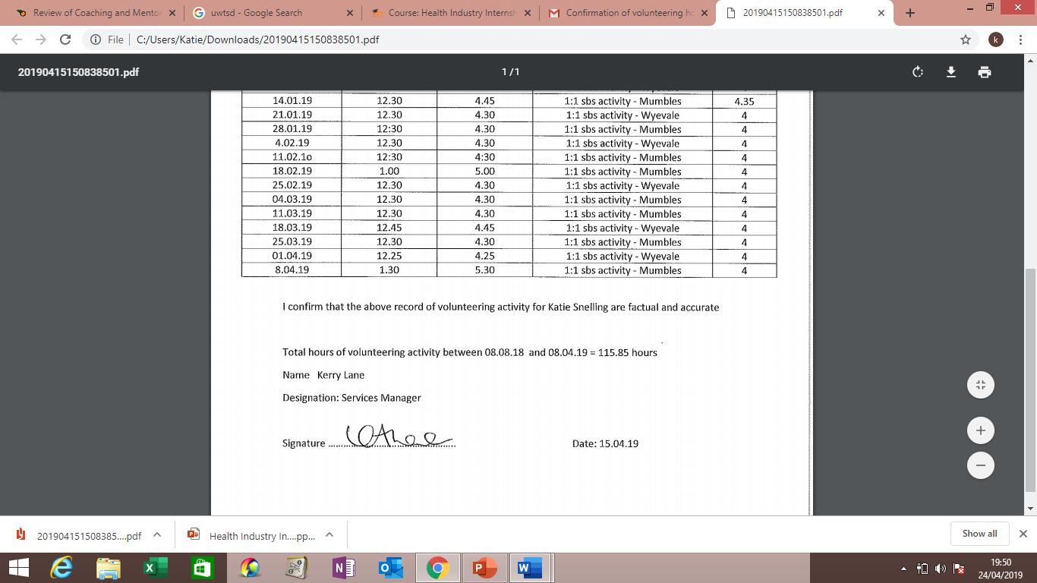
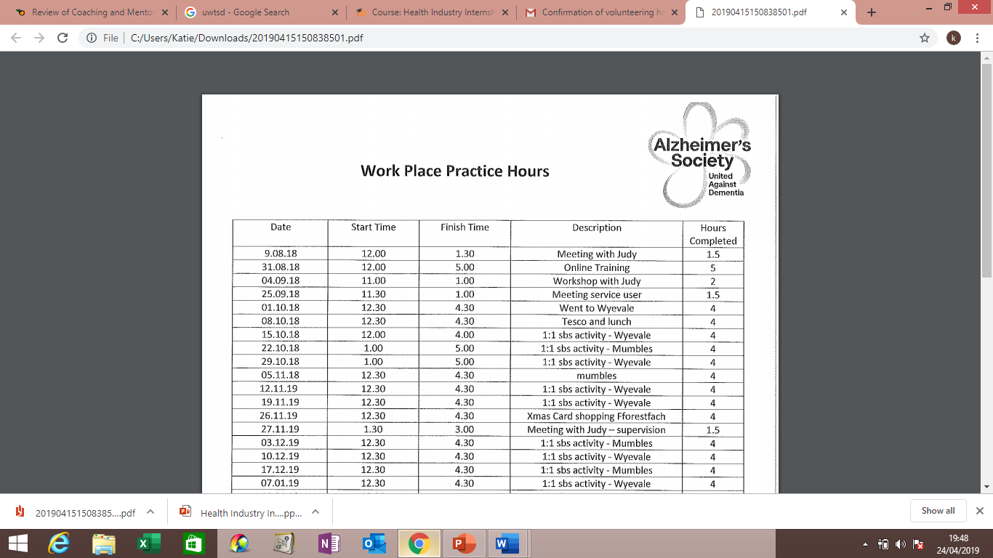


Mentoring Hours

Mentor: Katie Snelling – Year 2 Nursing Student
Mentee: Allessi Lloyd- Year 2 Nursing Student

Date | Time Start | Time Finish | Hours
5/02/19 | 1.00 | 2.00 | 1
11/02/19 | 12.45 | 1.45 | 1
19/02/19 | 9.00 | 10.00 | 1
26/02/19 | 12:45 | 1:45 | 1
5/03/19 | 12.30 | 1:30 | 1
12/03/19 | 12:30 | 1.10 | 40 min
19/03/19 | 12.35 | 1.25 | 45 min
26/03/19 | 9:30 | 10:00 | 30 min
16/04/19 | 11.10 | 12:10 | 1

Total Hours Mentoring = 7.75 Hour
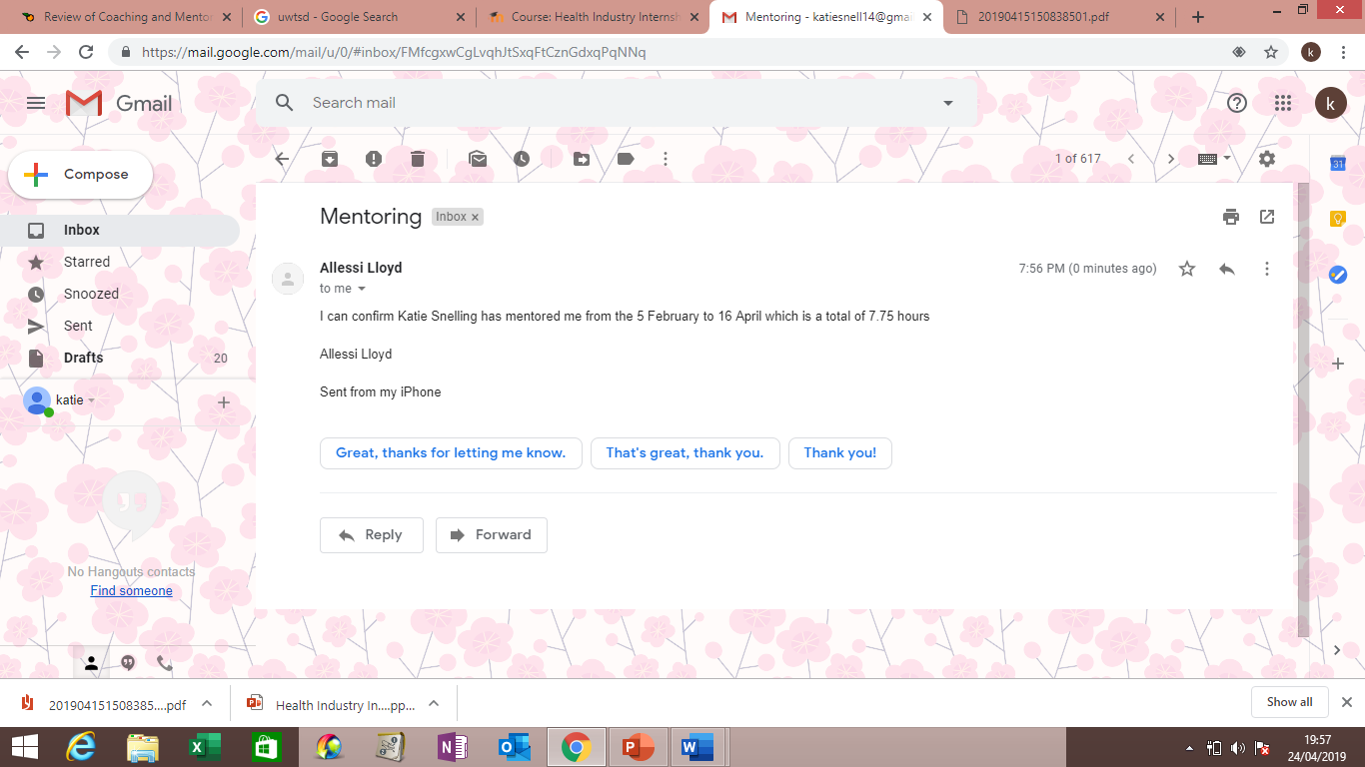

Total Hours of Workplace practice = 123.6

