

Certificate of Higher Education

Employability Skills
Module: Digital Skills for Personal and Professional Growth

Module code: BMSW4008

Lecturer: Philippa Fitzgerald

Student: Alexandru Ion Tutuiu (2313069)

I confirm that I have not presented any AI generated materials as my own work.
I confirm that I have copies of my drafts, notes, and other resources I used, which I may be asked to provide in evidence.

Task 1 - Analysis Report

Snack Wall Society represents a modern response to the growing demand for catering solutions that are both visually impactful and practically enjoyable. The business model spins around a striking concept: decorative display walls filled with edible cones made from sweet or savoury waffles, offering an alternative to traditional catering methods. In developing this business concept, a focused questionnaire was conducted to gain insights into potential customer preferences, event types, and purchasing behaviour. The findings have significantly shaped the direction of the brand, from the service offering to the digital presence and marketing strategy.
The questionnaire targeted a broad demographic likely to organise or attend events that require catering. Respondents were asked about the types of events they are typically involved in, their interest in the Snack Wall Society concept, and their key priorities when selecting a catering service. Three questions stood out for their relevance and impact as shown in figures (1, 2, 3).
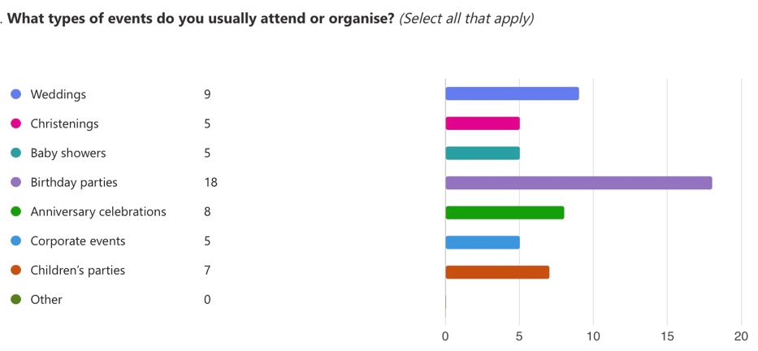
Figure 1. Screenshot of questionnaire responses: types of events attended. Source: Tutuiu, A. (2025).

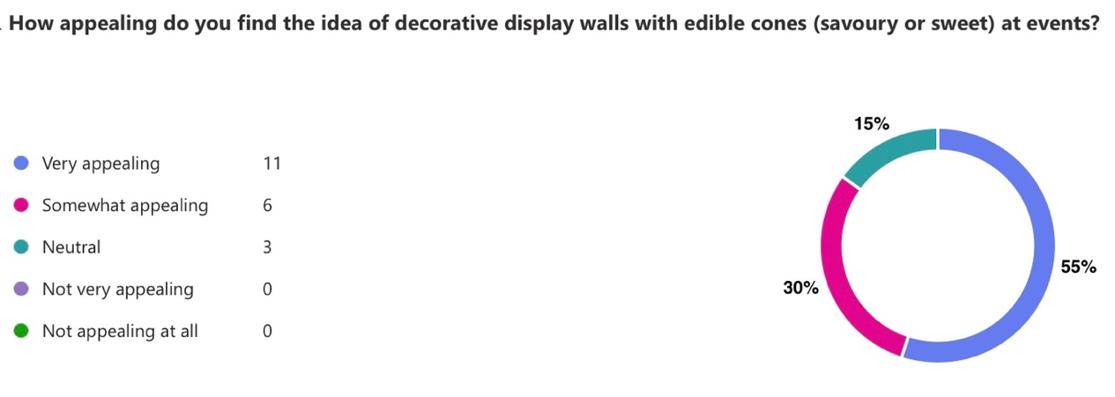
Figure 2. Screenshot of questionnaire responses: appeal of decorative edible cones. Source: Tutuiu, A. (2025).

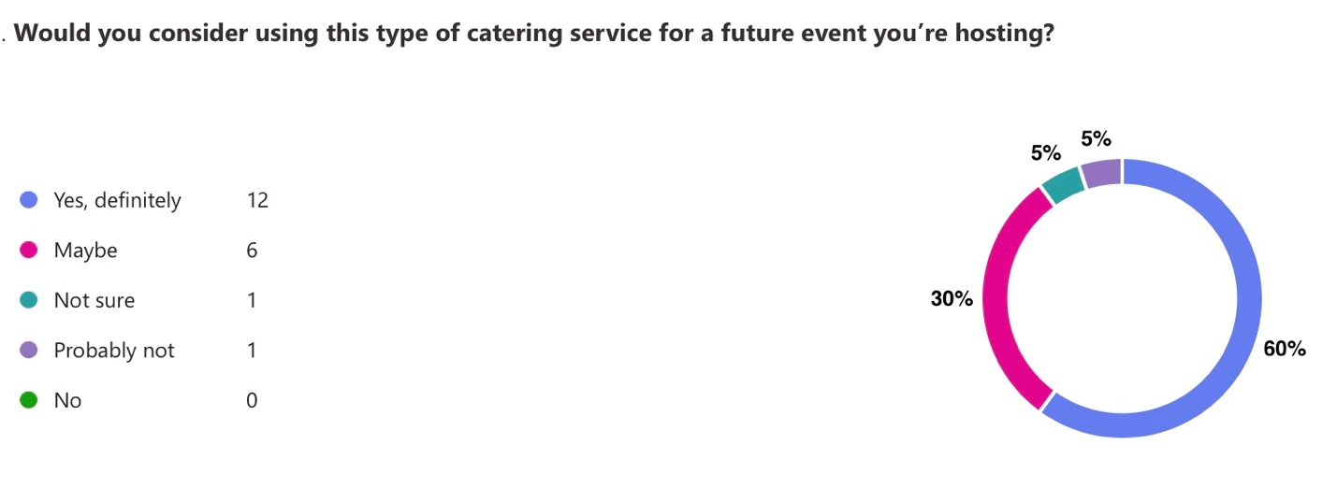
Figure 3. Screenshot of questionnaire responses: willingness to use this service in the future. Source: Tutuiu, A. (2025).

The responses to these questions indicate clear interest in and enthusiasm for this form of catering. The predominance of birthday parties and weddings within the types of events attended or hosted supports the need for visually unique and customisable offerings. Additionally, the high number of respondents who found the display wall concept “very appealing” or “somewhat appealing” suggests that this model resonates well with potential customers. Most importantly, the majority expressing willingness to book such a service for future events further validates the business idea.
Another critical aspect explored in the questionnaire focused on the decision-making process when choosing a catering service. The responses highlight what factors are most important to customers, as shown in (figure 4).
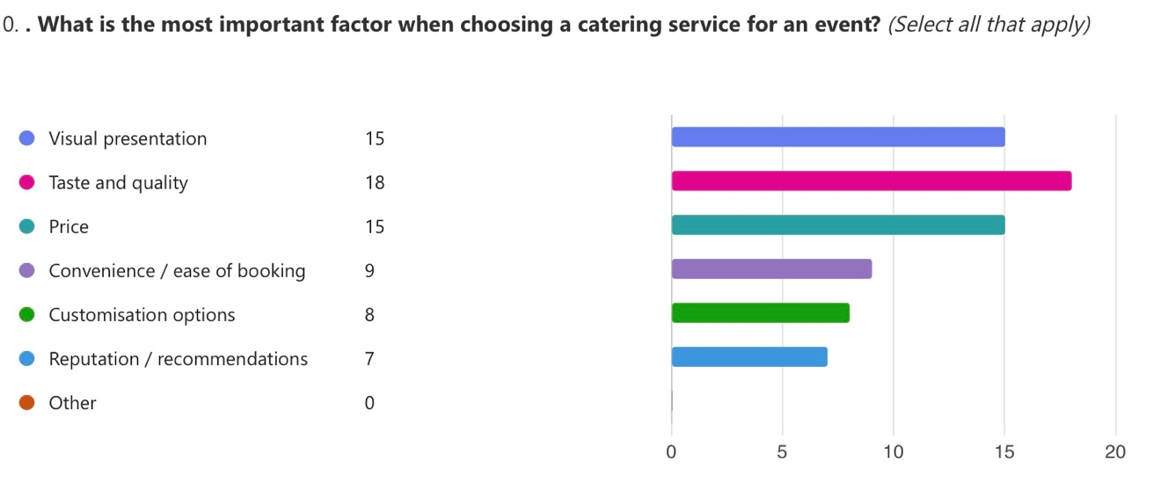
Figure 4. Screenshot of questionnaire responses: key factors in choosing catering services. Source: Tutuiu, A. (2025).

These insights reinforce the importance of a catering service that delivers on both aesthetics and substance. As Dadwal (2020) observes, modern consumers expect a balance between visual appeal and functional value. In this sense, Snack Wall Society (2025) is well-positioned to appeal to a visually conscious and quality-oriented audience.
The website design reflects these preferences. At this stage, the site includes four core pages: Home, Menu, About Us, and Contact (Figure 5). This minimalist layout supports clarity and ease of navigation, which responds directly to user preferences for convenience (Reedy and Parker, 2017). This combination of visual identity and messaging helps reinforce the product’s dual appeal both practical and aesthetic which is essential in today’s digital brand experience (Reedy and Parker, 2017).

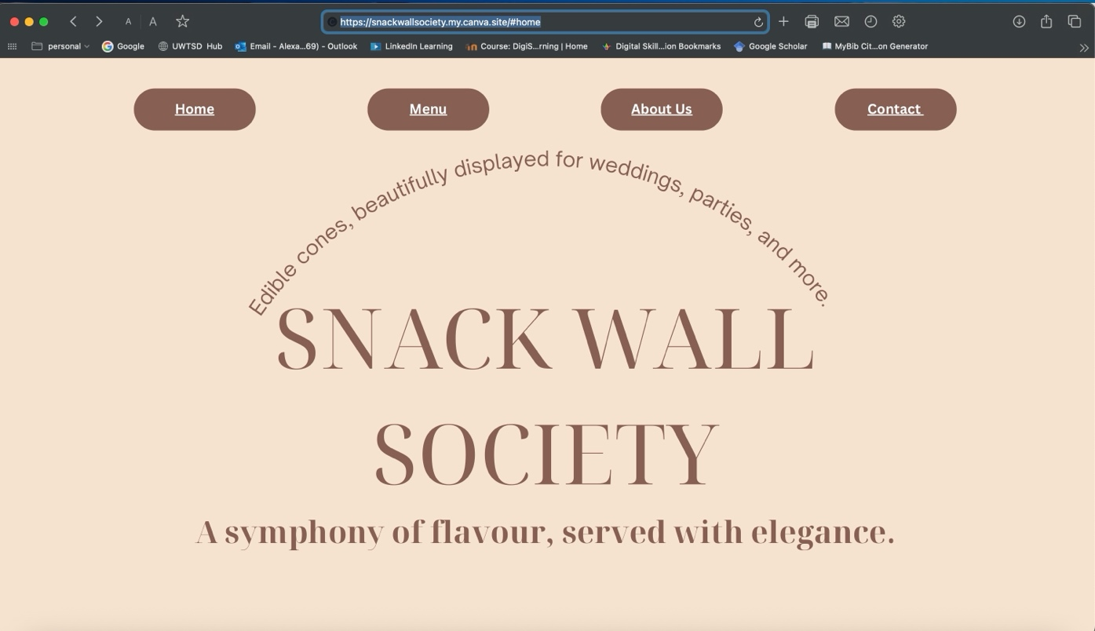
Figure 5. Snack Wall Society (2025) Home page. Available at: https://snackwallsociety.my.canva.site/#home

The ‘About Us’ (Figure 6) section offers visitors a clear understanding of the concept: food as both experience and decor. It outlines the dual product lines savoury cones with charcuterie-style fillings and sweet cones with desserts making it easy for users to visualise potential applications across a variety of event types. By focusing on events such as weddings, baby showers, birthdays, and corporate receptions, the business connects directly with the most popular event types identified in the questionnaire.
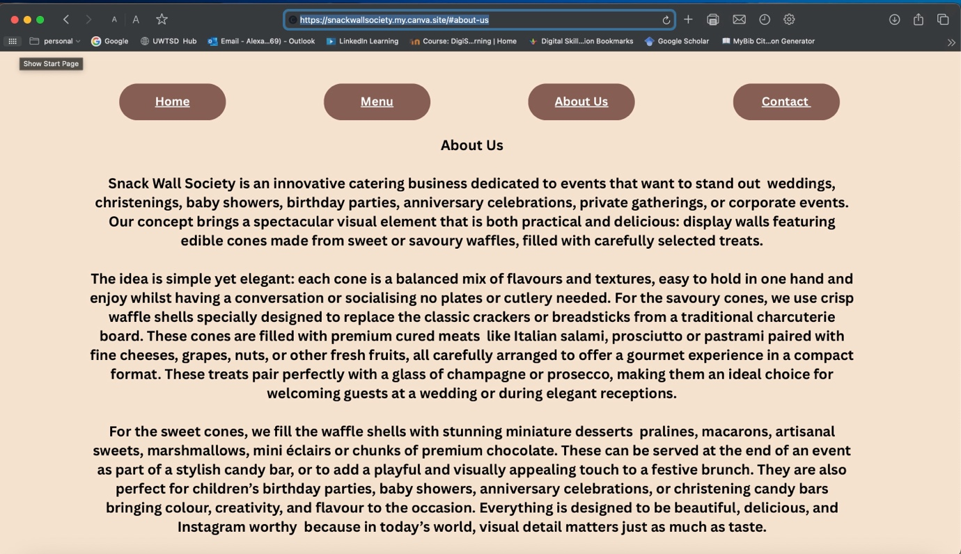
Figure 6. Snack Wall Society (2025) About Us. Available at: https://snackwallsociety.my.canva.site/#aboutus

The ‘Menu’ page allows users to browse and select the types of cones available, with descriptions and imagery that reflect the gourmet nature of each option. It provides a way for customers to plan their event menu ahead of time and make informed choices. Future improvements could include booking calendars or real-time chat support, reflecting customer needs for accessibility and customisation, as noted by Pinto and Guarda (2020). Audience segmentation emerged naturally through the analysis. Three primary customer profiles became evident. First, event planners and organisers seeking premium and elegant food displays for high-profile events. Second, individuals hosting intimate family gatherings who want something memorable but practical. And third, socially savvy customers who have seen similar ideas online and are actively looking for stylish, photo-friendly solutions. These segments align with findings from Soltanifar et al. (2021), who argue that audience-specific branding is critical in building long-term loyalty in digital entrepreneurship.

In developing the marketing strategy, the business has started with a practical, resource-conscious approach. For now, the primary marketing materials include a well-designed flyer and business card, both reflecting insights gathered from the questionnaire (Snack Wall Society, 2025a; Snack Wall Society, 2025b).
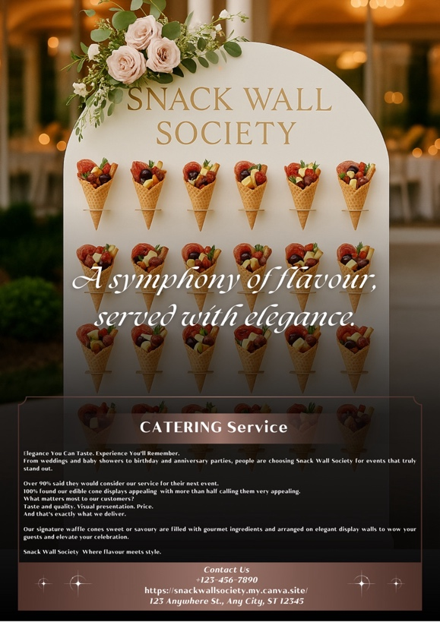
Figure 7. Snack Wall Society promotional flyer. Source: Snack Wall Society (2025a).

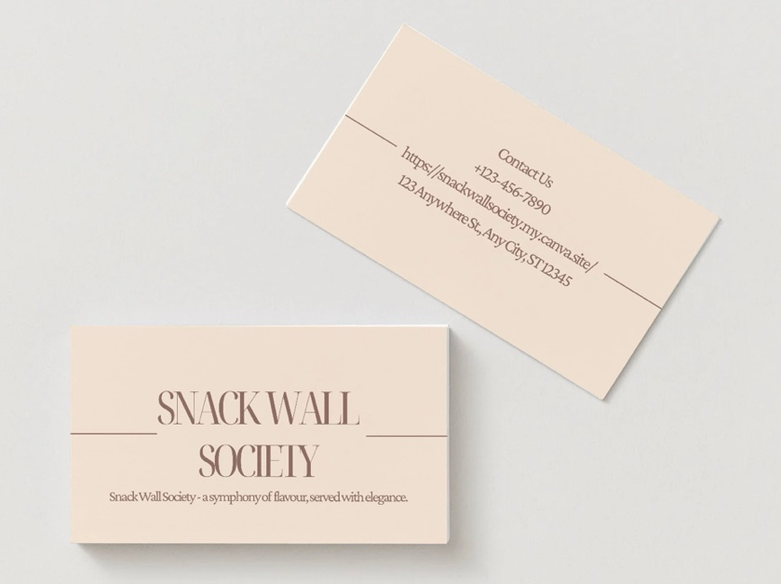
Figure 8. Snack Wall Society business card design. Source: Snack Wall Society (2025b).

The flyer presents a clean overview of the service, listing the main event types supported: weddings, dinner parties, and corporate events, and introduces the brand as an elegant catering concept that transforms food into a visual experience, one that stands out briefly and stays memorable. As recommended by Byrd (2021), early-stage entrepreneurs should focus on storytelling and aesthetics when positioning their brand in competitive markets. The data also highlighted the value of customisation and booking convenience. While the current website only allows contact-based booking, the long-term plan is to introduce a booking portal where users can choose event type, number of guests, cone selection, and even backdrop styling. As Sandhu (2020) suggests, businesses that integrate user-led service configuration often see increased customer satisfaction and higher engagement. In terms of content marketing, the brand will continue to publish photos, short videos, and customer testimonials that showcase the cones in action. As Burgess, Marwick and Poell (2018) explain, social media content that appears authentic and emotionally resonant is far more likely to be shared, building organic brand awareness. Moreover, consistently positive visual presentation reinforces the premium identity of the brand. What stands out from the data is that people are willing to embrace new formats if those formats add value. They’re drawn to creative presentation, especially when it feels thoughtful and convenient. The questionnaire has been instrumental in validating these assumptions and refining the initial business concept. It confirmed that this idea meets a real need, fits a variety of occasions, and appeals to modern values: convenience, aesthetics, and shareability.
In conclusion, the research conducted through the questionnaire has provided clear, actionable insights that directly shaped the concept of Snack Wall Society. It informed everything from product design and website layout to digital marketing strategy and customer engagement. As this business evolves, continued feedback collection and customer interaction will be essential to refining and scaling the service.

References:
Burgess, J., Marwick, A. and Poell, T. (2018) The SAGE Handbook of Social Media. London: SAGE Publications Ltd. Available at: http://www.doi.org.ezproxy.uwtsd.ac.uk/10.4135/9781473984066
Byrd, L. S. (2021) Cultivating Entrepreneurial Changemakers Through Digital Media Education. IGI Global. http://doi:10.4018/978-1-7998-5808-9
Dadwal, S. S. (2020) Handbook of Research on Innovations in Technology and Marketing for the Connected Consumer. IGI Global. http://doi:10.4018/978-1-7998-0131-3
Pinto, F. M. and Guarda, T. (2020) Digital Marketing Strategies and Models for Competitive Business. IGI Global. http://doi:10.4018/978-1-79982963-8
Reedy, K. and Parker, J. (2017) Digital Literacy Unpacked. Facet Publishing. https://ebookcentral.proquest.com/lib/trinity/detail.action?docID=5490897
Sandhu, K. (2020) Digital Transformation and Innovative Services for Business and Learning. IGI Global. http://doi:10.4018/978-1-7998-5175-2
Soltanifar, M., Hughes, M. and Gocke, L. (2021) Digital Entrepreneurship. Springer. http://10.1007/9783-030-53914-6
Tutuiu, A. (2025) Screenshots of questionnaire responses on event catering preferences.
Snack Wall Society (2025) Home page. Available at: https://snackwallsociety.my.canva.site/#home
Snack Wall Society (2025) About Us. Available at: https://snackwallsociety.my.canva.site/#about-us
Snack Wall Society (2025a) Promotional flyer for catering services.
Snack Wall Society (2025b) Business card with contact information and brand identity.

Task 2 - The Importance of Excel in the Digital Era

In the digital era, where businesses rely heavily on data, planning, and efficiency, Microsoft Excel remains one of the most practical and reliable tools available. Despite the rise of cloud-based apps and automated systems, Excel continues to be widely used across industries (Microsoft, 2023). It is flexible, easy to learn, and powerful enough to support complex analysis. For small and medium-sized businesses like Snack Wall Society, Excel plays a key role in managing daily operations and making smart decisions based on real data.
Snack Wall Society is a catering business focused on visual, elegant food displays using sweet and savoury cones at events like weddings, baby showers, birthdays, and corporate functions. Our concept is creative, but the business side of it requires structure stock planning, cost control, seasonal forecasting, and tracking bookings. Excel helps organise all these moving parts (Mitra, 2022). One of Excel’s biggest strengths is ability to manage financial data. For Snack Wall Society, Excel is used to create cash flow spreadsheets, calculate profit margins, and monitor monthly income and expenses. Each event type has a different scale and cost. A wedding for 120 guests requires a different level of preparation than a small birthday party. With Excel, we can create cost templates that adjust based on guest numbers, cone type sweet or savoury, and any custom requests. This helps us stay profitable without under-pricing or overspending (PwC, 2021).
Excel is also useful for stock and inventory control. Our cones are made from fresh ingredients and premium products, which need to be ordered in the right amounts and at the right time. Using spreadsheets, we can track how many cones were used per event, how much stock is left, and when to reorder. According to WallStreetMojo (2023), Excel’s ability to analyse historical usage data makes it ideal for stock management. Conditional formatting, formulas, and charts help us spot patterns like savoury cones selling better during evening events or sweet cones being popular at children’s parties. Seasonality is another factor we manage using Excel. Our busiest times are from May to September (wedding season) and December (holiday events). By reviewing data from past years, we can forecast demand and prepare in advance. As noted by Microsoft (2023), Excel is a powerful tool for identifying trends and planning for growth, particularly for businesses that operate seasonally. Forecasting helps reduce last-minute stress and allows us to negotiate better deals with suppliers. Beyond finances and stock, Excel supports our day-to-day event planning. We use it to log client bookings, manage specific requests, assign staff, and plan delivery schedules. If we have multiple events in one weekend, Excel lets us break down the logistics clearly who delivers where, how many cones are needed, and what time setup begins. According to TechRadar Pro (2022), Excel’s real strength lies in adaptability to different industries and workflows, from catering to logistics.
Excel is also compatible with other digital tools. Files can be stored on OneDrive, shared with team members, or connected to other software like Stripe or QuickBooks. This integration helps centralise operations. As Forrester (2021) highlights, Excel’s integration with modern platforms such as Power BI has extended its usefulness in data reporting and collaboration. One of the less obvious benefits of Excel is how it helps improve data literacy. The Chartered Institute of Management Accountants (CIMA, 2023) emphasises that business owners today must understand and interpret data confidently. Excel is often where this begins. Even basic spreadsheets help build comfort with financial information, trends, and projections. In Snack Wall Society, I’ve become more confident in reading my own data not just recording it. This means I make better pricing and planning decisions over time.
Another powerful feature of Excel is its support for “what if” scenarios. For example, I can model how profits change if we add five more events per month or raise prices slightly during peak season. This helps reduce guesswork and makes planning more realistic. WallStreetMojo (2023) describes scenario modelling as one of Excel’s core strengths for small business strategy, and I can personally confirm how useful that has been in my own decision-making. That said, Excel isn’t perfect. Mistakes can happen with incorrect formulas or forgotten updates. PwC (2021) warns that spreadsheet errors are one of the most common risks for small businesses. However, with clear formatting, regular checks, and simple version control, most of these problems can be avoided.
In summary, Excel remains one of the most important tools in the digital business landscape. For Snack Wall Society, it does more than track sales or expenses it supports planning, decision-making, and long-term growth. It helps us stay organised, efficient, and financially aware, without needing complex software or expensive systems. In a world full of digital innovation, sometimes the best solution is the one that’s been right in front of us all along.

References:

CIMA. (2023). Why data literacy matters in business today. [online] Available at: https://www.cimaglobal.com [Accessed 20 Jun. 2025].
Forrester. (2021). The Total Economic Impact™ of Microsoft Excel with Power BI Integration. [online] Microsoft. Available at: https://info.microsoft.com [Accessed 20 Jun. 2025].
Microsoft. (2023). Overview of Excel and its business applications. [online] Available at: https://support.microsoft.com/excel [Accessed 20 Jun. 2025].
Mitra, S. (2022). Excel for Small Business Finance. 2nd ed. London: Kogan Page.
PwC. (2021). Spreadsheet risk: A practical guide for small businesses. [online] Available at: https://www.pwc.co.uk [Accessed 20 Jun. 2025].
TechRadar Pro. (2022). Excel gets modern updates to stay competitive in 2022. [online] Available at: https://www.techradar.com/pro/news/excel-modern-features [Accessed 20 Jun. 2025].
WallStreetMojo. (2023). Top 10 Uses of Microsoft Excel in Business. [online] Available at: https://www.wallstreetmojo.com/uses-of-microsoft-excel/ [Accessed 20 Jun. 2025].

