
Technical Report: Engine Dynamometer testing and analysis.

Motorsport and Vehicle Technology (ACHA4012_4004)

Connor Casey (2103540)
March 2024

Contents
1 Introduction ………………………………………………………………………………………………………………
1.1 Equipment needed……………………………………………………………………………………………..
2 Methodology……………………………………………………………………………………………………………...
3 Results (Raw data) ….………………………………………………………………………………………………….
4 Analysis……………………………………………………………………………………………………………………
4.1 Graphical data…………………………………………………………………………………………………
5 conclusion from test results………………………………………………………………………………………...
6 Evaluation…………………………………………………………………………………………………………………
7 References………………………………………………………………………………….…………………………...

Introduction.
This report focuses on engine dynamometer testing and analysis which is a crucial part of engine development and testing the main goal of engine dynamometer testing is to be able to test the performance of the engine under different loads to simulate strain on the engine.
Using the information given through the dyno these being the area of rotation around the arm of the dyno (M), the load against the engine (N) the engine speed (RPM) the fuel flow rate (l/min) you can work out the performance factors of the engine these being:
- Break power (KW)
- Torque (Nm)
- Break Mean Effective Pressure or BMEP (Kpa)
- Specific Fuel Consumption or SFC (KG/KWH)
- Overall Fuel Efficiency as a percentage

Equipment needed.
To perform the tests, you will need the following equipment.
- An engine to run your tests on
- An engine dynamometer rig
- A fuel delivery system and storage
- A sensor system for measuring engine rpm temperature and other safeguarding
- And a dyno arm for which you can record specific measurements for calculations.

Methodology
To begin with you must understand the purpose of performing the Engine dynamometer testing typically the main 3 reasons you use the dynamometer would be engine performance testing, vehicle emission testing or troubleshooting once you have decided why you are going to be using the dynamometer you can begin setting up the dynamometer for your required testing.
There are 3 ways you can set up the dynamometer these are:
- Manual operation, this is where you control the engine manually by adjusting the load of the dyno and the throttle position of the engine.
- Automatic operation, this is where you prepare automated tests using the dyno’s software specifying test parameters such as dyno load, engine RPM throttle position and test duration.
- P-curve test set up this defines parameters for P-curve tests such as start and end engine RPM, logging intervals, and test duration.
For the tests that I performed I used the manual set up as I had to record data for dyno load, engine RPM, fuel flow rate and lambda to use these for further calculations.
To do this you first have to set the software into manual adjustment mode on the computer once you have done this you can put in the put in the parameters that you want to measure in my case that was dyno load engine rpm fuel flow rate and lambda.
Once you have set your parameters you can begin adjusting the engine speed and dyno load using the dials on the console, make sure that you increase them both gradually taking measurements regularly for your set parameters until the engine rpm has increased by 1000 RPM as an example, I took readings for approximately every 50rpm gained, keep going until you reach the safety threshold hold of 5500rpm. Once you have done this you can take your readings into an excel spreadsheet which you can use to do calculations for the Break Power, Torque, BMEP, SFC and Overall Thermal efficiency.

Results (Raw data)
Once you have completed your engine dynamometer testing you can produce an excel table containing the results with the parameters you put into the software theses were the results I gathered from my set of manual testing:

Table 1: this is the table with the original gathered results from my dyno testing.
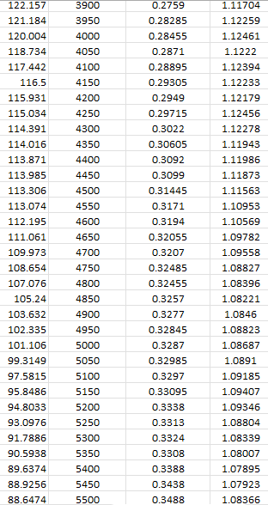
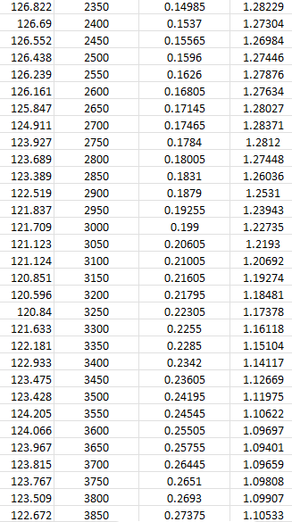
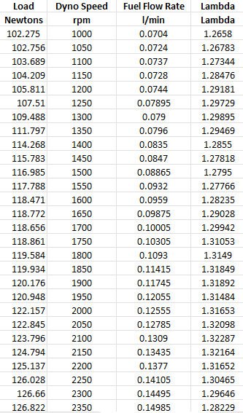

Analysis
After getting the results from the original dyno testing you can then you can then use these results to calculate the figures for Break power, Torque, BMEP, SFC and Overall Fuel efficiency be sure to take down the figures for PI the length of the dyno arm in metres and the number of cylinders the engine has as these figures come into some of the calculations.
Table 2: a section of my completed table with calculations for Break Power, Torque, BMEP, SFC, and Overall Thermal efficiency.
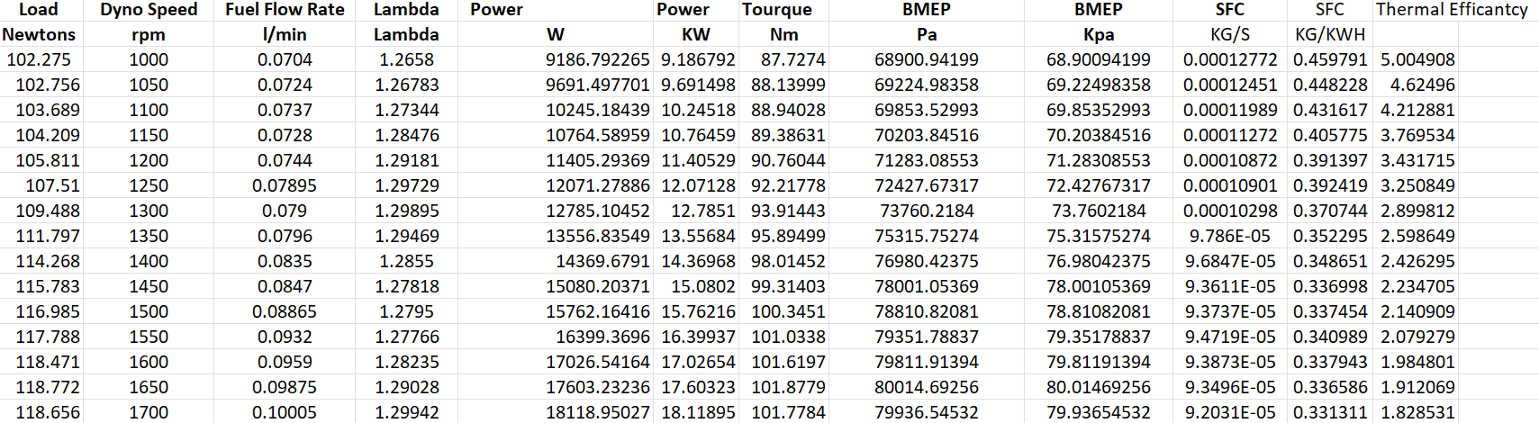
Firstly you can calculate the engine torque to do this you multiply the load of the dyno by the length of the arm of the dyno as an example we used a dyno arm with a length of 0.85776M so to work out the torque at an example RPM of 1500 you would multiply the load of the dyno at 1500 RPM Which was 116.985N by the 0,85776M of the Arm to get a engine torque value of 100.3451N
After working out the engine torque value you are able to work out the break power being produced from the engine to do this you use the formula for break power $P=\frac{2πNT}{60}$ where N is the Engine speed T is the torque as an example to work out the power for 1000 rpm you would use the equation with your figures from the testing e.g $P=\frac{2π*1000*87,7274}{60}=9186.792265W$ once you have your power in watts you can then divide your answer by 1000 to get your answer in KW
Once you have your power calculated you can work out the BMEP in pascal to do this in excel by using this formula =100000*((4*$C$2*G6)/(1.6*1000)) where C2 is the value of PI G6 is the torque value as an example for 1000RPM and a torque value 87.7274 this would give a BMEP value of 68900.94199Pa then to get your answer in Kpa you just divide by 1000.
Next you can work you’re the SFC first in KG/S then dividing your working out by 3600 to get your workings out in KG/KWH to get the figure in KG/S you divide the fuel flow rate by 60 then divide then divide that answer by the power in watts divided by 1000 as an example for 1000RPM the fuel flow rate is 0.0704/60 = 0.0011733 then divide that by power figure of 9186.792265/1000 to get your SFC figure in (KG/S) I got 0.00012772 (KG/S) to get the value int KG/KWH you multiply your original value by 3600 I got a value of 0.459791(KG/KWH) for 1000RPM
Finally, to work out to work out the fuel efficiency you divide the SFC (KG/KWH) by the brake power (KW) as an example for 1000RPM I has a SFC figure of 0.459791(KG/KWH and a power figure of 9.186792KW so 0.459791/9.186792 = 0.05004953*100 = 5.0049529% overall fuel efficiency at 1000rpm.

Graphical Data
Figure 1: a graph comparing the relationship with SFC and engine speed.

The specific fuel consumption has a direct relationship with engine speed this is because when the engine is at ideal it uses a higher amount of fuel to keep the engine from stalling, as the engine revs increase the SFC decreases until the engine begins to require more fuel to produce higher RPM at this point the SFC will increase to a level like the level at idle. (Irawan, 2021)

Figure 2: a graph comparing the relationship with Torque and engine speed.

The engine torque has a direct relationship with the engine RPM as when the RPM increases the engine torque increases until the engine reaches peak torque at around 3000 rpm then the torque slowly drops as the rpm increases this is because the engine cant keep up with the increased frictional resistance hence the drop in engine torque. (MESIMPSON, 2008 )

Figure 3: a graph comparing the relationship with brake power and engine speed.

Finally the engine speed and brake power also share a direct relationship as when the engine rpm increases the brake power also increase until it reaches around 4500RPM then the break power dips slightly this is because as the engine rpm increases the more fuel is burnt and hence the engine power increases how ever as the engine speed increases pass the peak power the engine cant keep up with the increased friction all resistance causing the drop in power in the higher RPM.

- Conclusion from test results.
Judging from the comprehensive graphical data extracted during the dyno testing session conducted on the Honda CRX engine, it is evident that the engine adheres to typical trends observed in power, torque, and specific fuel consumption (SFC) metrics, aligning well with those of other vehicles. This comparative analysis gives me confidence in the engine's operational integrity, suggesting that it is functioning optimally. The consistency exhibited across the recorded power, torque, and SFC parameters further bolsters this assessment, affirming that the engine's performance remains within anticipated norms.

- Evaluation
Overall I believe that my engine dynamometer testing was a relative success as I was able to produce an intuitive set of results for the parameters that I chosen with these results I was able to put them into a excel table and do the relative calculations to get calculations for torque power, BMEP, SFC, and thermal efficiently and was able to produce three clear graphs with the gained info from the calculations. However I believe that if I did a automatic dyno test with the same parameters I believe that the results would be as more accurate making my calculated results even more accurate allowing the data to be more conclusive.

References

Irawan, B. (2021, Febuary ). researchgate. Retrieved from researchgate: https://www.researchgate.net/figure/Engine-speed-vs-SFC_fig3_349656199#:~:text=...%20the%20increase%20in%20fuel,the%20SFC%20will%20increase%20again.
MESIMPSON. (2008 , July 10). Why Does the Torque Curve Drop Off at Low RPM in a Typical Piston Engine? Retrieved from physicsforums: https://www.physicsforums.com/threads/why-does-the-torque-curve-drop-off-at-low-rpm-in-a-typical-piston-engine.244434/

