REHAN JOSEPH
NOS
ACCA5023
Assignment 2
11 May 2026

Contents
Question 1: Routing 2
Question 2: Domain Server 3
Question 3: Encrypted Connection between Swansea and London 4
Question 4: Users 5
Question 5: Domain Membership 5
Question 6: DHCP Server 6
Question 7: Test and Troubleshoot 6
Question 8: Disk Drive 8
Question 9: IIS Server 8
Question 10: Remote Desktop Services 9

Figure 1: Routing 3
Figure 2: ICMP Traffic 3
Figure 3: Persistent IP Forwarding 4
Figure 4: Domain Server 4
Figure 5: VPN Connection 5
Figure 6: IPsec Statusall 5
Figure 7: Users 6
Figure 8: Domain Membership on Client 6
Figure 9: DHCP Server 7
Figure 10: Client Ping 7
Figure 11: Debian Server Ping 8
Figure 12:Debian Client Ping 8
Figure 13: Disk Drive 9
Figure 14: IIS Server 9
Figure 15: Remote Desktop 10

Question 1: Routing
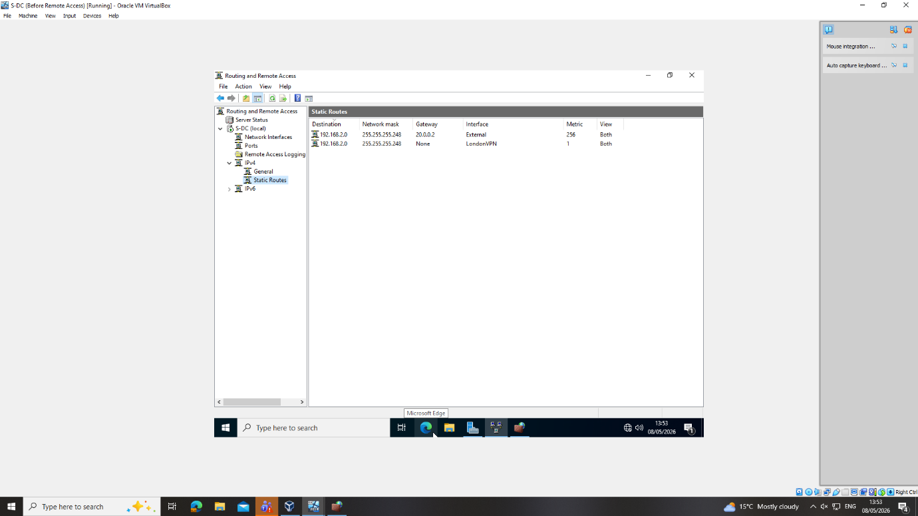
Figure 1: Routing

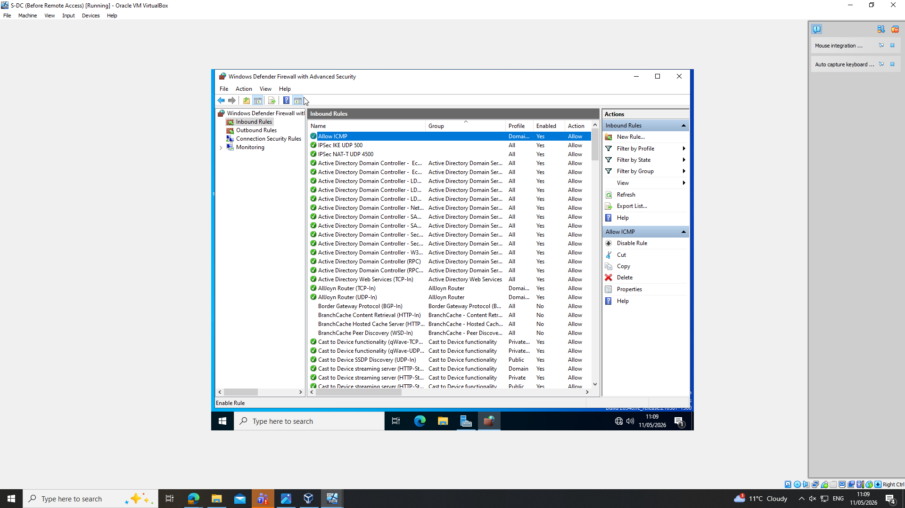
Figure 2: ICMP Traffic
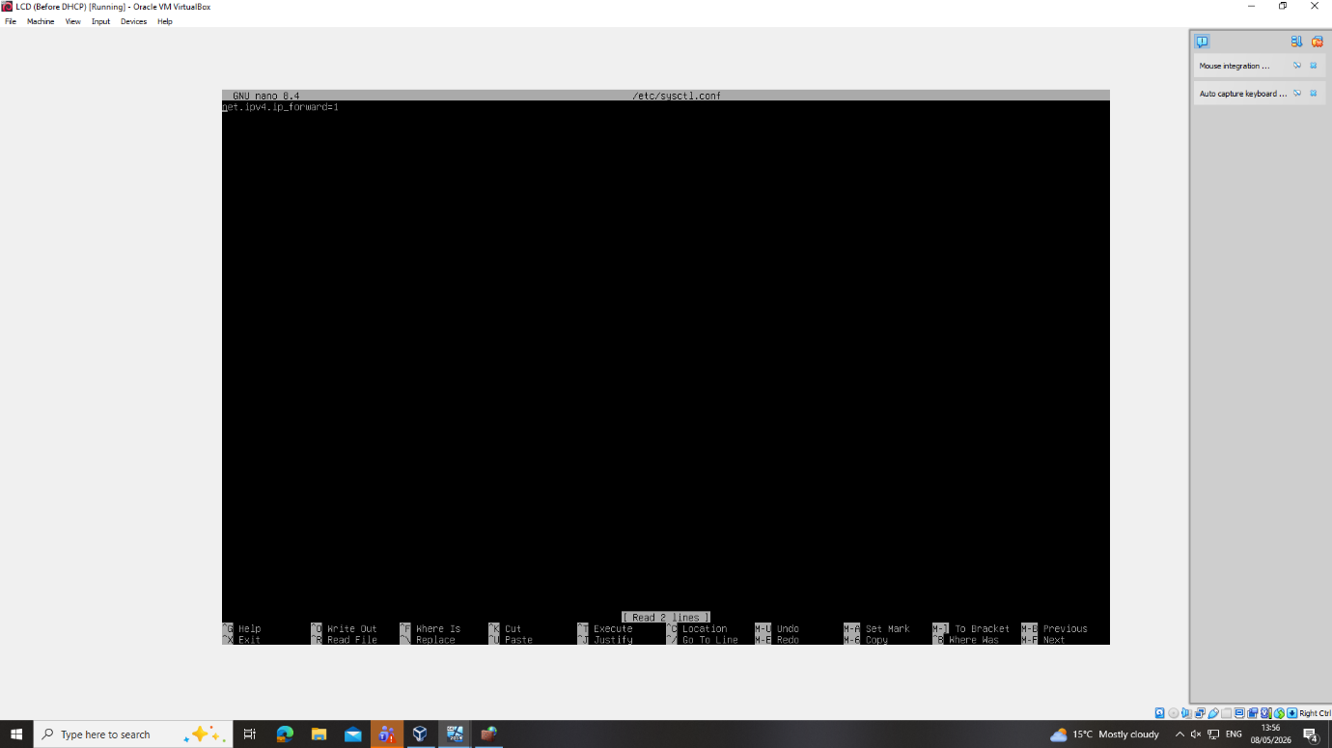
Figure 3: Persistent IP Forwarding

Question 2: Domain Server
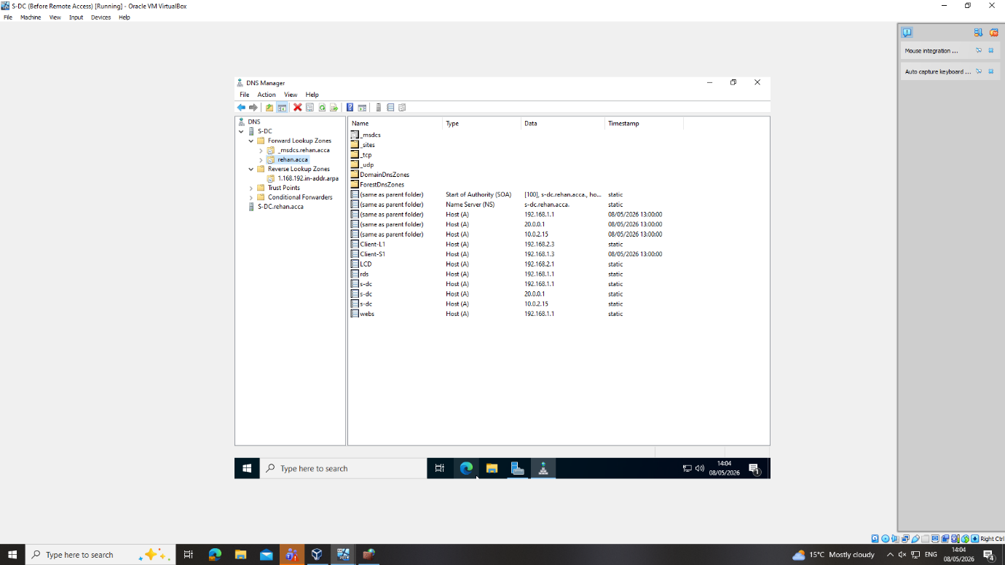
Figure 4: Domain Server

Question 3: Encrypted Connection between Swansea and London
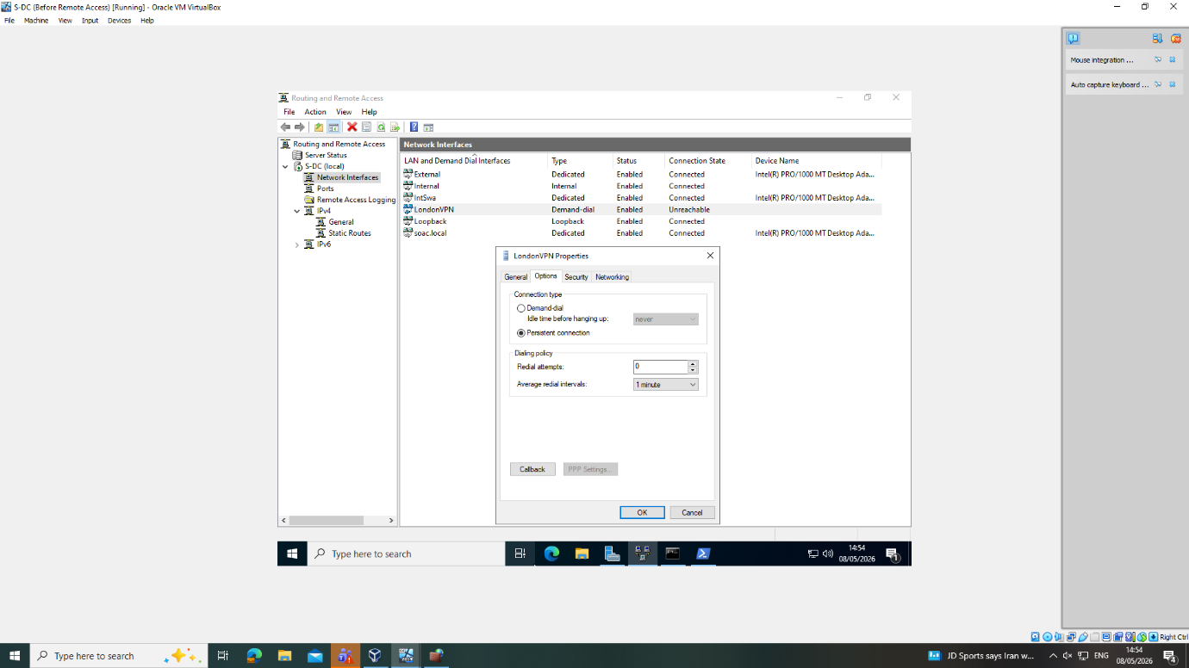
Figure 5: VPN Connection

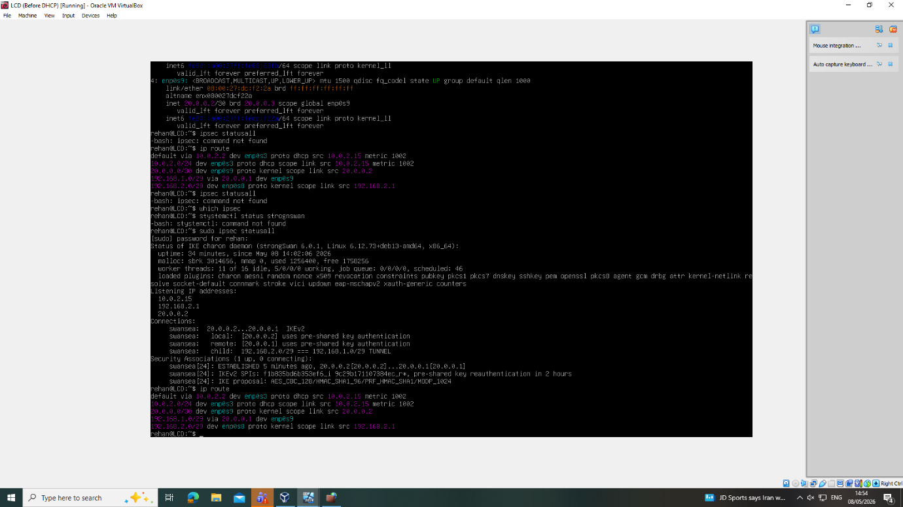
Figure 6: IPsec Statusall

Question 4: Users
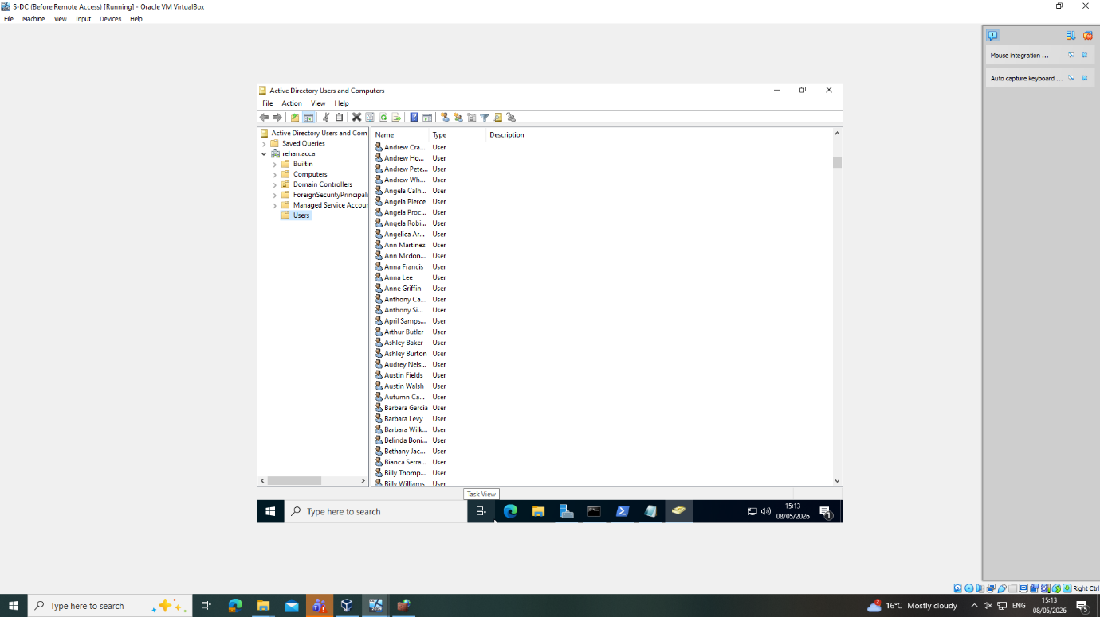
Figure 7: Users

Question 5: Domain Membership

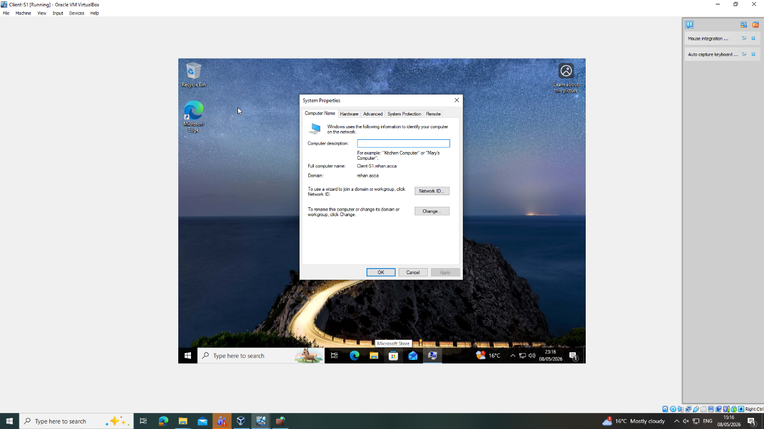
Figure 8: Domain Membership on Client

Question 6: DHCP Server
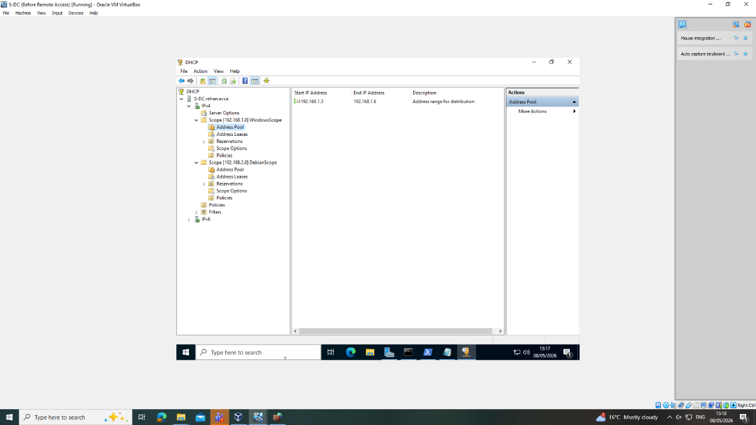
Figure 9: DHCP Server

Question 7: Test and Troubleshoot
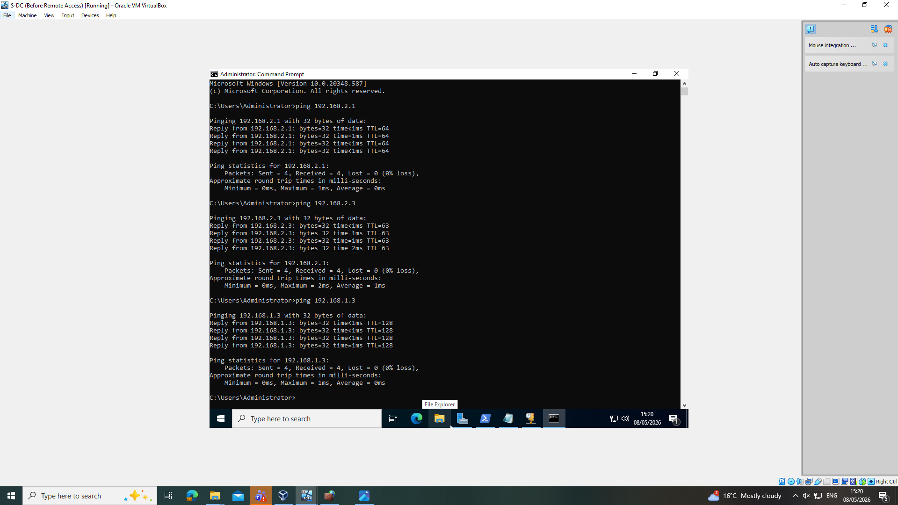
Figure 10: Server Ping

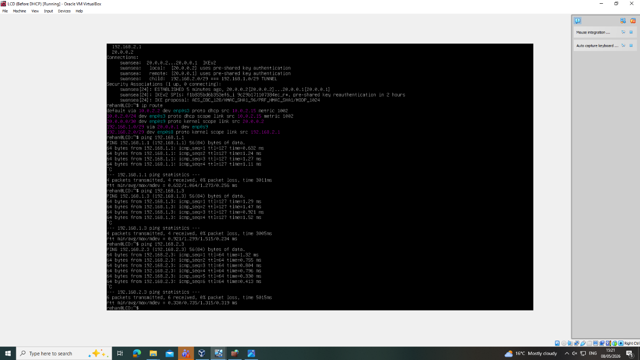
Figure 11: Debian Server Ping
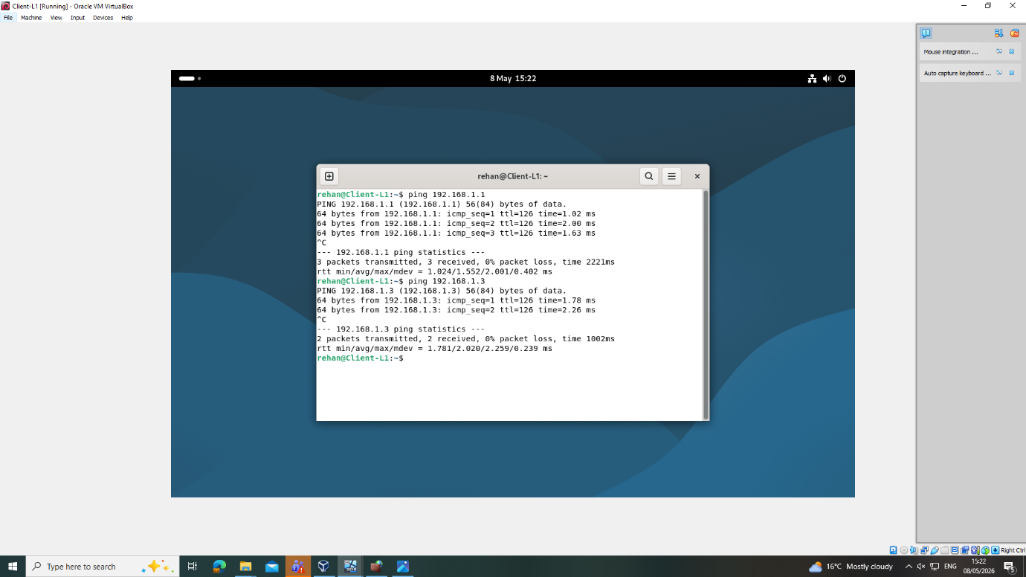
Figure 12:Debian Client Ping

Question 8: Disk Drive
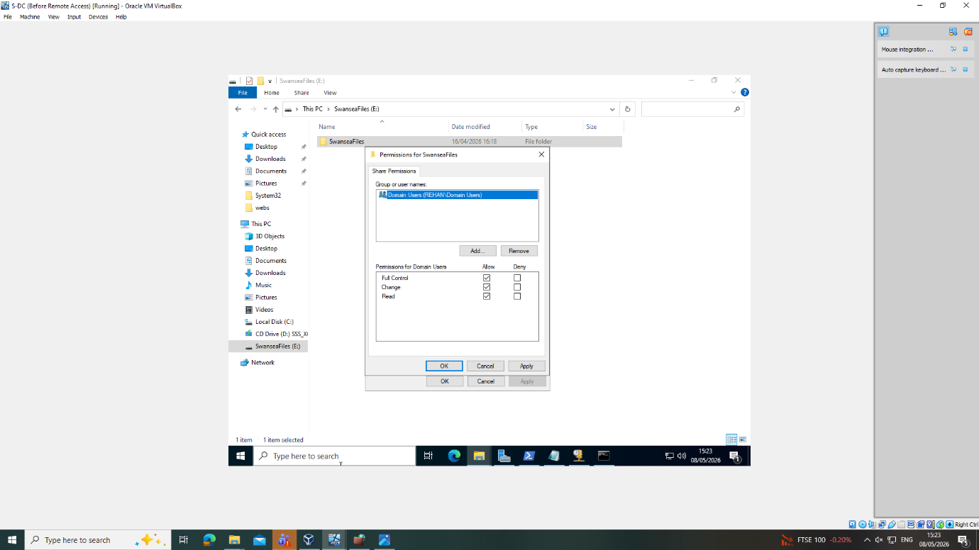
Figure 13: Disk Drive

Question 9: IIS Server
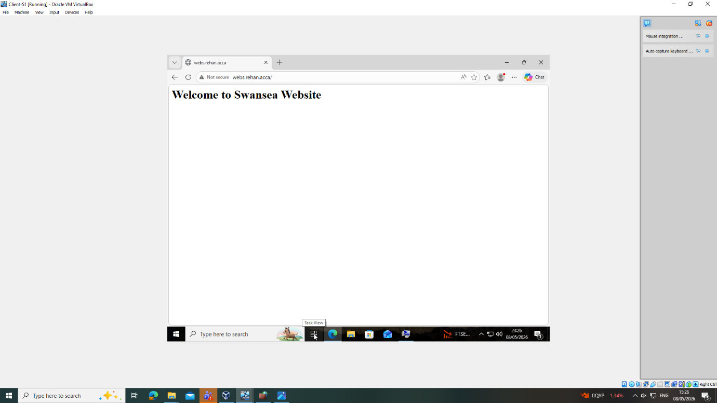
Figure 14: IIS Server

Question 10: Remote Desktop Services
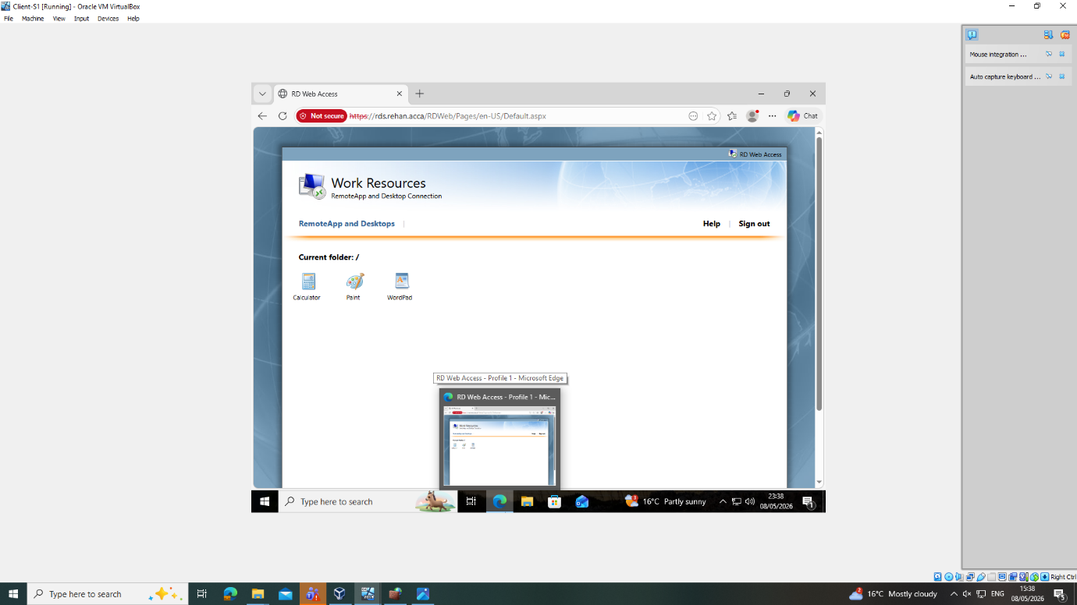
Figure 15: Remote Desktop

