Student Number- 1708009
Module- Mental Health and Wellbeing
Module Code- SJSS4003 Ass 1- Resit
Course- BA Health and social studies
Lecturer- Ken Dicks
Date-22/07/2019

Introduction

This assignment will be discussing the current welsh government's legislation or promoting well-being as well as maintaining it in an educational setting and schools across Wales. It will be focussing on how school life can affect a pupil’s well-being a mental health and looking at the positive and negative outcomes this may have for the child while also referring to policy and legislation. The essay will also be discussing areas in which certain schools have succeeded and also certain ways some have failed in promoting well-being and identifying why this may or may not be and also how a student’s school life can impact on their home and social life outside of education.

Wellbeing
‘Well-being is a positive outcome that is meaningful for people and for many sectors of society because it tells us that people perceive that their lives are going well. Good living conditions (e.g., housing, employment) are fundamental to well-being. Tracking these conditions is important for public policy. However, many indicators that measure living conditions fail to measure what people think and feel about their lives, such as the quality of their relationships, their positive emotions, and resilience, the realization of their potential, or their overall satisfaction with life’
( National Center for Chronic Disease Prevention and Health Promotion, 2018)
Wellbeing is usually described as a state of being comfortable, healthy and happy in life and functioning well in in the world. People all usually have a different idea of what well-being means and different opinions on what it takes the achieve it. Wellbeing is usually measured by examining someone’s mental and physical state over time and how they feel about this. Physical and mental health can deteriorate or improve daily and this is usually because of the individual’s surroundings, circumstances in their personal life and also their relationships with family and friends. Past experiences and childhood trauma can also have a serious effect on their future wellbeing. Typically, in simple terms an adequate level of wellbeing can be achieved when an individual manages to achieve good social connections with family and friends, financial stability is maintained and when they are in a good physical and mental state.

Maslow’s Hierarchy of needs
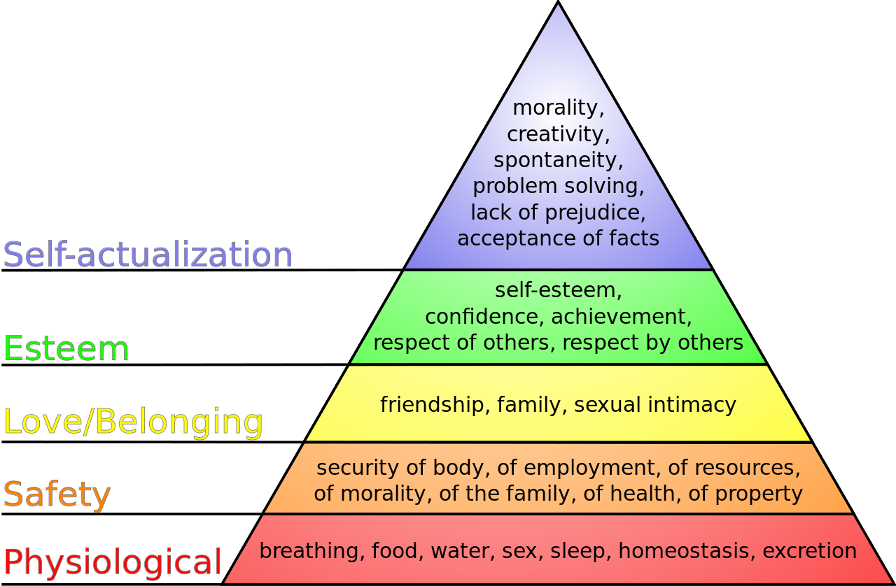
(Chinese University of Hong Kong, 2014)

Maslow’s hierarchy of needs is usually good to refer to when it comes to wellbeing, Abraham Maslow’s hierarchy of needs is broken down into a pyramid from basic needs to psychological needs and then finally to self-actualization, and the idea was that humans have 5 main needs. The most basic need on the pyramid is the physiological need and this can include anything from food, water, breathing, sleep, etc. The second level is our need for security, for example, the safety of employment or resources, property, etc and all of these are basic needs also but require all elements from the first level of the pyramid to be achieved and maintained. Maslow went on to name the third level and this level is an individual need for love and belonging, the social needs level. The fourth level is the human need for esteem, a sense of achievement and respect from other’s and sat but not least is the fifth level which Maslow believed was the need of self-actualization which is the need for wanting a sense of morality, acceptance, and creativity which essentially is the need for someone to reach their full potential. Maslow claims you can’t achieve any of these levels without reaching the needs in the level below. Although there are many theories on how to achieve and maintain wellbeing, Maslow’s Hierarchy is one of the most popular and is the basis for a lot of government wellbeing plans worldwide.

Wellbeing in an educational setting

The majority of schools in the UK and other countries claim to prioritize the wellbeing of their pupils. In Wales and elsewhere many schools have taken various steps to ensure that their students are happy and healthy and maintain a good level of wellbeing as they start and continue their educational journeys by creating safe learning and teaching environments. Most schools have a strict anti-bullying policy and have no tolerance for such behavior

The wellbeing of future generations act wales (2015)
The wellbeing of future generations acts Wales was first introduced in 2015 with the main goal to promote wellbeing and equality in Wales and also to attempt to improve the Welsh economy. The Welsh government is attempting to focus more on the long-term and prevent problems before they happen essentially and take a more joined-up approach. The act has seven main goals for a healthy, prosperous, resilient and more equal wales whilst also trying to keep the Welsh language alive and to encourage inclusiveness in communities. The seven goals are as follows-
- A prosperous Wales
- A resilient Wales
- A healthier Wales
- A more equal Wales
- A Wales of cohesive communities
- A Wales of vibrant culture and a thriving Welsh language
- A globally responsible Wales
The Welsh government believe that in order to achieve wellbeing, an individual must be given equal opportunities in education

The Welsh educational system

The welsh educational system is changing, and the main change will be introducing a new curriculum for funding non-maintained settings and schools across Wales. Schools will see the final version of the curriculum in 2020 which gives them time to prepare and make any essential changes for it to be put into practice from September 2022 for all schools apart from independent schools for up to year 7 and then it’s expected to be introduced to secondary education by 2026. The curriculum has been constructed by the Welsh government by taking on board ideas from all over the world. There will also be changes to improve the assessment process for children and infants in education, more support will be added for children who suffer from learning difficulties and various other additional needs and more training will be put in place for teachers to understand and assist each child correctly.

The need for these changes came about when evidence from the international surveys and other evaluations showed that students in Wales’ level of achievement is not as high as they could be and are slowly decreasing as time goes on. The Welsh government has recognized that in order to thrive in the modern world, children must be taught more digital skills and encouraged to express themselves with creativity alongside knowledge and prepare pupils for an ever-adapting and changing future. The current focus is to improve how schools support children with additional needs but the next step plans to focus on assisting and helping children to cope with life’s demands by focusing on pupils physical and mental wellbeing and to help children learn with ease.

Welsh Government laws and legislation in education

Education has changed vastly over the years in Wales and worldwide, this is mainly thanks to the changes in law and legislation. These acts and laws indicate that every child in Wales is entitled to an education of some sort and ideally all receive the same quality of education, also focusing on keeping the child happy and meeting their needs while they start their educational journey and throughout. Some of the major education legislation is as follows-

‘• Everybody’s Business (2001) - The National Assembly for Wales’s Childhood and Adolescent Mental Health Strategy.

• Children and Young People’s Plans.

• The National Service Framework for Children, Young People and Maternity Services (2005). • The Welsh Network of Healthy School Schemes (WNHSS)

. • The Learning Country (2001) and Learning Country II (Vision Into Action) (2006).

• The National Strategy for School-Based Counselling Services in Wales (2008).

• The increased participation of children and young people in the decision-making process, including the introduction of statutory school councils.

• Talk to Me: A National Action Plan to Reduce Suicide and Self Harm in Wales (2008). • Breaking the Barriers: Meeting the Challenges – Better Support for Children and Young People with Emotional Well-being and Mental Health Needs (2010).

• The School Effectiveness Framework (2008).

• Personal and Social Education Framework for 7-19 year-olds in Wales (2008).

• The Foundation Phase for 3-7-year-olds.

• 14-19 Learning Pathways.

• A Framework for a School Nursing Service for Wales (2009).

• Effective Practice in Learning and Teaching – A Focus on Pedagogy (2009).

• Guidance on Youth Support Services and 14-19 Learner Support Services (2009/2010).

• Getting it Right (2009) (5-year rolling action plan on implementing the UNCRC). ‘
(Welsh Assembly Government, 2019)

How are schools promoting well-being in Wales?
‘Well-being is at the heart of the School Effectiveness Framework (SEF) and is a crucial core element of the work of education settings. This is also reflected in the increased emphasis on well-being within the new common inspection framework, introduced in 2010 by Estyn.’
(Welsh Assembly Government, 2019)
It is a widely known opinion children’s emotional health and wellbeing will have a big impact on how they learn and develop through their school years and this may affect their mental health and wellbeing in adulthood also so it's important that all children’s emotional needs are met in early life. Most governments have constructed a guidance document for all schools, teachers, and headteachers to help maintain and achieve wellbeing. School guidance for wellbeing usually begins with a guide on how to recognize the issues children may face and identify anyone who may suffer from their mental health and then how schools can tackle these issues whilst still maintaining a disciplinary approach when needed. Promoting wellbeing can also be extremely beneficial for schools as its believed children are more engaging and are more likely to concentrate in class and home life, attendance levels will rise and behavior, in general, is believed to improve.

In 2004, the Welsh Assembly Government decided to base its policy for early years and above on the UN Convention of Rights of the Child. They based the idea of achieving wellbeing in welsh education on seven main aims for children and young individuals and planned to focus on these to promote wellbeing and mental health in young people-

1. have a flying start in life;
2. have a comprehensive range of education and learning opportunities;
3. enjoy the best possible health and are free from abuse, victimization, and exploitation;
4. have access to play, leisure, sporting, and cultural activities;
5. are listened to, treated with respect, and have their race and cultural identity recognized;
6. have a safe home and a community which supports physical and emotional well-being;
and 7. are not disadvantaged by poverty
(Welsh Assembly Government, 2019)
The Welsh governments main objective is to develop emotionally healthy educational settings for children all across Wales in which every individual pupil is taught the necessary skills to thrive and also promoting staff wellbeing at the same time as it’s believed this goes hand in hand.
‘Two key questions can be used to help to identify an emotionally healthy school:
Do all young people (and staff) feel nurtured, supported and valued by the school?
Are good relationships between people valued and given priority in the organization both explicitly and through its structures?
Each school should take active steps to ensure that its own perception of the answers to these questions matches the view of pupils and parents/carers. ‘
(Welsh Assembly Gov, 2019)
The Welsh Network of Healthy School Schemes has come up with the eleven criteria, this is a guide containing eleven main elements and ideas on how to promote wellbeing and mental and emotional health in schools.
- ‘Anti-bullying policies and other appropriate strategies in place to tackle unfair behavior and discrimination against race, religion, sexual orientation, sexism, special needs, and another health usual.
- More training for staff in general in mental and emotional health and how to recognize early stages.
- More involvement with local and national issues, be it environmental or social.

4. Mental and emotional health and well-being covered by Foundation Phase, National Curriculum and Personal and Social Education.

5. More out of school activities to increase pupil’s self-esteem levels and promote mental health and wellbeing.

6. Encourage higher levels of pupil participation.

7. Encourage higher levels of staff participation

8. The school environment, ethos and the informal curriculum.

9. Attempt to involves families and the community more.

10. Involvement and collaboration with outside statutory and voluntary agencies and individuals.

11. The development of a health-promoting workplace which recognizes the importance of support for mental and emotional health and well-being.

None of these aspects is exclusive to promoting emotional health and well-being, and this further endorses the need to consider this aspect in all areas of school planning and development.
Unfortunately, this approach doesn’t seem to be exclusive to promoting well-being and focusing on emotional health and therefore a further look into the issue and a more sustainable idea may be needed in order to tackle the ever-growing issues children face in school like, even leading to suicide in the more severe cases.

Supporting Individual Student Needs
At some point in school life, it's highly likely that all children will require individual support of some sort, whether it's accessing certain info or seeking advice or support for an issue they may be dealing with. These services fall into three main areas: Targeted support, Universal support, and specialist support, the school's main concern is to identify pupils who would benefit from this additional support.

Universal services

These services are usually for everyone and anyone who needs them, there isn’t usually a criteria regarding who can receive these, for example, health information, carers or financial advice, etc. The quicker universal services can respond to the issues the pupils may face, the more likely the pupil will feel at ease and a level of wellbeing will be maintained and the swifter the response is, the less likely problems will arise. Although schools are unable to provide responses themselves in most cases, most will ensure students have access to any necessary services and helplines.

Targeted services for pupils with specific needs
On occasion students may need help on an in-person basis, possibly to talk about problems at home or delicate issues they have in life or even something as simple as a homework problem. Targeted services are usually provided through school counselors and support staff but there’s also various peer support projects and various other services for individuals. This is why it’s crucial that schools have early identification processes and others in place for all members of the school, even parents to access support in good time.

Specialist support
Certain vulnerable students may need specific and tailored support that can be delivered by school-based practitioners, but on occasion, the issue may be severe enough to require the input of other specialists, such as mental health teams, educational psychologists and various other support agencies within the educational setting or outside of it. Substance misused and suicide prevention services may be required in more severe cases. Schools may be proactive in approaching them if the external agencies are uninvolved with the school initially.

School-Based Counselling

Reference has already been made in this good practice document to the National School-Based Counselling Strategy for Wales which is currently being implemented. The strategy aims to extend the number of qualified counselors providing formal counseling services in Wales, adding to those already operating in schools across Wales. Formal counseling is undertaken by a professional counselor acting in a specialist role and in accordance with a recognized code of ethics that requires confidentiality, accountability, supervision and continuing professional development.’
(Welsh Assembly Government, 2019)

References
National Center for Chronic Disease Prevention and Health Promotion, Well-being concepts, (2018)
Can be found at
https://www.cdc.gov/hrqol/wellbeing.htm
Welsh Government, Law Wales, (2019)
Can be found at
https://law.gov.wales/publicservices/education/?lang=en#/publicservices/education/?tab=key-legislation&lang=en
Welsh Assembly Government, Young Wales, Thinking positively- emotional health and wellbeing in school and early years. P2 (2019)
Can be found at
https://gov.wales/sites/default/files/publications/2018-03/thinking-positively-emotional-health-and-well-being-in-schools-and-early-years-settings.pdf
Welsh Assembly Government, Young Wales, Thinking positively- emotional health and wellbeing in school and early years. P3 (2019)
Can be found at
https://gov.wales/sites/default/files/publications/2018-03/thinking-positively-emotional-health-and-well-being-in-schools-and-early-years-settings.pdf
Welsh Assembly Government, Young Wales, Thinking positively- emotional health and wellbeing in school and early years. P22 (2019)
Can be found at
https://gov.wales/sites/default/files/publications/2018-03/thinking-positively-emotional-health-and-well-being-in-schools-and-early-years-settings.pdf
Welsh Assembly Government, Young Wales, Thinking positively- emotional health and wellbeing in school and early years. P38 (2019)
Can be found at
https://gov.wales/sites/default/files/publications/2018-03/thinking-positively-emotional-health-and-well-being-in-schools-and-early-years-settings.pdf

