
Professional Career development


MAY 11, 2020
LECTURE: MARY MARCH
STUDENT: Edgar Gomes- 1817132
Introduction
My name is Edgar Vila Nova Correia Gomes, I am student in Higher Education: Skills for Workplace Course at the University of Wales. This is already my third term and I am here to do a reflection about what has been my route as student. It arises in the context of the end of the third term, where I will do an introspection that consist in demonstration of the contents learned in this subject throughout this term and its application practices along this third term, where I will mention about how helpful has been my knowledge in Professional Career Development subject supported in all in class exercise and all provided matter along the lecture, and I will demonstrate an understanding of the skills and knowledge which contribute toward working effectively, their readiness for employment, an understanding of personal strengths and areas for further development, as well as establishing their employment goals and develop a personal action plan/development plan.

Rationale

Why did I?
I have chosen this challenge to improve myself to face the job market towards the process of technology speed and its constant change linked with the need to fill the gaps of the skills I think to be missing.
I opted for this course because I believed that its guidelines can help me boost qualities that allow me to be able to compete with others, as well as, guide me, so that based on knowledge to acquire, I can aim other horizons and launch myself to projects that allow me to work on my own.
Regarding to the university, it could be anyone, but honestly, this was the only university or the first one I met with subjects that interested me.
My decision to return to the university framework in the objective to take the opportunity of time that pass fast and don’t give us any other chance to make up for lost time, but my previous studies in Art have also influenced my choice, considering that, I cannot work on behalf of the other and that there is a great margin of manoeuvre for creating work on our own, based on adding the new ideas and future projects to this whole process as well. The previous studies include my schooling along with couple of internship and voluntary work which I did. These internships were related to developing communication skills and behaviour and other one was of entrepreneurship. In my first internship of developing communication skills, I leaned to improve my verbal as well as my written communication. The internship taught me how to communicate with office people what should be the behaviour and tone of conduct. In the verbal communication I learned how to develop and use the vocabulary in my verbal communication. We also given the task of writing an email or draft an official letter, through these tasks we learned to write more formal and clear letters. This helped me into the development of my written communication. Having a clear and good communication is very much necessary of a person as he needs to be very much clear and accurate about his speaking that the other person to whom the message is given must understand it properly. Apart from communication skills internship, I joined another internship which was of entrepreneurship. In this, the learned about the factors which are related to entrepreneurship. There I learned how can I start my own business, what are the factors required or resources required for starting up a business, sources for finance and many more. Through the internship I got many ideas for starting up my own work and in which way I should launch it. Apart from this I also volunteer myself in an NGO which helps the new or budding entrepreneurs in their growth of business. In this I learned some advisories which is necessary to keep in mind while starting or running a business.

What is the influencing Factor?
The factor that push me for this decision-making was obviously the positive thinking even aware of the difficulties due to be surrounded by other commitments that prevent us from doing so. For example, he I have an urge to starting my own business, then there would a need for many resources which majorly includes finance. To collect the finance is the hardest among the lot. Parents or the family members might refuse the idea of starting up an own business as they know the amount of risks and hard work it indulges in it. So, to better not to get into it parents or relatives support less. Apart from this there are many external forces also which makes it hard to perform the work you like, for example the idea which you have for your business might get workable or might not work, the resources or capital put into the business can provide us the result and cannot provide us with the result, the threat of any political change in rules and regulation hamper the operations and activities of business and much more. All these factors work as negative elements which somewhere or the other disappoint a person in following the dreams.
Examining the option ahead
Working like supervisor fits well in my life, I try to adapt giving the best of me, trying to realize the best way to do them so that they become easier and of simple execution through the mix between knowledge and the experience acquired in the workplace. Although I am a student yet, I am in my third semester of my studies but as per the internships and voluntaries work, I have attended yet, I believe that this is something which suits me well in my life.
This whole process only helps to dignify our competence in the search for solutions and in the training of mental exercise. The study also has a good framework in my life, as it keeps me up to date, developing my trust, courage to do something, to decide on something, to use thought, and seek strategy and solutions within the standards and regulatory. The skills we develop, helps our cognitive ability to reveal who we really are and what our capabilities are. This mix that the work and study fill contribute for our future becoming feasible, bringing more prosperity, qualities, simplification of processes, functionality and less cost.

What are the options?
I use to face study like a training question. This is the only way to keep up to date the constant changes of everyday life. it's not worth taking a course in the drawer and saying I'm a graduate if we're not practicing it.

What do you need to consider?

Actually, I need to consider my skills of communication skills and the knowledge which I have grab from my workplace course of my college, who have art do not starve. Apart from this my skills and knowledge also got developed regarding entrepreneurship for my voluntary work. I acquired the skills of advising the people who have start their own business or running their own business and facing issues in that. Therefore, my communication skills and my advisory skills and knowledge I consider as a major strength of mine from which I can develop and yield growth into my business or work.
A wise man, will find opportunities wherever he is, or wherever he goes. The Wisdom is something that consolidates our ability to improvise, to do something with confidence, and to be able to generate experiences. The skills by itself is the middle way walked to the objectives, finances, or any other considerations, such as, circumstantial or compromises. For example I have to start up my own business, for this I might can face many problems and issues and it could be possible that the business which I would start might not yield me profit at the early stages, this can be a big disappointment in myself but starting a business requires patience and determination. The compromise is to cut your own expenses as your whole income or money has already been into your business idea. Some other compromises would be count as cutting your personal time and giving it to business or work, missing out from social life, going through confusion and unclear thoughts and the so forth. But a determined mind has the capacity to take out the opportunity irrespective to the place and situations.

Reflation by Kolb Reflective cycle
Description
I would like to assume that looking at my history in function of my lifeline, my experiences, not with any of the ups and downs, prioritize knowledge and trust as the elements sine qua non ( sine quo non refers to a condition which is consider very much necessary to happen ) that emulate me to the point to give me back the confidence to continue this ultimate challenge. In short, throughout my life I have always been an attentive observer of the indescribable beauty that nature provides us. Perhaps, that's why I created a symbiosis with nature to the point of trying to draw them, which caused me to find my refuge in the art of representation. The model of reflection is a model which was drawn by a sociologist and psychologist Graham Gibbs. In this model the Gibbs suggests the people to think systematically regarding the experiences they encounter into their lives. As observing the basic stimuli in the nature or around a person, he can develop a clear and accurate reflexive towards others. A deep study about the situation and the results which has been decided about the situation and what should be the actual result helps a person in generating the better understanding of the people or the things which is around him. For example, as an entrepreneur it is very much necessary for the owner to judge about a situation and what could be the results or behaviour of people or the things around them, he can easily judge and think about the path wisely. Therefore, any new experience whether positive or negative a person should consider it as an opportunity to analyse it properly and develops the required understanding form it about what he can learn from this experience or situation. There is always the scope of learning at every step of a person lives.
Feeling
Once insecure and uncertain for the career to follow in the future, much because of the pressure of parents who in turn projected the profession of children in function of their choices, I decided to make a VAK Leaning Style analysis to better understand what was my best learning methodology so that I could define my area of study and immediately start projecting my dreams(https://www.mindtools.com/pages/article/vak-learning-styles).htm. when I concluded that my learning model was tied to Visual Learning Style, I had no doubt that I was on the right track and that art was my world. this caused me to start betting seriously on improving my technical skills. In the event of these improvements, I was able to find answers to my emotional satisfactions, where I could absorb any types of controversies, desires or anxieties, although I still did not face it professionally. Given that at some point I was invited to represent the country in an international exhibition, where the exchange of experiences with other artists from different areas encouraged me to project my dreams in this perspective; betting more and more on developing my skills to the point of beginning to master an extensive variety of techniques, which empowered me even more and definitely determined the desire to want to be Mr. architect.
VAK Learning style
The VAK learning style stands for visual, auditory and kinaesthetic learning style. In this the person or the learner retain the things via experience the things in live or by visual representation, or he learn the things via listening it from other like from teachers or professor and sometime the person learns things from movement of the people. Different people have different styles to learn and perform the work. For example, I learn or retain the things via performing them in my real life or by seeing the visual of it; this helps me more in retaining the things. The things which I learned by myself from text book or from other sources does not help for me as I won’t be able to learn or understand the things which have been presented in the text book. I also can learn things when someone teaches me, for example I do my main learnings at my class where the teacher explains everything by himself. But Apart from this there are some people who learn the things through the help of text books or other available reading materials. From them reading is the easiest and comfortable way for learning.

Evaluation
If I was prepared for art, the fact of opting for one of its strands, required from me much more qualities and knowledge to really respond to the content and demand of the market. This followed that it was necessary for me to invest again in knowledge, in order to improve on what was still missing, for a full performance of the function. Although I had already worked within the area of technical design, it was really paramount to have to retreat and have to practically start all over again, which was in fact a little harmful, derived from the time factor, commitments inherent to the family and the expenses of the day to day. I confess, because it was a mere bet to the extent that, with the consent, I had my position improved within this branch of activity, and can even develop projects, have own initiatives without relying on third parties, direct teams, have the skills to negotiate, budget and deal with a number of situations, so I really wasn't prepared to deal with them. All this process, exalted in what way my feedback as a professional. I confess, however, that this whole process was an asset to me as a man and as a professional. Through the life which I have live it yet, I have learned about many things about communication skills, advisory skills, I have invested too much on observing the stimuli of people or the things which are happing with and around me. The urge to learn more and more has helped to develop the professional skills in me which I consider it has my strengths. The behaviour which I should have at a particular situation, the code of conduct which I must exercise into my professional life and so on is contributing in becoming the person who I want to be. More of the knowledge about my career field has gained from the internship of entrepreneur which has enable me to develop a critical thinking, good advisory mind, preparation of budgets, pitching to clients and many more. All these things have helped me in gaining the confidence in myself to do the work which I have planned for myself.
Conclusion
Notwithstanding all that initial insecurity and the retreat time in which I had to re-invest in knowledge, as a result of this whole process I found satisfactory answers, which further confines my idea that there is no age for knowledge. From here, I started looking at other opportunities, very much on the merits of quality. Opportunities for invitations to participate in higher-profile projects arose as an analyst consultant, to participate in workshops, lectures and even to participate in the study areas related to the influence of digital processes in architecture with the themes of developing processes and platforms that could serve as a guide for trainees and recent graduates, instilling in them awareness of the dynamics of technological advances. All of this brought a mix of fulfilment where the pleasure of doing, the complicity and the love coexist and give me more and more strength to continue.

Performance plan
If there was a need to do it all over again, I would not hesitate to do it. Today I am happily grateful for everything, and it is relevant to say that knowledge only promotes our ability to not be exceeded in time. A wise man is one who always finds a way out of the labyrinth of life, and in different situations, to face the ignorance of others. Currently, thanks to these and the most diverse situations that have happened to me along this path, I confess that I was able to equip myself with experiences, making a management of them, which allows me to launch, research, and discuss other areas of knowledge. It is important to emphasize that prevention is good, but that not all care is sufficient. With these words, I honestly want to say that no matter how prepared we think we are, there is always something that is missing. The ambitious man, and the one who is never satisfied with what he has, he always aims for more and better for himself. This is how I identify myself with knowledge as the citizen of the world.

Career Plan
In fact, I was already motivated. In my whole life, the dream was the starter for my motivations. I don't make it a habit to leave things hanging in my life, that's why I'm a born fighter. But when making use of some tools such as VAK Learning Style and Learning Style Application in the career plan process in the second week of learning in the discipline of Personal Career Developments, doubts were resolved. The verification of these exercises was of salutary importance, as they reinforced my existing positive thinking, further increasing my confidence and efficiency as the guide in my efforts to open my own architecture, design and advertising studio. In order for this dream to become reality, it is necessary for me to make a retrospective around myself to the point of knowing what is still missing, and what will allow me to make a good management of a business, in order to become a successful entrepreneur. In fact, to create an inspired vision of the future, motivate and inspire people to commit to my vision, manage the delivery of my vision, train and build a team so that the achievement of my vision is effective. (https://www.mindtools.com/pages/article/newLDR_41.htm), being a good architect is just not enough. I still need Communication, reliability and feedback. (https://www.google.pt/search?source=hp&ei=ZCLXtTcJI2hUKjhkPgO&q=leadership+skills&oq=leadership&gs_lcp=CgZwc3kt) in order for me to be a good leader).

What the employer Want
I personally, although I intend to work on my own, I need to be prepared to deal with what employers want from their employees for two reasons: The first is because in the event that I compete for a position, a competition, or project and the another because I may need to recruit people with a good profile to assemble my work team in the future when everything is ready, so that I can work on my own. One more reason could be elementary saying that despite the two previously mentioned by me, any good quality would be an added value because it qualifies the employee qualitatively. I believe that it is very much necessary to analyse that how an employer would be achieving its goal from the work which I will be performing for him. Through this clarification, I as an employee would better understand the goal and approach of my employer, I can also help him in accomplishing the objectives by giving the required advisory about the things which can prove to be a great him for the organisation. And secondly, I believe when an employee considers the work which he is performing of his forte and interest he would do it with more zeal and motivation. When the career plan of a person matches with the work which he is allotted he would be showing more interest into that work and perform to its best.
These qualities were evidenced during this quarter in this discipline through some exercises done in the classroom with emphasis on honesty and integrity, trustworthy, and plan and manage, as being the most important, considering the ability to present ideas verbally and in writing, work safety , and demonstrate attention to detail, as equally important, but with less impact than the first three mentioned above. I may not be the master of all these qualities, but I must admit, that some of them fit within my posture as a man and as a professional. Behold, being honest and trustworthy, made me, after one year in my job, be promoted to supervisor at the expense of people who had already worked there longer. Being honest can be mistaken for honesty with ourselves, but in reality, it also implies being honest with our work and our professional relationships. I would like to add, that efficient communication, commitment and intelligence, are other qualities that employers want, and which we need to raise awareness and highlight if we are to be called for an interview in the future or even if we need recruit people for our work team. (Ferreira, As 5 qualidades que os empregadores procuram, 2014)

Self-Motivation
What motivated me was the desire and ambition to want to do what I really like. But there is a truth to that. "That's a bonus, but is not necessarily sufficient in itself." Your job applications will be more powerful if you can articulate your skills in ways that make sense in terms of the workplace. (Cottrell, 2015)
For this reason, when I look to the side and see that within the area that I intend to follow, there are many talents and professionals with great achievements, my motivation stimulates my desire to continue. Continue is to make it happen and make it happen mean:
- Aspire. Be ambitious for yourself. Aim high, considering the portfolio of jobs you might have over many years.
- Investigate. Be well informed about the range of career and life options open to you - and how to access these.
- Reflect. Increase your self-awareness: develop good habits of introspection, self-evaluation and self-questioning. Become more attuned to what matters most to you.
- Decide. Put time aside to think through the implications of potential choices - and then choose a direction. Make decisions, as this brings focus to your planning and studies.
- Plan. Map out what to do to have a good chance of achieving the life, career and academic success you want.
- Personalize. Adapt your strategies to suit your individual combination of skills, strengths, experiences, interests, needs, preferences and style.
- Achieve. Follow through on your plans, adapting these to suit changes
in your interests and ambitions. (Cottrell, 2015)
Learning style
It is a process in which a group of competing and contrasting questions is used in order to clarify the differences in learning in a given individual. It is always good to know our learning style, since it aims to enable and facilitate us to choose the area of ​​study where the learning process best fits our way of learning. The learning style is based on 4 different models of learners, namely Visual, Auditory, kinaesthetic and Reading / writing which is summarized or called the VAK Learning Style.
There is no right way to study, some methods may work very well for one person and not for others, but it is also likely that a combination of different styles will be effective in discovering your learning style. There is a variety available that consists of multiple-choice questions. However, you can also look at yourself and your previous learning experiences to get an idea of ​​how you learn best. (https://www.bing.com/videos/search?q=learning+styles&&view=detail&mid=88646C1AFD2A1A6DF92388646C1AFD2A1A6DF923&rvsmid=D686453C79318610C883D686453C79318610C883 & FORM = VDQVAP). Regarding me, being a creative person and linked to the art of acting, I undoubtedly identify myself with the visual learning area, but I confess that maybe I can position myself where the combination of different styles is effective given that in an essay done in the classroom class, and that I had previously reported, the values ​​between the visual and the kinaesthetic learning style are very close to each other. I feel, however, that it helps me to define my own learning strategy so that I really have a better result. In view of VAK Learning
Style, I would like to list a few examples such as:
A student who is in the classroom and is easily distracted, where words go in one ear and come out in the other, but when the teacher begins to use the visual resource, he finds it easier to focus and understand the material. It can be assigned to a student whose learning is visual. A student can also be considered a visual learner if he finds it useful to color-coded his notes so that this helps him organize information and internalize it better or if he creates a diagram while studying, so that it helps him to better understand certain structures and ideas.
One who likes to study in a group and discuss the subject with another person or who sometimes reads his notes out loud because it helps him to hear what he is studying and even record the lessons so he can listen again later is obviously a student whose learning is auditory.

All those who learn best by reading and writing, who take substantial notes during classes and read them frequently when trying to memorize everything are kinaesthetic learners.

My learning style is Visual and auditory, I prefer to learn more through practical’s and from attending the classes or lessons. By doing what I have learn in a practical form has helped me much in retaining it through the life time. Also, the things or the learning which I done through classes or through lectures has helped me in retaining or learning the things. But I can’t learn from the text books or through readings. I don’t prefer to read as it does not prove to be of any help in learning it.
(https://www.bing.com/videos/search?q=learning+styles&&view=detail&mid = 88646C1AFD2A1A6DF92388646C1AFD2A1A6DF923 & rvsmid = D686453C79318610C883D686453C79318610C883 & FORM = VDQVAP).

Personal Development
Despite our previous experiences, knowledge is our daily supplement. it is good to be aware of our updates so that we can make a good projection of our future priorities.
I am the type of man who strives for transparency, fairness, impartiality and above all honesty. I particularly like to motivate and use reasoning to recreate to the point of making things easier, as well as trying to find new methods to do the same thing. I also like that my colleagues have the capacity for initiative and decision when necessary.
By default, I am the type of leader who instead of saying do, I like to say let's do it, because, just like the captain of a ship when he is shipwrecked, he will have to be the last to abandon it, I also like to assume my responsibilities without having to delegate it to anyone, not least because I think the example must start from above. Although I have already experienced various types of leadership, it is healthy to say that I do not identify with many of them. For example, innovation is the key of very business, changing the structure or system of business according to the needs of current trends has never stop or terrified me. I am most welcome when it comes to change because I believe that thinking out of the box is very much necessary. And also, if my employees are not comfortable with the methods of my work I am ready to take their ideas of thinking about work, their methods of doing work which I believe can prove to be a great help as I only concern about the work done and not about the method. Let my employees bring their own innovative and creative ideas to do the work. This can help them also in bringing the skills and knowledge from them.
Like each one, is like each one, I also like to be like myself, printing my own leadership style. Still regarding my future, I would like to point out that, despite my current background, due to the existence of many mutations in the labour market, whether of technological, scientific or even of procedures, it is imperative that we become aware that what we have is never enough if we don't always go after the news, so as not to be overcome. I currently have
skills and competence as:
- Leadership Creative Skills
- Design Skills
- Team Work Skills
- Artistic Skills
- Visualizing Skills
- Numerical Skills / Management Skills
- Attention to Details Skills

All the skills which I have mentioned above have helped in my path for success. These are the skills which I have gained from my past experiences of internships, voluntary work, from classes or lectures and from personal experience. This has helped in building up the knowledge which I might require into my work. For example, as an advisor I should have the have the ability to visualize the situation or condition of a business when they follow a specific policies or strategy. What would be the impact of designed product or service or any innovation idea upon the business or upon the market and the so forth. (https://nationalcareers.service.gov.uk/job-profiles/architect)
Fortunately, as a student in Higher Education: skills for the Work Place, I am training myself in such skills:
Academic and employability skills, Team work and communication skills, Digital skills and research methods, problem solving and decision maker, professional career development and managing enterprise in 21st century
Those skills have given me a good references and plausible indications and has skilled me with deserved merit.
SWOT Analysis
Strengths  - Good communication skills  - Critical thinking  - Advisory knowledge and skills  - Knowledge about business  - Qualities of a good leader  - Good with forming budgets  - Computer software | Weakness  - Lack of legal knowledge  - Lack of commercial awareness  - Lack of engineering skills
Opportunities  - Collaborations with big clients or companies  - Starting the own advisory firm  - Expansion of the business  - Work under government in forming the budgets | Threats:  - Competition into the market place  - Any law knowledge which proves to be a get disadvantage.  - Improper promotional or advertising of firm.

The action I will Make
The most paramount action which I would like to make as an action would be fully updated about function irreverently for which I would also practise. Keeping a good health is also comes under the action plan because when your body is happy, your mind will automatically will do work. Improving my legal knowledge and vocabulary is also one of the things which I will perform. Last but the most important I will do all the hard work which is required to attain my desired goal or dream.
My Success criteria will be:
The success criteria for me is when I will gain confidence and trust in myself and by seeing my confidence the others also would gain trust into me. My success would be when I respond to the needs of market and try to overcome them. Also, I become very pro in using the linguistic languages or terms and develops a personality such that everybody gets impress with me and my skills.
My Application will be:
I would prefer to be explicit, clear and consistent. To achieve or attain my goals I have to be resilient and determined towards the performance and learn to manage the time better. My actions should speak from myself; I should be developing such personality that I communicate without noise. I want to be responsible and recognized by the people.

My deadline:
It is scheduled for the next three years.
Of course, I also tried to do a thorough analysis of my self-awareness where I could see my strengths, my weaknesses, opportunities and threats in the face of the market challenge where I intend to implement my business, so I quote.
My strengths:
Previous knowledge and experience in the workshop and on the ground
Domain of more than three of the most used 3D design software used in architecture

My weaknesses:
Successive global and financial crises that diminish demand and weaken many companies
Opportunities:
Absences of offices with cutting-edge technicians and technologies and modern equipment
My threats:
Appearance of free tutorials on the internet
training new generations of architects across the border

Employment Goal
In regard with my employment goals, I want to be an employer which has a business of advisory firm or a consultancy firm. The skills and knowledge which I have developed so far is with the view of this goal only. I want to open a firm in which I give the strong and required consultancy advise to all kinds of business and my services should be such that it liked by everybody and my advises proves to be a great help for my clients. I also want to hire such people who want to contributes more into my business through their knowledge or skills, like I would like to hire a law person which can help me in law things and develop a very strong team which can help me in taking the business into next level.
My career plan for the future is to bring together a team of people with hard skills, where each one will be responsible for their area of expertise and where the treatment and participation of all will be active in the work to be carried out and take them to a market where there are few offers, where technology still sounds little, joining architecture, design and advertising, this time diversifying the type of service to be provided in order to meet the needs of the market where demand is low and maintain vertical growth or where it is not possible, we can jointly reflect in as little time as possible, in other varieties that will allow us to take to reach the goal of the team without having to change the line of business.

Conclusion
From the report presented above, the goals or career plan of an individual has been mentioned. The career goal which an individual has in his life and the ways or the paths he would be following to accomplished those goals has also been mentioned into the report. Apart from this the report also includes the learning skills and knowledge which individual has acquired along with the action plan which helps the individual in the attainment of his career goals.

Appendix 1
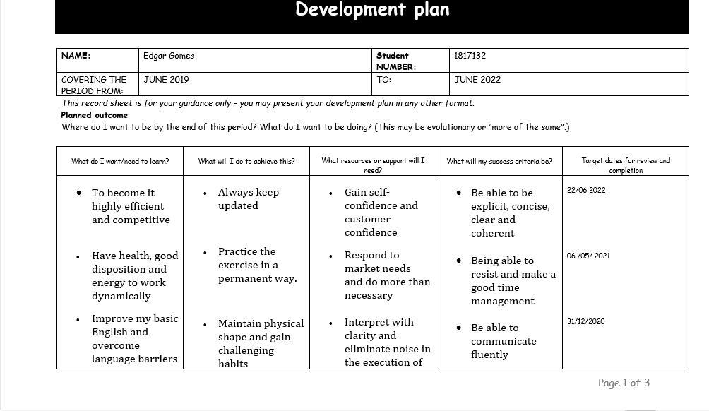
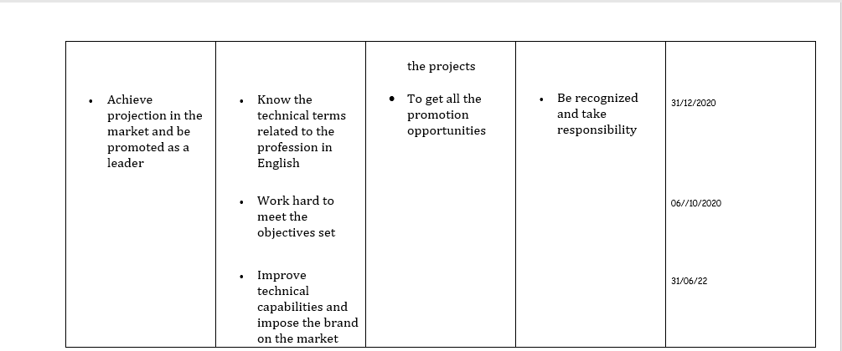

Appendix 2
Lifeline

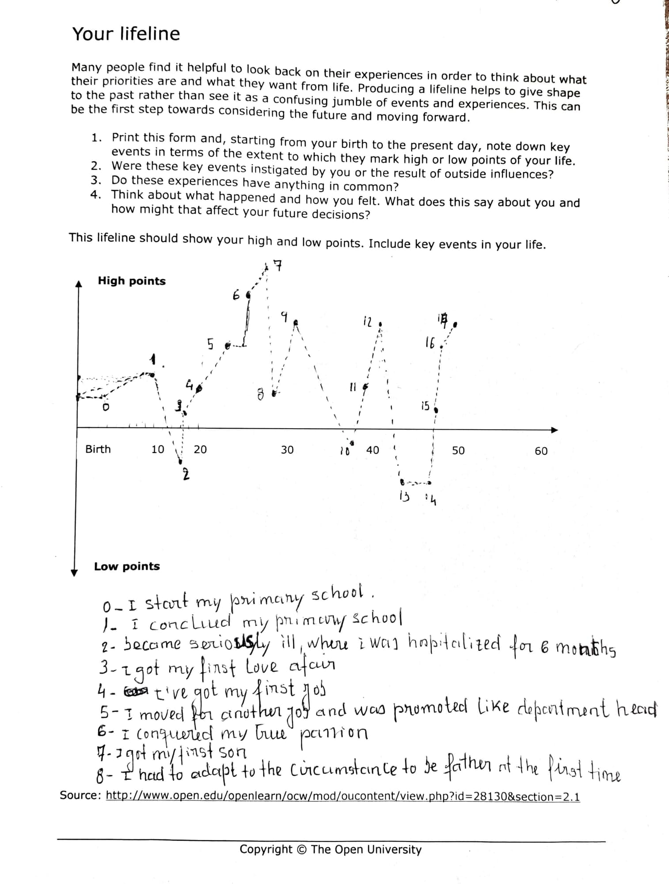
Appendix 3
What Employer Want
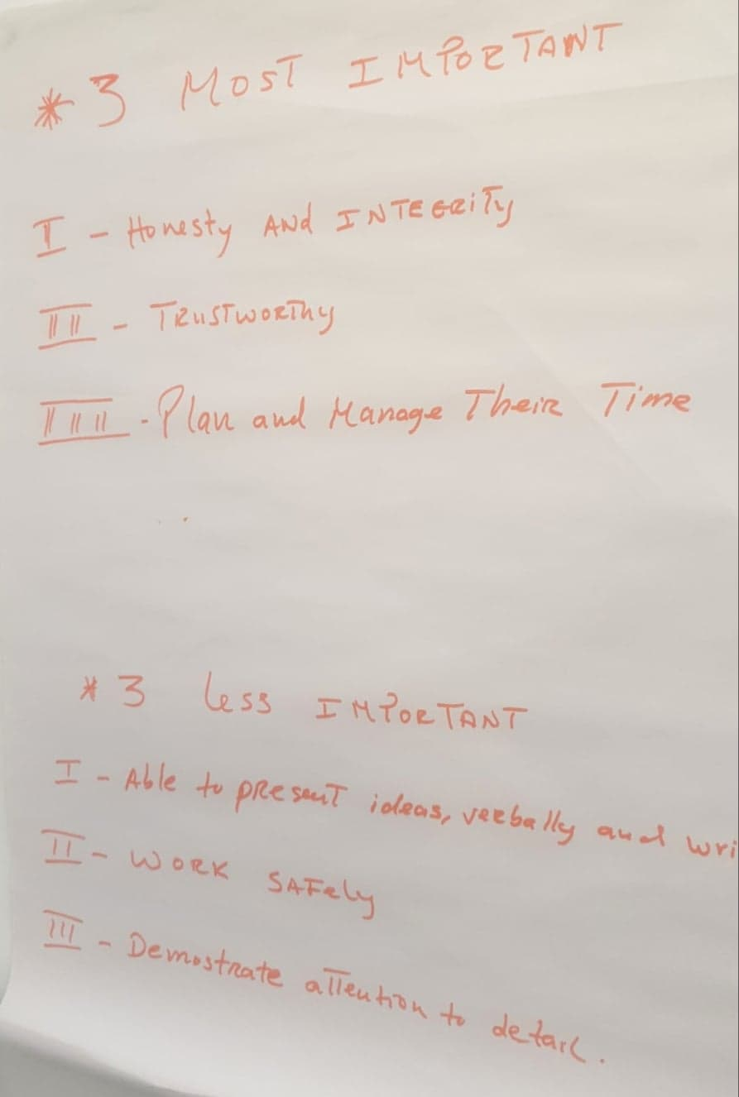

Appendix 3
Job Description

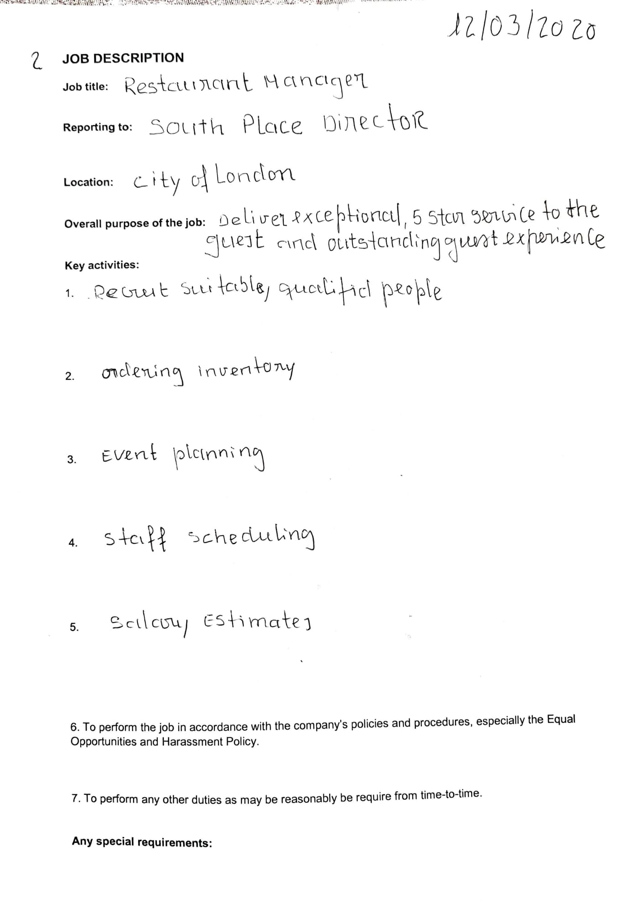
Appendix 4
Force field Analysis
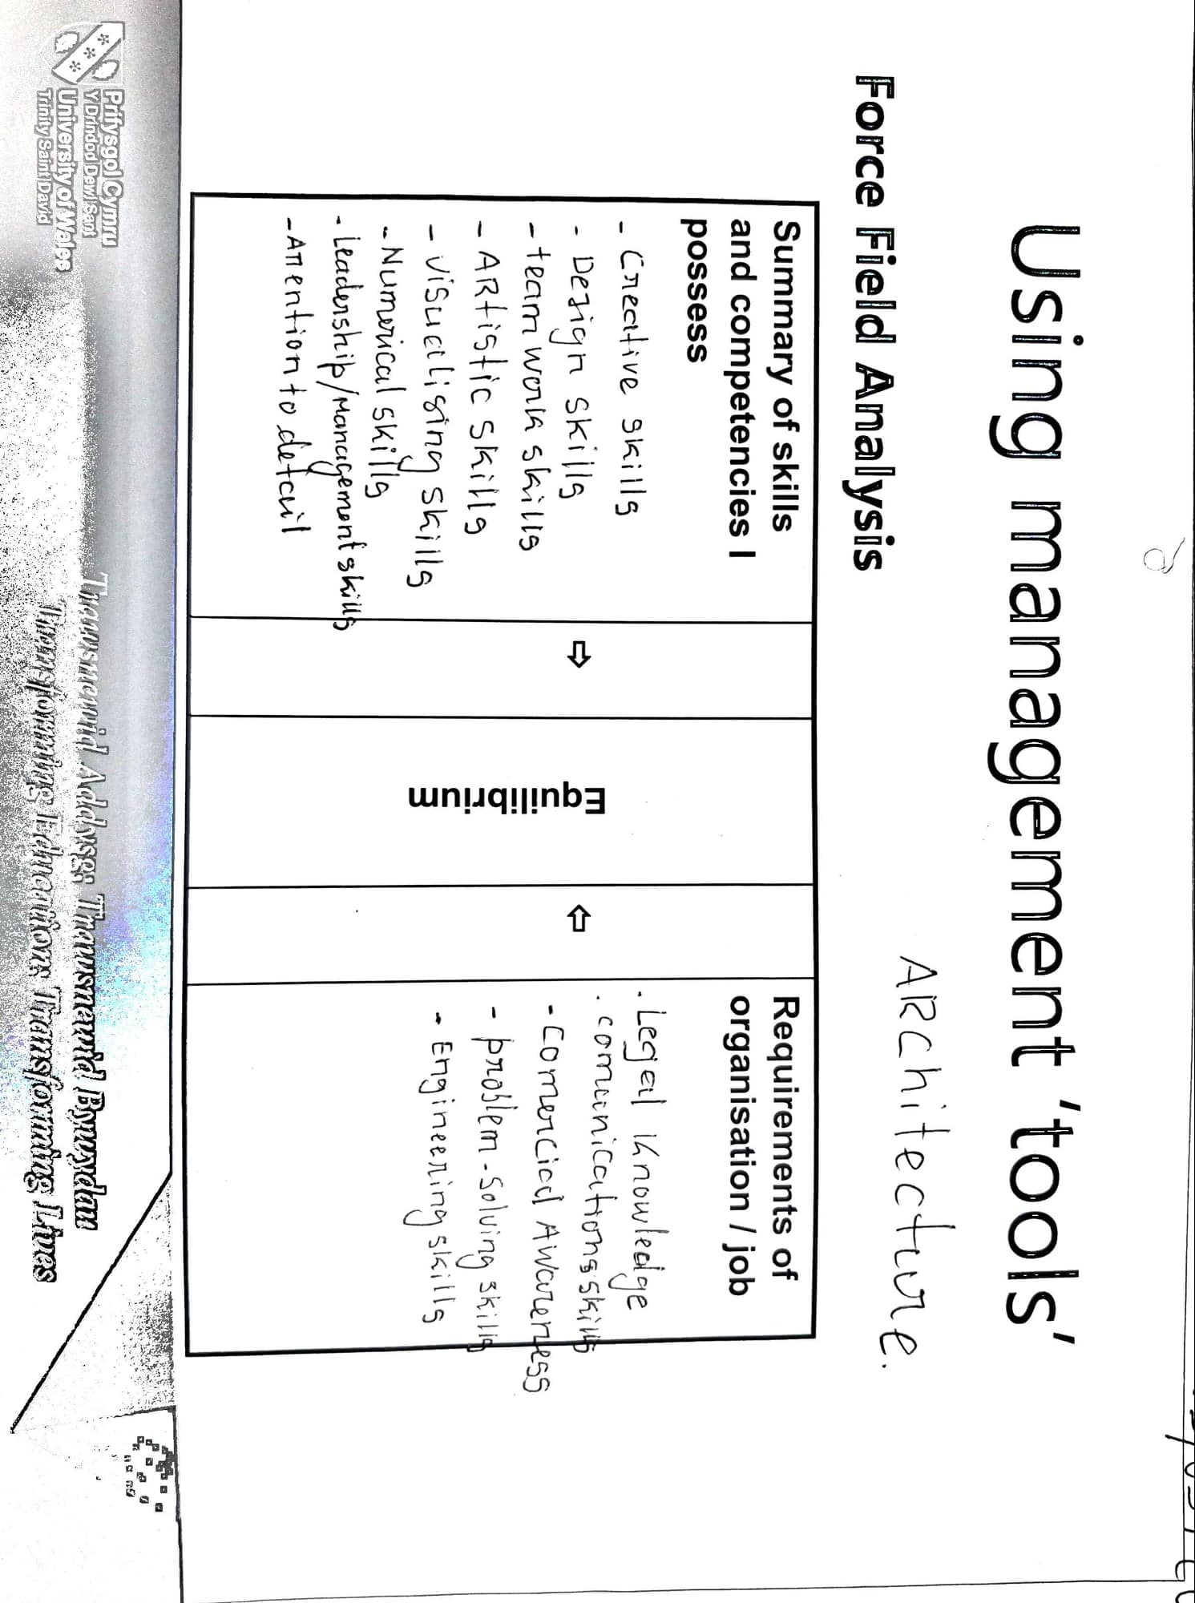

References
https://www.mindtools.com/pages/article/newLDR_41.htm
https://www.google.pt/search?source=hp&ei=-ZCLXtTcJI2hUKjhkPgO&q=leadership+skills&oq=leadership&gs_lcp=CgZwc3kt
https://www.e-konomista.pt/as-5-qualidades-que-os-empregadores-procuram/
(Cottrell, Stella. Skills for Success: Personal Development and Employability, Palgrave Macmillan, 2015. ProQuest Ebook Central, http://ebookcentral.proquest.com/lib/trinity/detail.action?docID=4762723).
(https://www.bing.com/videos/search?q=learning+styles&&view=detail&mid = 88646C1AFD2A1A6DF92388646C1AFD2A1A6DF923 & rvsmid = D686453C79318610C883D686453C79318610C883 & FORM = VDQVAP).
https://nationalcareers.service.gov.uk/job-profiles/architect

