Making use of funerary evidence associated with one individual pre-Roman Iron Age site, discuss how the evidence can be used to identify differences in social status in this community.
The Hallstatt site of Heuneburg, Southwest Germany can identify lots regarding the social status of the community. It is generally accepted within scholarship that the site as a whole contains primarily those of high status, generally referred to as ‘princely tombs’. This work will firstly assess the general patterns across the whole Heuneberg funerary complex, then look at the specific examples of Tumuli 17 and 18, Hohmichele and Bettelbühl to show how social status is identified, and what it shows us about how these social hierarchies manifested themselves.
Generally, the graves at Heuneburg consist of tumulus burials, which mark a visible section of the landscape associated with the deceased. The purpose of this is to tie a particular family or social group to specific parts of the land, perhaps for the use of ancestor veneration. The majority of the central tombs of these tumuli were looted in antiquity, suggesting that these tombs held objects of the highest value and were tombs for the highest status individuals. Overall, these tumuli alone suggest burials of people with very high status. The objects within the tombs can also indicate status, among other factors, such as gender. For example, neck rings are found on bodies of both sexes, showing that they are indicators of status, rather than gender. However, the material of the neck rings can indicate gender, with male bodies found with gold or iron rings and female bodies with bronze rings. It is noteworthy that bronze neck rings are given to subadults, presumably of both sexes, showing that children and women were associated with the same gender markers. This may be an indication that adult men were generally held in a higher regard than women and children, possibly hinting at a ‘aging ritual’ of boys becoming men, or could simply be an indicator of gender roles, rather than hierarchy. There are, however, some artefacts which are gender-specific. For example, weapons as a sign of an elite male. The weapons found in these tombs are generally too elaborate to be practically used for combat, so are likely ceremonial in nature. This shows that the object is specifically intended to be a mark of that individual, or an ‘inalienable object’, an indication of a high status person. The female equivalent to weaponry is ornamental leather belts and head ornaments, which signify a high status female figure. The lack of these gender-specific items could be an indication of being of a lower status to those who are buried with them. Overall, there are more confirmed female burials to those of male burials, with most being not gender-specific. This likely shows that the presence of specifically gendered items was reserved for those in the highest section of the elites.
Two particularly important tumuli are tumuli 17 and 18. They are particularly interesting, as they show two different uses of a tumulus. Tumulus 17 appears to function primarily as a memorial, with evidence of non-burial features, such as charcoal or ash burning, possibly showing its use for ancestor veneration, used between c.600-450BC. The individual in this tomb may have therefore been a particularly important person in his life, holding high status after death as a result of his actions, possibly an indication that people in the earlier stages of the Heuneburg community held status according to their deeds in life and honoured that status through giving later offerings. Tumulus 18, on the other hand, acted primarily as a mausoleum, with 19 graves dating from c.700BC to the early La Tene period, containing people usually buried in pairs around the initial cremation. This shows that tumulus 18 was likely a mound used by the descendants of the initial central cremation, tying their lineage to the tumulus of the original tomb, associating themselves with the person in the centre. Interestingly, tumulus 18 has a disproportionately high female to male ratio, with 4 of the graves containing leather belts, but only one grave containing weaponry. Overall, these graves show that some people’s status passed down their familial line, whereas others were more individual to themselves. Therefore, it can be implied that the Heuneburg community had a mixture of status by merit and status by association.
Another important site is Hohmichele. Although most of the graves were robbed, a sign of high wealth and status, a grave of a man and woman, presumably a couple due to the rich ornamentation of them both. Of particular significance is the presence of imports, particularly the woman’s clothing, made from Chinese silk, which shows links to very distant areas through trade or diplomacy. Although Diodorus states that ‘Celts’ wear elaborate clothing, fabrics of this type were likely extremely rare for the location, presumably giving the fabric extremely high value. Due to this scarcity, it can be inferred that the person wearing the silk was dressed in the tomb in a unique way for the community, therefore the silk becomes an inalienable item associated with the individual, with its scarcity and high value representing a person of high value and status. This tomb shows how the community used inalienable objects as a means of associating high value objects and materials to people of high status.
The final site which will be discussed is mound 4 of the Bettelbühl complex, excavated between 2003-10. The main, central tomb, rather well preserved due to high humidity levels, is that of a 30-40-year-old woman, with grave goods showing her to be of the elite. Similar to the Hohmichele tomb, this grave also contains imports, most notably a bronze chamfron (fig. 3), more commonly associated with the area in today’s Slovenia. This is also likely placed to associate an object of value through scarcity in the area with the subject of the tomb. Also interestingly, this tomb is one of the oldest examples of high status female burials, dating from the 583BC, c.100 years older than a comparable site at Vix. A different grave of a 2-4 year old girl found earlier contains pendants similar to those in the main tomb, showing strong social links and a similar high status which, due to her age, would not have been granted due to actions, but rather due to lineage, presumably from the individual in the main tomb. This shows that as early as the early 6th Century BC, status was largely derived from lineage, marked with objects associated with the family.
Overall, the funerary evidence at Heuneburg shows us that status was granted either through merit, as in tumulus 17, or primarily through lineage, such as tumulus 18 and Bettelbühl, with the latter being marked with inalienable objects associated with their ancestry. It also shows that men, women and children could all be granted an extremely high social status, showing that gender may not have been a determining factor of status, although this is not conclusive. The lack of evidence of low status burials may also be a problem, due to the lack of comparisons available, or it may have been the case that burial in general was reserved for those with high status. In general, the funerary evidence shows Heuneburg to have a highly structured, largely hereditary system of status, marked by associations to objects of value or associated with previous high-status individuals.
Word count: 1340

Appendix
Figure 1: The Iron Age burial landscape surrounding the Heuneburg hillfort. From Gartski et. al., 2015, p. 25.

Figure 2: Tumulus 18 burials designated by the Heuneburg construction phases. From Gartski et. al., 2015, p. 28.
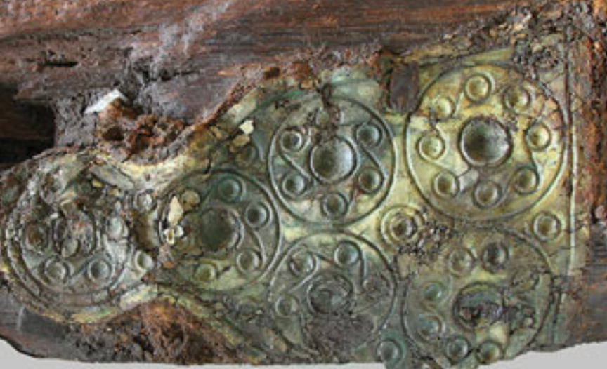
Figure 3: Bronze chamfron from Bettelbühl mound 4. From Krausse et. al. 2017, p. 118.

Ancient Sources
Diodorus Siculus, Philip Freeman (trans.). In: Koch, J. T. & Carey, J. eds., 2003. The Celtic Heroic Age: Literary Sources for Ancient Celtic Europe & Early Ireland & Wales. 4th ed. Aberystwyth: Celtic Studies Publications.

Modern Scholarship
Arnold, B., 2012. Gender, Temporalitis, and Periodization in Early Iron Age West-Central Europe. Social Science History, 36(1), pp. 85-112.
Cuncliffe, B., 1992. The Celtic World. London: BCA.
Fernandez-Götz, M. & Krausse, D., 2013. Rethinking Early Iron Age Urbanisation in Central Europe: the Heuneburg Site and its Archaeological Environment. Antiquity, Volume 87, pp. 473-487.
Frey, O. H., 1991. "Celtic Princes" in the Sixth Century BC. In: S. Moscati, ed. The Celts. London: Bompiani, pp. 75-92.
Garstki, K., Arnold, B. & Murray, M. L., 2015. Reconstituting Community: 3D Visualization and Early Iron Age Social Organization in the Heuneburg Mortuary Landscape. Journal of Archaeological Science, Volume 54, pp. 23-30.
Green, M., 1996. Celtic Art. London: Calman & Sons.
Kimming, W., 1991. The Heuneburg Hillfort and the Proto-Celtic Princely Tombs of Upper Rhineland. In: S. Moscati, ed. The Celts. London: Bompiani, pp. 114-5.
Kovacevich, B. & Callaghan, M. G., 2014. Introduction: Inalienability, Value, and the Construction of Social Difference. Archaeological Papers of the American Anthropological Association, Volume 23, pp. 1-13.
Krausse, D. et al., 2017. The Keltenblock Project: Discovery and Excavation of a Rich Hallstatt Grave at the Heuneburg, Germany. Antiquity, Volume 91, pp. 108-123.
Weiner, A. B., 1985. Inalienable Wealth. American Ethnologist, Volume 12, pp. 210-227.
Weiner, A. B., 1992. Inalienable Possessions. Berkeley: University of California Press.

Green, 1996, p. 73; Cuncliffe, 1992, p. 36; Kimming, 1991, p.p. 114-5; Frey, 1991, p. 80.
Fernandez-Götz and Krausse, 2013, p. 480.
Fernandez-Götz and Krausse, 2013, p. 480; Frey, 1991, p. 78.
Arnold, 2012, p.p. 98-9.
Arnold, 2012, p. 100.
Arnold, 2012, p. 102.
Frey, 1991, p. 81.
Weiner, 1985: p.p. 210-2; Weiner, 1992, p. 3; Kovacevich and Callaghan, 2014.
Arnold, 2012, p. 100.
Arnold, 2012, p.98.
Arnold, 2012, p.p. 97-8.
Garstki et. al., 2015, p. 25.
Garskti et. al., 2015, p.p. 25, 27.
Arnold, 2012, p.p. 100, 106.
Frey, 1991, p. 78; Kimming, 1991, p. 114.
Frey, 1991, p. 80; Green, 1996, p. 73.
Diod. 5.30.
Krausse et. al., 2017, p.p. 113-7.
Krausse et. al., 2017, p.p. 118-9.
Krausse et. al., 2017, p. 120-1; Fernandez et. al. 2013, p. 481.
Fernandez-Götz and Krausse., 2013, p. 480.

