
International business COMMUNICATION
Jewelry company enter the Asian market

November 7, 2019
University of Wales Trinity Saint David

Group 10
Student ID & name:
1900868 &You Lu
1903732& Qin Tian
1903330 &Xu ZiLi
1904658 &Ma YeQIN

Content

1.0 Introduction 2
2.0 Skills and abilities required 2
3.0 The importance of skills for cooperation 3
4.0 Benefits 4
5.0 Possible causes and effects of failure 5
6.0 Conclusion 6
7.0 Reference 7

Introduction

Nowadays the world market is mature, developing international markets and expanding international trade have become the main channels for jewelry companies to develop their business. Due to the gradual saturation of the domestic market, to seek further development, jewelry companies have chosen to shift their target markets to Asia. Therefore, how to reach a cooperative relationship with companies in various Asian countries is a very important issue. The establishment of partnerships needs to be negotiated. Therefore, the skills and abilities of business communication are very important. This article describes the skills and abilities of jewelry companies to develop business relationships with Asian companies and suggests possible obstacles and failures.

2.0 Skills and abilities required

In fact, the difference in language is just a small problem. If we really want to be successful, we need to have a well-known and experienced partner in the Asian market to lead us into the market. So it is very important to build a good relationship with international partners.
I have three different options today, on how to build a relationship with a partner. I will use China as an example.
Firstly, we need to take the right attitude to face cultural differences, to respect and understand the local culture. (Moore,2018)
For example, China is a nation that attaches great importance to giving gifts, and people always express their importance to each other in a gift-giving way. So when we exchange with Chinese partners, we need prepare a gift.
We need to pay attention to some matters when preparing presents and design products. white represents purity in some European countries. But in China, white stands for sadness and poverty. Black is also regarded as unlucky and represents a disaster and darkness. And red. It is a symbol of the celebration, the peace and the love. (Shutterstock,2015)
So, when we choosing a present. We must pay attention to cultural differences. And the gift doesn’t need to be very expensive, but it must be a meaningful present. (Fisher,2007)

Secondly, I think the most important thing between partners is communication. Through communication, we can identify problems in cooperation through effective communication and deal with them in a timely manner. (Barnlund, 2008)
For example, in China, people are very good at discovering, dealing with and discussing problems through communication. I think communication can be divided into three levels.
Firstly, for employees, I think we can establish a channel with Chinese partners.
Then, there can be regular video conferencing between managers.
Finally, frequent meetings between company leaders are conducive to reliable partnerships.
Last，According to Geert Hofstede’s uncertainty avoidance theory.（Hofstede,1991）
From the uncertainty avoidance, leaders of Asian companies, especially in China, they prefer to make terms and rules to restrict employees. so they are not adventurous. But in European countries, such as Britain and France, they are easier to accept new things. So, when we are negotiating with them, our company needs to slow down the progress, especially in the early stages of negotiation, we need to spend lots of time, energy and patience. So, when we work together with Chinese companies, we should respect the way of local companies handle things.

3.0 The importance of skills for cooperation

In international business communication, having excellent communication skills and using communication skills reasonably is very important for the company. In the cross-cultural cooperation and exchange, understanding the cultural background of the partners in advance, and making some solutions to the emergency, etc., are conducive to gaining competitive advantage and international business initiative.（Mashi,2008） Moreover, in cross-cultural exchanges, both parties to exchange hope that the exchange will be smooth and establish a cooperative relationship. However, in cross-cultural communication, due to different cultures, various misunderstandings may occur during the exchange, resulting in the failure to establish a cooperative relationship. Therefore, it is very important for the company to have excellent communication skills and abilities.（Wang，2009）

First, a suitable gift is very important before talking to representatives of multinational companies. A suitable gift can close the relationship with the partner and make the talks have a pleasant start. Even in some cases, it can promote the cooperation between the two parties.（Schultz, B.2006）

Second, proper communication and effective communication are important when communicating with multinational partners. Effective international business communication helps to enhance international exchanges and cooperation between companies and enhance their international competitiveness. At the same time, effective international communication can strengthen the information exchange between enterprises, so that partners can more clearly recognize the effective information of both companies. And through the exchange of information and technology between enterprises, learning the advantages of the other company or introducing the technology of the other company, the company can effectively carry out information dissemination and exchange and technology update and improvement.（Forman, J. 2007）
For example, as mentioned above, communication can be divided into three levels. This is a very effective way of communication for both companies. Because in the cooperation of two cross-cultural enterprises, there will be various problems. For example, the company has a divergence in the timing of a new product launch. The managers of both companies can negotiate solutions through video conferencing.
The video conferencing method is the fastest way to meet the senior leaders of both parties, so that some emergencies can be dealt with as quickly as possible. Therefore, in the cooperation of multinational companies, the way of communication is very important.

4.0 Benefits

I will introduce some of the benefits of developing partnerships with global partners.

Firstly, cooperation is conducive to learning from each other's advanced production techniques. The success or failure of cooperative operation is directly related to the interests of partners. Partners are constantly providing technology and equipment for their own benefit (Jeremy Swan, 2017). This can effectively generate productivity.

Secondly, because of joint operations, our organization can learn the management methods and experience of foreign partners.

Thirdly, our organization uses the sales channels of our partners to develop international markets. This method can increase export earnings. This is directly related to the balance of foreign exchange and the benefits of partners. Therefore, partners may provide their original sales channels to promote their products. This can be used to enter the foreign internal market (Bruna Martinuzzi, 2017).

Fourthly, the partnership helps to manage the partner company. Because the cooperative companies have people from our organization. This can reduce the side effects of excessive foreign capital (Patricia Schaefer, 2019).

Fifthly, our organization can learn about the social, political, and economic conditions of other countries through partners. To increase business and business knowledge. Through the channels of partners, our organization can obtain material procurement, product sales, capital and credit (Charles Mburugu, 2015).

Lastly，through the partnership, our organization can get many benefits. By operating a business with our partners, we can get preferential and support from the government of the partner countries (Fang XiaoZhi, 2016).

5.0 Possible causes and effects of failure

According to Geert Hofstede 's five cultural yardsticks, which are used to measure cultural differences and value orientations in different countries, there are five measures. （Hofstede,1991）
Power distance, Uncertainty Avoidance, masculinity and femininity, Individualism and collectivism, long-term orientation and short-term orientation.
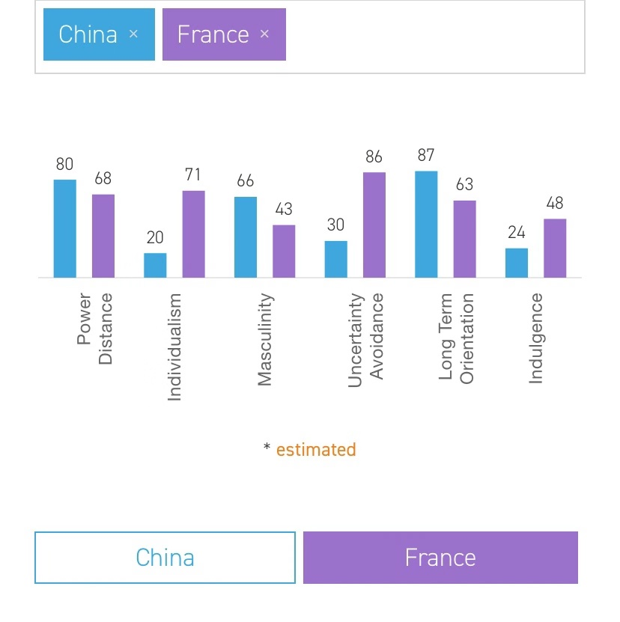
These reasons can lead to a failure of cooperation.

Power distance refers to "the extent to which a society can accept the unequal distribution of power in an organization." (Paul,M.2018)

Individualism refers to a loose social structure, while collectivism is divided into internal and external groups in a close social structure.

The avoidance of uncertainty refers to "the degree of threat a society feels to uncertainty and ambiguity, trying to ensure occupational safety, making more formal rules, and rejecting deviant views and behaviors." (Wiley, Chichester,2000)

Masculinity and femininity refer to the degree of dominance of 'male' values in society. On the contrary, the value of "women" is dominant. (Fritzsche,D,J ,2005)

Long-term oriented culture and society are mainly oriented to the future and pay more attention to the future. Short-term oriented culture and society are oriented to the past and present, focusing on immediate interests and respect for tradition. (Farh, J, Dobbins, G and Cheng, B.1991)
The above five cultural dimensions are likely to lead to the failure of international cooperation.

The impact of partner failure also has the following effects.
First of all, it is not conducive to the friendly communication and development between cooperation. secondly, the company will loss of customers, moreover, the reduction of brand stores, resulting in a decline in profits, is not conducive to the development of the enterprise economy finally, the brand word-of-mouth and the image have negative news

6.0 Conclusion

With the development of economic globalization, the role of cross-cultural business communication is very large. Successful communication is very important to build a partnership. Therefore, understanding different cultural backgrounds is conducive to the normal development of business communication. Moreover, understanding the cultural differences between different countries and adopting appropriate ways to conduct business communication with different companies is the key to successful partnerships. The relevant content and suggestions mentioned in this article can help the jewelry company.

7.0 Reference

1.Barnlund, D.C. (2008). A transactional model of communication. In. C.D. Mortensen (Eds.), Communication theory, 2nd ed., pp. 47–57.

2.Hofstede, G. (2001). “Culture’s consequences: Comparing values, behaviors”, institutions, and organizations across nations, 2nd ed., pp.79-123.

3.Moore,E. (2018), “Understanding Different Cultures: embracing diversity”. Lifelong Learning [Online], http://50atx.statesman.com/understanding-different-cultures-embracing-diversity/, (accessed on 6th November 2012).

4.Shutterstock. (2015). “Symbolism Of Colour And Color Meanings Around The World”. Design Trip [Online] /https://www.shutterstock.com/blog/color-symbolism-and-meanings-around-the-world, (accessed on 6th November 2012).

5.Fisher,J, (2007). Business gifts; A from of non-verbal and symbolic communication. European. Management journal, 14（1），pp. 61-68

6.Jeremy Swan. (2017) The benefits of international partnerships. Available at: https://blog.derby.ac.uk/2017/06/benefits-international-partnerships/ (Accessed: 6 November 2019)..

7.Bruna Martinuzzi. (2017) Advantages and Disadvantages of a Partnership. Available at: https://www.americanexpress.com/en-us/business/trends-and-insights/articles/what-are-the-advantages-and-disadvantages-of-a-partnership/ (Accessed: 6 November 2019).

8.Patricia Schaefer. (2019) The Pros and Cons of Business Partnerships. Available at: https://www.businessknowhow.com/startup/partnership.htm (Accessed: 6 November 2019).

9.Charles Mburugu. (2015) 4 Advantages of Strategic Partnerships. Available at: https://www.careeraddict.com/4-advantages-of-strategic-partnerships (Accessed: 6 November 2019).

10.Fang XiaoZhi. (2016) Significance of developing comprehensive cooperative partners. Available at: http://opinion.china.com.cn/opinion_48_154148.html (Accessed: 6 November 2019).

11.Mashi.（2008）Cross-cultural business communication.University of International Business and Economics Press

12.Wang Jianhua.（2009）Communication skills.Electronic Industry Press

13.Schultz, B. (2006). The importance of gifts in business negotiations. Business etiquette quarterly，69, 407-410.

14.Forman, J. (2007). Effective communication between companies: Finding Waldo. Business Communication Quarterly,70, 369-374.

15.Opsteegh, M. (2008, October). What technical communicators can learn from comics. Techniscribe, 47(9), 1, 6,[Online] ， http://www.ocstc.org/pdf/ts102008.pdf(accessed on 3th November 2012).

16.Farh,J,Dobbins,G and Cheng, B.(1991) cultural relativity in action: a compassion of self-rating made by Chinese and U.S worker personnel psychology, 44(1), pp. 129- 147

17. Hofstede, G, (1991), cultures and organizations, London: McGraw-Hill

18.Wiley, Chichester (2000), C, Gronroos Service management and marketing (2nd edition)

19.Paul,M.(2018),”The Ambiguities of religious freedom in Indonesia” The Review of faith & international affairs, pp.16 (1): 85-96

20Fritzsche,D,J (2005). Business ethics: A global management perspective, new York, McGraw Hill Irwin .

