Marketing Essentials
BMIH 4005 REWORK

REWORK Presentation & Supporting Marketing Plan

Lecturer: Chris Wilkin
Student id: 2212951
Student name: Samuila Georgiana Gabriela
Word count: 1618

This paper is tailored particularly for Raffles Hotels & Resorts, a prestigious global luxury hospitality brand headquartered in Singapore. The purpose of this document is to define effective strategies for increasing brand visibility, customer engagement, and overall brand profitability. The plan functions as a road map that directs Raffles in achieving its business objectives within the specified time frame. This marketing strategy employs a variety of robust frameworks, each offering a unique perspective and serving a distinct function. These include the SOSTAC framework, which outlines a comprehensive approach to planning, the Marketing Mix model, which guides on the product strategy elements, and Bowman's Strategy Clock, which helps us comprehend competitive positioning. In addition, it will be employed the 5 'C's framework for the situation analysis, which will incorporate a comprehensive view of the Company, Customers, Competitors, Collaborators, and Climate.
Firstly, Raffles Hotels & Resorts primarily targets wealthy individuals and high-end business travellers from all over the world. The primary customer profiles consist of seasoned globetrotters who value bespoke luxury services, high-level executives conducting business meetings, and families seeking exceptional and luxurious vacation experiences. Generation X (aged 40-55) with a high disposable income and Millennials (aged 25-39) with a taste for luxury travel and distinctive experiences make up the majority of Raffles' customer base (Similarweb, 2023). Raffles maintains its reputation as an iconic luxury hospitality brand by strategically targeting these customer profiles with individualised and high-quality service offerings (Jobber and Ellis-Chadwick, 2020).
Furthermore, Raffles Hotels & Resorts competes with The Ritz-Carlton, Four Seasons Hotels & Resorts, and Mandarin Oriental in the high-end luxury segment (SimilarWeb, 2023). Using Bowman's Strategy Clock as a lens, Raffles adopts a 'Differentiation Focus' strategy. It endeavours to provide exclusive, unmatched luxurious experiences to justify its premium pricing (Jobber & Ellis-Chadwick, 2020). In contrast to its competitors, who may incline towards cost leadership or cost-based differentiation, Raffles uses its long-standing heritage and personalised service to differentiate itself in the luxury hospitality market, thereby reinforcing its distinct brand positioning (Bowie et al., 2017).
As part of the Accor Group, Raffles Hotels & Resorts engages in a number of strategic partnerships to enhance its luxury offering. Key partnerships include global airline companies for mutual loyalty programme benefits, such as Air France KLM's 'Flying Blue'. This partnership enables them to target affluent travellers, an important consumer segment (Kotler et al., 2020). In addition, they collaborate with luxury brands in the wellness and lifestyle industries to enhance visitor experiences. (Bowie et al., 2017) The franchising model of Raffles enables expansion into new markets while maintaining service standards. In addition, business-to-business relationships with event management firms and luxury travel agencies contribute to customer acquisition and occupancy rates (Ryan, 2012).
Also, the marketing mix of Raffles Hotel & Resorts consists of four essential elements such as product, price, place, and promotion (Smith & Zook, 2020). In terms of the product, Raffles provides a variety of opulent accommodations and services, including spas, exquisite dining, and exclusive cultural experiences. Their properties are situated in prime locations and are designed with distinctive architectural elegance, offering a distinctive combination of history, culture, and luxury that makes each stay unforgettable (Ghauri, 2014). Moreover, Raffles, being a prestige brand, utilises a premium pricing strategy. The high price of accommodations and services reflects the superior quality, exceptional service standards, and one-of-a-kind experiences offered at Raffles' properties (Kotler & Kartajaya, 2017). At the same time, Raffles hotels are strategically positioned in key global destinations, including Paris, Singapore, Seychelles, and many others. In addition, the company optimises its digital presence with an interactive and user-friendly website where customers can research hotels, make reservations, and access personalised services (Chaffey & Ellis- Chadwick, 2019). In terms of promotion, Raffles employs both traditional and digital marketing strategies for promotion. It takes advantage of public relations, event sponsorship, print and broadcast media, and collaborates with luxury travel agencies. Raffles has increased its emphasis on digital marketing in recent years, leveraging its website, email newsletters, and social media platforms to reach a global audience and provide customised content and offers (Ryan, 2012).
In accordance with Jobber and Ellis-Chadwick's (2020), the primary objective of the marketing plan for Raffles Hotels & Resorts should be to strengthen customer loyalty and increase digital engagement. Specific SMART objectives for the next 12 months include a 20% expansion of the loyalty membership programme and a 10% increase in the engagement rate across all social media platforms. By utilising key performance indicators such as new loyalty programme enrolments, engagement rates, likes, shares, and comments on social media platforms, progress will be monitored. This strategy guarantees a balanced emphasis on customer retention and digital presence, both of which are crucial to Raffles' success in the modern hospitality industry (Housden, 2008).
Furthermore, Raffles Hotels & Resorts will shift its value proposition to "Creating Unforgettable Luxury Experiences." The goal is to infuse every consumer touchpoint with personalised, bespoke experiences, redefining luxury in the hospitality industry. In accordance with Ansoff's Matrix, the recommended strategy is market development (Clow and Baack, 2013). Thus, the intention is to expand Raffles' luxury offerings to emerging markets, particularly the affluent class in Asia's expanding economies. The marketing formulation will be modified to support this strategic shift. Raffles will enhance its 'Place' strategy by leveraging digital platforms for booking, providing virtual tours of its properties, and facilitating online customer service, while maintaining its premium pricing (Smith & Zook, 2020). The 'Promotion' strategy will emphasise the unique experiences provided by Raffles, with an emphasis on online and social media marketing.
Moreover, the brand will use the RACE strategy to achieve the SMART targets and reposition Raffles as the top of individualised luxury experiences (Smith and Zook, 2020). This entails improving the marketing mix and streamlining the communication mix. Firstly, by making its website SEO-friendly, implementing geo-targeted PPC advertising, and boosting its social media presence, Raffles will broaden its reach (Kotler and Kartajaya, 2017). Additionally, it will interact with luxury travel bloggers and influencers to increase its exposure to the affluent class in emerging economies. Secondly, the website will be updated to include interactive elements such as virtual tours and real-time chat support in an effort to promote interaction. Customers will also receive customised emails depending on their choices and conduct (Hartemo, 2016). Thirdly, the brand will concentrate on improving the user experience on its booking platform, providing direct bookers with perks from its loyalty programme, and creating customised offers to tempt new clients. Lastly, to increase client loyalty, Raffles will foster relationships by sending members of its loyalty programme premium, tailored post-stay communications and special offers. To promote additional involvement, client stories and experiences will be shared on social media sites (Ryan, 2012). However, Raffles will not significantly alter its pricing structure in terms of the marketing mix, preferring to strengthen the value offer in order to support its premium pricing. Digital platforms and collaborations with luxury travel agents will improve distribution. Also, the product line will be enhanced with custom experiences and services. While promotional initiatives will change to highlight content marketing and digital media while emphasising storytelling and user experiences (Tracy, 2014). As a result, Raffles may effectively communicate its new value proposition, build its reputation, and accomplish its strategic goals by concentrating on these strategies.
In addition, to effectively execute the RACE model, a phased approach utilising multiple marketing channels will be implemented throughout the year. For instance, in Q1, Reach will be the primary focus. Thus, primary focus will be on SEO optimisation, PPC campaigns, and social media expansion (Website Traffic, Click-Through Rate, Social Media Followers as Metrics). In the second quarter of the Act phase, website enhancements and personalised email campaigns will be rolled out (KPIs: Bounce Rate, Time-on-Site, Email Open and Click Rates). In Q3, the Convert phase will take centre stage as the booking platform is optimised and loyalty promotions are launched (KPIs: Conversion Rates, Direct Bookings).In the fourth quarter, the focus will be on the Engage phase, which includes post-stay communications and social media storytelling (KPIs: Customer Retention Rate, Social Media Engagement).
As suggested by Jobber and Ellis-Chadwick (2020), measuring achievement will require monitoring a mixture of metrics in accordance with SMART objectives and the RACE model. For each phase, particular KPIs have been chosen. During the Reach phase, success will be determined by website traffic, click-through rates (CTR) of PPC campaigns, and social media follower growth. Included in the metrics for the Act phase are bounce rate, duration on site, and email open and click rates. Key indicators for the Convert phase are conversion rates and direct bookings, whereas for the Engage phase, it will be tracked customer retention and social media engagement (Marr, 2012). These metrics provide a comprehensive view of the quantitative (traffic, conversions) and qualitative (engagement, time-on-site) aspects of the campaign's success (traffic, conversions, engagement). This method will aid in comprehending the effectiveness of the strategies, enlighten any necessary adjustments, and guarantee that everything is on track in achieving Raffles goals (Ghauri, 2014).
In conclusion, this marketing strategy for Raffles Hotels & Resorts aims to increase the brand's visibility, enhance customer engagement, and increase profitability. The strategy hinges on a refined approach to consumer segmentation and targeting, a well-rounded competitive perspective, and the utilisation of strategic B2B relationships. The plan is centred on enhancing the brand's digital presence and optimising its marketing blend. Using the RACE model, SMART objectives, and Ansoff's Matrix, the strategy aims to redefine Raffles' value proposition and achieve measurable expansion. Various KPIs that correspond to each stage of the RACE model will be used to evaluate the plan's effectiveness. This strategy may facilitate Raffles' evolution in accordance with dynamic market trends and customer preferences, thereby strengthening its position as a market leader in luxury hospitality.

References

Accor (n.d.). Accor - Discover Raffles. [online] Available at: https://group.accor.com/en/brands/luxury/raffles.
Bowie,D. Buttle,F. Brookes,M & Mariussen,A (2017), Hospitality Marketing. 3rd ed, Routledge, London
Chaffey, D and Ellis- Chadwick, F. (2019) Digital Marketing. 7th ed, Pearsons, London
Clow, K & Baack, D (2013), Integrated Advertising, Promotion and Marketing Communications. 6th ed, Pearson, London
Ghauri, P N (2014) International Marketing, 4th Ed, McGraw Hill, London
Hartemo, M., 2016. Email marketing in the era of the empowered consumer. Journal of Research in Interactive Marketing.
Housden M (2008), Marketing Research & Information, Butterworth Heinemann, Oxford.
Jobber, D. and Ellis-Chadwick, F (2020), Principles and practice of marketing. 9th ed. London:
Kotler,P and Kartajaya, H. Marketing 4.0 Moving from Traditional to Digital (2017) Wiley. New York
Kotler, P., Armstrong, G., Harris, L. and He, H., 2020. Principles of marketing. 8th European ed, London: Pearson Education Limited.
Marr, B. (2012). Key Performance Indicators (KPI): The 75 measures every manager needs to know. [online] Google Books. Pearson UK. Available at: https://www.google.co.uk/books/edition/Key_Performance_Indicators_KPI/WleQ-F6WC3sC?hl=en&gbpv=1&dq=kpi&pg=PT24&printsec=frontcover.
Ryan, D. (2012) Understanding Digital marketing: Marketing Strategies for Engaging The Digital Generation. Kogan Page, London.
SimilarWeb (2023). Website Performance. [online] secure.similarweb.com. Available at: https://pro.similarweb.com/#/digitalsuite/websiteanalysis/overview/website-performance/.
Smith PR & Zook ZE (2020) Marketing Communications. 7th ed, Kogan Page, London
Tracy, B. (2014). Marketing (The Brian Tracy Success Library). [online] Google Books. AMACOM. Available at: https://www.google.co.uk/books/edition/Marketing_The_Brian_Tracy_Success_Librar/4WB7AwAAQBAJ?hl=en&gbpv=1&dq=tracy+2014+marketing&pg=PP1&printsec=frontcover [Accessed 16 May 2023].
‌

Appendix
- SWOT analysis

Strengths | Weaknesses
- With a heritage dating back to the 19th century, Raffles Hotels & Resorts possesses a strong reputation for luxury and exceptional service (Accor, n.d.)  - Raffles has established its reputation on the provision of superior services, such as upscale lodging, gourmet dining, spas, and other luxury offerings (Kotler et al., 2020))  - Raffles properties are situated in some of the world's most desirable locations, including Paris, Seychelles, Singapore, and others.  - Raffles is a subsidiary of Accor Group, the world's foremost hotel group, which provides financial stability and strategic support. | - Raffles's high-end focus exposes the brand to the volatility of the luxury market segment, which is susceptible to economic fluctuations (Bowie et al., 2018).  - While the high price reinforces the luxury positioning of the brand, it may deter price-conscious customers.  - Although Raffles has a presence in major locations, its global footprint is limited in comparison to that of some of its competitors (Jobber and Elis-Chadwick, 2020).
Opportunities | Threats
- Raffles can explore expansion opportunities in rapidly growing economies like China and India, where demand for luxury hospitality is rising.  - Investing in digital marketing, online customer service, and digital partnerships can increase consumer engagement and brand visibility through digital transformation (Ryan, 2012)  - Luxury consumers increasingly value sustainability. Raffles can leverage on this trend by incorporating and effectively communicating more sustainable practises. | - The prestige hospitality market is extremely competitive, with brands such as Four Seasons, The Ritz-Carlton, and Mandarin Oriental posing formidable challenges.  - Due to its reliance on the luxury market, global economic instability or recessions can negatively impact Raffles' business.  - Changing customer trends and preferences necessitate constant innovation in the hospitality industry to maintain customer interest and loyalty (Tracy, 2014).

- PESTLE analysis
Political | - International travel policies can affect the number of travellers.  - Political instability and restrictive visa policies can reduce the number of tourists visiting a destination, thereby affecting occupancy rates.  - Laws and regulations pertaining to hospitality operations, labour, and taxes in various countries can have an impact on Raffles Hotels' operational efficiency and profitability.
Economic | - Economic recessions or financial crises can reduce consumer expenditure on luxury travel, which impacts Raffles' revenue.  - Since Raffles operates in multiple countries, fluctuations in exchange rates can have an impact on the company's expenses and revenues.
Social | - Trends like wellness tourism, ecotourism, and experiential travel can impact consumer preferences. Raffles must adapt to these shifting preferences in order to remain competitive.  - The emergence of Millennials and Generation Z as significant consumer segments with distinct preferences, such as digital convenience, may have an effect on Raffles' marketing strategies.
Technological | - Technology advancements present opportunities to enhance customer service, reservation systems, and marketing initiatives.  - The utilisation of data analytics can assist Raffles in better comprehending customer behaviour and customising its offerings.
Legal | - As a global company, Raffles must comply with numerous data protection laws, including the GDPR in Europe.  - Compliance with health and safety laws is essential, especially in view of the COVID-19 pandemic.
Environmental | - Consumer and regulatory pressure on businesses to operate sustainably is increasing. Raffles can capitalise on this trend by instituting and promoting eco-friendly practises.  - Changes in climate patterns can have an impact on the allure of certain destinations, thereby influencing the demand for Raffles' properties in these areas.

- Perceptual map
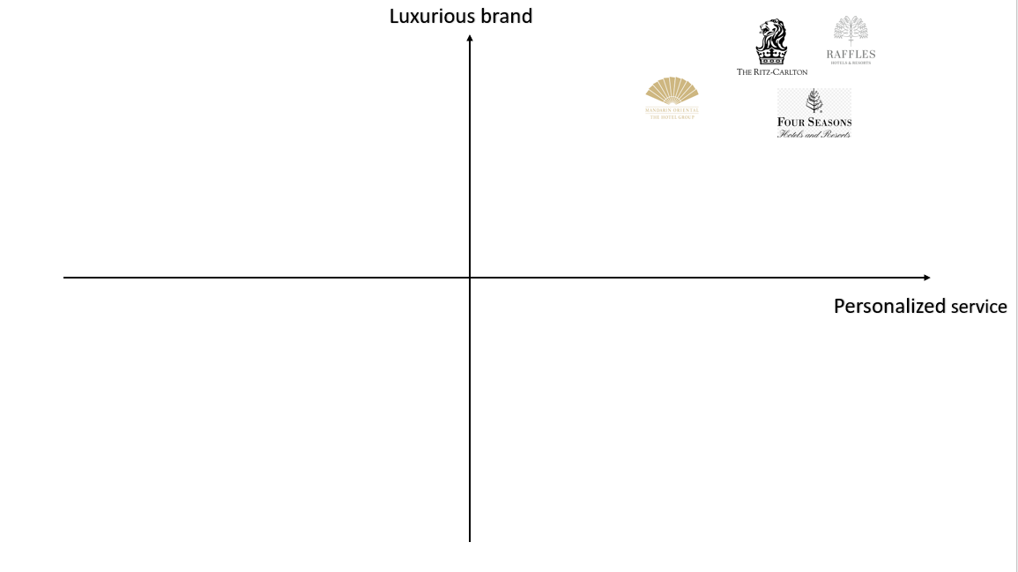

- Gannt chart
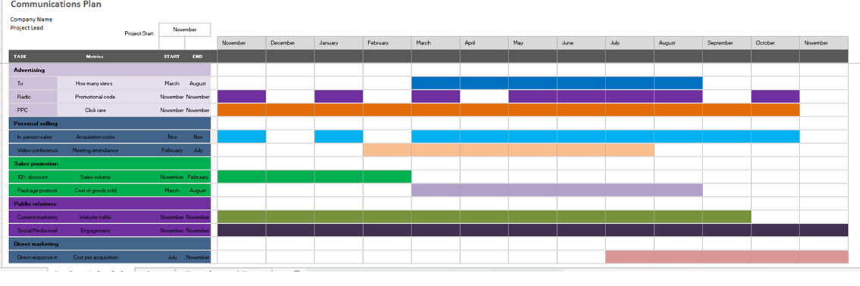

- Presentation



