Title: Reflections of Light
Student Name: Alesia Tatlow
Student Number: 2501593
Programme of Study: Graphic Design
Module: Ways of Percieving ADDA4023/C
Word Count: 1511 words
Course Tutor- Donna Williams
Task: Curate an exhibition

This exhibition has been curated to study the era of French Impressionism, its beginning, end, the meanings behind it, and it’s influence on art both at the time and in the future. It explores how the impressionists challenged the exploration of art at the time: changing perspectives on what art could be and challenging how people thought about art at the time. Scenes of everyday life weren’t something regularly painted at the time, but art was a part of everyday life, that represented all sorts of things. “Art and life are here so closely interwoven, so inseparably bound up with one another, that we cannot attempt to describe them separately, as is so often done in monographs on artists” (Uhde, W. 1970) This quote replicates the view on art at the time, as the impressionists using scenes of everyday life in their work were very highly criticised. In comparison to the impressionists, who didn’t follow the crowd when it came to the art scene in 19th century France, painting landscape scenes focusing on light and its reflections, they weren’t taken seriously at it wasn’t a style that had been seen before. “In the eyes of the art establishment, however, the quality of the work was irrelevant, produced by dabblers who did not deserve to be considered real artists. The impressionist movement was important because it challenged this way of thinking.” (Hirschmann, K. 2015)
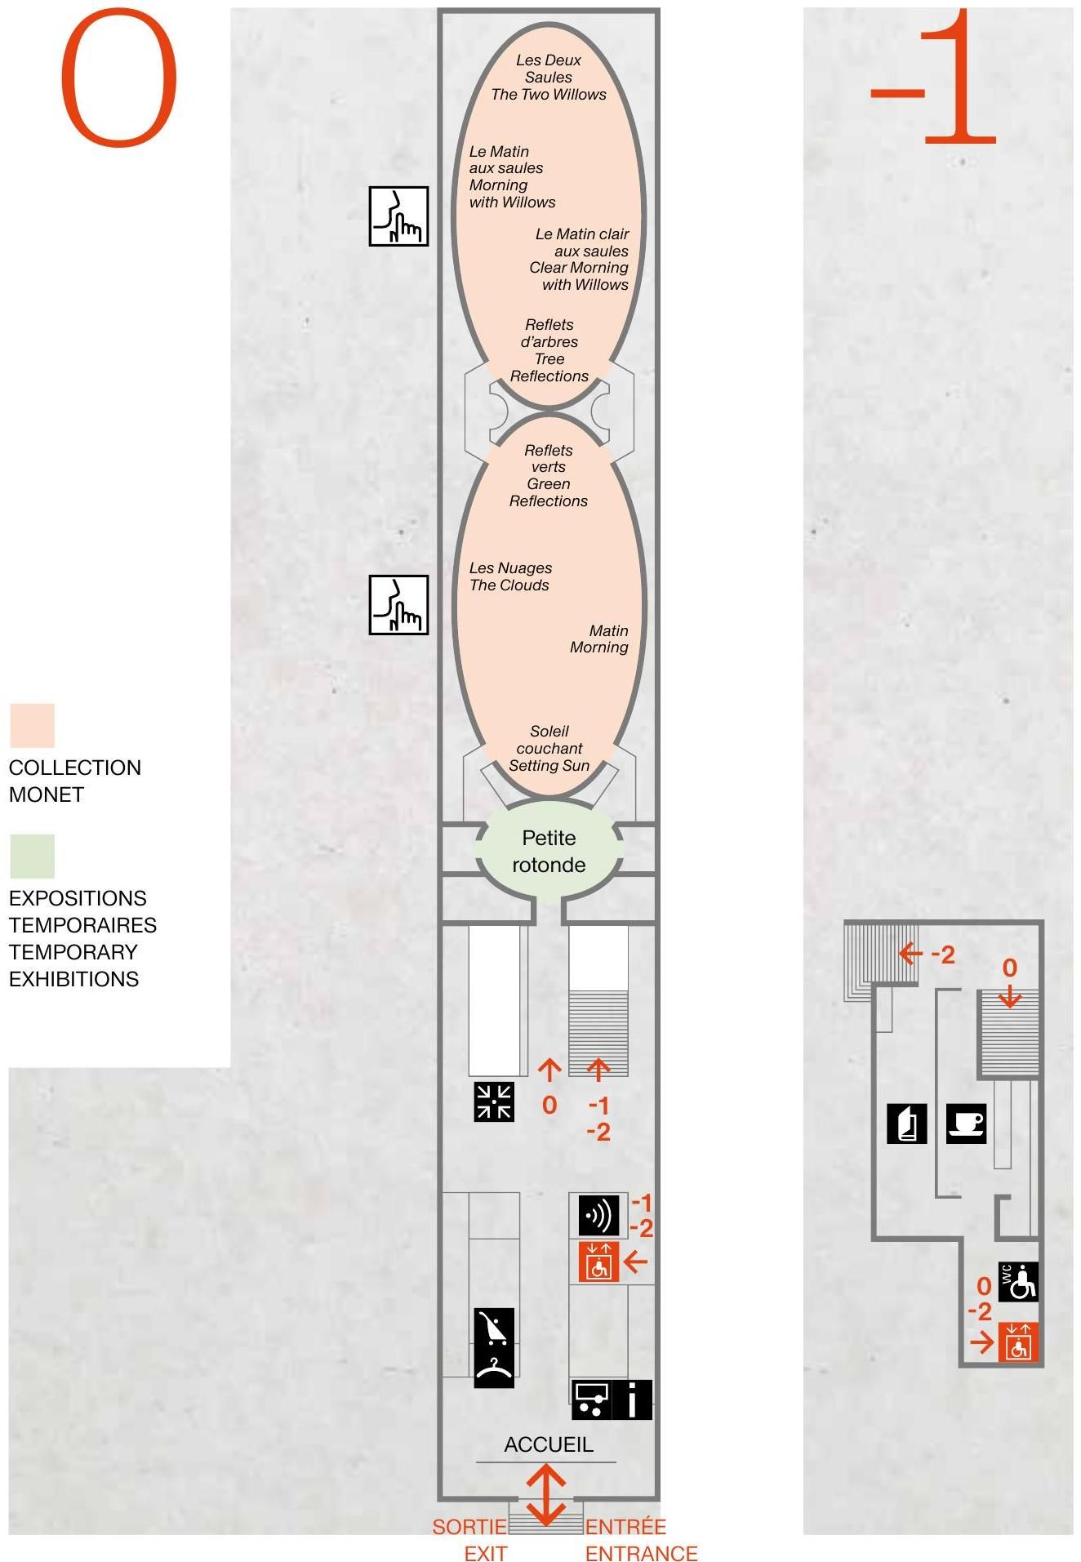
Figure 1 (Camille Gharbi, Musée de l’Orangerie map)
This exhibition will be showcased in the Musee l’orangerie, as a reference to Claude Monet, the beginning of the impressionist era, with his piece that inspired the name. The Musee l’orangerie has circular rooms specifically meant to sit and take in and contemplate the pieces, which is perfect for an exhibition of this theme, as it allows people to see the hardships, struggles, life experiences and things that these pieces represent, especially with social issues at the time. The Musée de l’Orangerie is an important place for impressionism as it is where Monet decided his work was going to be displayed, and it is a well-known gallery for displaying plenty of pieces of work from the impressionists, as well as Paris being known as the city of light, and the birth places of impressionism, which links in nicely to the exhibition title.

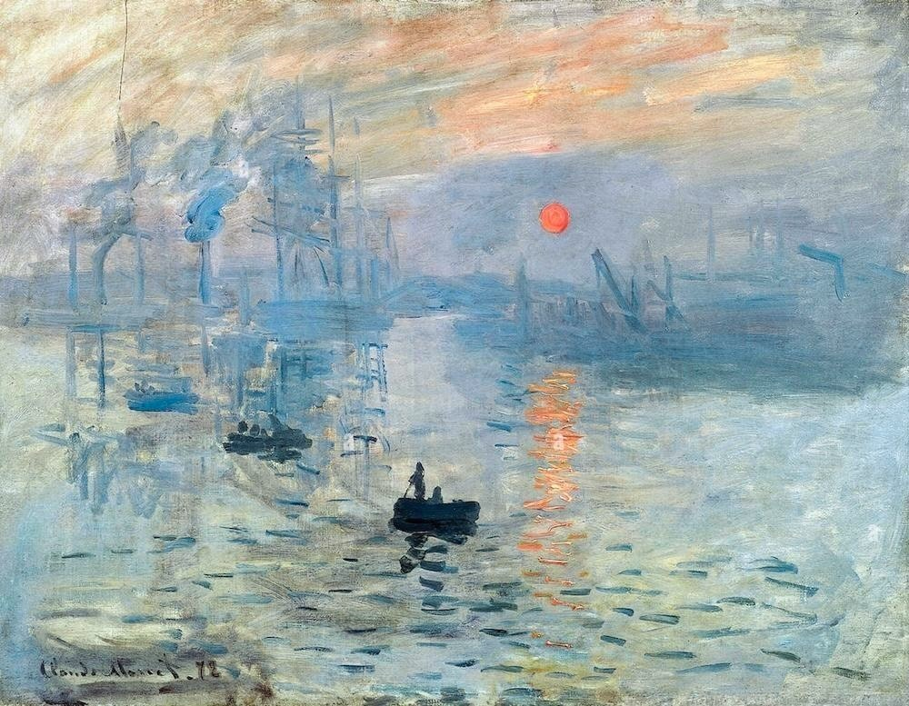
Figure 2 (Claude Monet, 1872, Impression Sunrise)
Claude Monet was the leader of the impressionists, with the name coming from the creation of this piece, largely being called the start of the impressionist era, being shown in the first ever impressionist exhibition they created. Monet came into creating landscapes from an artist he took great inspiration from as a teenager: Eugene Boudin, who encouraged him to paint ‘en plein air’ this really stuck with Monet. “Suddenly a veil was torn away. I had understood- I had realised what painting could be. By the single example of this painter devoted to his art with such independence, my destiny as a painter opened out to me” (Haynes, D. 2019) This piece represents the beginning of a new era in art, one that was not very well received in France at the time, as it challenged other work that was being created, and the way feelings were reflected in the work was very different. “The impressionist artists were not trying to record every detail of the scenes they painted. Rather, they were trying to capture fleeting moments in time. They were fascinated by the way different types of light, shadow and colours interacted with objects.” (Hirschmann,K. 2015) Impressionism was largely created as a way to showcase these moments in time.
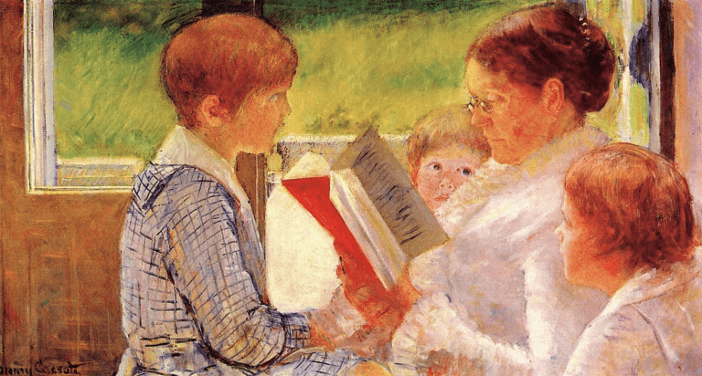
Figure 3 (Mary Cassatt, 1880, Mrs Cassatt reading to her grandchildren)
Impressionism also allowed for women to be more represented within art, as social standards in 1800s France highly restricted them. This was an important piece as it was during a time when “not many women pursued careers as artists, Cassatt was a professional who became recognised and celebrated around the world” (Morlock, R. 2019) Cassatt’s work was based on the reflection of light indoors, in more domestic scenes, which allowed for a view into the lives of women at the time, as unlike the male impressionists, female impressionists like Mary Cassatt and Berthe Morisot mostly painted scenes of children and things which were seen as essential for a women’s role, giving a new light into everyday life. This piece shows the same flowy strokes used in Monet’s work but uses a different form of light to showcase scenes of everyday life, with Monet’s focusing on catching the last ray of light from the sunset, partly focusing on twilight, with Cassatt’s focusing on a brighter midday sunlight streaming in through the window with light rays bouncing all through the room.
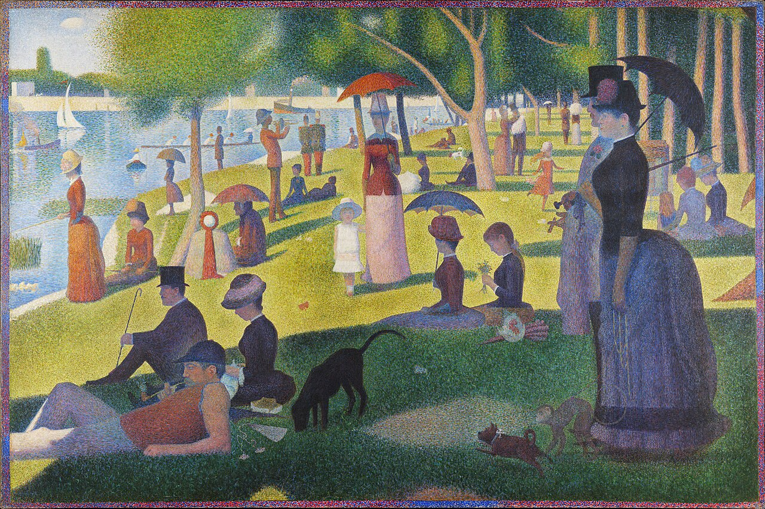
Figure 4 (Georges Seurat, 1884, A Sunday Afternoon on the Island of La Grande Jatte)
Seurat’s painting was part of the final impressionist exhibition in 1886, marking the move from impressionism to post impressionism. “La Grande Jatte was described by both admirers and critics as possessing the quality of emitting light” (Verhaeren,E. 1891) This piece showcases the reflection of the light coming through the trees, creating shadows behind people, highlighting the soft and calm feeling of a regular sunny day out to a park. George Seurat is often applied to the Neo impressionism period in the impressionism era. The Neo impressionism era marked a split in the thought process of impressionists, with George’s Seurat being a continuation and evolvement of Cezanne’s work as a post-impressionist. “In 1884, at the Salon des Independants in Paris, Georges Seurat revealed an intention similar to Cezanne’s with paintings that showed more attention to composition than did those of the Impressionists and that delved into the science of colour. Taking as a point of departure the Impressionist practice of using broken colour to suggest shimmering light.” (Britannica Editors. 2026)
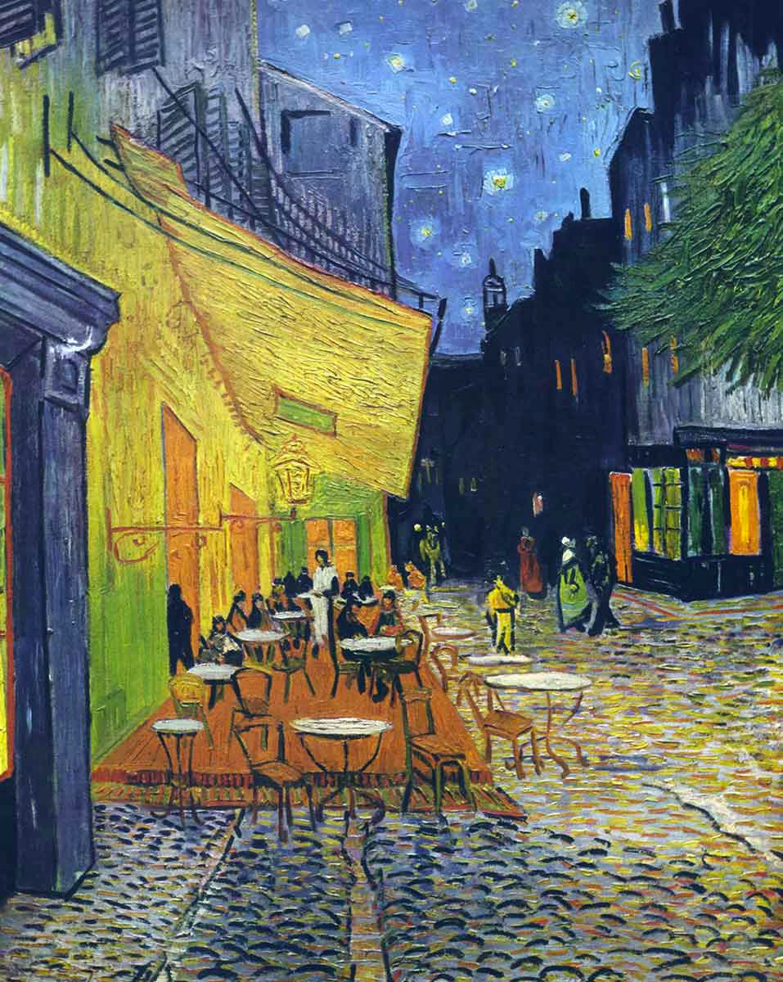
Figure 5 (Van Gogh, 1888, Café Terrace at Night)
Van Gogh was largely towards the end of impressionism, more part of the post impressionism era of the timeline, however, impressionism formed a new insight into art for him. “Here were revelations for him: light, colour, a new technique” (Uhde, W. 1970) It can be perceived that Van Gogh was another period of impressionism, as he used their techniques, “both being inspired by the same Japanese school. He loved passionately the things themselves. They liked brightness. He was a fanatical worshipper of the sun. That was something different, something deeper.” (Uhde, W. 1970) He was fascinated with the reflection of the sun, as recognised later with his sunflower paintings. But his inspiration came from the techniques used by the impressionists, largely looking at lights of all sorts, café lights, stars, how they twinkle, street lights, he showed the renovated Paris and the beauty that could be seen in the world in scenes that were normal to people, but there was a quiet calm that was represented in the night scenes he painted.
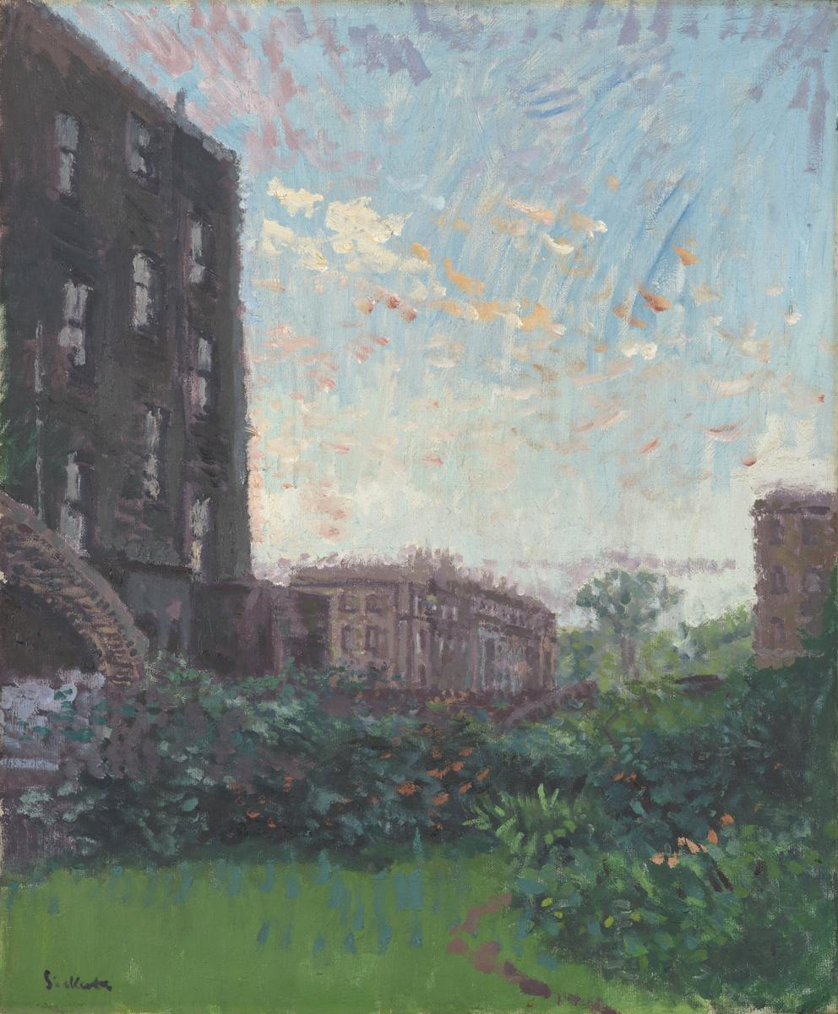
Figure 6 (Walter Sickert, 1910, Rowlandson House Sunset)
Walter Sickert represents British impressionism, showing the popularity of the movement with its transfer to other countries. Sickert focused on the pale sunrise light of dawn created by the rising sun, giving that feeling of peace and tranquillity, focusing on the little moments that are often improved by the way the light is at that moment in time. Sickert himself spoke about the changes that Impressionism made: “I have said that the impressionists have added two things to the language of painting, and I have named one, enlargement of the possibilities of composition. Their second gift has been an enlargement equally extensive and important of the understanding of colour, especially in the shadows.” (Sickert, 1910) This shows his admiration for their techniques and highlights the importance of his piece into bringing impressionism into Britain, showing the changes that impressionism has made to the art scene everywhere. Its changed how art is viewed, what was originally seen as important in art at the start of the impressionist era has now changed to incorporate many different styles of art.
The exhibition of these pieces is to highlight the changes that impressionism made at the time in the terms of ways of thinking in art, and how it changed what art could be, and how it influenced art in the future. “In the 20th Century, Monet’s work influenced artists who painted styles such as Cubism, Surrealism and Abstract Expressionism. Thus, Monet laid the foundations for modern art whilst creating unmatched visions of beauty that are among some of the most popular fine art images in the world today.” (Haynes, D. 2019) This quote doesn’t just represent Monet, all the artists involved in impressionism are widely popular today, all having an impact on modern art and keeping landscape paintings alive, some continuing that reflection of light off different surfaces.
The important meaning behind this exhibition is to note how they used the light to express important things and emotions in the pieces, highlighting the emotions of everyday life and things that were seen as normal at the time, and scenes that made people angry as it was seen as something that wasn’t meant to be painted, as if paintings at the time had to be this fake version of reality of how people and the artists included wanted it to be, whereas the impressionists painted scenes that were more realistic to the time period, and that was heavily criticised.
List of Figures
- Figure 1: Camille Gharbi, Musée de l’Orangerie map,
- Figure 2: (Claude Monet, Impression Sunrise, 1872, Available at: https://www.claude-monet.com/impression-sunrise.jsp)
- Figure 3: Mary Cassatt, Mrs Cassatt reading to her grandchildren, 1880: Available at: https://www.marycassatt.org/Mrs-Cassatt-Reading-To-Her-Grandchildren-1888.html
- Figure 4: Georges Seurat, A Sunday Afternoon on the Island of La Grande Jatte, 1884, Available at: https://www.artic.edu/artworks/27992/a-sunday-on-la-grande-jatte-1884
- Figure 5: Van Gogh, Café Terrace at Night, 1888, Available at: https://www.vangoghstudio.com/cafe-terrace-at-night-by-vincent-van-gogh/
- Figure 6: Walter Sickert, Rowlandson House Sunset, 1910, Available at: https://www.tate.org.uk/art/research-publications/camden-town-group/walter-richard-sickert-rowlandson-house-sunset-r1139032
Bibliography
- Britannica Editors (2026) Post Impressionism. Available at: https://www.britannica.com/art/Impressionism-art (Accessed on: 21^{st.} April 2026)
- Haynes, D. (2019) Claude Monet: Founder of French Impressionism. Lucent Press. (Accessed on: 1st April 2026)
- Hirschmann, K. (2015) Impressionism. Reference Point Press.
- Morlock, R. (2019) Mary Cassatt: famous female impressionist. Lucent Press. (Accessed on: 21st April 2026)
- Sickert, W. (1910) The New Age: Impressionism. pp.204/5 Available at: https://www.tate.org.uk/art/research-publications/camden-town-group/walter-richard-sickert-impressionism-r1104297 (Accessed on: 1st March, 2026)
- Uhde, W. (1970) Van Gogh- Great Artists Collection. 1st ed. Encyclopaedia Britannica. Accessed on: 1st March 2026)
- Verhaeren, E. (1891) ‘Georges Seurat’, La Societe Nouvelle, 7(1). Accessed on: 21st April 2026)

