

Programme: Master of Business Administration
Module: Human Capital Management
Module code: LCMB7023
Report on the Influence of National and International Labour Markets on HRM and IHRM Strategies

Lecturer’s Name: Hoang Nguyen (London)

Student Name: Hardeep Vijaysinh Zala
Student ID: 2509957
Date: 13/11/2025
Word Count: 2561

Table of Contents
1. Technological Advancements and Their Impact on Labour Markets, HRM, and IHRM Strategies 3
1.1 Technological Advancements: Key Drivers of Change 3
1.2 Implications for HRM and IHRM 4
2. Demographic and Geopolitical Factors Influencing Employment Markets 6
2.1 Key Demographic and Geopolitical Drivers 6
2.2 Challenges for HR Professionals 8
3. Addressing Skills Gaps and Talent Shortages in Critical Sectors 9
3.1 Identifying Critical Sectors and the Skills Gap 9
3.2 Strategic HRM Responses 10
4. Reflective Report on Personal Capabilities in an International Context 11
4.1 Current Capabilities and Self-Assessment 11
4.2 Identified Areas for Improvement 12
4.3 Leveraging Strengths and Addressing Weaknesses 13
Reference List 14

1. Technological Advancements and Their Impact on Labour Markets, HRM, and IHRM Strategies

1.1 Technological Advancements: Key Drivers of Change
According to Tokunova et al., (2024), the emergence of new technologies like artificial intelligence, automation, and digital platforms has transformed both national and international labour markets radically. The use of AI and automation is being incorporated in more industries, including manufacturing or services. These innovations have seen that monotonous work is automatized and new positions are developed that demand more technical expertise, creativity, and flexibility. A report by Joshna (2025), claims that by 2030, up to 800 million jobs around the globe will be removed through automation, but the technology, data science, and AI-driven sectors would potentially create jobs.
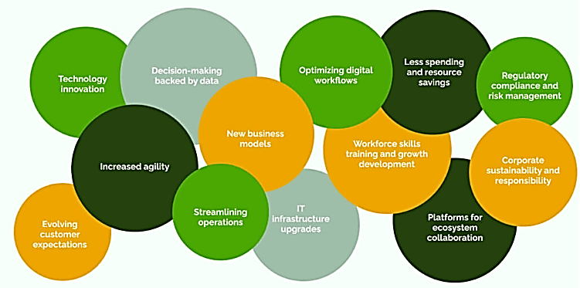
Figure 1: The key drivers of digital transformation
(Source: Nieem Sekiri, 2025)
These technological changes in the HRM and IHRM context necessitate the adoption of strategies that support the changing position of the work. The emergence of AI and automation demands that HR professionals should pay attention to reskilling and upskilling plans so that employees can be ready to adapt effectively to the new requirements of the work environment (Morandini et al., 2023). One such case is that the HR professionals will have to create training programmes that will provide employees with the technical capability and adaptability to the AI-driven tools. Moreover, the use of online recruitment, employee engagement, and performance management is becoming a common phenomenon (El-Ghoul et al., 2024). This type of platform allows organisations to simplify HR procedures, increase the suitable matching of a candidate, and increase productivity of the workforce.

1.2 Implications for HRM and IHRM
The strategies of HRM and IHRM need to be changed to accommodate the growing demands of a digitally literate workforce. The organisations should focus at the establishment of a culture of learning and adaptability, including technologies that provide an employee the opportunity to learn his skills in real-time. As Elugbaju et al., (2024), highlighted the HR departments have to apply their analytics to forecast the future talent requirements and enhance decision-making procedures. Internationally, organisations should address issues of technological potential and infrastructure existing in other countries in order to implement digital HR systems successfully within any country around the world.
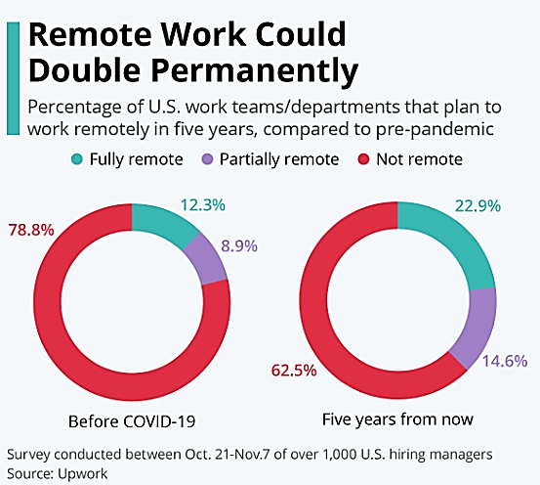
Figure 2: Remote Work Could Double Permanently
(Source: Roper, 2020)
According to Roper (2020), in figure 2 stated in an additional report that was published recently by Upwork, close to 23% of work teams and departments in the US have intentions of still working remotely in an additional 5 years. It is a difference in the number of people working outside the office by more than 10-percentage points since the pandemic restrictions. About 63% of teams and departments will revive to full remote workflow and approximately 15% will work half a day remotely within 5 years, which is almost six percentage points higher than it was prior to the pandemic.
Vaiman et al., (2021), claimed that the emergence of digital platforms and remote employment opportunities changes talent mobility in the world. Since companies are increasingly adopting remote working, HR managers need to formulate policies that will facilitate cross-border working and still be compliant with the international labour laws and regulations. As such, HRM and IHRM are required to weave technology and digital platforms strategically to become more productive, talent management and global workforce management.

2. Demographic and Geopolitical Factors Influencing Employment Markets

2.1 Key Demographic and Geopolitical Drivers
The labour market in any region or country is significantly influenced by the demographics of the country. The supply and demand of labour in various industries is affected by such trends as the ageing of the population, migration processes, and changes in the education systems (Macaluso, 2022).
There is an increasing population of the ageing population in developed countries, especially in Europe and Japan, which is posing an increasing demand of healthcare professionals on the one hand and ageing population is on the other hand, is creating a dilemma of the decreasing working-age population in terms of the ability to maintain economic growth (Nakatani, 2019). However, the young population is rising in emerging markets, especially in Africa and Asia, and this is creating a bulge in the youth that needs significant investments in education and skills development, but at the same time, creates an opportunity of growth.
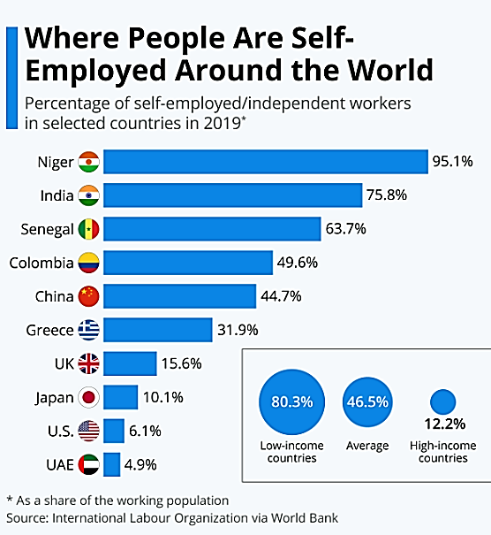
Figure 3: Where People Are Self-Employed Around the World
(Source: Buchholz, 2021)
As stated in figure 3, in high-income economies, 12.2% of employees are on average self-employed whereas in low-income economies, it is 80.3%. This is a sign of the many subsistence farmers and people with no pay to work in their family enterprises included in the data under self-employed. The highest country with the highest level of self-employment was Niger in 2019 with over 95% the lowest levels of self-employment were recorded in Arab countries. On the other hand, 4.9% of employees made their wages on their own in the United Arab Emirates in 2019. The figure was even less in Kuwait and Qatar at 1.8% and 0.4% respectively (Buchholz, 2021).
The effects of geopolitics on the international labour market are notably significant due to policies like political instabilities, trade wars and shifting immigration policies. According to Gammeltoft and Panibratov (2024), political instabilities and economic sanctions have the capacity to disrupt labour flows between countries, making multinational organisations rely on this factor to hire and transfer talents across the borders. Brexit has had eminent effects on the European labour market, especially in regards to the labour mobility between the UK and the EU. The international pools of talent and recruitment patterns are also influenced by modifications in immigration legislation, including the one observed in the United States and Australia (Macaluso, 2022).

2.2 Challenges for HR Professionals
There are various issues that HR professionals encounter in assimilating such demographic and geopolitical shifts. Talent retention, knowledge transfer, and workforce flexibility are all crucial in the developed countries where the workforce is aging (Hennekam and Dumazert, 2021). For instance, the introduction of policies that enable the elderly employees to work longer hours in the company, by giving them part-time work schedules or alternative working hours. Moreover, HR staff have to contend with the issues of working with a multigenerational workforce, as the policies adopted by the organisation will need to support the needs and expectations of the representatives of various age categories. Geopolitically, HRM and IHRM need to be flexible in the impending changes in immigration policies, international trade agreements, and political tensions.
Running a workforce that is geographically dispersed all over the world means that HR professionals possess the knowledge of various cross-cultural management, ability to comply with the local laws, and navigate through politically uncertain situations (Malik et al., 2022). The organisations should foster that it is responsive to these external forces and HR departments help in minimising risks and exploiting opportunities in the global labour market.

3. Addressing Skills Gaps and Talent Shortages in Critical Sectors

3.1 Identifying Critical Sectors and the Skills Gap
Some sectors such as technology, health care and hospitality are facing serious shortage of talent and also skill gaps. The technology sector has seen a growing number of demands in fields like cybersecurity, data science, and software development, which has given rise to the high rate of change in technology usage. Likewise, there is a shortage of medical professionals across the globe in the healthcare sector that is worsened by the ageing of the population and the developing number of chronic diseases (Khan et al., 2024).
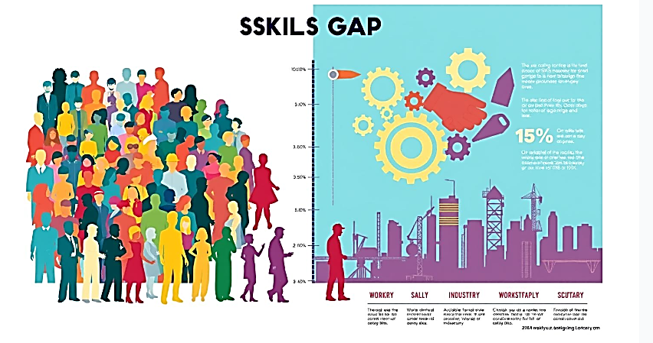
Figure 4: Skills Gap Analysis: Statistics Comparing Required Skills vs. Available Talent in Key Industries
(Source: Matsh People Development, 2024)
As figure 4 demonstrated, the skills gap crisis is increasing. Approximately 3 million employment opportunities in the trade will be vacant by 2028. It is due to an incompetence in the technological, medical and production spheres. Around 31% of HR people believe that their companies understand well how to identify these gaps. This demonstrates that we actually have to strive to identify and rectify these skill deficiencies as early as possible. Moreover, 69% of HR people in the US in 2023 indicated that they perceived skills gaps at work. This is up from 55% in 2021. This is an indication of the size of the problems (Matsh People Development, 2024).
In managing these areas, HRM and IHRM strategies should take into consideration attracting, developing, and retaining these talents in these vicious areas. Li (2022), estimated that 50% of the work force will be required to have undergone reskilling by 2025 with a digital oriented requirement. In solving these gaps, HR specialists are required to adopt specific talent absorption tactics that not only recruit in advanced talent pools like remote employees but also to engage educational bodies in order to ensure that that future workforce is suitably equipped to meet the requirements of these industries.

3.2 Strategic HRM Responses
In order to fill the skills gaps, the HR departments have to collaborate together with other stakeholders like the educational institutions, the government agencies, and the industry sector to have a pipeline of skilled talent (Bristol-Alagbariya et al., 2024).
As a case in point, organisations collaborate with universities and technical colleges by providing internship, apprenticeship, and training opportunities where learners acquire the skills that are highly required in the job market. Furthermore, organisational talent development should be conducted locally by workforce reskilling and upskilling. The skills gap is addressed with online learning platforms, internal training, and mentorship as well as make employees flexible to technological changes (Ogunbukola, 2024). Diversity and inclusion should also be put high on the agenda of HR professionals, such that talent acquisition strategies increase the number of underrepresented groups in the key areas.

4. Reflective Report on Personal Capabilities in an International Context

4.1 Current Capabilities and Self-Assessment
Flexibility and Interpersonal skills.
My adaptability is one of the important strengths that allow me to work with an international setting. I have been able to work and learn in different cultural settings and this has prepared me with skills of adapting to different working practices, cultures and the ways people communicate. Considering that I conduct work with teams based in separate geographical locations and collaborate with co-workers with diverse professional experience, I have learned to be open-minded and, thus, be flexible and responsive to emerging issues. Self-assessment flexibility will be essential in a global environment, where teamwork and business dynamics differ significantly depending on the region (Yousef, 2024).
My ability to be flexible is not the only way my communication skills have contributed to my success in foreign cultures. I possess expert skills in verbal and written communication, and I feel especially at ease when communicating with representatives of other cultures. I have come to acknowledge and appreciate the differences in language, adapt my style of communicating to various audiences, and overall be clear and understandable when communicating with different audiences one-on-one or in a group. In the globalised workplace, effective communication is paramount in order to make the expectations transparent and the cooperation process fluent (Onyebueke, 2024).
Technological Competence
Since the use of digital tools and platforms in the work environment grows, especially in remote and international partnerships, my technological skills have also become an important asset. I will not hesitate to utilise multiple communication tools (including Zoom, Microsoft Teams, and Slack), along with productivity tools (figure, Google Workspace, and Asana), which are numerous in the setting of the global team. These tools can help me work effectively with colleagues who are miles apart in time zones and this cannot be ignored in the current virtual workplaces (Dalal, 2025). Furthermore, I possess a minimum knowledge of data management software, project management software and online collaboration specialist, which enables me to participate in international projects. The technological fluency will help me to work on international projects and deal with cross-border projects teams, helping to coordinate and implement the project more easily.

4.2 Identified Areas for Improvement
Leadership Skills
Although I am not afraid to work with teams and participate in group assignments, I am still to be given a chance to be put in charge of major teamwork in overseas projects. With the growing need to have leaders who can operate beyond national borders in international organisations, there is a reason as to why I need to learn how to work with cross-border teams, lead processes in addition to leading initiative to success.
In order to further develop my leadership skills, I will work to identify the opportunities in which I can assume responsibility that includes leading smaller projects or initiatives in my present work or academic environment. I will seek mentorship with experienced senior professionals who have had experience in managing international teams since their opinions and feedback will further guide me on how to be a more strategic and effective leader.
Self-Directed Learning and Continuous Development
I am dedicated to personal and professional growth but, at times, I fail to organise my learning process in a manner that will provide a steady progress. Since the globalisation of business has developed over a rapid pace, it is of utmost importance that I keep up with the latest trends and technology, especially in areas of cross-cultural management and international business. Furthermore, I intend to respond to this by becoming formal in my approach to learning. I will develop specific objectives and deadlines diligent in gaining diverse knowledge, especially in those domains that are pertinent to the activities of the international context, including intercultural communication, global leadership practices, and technological innovations in business. The online platforms such as Coursera and LinkedIn are learning to pursue specialised courses that will improve knowledge and skills (Lachabi, 2025). Therefore, it will enable me to better respond to the requirements of a shifting global labour market since I should have a disciplined approach to self-directed learning.

4.3 Leveraging Strengths and Addressing Weaknesses
Maximising Strengths
In order to exploit the strengths that I have, I will pursue leadership roles both in academics and career. For instance, I would assume more separate duties in team-based projects particularly those involving international elements. This will raise me the opportunity to test my skills in team leadership, decision makers and cross boundary drivers. On top of that, I will keep using effective communication skills to build rapport and share working with different teams, where all the team members will feel heard and valued, irrespective of their location.
Likewise, I acknowledge the need to enhance my technological fluency, as well. Since technology remains a significant implementation tool in international organisations, this is why I will ensure that I keep abreast with new tools and platforms that support international collaboration.
Improving Leadership and Self-Directed Learning
In order to enhance my leadership skills, I will use the leadership of mentors who have experienced working under different international settings. Through watching their strategies of handling cross-cultural teams and learning how they cope with challenges in cross-cultural settings, acquire valuable lessons in an attempt to improve leadership style (Hadi, 2023). Moreover I will also be open and receptive to taking feedback on my leadership with peers and supervisors so that I can continually enhance my leadership. On self-directed learning, I will develop a personal development plan which will contain certain learning objectives, which are in reference to international business and leadership. The strategy will assist me in prioritising on the most relevant skills and knowledge areas in my career aspirations.

Reference List
Bristol-Alagbariya, B., Ayanponle, O.L. and Ogedengbe, D.E., (2024). Leadership development and talent management in constrained resource settings: A strategic HR perspective. Comprehensive Research and Reviews Journal, 2(02), pp.013-022.https://crrjournals.com/crrj/sites/default/files/CRRJ-2024-0031.pdf
Buchholz, K. (2021). Infographic: Where People Are Self-Employed Around the World. Statista Daily Data. https://www.statista.com/chart/18908/self-employed-workers-by-country/?srsltid=AfmBOop2gkK6b81yo8CbboeZnXgwySGr8eAzlooU-xG9knVtrY2C-Vi4
Dalal, A., (2025). BRIDGING OPERATIONAL GAPS USING CLOUD COMPUTING TOOLS FOR SEAMLESS TEAM COLLABORATION AND PRODUCTIVITY. Available at SSRN 5268126.https://papers.ssrn.com/sol3/Delivery.cfm?abstractid=5268126
El-Ghoul, M., Almassri, M.M., El-Habibi, M.F., Al-Qadi, M.H., Abou Eloun, A., Abu-Nasser, B.S. and Abu-Naser, S.S., (2024). AI in HRM: Revolutionizing recruitment, performance management, and employee engagement. https://philarchive.org/archive/ELGAIH
Elugbaju, W.K., Okeke, N.I. and Alabi, O.A., (2024). Human resource analytics as a strategic tool for workforce planning and succession management. International Journal of Engineering Research and Development, 20(11), pp.744-756.https://www.researchgate.net/profile/Wande-Elugbaju/publication/387222842_Human_Resource_Analytics_as_a_Strategic_Tool_for_Workforce_Planning_and_Succession_Management/links/6764752e117f340ec3cd9055/Human-Resource-Analytics-as-a-Strategic-Tool-for-Workforce-Planning-and-Succession-Management.pdf
Gammeltoft, P. and Panibratov, A. (2024). Emerging market multinationals and the politics of internationalization. International business review, 33(3), pp.102278–102278. https://doi.org/10.1016/j.ibusrev.2024.102278.
Hadi, A., (2023). Leading Across Cultures: Examining Cross-Cultural Leadership Styles and Their Impact on Global Teams. Journal of Leadership & Administrative Development, 2(1), pp.11-20. https://journals.asmara.com.pk/index.php/JLAD/article/download/12/12
Hennekam, S. and Dumazert, J.P., (2021). Managing Talent in the Context of an Aging Global Workforce: Emerging Challenges. In Contemporary Talent Management (pp. 91-108). Routledge.https://www.researchgate.net/profile/Sophie-Hennekam/publication/354102546_Managing_Talent_in_the_Context_of_an_Aging_Global_Workforce/links/61360025c69a4e487981b994/Managing-Talent-in-the-Context-of-an-Aging-Global-Workforce
Joshna (2025). Automation’s Impact on Employment Trends Statistics. Zoe Talent Solutions. https://zoetalentsolutions.com/automations-impact-on-employment-trends/.
Khan, H.T.A., Addo, K.M. and Findlay, H. (2024). Public Health Challenges and Responses to the Growing Ageing Populations. Public Health Challenges, 3(3), pp.1–9. doi:https://doi.org/10.1002/puh2.213.
Lachabi, F.Z., (2025). Digital Learning: An Innovative Solution to Modern Human Resource Management Challenges. les cahiers du mecas, 21(1), pp.233-247.https://asjp.cerist.dz/en/downArticle/174/21/1/268148
Li, L. (2022). Reskilling and Upskilling the future-ready Workforce for Industry 4.0 and beyond. Information Systems Frontiers, 24(3), pp.1–16. doi:https://doi.org/10.1007/s10796-022-10308-y.
Macaluso, M. (2022). The influence of skill-based policies on the immigrant selection process. Economia Politica, 39(2). doi:https://doi.org/10.1007/s40888-022-00264-w.
Malik, A., Pereira, V., Budhwar, P., Froese, F.J., Minbaeva, D., Sun, J., Nguyen, A.T. and Xue, S. (2022). Multilevel Relational Influences on HRM practices: a cross-country Comparative Reflective Review of HRM Practices in Asia. Asian Business & Management, 21(5), pp.745–779. doi:https://doi.org/10.1057/s41291-022-00208-z.
Maths People Development. (2024). Skills Gap Analysis: Statistics Comparing Required Skills vs. Available Talent in Key Industries. Available at: https://www.matsh.co/en/statistics-on-skills-gap-in-key-industries/
Morandini, S., Fraboni, F., De Angelis, M., Puzzo, G., Giusino, D. and Pietrantoni, L., (2023). The impact of artificial intelligence on workers’ skills: Upskilling and reskilling in organisations. Informing Science, 26, pp.39-68.https://cris.unibo.it/bitstream/11585/917132/1/InfoSciV26p039-068Morandini8895.pdf
Nakatani, H. (2019). Population aging in Japan: policy transformation, sustainable development goals, universal health coverage, and social determinates of health. Global Health & Medicine, [online] 1(1), pp.3–10. https://doi.org/10.35772/ghm.2019.01011.
Nieem Sekiri (2025). 13 Key drivers of digital transformation. Digital Adoption. https://www.digital-adoption.com/drivers-of-digital-transformation/.
Ogunbukola, M. (2024). Digital Transformation and Workforce Adaptability: Navigating the Global Skills Gap in the Age of Automation. ResearchGate. https://www.researchgate.net/publication/385701497_Digital_Transformation_and_Workforce_Adaptability_Navigating_the_Global_Skills_Gap_in_the_Age_of_Automation.
Onyebueke, C.E., (2024). The Role of Effective Communication in Ensuring Enhanced Productivity in Multicultural Organizations in a Third World Setting https://livrepository.liverpool.ac.uk/3182182/1/Appoved%20version%20of%20DBA%20Thesis%20-%20Post%202nd%20Viva%20Examination.pdf
Roper, W. (2020). Infographic: Remote Work Could Double Permanently. Statista Daily Data. https://www.statista.com/chart/23781/remote-work-teams-departments/?srsltid=AfmBOopkAR8_hTyBUouGyoKzWv8H-VGy1l2qTyH4bgq8_kZhguvsXnlo
Tokunova, A., Zvonar, V.I.K.T.O.R., Polozhentsev, D., Pavlova, V. and Fedoruk, O.L.E.S.I.A., (2024). Economic consequences of artificial intelligence and labor automation: Employment recovery, transformation of labor markets, and dynamics of social structure in the context of digital transformation. Financial Engineering, 2, pp.1-12.https://wseas.com/journals/fe/2024/a02fe-001(2024).pdf
Vaiman, V., Cascio, W.F., Collings, D.G. and Swider, B.W., 2021. The shifting boundaries of talent management. Human Resource Management, 60(2).https://www.researchgate.net/profile/Vlad-Vaiman-2/publication/349967658_The_shifting_boundaries_of_talent_management/links/6400fa5a0cf1030a566794b7/The-shifting-boundaries-of-talent-management.pdf
Yousef, K., (2024). Exploring the impact of cultural diversity in global projects: A comparative analysis of virtual and face-to-face teamwork. International Journal of Cross Cultural Management, 24(2), pp.411-430.https://journals.sagepub.com/doi/pdf/10.1177/14705958241253754

