Rhodri Owen Phillips – 1805871
BA Business and Management – Year 2 (2020)
Business Inquiry and Research - BMSP5007
Dr Alex Bell
University of Wales Trinity St David

Research Proposal

“The effect the Corona Virus pandemic will have on the property market within the UK”


1.0 - Introduction
With the current pandemic far from being a thing of the past, it’s dawning on many industries that the effects of COVID – 19 will see years of hard work be wiped away within months by this grueling virus. As expected, many companies throughout various industries have felt the blow of the pandemic that became known to us at the beginning of 2020. In my research, I will be concentrating on one industry in perticular, and the damage that’s been caused as of yet, with the worse undoubtedly yet to come. I’ve chosen the property market industry as my topic for this research proposal as it’s something i feel will effect a lot of property owners, buyers, landlords and tennants throughout the UK, and it comes with a great ripple effect to our already defeated economy. According to the Guardian, house prices had fallen for the third month running back in May, and with lockdown measures ataking its toll, the average price for a UK house had dropped 0.2% for May, and stands at £237,808 (The Guardian). Uk house prices had posted their biggest monthly fall in 11 years back in June (BBC News), and this is just the tip of the iceberg for the industry. Over the inital three month period the pandemic was declared, prices were down 0.5%. The bank of Halifax had reported a higher interest from buyers following the relaxation of lockdown, and a strong interest from the house builder since reopening its sales centres (The Guardian). I will be looking at various figures and statistics involved with the current housing market, as well as historically. To structure my research proposal, i will concentrate on 5 questions.

  - - Research Questions
- what was the housing market like prior to Covid – 19?
- What effect has the pandemic had on potential buyers of property?
- What effect has the pandemic had on potential sellers of property?
- How has the pandemic affected the housing market as a whole?
- What does the future hold for the housing market and the economy?

  - Research Objectives
Taking into consderation that this topic can be very bold, and answering my five questions will mean gathering a lot of information from different resources to strengthen my findings. I felt that this topic would be appropriate as we are currently undergoing a pandemic that will go down in history, and the effects of this current situation will be felt for years to come. Concluding the research I’d like to have answered all questions in detail, gaining full insight to the impact of the Covid – 19 on the housing market. The housing market is an interesting topic for me as I’m considering a career in property development after graduation, and this research will aid me with my knowledge on the industry.

  - - Research Aim
The aim of this research proposal is to conduct a research on the impact that the current corona virus pandemic has, and will have on our housing market here in the United Kingdom. The 5 questions noted above will be used as a structure for my findings.

  - – Research Boundaries
To conduct the research, I will be speaking with local individuals with expertiese in property, these can range from estate agents, landlords, property surveyors and architects. According to a RICS report, there’s been a decline of 80% in business, just under half of the profession (49%) are working from home. Only 1.1% of the industry profession had experience no impact from Covid – 19 (www.RICS.org) I will be looking at the opinions and predictions of economists and industry experts to determine the ansnwers to these questions, and find out the true impact that this pandemic has had on the industry and beyond. I will be using different sources of information such as news articles, pdf files, and graphs and charts for statistics.

2.0 – Literature Review
In this section of my dissertation i will review relevent literature found for my topic. Senioor economist for “relator.com” George Ratiu said “when you woke up on January the 1st this year, you would not expect that come June you would be looking at the economy and environment we have today” (Qualia Insight 2020) This sums up the current situation well, and puts in prespective how it’s unexpectedly sprung up on the nation. Inital research by (Realtor.com) on the topic states historical statistics. The article by Javier Vivas displays information on home sales, housing inventory, and goes into great detail on economic and housing indicators. Research conducted by (Savills) pinpoints what they believe is the three main areas that will be affected by Covid – 19. This would be a valuable benchmark to begin my research from. Artciles such as What Coronoa Virus Could Mean for the Global Economy (Harvard Business Review, 2020) are also valuable benchmarks to get background information on the topic and it’s fundementals.

3.0 – Methodological Approach
To conduct this research, i will be using a range of different approaches. With the nature of my topic being highly dependent on figures and statistics to show the true impact and effects that Covid – 19 has had on the property industry, my data will be made up of a mixture of qualitative and quantitative data, and therefor, research for both styles will have to be conducted by myself, the researcher. The outcome of the research will be highly based on facts from expert economists that study the industry. Taking this in to consideration, i feel that the most appropiate form of collecting the data would be secondry research. In addition to the secondry research, I will be condcuting some primary research in the form of interviews with some local individuals within the industry. These individuals might include architects, chartered surveyors, property developers, estate agents or property landlords or sellers. I feel that these individuals will have a range of different views and will have various levels of experience within the indursty, and results for the research will be more credible. I will be taking a descriptive approach, ensuring all facts and figures gathered are from a dependable source with refrences to the source of information to be displayed at the end of the research. My opinion on the topic will not be portrayed in the research, and I will be taking a neutral apporoach throughout. An explanation on descriptive research by (Gall, Gall & Borg 2007) says that descriptive data describes a phononemon and it’s characteristics. This type of resarch is more concerned with what rather than how or why something has happened.
4.0 - Planned Data Analysis and Presentation
Something crucial to my research and it’s findings will be to analyze the data collected. This can be done by different approaches, mostly dependent on preferences of the researcher themselves. The nature of the topic is also a factor in choosing the approach. For this research, a thematic approach will be adopted. With the research project conducted by both qualitative and quantitative research methods, (Braune & Clark, 2006) believed that thematic analysis should be the foundation method for qualitative data analysis. A major factor that can determine if the data will be analyzed in real time, as i am collecting the data, or if the data will firstly i will be developing an analysis plan, this takes place after the data is collected, processed, and cleaned (Guest, McQueen, Namey, 2012). Taking advantage of SPSS to collect and process data, I will also be able to manually enter queries to compare data that has been collected by all parties involved in the research, and discuss the variation of feedback. Following completion of the research, the data collected should provide answers to the topic in question and views on the impact of Covid – 19 on the housing market within the UK from different industry experts as previously stated.

5.0 - Research Planning
This is the final step in the research process and will determine different aspects of the project, including costs, resources and the time taken to complete the different stages of thr project. The foundation of the project will be rearch resources, that will be available at various libraries located locally, and the university library. The internet will also be used to retrieve articles and subtract information from journals previously written on my topic. Figures and statistics will also be retrieved from the internet from historical archives as well as predicitons for the future.
The cost for the research is expectedly low, with the only main costs being travelling to interviews and refreshments for the interviewees in the occasion of meeting in a cafe/pub or similar. Completing questionnaires and the use of SPSS will be free, but costs could occur when posting the questionnaire to an individual. The use of email will be compulsory for organizing interviews and is set as a minimal source of communication.
Managing my time is also important, and to guide me with this and ensuring the research is completed efficiently, I have designed a time management table of how my time will be distrubuted in completing the research.

This table can be seen below:

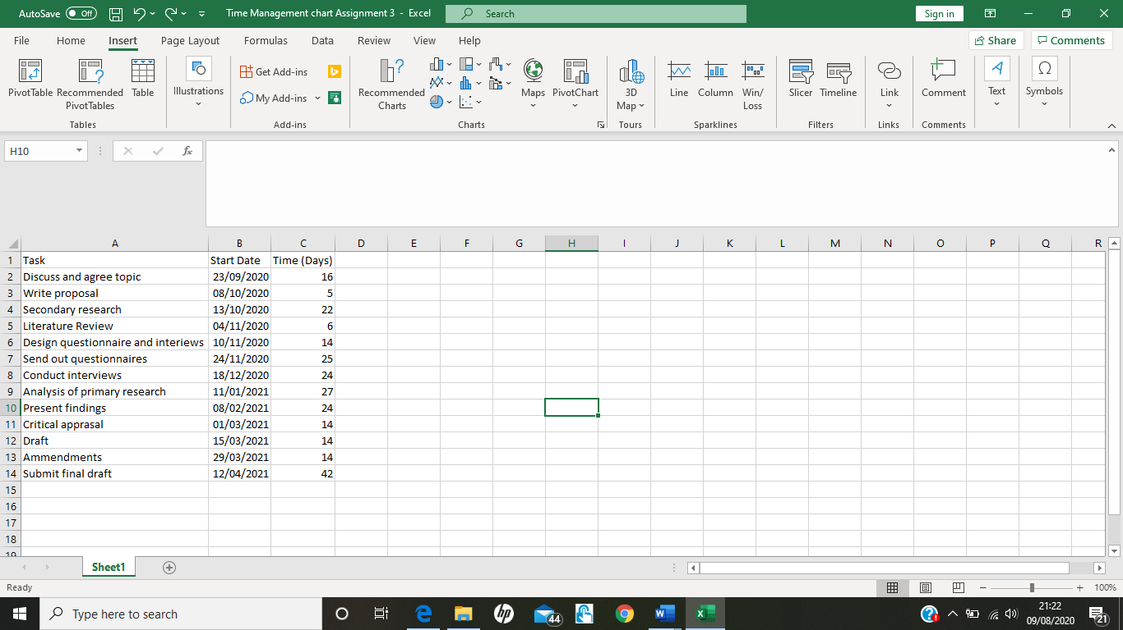

Bibliography
- Osborne, H (5th of June, 2020) The Guardian – Uk house prices fall for third month in a row as COVID – 19 stifles market. Retrieved from - https://www.theguardian.com/money/2020/jun/05/uk-house-prices-fall-for-third-month-in-a-row-as-covid-19-stifles-market-halifax Accessed on 01/08/2020
- Bloom, J (11th of June, 2020) BBC News- Corona Virus may have huge impact on property markets. Retrieved from - https://www.bbc.co.uk/news/business-52977890 Accessed on 01/08/2020
- RICS (Royal Institution Chartered Surveyors) (27th of May 2020) RICS 2020 - The impact of Covid – 19 on UK property and constrction market survey. Retrieved from - https://www.rics.org/uk/news-insight/latest-news/news-opinion/findings-from-rics-2020-impact-of-covid-19-on-uk-property--construction-market-survey/ Accessed on 01/08/2020
- Galles, K (29th of June 2020) Qualia Insight – Will the housing market recover? Predictions from realtor.com senior economist. Retrieved from - https://blog.qualia.com/housing-market-predictions-covid/ Accessed on 03/08/2020
- Vivas, J (6th of April, 2020) Realtor – Inital Impact of Covid – 19 on the Housing Market. Retrieved from - https://www.realtor.com/research/initial-impact-covid-19-housing-market/ Accessed on 03/08/2020
- Cook, L (March the 16th, 2020) Savills – What might Covid – 19 Mean for the Housing Market. Retrieved from - https://www.savills.co.uk/blog/article/297216/residential-property/what-might-covid-19-mean-for-the-housing-market.aspx Accessed on 04/08/2020
- Carlsson Szlezak, P. Reeves, M. Swartz, P (March 03rd, 2020) Harvard Business Review – What Corona Virus Could Mean for the Global Economy. Retrieved from - http://www.amcham-egypt.org/bic/pdf/corona1/What%20Coronavirus%20Could%20Mean%20for%20the%20Global%20Economy%20by%20HBR.pdf Accessed on 04/08/2020
- Gall, M.D., Gall, J.P., Borg, W.R. (2007), Educational research: An introduction (8th ed.). Boston: Pearson. Accessed on 06/08/2020
- Braun, V., Clarke, V. (2006). Using thematic analysis in psychology. Qualitative Research in Psychology, 3, 77–101. doi:10.1191/1478088706qp063oa. Accessed on 06/08/2020
- Guest, G. McQueen, K. Namey, E (2012) Applied Thematic Analysis. Retrieved from - https://books.google.co.uk/books?hl=en&lr=&id=Hr11DwAAQBAJ&oi=fnd&pg=PP1&dq=thematic+analysis&ots=Xi5DpOBKrD&sig=0Odxd1mxXDqvLwpPtzofVl8IdlI#v=onepage&q=thematic%20analysis&f=false Accessed on 06/08/2020

