
MBA – Masters of Business Administration
LCMB7006
INTERNATIONAL MARKETING

Student Name Ajay Aravind Kulappurath
Student ID 2210730

Executive Summary
Organisations tend to make significant changes in operational and strategic parameters with the aim of retaining their momentum in the international market. The macro and micro analysis shows external and cultural similarities and differences that Boohoo needs to take into account in optimising its operations in the UK and USA. The "Porter's five forces" shows the threat of substitution is likely to be a threat in the UK market compared to the US market. SWOT analysis exhibits Boohoo's inclination towards the "brick-and-mortar" option for the US with dependence on the "e-commerce" platform in the UK. This report makes a critical comparison and contrasts Boohoo’s market entry approaches to operate both in the UK and the USA and gain a competitive advantage to globally operate. Further, the study identifies critically contemporary ethical practices at the time of exporting, and internationalisation in the UK, and the US, determining their advantages and disadvantages.

Table of Contents
1. Introduction 5
2. Macro-environmental analysis 5
a. PESTLE 5
b. Hofstede cultural dimension model for social or cultural factors 9
c. Critical analysis of Hofstede cultural dimension model 11
d. Environmental scanning 12
e. Environmental analysis 12
3. Porter's five forces model 13
a. Similarities and differences 13
4. SWOT analysis 16
a. Similarities and differences 16
5. STP analysis 17
a. Perceptual mapping 17
b. Similarities and differences 18
6. Marketing mix elements 7Ps 21
a. Market entry methods in “place” element 21
7. Directional development strategy 25
a. Ansoff matrix 25
b. Recommendations using TOWS matrix 26
c. Critical analysis of the ansoff matrix model 27
8. Product lifecycle model 28
a. Strategies to be used in each stage 28
9. Conclusion 29
10. References 30
11. Appendices 38
Appendix 1 38
Appendix 2 39
Appendix 3 40

1. Introduction
International marketing is considered the marketing of products and services to gain a domestic audience for the brand. Most multinational companies are associated with the incorporation of marketing principles across national boundaries with international marketers. The global marketing initiatives help in building diversities and the constraints of linguistic mobility whilst giving scope for internationalise business exaggeration and gaining niche growth in globalised business. Boohoo, the chosen brand for the study, operates both in the UK and the USA adopting an international expansion strategy for meeting the basis of its competitive market. This report makes a critical comparison and contrasts Boohoo’s market entry approaches to operate both in the UK and the USA and gain a competitive advantage to globally operate. Further, the study identifies critically contemporary ethical practices at the time of exporting, and internationalisation in the UK, and the US, determining their advantages and disadvantages.

2. Macro-environmental analysis

a. PESTLE
United States of America (USA)
Factors | Implications | Impact
Political | - The political stability of the USA stands at 0 as estimated in 2021, which shows that this country is neither stable nor can be considered as highly unstable (Theglobaleconomy.com, 2021)  - Identity politics have turned USA’s political environment from inclusion to division (Newyorker.com, 2022) | Unfavourable
Economic | - The GDP of the USA is increasing with an "annual growth rate" of 2.6% implying that the economy is growing substantially (Bea.gov, 2023)  - USA’s inflation rate reduced to 5% in 2023 implying that customers purchasing power would increase significantly (Theguardian.com, 2023) | Favourable
Social | - USA’s rank in the “Social Progress Index” is 84.65 showing that society is improving consistently (Statista.com, 2023a)  - An increasing number of conscious customers in "the apparel industry" implies that organisations are changing their operational scope to meet the growing demand for sustainability (Gcpit.org, 2020) | Favourable
Technological | - In 2022, the USA made an investment of $280 billion in high technology to add a competitive edge to the economic landscape (Bbc.com, 2022)  - Organisations are rapidly incorporating "digital transformation" with 44% of firms having maturity in action to expand operations of the apparel industry (Deloitte.com, 2023) | Favourable
Legal | - “Civil Rights Act of 1991” prohibits any form of employment discrimination (Iclg.com, 2023)  - USA's free trade policies with a negotiation approach are beneficial for market penetration of foreign countries (Crsreports.congress.gov, 2023) | Unfavourable
Environmental | - "National Environmental Policy Act (NEPA)" of 1970 strictly prohibits the unregulated exploitation of natural resources (Epa.gov, 2023)  - The USA has made an ambitious goal of achieving net-zero emissions by 2050 (Mckinsey.com, 2022) | Favourable
United Kingdom (UK)
Political | - UK’s rank in the “political stability index” is 0.54 indicating that this country is partially stable (Theglobaleconomy.com, 2021)  - The impact of Brexit has caused political disruption affecting the business landscape equally (Bbc.com, 2023) | Unfavourable
Economic | - UK’s GDP is growing by 0.4% in 2023 implying increased production in the economy (Ons.gov.uk, 2023)  - UK’s inflation rate rose from 5.3% to 5.7% showing that consumers purchasing power might decline (Ons.gov.uk, 2023) | Favourable
Social | - The UK stands at 86.13 in the "Social Progress Index" showing the progress of society (Statista.com, 2023a)  - Around 75% of people started using recycled products showing a rising consciousness for the environment (Statista.com, 2023b) | Favourable
Technological | - UK government has pledged to make £370 million to boost their technological performances (Pitchbook.com, 2023)  - The UK is strengthening its frontier of digital strategy to make this country a technological hub, which would help in strengthening e-commerce operations in the apparel industry (Gov.uk, 2022) | Favourable
Legal | - "Equality Act (2010) prohibits discrimination of any form on employees (Legislation.gov.uk, 2010)  - UK facilitates different trade opportunities helping organisations to perform well (Gov.uk, 2023) | Unfavourable
Environmental | - "Environment Act of 2021" preserves natural resources and prohibits the unregulated use of natural resources (Legislation.gov.uk, 2021)  - The UK aims at reaching "net-zero emissions" by 2050 (Gov.uk, 2019) | Favourable

Table 2: PESTLE Analysis of UK
(Source: Created by author)
Analysis
Based on the PESTLE of the USA and UK, it is evident that both exhibit a developed economy, which enabled Boohoo to strengthen their operations in the market of both countries. In addition, the government's investment in technology has helped in shaping the digital frontier of the company making the factors more favourable for Boohoo. However, the UK's legal structure is complex compared to the USA's, which implies staying conscious as every action makes Boohoo to be more accountable (Gov.uk, 2023). This can be stated that UK's legal structure is not favourable and USA's structure is more favourable for Boohoo. Analysis of the political frontier, it can be stated neither UK nor USA is a stable country, which can bring operational implications causing disruption and indecisive policies of both countries' governments. This reflects that the political condition is not favourable enough for the company. It is also observable that society is progressing quite rapidly with rising consciousness among customers regarding the environment. However, the living patterns and beliefs of customers in both countries differ greatly, which can be understood properly with help of an analysis of cultural dynamics (Firstinsight.com, 2023). The technological improvements are quite significant in the countries making it favourable for Boohoo to boost its operations. Overall, it can be said that both countries accommodate different opportunities, which can help Boohoo to tap its full potential to fortify its operational presence further.
In comparison to USA, UK has facilitates different trade opportunities helping organisations to perform well. ESG framework of UK is well constructed with milestones of reaching The UK aims at reaching "net-zero emissions" by 2050 in comparison to that of USA. Therefore, internationalisation of business of Boohoo is more favourable to be operative in the UK than USA adopting an international expansion strategy for meeting the basis of its competitive market.

b. Hofstede cultural dimension model for social or cultural factors
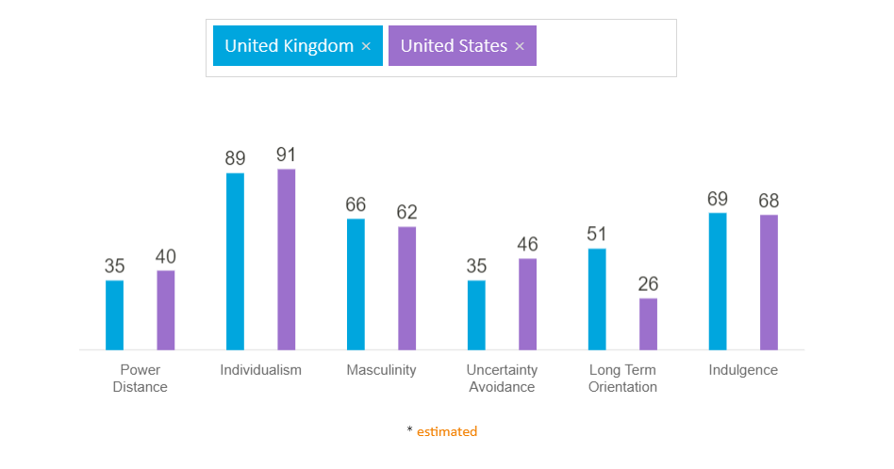
Figure 1: Country comparison
(Source: Hofstede-insights.com, 2023)
Analysis
Hofstede's Cultural analysis is a key tool that helps in defining the cultural beliefs, principles, and values, which constitute an important aspect of the market. The country comparison between the USA and the UK shows that overall; the cultural dynamics of both these countries are similar. However, there are subtle differences, which need to be identified and analysed properly. The UK's low score on the "political distance index" shows inequality in society needs to be minimised, which can be reflected in their strong adherence to discrimination policy. In contrast to this, the USA ranks at 40 in this index, a slight increase from that of the UK implying that society still has an inclination towards discriminatory practices (Hofstede-insights.com, 2023). Therefore, Boohoo's operations in both these countries must take account of these factors as in the UK, Boohoo needs to have strict vigilance for eliminating discrimination. Scoring 89 in the "individuality index", the UK is considered highly individualist, preferring to have privacy in their life (Hofstede-insights.com, 2023). While dealing with customers, Boohoo ensures that customer profile and their data can be protected as any breach can cause this brand to lose its credibility.
It is observable that USA's score in the individuality index is quite high, which can be traced to their underlying belief in "liberty and justice for all". Therefore, individual rights are preferred over collective rights and Boohoo needs special consideration while maintaining office decorum and building relationships among managers and employees (Hofstede-insights.com, 2023). It needs to be remembered that hierarchical structures in USA organisations are created out of convenience compared to the idea of ease of operations as perceived in the UK. High scores on the masculinity index by both the countries show that a masculinity driver potentially influences and motivates people to work in society. This can be discussed in terms of highly competitive factors and pay rise implying financial points that influence and motivates performance. Conversely, a subtle distinction can be made here like USA's attitude towards competitiveness is more upfront and rigorous. However, in the UK there is a subtleness in an attitude of people in showing their competitive rage (Hofstede-insights.com, 2023). Therefore, Boohoo's strategic approach needs to be balanced in both countries, which can be reflected in their changing mindset and changing management principles to manage employees accordingly.
A major point of differences in the attitude among people can be observable in the "uncertainty avoidance and long-term orientation" index. UK stands at 35 whereas the USA scores 46 implying that the planning horizon is quite short in the case of the UK whereas, in the context of the USA, it is quite detailed. This can be attributed to the underlying principles of the people of the USA who believe that staying prepared would help in managing risk properly. Boohoo may witness a change in their risk management and forecasting principles to make it more detail oriented based on society's perceptions (Hofstede-insights.com, 2023). It also reveals that new ideas are not welcomed as much as it is in the UK, Boohoo needs to ensure that a proper strategic frontier can be prepared. This would help in conveying the importance of a product as this would help in developing recognition among customers. On the other hand, the UK's high score in "long-term orientations" imply that it prefers a pragmatist approach compared to normative ones, which is embedded in past heritage. This can be reflected in changing the outlook of society for different aspects, which can bring momentum to operations.
The USA scores 26 in the "long term orientations" index implying that people in USA are more concerned with information they are consuming and tend to do extensive research before accepting any idea. Therefore, Boohoo needs to make a proper statement of their operations ensuring that information flows from credible sources and this would help in building customer loyalty (Laukka and Elfenbein, 2021). In the indulgence index, both the countries prefer working and entertainment at the same time, which can be used for managing employees and retaining their satisfaction level.

c. Critical analysis of Hofstede cultural dimension model
Advantages
The Hofstede cultural model is developed with the aim of distinguishing underlying beliefs, values and principles, which affects a company’s operations similarly in this stance. The country comparison of UK and USA shows that it can be stated that developing hierarchical structure with proper distinction and separation of task would help in managing operational consistency for Boohoo. According to Hugo et al. (2019), having a clear idea about the potential vision and values of customers and people help organisations in formulating policies, which can enhance organisational turnover rate. For instance, in a given society like UK, where discrimination is forbidden, practising discriminatory attitudes can bring legal complications. Consequently, this would damage brand image and resilience resulting in their declining growth and financial prosperity.
Disadvantages
In analysing weakness of this Hofstede’s cultural model, it can be stated that the results are based on inconclusive research, which cannot be applied to present day changing cultural dynamics. In view of Cao et al. (2021), this model needs to upgrade as the business environment is constantly changing in face of “globalisation, convergence, and polarisation”. In order to address these factors, it is important for this model to modify their application of research tools. One possible limitation is its low scope in analysing the changing consumption pattern, which influences business immensely. Therefore, underlying ambiguity of results and robust structure raises concerns of efficacy of this model in meeting present cultural challenges.

d. Environmental scanning
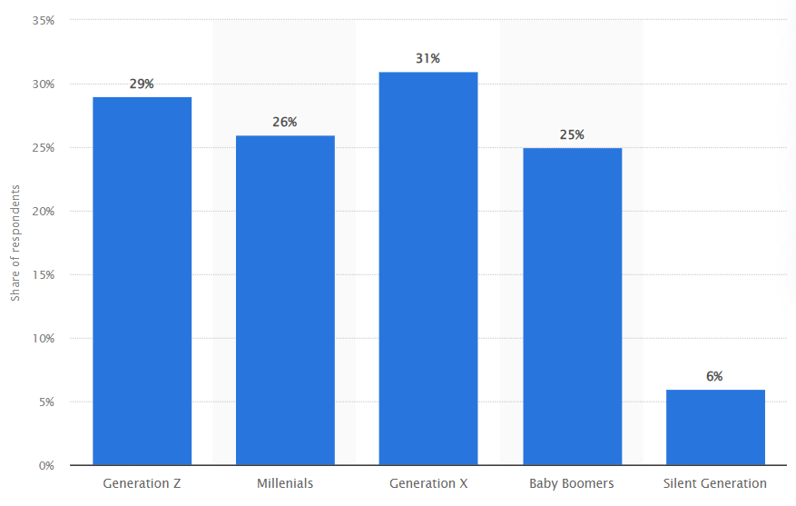
Figure 2: Share of consumers who would buy more sustainable fashion items if they were more widely available in the UK as of 2021, by generation
(Source: Statista.com, 2023c)
UK’s apparel market is evolving constantly with changing consumer patterns, which can be reflected in customers being more conscious about their buying pattern. A close analysis highlights that Gen X customers are more inclined towards preferring sustainable fashion over others. A statistical report of 2021 demonstrates that around 31% of Gen X claims that they have started purchasing sustainable apparel (Statista.com, 2023c). This is followed by Gem Z and millennial who are slowly changing their consumption to bring more sustainability in their living. It can be stated that UK is the third largest “apparel and footwear” market in the world with a market size of approximately 70.7 billion dollars (Fashionunited.uk, 2023). It depicts that this industry is slowly improving with rising demand and interest among potential customers. In respect to USA, the same developments can be observable with a preference for sustainability. Therefore, Boohoo needs to change their production design to become more sustainable and add value in their operations.

e. Environmental analysis
Boohoo’s management approach is quite flexible, which shows that it can adapt to trends in the market quickly. This can be further reflected in Boohoo’s “sustainable plan UpFront”, that ensures that recycled material can be used for production (Boohooplc.com, 2023). In the context of USA’s customers, it is observable that an affordable pricing strategy is beneficial. However, adoption of “geographical pricing strategy” would help in bringing more flexibility in enhancing their profitability. This shows a higher price from areas with a high-end background and affordable price for people belonging to the middle-class background. The US has the largest apparel market with its market value estimated at 312 billion U.S. dollars (Statista.com, 2023d). Compared to UK, USA’s market value is quite high implying that companies use high-end technology to retain customers. Consequently, Boohoo needs to make use of AI and ML in enhancing customers' shopping experiences and retaining their market momentum. This innovative strategy for customer care can be applicable to both UK and USA for rising instances of technological use in this industry.
Environmental sustainability based textile business operations is more operative in UK that in USA. Boohoo’s “sustainable plan Up Front” aligns with UK being the third largest “apparel and footwear” market in the world in terms of its market size. There are opportunities in UK to leverage investment opportunities in R&D for gaining realistic and authentic information on marketing trends.
In conclusion, internationalisation of business of Boohoo is more constructive to be functioning in the UK than USA adopting an international expansion strategy for meeting the basis of its competitive market.

3. Porter's five forces model

a. Similarities and differences
Factors | USA | Factors | UK
Competition in industry (High) | - Revenue in apparel industry is estimated at US$343.70 billion in 2023 and growing annually by 1.96% making this industry is lucrative compared to others (Statista.com, 2023e)  - This industry is dominated by brands like “TJX companies, Nike, and The Gap” (Statista.com, 2023f) | Competition in industry (High) | - Revenue in “apparel industry” is constantly increasing amounting to 55 billion British pounds (Statista.com¸2023h)  - “Primark, Next and ASOS” are dominating this industry (Statista.com¸2023h)
Potential new entrants (High) | - Emergence of potential new entry in apparel industry is high due to its simplified legal structure (Trade.gov, 2023)  - “Average volume per person” in “apparel industry” is expected to amount to 89.24 pieces in 2023, increasing new entries further (Statista.com, 2023e) | Potential new entrants (Moderate) | - It is expected that by 2025, e-commerce sales are expected to grow by 60% of total apparel sales (Statista.com¸2023h)  - Legal obligations are complex in UK, this can limit expansion of potential new entries (Uk.practicallaw.thomsonreuters.com, 2022)
Threat of substitution (Low) | - Threat of substitution is low due to quality and standardisation of products  - Each brand has their distinctive feature, which makes imitation challenging (Statista.com, 2023f) | Threat of substitution (High) | - Threat of substitution is significantly high due to lack of intricate designing (The-mtc.org, 2023)  - In presence of cheap manufacturing, threat of imitation rises exponentially (The-mtc.org, 2023)
Power of suppliers (Low) | - Power of supplier is low due to the large availability in their numbers in the US market  - High availability of raw materials also decreases the demand of suppliers (Trade.gov, 2023) | Power of suppliers (High) | - Due to Brexit, “apparel industry” has lost significant suppliers (Mckinsey.com, 2019)  - Low availability of quality and standards raw materials
Power of customers (High) | - Customers hold an important position as changes in their consumption also influences organisations operations  - GenZ customers of around 34% have started using “sustainable clothing” (Statista.com, 2023g) | Power of customers (High) | - Power of customers are quite considering as rising demand for e-commerce caused revenue to be projected around US$166.70 billion in 2023 (Statista.com, 2023i)  - Changing living pattern and more emphasis on sustainable clothing enables companies to incorporate sustainable design
Table 2: Porter's Five Forces
(Source: Created by author)
Analysis
Based on the “Porter's five forces” analysis, the point of similarity can be found in “competitive and bargaining power of customers” factors. Apparel industry in the UK and USA holds a dominant position with the UK holding the third-largest position (Statista.com¸2023h). It can be stated that this industry is quite lucrative and rising demands for fashionable and sustainable clothing makes it more popular among customers. In the USA, Boohoo’s operations focus on both ecommerce and Brick-and-mortar options to strengthen their operations further (Forbes.com, 2021). On the other hand, entry potential is high in comparison to the UK due to the simplified legal structure in the USA. It is also observable that substitution in the USA is low pertaining to adequate use of product standardisation. In the context of UK, rising cheap manufacturing is expected to undermine operations, largely expanding scope of substitution further. Another point of difference is large availability of suppliers, whereas the emergence of Brexit caused UK companies to lose some potential suppliers. Boohoo’s emphasis on collaborative strategy for “suppliers and their high product standardisation” helped in evading issues of substitution and high supplier demand (Boohooplc.com, 2023). This can be stated that a difference in strategies is one aspect that allows Boohoo to enhance its operational scale in both the countries equally.
In conclusion, substitution in the USA is low due to sufficient making use of product standardisation. In comparison, in UK, there is increasing aspects of cheap manufacturing which can undermine textile manufacturing operations in fast fashion business of Boohoo. It leads to increasing scope of substitution.

4. SWOT analysis

a. Similarities and differences
Strength  - Strong customer care service and affordable price range made its popular  - Sustainable operations enabling Boohoo to add value to customers life | Weakness  - Extensive emphasis on customer-driven model  - Fewer “Brick-and-motor” options
Opportunity  - Sustainability helped in launching Up.Front enabling Boohoo to advance its profitability  - Affordable pricing range has made it popular among customers of different backgrounds | Threat  - Emphasis on customer-driven strategy can limit the scope of “growth-driven” strategy  - Dependence of “e-commerce” options can limit their operations compared to those with strong presence in market
Table 3: SWOT analysis of Boohoo
(Source: Created by author)
Analysis
Boohoo’s strategy of “affordable pricing” remains their stronghold in both the USA and UK, helping this company to gain more momentum in the market. Boohoo's strategic inclination can be reflected in launching “brick-and-mortar” options in the USA (Forbes.com, 2021). This can be seen as a strategic move for expanding the scale of brand recognition with the aim of driving their growth in a positive direction. Contradictorily, e-commerce sales are about to make more contribution to the “apparel industry” in the UK (Statista.com¸ 2023h). This is the reason for which Boohoo focused on enlarging the scope of the e-commerce platform ensuring that it can bring more profitability to business. However, adherence to their sustainable plan allows in changing their production phases by increasing application of “recycle and reusable materials”. A high investment in R&D sector helped Boohoo to accumulate 1.2 billion British pounds and 452 million of revenue in UK and USA respectively (Statista.com, 2023j). Therefore, it can be stated that its strategic directions are quite beneficial as it is useful for Boohoo in strengthening their operations gradually.
Comparing investment in R&D sector of UK and USA, it is observed that Boohoo has high scope in e-commerce platform ensuring that it can bring more profitability to business in UK.
In conclusion, investment opportunities givers scope to the company for leveraging foreign direct investment and expand its venture capital.

5. STP analysis

a. Similarities and differences
Segmentation
Geographical segmentation
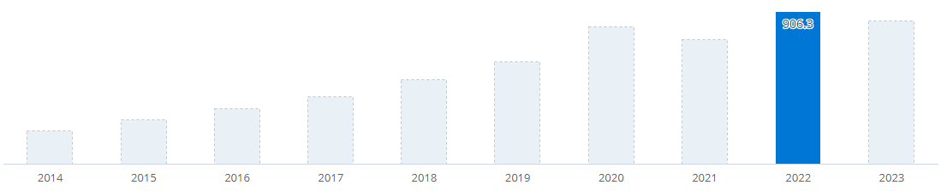
Figure 4: e-Commerce net sales of Boohoo
(Source: E-commerce Db, 2023)
Boohoo uses definite geographic segmentation to segment its low-involvement brand fashion clothing products operating mainly in the UK and USA with differing administrative systems, customer preferences, and cultures. Geographically, the company is accessible online with most available in countries such as the UK, US, Australia, and Europe. In the fashion market of the UK in 2022, Boohoo has been ranked 11 with an estimated net e-commerce sale of 906.3 million USA dollars (Ecommerce Db, 2023). It shows an online business strategy is mostly preferred to geographically segment Boohoo products leveraging its e-commerce business. On the contrary, in comparison to the UK, USA revenue generation in the fiscal year 2022 is estimated to be 451.6 million USA dollars (Statista, 2023). USA revenue generation is where firm positioning is mainly based upon traditional physical store services. Comparing and contrasting Boohoo’s geographical segmentation in the UK, and the US, online e-commerce trends are mostly preferred by customers driven by increased e-commerce sales of Boohoo.
Demographic segmentation
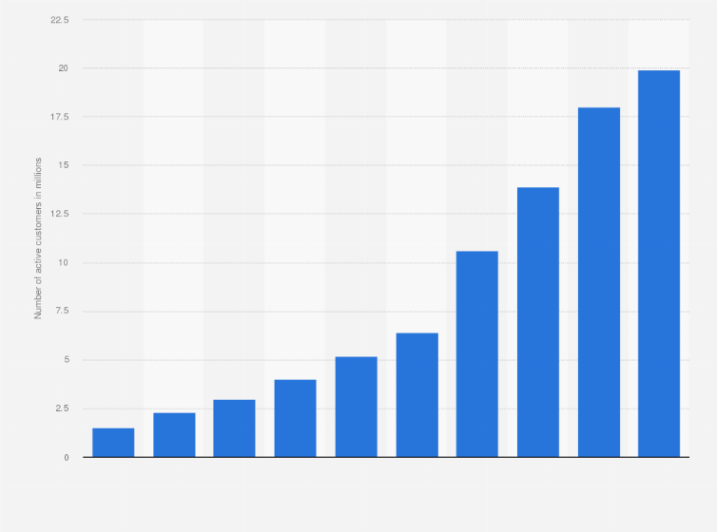
Figure 5: Number of active customers of Boohoo
(Source: Statista, 2023)
In the UK, Boohoo is demographically segmented based on customer design, markets, sources, beauty products, accessories, shoes, and clothing. The targeted customers in this aspect are consumers aged between 16 to 30 years mainly teenagers, young adults, and adults. Empirical data shows total active users of Boohoo in the UK are 19.9 million active customers on the organisation's fashion website from 2021 to 2022 (Statista, 2023). It shows UK customers of the firm are highly adaptable to online shopping mostly after the post-COVID-19 pandemic period. On the contrary, Boohoo has a large logistics and supply chain that manages overall USA retail fashion operations with the creation of supermarket and retail chains (Russell, 2022). Comparing and contrasting Boohoo’s demographic segmentation in the UK, and the US, the retail chain operation and distribution operations of Boohoo are traditionally operative. In contrast to this, e-commerce and omnichannel operations are highly driven in the UK.
In consideration of the psychographic or behavioural segmentation of Boohoo, the USA adult population is segmented under VALS (Values, Attitudes, and Lifestyles, a framework for psychographic segmentation). VALS customer segmentation is categorised into eight distinctive subgroups such as innovators, achievers, thinkers, believers, experiencers, makers, strivers, and survivors (Russell, 2022). It shows Boohoo has a distinctive and loyal customer base that significantly is driven by fashion preferences and trends through direct-to-consumer fulfilment. On the other hand, UK customers are highly driven to online fashion shopping based on self-concept, uniqueness, brand image, perceived quality, and word of mouth. Increased purchasing intention of Boohoo fashion brands gives an opportunity for the company to optimise its brand and gain more customer base.
b. Targeting
Targeting UK customers, Boohoo does not face any significant investment or trade barriers with no restrictions on capital transfer and repatriation of profits. However, the UK's administrative system helped the company to make a globally connected fashion market, gaining assets and resources of governmental support, access to capital, and highly skilled talents. Empirical data shows in 2022, total expenditure on research and development (R&D) is estimated to be more than £25 billion (GOV.UK, 2023). It shows targeting the UK to expand its business helped the company to gain significant investment opportunities with high returns on investment.
On the other hand, targeting USA customers, Boohoo faced significant market entry barriers and was subjected to entry requirements with the lengthy process of taxation. Foreign firms are required to make a 4% tax on an annual basis under US-source gross transportation income (USS GTI) in USA marketing and trade business (Tax Summaries.pwc, 2023). It shows USA marketing and entry have significant barriers in terms of tax regimes. Comparing and contrasting, targeting segments of Boohoo in the UK has low barriers but high-end customer gain than that in the US.

c. Perceptual mapping
Positioning
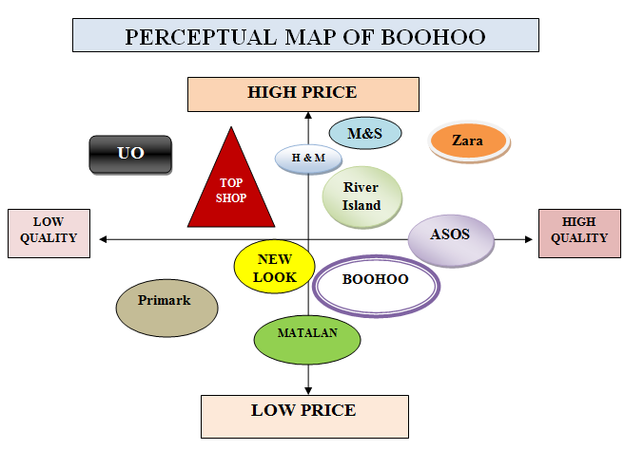
Figure 3: Perceptual mapping of Boohoo
(Source: Created by the researcher)
Unique selling proposition
Unlike other online retailers, Boohoo has its own USP of not just being imagery of its brand perception, but rather exaggerating content marketing aspects. Boohoo Group in its multinational branding has upheld authentic brand designing, outsourcing, and selling greater quality apparel, accessories, and shoes at an unbeatable price. Thus, in the UK Boohoo emerged to grow as a singular fashion brand with the most affordable and high-quality product compared to its competitors. On the contrary, Boohoo’s competitors such as M&S, River Island, and Zara has maintained high quality but at exceptionally high prices (GlobalData, 2023). In this context, Boohoo gathered more midline group Gen-Z and millennial customers whereas Primark deteriorated its brand value with low-quality and low-priced products. Therefore, Boohoo’s USP created its market value not only in the UK, and the US, but globally, in terms of brand online retailers and the leading e-commerce fashion market.
Both UK and US has the possibilities for its product advertisements and multinational branding however, Boohoo operating in UK has more grow opportunities as a singular fashion brand with the most affordable and high-quality product. Therefore, increasing scope of business expansion is more operative and profitable in UK than in USA.

6. Marketing mix elements 7Ps
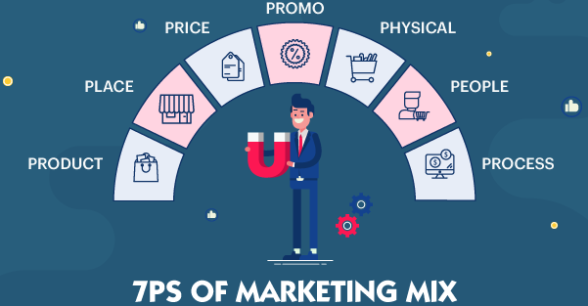
Figure 6: 7Ps marketing mix elements
(Source: Adapted from Paul and Mas, 2020)

a. Market entry methods in “place” element
Boohoo sells apparel and shoes via two-way marketing channels of which the first and foremost is business-to-customer operations. In business-to-customer operations, the company mostly operates in the UK with direct sales of its products to customers via the option of an online website. On the contrary, at the time of operating in the US, the company has opted for both business-to-business and business-to-customer operations. In the US, it has been observed the country operates almost 500 retailers in its B2B operations followed by utilisation of influencer marketing (Boohooplc.com, 2023). In contrast to this, in the UK, there has been a substantial amount of online sales via search engine optimisation or (SEO) marketing. A key performance indicator behind the exaggerated online operation is the frequent rise in online audience traffic in the SEO-optimised UK website of Boohoo. Further, extensive distribution networking operations are optimised and operated via integrated omni channel multi-integrated networking distribution channels. However, in the international aspect, in a vertically integrated network, there are 500 suppliers which are in outsourcing and procurement of raw materials for production (Boohooplc.com, 2023). The omnichannel distribution system gives opportunities for many delivery service providers to provide timely deliveries.
Comparing and contrasting, Boohoo in UK has facilities for foreign direct investment with online and omni-channel multi-integrated networking distribution channels. This is because UK investment opportunities are high and advantageous in R&D. However, licensing strategy required high trade barriers in UK. On the contrary, USA have low restricted areas of market expansion leveraging scope of licensing strategy in business, while FDI has low scope due to low investment opportunities.
6Ps
Product
Boohoo’s prime aim is to leverage its global brand portfolio under five broad categories utilising a product differentiation strategy. The company has adopted a flexible “inventory management model”. The flexibility of the “inventory management model” is driven by a “test and repeat” model for effective outsourcing and vertically integrated supply chain operations in a global aspect (Boohoo.com, 2023). The success behind globally operating in potential markets like the UK and the USA lies in vertical product differentiation in its outsourcing and supply of raw materials that are environmentally sustainable and eco-friendly products. Cotton and polyester products of the company are processed by recycling, reusing the wattage disposed of after manufacturing and production with the most sustainable sourcing method (Boohoo.com, 2023). Both UK and USA markets are highly driven to sustainable sourcing in the fashion industry such as organic cotton, and recycled synthetic cellulose as the most suitable eco-friendly and sustainable sources.
Price
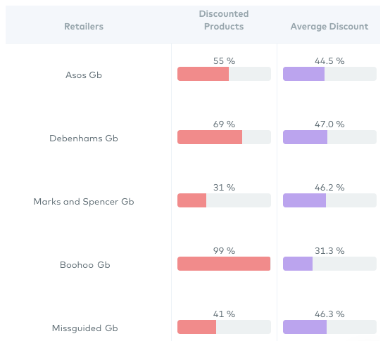
Figure 7: Boohoo’s pricing strategy
(Source: Statista, 2023)
Pricing strategy adopted by Boohoo is “Low Price High Volume” with its mastering supply chain outsourcing and vertical integration and low bargaining power of suppliers in the UK and the US. Unlike its competitors such as M&S, Zara, River Island, and ASOS, with high-quality and high-priced products, Boohoo focuses on low pricing with high volume production mainly in key seasonal trends. Boohoo has exaggerated its pricing tagline with its “sale is always on” strategy with catalogue on sale of 99% of products (Greendeck, 2019). The company has implemented a penetration pricing strategy for product value-based offers, trend offers, promotional sales, and seasonal sales. In comparison to its competitors, Boohoo emerged to sell 99% of its discounted products with average annual sales increasingly high.
Promotion
Boohoo's marketing strategy is driven by influencer marketing where the tagline of the organisational brand perception of “product, at a cheap, affordable price” is amplified by influencers and celebrities. Boohoo Group in the USA integrated new brands into folds and expanded to customer-centric markets. The strategic perspectives highlighted integrate its last-click ROI and measuring KPIs based on spending the money effectively (Innes, 2023). On the contrary, in the UK, the digital marketing strategy of Boohoo has revolved around its intuitive online shopping experiences leveraging its e-Commerce branding. In comparison to influencer marketing in the US, Boohoo in the UK promotional perspective preferred e-Commerce brands. This is because the e-Commerce brand leveraged brand valuation towards a strong social media presence, thereby outpacing its competitor ASOS. The strategic activity by which the company exaggerated its social media presence on popular platforms such as Instagram, Facebook, and Twitter is via affluent audience engagement (Boohooplc.com, 2023). Affluent audience engagement is successfully driven in the UK due to significant benefits in investment opportunities. Empirically in 2022, the research and development (R&D)’s total expenditure has been estimated to be more than £25 billion (GOV.UK, 2023). Comparing and contrasting, it has been observed the UK is more strategically in a better position for marketing opportunities for Boohoo for promotional activity options.
People
The sales team of Boohoo plays a significant role in operating entire sales and marketing operations in the UK and the US. Moreover, suppliers have a close working relationship with their suppliers that allow them to work through innovation and deliver trendy and sustainable outsourcing and procurement of raw materials. In the UK, Boohoo investors have the potential for the largest shareholders in fast fashion with a stake in extensive fund management. Boohoo handed shares to over 5000 employees who are highly committed to encouraging its employees and effective shareholder engagement (Robinson, 2022). In people management, Boohoo opted for midline group Gen-Z and millennial customers. In the UK and the US, customers prefer Boohoo brands in its online e-commerce trends driven by increased e-commerce sales. Moreover, Boohoo’s UK customers are highly adaptable to online shopping as analysed via customer values, attitudes, and lifestyles (Russell, 2022). In this perspective, in B2B operations, the company operates with direct sales of its products to customers through online websites in the UK. In contrast to this, in the US, Boohoo operates more than 500 retailers in its B2B operations utilising vertical integration networks.
Process
Boohoo’s e-Commerce business is driven by the creation of platforms for selling directly to shoppers with the removal of retail sales. Boohoo's business model has focused on ultra-cheap clothing and ultra-fast business operations unlike its competitor ASOS. In the UK, Boohoo’s revenue generation is crafted by selling fast fashion with effective distribution, marketing, and advertising (Cuofano, 2023). Further, the company has chosen the “test and repeat model” for the formulation of new fashion items in its saleability and mass production ramping up profit maximisation. In contrast to the UK business model, in the US, Boohoo is more driven towards fast fashion retailing with trends of a vertically integrated network. In its “test and repeat” model, the company tests the authenticity of procured raw materials driven to effective outsourcing and vertically integrated supply chain operations (Cuofano, 2023). The company is driven by the Environmental, Social, and Governance framework with vertical product differentiation in its outsourcing and supply of raw materials. It helps in the procurement of raw materials, and environmentally sustainable and eco-friendly products.
Physical Evidence
In both the UK and the US, Boohoo sells its products in distinctive colour packaging easily identifiable from the retail products. The specialty of the logo and identity of the Boohoo brand lies in its unique product detailing, casualness, specificity, and simplicity (Boohooplc.com, 2023). Colour combinations are very attractive and light with moral advice to the customers to choose a brand.
Analysis
Based on the analysis, it is analysed that both USA and UK both follow ethical pattern in packaging and distribution. This shows points of similarities in the application of 7 Ps including the use of sustainable packaging to consider the concerns of employees effectively (Cuofano, 2023). In addition, the inventory management is quite significant coupled with vertical integration that adds impetus to the company. On the other hand, "digital marketing" is more flexible in the UK compared to UK, where "intuitive online shopping experiences" is more emphasised to bring growth to operations.

7. Directional development strategy

a. Ansoff matrix
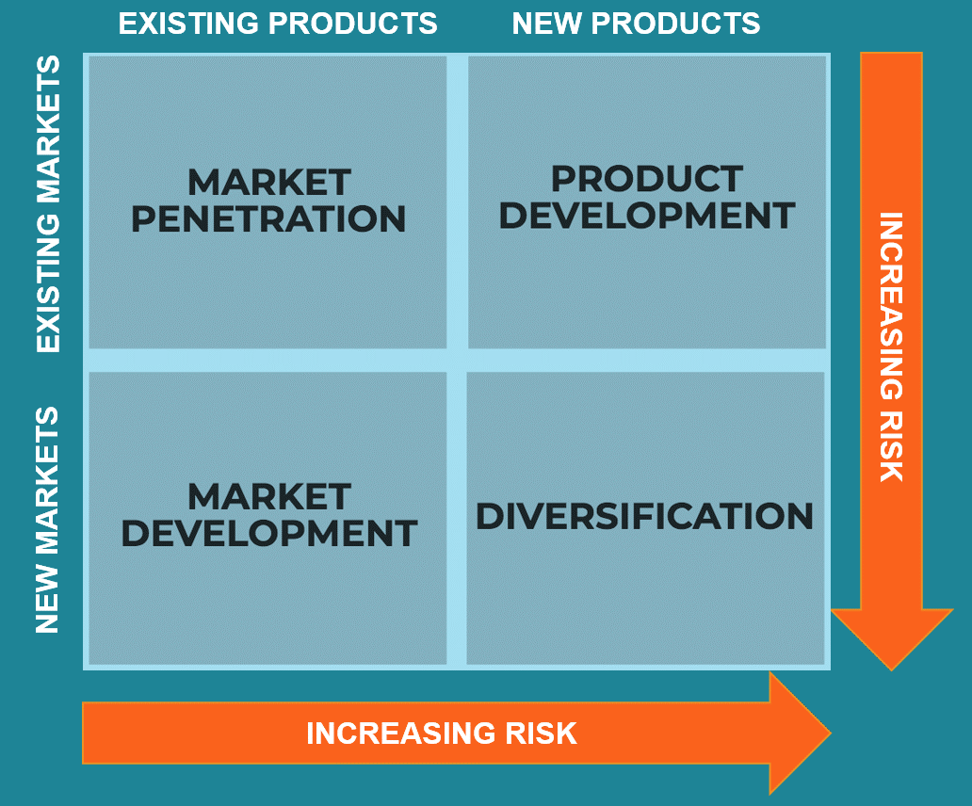
Figure 8: Ansoff matrix for successful international growth of Boohoo
(Source: Clarissia, 2020)
Directional strategy helps in keeping the firms focused on the most strategic possible ways with a continuation of business growth with a generation of revenues. As opined by Clarissia (2020), the Ansoff matrix helps in offering strategic choices for firms towards market penetration, product development, market development, and diversification.
Market penetration
Increase in production capacity allowed Boohoo to enter the USA and exaggerate vertical integration networks and authentic procurement in supply chain operations. The increase in production capacity in USA supply chain operations is positively driven due to the low bargaining power of suppliers and highly controlled overhead costs. Controlling the overhead costs led to choosing competitive pricing and operating in competitive markets. The company’s core market penetration strategy lies in the adoption of “Low Price High Volume” (Boohooplc.com, 2023). The strategy helped in mastering supply chain outsourcing and vertical integration and the low bargaining power of suppliers in the UK and the US. In this aspect, Boohoo's marketing strategy is driven by influencer marketing with a brand perception of “product, at a cheap, affordable price” being influenced by influencers and celebrities.
Market development
In the UK, the company leveraged foreign direct investment opportunities, significant investment opportunities with high returns on investment. Statistically, total expenditure on R&D is more than £25 billion in 2022 (GOV.UK, 2023). It shows targeting the UK to expand its business helped the company to gain a mass media base and a high generation of revenues. In this context, the business integrated its international human resource management for training and development initiatives. Effective grooming of employees helped build inclusivity and work as teams in cross-border regions.
Product development
Boohoo is engaged with R&D activities for understanding new product features as the consumer demands. In this process of configuring the product portfolio, new product development (NPD) helped in making product formulation as per trends and market orientations. Boohoo optimised its global brand portfolio via a product differentiation strategy with the adoption of an “inventory management model”. The vertical product differentiation helped in extensive outsourcing and supply of raw materials that are environmentally sustainable and eco-friendly products. Organic cotton, recycling, and reuse of polyester products are processed by recycling, reusing the waste disposal driven by manufacturing and production (Boohoo.com, 2023). Both UK and USA markets are highly driven to sustainable sourcing in the fashion industry such as organic cotton and recycled synthetic polyesters leveraging eco-friendly and sustainable sourcing operations.
Diversification
A diversification strategy is an outcome of deep consumer knowledge of introducing eco-friendly products into a business (Boohooplc.com, 2023). It helped in gaining mass customers with and leveraging social media and digital strategy for targeting potential markets.

b. Recommendations using TOWS matrix
TOWS matrix | External factors
Internal factors |  | Opportunities | Threats
Internal factors | Strengths | Strengths or opportunities | Strengths or threats
Internal factors | Strengths | Boohoo opted for vertical integration for sourcing and procurement of raw materials in its diversification strategy for vertical diversification of new products in eco-friendly product lines. | The company has incorporated diversity and inclusion in the workplace for internationally leveraging cross-cultural and multi-linguistic business communication and operations.
Internal factors | Weaknesses | Weakness or opportunities | Weakness or threats
Internal factors | Weaknesses | The “inventory management model” helped in driving the “test and repeat” model for effectual outsourcing and vertically integrated supply chain operations in USA and UK (Boohoo.com, 2023). | Intense competition and white space markets
Table 4: Recommendations using TOWS matrix
(Source: Created by the researcher)

c. Critical analysis of the ansoff matrix model
Advantages | Disadvantages
In market penetration, ansoff matrix accurately discussed Boohoo’s production capacity to enter the USA and exaggerate vertical integration networks and authentic procurement in supply chain operations. | In market development, ansoff matrix lacked talking about import and export strategy possibilities and opportunities in deep consumer knowledge of introducing eco-friendly products into a business.
Table 5: Critical analysis of the ansoff matrix model
(Source: Created by the researcher)

8. Product lifecycle model

a. Strategies to be used in each stage
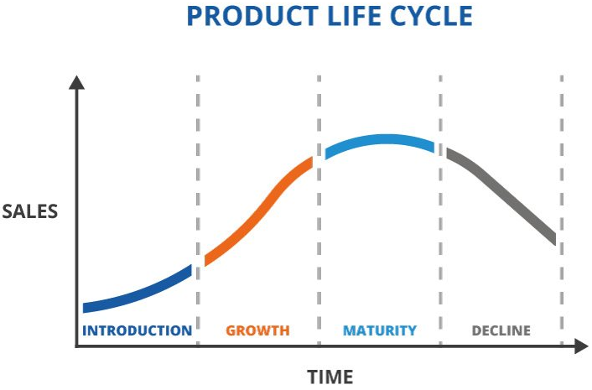
Figure 9: Product lifecycle model
(Source: Eslami et al. 2022)
Introduction
In the introduction phase of eco-friendly new clothing lines in new markets by Boohoo is associated with fast fashion technologies and circular economy driven. As opined by Eslami et al. 2022, product lifecycle model helps in analysing new product launch and gaining insight of its profitability in market. The most innovative promotional aspects in this case of introducing eco-friendly new clothing lines are celebrity endorsements, fashion magazines, and fashion shows.
Growth
In the growth phase, effective brand promotion in potential targeted markets helps in increasing the popularity of eco-friendly new clothing lines. It is associated with the acceptance of increased purchasing power of customers to buy eco-friendly fashion products.
Maturity
In the maturity phase, the new product line of eco-friendly and sustainable products reaches its peak with global recognition of Boohoo’s branded new products globally. It creates an opportunity to globally segment into new potential markets and gain white space markets. It has been observed that both the UK and the US are highly intense competitive markets with heavy fast fashion competition. It shows white space and less competitive and potential marketing areas help in gaining the visibility of the brand and leveraging its revenue generation. It can lead to increased cases of a huge customer base, leveraging ESG framework and environmental sustainability.
Decline
In the declining stage, after a certain period of time, there can be a dilemma in fast fashion and eco-friendly products becoming common in global fast fashion markets. There can be possibilities of the increasing popularity of old fashion over new fashion. It can lead to depreciation in Boohoo's brand valuation thereby declining the basic cycle of clothing. It creates dilemmas in Boohoo's core NPD processes to make transferable operations in product portfolio development.

9. Conclusion
It can be concluded that there have been differing elements utilised in international marketing such as research, infrastructure, product localisation, marketing localisation, communication, inbound marketing, and outbound marketing. International marketing gives scope to exporting enterprises that expand via business towards new markets and exporting products to foreign countries. In external market analysis, it has been observed that the government's investment in technology led to the digital frontier of Boohoo. In Hofstede model analysis, it has been pointed out USA organisational hierarchical structure is more convenient, easily communicating, transparent, and flat in comparison to ease in carrying out operations in the UK. In environmental scanning, it has been observed that Gen X customers are more inclined towards preferring sustainable fashion over others. On the contrary, Gen Z and millennials are slowly changing their consumption to bring more sustainability to their lives. It shows substitution in the USA is low pertaining to product standardisation. In contrast to this in the UK, cheap manufacturing helps in normalisation of undermined operations, and large expansion of the scope of substitution. Further, Boohoo extensively forecasted R&D activities for NPD in new product features as per consumer demands. It helped in the adoption of environmentally sustainable and eco-friendly products via extensive outsourcing and supply of raw materials. Therefore, both UK and USA markets drove sustainable sourcing of organic cotton and recycled synthetic polyesters leveraging eco-friendly and sustainable sourcing operations.

10. References
Bbc.com, (2022). US invests $280bn in high tech to compete with China. Available at: https://www.bbc.com/news/business-62482141[Accessed on: 14 April 2023]
Bbc.com, (2023). What impact has Brexit had on the UK economy?.Available at: https://www.bbc.com/news/business-64450882[Accessed on: 14 April 2023]
Bea.gov, (2023). Gross Domestic Product. Available at: https://www.bea.gov/data/gdp/gross-domestic-product[Accessed on: 14 April 2023]
Boohoo.com., (2023). Our Sustainability Plan. Available at: https://www.boohoo.com/page/sustainability-guide.html [Accessed on 14 April 2023]
Boohooplc.com, (2023). UP.FRONT boohoo group’s sustainability plan. Available at: https://www.boohooplc.com/sustainability[Accessed on: 14 April 2023]
Boohooplc.com., (2023). A fashion brand for a social generation. Available at: https://www.boohooplc.com/ [Accessed on 14 April 2023]
Boohooplc.com., (2023). Sustainability Report 2021. Available at: https://www.boohooplc.com/sites/boohoo-corp/files/boohoo-sustainabilty-report-2021.pdf [Accessed on 14 April 2023]
Cao, Y., Triebs, T. and Tumlinson, J., (2021). Does Language Disadvantage exist in Academia? An Empirical Analysis.
Clarissia, S.M.S., (2020). A study on Ansoff Matrix Technique: As a growth strategy and an adaptive learning technique adopted in the leading brand of products. BIMS Journal of Management, p.18.
Crsreports.congress.gov, (2023). U.S. Trade Policy: Background and Current Issues. Available at: https://crsreports.congress.gov/product/pdf/IF/IF10156#:~:text=Key%20Components%20of%20U.S.%20Trade%20Policy&text=Negotiation%20of%20trade%20agreements%20to,settlement%20and%20U.S.%20trade%20laws.&text=financing%2C%20market%20research%2C%20advocacy%2C,and%20control%20of%20strategic%20exports. [Accessed on: 14 April 2023]
Cuofano. G., (2023). The Boohoo Business Model in a Nutshell. Available at: https://fourweekmba.com/boohoo-business-model/ [Accessed on 14 April 2023]
Deloitte.com, (2023). Unleashing value from digital transformation: Paths and pitfalls. Available at: https://www.deloitte.com/global/en/our-thinking/insights/topics/digital-transformation/digital-transformation-value-roi.html[Accessed on: 14 April 2023]
Ecommercedb.com., (2023). e-Commerce revenue analytics of boohoo.com. Available at: https://ecommercedb.com/store/boohoo.com [Accessed on 14 April 2023]
Epa.gov, (2023). What is the National Environmental Policy Act? Available at:https://www.epa.gov/nepa/what-national-environmental-policy-act#:~:text=The%20National%20Environmental%20Policy%20Act%20(NEPA)%20was%20signed%20into%20law,actions%20prior%20to%20making%20decisions. [Accessed on: 14 April 2023]
Eslami, S.P., Ghasemaghaei, M. and Hassanein, K., (2022). Understanding consumer engagement in social media: The role of product lifecycle. Decision Support Systems, 162, p.113707.
Fashionunited.uk, (2023). UK fashion industry statistics. Available at:https://fashionunited.uk/uk-fashion-industry-statistics[Accessed on: 14 April 2023]
Firstinsight.com, (2023). Key Sustainability Differences Between UK And US Consumers. Available at:https://www.firstinsight.com/blog/key-sustainability-differences-between-uk-and-us-consumers[Accessed on: 14 April 2023]
Forbes.com, (2021). As ASOS And Boohoo Snap Up High Street Brands, Are They Missing An Opportunity To Add Bricks And Mortar Custom To Their Shopping Basket? Available at:https://www.forbes.com/sites/alliancembs/2021/02/24/as-asos-and-boohoo-snap-up-high-street-brands-are-they-missing-an-opportunity-to-add-bricks-and-mortar-custom-to-their-shopping-basket/[Accessed on: 14 April 2023]
Gcpit.org, (2020). Sustainable Fashion in United States: Challenges, Solutions, and Opportunities for Entrepreneurs. Available at: https://gcpit.org/sustainable-fashion-in-united-states-challenges-solutions-and-opportunities-for-entrepreneurs/[Accessed on: 14 April 2023]
GlobalData.com., (2023). Competitor comparison. Available at: https://www.globaldata.com/company-profile/boohoo-group-plc/competitors/ [Accessed on 14 April 2023]
Gov.uk, (2019). UK becomes first major economy to pass net zero emissions law. Available at:https://www.gov.uk/government/news/uk-becomes-first-major-economy-to-pass-net-zero-emissions-law[Accessed on: 14 April 2023]
Gov.uk, (2022). UK Digital Strategy. Available at:https://www.gov.uk/government/publications/uks-digital-strategy/uk-digital-strategy[Accessed on: 14 April 2023]
Gov.uk, (2023). Trade. Available at: https://www.gov.uk/government/organisations/department-for-international-trade[Accessed on: 14 April 2023]
GOV.UK., (2023). Corporate report. BEIS research and development (R&D): UK Research and Innovation allocation 2022-2023 to 2024-2025. Available at: https://www.gov.uk/government/publications/beis-research-and-development-rd-partner-organisation-allocation-2022-to-2025/beis-research-and-development-uk-research-and-innovation-allocation-2022-2023-to-2024-2025#:~:text=On%2014%20March%202022%20the,%2D2023%20to%202024%2D2025. [Accessed on 14 April 2023]
Greendeck.co., (2019). A comparison of the contrasting promotion strategies of Debenhams and Boohoo. Available at: https://blog.greendeck.co/a-tale-of-two-discount-strategies/ [Accessed on 14 April 2023]
Hofstede-insights.com, (2023). Country Comparison. Available at:https://www.hofstede-insights.com/country-comparison/the-uk,the-usa/[Accessed on: 14 April 2023]
Hugo, J., Sauerman, R., Schutte, H., Schutte, D. and Van Eeden, E., (2019). Managing a culturally diverse workforce: A managerial accountant perspective. International Journal of Management Excellence (ISSN: 2292-1648), 13(2), pp.1904-1909.
Iclg.com, (2023). Terms of employment. Available at:https://iclg.com/practice-areas/employment-and-labour-laws-and-regulations/usa#:~:text=The%20primary%20federal%20employment%20laws,Pay%20Act%20of%201963%3B%20the [Accessed on: 14 April 2023]
Innes. M., (2023). ‘A big transition’: How Boohoo Group’s marketing strategy is evolving. Available at: https://www.marketingweek.com/big-transition-boohoo-group-marketing-strategy/ [Accessed on 14 April 2023]
Laukka, P. and Elfenbein, H.A., (2021). Cross-cultural emotion recognition and in-group advantage in vocal expression: A meta-analysis. Emotion Review, 13(1), pp.3-11.
Legislation.gov.uk, (2010). Equality Act 2010. Available at:https://www.legislation.gov.uk/ukpga/2010/15/contents[Accessed on: 14 April 2023]
Legislation.gov.uk, (2021). Environment Act 2021. Available at:https://www.legislation.gov.uk/ukpga/2021/30/contents/enacted[Accessed on: 14 April 2023]
Mckinsey.com, (2019). Brexit: The bigger picture—Rethinking supply chains in a time of uncertainty. Available at: https://www.mckinsey.com/featured-insights/europe/brexit-the-bigger-picture-rethinking-supply-chains-in-a-time-of-uncertainty[Accessed on: 14 April 2023]
Mckinsey.com, (2022). Navigating America’s net-zero frontier: A guide for business leaders. Available at: https://www.mckinsey.com/capabilities/sustainability/our-insights/navigating-americas-net-zero-frontier-a-guide-for-business-leaders[Accessed on: 14 April 2023]
Newyorker.com, (2022). The Defeat of Identity Politics. Available at: https://www.newyorker.com/books/under-review/the-defeat-of-identity-politics[Accessed on: 14 April 2023]
Ons.gov.uk, (2023). Consumer price inflation, UK: February 2023. Available at:https://www.ons.gov.uk/economy/inflationandpriceindices/bulletins/consumerpriceinflation/february2023#:~:text=The%20CPIH%20inflation%20rate%20is,between%20January%20and%20February%202023. [Accessed on: 14 April 2023]
Ons.gov.uk, (2023). Gross Domestic Product (GDP). Available at:https://www.ons.gov.uk/economy/grossdomesticproductgdp[Accessed on: 14 April 2023]
Paul, J. and Mas, E., (2020). Toward a 7-P framework for international marketing. Journal of Strategic Marketing, 28(8), pp.681-701.
Pitchbook.com, (2023). UK launches $445M+ plan to boost tech investment. Available at:https://pitchbook.com/news/articles/uk-government-tech-science-investment#:~:text=The%20UK%20government%20has%20pledged,and%20technology%20superpower%22%20by%202030. [Accessed on: 14 April 2023]
Robinson. J., (2022). Top Boohoo investor slashes stake by more than half in major shares sell off. Available at: https://www.business-live.co.uk/retail-consumer/top-boohoo-investor-slashes-stake-22799185 [Accessed on 14 April 2023]
Russell. M., (2022). Boohoo eyes US sales growth with first stateside warehouse. Available at: https://www.just-style.com/news/boohoo-eyes-us-sales-growth-with-first-stateside-warehouse/#:~:text=Logistics%20firm%20DHL%20Supply%20Chain,growth%20in%20the%20US%20market. [Accessed on 14 April 2023]
Statista.com, (2023a). Country ranking by Social Progress Index 2022, by score. Available at:https://www.statista.com/statistics/256975/worldwide-index-of-social-progress/[Accessed on: 14 April 2023]
Statista.com, (2023b). Share of sustainable shopping behaviors among UK shoppers in 2022. Available at: https://www.statista.com/statistics/1056522/sustainable-shopping-behavior-of-uk-shoppers/[Accessed on: 14 April 2023]
Statista.com, (2023c). Share of consumers who would buy more sustainable fashion items if they were more widely available in the UK as of 2021, by generation. Available at:https://www.statista.com/statistics/1276255/importance-of-availability-of-sustainable-fashion-consumers-in-the-uk/#:~:text=In%20the%20UK%2C%20Gen%20X,the%20sustainable%20consumption%20of%20generations. [Accessed on: 14 April 2023]
Statista.com, (2023d). U.S. apparel market - statistics & facts. Available at:https://www.statista.com/topics/965/apparel-market-in-the-us/#topicOverview[Accessed on: 14 April 2023]
Statista.com, (2023e). Apparel - United States. Available at:https://www.statista.com/outlook/cmo/apparel/united-states[Accessed on: 14 April 2023]
Statista.com, (2023f). U.S. apparel market - statistics & facts. Available at:https://www.statista.com/topics/965/apparel-market-in-the-us/#topicOverview[Accessed on: 14 April 2023]
Statista.com, (2023g). Share of consumers who would buy more sustainable fashion items if they were more widely available in the United States as of 2021, by generation. Available at:https://www.statista.com/statistics/1276251/importance-of-availability-of-sustainable-fashion-consumers-in-the-us/[Accessed on: 14 April 2023]
Statista.com, (2023i). eCommerce - United Kingdom. Available at:https://www.statista.com/outlook/dmo/ecommerce/united-kingdom[Accessed on: 14 April 2023]
Statista.com, (2023j). Revenue of Boohoo.com Plc. group during the fiscal year 2021/22, by region. Available at: https://www.statista.com/statistics/794936/boohoo-plc-group-revenue-by-region/#:~:text=In%20the%20year%20ending%20February,and%20BoohooMAN%20in%20the%20UK. [Accessed on: 14 April 2023]
Statista.com., (2023). Number of active customers on Boohoo.com worldwide during the years 2012/13 to 2021/22 (in millions). Available at: https://www.statista.com/statistics/794926/boohoocom-active-customers-worldwide/#:~:text=The%20group%20designs%2C%20sources%2C%20markets,%2C%20US%2C%20Europe%20and%20Australia. [Accessed on 14 April 2023]
Statista.com., (2023). Revenue of Boohoo.com Plc. group during the fiscal year 2021/22, by region (in million GBP). Available at: https://www.statista.com/statistics/794936/boohoo-plc-group-revenue-by-region/#:~:text=This%20statistic%20shows%20the%20revenue,million%20in%20the%20United%20States. [Accessed on 14 April 2023]
Statista.com¸(2023h). Apparel market in the United Kingdom (UK) - statistics & facts. Available at:https://www.statista.com/topics/3348/apparel-market-in-the-uk/#topicOverview[Accessed on: 14 April 2023]
Taxsummaries.pwc.com., (2023). United States. Corporate - Taxes on corporate income. Available at: https://taxsummaries.pwc.com/united-states/corporate/taxes-on-corporate-income#:~:text=Foreign%20corporations%20and%20non%2Dresident,a%20US%20trade%20or%20business. [Accessed on 14 April 2023]
Theglobaleconomy.com, (2021). United Kingdom: Political stability. Available at:https://www.theglobaleconomy.com/United-Kingdom/wb_political_stability/#:~:text=Political%20stability%20index%20(%2D2.5%20weak%3B%202.5%20strong)&text=The%20latest%20value%20from%202021,to%20compare%20trends%20over%20time. [Accessed on: 14 April 2023]
Theglobaleconomy.com, (2021). USA: Political stability. Available at:https://www.theglobaleconomy.com/USA/wb_political_stability/#:~:text=Political%20stability%20index%20(%2D2.5%20weak%3B%202.5%20strong)&text=The%20latest%20value%20from%202021,to%20compare%20trends%20over%20time. [Accessed on: 14 April 2023]
Theguardian.com, (2023). US inflation at 5%, the lowest it has been since 2021. Available at:https://www.theguardian.com/business/2023/apr/12/cpi-inflation-rate-march-prices-fed#:~:text=US%20annual%20inflation%20reduced%20to,they%20first%20began%20to%20climb. [Accessed on: 14 April 2023]
The-mtc.org, (2023). Uk Textiles Manufacturing. Available at:https://www.the-mtc.org/media/njaiqfj4/uk-textiles-manufacturing-opportunities-and-challenges-for-the-uk-and-midlands.pdf[Accessed on: 14 April 2023]
Trade.gov, (2023). U.S. Market Entry Requirements. Available at:https://www.trade.gov/textile-and-apparel-us-market-entry-requirements[Accessed on: 14 April 2023]
Uk.practicallaw.thomsonreuters.com, (2022). Legal Systems in the UK (England and Wales): Overview. Available at: https://uk.practicallaw.thomsonreuters.com/5-636-2498?transitionType=Default&contextData=(sc.Default) [Accessed on: 14 April 2023]

11. Appendices

Appendix 1
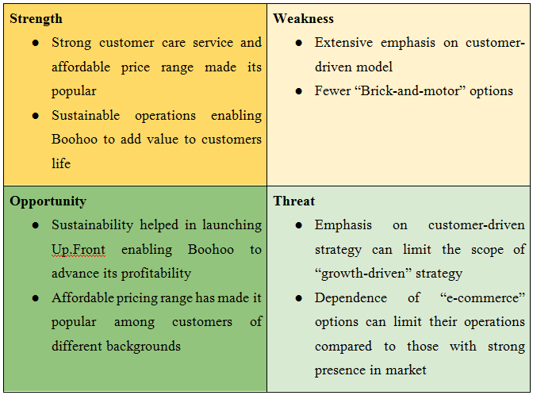
Figure 1: SWOT analysis of Boohoo
(Source: Created by author)

Appendix 2
Figure 2: Perceptual mapping of Boohoo
(Source: Created by the researcher)

Appendix 3
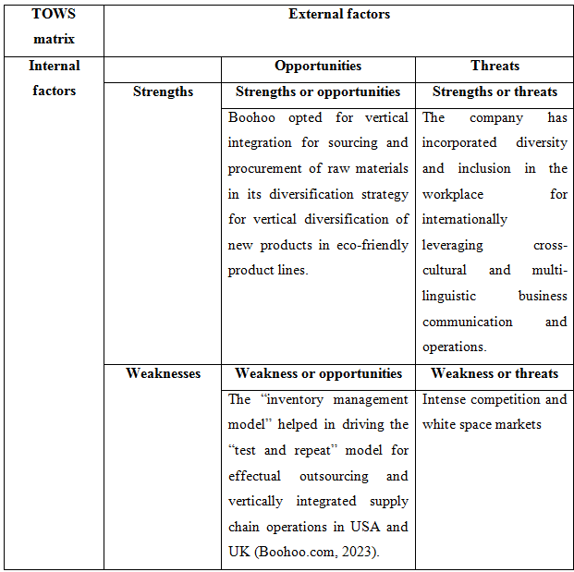
Figure 3: Recommendations using TOWS matrix
(Source: Created by the researcher)

