

Module name: Leading and Implementing Change
Module code: LCLM 60003
Lecture name: Ivan Rodriguez Hernandez
Student name: Yanis Popov
Student number: 2241239

A Strategic Change Plan for Concero Education

Table of Contents
1.Organisational Profile and Strategic Context 4
2.External Pressures Shaping Concero Education (PESTLE Analysis) 5
2.1 Political Factors 5
2.2 Economic Factors 5
2.3 Social Factors 5
2.4 Technological Factors 5
2.5 Legal Factors 6
2.6 Environmental Factors 6
3.Internal Capabilities and Constraints (SWOT Analysis) 7
3.1 Strengths 7
3.2 Weaknesses 7
3.3 Opportunities 7
3.4 Threats 8
4.Strategic Change Challenges and Risks 9
4.1 Organisational Capacity and Resource Constraints 9
4.2 Change Readiness and Cultural Resistance 9
4.3 Knowledge and Skills Gaps 9
4.4 Operational and Reputational Risk 9
4.5 Strategic Alignment and Leadership Gaps 10
5.Evaluation of Change Management Models 10
5.1 Lewin’s Three-Step Model: Foundational but Simplistic 10
5.2 Kotter’s Eight-Step Process: Momentum and Structure 11
5.3 ADKAR: Individual-Level Behaviour Change 11
5.4 McKinsey 7-S Framework: Ensuring Organisational Alignment 11
5.5 Comparative Synthesis and Relevance to Concero 11
6. Leadership and Organisational Culture 12
6.1 The Central Role of Leadership in Change 12
6.2 Appropriate Leadership Style for Concero 13
6.3 Current Cultural Characteristics and Their Impact 13
6.4 Shaping Culture to Support Change 13
6.5 Building Leadership Capacity 14
7.Integrated Change Strategy for Concero Education 14
7.1 Strategic Change Objectives 14
7.2 High-Level Financial Plan 15
7.3 Communication and Engagement Plan 15
7.4 Evaluation and Performance Monitoring 16
7.5 Risk Register and Mitigation Plan 16
8.Conclusion and Recommendations 16
Key Recommendations 17
9. Reference: 18

1.Organisational Profile and Strategic Context
Concero Education is a UK-based provider of IT services and educational technology (EdTech), with a focus on cybersecurity, cloud infrastructure, managed ICT support, and accessibility solutions for elementary and secondary schools. Since its founding in 2008, the organisation has developed into a reliable partner for West Midlands schools as well as the larger UK education sector. With about 40 employees, including technicians, engineers, and training specialists, Concero is positioned as a small-to-medium business with a strong emphasis on individualised and responsive service.

Figure 1: Concero Education Logo (Concero, 2025)

Concero provides digital training, hardware and software deployment, network management, and security compliance. It seeks to assist schools in developing dependable and secure digital systems by serving as a strategic partner.
The UK education sector has changed because of rapid technological advancement and the Covid-19 pandemic's acceleration of remote learning (Selwyn, 2021; Williamson and Hogan, 2020). Concero profited from the rise in demand, but schools now have tighter budgets and demand more sophisticated digital solutions.
Additionally, the organisation works in a highly regulated environment where strict adherence to Department for Education safeguarding standards and the UK GDPR is required. To preserve trust, cybersecurity and data privacy are still essential (Livingstone & Stoilova, 2021).
Concero's ability to implement automation, artificial intelligence, and advanced analytics is constrained by its small size and reliance on human-dependent processes, despite its strong customer relationships. Investing in technology, aligning cultures, and developing leaders are necessary to address this (Al-Ali et al., 2017).
Concero needs to move towards a scalable, cloud-based service model backed by digital transformation to remain competitive. Aligning people, procedures, and technology will increase resilience and allow the organisation to keep providing schools with safe, excellent services (Verhoef et al., 2021).

2.External Pressures Shaping Concero Education (PESTLE Analysis)
Concero Education offers cloud infrastructure, cybersecurity, accessibility, and ICT support to schools in the rapidly developing educational technology (EdTech) sector in the UK. But the environment in which it functions is changing due to a confluence of political, economic, social, technological, legal, and environmental forces. When taken as a whole, these factors show how urgent it is that Concero implement a single, integrated transformation: switching to a service model that is digitally enabled, scalable, and secure.

2.1 Political Factors
The education sector in the United Kingdom is significantly shaped by government policies and regulations. While Ofsted inspections increasingly assess schools' digital infrastructure and safeguarding, the Department for Education (DfE) sets digital priorities. Political focus is turning to digital resilience as cyber threats increase. Concero must, however, continue to be flexible and in line with national agendas due to the uncertainty caused by frequent policy changes and shifting funding priorities (Greany and Higham, 2018).

2.2 Economic Factors
Because of the legacy of COVID-19 and the cost-of-living crisis, school budgets are still under pressure. This has increased demand for cloud-based ICT that lowers operating and upfront costs. Research indicates that businesses that offer savings and efficiency tend to increase their market share during recessions (Dekimpe and Deleersnyder, 2018). Concero needs to position itself as an affordable supplier of scalable cloud solutions without sacrificing dependability if it wants to be successful.

2.3 Social Factors
Technology-enabled learning environments are becoming increasingly expected by society. The public demanded greater equity after the pandemic revealed disparities in digital access (Williamson and Hogan, 2020). While accessibility for people with special needs is becoming more important, parents, students, and educators now expect seamless digital learning (Selwyn, 2021). Therefore, Concero faces both chances to encourage inclusion and reputational risks if its services are viewed as insufficient.

2.4 Technological Factors
The performance bar for EdTech providers is rising due to the rapid innovation in cloud platforms, virtual learning environments, and AI-based analytics. Smaller businesses like Concero run the risk of becoming obsolete if they don't continuously innovate because schools demand solutions that are flexible and future-ready (Zawacki-Richter et al., 2019). According to Verhoef et al. (2021), a successful transformation necessitates not only the adoption of tools but also the alignment of processes, structures, and culture with digital delivery.

2.5 Legal Factors
The legal system is stringent, particularly when it comes to data. Adherence to safeguarding standards, the UK GDPR, and the Data Protection Act (2018) cannot be compromised. According to Livingstone and Stoilova (2021), data privacy is now a cornerstone of EdTech trust. Any violation would harm Concero's reputation with schools in addition to resulting in legal repercussions.

2.6 Environmental Factors
Purchasing decisions are increasingly taking sustainability into account. Schools look for vendors who are dedicated to managing e-waste, green IT, and carbon reduction. Concero can improve its market position by providing energy-efficient digital tools and circular IT lifecycle services, which are in line with the UK's Net Zero commitments (Salvia et al., 2019).
All things considered, Concero works in a challenging, heavily regulated, and resource-constrained setting. Political agendas, limited funds, the need for digital equity in society, the speed at which technology is developing, and sustainability standards all influence the purchases made by schools. Instead of requiring several distinct responses, these external pressures point to a single necessity: Concero needs to speed up its digital transformation in order to increase resilience, provide efficiency, and maintain its competitiveness in the UK EdTech market.
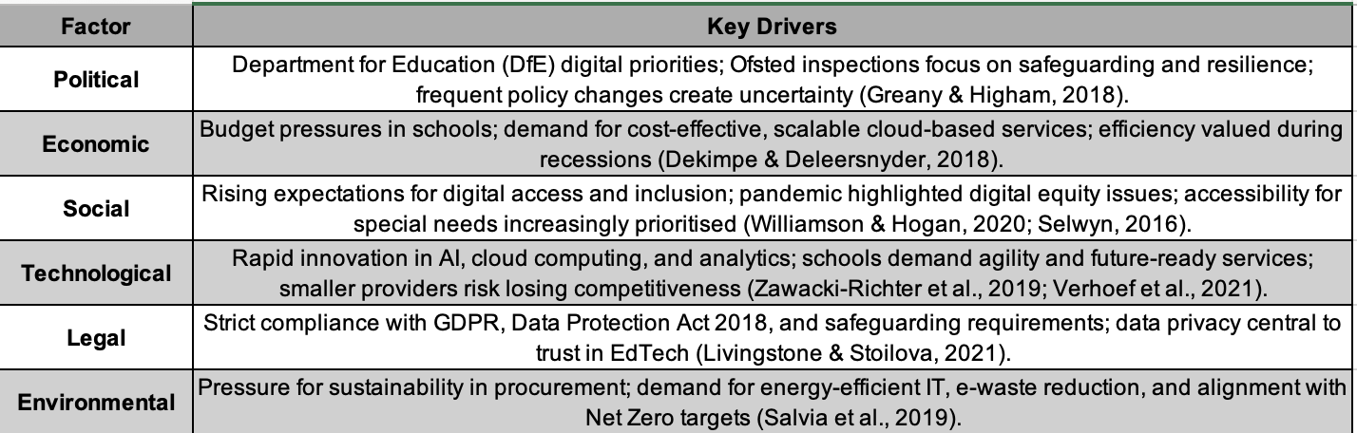
Figure 2: PESTLE Analysis of Concero (Yanis Popov, 2025)

3.Internal Capabilities and Constraints (SWOT Analysis)
Concero Education's internal resources and limitations determine its capacity to adapt to outside pressures. According to the SWOT analysis, the business has solid industry knowledge and customer confidence, but it also has structural flaws that restrict its ability to grow. These elements clearly support the pursuit of a single, integrated strategic shift: Concero's digital transformation via a cloud-based, scalable, and secure service model.

3.1 Strengths
- Sector-specific expertise:
Concero has a competitive edge over generalist IT providers due to its in-depth understanding of school ICT requirements, compliance, and pedagogy (Ng & Kwok, 2017).
- Trust-based service culture:
Long-standing connections with educational institutions encourage allegiance and lessen opposition to the adoption of new technologies (Selwyn, 2021).
- Flexibility and agility:
Compared to larger competitors, a lean structure facilitates speedy decision-making, enabling the implementation of transformation initiatives more quickly (Verhoef et al., 2021).

3.2 Weaknesses
- Over-reliance on people-dependent processes:
Instead of using codified systems, a large portion of service delivery relies on individual technicians, which restricts scalability and increases operational risk (Vial, 2021).
- Limited resources for innovation:
According to Bouwman et al. (2019), Concero lacks the financial and technological resources necessary to compete with bigger rivals in R&D, analytics, and AI development.
- Skills gaps:
Underdeveloped staff development in cutting-edge fields like cybersecurity and cloud orchestration could impede transformation initiatives (Ertmer and Ottenbreit-Leftwich, 2010).

3.3 Opportunities
- Cloud migration leadership:
Helping schools switch from on-site to cloud-based platforms allows for cost savings and scalability.
- Cybersecurity differentiation:
Growing cyberthreats present Concero with a chance to establish a solid reputation as a reliable supplier of safe educational systems.
- Data-driven decision tools:
Schools can gain a competitive edge by assisting them in using analytics to enhance results (Ertmer and Ottenbreit-Leftwich, 2010).
- Sustainable IT services:
Energy-efficient technologies, recycling e-waste, and green lifecycle management are all in line with Net Zero objectives (Salvia et al., 2019).

3.4 Threats
- Large competitors:
Concero's market share is at risk from national providers with greater resources.
- Talent retention risks:
Service continuity may be weakened if skilled technicians depart for larger organisations or higher salaries.
- Compliance and reputational risks:
One cybersecurity lapse could lead to lost contracts and erode trust (Livingstone & Stoilova, 2021).
Concero's agility, industry knowledge, and trust-based culture make it a strong candidate for change. However, growth is constrained by shortcomings in workforce skills, innovation resources, and scalability. The strategic imperative to convert operations into a scalable, secure, and digitally enabled service model is indicated by opportunities in cloud services, cybersecurity, analytics, and sustainability.
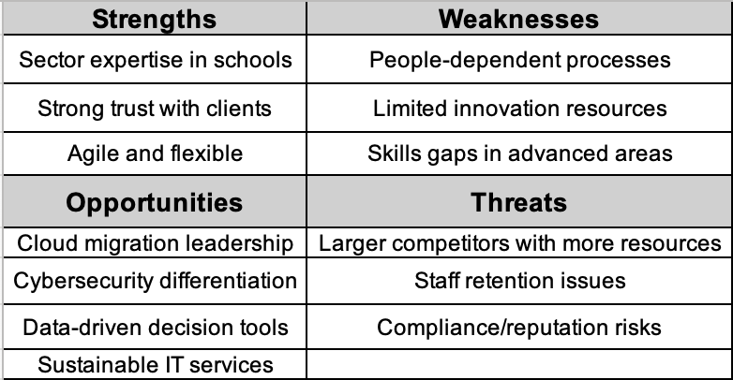
Figure 3: SWOT Analysis of Concero (Yanis Popov, 2025)

4.Strategic Change Challenges and Risks
It will be difficult to execute strategic change, even with Concero Education's industry experience and dependable clientele. The business works in a complicated environment that is influenced by changing laws, financial limitations, quick changes in technology, and rising demands for compliance and sustainability. These outside factors combine with Concero's internal flaws, such as a lack of resources, a lack of skilled workers, and a reliance on personnel-dependent procedures, to create significant risks that need to be properly controlled if the company's digital transformation project is to be successful.

4.1 Organisational Capacity and Resource Constraints
Concero is a small-to-medium-sized business (SME), so it does not have the same financial or human resources as its larger competitors. This leads to conflict between continuing to provide daily services and making investments in new systems like cybersecurity, cloud infrastructure, and employee training. SMEs frequently find it difficult to pursue digital transformation because operational demands take precedence over strategic innovation, claim Bouwman et al. (2019). Concero runs the risk of overworking its staff and eroding customer confidence if it doesn't plan.

4.2 Change Readiness and Cultural Resistance
Although valuable, Concero's informal, relationship-based culture and strong service ethos may encourage resistance to change. Employees used to autonomy and flexibility may view new systems, automation, and compliance protocols as a threat. Instead of being against change per se, resistance frequently results from a fear of losing identity or routines, as Oreg et al.,(2011) point out. Therefore, fostering buy-in via participation, communication, and psychological safety will be essential to the transformation

4.3 Knowledge and Skills Gaps
Although Concero's staff has experience with traditional systems, they are not proficient in cloud orchestration, cybersecurity, or AI-driven analytics. One of the most common obstacles to digital transformation in SMEs, according to Vial (2021), is a lack of skills. Concero runs the risk of project delays, low adoption, or even system failures if it tries to deploy cutting-edge technologies without making professional development investments. Building capacity will require selective hiring, mentorship, and structured training.

4.4 Operational and Reputational Risk
Change poses a significant risk to Concero's reputation and legal standing because it involves sensitive school data. Upgrades to the system could introduce vulnerabilities, and any noncompliance could erode confidence and cost you contracts. Credibility in EdTech requires data security and privacy, as argued by Livingstone and Stoilova (2021). In order to guarantee service dependability throughout the transition, Concero must control this risk through phased rollouts, rigorous quality assurance, and continuous monitoring.

4.5 Strategic Alignment and Leadership Gaps
Another difficulty is leadership ability. Due to their intense involvement in daily operations, Concero's leaders have little time for long-term planning and change management. However, to guarantee that new systems, culture, and procedures reinforce one another, strategic alignment and leadership commitment are necessary (Al-Ali et al., 2017). The digital transformation runs the risk of stalling or yielding only modest gains in the absence of clear, committed leadership.
Significant risks are associated with Concero's digital transformation, including a lack of funding, cultural opposition, a lack of skills, operational weaknesses, and a lack of leadership. However, these difficulties can be lessened and the transformation effectively accomplished with strong governance, workforce capability investment, phased implementation, and dedicated leadership.
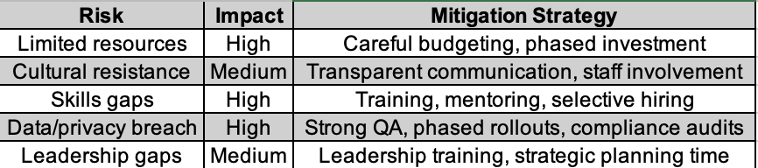
Figure 4: Risk Management for Concero’s Digital Transformation (Yanis Popov, 2025)

5.Evaluation of Change Management Models
To carry out its digital transformation while reducing disruption and increasing organisational capacity, Concero Education will require a methodical approach. Given Concero's small size, resource constraints, and people-centric culture, choosing the appropriate framework is essential. This section assesses four popular models: the ADKAR model, Kotter's Eight-Step Process, Lewin's Three-Step Model, and the McKinsey 7-S Framework. It contends that a hybrid strategy that incorporates their complementary advantages will be the most successful way to implement Concero's transformation.

5.1 Lewin’s Three-Step Model: Foundational but Simplistic
Three stages are described in Lewin's seminal model (1951): unfreezing, changing, and refreezing. The unfreezing stage is especially helpful for Concero, where staff members are very devoted to their current routines, to get them ready for new systems and mindsets (Burnes, 2004). Its linear structure, however, is too basic for the ongoing modifications required by digital transformation (Vial, 2021). As a result, Lewin's framework can serve as the basis for sequencing change, but it needs assistance from more intricate models.

5.2 Kotter’s Eight-Step Process: Momentum and Structure
By placing more emphasis on urgency, leadership, and momentum, Kotter's (1996) model builds upon Lewin. According to Concero, overcoming cultural inertia and preserving morale during resource-intensive changes require actions like assembling a guiding coalition, formulating a vision, and producing quick victories (Al-Ali et al., 2017). However, its top-down, hierarchical structure might be too inflexible for Concero's flat organisational structure (Pollack and Pollack, 2015). Kotter's procedure would be more successful if it were modified to involve staff involvement.

5.3 ADKAR: Individual-Level Behaviour Change
Individual awareness, desire, knowledge, ability, and reinforcement are highlighted in Hiatt's ADKAR model (2006). This is particularly important for Concero because the success of digital transformation will depend on how well frontline technicians adopt new tools. To determine whether barriers are caused by skills, motivation, or reinforcement, ADKAR offers a diagnostic tool (Ertmer and Ottenbreit-Leftwich, 2010). But because ADKAR doesn't focus on systems, it needs to be combined with more comprehensive models that take strategy and culture into account.

5.4 McKinsey 7-S Framework: Ensuring Organisational Alignment
The goal of the McKinsey 7-S model (Waterman et al., 1980) is to align shared values, staff, skills, systems, structure, strategy, and style. This is crucial for Concero: staff training, new leadership behaviours, and cultural change are required to support new technologies (Verhoef et al., 2021). The model assists in identifying misalignments that could impede transformation, such as those between Concero's informal structure and its innovative ambitions, even though it is diagnostic rather than prescriptive (Ravanfar, 2015).

5.5 Comparative Synthesis and Relevance to Concero
Each model offers distinct advantages but is insufficient on its own. A blended approach is therefore most appropriate for Concero’s digital transformation:
- The general sequence is given by Lewin.
- Kotter creates momentum, urgency, and vision.
- ADKAR guarantees technicians' individual adoption.
- Organisational alignment between people, processes, and systems is confirmed by McKinsey 7-S.
Concero's main risks—leadership gaps, cultural resistance, skills shortages, and structural misalignments—are all addressed by this hybrid framework. Concero can pursue its digital transformation with both strategic clarity and pragmatic adaptability by combining models.
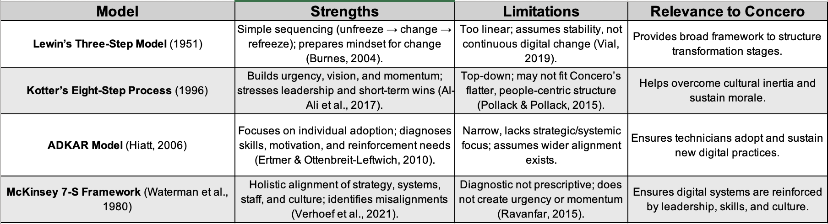
Figure 5: Comparative Evaluation of Change Models for Concero (Yanis Popov, 2025)

6. Leadership and Organisational Culture
Successful strategic change depends as much on an organization's human and cultural components as on its systems and processes. Leadership effectiveness and cultural alignment will be critical to the success of Concero Education's digital transformation initiative. Concero Education is a small, relationship-driven company. This section assesses which leadership philosophies are best suited for Concero and examines how the company's current culture might either facilitate or impede change.

6.1 The Central Role of Leadership in Change
An organization's culture and employee attitudes are greatly influenced by its leadership. According to Al-Ali et al. (2017), leadership has an impact on cultural alignment, which in turn influences how change turns out. The behaviour and attitudes of leaders set the tone for SMEs like Concero. Now, customer service and operational delivery are major responsibilities of Concero's leadership. Although this guarantees top-notch support, it restricts their ability to concentrate on long-term planning and methodical change management. Effective change leadership, according to Kotter (1996), necessitates not only overseeing operations but also developing alliances, inspiring dedication, and expressing a compelling vision.
Concero's transformation requires leaders to become strategic change leaders rather than merely operational managers, investing time in long-term goals and clearly exhibiting new behaviours.

6.2 Appropriate Leadership Style for Concero
Concero's digital transformation is best suited for transformational leadership. Transformational leaders encourage motivation and creativity by articulating a compelling vision, promoting innovation, and offering tailored support (Bass and Riggio, 2006). According to Oreg et al.,(2011), such actions are crucial for overcoming cultural resistance and motivating employees to view digital initiatives as opportunities rather than threats, such as cloud migration or cybersecurity upgrades.
However, participative leadership, which encourages employees to share ownership of change and offer ideas, must be used in conjunction with transformational leadership. Incorporating technicians into planning will foster internal champions, increase trust, and lessen resistance in Concero's close-knit community (Lines, 2004).

6.3 Current Cultural Characteristics and Their Impact
Concero has a casual, relationship-focused, and customer-focused organisational culture. Although this culture encourages responsiveness and loyalty, it might not align with the standardisation and systematisation needed for scalable digital solutions. Organisational culture is influenced by deeply held beliefs, as Schein (2010) points out. At Concero, convictions like "personal service is better than standardised processes" may make automation and compliance-based procedures difficult to implement. Concero has to actively reshape its cultural foundations because cultural misalignment is one of the best indicators of resistance (Oreg et al., 2011).

6.4 Shaping Culture to Support Change
Leaders must combine structural and symbolic actions to align culture with transformation goals:
- Symbolic actions include:
Articulating a clear vision that connects digital transformation to better school outcomes, demonstrating desired behaviours using new systems and candid sharing of educational experiences.
- Structural measures:
Match incentives and HR policies to the new cultural values by:
- Integrating creativity and teamwork into performance evaluations.
- Allowing time and resources for experimentation.
- Rewarding those who implement new practices first.
Schein (2010) emphasises that daily behaviours and rewards, not catchphrases, are what reinforce culture. Concero may eventually come to believe that "service depends on systems and teams" rather than "service depends on individuals."

6.5 Building Leadership Capacity
Concero's small size means that a small number of people bear most of the leadership duties. Expanding leadership capacity is necessary to maintain transformation. This entails enabling senior technicians and middle managers to act as change agents and connect frontline execution with top-level strategy (Floyd and Wooldridge, 1997). By investing in coaching, mentoring, and leadership development, these individuals will be able to motivate their peers and instill change throughout the organisation.
For Concero's digital transformation to be successful, culture and leadership must change in tandem with technology. In addition to adopting a transformational-participative style and purposefully reshaping cultural presumptions, leaders must transition from operational to strategic roles. To maintain change, a broader base of leadership must be established. Even technically sound projects run the risk of failing in the absence of dedicated leadership and cultural alignment.

7.Integrated Change Strategy for Concero Education
Concero needs to switch from a people-dependent support model to a scalable, digitally enabled service model to stay competitive in the quickly changing EdTech sector. Investments in cloud infrastructure, improved cybersecurity, process automation, workforce upskilling, and cultural realignment are all necessary for this. The goals, tools, framework for communication, monitoring, and risk management required for a successful digital transformation are outlined in the integrated strategy that follows.

7.1 Strategic Change Objectives
Based on the PESTLE and SWOT analyses, Concero’s transformation will be guided by five objectives:
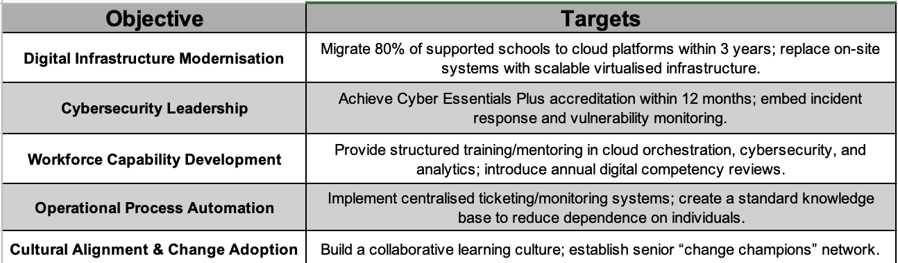
Figure 6: Strategic Objectives for Concero’s Transformation (Yanis Popov, 2025)

7.2 High-Level Financial Plan
Phased transformation is necessary to strike a balance between ambition and viability, given Concero's SME status and limited financial resources. A proposed three-year staged budget is as follows:
- Year 1: Building Capacity: Set aside 15% of the yearly operating budget for cybersecurity and cloud training for employees, the hiring of one or two specialist engineers, and the Cyber Essentials Plus certification procedure.
- Year 2: Systems and Infrastructure Set aside about a quarter of the funds for the purchase of automation platforms, monitoring systems, cloud orchestration tools, and the creation of standardised processes and a common knowledge base.
- Year 3: Scaling and Optimisation: Allocate roughly 20% of the budget to expanding the reach of managed cloud services to additional educational institutions, streamlining procedures, and optimising delivery models.
Although these allocations seem doable, rigorous cost control and phased reinvestment are necessary for them to be adequate. If Concero reinvests early cloud migration project revenues to finance later phases, I believe the plan is financially feasible. However, SMEs frequently incur unforeseen costs, especially when it comes to staff training, IT integration, and licensing. Concero should set aside at least 10% to 15% of the budget for a contingency fund in order to protect against these risks. If costs surpass initial projections, this buffer would guarantee resilience and safeguard service quality.
It has been demonstrated that SMEs can scale innovation while controlling financial exposure through phased investment backed by reinvestment of early project gains (Bouwman et al., 2019). This strategy gives the financial plan flexibility to adjust to unforeseen obstacles while maintaining ambition and realism.
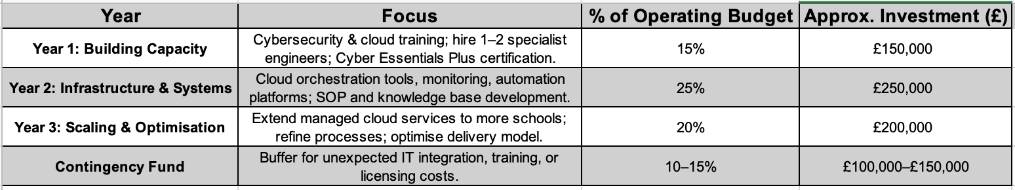
Figure 7: High-Level Financial Plan for Concero’s Transformation (Yanis Popov, 2025)

7.3 Communication and Engagement Plan
Overcoming resistance requires structured, multi-level communication (Lines, 2004). Concero should adopt a three-tier approach:
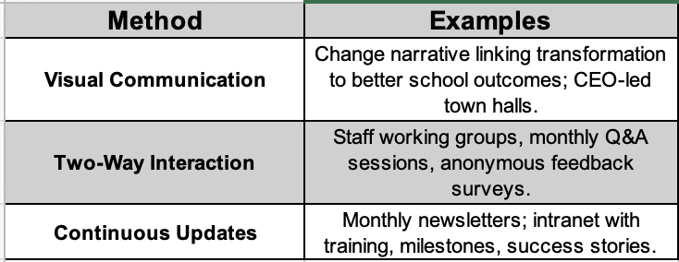
Figure 8: Communication and Engagement Plan (Yanis Popov, 2025)

7.4 Evaluation and Performance Monitoring
Progress should be tracked quarterly using Key Performance Indicators (KPIs). Suggested indicators include:
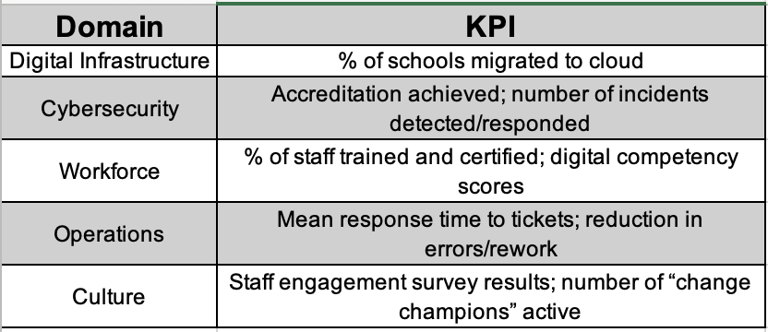
Figure 9: Key Performance Indicators for Transformation (Yanis Popov, 2025)
Balanced scorecards and review meetings (Kaplan and Norton, 2005) can ensure accountability and momentum.

7.5 Risk Register and Mitigation Plan
Digital transformation carries risks that must be proactively managed:
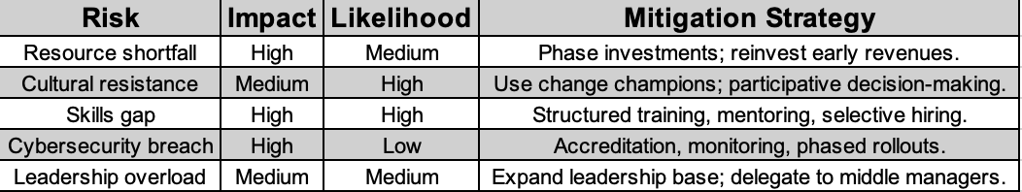
Figure 10: Risk Register for Concero’s Transformation (Yanis Popov, 2025)

8.Conclusion and Recommendations
Concero Education's strategic position in the UK EdTech market and the pressing need for organisational change have been evaluated in this report. According to the analysis, Concero gains from its sector-specific knowledge, agility, and reliable clientele. Political unpredictability, shrinking school budgets, technological disruption, data security regulations, and sustainability pressures pose serious threats to it as well (PESTLE). Internal weaknesses brought about by Concero's people-dependent model include a lack of resources, a lack of skills, and an excessive dependence on unofficial procedures (SWOT).
Concero needs to change from a relationship-based support provider to a scalable, digitally enabled learning technology partner in order to maintain its competitiveness in the future. Coordination of investments in workforce competencies, digital infrastructure, cultural fit, and leadership ability are necessary to achieve this.
According to an analysis of change management models, no one framework is adequate. Concero should instead take a hybrid approach that makes use of Kotter's steps for urgency and momentum, Lewin's three stages for sequencing, ADKAR for individual adoption, and McKinsey 7-S for organisational alignment. This process revolves around leadership and culture. Leaders need to adopt a transformational-participative approach, involving staff members with a clear vision and integrating learning and accountability.
An integrated change strategy that incorporates precise goals, a phased financial investment, strong communication, organised monitoring, and proactive risk management was described in Section 7. Concero will be able to maintain trust with schools while creating the digital systems and culture needed for long-term growth thanks to this phased and participatory approach.

Key Recommendations
- Adopt a Hybrid Change Framework
To provide structure, momentum, behavioural adoption, and organisational alignment, combine Lewin, Kotter, ADKAR, and McKinsey 7-S (Burnes, 2004; Verhoef et al., 2021).
- Prioritise Workforce Development
To boost motivation and retention, provide structured training in analytics, cloud services, and cybersecurity. Connect newly acquired skills to career advancement (Ertmer and Ottenbreit-Leftwich, 2010).
- Embed Transformational-Participative Leadership
Middle managers serve as change agents, and senior leaders must move from operational focus to vision-setting and cultural change (Bass and Riggio, 2006; Lines, 2004).
- Formalise and Automate Processes
Implement standardised knowledge bases, monitoring systems, and workflows to guarantee scalability and lessen reliance on specialised knowledge.
- Implement Continuous Evaluation and Risk Management
To keep things moving forward and address problems as soon as they arise, monitor progress using quarterly KPIs, balanced scorecards, and frequent risk assessments (Kaplan and Norton, 2005).

9. Reference:
Al-Ali, A.A., Singh, S.K., Al-Nahyan, M. and Sohal, A.S., 2017. Change management through leadership: the mediating role of organizational culture. International Journal of Organizational Analysis, 25(4), pp.723-739.
Available at: https://www.emerald.com/ijoa/article-abstract/25/4/723/137536/Change-management-through-leadership-the-mediating?redirectedFrom=fulltext

Bass, B.M. and Riggio, R.E., 2006. Transformational leadership. Psychology press.
Available at: https://www.taylorfrancis.com/books/mono/10.4324/9781410617095/transformational-leadership-bernard-bass-ronald-riggio

Bouwman, H., Nikou, S. and De Reuver, M., 2019. Digitalization, business models, and SMEs: How do business model innovation practices improve performance of digitalizing SMEs?. Telecommunications Policy, 43(9), p.101828.
Available at: https://www.sciencedirect.com/science/article/abs/pii/S0308596117304238

Burnes, B., 2004. Kurt Lewin and the planned approach to change: a re‐appraisal. Journal of Management studies, 41(6), pp.977-1002.
Available at: https://onlinelibrary.wiley.com/doi/full/10.1111/j.1467-6486.2004.00463.x

Dekimpe, M.G. and Deleersnyder, B., 2018. Business cycle research in marketing: A review and research agenda. Journal of the Academy of Marketing Science, 46(1), pp.31-58.
Available at: https://link.springer.com/article/10.1007/s11747-017-0542-9

Ertmer, P.A. and Ottenbreit-Leftwich, A.T., 2010. Teacher technology change: How knowledge, confidence, beliefs, and culture intersect. Journal of research on Technology in Education, 42(3), pp.255-284.
Available at: https://www.tandfonline.com/doi/abs/10.1080/15391523.2010.10782551

Floyd, S.W. and Wooldridge, B., 1997. Middle management’s strategic influence and organizational performance. Journal of Management studies, 34(3), pp.465-485.
Available at: https://onlinelibrary.wiley.com/doi/abs/10.1111/1467-6486.00059

Greany, T. and Higham, R., 2018. Hierarchy, markets and networks: Analysing the'self-improving school-led system'agenda in England and the implications for schools.
Available at: https://discovery.ucl.ac.uk/id/eprint/10053501/

Hiatt, J., 2006. ADKAR: a model for change in business, government, and our community. Prosci.
Jarke, J. and Breiter, A., 2019. The datafication of education. Learning, Media and Technology, 44(1), pp.1-6.
Available at: https://books.google.co.uk/books?hl=en&lr=&id=Te_cHbWv-ZgC&oi=fnd&pg=PA1&dq=Hiatt,+J.,+2006.+ADKAR:+a+model+for+change+in+business,+government,+and+our+community.+Prosci.+Jarke,+J.+and+Breiter,+A.,+2019.+The+datafication+of+education.+Learning,+Media+and+Technology,+44(1),+pp.1-6.&ots=1tjLl-nZKI&sig=1zC8Nvg29yh8EkSDxaK_tBtKUzM&redir_esc=y - v=onepage&q&f=false

Kaplan, R.S. and Norton, D.P., 2005. The balanced scorecard: measures that drive performance (Vol. 70, pp. 71-79). Boston, MA, USA: Harvard Business Review.
Available at: https://images.template.net/wp-content/uploads/2016/04/11122659/balanced-scorecard-key-performance-indicators.pdf
Kotter, J.P., 1996. Leading Change, Harvard Business School Press, Boston. Search in.
Available at:

Lines*, R., 2004. Influence of participation in strategic change: resistance, organizational commitment and change goal achievement. Journal of change management, 4(3), pp.193-215.
Available at: https://www.tandfonline.com/doi/abs/10.1080/1469701042000221696

Oreg, S., Vakola, M. and Armenakis, A., 2011. Change recipients’ reactions to organizational change: A 60-year review of quantitative studies. The Journal of applied behavioral science, 47(4), pp.461-524.
Available at: https://journals.sagepub.com/doi/abs/10.1177/0021886310396550

Pollack, J. and Pollack, R., 2015. Using Kotter’s eight stage process to manage an organisational change program: Presentation and practice. Systemic practice and action research, 28(1), pp.51-66.
Available at: https://link.springer.com/article/10.1007/s11213-014-9317-0

Salvia, A.L., Leal Filho, W., Brandli, L.L. and Griebeler, J.S., 2019. Assessing research trends related to Sustainable Development Goals: Local and global issues. Journal of cleaner production, 208, pp.841-849.
Available at: https://www.sciencedirect.com/science/article/abs/pii/S0959652618329810

Schein, E.H., 2010. Organizational culture and leadership (Vol. 2). John Wiley & Sons.
Available at: https://books.google.co.uk/books?hl=en&lr=&id=Mnres2PlFLMC&oi=fnd&pg=PR9&dq=Schein,+E.H.,+2010.+Organizational+culture+and+leadership+(Vol.+2).+John+Wiley+%26+Sons.&ots=oqhrLa0qLn&sig=b5rQ9aYHsVHvvPgAn0uHESeO7_Q&redir_esc=y - v=onepage&q=Schein, E.H., 2010. Organizational culture and leadership (Vol. 2). John Wiley %26 Sons.&f=false

Selwyn, N., 2021. Education and technology: Key issues and debates. Bloomsbury Publishing.
Available at: https://books.google.co.uk/books?hl=en&lr=&id=dMZKEAAAQBAJ&oi=fnd&pg=PR1&dq=Selwyn,+N.,+2021.+Education+and+technology:+Key+issues+and+debates.+Bloomsbury+Publishing.&ots=wnTOPJZHAu&sig=-ydEqIFDg_KcoJJK2DQ8DOzgFDM&redir_esc=y - v=onepage&q=Selwyn, N., 2021. Education and technology%3A Key issues and debates. Bloomsbury Publishing.&f=false

Verhoef, P.C., Broekhuizen, T., Bart, Y., Bhattacharya, A., Dong, J.Q., Fabian, N. and Haenlein, M., 2021. Digital transformation: A multidisciplinary reflection and research agenda. Journal of business research, 122, pp.889-901.
Available at: https://www.sciencedirect.com/science/article/pii/S0148296319305478

Vial, G., 2021. Understanding digital transformation: A review and a research agenda. Managing digital transformation, pp.13-66.
Available at: https://www.taylorfrancis.com/chapters/edit/10.4324/9781003008637-4/understanding-digital-transformation-gregory-vial

Waterman Jr, R.H., Peters, T.J. and Phillips, J.R., 1980. Structure is not organization. Business horizons, 23(3), pp.14-26.
Available at: https://tompeters.com/docs/Structure_Is_Not_Organization.pdf

Williamson, B. and Hogan, A., 2020. Commercialisation and privatisation in/of education in the context of Covid-19.
Available at: https://eprints.qut.edu.au/209028/

Zawacki-Richter, O., Marín, V.I., Bond, M. and Gouverneur, F., 2019. Systematic review of research on artificial intelligence applications in higher education–where are the educators?. International journal of educational technology in higher education, 16(1), pp.1-27.
Available at: https://link.springer.com/article/10.1186/S41239-019-0171-0

