MARKETING MANAGEMENT
Executive Summary
Sainsbury has prepared their marketing policies for knowing their customers and their requirements in order to meet their needs successfully. The vision of this company is to provide quality goods at fair prices for getting medium to high-profile consumers. Marketers conducting demographic segmentation have become fruitful for this company to know the preferences of the customers. Digitization has improved the standard of marketing approaches which has developed brand awareness and brand reputation. The study has portrayed that Sainsbury has been following “omnichannel marketing approach” to give their consumers a unified buying experiences.

Table of Contents
a) Environmental marketing analysis 3
Background of Sainsbury's 4
Analysis of key external influencing drivers 5
Analysis of the internal environment 6
The role of marketing plays in Sainsbury's 7
b) Future Recommendations for the company Sainsbury's 9
Reference List 12

a) Environmental marketing analysis

Figure 1: Environmental marketing analysis
Environmental market analysis (EMA) evaluates certain factors that affect the companies to understand the position of the companies in the market. This analysis can be beneficial for marketers to understand the opportunities, threats, strengths, and weaknesses which help to reform their operational strategies. Natural environmental analysis helps marketers to detect the company’s internal and external issues and strengths that have an impact on achieving success (Liute and De Giacomo, 2022). Demographic segmentation allows marketers to know about the customers’ financial standards. The political conditions of the country help establish trading policies and pay taxes accordingly.
Marketers effectively select the target markets for understanding the socio-culture, values, habits, beliefs, and customs of the customers which make them make purchasing decisions. Economic factors determine the cost of labor, rate of unemployment, job growth, the effect of inflation, and the income of the customers. EMA allows marketing managers to improve the structure, culture, and strategies of the business organization for their growth and development (Patwary et al. 2022). Hence, market analysis needs to be conducted to have knowledge about the interests of stakeholders, dealers, suppliers, and consumers.
In addition, digital marketing has improved its sales record high and is able to compete with its competitors. Marketers of Sainsbury have been focusing more on online marketing to understand the changing attitudes and switching brands tendencies of the customers. The feedback achieved by the companies through the platforms of social media can be effective for forming marketing policies to gain more customers (Ngo, 2022). Hence, EMA can help marketers to conduct customer segmentation easily and rapidly which helps to improve their product quality and delivery services. PESTLE and SWOT analysis have been discussed for this company to understand its market position in the UK. The performance of the company can be analyzed in an effective way to gain scope and reduce market threats.

Background of Sainsbury's
Sainsbury has been denoted as one of the leading grocery retail companies in the UK. Mark Given, the marketing director has been playing a significant role to improve their strategies to acquire more investors and consumers to increase their sales record. The main competitors of Sainbury are Tesco, Aldi, ASDA, and Morrisons (sainsburys.co.uk, 2023). The marketing policies need to reframe for mitigating market risks and combating competitors. Hence, Sianbury has been operating supermarkets and other stores conveniently by providing fresh groceries for their consumers. The study has shown that this company has more than 180,000 employees who have been providing effective services to retain their customers.
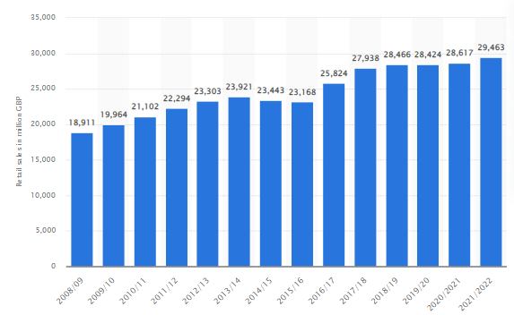
Figure 2: Annual retail sales of Sainsbury's
(Source: statista.com, 2023)
Figure 2 depicts that the annual record of sales of this company in recent years has increased nearly to 29.46 billion British pounds. This company has been developing marketing strategies for its future growth and expansion of business. Marketing mix policies and unique selling price strategies can be effective for increasing sales revenue after having a huge financial loss during the pandemic situation.

Analysis of key external influencing drivers
PESTLE analysis
Factors | UK
Political | - The political environment is stable  - Attracts investment for the growth of the business organization
Economical | - Annual GDP is nearly 2.979 trillion US dollars  - Inflation rate declined to nearly 0.77%
Social | - Multicultural population  - Education level is high
Technological | - Technologically advanced country  - Allows innovation and creativity in the business to progress
Legal | - Equality Act 2010 and Employment Act 1996  - Laws related to trade have allowed the companies to execute their business operations
Environmental | - Sustainable environment  - Pollution has decreased
Table 1: PESTLE analysis
Stable monarchy rule in the UK has allowed industrial growth through embracing technology and innovation in marketing management skills. The study has depicted that the low corruption level in the country has influenced many retail companies to grow their business effectively. The rate of literacy can increase the level of employment which is beneficial for economic growth (Roh et al. 2022). The study has depicted that the unemployment rate in the UK has recently increased nearly to 0.4%. The growth of the GDP of this country has helped to achieve the rank 26th for sharing capital in the market. Moreover, the corporate tax has been reduced by the UK government by 17%. This has increased the progress of retail industries and consumers have been obtaining groceries at affordable costs.
The pandemic situation has lowered the rate of sales which has aware marketers to develop unique strategies for conducting marketing to gain more customers. The acceptance of technology has improved the working process of the companies (Adhikara et al. 2022). The recent population of the UK is 67 million people which have increased the standard of the consumer market significantly. In addition, the diverse culture of the UK has allowed retail companies to offer different types of commodities to meet their daily requirements.

Analysis of the internal environment
SWOT analysis
Strength  - Follow specific and unique strategies for promoting products  - Online presence has improved brand recognition  - Provides segments products  - Skills in digital marketing | Weakness  - High completion in retail markets  - Uncertain economy due to pandemic situation  - Customers have been switching brands  - Financial loss
Opportunities  - Provides “24*7” services  - Global expansion of business  - Diversify in new products  - Growth in rural areas | Threats  - The advent of new technologies  - Developing competitors  - Economic loss  - Liability laws
Table 2: SWOT analysis
Sainsbury uses a “Brand Match” strategy for promoting their grocery products to the customers. High-quality and cheaper products can increase consumer engagement (Krishnan et al. 2022). Hence, this company has significantly and positively built loyal connectivity with its customers by staying consistent in its trading relationships. Digital marketing has improved its sales record highly and is able to compete with its competitors. The trading and liability laws can become a threat for this company and required to set new policies for selling the products and rising margin of profit. Timely services of this company have become advantageous for retaining customers and building a better connectivity with them.
Retail brands have been facing business risks the customers have been switching to new brands (Qing et al. 2022). Hence, the annual profit of this company decreased in the year 2020. The pandemic situation has created a financial loss and marketers have been focusing on digitization for the growth of this company. The threat from competitors has increased highly since they have attracted a major share in the demanding markets. Digital marketing has been helping marketing executives to know the purchasing experiences of the customers which help this company to improve their decision-making plans.

The role of marketing plays in Sainsbury's
The pandemic situation has created a financial loss and marketers have been focusing on digitization for the growth of this company. The diverse culture of the UK has allowed retail companies to offer different types of commodities to meet their daily requirements. Marketing mix policies and unique selling price strategies can be effective for increasing sales revenue. Media advertisements and online channels play magnificent role in executing the process marketing effectively and creatively (Liute and De Giacomo, 2022). Hence, the content needs to be informative and factual for attracting the customers. Sainsbury uses a “Brand Match” strategy for promoting their grocery products to the customers. Marketers effectively select the target markets for understanding the socio-culture, values, habits, beliefs, and customs of the customers which make them make purchasing decisions. EMA can help marketers to conduct customer segmentation easily and rapidly which helps to improve their product quality and delivery services.
Digitization has improved the standard of marketing approaches which has developed brand awareness and brand reputation. The study has portrayed that Sainsbury has been following “omnichannel marketing approach” to give their consumers a unified buying experiences. The study has depicted that this company has been facing challenges, such as globalization, changing environment of business, competitiveness in the markets, managing reputation, and expectations of customers have increased. Effective communication of marketers can help to interpret value proposition of the companies to gain advantages of sustainable competition (Karimjanova and Soliyeva, 2022). Hence, digital marketing has improved business strategies effectively for staying active in the markets. In addition, selecting specific target market can be beneficial for conducting marketing plans.

Figure 3: Marketing approaches of Sainsbury
Sainsbury has prepared their marketing policies for knowing their customers and their requirements in order to meet their needs successfully. The vision of this company is to provide quality goods at fair prices for getting medium to high-profile consumers. Marketers conducting demographic segmentation have become fruitful for this company to know the preferences of the customers (sainsburys.co.uk, 2023). Thus, the marketing objectives of this company is to increase sales record, improve brand awareness programs, increase market share, and introduce new products to gain the attention of the customers. Moreover, this company has become involved in embracing technology and innovative products to overcome the economic loss due to the pandemic situation. Hence, the market research has guided the company to improve their financial condition highly with consistency in their products and maintaining cost-effective pricing strategy.

b) Future Recommendations for the company Sainsbury's
The omnichannel marketing strategies have been followed in the company Sainsbury's workplaces around their different outlets in the world. Though the increasing market share of the company may lead it to be in number one position again in the UK retail stores, few recommendations are suggested for the company.
- Pricing strategy should be implemented in their stores by reducing price of their products according to the preferences of the products that can be bought from other small retail stores at a less price (Alshuridehet al. 2020). As the price is one of the most important factors for the consumer's daily savings of household expenditure, current situation should be considered for the effective pricing.
- To improve the sales according to the consumer's behaviours of the current global recession period, the management of the company should have the consideration of these crisis in the due time and follow some strategic options to have the consistent productions according to the demand and supply.
- The leaders of the marketing management team should be aware of the store sizes and its operating time schedules in the different areas within the country of United Kingdom. As the operating hours in different areas are the most important factors for the attractions of the customers, there should have the flexible operating scheduling in the respective stores with the capabilities of bigger outlets as demanded by the consumers (Mukherjeeet al. 2020).
- There should be the more collection of standard products of different brands in their outlets and the prices of the products should be cost-effective so that the people would get more options to buy with their income levels. However, more the wider brand selection with various price ranges will attract more numbers of customers in their stores.
- The financial managers of the company should focus on attracting more stakeholders and investments in their business to reduce the overall debt of the company through their different financial operations across the globe. They should also focus on their internal management first and then look into the expanding their outlets worldwide through developing their own offline stores and the online stores as well.
- The management should study the market movements properly as there were different crisis and recession is ongoing around the world and these factors can impact their businesses. Recent credit crisis in UK in the year of 2020, covid pandemic effect, Russia-Ukraine war and the recession hits the UK's GDP and as well the markets of the retail businesses also (Jonesand Comfort, 2020).

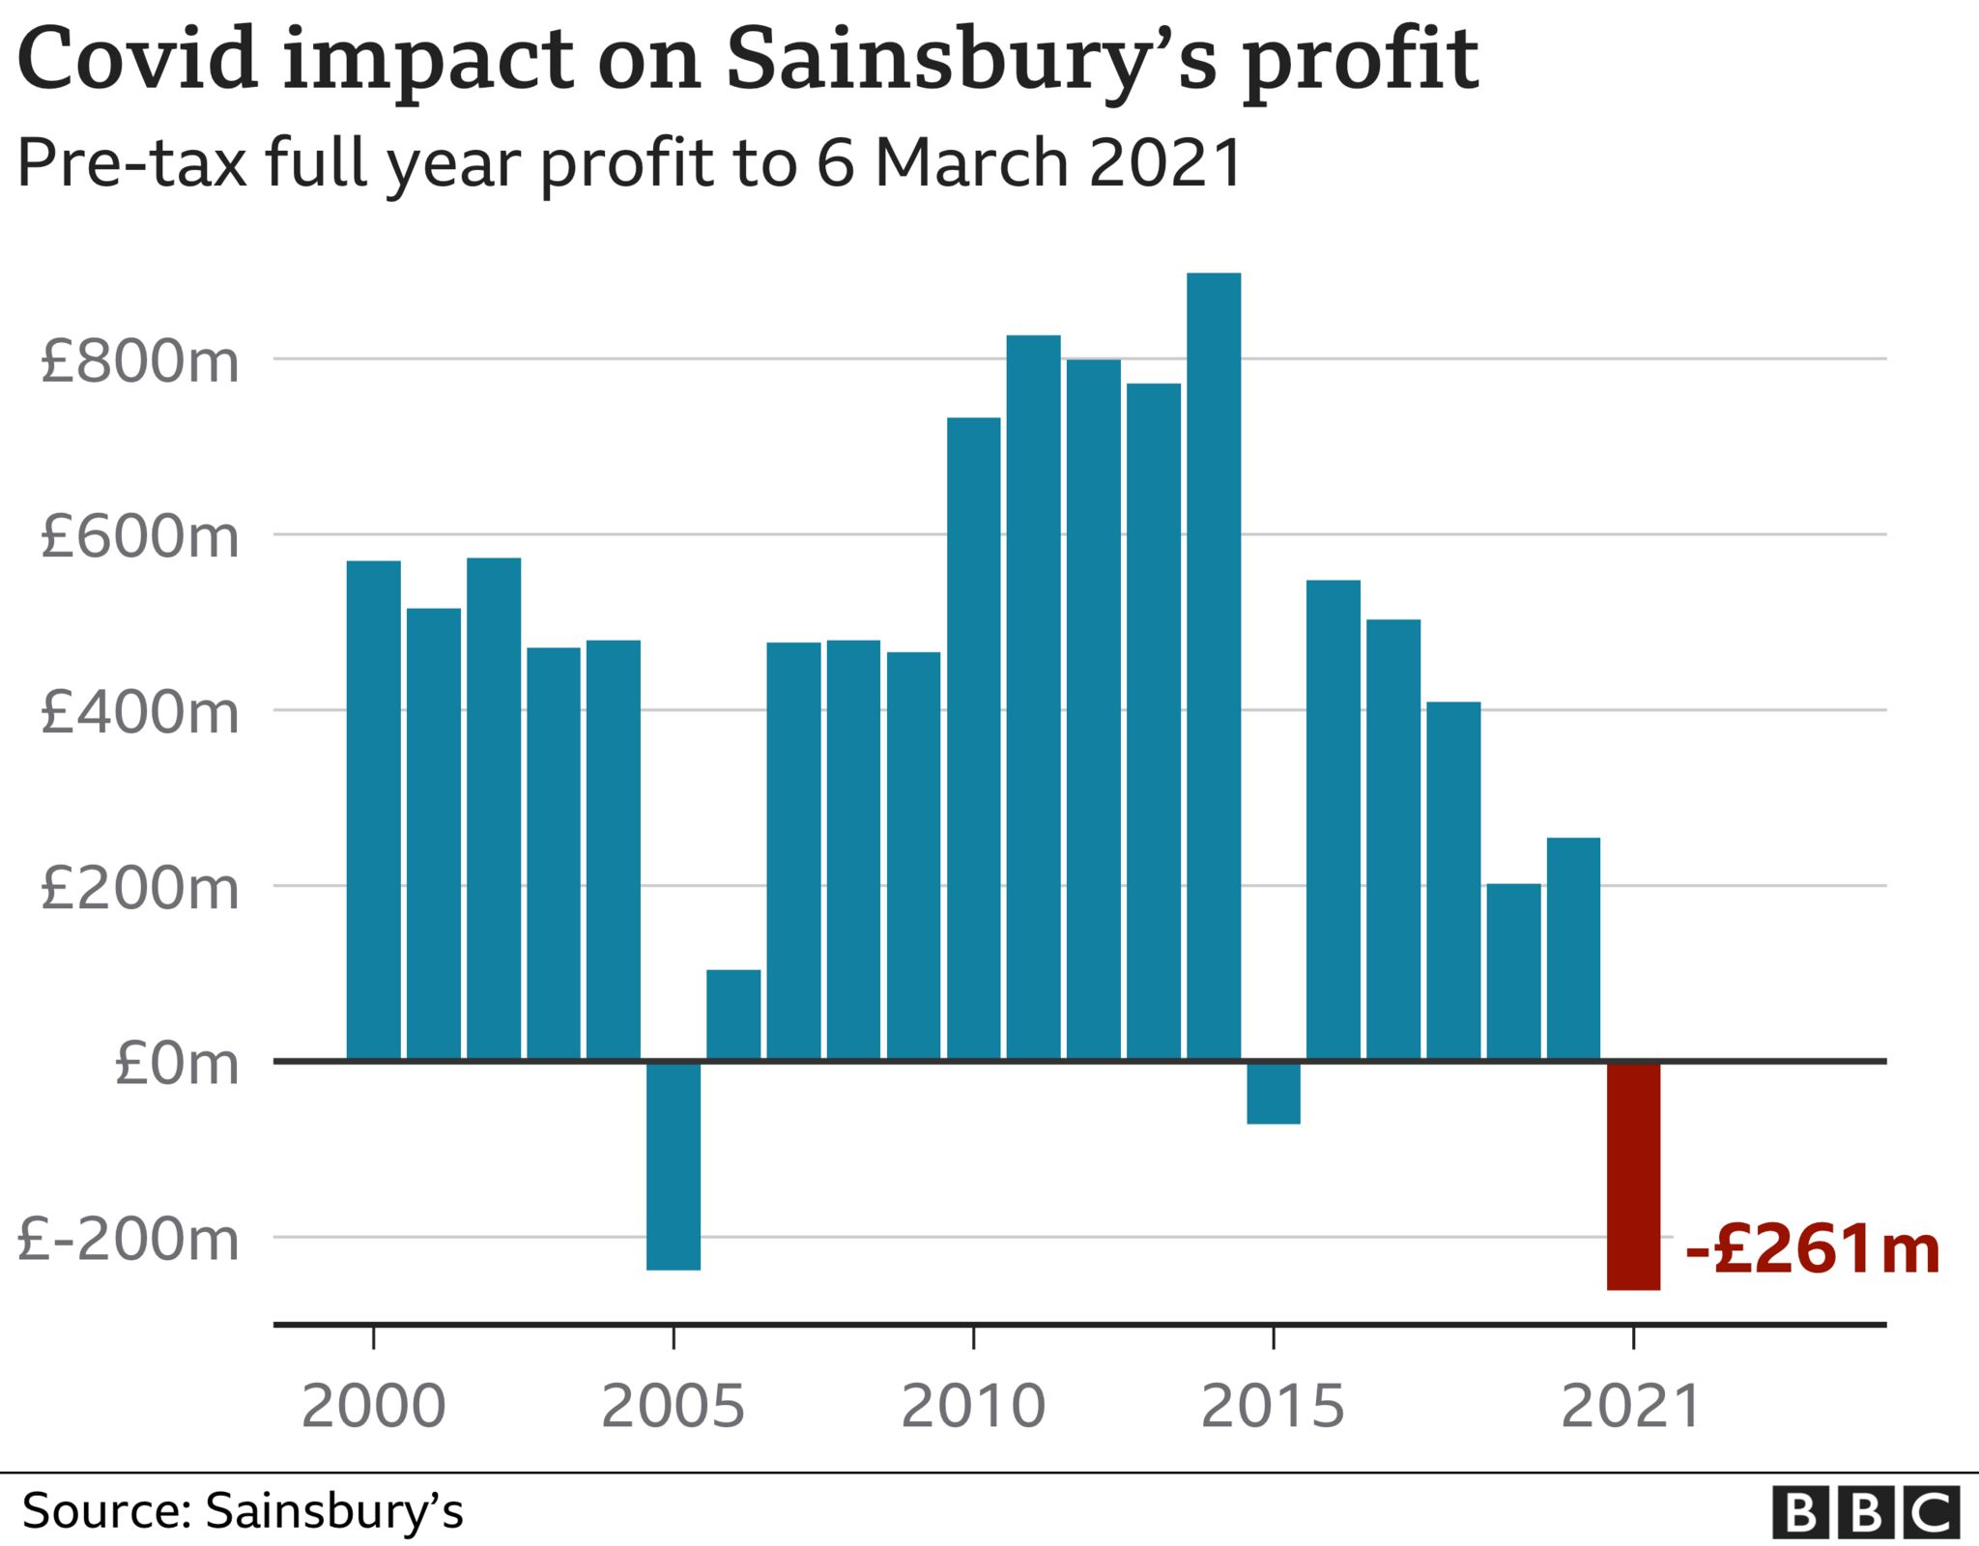
Figure 1: Impact of Covid-19 crisis in the profits of Sainsbury’s
(Source:Sainsburys,2023)
- Although the company has implemented all the required innovations and creative strategies in their in-stores and as well in various options of online shopping, there has been the use of Samaritan that is providing the significant services and it is the product of "Contact Pigeon". This chatbots are offering and helping the Sainsbury's different operations for improving customer experiences and supports and overall, more engagements of new consumers as well. This functional technology may help to increase the sales in their stores through providing new offers and services that has not being served by other competitors.

Reference List
Adhikara, A., MF, M. and Nur Diana, M.B., 2022. Organizational Performance in Environmental Uncertainty on the Indonesian Healthcare Industry: A Path Analysis. Academic Journal of Interdisciplinary Studies, 11(2), pp.365-377.
Alshurideh, M., Gasaymeh, A., Ahmed, G., Alzoubi, H. and Kurd, B., 2020. Loyalty program effectiveness: Theoretical reviews and practical proofs. Uncertain Supply Chain Management, 8(3), pp.599-612.
Jones, P. and Comfort, D., 2020. Sustainability bonds and green bonds in the retail sector. International Journal of Sales, Retailing and Marketing, 9(1), pp.37-43.
Karimjanova, R.M. and Soliyeva, G.A., 2022. The Role and Importance of Marketing Research in the Modernization of the Economy of the Republic. European journal of innovation in nonformal education, 2(1), pp.220-224.
Krishnan, A., De Marchi, V. and Ponte, S., 2022. Environmental upgrading and downgrading in global value chains: A framework for analysis. Economic Geography, pp.1-26.
Liute, A. and De Giacomo, M.R., 2022. The environmental performance of UK‐based B Corp companies: An analysis based on the triple bottom line approach. Business Strategy and the Environment, 31(3), pp.810-827.
Mukherjee, M., Ramirez, R. and Cuthbertson, R., 2020. Strategic reframing as a multi-level process enabled with scenario research. Long Range Planning, 53(5), p.101933.
Ngo, T.Q., 2022. How do environmental regulations affect carbon emission and energy efficiency patterns? A provincial-level analysis of Chinese energy-intensive industries. Environmental Science and Pollution Research, 29(3), pp.3446-3462.
Patwary, A.K., Mohamed, M., Rabiul, M.K., Mehmood, W., Ashraf, M.U. and Adamu, A.A., 2022. Green purchasing behaviour of international tourists in Malaysia using green marketing tools: theory of planned behaviour perspective. Nankai Business Review International, 13(2), pp.246-265.
Qing, L., Chun, D., Ock, Y.S., Dagestani, A.A. and Ma, X., 2022. What myths about green technology innovation and financial performance’s relationship? A bibliometric analysis review. Economies, 10(4), p.92.
Roh, T., Noh, J., Oh, Y. and Park, K.S., 2022. Structural relationships of a firm's green strategies for environmental performance: The roles of green supply chain management and green marketing innovation. Journal of Cleaner Production, 356, p.131877.
sainsburys(2023), about,Accessed from: https://www.sainsburys.co.uk/, [Accessed on 18.04.2023]
sainsburys.co.uk, 2023 About Us Available at: https://www.sainsburys.co.uk/ [Accessed on; 28th March, 2023]
statista.com, 2023 Annual retail sales of Sainsbury's Available at: https://www.statista.com/statistics/386342/sainsburys-retail-sales-united-kingdom-uk/ https://www.sainsburys.co.uk/ [Accessed on; 28th March, 2023]

