Critical Evaluation of the NHS App as a Digital Transformation in Health and Social Care

Student Name – Kiran Ashraf
Student Number - 2331397

Table of Contents
Introduction 2
Workforce 2
Service Delivery 4
Patient/Service User 5
Community 6
Conclusion 8

Introduction
The NHS App was launched in England in 2019 as an official digital route into NHS services. It enables patients to request repeat prescriptions, access GP records, make appointments, and access NHS 111 online. The technology is a web and mobile based application, not a physical medical device. Implementing it is significant as it transforms the way patients, staff, families, and communities communicate with healthcare services. The report is a critical assessment of how the NHS App is implemented in workforce, service delivery, patient experience, and community impact. The discussion is based on the official NHS sources and academic research to discuss advantages and drawbacks.
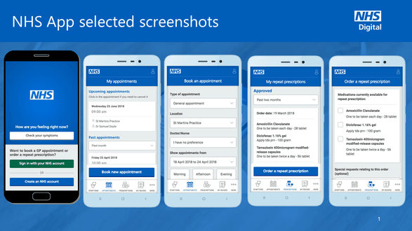
Figure 1: NHS App Screenshot

Workforce
According to NHS England (2023), NHS App aids in prescription requests, GP records, messages, and appointment functions in primary care. This demonstrates that implementation shifted the frontline work as the daily interaction with patients shifted partially into the digital system. Receptionists and care navigators thus were required to assist with access to apps, log-in problems, prescription inquiries, and record-related queries. Reidy et al. (2025) confirm this argument with a national assessment of the NHS App implementation in England. They discovered that implementation was based on personnel capacity, local leadership, training, and faith in linked GP systems. This implies that once the technology was introduced in primary care, it did not automatically decrease the working load. Rather, it moved work to digital instructions, patient facilitation, and system navigation to already strained practices. Thus, during workforce transformation, there was a reduction of tasks, and a redesign of tasks.
The recovery plan provided by NHS England provides a practical example of the Solihull Healthcare Partnership Primary Care Network. It claimed that 650-700 repeat prescriptions were made per week via the NHS App. This means that online prescription ordering will decrease part of the routine phone and reception requests (NHS England, 2023). KC et al. (2023) further concluded that the number of prescription orders via the app had grown significantly following the initial lockdown. In their research, they propose that the app was particularly helpful when they could not access traditional services. But, as their results were revealed, registration and active use did not coincide. This restricts the benefits of the workforce since patients might download the app and still require the assistance of personnel. Thus, the decrease of workloads is conditioned by the digital confidence, local promotion, and patient capability to utilize certain functions.
Online access to GP records resulted in unintentional consequences of primary care staff (Turner et al., 2023). Employees were required to control access, clarify clinical data, and consider risks associated with record visibility. This directly concerns the matter since the ability to look at GP records is one of the main features of the NHS App. Their results are a blow to the belief that access to records only brings transparency and efficiency. Reidy et al. (2025) also discovered that the complexity of implementation influenced the utilisation of the app by staff and patients. This implies that the effect of the workforce occurs based on local preparedness, quality of the system, and prudent role development. The NHS App thus results in a hybrid workforce. It saves some of the repetitive administration work, yet it introduces new digital, communications, and protecting duties.

Service Delivery
According to NHS England Digital (2026), there were 74.8 million NHS App login sessions in April 2026, which indicates significant routine use. It also registered 14.87 million unique monthly users and over seven million repeat prescription orders. These statistics indicate that the service delivery has moved offline of contact routes to digital self-service routes. Additional functions given by NHS England Digital (2026) include prescriptions, GP health records, messages, and GP registration changes. This implies that the app is not only an information tool, but a convenient access route. Patients are now able to do routine duties without going to surgeries or queuing on telephone lines. Thus, the implementation has transformed day-to-day delivery by making it available outside the normal practice opening hours.
KC et al. (2023) discovered that the post-first COVID-19 lockdown NHS App prescription ordering was higher than before by 225%. This observation indicates that the application facilitated continuity in the event of interruption of face-to-face primary care. According to NHS England Digital (2026), prescriptions in 3,060 pharmacy locations were also tracked by April 2026. This facilitates service delivery since the patients are able to monitor the progress of prescriptions better by the app. Nonetheless, KC et al. (2023) revealed that the rate of appointments booking decreased at the time of lockdown. According to them, certain procedures turned off the online booking of appointments due to safety and capacity concerns. This reveals that the impact of the service provided by the app is dependent on local operational decisions. The national app thus does not ensure equal access to all functions in England.
Reidy et al. (2025) discovered that the NHS App tends to be a portal into the pre-existing GP systems. This is significant since the provision of services relies on local software, permissions, coding, and information quality. Patients might hope to get a single national NHS experience, which is not the case with the app, which shows various local digital infrastructures. KC et al. (2025) also discovered that an increased use of apps did not necessarily correlate with an improved patient experience. They provided an ecological analysis that revealed that the use of apps differed with broader access conditions in general practice. This implies that the NHS App is optimized when using a robust multi-channel access model. It must be able to supplement telephone, web based, and face-to-face services and not eliminate them. The app thus enhances service delivery, though it requires the local systems to be accessible and coordinated.
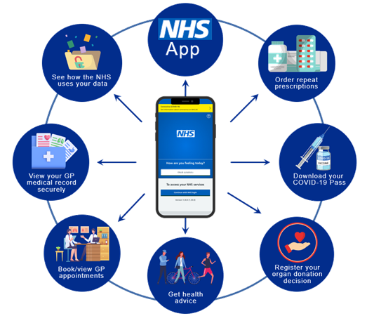
Figure 2: Service Delivery of NHS App

Patient/Service User
According to the NHS (2026), the NHS App is a patient-facing tool that is offered to those patients who are registered at a GP surgery in England. It enables qualified users to handle healthcare using a phone, tablet, computer, or NHS account online. This formal explanation demonstrates that this app was deployed to enhance patient control of routine healthcare activities. Reidy et al. (2025) observed that practical functions were appreciated by patients, particularly prescription ordering and access to COVID Passes. It implies that patients are the most benefited when the app resolves definite daily issues. The app can thus enhance convenience, less waiting time, and provide users with greater access to information on health. Nevertheless, this advantage will be determined by the ability of patients to operate the technology safely and comfortably.
KC et al. (2024) examined NHS App utilisation in 6,386 GP practices in England. They have identified reduced access to all the features of the app in poorer general practice groups. Analysis revealed reduced registrations, logins, record views, appointment bookings, and prescription orders in the deprived areas. This fact poses a significant constraint to patient experience and digital transformation. The application can enhance the accessibility of confident users and leave patients with limited digital resources. KC et al. (2023) also found lower registration in more deprived practices and higher registration among younger populations. These results indicate that the implementation can recreate the current health inequalities unless digital barriers are addressed. Thus, the patient's goodwill is not even shared among all social groups.
Turner et al. (2023) discovered that online access to records may confuse, give anxiety, and misunderstand patients. This is applicable since the NHS App will enable patients to see new record information in GPs. According to the report by the Health and Social Care Committee (2023), transparency and patient involvement can be enhanced by accessing records. Nevertheless, as demonstrated by Turner et al. (2023), transparency is not a sufficient condition to achieve an improved patient understanding. Coded diagnoses, test results, or clinical notes can be visible to patients without their explanation by a clinician. Mixed user experiences were also discovered in Reidy et al. (2025) because the functions of the apps were extended over time. This implies that patient experience requires accessibility in design, comprehensible language, and human support. The NHS App can enhance patient autonomy in cases where information is comprehensible but may undermine trust in cases where users cannot find a supportive user.

Community
According to NHS England (2023), non-digital support should not be substituted with inclusive digital healthcare. The significance of this principle is that the NHS App transfers healthcare tasks at home, in the workplace and in the community. Patients would be able to order the prescription, get the messages and see the health information without having to go to GP surgery. This can assist those people who have long-term conditions, carers, disabled patients, and working adults. NHS England (2023) also lists barriers related to devices, data, skills, accessibility, and trust, though. This implies that implementation at the community level should have support to individuals who are digitally inaccessible. The app can only enhance community access when it is regarded as an implementation factor when it comes to digital inclusion.
KC et al. (2024) discovered that the less deprived practice populations had less NHS App use. This observation demonstrates that digital transformation can be more advantageous to certain communities than others. Communities that are more internet connected, digitally literate, and with better device ownership could receive more advantages. Poverty, language, and lack of confidence may also weaken the access of communities through the same technology. Reidy et al. (2025) also discovered that implementation was influenced by broader local and national contexts. It is impossible to assess the NHS App as a national software product. Its community effect relies on local outreach, personnel assistance, and effective assistance among marginalized groups. Thus, digital inclusion on a community level is necessary to be implemented successfully, rather than merely the availability of apps.
According to NHS England Digital (2026), linked profiles enable authorized carers to administer services on behalf of a different individual. These services may incorporate prescription ordering and appointment management, as well as access to health information that is held by the GP of choice. NHS England (2025) reported that almost 12,000 people applied through family-access pilots in 68 GP practices. This implies that the app is capable of helping families and carers cope with healthcare tasks. It can assist the elderly, children, persons with disabilities, and patients who have language or digital confidence issues. But NHS England Digital (2026) also mentions that proxy access must be consented to, time-limited and reviewed. This poses tension between patient privacy and practical support at the community level. Co-production can be facilitated with the help of the NHS App, though the protection and consent must be handled.

Conclusion
The NHS App has become one of the significant digital changes in the English health and social care. The official data indicate a high utilization of prescriptions, records, messages, and increased access to patients. The scholarly literature indicates that its practice has transformed job roles, service provision, patient experience, and community involvement. The app can alleviate a part of routine pressure and enhance convenience among digitally confident users. Nonetheless, research also reveals the workload variations, discontinuous local application, patient confusion, and digital disparity. The NHS App is thus an effective yet lacking revolution. Its success lies in training, inclusion, protection, local preparedness, and sustained non-digital access.

Reference
Department of Health and Social Care (2018) ‘New NHS app will make it quicker and easier to access health services’. Available at: https://www.gov.uk/government/news/new-nhs-app-will-make-it-quicker-and-easier-to-access-health-services
House of Commons Health and Social Care Committee (2023) Digital transformation in the NHS. Available at: https://publications.parliament.uk/pa/cm5803/cmselect/cmhealth/223/report.html
KC, S., Tewolde, S., Laverty, A.A., Costelloe, C., Papoutsi, C., Reidy, C., Gudgin, B., Shenton, C., Majeed, A., Powell, J. and Greaves, F. (2023) ‘Uptake and adoption of the NHS App in England: an observational study’, British Journal of General Practice, 73(737), pp. e932–e940. doi: 10.3399/BJGP.2022.0150.
KC, S., Papoutsi, C., Reidy, C., Gudgin, B., Powell, J., Majeed, A., Greaves, F. and Laverty, A.A. (2024) ‘Differences in use of a patient portal across sociodemographic groups: observational study of the NHS App in England’, Journal of Medical Internet Research, 26, e56320. doi: 10.2196/56320.
KC, S., Papoutsi, C., Reidy, C., Gudgin, B., Powell, J., Majeed, A., Greaves, F. and Laverty, A.A. (2025) ‘Ease of access to general practice, patient experience and use of the NHS App: an ecological analysis of English data’, JRSM Open. doi: 10.1177/20542704251398918.
NHS (2026) NHS App. Available at: https://www.nhs.uk/nhs-app/
NHS England (2023) Delivery plan for recovering access to primary care. Available at: https://www.england.nhs.uk/long-read/delivery-plan-for-recovering-access-to-primary-care-2/
NHS England (2023) Inclusive digital healthcare: a framework for NHS action on digital inclusion. Available at: https://www.england.nhs.uk/long-read/inclusive-digital-healthcare-a-framework-for-nhs-action-on-digital-inclusion/
NHS England (2025) ‘NHS App’s family access feature “as simple as switching Netflix profiles”’. Available at: https://www.england.nhs.uk/2025/09/nhs-apps-family-access-feature-as-simple-as-switching-netflix-profiles/
NHS England Digital (2026) NHS App features. Available at: https://digital.nhs.uk/services/nhs-app/nhs-app-features
NHS England Digital (2026) NHS App Management Information: April 2026. Available at: https://digital.nhs.uk/data-and-information/publications/statistical/nhs-app-statistics/april-2026
NHS England Digital (2026) Manage health services for others in the NHS App: proxy access. Available at: https://digital.nhs.uk/services/nhs-app/nhs-app-features/manage-health-services-for-others-in-the-nhs-app-proxy-access
Reidy, C., Papoutsi, C., KC, S., Gudgin, B., Laverty, A.A., Greaves, F. and Powell, J. (2025) ‘Qualitative evaluation of the implementation and national roll-out of the NHS App in England’, BMC Medicine, 23(1), article 20. doi: 10.1186/s12916-024-03842-w.
Turner, A.J., Morris, R., McDonagh, L., Hamilton, F., Blake, S.E., Farr, M., Stevenson, F., Banks, J., Atherton, H., Rakhra, D., Lasseter, G., Feder, G., Ziebland, S., Hyde, E., Powell, J. and Horwood, J. (2023) ‘Unintended consequences of patient online access to health records: a qualitative study in UK primary care’, British Journal of General Practice, 73(726), pp. e67–e74. doi: 10.3399/BJGP.2021.0720.

