Course title: Academic and Employability Skills

Student name: Khalilur Rahman
Student number: 2112662
Course code: BMSW4001
Lecturer name: Ms. J. Walsh
Name of University: University of Wales Trinity Saint David

Table of Contents
Time Management 3
Cover Letter 6
Curriculum Vitae 8
Individual presentation …………………………………………………………………………. 10
References ………………………………………………………………………………………………13
Appendices – weekly time management plan …………………………………………………...15

Time Management
What
This report is about time management, this topic was discussed in great details in class on 16/10/21, I will be writing this report in the Borton’s reflective writing model, (Borton's Model of Reflection, 2021)

So What
Time management refers to the efficiency of a person to accomplish the given task within the given time frame (Cottrell, 2013). For the success of individuals in both academic and professional life, it is necessary to have proper time management skills.
The two following methods were discussed in great details the class, I now do believe that both methods are interesting and will be looking to adapt these methods in my work and personal life as much as possible.
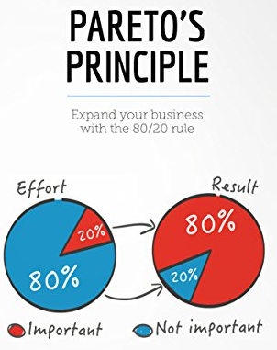
Figure 1: Pareto's Principle (The Pareto Principle (80/20 Law) and How to Get Started Using It, 2022)
For successful establishment of time management strategy in the workplace, Pareto Principle can be established, which is also known as the 80/20 Rule. According to this principle, 80% of the consequences of the work come from 20% causes, which indicates the efficiency of work from where the appropriate or expected result can be found (Fowler, 2012). Therefore, proper utilisation of time and proper management of time is significant. Nevertheless, to do so, it is also necessary to know the importance of work to manage the time successfully according to their preferences. In this regard, The Eisenhower Method / Matrix can be very helpful for individuals.
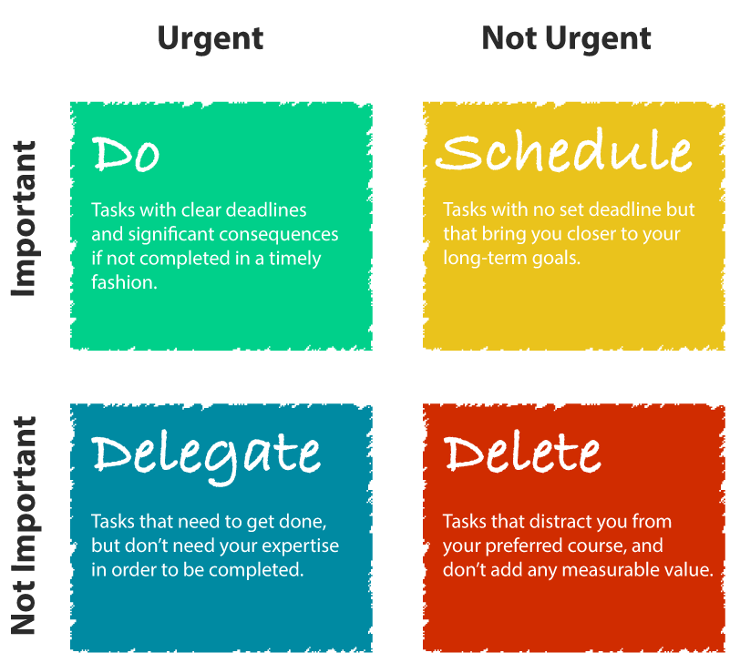
Figure 2: Eisenhower Method / Matrix (Victorino, 2022)
According to The Eisenhower Method / Matrix, individuals may have four different types of work in hand according to their importance. For example, an individual may have work in hand that is not urgent and unnecessary. In this situation, avoiding the task will help individuals reduce work or reduce the causes (Walsh, 2008). Some works have urgency without importance. Here, individuals should not spend time on this kind of work. Instead, they can delegate this kind of work to others. By doing so, the success ratio of the individual will increase because it will reduce the causes or number of works (Le Blanc, 2008). There will be some works that are not Urgent but important to complete within the given time frame in future. For this kind of work, it is necessary to find the appropriate schedule to complete the work with appropriate efficiency and expertise (Forsyth, 2013). Here, the value addition of the individuals will be very much dependent on this kind of work. So, time management will start from this area where individuals need to focus on finding out the essential work and the least essential work for scheduling. There will always be some work with urgency and importance of work (Forsyth, 2013). Here, it is the responsibility of the individuals to make this work done at the first stage. Here, the success ratio of the individuals will be very much dependent on this kind of work.
Moreover, the individuals need to find out appropriate and adequate time to complete this work urgently. It is also true that the consequence and causes balance are very much dependent on this particular work and its completion efficiency (Forsyth, 2013).

What now
Now that I learned how use time management tool, i will need to manage my time for my daily life, regardless whether I am working or studying. When I am working, I will arrange my tasks in appropriate categories, for example, the urgent work will be at the top of my to do list, followed important and so on. This will help me to improve my efficiency level to complete all my tasks with appropriate standards and can succeed in academic and professional life.

Cover Letter

What
This report is about Cover Letter, this topic was discussed in great details in class on 04/12/21, I will be writing this report in the Borton’s reflective writing model, (Borton's Model of Reflection, 2021)

So, What
Generally, a covering letter can be defined as a letter sent with the goods with the descriptions of all the contents of a parcel (Yate, 2004). In most cases, people send a cover letter with a brief description of their work-life to make potential employers aware of their capability and efficiency to get the job they are applying (Yate, 2004). So, this is one of the most crucial elements of successful job application for the individuals to distinguish themselves from others to the employers.
There are many benefits that a cover letter can easily give to me when I am applying for a job in different posts. For instance, it helps the employers get attracted towards my profile because it will help the employers get the summary of my job experiences or work profile quite efficiently (RICHARD, 2004). With the help of the job application, my approach, attitude, capability of writing, and communication skills can be quickly evaluated, which will help the employers judge my profile quite quickly, It will also help me to impress the employers by creating an excellent review of my experiences and the capability. So, it will be a massive point of attraction for employers while searching for quality employees for different posts (Enelow & Kursmark, 2004). This letter will also help the employers to find out my strengths and capabilities, which will increase the organisation's value in accomplishing different kinds of work related to the efficiency. Therefore, my contribution towards the organisation after getting a chance to work for the organisation will be evaluated with the help of this particular letter.
There can be problems sometimes and it can be difficult for the employees to find quality jobs due to this particular cover letter ((bowles, 2021)). For instance, If I do not create a proper and effective cover letter in different job circular, then it can create a wrong impression of me to the employers which will make very difficult for me to get through to the interview stage. In addition to this, lack of efficiency in writing a cover letters will create trouble for the employers to find out the efficiency of the employees in terms of adding value for the organisation, resulting in wasting time for both parties. However, I will feel positive and confident if create an efficient cover letter, but it can be a challenging and time-consuming task for me to create a new cover letter for each new job I apply for. It will take time for me to find out the appropriate ways express myself in different job positions for different employers in my cover letter.

What now
I would need to create cover letters carefully and cautiously using the knowledge that I have learned from my class. I do understand that it will be difficult challenging for me to create a very good cover letter for each and every jobs, but if i can succeed in creating an effective cover letter for my potential future employers then I think I will have a better chance of success in this highly competitive job market.

Curriculum Vitae

What
In this report I am going to write about Curriculum Vitae, this topic was discussed in our class on 04/12/21, I am going to write this report in the Borton’s reflective writing model, (Borton's Model of Reflection, 2021)

So What
A Curriculum vitae or CV summarises a person's career, qualification, experiences, and personal information. The employer can get a complete overview of the profile of the individuals to get the most eligible candidates for specific vacant positions (Weber, 2012) In terms of getting extracted by the employers, an establishment for proper CV preparation will benefit the individuals. However, sometimes due to lack of efficiency in CV can create trouble for the potential employees and employers in terms of spending time to get the most potential applicants.
With the help of a CV, I can provide various appropriate information to my potential employers. I have learned from my class about how i can create my brand listing my Skills, Knowledge, Experiences, Qualifications, Attitudes and Behavior. I can also apply the Marketing mix of 7ps, Products, Promotion, Price, Places, People, Process and Physical evidence (What are the 7 Ps of marketing? 2021). The knowledge of the potential candidates about the prices of the products can be judged quite easily with the help of a CV where i can incorporate all my experiences and skills. The knowledge level of the potential employees regarding the distribution of the products can be easily understood with their experiences in sales and marketing experiences (Turner, 2008). Different kinds of knowledge related to the products and services, such as places, people, and processes, can be identified with the help of a CV. It is straightforward to distinguish one potential candidate from another by their experiences in different fields where there will be a requirement of different skills and knowledge related to the company’s products and services that the organisation is offering (15 Transferable Skills Companies Want: Examples & Definitions | FlexJobs, 2021). The knowledge level of the individuals about the appearance of the products and services and their capability to make the appearance much more attractive can also be evaluated by the help of quality and proper CV. Therefore, individuals will be able to make their marks in the mind of the employers by expressing their knowledge and idea about different kinds of elements related to products and services of their current organisations, which will ultimately help the employers to evaluate their eligibility for or that particular vacant position for which the circular has been made, (Lal, 2021).

What now
I believe that an effective and proper CV will have a significant impact on a potential employers of different organisations, where i will have an opportunity to express my knowledge and ideas to the employers in order to successfully go through to the next stage of the recruitment process and possibly get the job. Since it increases chances of making through to the next stage towards interview, I think it is worth spending some time preparing a quality CV for my future job prospects.

Individual Presentation

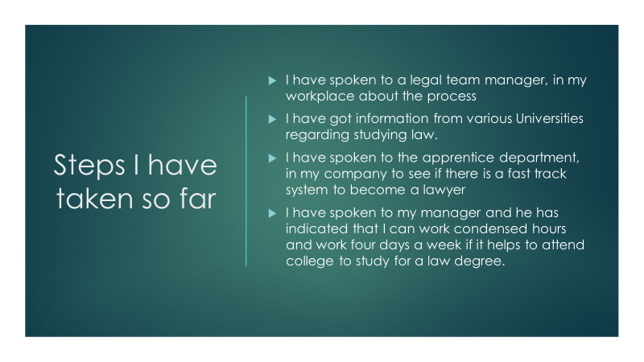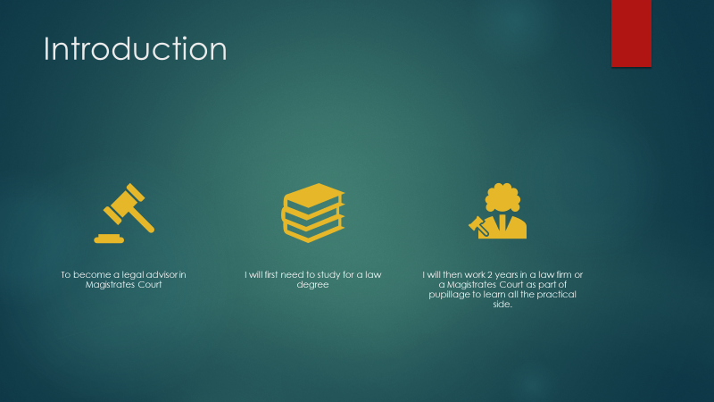
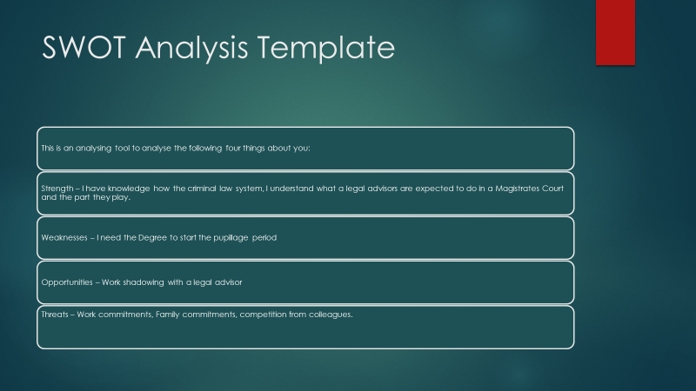

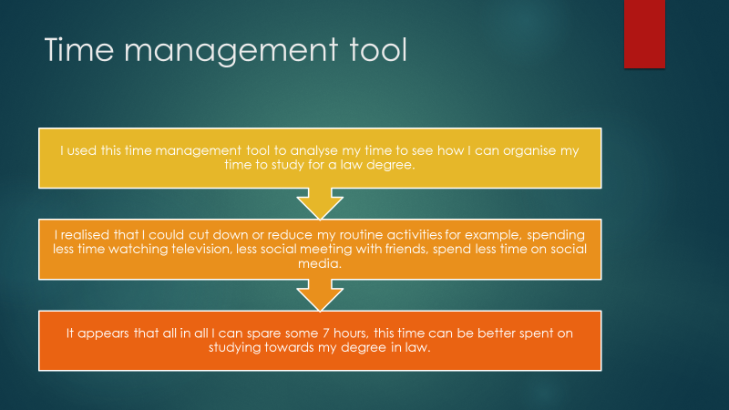

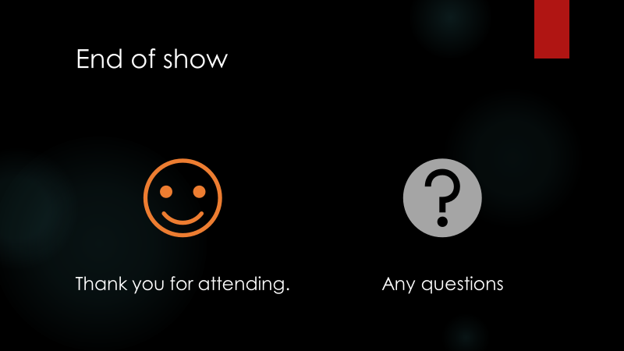

References
- Assemblo. 2021. What are the 7 Ps of marketing?. [online] Available at: <https://assemblo.com/guides/what-are-the-7-ps-of-marketing/> [Accessed 31 December 2021].

- bowles, K., 2021. Why A Bad Cover Letter Might Cost You Your Dream Job. [online] Linkedin.com. Available at: <https://www.linkedin.com/pulse/why-bad-cover-letter-might-cost-you-your-dream-job-katie-bowles> [Accessed 31 December 2021].

- Cottrell, Stella (2013). The Study Skills Handbook. Palgrave Macmillan. pp. 123+. ISBN 978-1-137-28926-1.

- Essaywritingserviceuk.co.uk. 2021. Borton's Model of Reflection. [online] Available at: <https://essaywritingserviceuk.co.uk/advice-and-guidance/bortons-model-of-reflection> [Accessed 31 December 2021].

- FlexJobs Job Search Tips and Blog. 2021. 15 Transferable Skills Companies Want: Examples & Definitions | FlexJobs. [online] Available at: <https://www.flexjobs.com/blog/post/transferable-skills/> [Accessed 31 December 2021].

- Forsyth, Patrick (2013). Successful Time Management. Kogan Page Publishers. pp. 90–93. ISBN 978-0-7494-6723-4.

- Fowler, Nina (2012). "App of the week: Eisenhower, the to-do list to keep you on task". Venture Village.

- Le Blanc, Raymond (2008). Achieving Objectives Made Easy! Practical goal setting tools & proven time management techniques. Maarheeze: Cranendonck Coaching. ISBN 978-90-79397-03-7.

- Lal, D., 2021. Top Trends in Human Resource Management in 2021. [online] theHRDIRECTOR. Available at: <https://www.thehrdirector.com/top-trends-in-human-resource-management-in-2021/> [Accessed 4 January 2022].

- Psycho-tests.com. 2022. The Pareto Principle (80/20 Law) and How to Get Started Using It. [online] Available at: <https://psycho-tests.com/blog/pareto-law> [Accessed 4 January 2022].

- RICHARD, H. BEATTY (2004). THE PERFECTCOVER LETTER, THIRD EDITION (PDF). JOHN WILEY & SONS, INC. p. 19. ISBN 0-471-47374-X.

- Slab.com. 2022. [online] Available at: <https://slab.com/blog/eisenhower-matrix/> [Accessed 4 January 2022].

- Turner, David; correspondent, Education (2008). "A degree of creativity on CVs". Financial Times. ISSN 0307-1766.

- Victorino, R., 2022. [online] Slab.com. Available at: <https://slab.com/blog/eisenhower-matrix/> [Accessed 4 January 2022].

- Walsh, Richard (2008). Time Management: Proven Techniques for Making Every Minute Count. Adams Media. pp. 161–163. ISBN 978-1-4405-0113-5.

- Weber, L., 2012. NPR Cookie Consent and Choices. [online] Npr.org. Available at:<https://www.npr.org/2012/02/08/146585368/keeping-your-resume-out-of-online-oblivion?t=1641336511897> [Accessed 4 January 2022].

- Yate, Martin John (2004). "What Is a Cover Letter?". Cover letters that knock 'em dead (6th ed.). Avon, MA: Adams Media. pp. 1–6. ISBN 978-1-59337-107-4 – via Google Books.

Appendices

Weekly Time Management Plan

time | Monday | Tuesday | Wednesday | Thursday | Friday | Saturday | Sunday
8-9 | Dropping kids to school and then going to work | Dropping kids to school and then going to work | Dropping kids to school and then going to work | Dropping kids to school and then going to work | Dropping kids to school and then going to work | Attending University  From 9am to 1pm | Attending University  From 9am to 1pm
9-4:30 | Working | Working | Working | Working | Working | 1pm to 2pm getting home from University | 1pm to 2pm getting home from University
4:30 to 5:30 | Getting home from work | Getting home from work | Getting home from work | Getting home from work | Getting home from work | 3pm to 5pm Shopping | 3pm to 5pm to swimming with family
6pm to 7:30 | Family time | Family time | Family time | Family time | Family time | 5:30pm to 7:30 entertainment | 5:30pm to 7:30 entertainment
7:30  to  8pm | others | others | others | others | others | 8pm to 9pm Study time | 8pm to 9pm Study time
8pm to 10pm | Study time | Study time | Study time | Study time | Study time | 10:30 Bedtime | 10:30 Bedtime
10:30 | Bedtime | Bedtime | Bedtime | Bedtime | Bedtime

