Mission Statement
The goal of the following exercise is to evaluate the part referred to as “Drill-Press Main Sliding unit”. The evaluation will establish this parts ability to contribute to total product desirability as well as its ease of manufacture and assembly.

Figure 1: Drill press unit - green component under evaluation.

Assessment
The assessment of the product will be comprised of a number of stages:
- Assessment of key quality features.
- Prioritisation of design features.
- Assessment of the current part against the desired features.
- Assessment of potential manufacturing techniques.
- Drafting and designing the new component.
- Assessment of re-designed component.
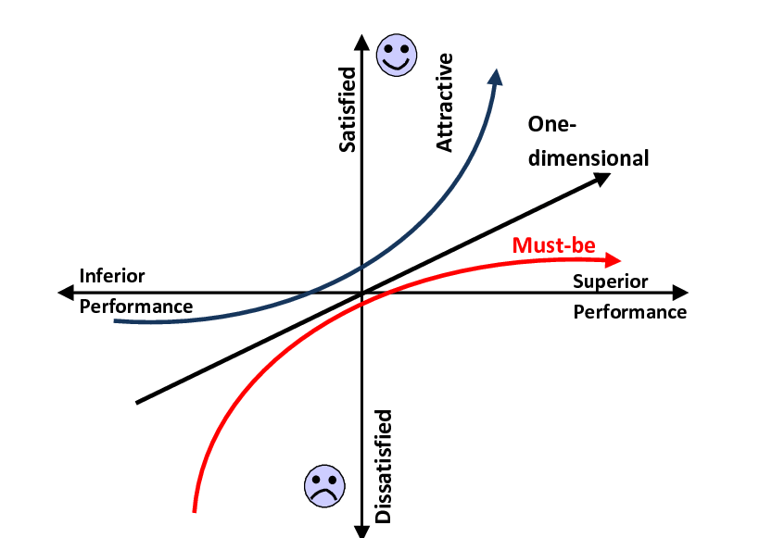
Assessment of potential features
According to the Kano model customer perception can be modelled by plotting a graph with the y axis representing customer satisfaction, and the x axis representing functionality/performance. Features on this graph are rated can be broken down into four broad categories (Morgan, 2016):
Figure 2: Kano's model example (Tontini, 2013)
- Delighters/Attractive – This feature garners a positive response from the customer, and its absence doesn’t not illicit a negative response.
- One dimensional – This feature elicits a positive reaction proportional to its functionality, the better this feature performs its task the more customers are satisfied. The worse it performs its task the less they are satisfied. This is often related to the core functionality of a product.
- Must be- These products elicit a negative reaction from the customers should they be absent, though including them will not provide any positive reaction.
- Indifferent- This feature holds no value to the customer, though it may hold value to the manufacturer. (Zacarias, 2020)
From our internal assessment of customer needs leads to the following conclusions can be made about the value of potential features.
Prioritisation of design features
Laying out our desired features we can see how well they contribute to the design

From our design requirements we can conclude that the design for this part should emphasise stiffness, the ability to fit into the wider assembly, and heavily penalises any excessive material usage

Assessment of the current part against the desired features.
The current design largely fits the criteria, though notably is far larger and heavier than it needs to be. Full assessment utilising the house of quality method are unviable at this time due to the original design not defining the materials used. As such defining the density and stiffness of the part is impossible, as such more qualitative assessments are needed:
From the assessment of the current design the following specification has been put together:
The designed part must:
- Fit into the pre-existing assembly without inhibiting assembly motion.
  - 1x 10.75mm diameter wide mount for the drill.
  - 1x 5mm diameter hole x 25mm diameter hole to mount the guide Shaft to.
  - 1x 25mm diameter hole through part to allow the part to traverse along main rod.
  - A Single attaching point to allow arm assembly to direct the motion of assembly. A 6mm diameter pin is likely to be used.

- Be able to be removed and replaced at will by end user.
- Design must maintain shape and design for a long period of time when compared to the part cost (must last 1 year or 5000 cycles for every £10 the customer spends)
- Be able to manufactured at 1000 units per week, at the lowest cost possible while maintaining quality.

As for relevant legal considerations:
- Since the most dangerous parts of the drill press are related to the drill assembly, which we are not producing, any regulations surrounding electrical systems or motorised moving parts can be disregarded.

- In order to be sold it will need to satisfy conditions to gain a UKCA (United Kingdom Conformity Assessed) marking, (or CE marking for European markets) as this product is a component of a larger assembly such an assessment is not applicable to this specific part. This statement is also applicable to the health and safety assessment surrounding the assembly.
- The codes of practice in this instance will largely relate to the material used in the component.

Assessment of potential manufacturing techniques.
Table of available manufacturing methodologies

Having assessed the methods available (see Table above) a number of good options present themselves:
- Cold metal stamping
- Sinter powder metallurgy
- Machining
From these options the most attractive of the three is cold metal stamping as it has the least requirement for post processing (no post processing needed), as well as an acceptable amount of material wastage whilst relying on a known and proven technology.
This will result in some of its own requirements on the design of the part. Stampings are constructed of a material of a known thickness and are largely incapable of curving back in on themselves/ forming a closed shape.
This part would be better constructed of 2 stamped plates held together with some bolts; this will have the added benefit of allowing the part to be easily removed. A cost effective option would be to use a single progressive stamping machine.
Given its relatively low cost, good formability and durability steel presents itself as a cost effective choice. Of the options for steel, since we are performing a cold forming option, a steel grade for cold forming is appropriate. For these reasons I have chosen DD14 hot rolled steel grade steel supplied at 5mm thick. The choice of steel will allow the product to bend during pressing but should maintain stiffness. In addition steel is hard wearing and recyclable, improving the products lifespan and end of life environmental impact.
These choices will not create the sturdiest product, they will however, create a cost effective one.
When designing a stamped product, a number of considerations need to be made (Geomiq, 2022):
- Sharp edges on parts tend to result in splits and as such should be minimised (excluding blanking.
- Formed shape must allow passage for dye to leave after pressing.
- Diameter of bend should be compared to material thickness for optimal stamping properties.
- Large flat sheets bend more easily so should be replaced by formed shapes to reduce flexing

Drafting and designing the new component.
Bearing the previously stated rules in mind the following design has been created:
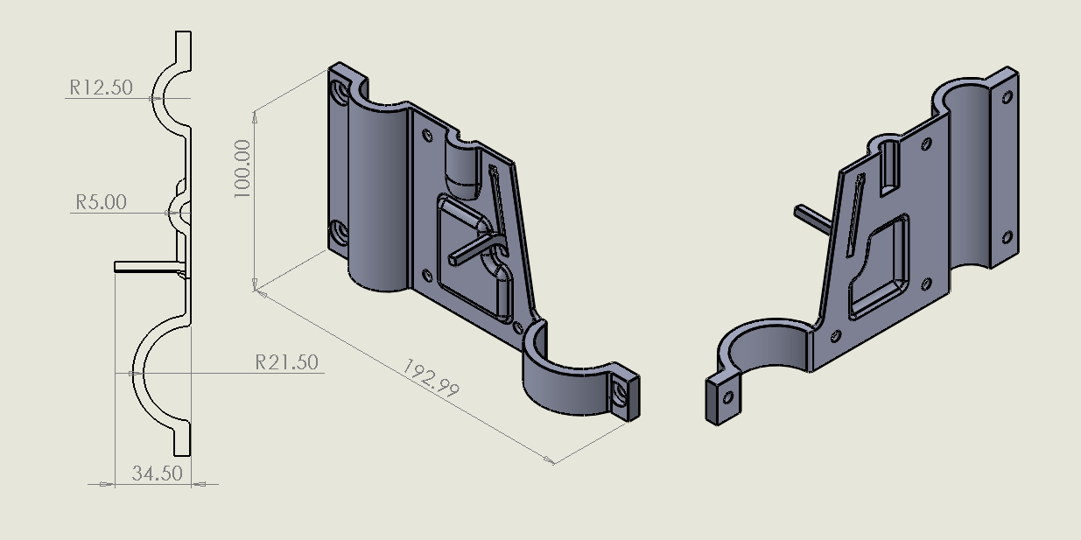Part right half
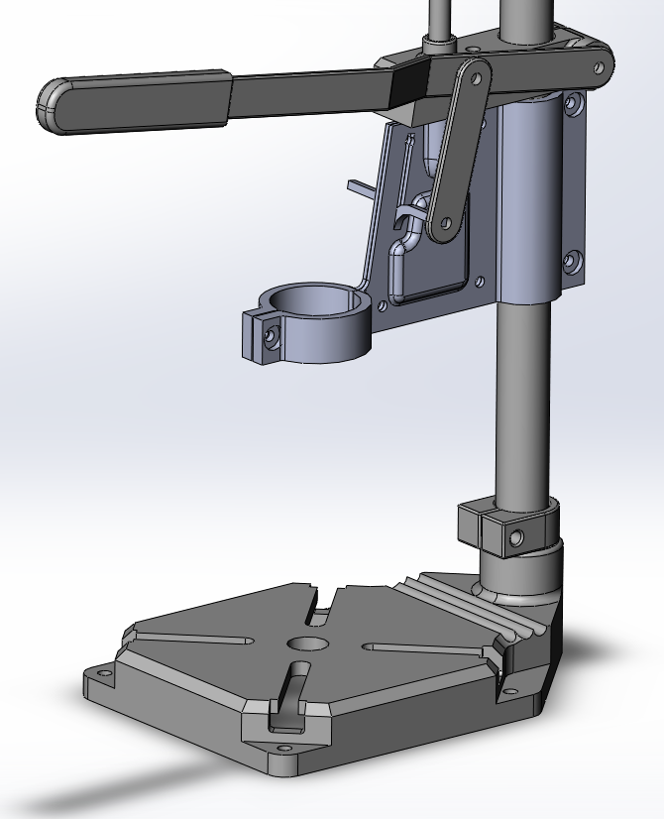
Full Part in assembly

The design is based of a single stamped sheet and as such retains a few features necessary to its design.
- The part has been split into two mirror imaged components.
- The components are held together using the same style of bolt as the original design.
- The cavity to hold the guide shaft has been replaced by adding a chamfer to the cavity walls, the act of bolting the plates together will wedge the guide shaft.
- A deformation to the parts surface has been added to minimise swaying of the plates.
- A sliver has been stamped perpendicular to the plane in order to interface with the lever assembly.
Assessment of re-designed component.
Customer needs |  | Original design | New design
 | Fits wider assembly | Yes | Yes
 | Able to hold a commercial power drill | Yes | Yes
 | Able to be produced at high volume | No | Yes
 | Material efficiency | Poor | Moderate
Consumer needs
 | Affordability | Poor | High
 | Ability to retain shape/alignment (Stiffness) | Good | High
 | Modularity | Poor | Poor
 | Environmental impact | Poor | Good
 | aesthetic | Poor | Adequate
 | Safe operation | Poor | Poor

Assesing the design based on the criteria selected we can see that the design has improved despite not including features such as eye shield or a light mount. The reason for this is that it is lighter and requires less material, therefore it is cheaper. And by representing the same value for less money, we have improved its value proposition.

Bibliography
Geomiq. (2022, February). Sheet metal design guide. Retrieved from Geomic.com: https://geomiq.com/sheet-metal-design-guide/
Morgan, J. M.-J. (2016). Lean Six Sigma For Dummies. Chichester: John Wiley and Sons Ltd.
Tontini, G. (2013, December). Figure 1 - uploaded by Gérson Tontini. Retrieved from ResearchGate: https://www.researchgate.net/figure/Kano-Model-of-Attractive-and-Must-be-Attributes_fig1_263248287

