Nathan J Morris

The following report will assess the feasibility of a new joint venture development between Marriot Hotels and City and county of Swansea at the Swansea foreshore development site identified in this report.
Preliminary site investigation report
Swansea foreshore development

Table of Contents
1. Introduction 2
1.1 Aim of the report 3
2. Site investigation 4
2.1. Description of the historical background of the site. 4
2.1.1. Site description and walkover. 4
2.1.2. Current land features. 4
2.1.3. Historical Land features. 4
2.1.4. Map Geology. 5
2.1.5. Topography. 5
2.1.6. Depth Groundwater. 5
2.1.7.Surface water / Rainfall. 5
2.1.7. Environmental considerations. 6
2.1.9. Potential contaminants. 6
2.2. Recommendations for the contents of a detailed site investigation. 7
2.2.1 Borehole Geology analysis. 7
2.2.2. Chemical analysis. 9
2.2.3. Soakaway test. 9
2.2.4. Groundwater analysis. 9
2.2.5. Gas analysis. 9
2.2.6. Utility analysis. 9
2.2.7. Site Access 9
2.3. The building regulations and codes of practice derived from the recommendations. 9
3. Results 10
Foundation details recommended from the study. 10
1. References 12

Introduction

The below text is a brief overview of the proposed development written by the client, a location plan can be found in Figure 1 below.

“City and County of Swansea have chosen to enter into a joint agreement with Marriot Hotels to create a new restaurant and ice-cream parlour (with manager’s apartment) on Swansea foreshore. The site is located between County Hall and the Marriot Hotel and is illustrated on the attached images. The building, which is to share parts of the car park of both of the existing adjacent facilities, is to have a GIA (Gross Internal Area) at ground floor level of approximately 300 square metres.
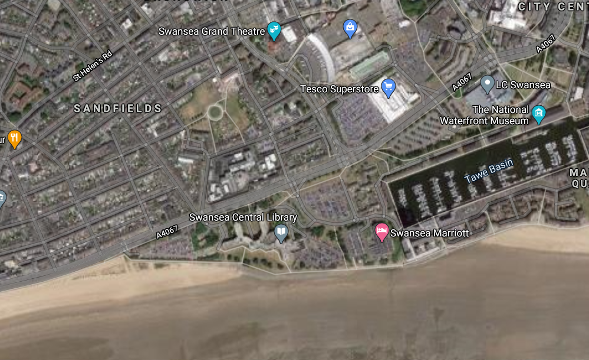
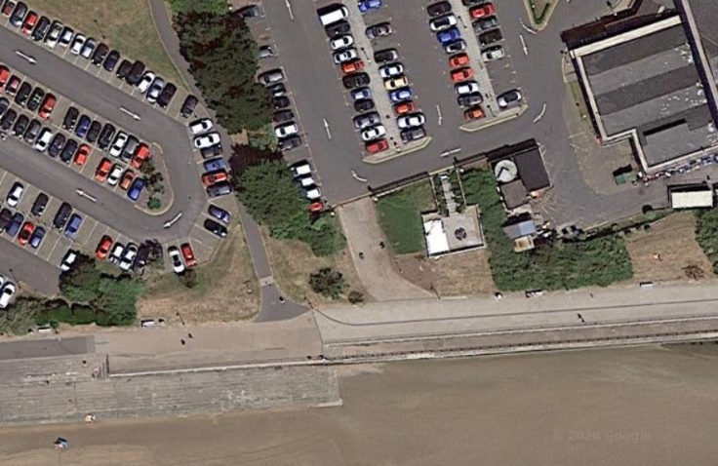
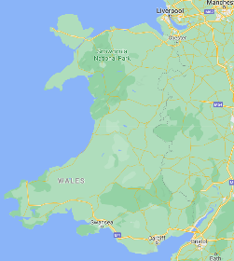
The building is to contain the restaurant, café bar, ice-cream parlour, kitchen, food-stores etc. At second floor level, there is to be a self-contained manager’s apartment and staff welfare facilities. This project is procured via a Design and Build contract.”
Proposed Site

Aim of the report

The below report will aim to provide a comprehensive preliminary study in preparation for a full site investigation as part of the feasibility stage of the project. The report will aim to identify any significant risks and provide recommendations to the geotechnical contractor on where the greatest risks lie on site, and what elements of the site investigation are most important.

Site investigation

The context and purpose of this report is as follows.

Description of the historical background of the site.

Site description and walkover.

The proposed site is currently used as car parking for both the Marriot hotel and Swansea council with partial coverage of grass and small shrubbery. There is also a small gated (locked) access route leading to the beach front next to a small viewing platform within the hotel grounds. There are numerous lampposts and road drainage throughout, indicating significant underground apparatus. There is also a small building on the Marriot hotel side of the development that appears to provide pumped treated water to the hotel.

Current land features.

The current land features are predominately flat, between 6-9m Aod (Google earth pro, 2020). The site is very close to the beach approximately 30m at its nearest point. The majority of the site is covered in tarmac with small grass shrub borders separating the hotel and the Council land.

Historical Land features.

Historical land features indicate large industrial use, OS maps from 1879 indicate train / tram lines leading from the south dock and passing through the proposed development site constructed to support the large copper works along the river Tawe. Nearby there are also signs of old train workshops and a hospital circa 1899. During the second world war the proposed site and surrounding docklands were flattened by prolonged German bombing that resulted in the town of Swansea being rebuilt and relocated approximately 0.5 miles further East (BBC wales / history, 2020). The above use of the historical land suggests a high likelihood of contaminants being present on site, this would lead to an increased recommendation for further chemical analysis on site prior to construction.
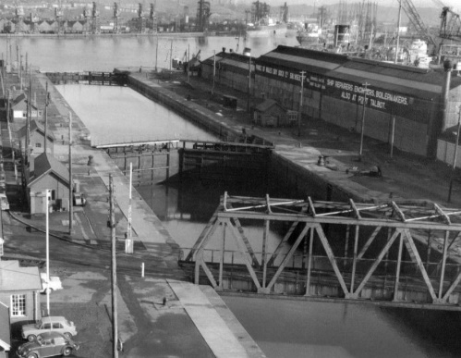
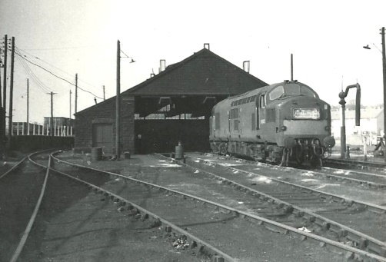
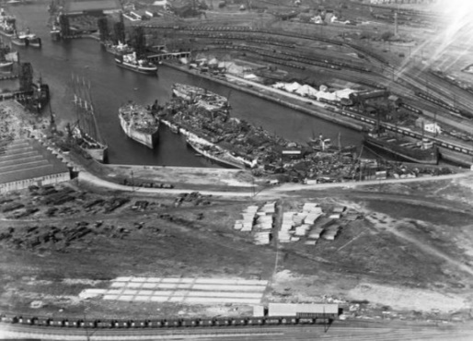

Historic photos of Swansea docks, illustrating heavy industrial use (Wales online, 2020)

Map Geology.

The underlying bedrock in this area is made up of mudstone, siltstone and sandstone. It is a sedimentary bedrock formed approximately 310 – 318 million years ago. (BGS, 2020). A map of the underlying geology can be found in Figure 2 below.
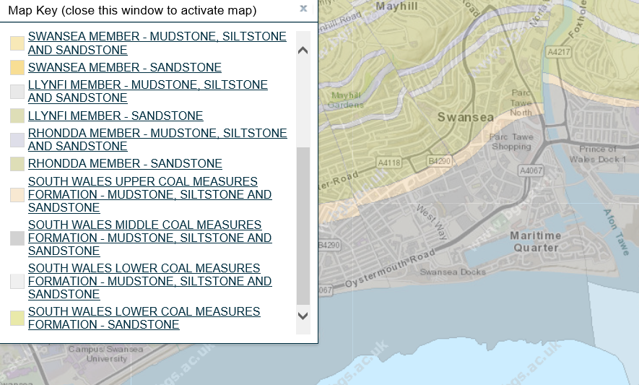
(BGS, 2020).

Topography.
The topography is relatively flat and between 6-9m Aod (Google earth pro, 2020).

Depth Groundwater.
Due to the proximity of the development in relation to the sea, an in depth study including trial holes and bore holes will be required (Chudley and Greeno, 2020)

2.1.7.Surface water / Rainfall.
As mentioned above due to the proximity of the site in relation to sea an in depth flood study will be required. Swansea has previously been classified as the UK’s wettest city with an average of 1360.8mm of rainfall per year (Wales online survey, 2014) (figure 3 below) and with ever increasing rainfall figures over the past few years (see figure 5 below) in depth soakaway / drainage tests will be required.
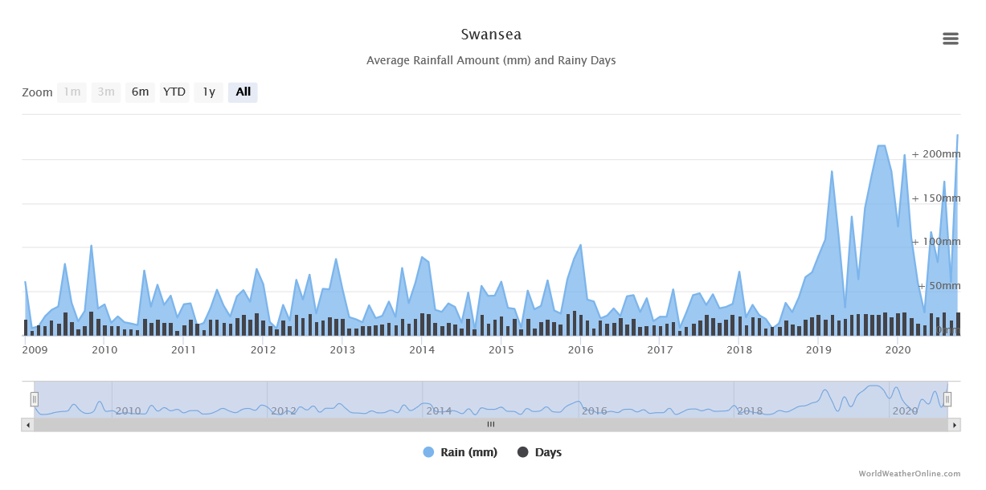

Environmental considerations.
Natural resources wales indicate a medium groundwater vulnerability for this site.
There are no further environmental designations, however an environmental impact assessment would be recommended to confirm the above.

2.1.9. Potential contaminants.
Potential sources of contaminants have not been identified on site; the area is currently used for car parking and a small seating area for the neighbouring hotel. But with the industrial history of the surrounding area further analysis would be recommended.

Recommendations for the contents of a detailed site investigation.

2.2.1 Borehole Geology analysis.
The nearest borehole log for this site can be found in Figure 4 below. This is approximately 160m west of the proposed development but will give a good indication of the ground conditions. There will be a requirement, however, for further site-specific borehole surveys.

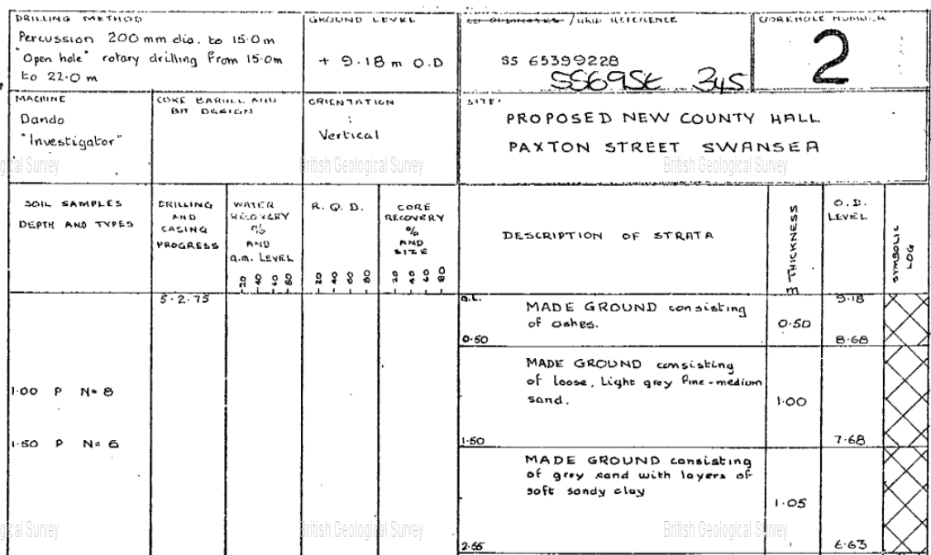
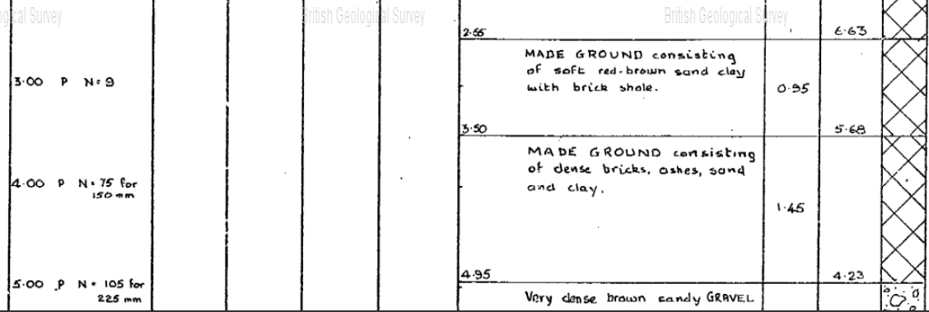
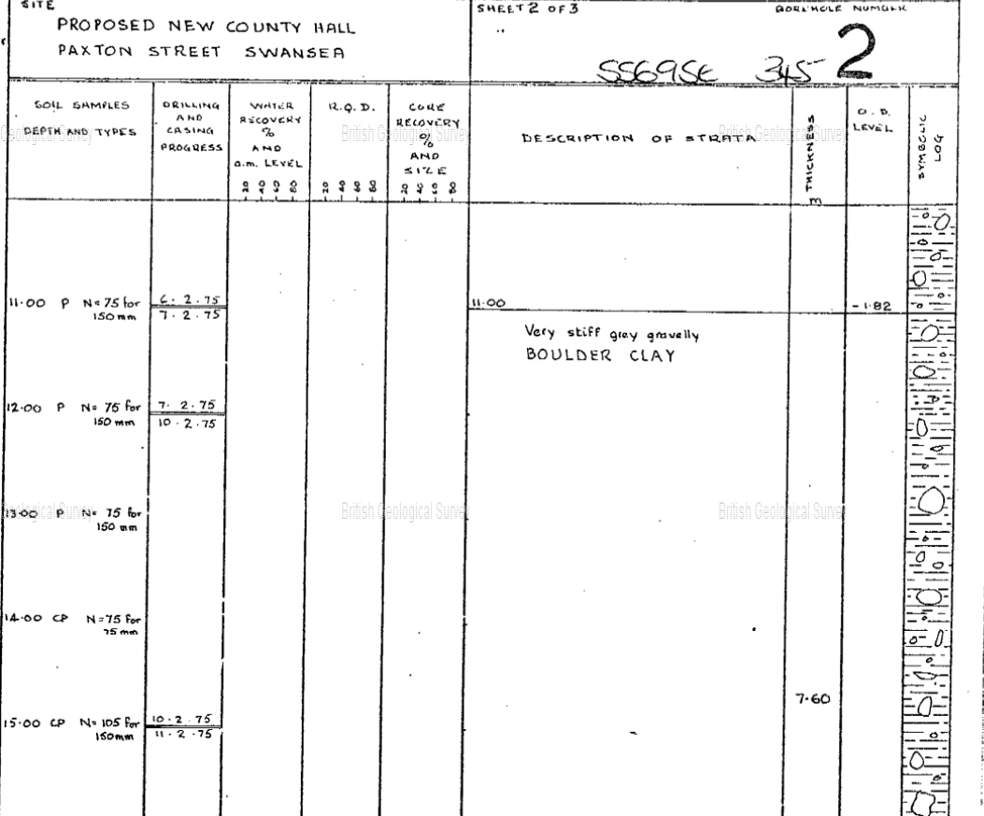
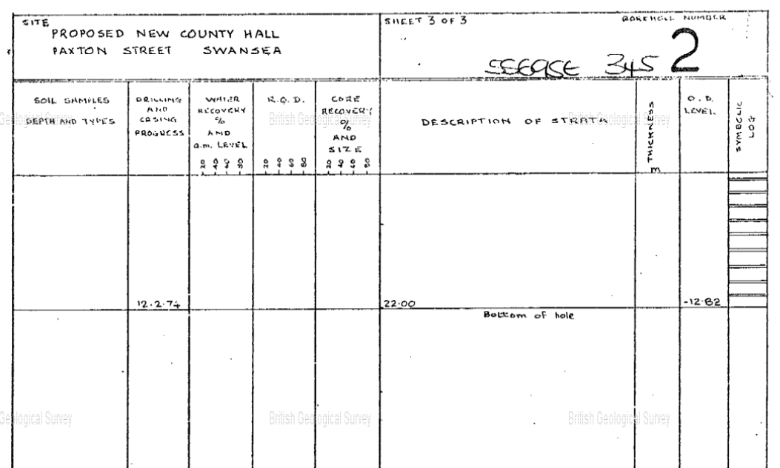

Borehole analysis indicates that the area for the proposed development consists of a large amount of “Made ground” from ground level (9.18mAod) to roughly 4.13mAod. This “made ground” largely consists of ash, sand and clay with traces of brick shale.
At depth 4.23Aod and below there is the emergence of dense brown sandy gravel with small traces of sandy clay, this continues for approximately 2m.
From 2.18mAod to 1.123mAod there is a band of dense brown sand with gravel.
At 1.23mAod to 1.182mAod there is a band of stiff dense brown sandy gravel.
From 1.82mAod and for over 7.6m there is a large band of stiff gravelly boulder clay extending to roughly -9.42mAod.
Beneath the stiff gravelly clay there is grey mudstone leading down to -12.82mAod and the bottom of the 22m borehole.

2.2.2. Chemical analysis.
Full chemical analysis should be undertaken on the underlying soil at this site due to the historic use of the land.

2.2.3. Soakaway test.
In accordance with the building research establishment (BRE) soakaway test standard (BRE365), this test should be undertaken due to the large hard surrounding surfaces near the proposed site to ensure adequate drainage of surface water is provided. (BRE, 2016)

2.2.4. Groundwater analysis.
Groundwater standpipe analysis will be required on site to understand depths and pore pressures specific to this site.

2.2.5. Gas analysis.
Analysis of gases will be required and these can be tied in with the above groundwater standpipe installation and testing.

2.2.6. Utility analysis.
Local utility plans will need to be acquired from local water, gas, telecommunication and electricity companies to determine the layout of the underground assets prior to any excavations.

2.2.7. Site Access
Site access is sufficient, but it may be advisable to insert a private entrance next to the main hotel entrance for site specific traffic only, and to minimise disruption to customers. An area in the either the Marriott hotel or Swansea council car park would need to be barriered off for a suitable site office.

The building regulations and codes of practice derived from the recommendations.

The guidance for the above desktop study is undertaken based on the British standard BS5930 “Code of practice for site investigations” with slight bias to the British standard BS10175 “investigation of potentially contaminated sites”. These standards are publications issued by the British standards institution and “give recommendations on the minimum standards for materials, components, design and construction projects” (Chudley and Greeno, 2020).
Borehole data was already made available but any further site investigation where new boreholes need to be inserted British standard BS EN ISO 22476-14 will need to be adhered to (BSI group, 2020)
For the specific testing for the soils at this site, British standard BS 1377-3 will need to be adhered to (BSI group, 2020).
For the soakaway testing that will be required on site, this will need to comply with the British standard BRE 365 to ensure consistency and accurate data collection.

Results

Foundation details recommended from the study.

Based on the preliminary desk top study and the information provided by the client of the building layout, the recommended foundation type for this development would be a deep foundation of approximately 11m to a suitable bearing layer of boulder clay (of thickness approximately 7m). This decision is recommended based on the borehole log indicating predominately inappropriate “made ground” for the first ~4 metres followed by a layer of sand ~2m until the boulder clay of adequate thickness is reached, enabling a suitable bearing capacity for the single height dwelling. It would be therefore recommended a piled foundation type be implemented in this instance. These foundations are recommended where there are layers of recently placed materials or unsuitable soils which have not yet consolidated (Chudley and Greeno, 2020) which we have encountered at this site. This enables the stress bulb associated with the new development to be transferred to the suitable boulder clay layer through frictional forces from the pile foundations, a pile cap with reinforcement will link multiple piles together for additional stability (Chudley and Greeno, 2020).
A proposed pile foundation diagram similar to what will be required can be found in figure 5 below.
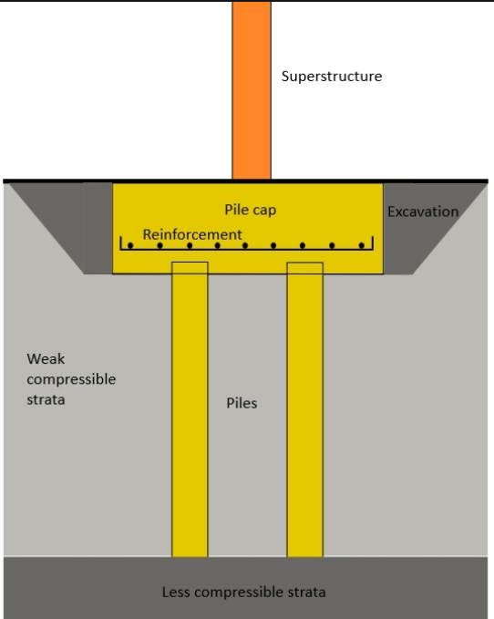

https://www.designingbuildings.co.uk/wiki/Pile_foundations

References

Chudley, R. and Greeno, R. (2020) Building construction handbook. 12th edn. Oxford: Routledge.

http://www.bbc.co.uk/wales/history/

https://mapapps.bgs.ac.uk/geologyofbritain/home.html

https://www.brebookshop.com/details.jsp?id=327631

Garvin, S, L. (2016). Soakaway design. BRE Press.

https://www.worldweatheronline.com/swansea-weather-averages/swansea/gb.aspx

https://shop.bsigroup.com/ProductDetail?pid=000000000030351284

BSI. (2018) Methods of test for soils for civil engineering purposes. Chemical and electro-chemical testing.

