Module Code: BMIH6005
Module Title: Organisational Consultancy
Assessment Type: Consultancy report
Student Name: Suruk Ahmod
Student ID: 2121358
Lecturer Name: Jaliya de Silva

Enhancing Guest Experience at The Ritz-Carlton, Bali
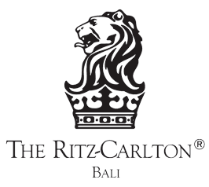
Contents
Executive Summary 3
Introduction 5
Analysis 6
Issues Identified 7
Analysis and Causes 8
PESTLE Analysis 9
SWOT Analysis 13
TOWS Analysis 13
Recommendations and Change Management 14
Action Plan 19
Conclusion 19
References 21

Executive Summary
The consultancy report on The Ritz-Carlton, Bali, is focused on these particular issues that led to the decline of the hotel's ability to offer superior services for guests and to stay ahead of the competition in the luxury hospitality sector. By carrying out a thorough analysis of internal attributes, market influences, and guest feedback, the report strives to develop practical suggestions and recommendations to get rid of these problems effectively.
The Problem or Issue at Stake
The Ritz-Carlton, Bali, has several issues that hit hard at its ability to offer top-notch guest experiences as well as compete on a high level in the luxury hospitality segment (Yasa et al., 2022). However, technology integration is one of the problems, and community engagement along with staff training are also considered problems, and finally, they are the initiators of poor service delivery and low guest satisfaction rates (Sun et al., 2020). On the one hand, the hotel suffers from a disparity between worn-out technology infrastructure and the requirements of both guests and employees that have changed and developed over time (Aeberhard et al., 2020). This causes the loss of operability between departments and staff, which results in the decline of the hotel's ability to provide customized experiences and smooth service. Besides, the lack of state-of-the-art digital tools limits the hotel's capacity to keep in pace with the ever-evolving guest preferences and the overall hospitality industry trends, which is a substantial disadvantage for the hotel's competitiveness in the market (Dev, 2024). The Ritz-Carlton, Bali is underperforming in community engagement categories that are vital for strong bonds with local key players. In today's travel market, where people aspire for genuine and culturally rich experiences, the hotel's inability to establish profound relations with local groups becomes a shortcoming, which, in turn, reduces its attractiveness and minimizes its possibility to provide guests with distinctive and enlightening experiences (Margaretha et al., 2022). The hotel staff training and development still have some gaps which make the said problems more challenging. Poorly trained workers may not be able to give guests the attention they want or deliver the service standard they expected, leading to a variation in the quality of service and experiences of the guests (Wangchuk and Wetprasit, 2019). Additionally, inadequate professional development hurts the employees’ morale and makes them leave the organization, therefore, costing the company an increase in turnover rates and operational disruptions (Ushakov et al., 2020). The main issue of The Ritz-Carlton, Bali is going to be improving its technological capabilities, enhancing community relations, and the people’s training and development. To achieve the process of the hotel improving the standards of service, exceeding the guest expectations, and being on the top of the list of the luxury hospitality industry, the hotel management should be able to address these fundamental challenges.
Findings
Along with the consultancy report, it is evident that several operational and guest experience critical insights regarding the Ritz-Carlton, Bali have been identified. Through the use of comprehensive research and analysis, the hotel soon saw there were serious issues when it came to the integration of technology, engagement with the community, and staff training (John-Mariadoss, 2023). The problems associated with these issues directly affected the hotel’s capacity to offer remarkable guest experiences and compete in the luxury hospitality market. The audit of the hotel's tech infrastructure has shown several weaknesses in its ability to provide what guests and the staff expect in the era of advancement in technology. The frontline is made ineffective by outdated systems and incompetent digital solutions which in turn leads to poor service delivery and a lack of tailored guest experiences (Moscardó Zaforteza, 2023). Alongside this, having no modern solutions at hand weakens the ability of the hotel to adapt to changing market trends and guest preferences and thereby turns out to be a crucial obstacle in the way to being competitive in the industry. Also, the review of community engagement efforts brought up an absence of significant links with local stakeholders that included not just residents, but also businesses and cultural organizations. In a period when people are looking for an authentic and immersive kind of travel, the failure of the hotel to develop a strong relationship with the local community through alliances will take away from it the appeal and limit its ability to offer special and cultural experiences to guests. They found that employee skills and knowledge were in bad shape affecting service quality and guest experiences. Improperly trained staff members may have trouble meeting the expectations of the guests and in such cases, the guests may end up with a bad experience which in turn can cause harm to the reputation of the hotel. Moreover, the lack of professional development opportunities continuously creates a negative consequence on the morale of employees and high turnover rates which aggravate the operational challenges.
Analysis of Findings
This implication clearly shows the desirable need for investments in technology and digital devices as a way to increase work efficiency, productivity, and guest satisfaction. Furthermore, the hotel is dedicated to developing a good relationship with the community and this can be one of the ways of proving that the hotel is socially responsible.
Recommendations to the Client
Some strategic recommendations offered to The Ritz-Carlton, Bali:
1. Technology Integration: Placing more priority on capital investments, namely the development of a property management system and adoption of digital guest service platforms, will help in improving operational efficiency and catering to the special needs of the guests.
2. Community Engagement: Establish closer ties between the local community and the various organizations to create more sustainable tourism, cultural exchange, and authentic local experience for the guests as a result the guests will be more satisfied and the loyalty index will be higher.
3. Staff Training and Development: Devise effective training and development programs to support the creation of a professional team that is capable of providing customers with the highest level of service, giving them the needed attention, and dealing with the challenges from the market successfully.
Conclusion
The solutions to the issues and the tactics that were mentioned are the major elements of the Ritz-Carlton, Bali, to accomplish its goal of serving the guests better and being competitive among the other luxury hotels. These three areas, namely, the technology adoption, the partnership development, and the staff development will gain the hospitality company a leading position in the industry and ensure it is ahead of the rising competition.

Introduction
Positioned on the tranquil shore of Nusa Dua, Indonesia, The Ritz-Carlton Hotel is a rare blend of sophistication and elegance, a perfect destination for those who love luxury and are quite selective with their holiday choices. Being the embodiment of unrivalled service, elegant rooms, and exceptional sea views, this hotel has been officially declared a sanctuary reserved for those looking for incomparable travel experiences. The Ritz-Carlton, Bali has all it takes to give one the peace of mind and luxury they desire when they go for a holiday as it is based on Balinese hospitality. The hotel features numerous exquisite rooms and suites that were carefully decorated to reflect the island in terms of culture and nature, thus, acting as a perfect haven for the high-end customers. We at Insightful Solutions Consultancy are honoured to cooperate with The Ritz-Carlton, Bali, in finding ways to overcome the issues and to identify possible new directions for the hotel to become the mark of excellence. Our skills in organizational analysis and strategic planning are mainly targeted to help the hotel overcome its obstacles, make maximum use of its strengths and realize its full potential in the fast-developing hospitality industry. The hospitality business, as it is, is undergoing a profound change, as a result of changing consumer preferences, technological increase, and global events like the COVID-19 pandemic. Guests' requirements, on the other hand, will keep changing over time, hence, Five Star hotels such as Ritz-Carlton, Bali, must be ready to add new services and continuous improvement to their experiences to ensure the sustainability others operations in the market. The cooperation between us and The Ritz-Carlton, Bali, is based on the hotel’s intention to decide to be and also to fulfill the needs of the customers. We will conduct a detailed investigation of the hotel operations, the guests' feedback, the market trends and the best practices in the industry so that we can find the places that can be improved and make strategic suggestions to ensure sustainable growth and profitability. This report is aimed at giving background and context not only for The Ritz-Carlton, Bali but also Insightful Solutions Consultancy as well as the services they offer. Firstly, we will examine the major attributes of The Ritz-Carlton, Bali, and these include the location of the hotel, the facilities and the service offerings, to fully understand the hotel and to appreciate the positioning of the hotel in the market. Nusa Dua, a small town located on the southern coast of Bali, is known for its crystal-clear waters, verdant landscapes, and an exciting mix of culture and tradition. The Ritz-Carlton, Bali utilizes this magnificent environment to give the guests the most beautiful and peaceful escape from the hecticness of normal days. Hospitality Excellence Solution is honoured to work with The Ritz-Carlton Bali to tackle one of the most challenging situations which is to improve the guest experience. The hospitality-focused firm assists businesses with optimizing guest services to the standards which, in turn, surpasses guests’ expectations and makes loyal customers. In this article, we will explore what is now the level of guests' experience at The Ritz-Carlton Bali, and we will consider some options in which certain improvements can be made. By determining the industry's external factors and internal strengths, weaknesses, opportunities, and threats through applying frameworks such as PESTEL, SWOT, and TOWS, we intend to find the areas for improvement and develop customized strategies to help the business bring the performance to a higher level of guest satisfaction and loyalty.
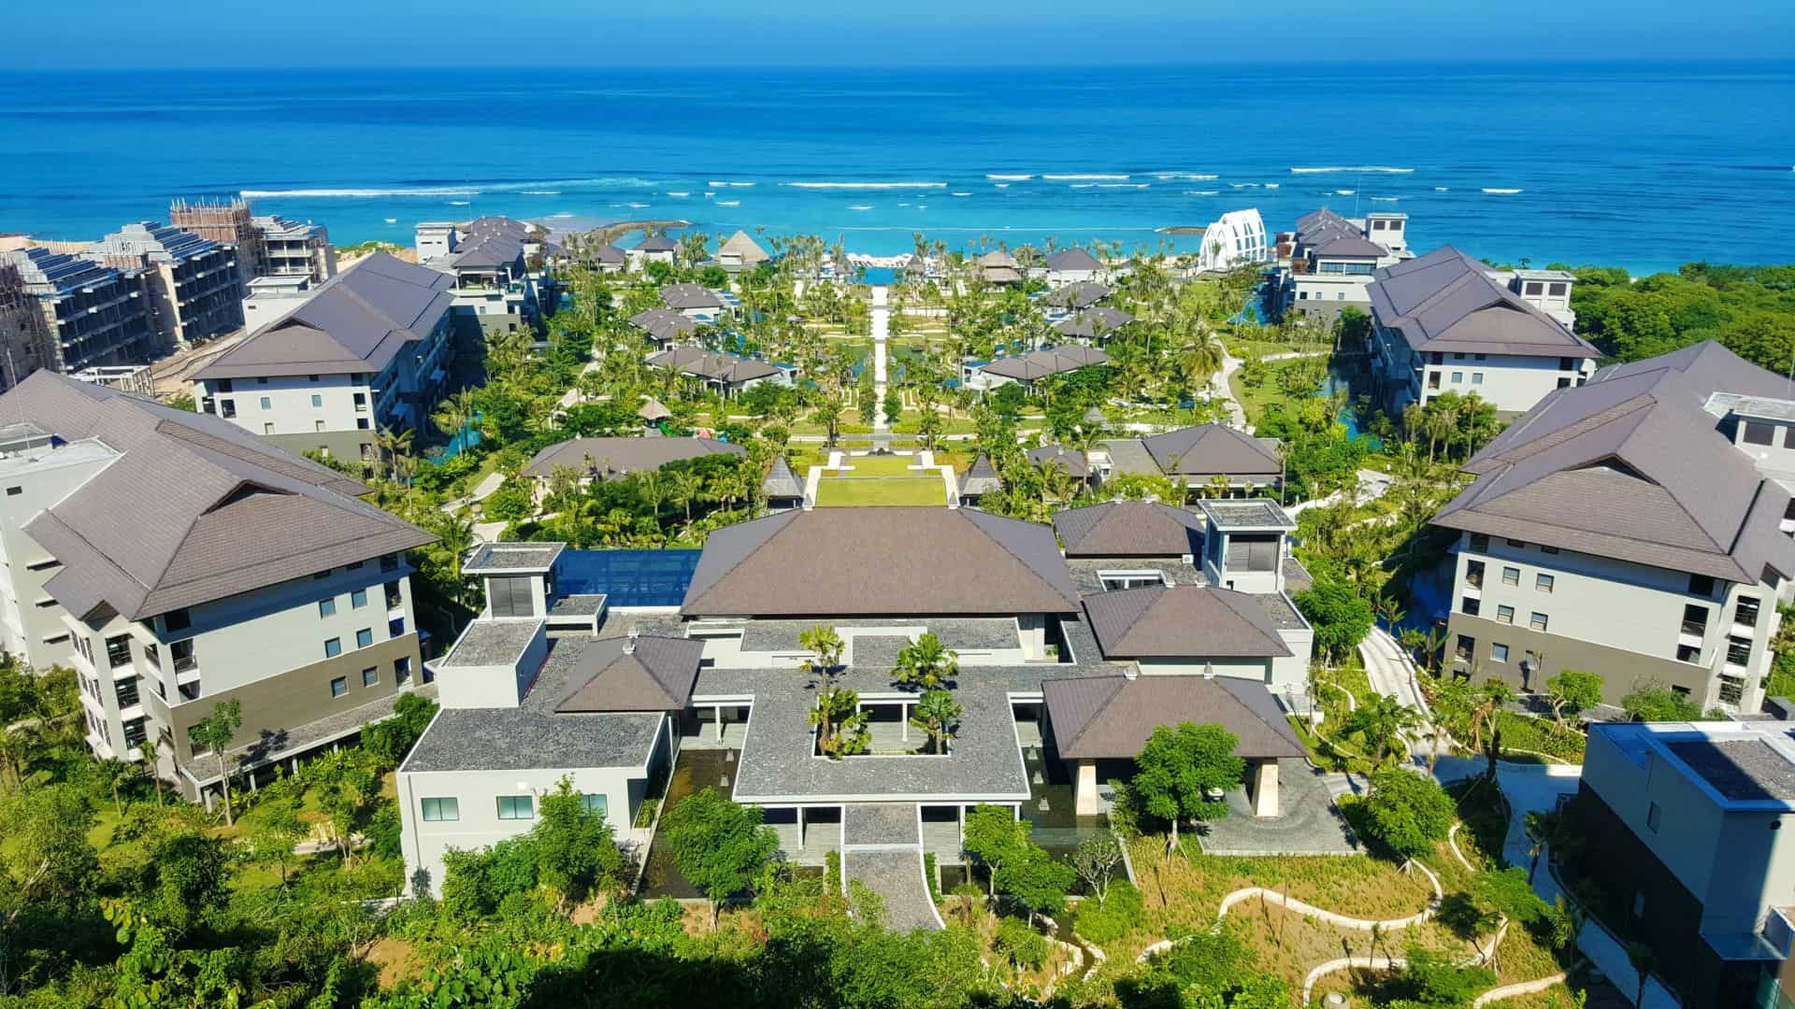
Figure 01: The Ritz-Carlton Bali: Luxury Hotel Resort in Nusa Dua (The Ritz-Carlton Bali, 2024).

Analysis
Famous for its five-star amenities and excellent customer service still the Ritz-Carlton, Bali has various obstacles that affect the hotel's efficiency and guest satisfaction (Paramita et al., 2022). Through a broad study, we strive to break down the problem, determine the causes of these problems, and give the best strategic advice for the problems.

Issues Identified
1. Guest Feedback Management: The hotel is faced with the problem of not managing guest feedback in time, which brings about missed opportunities for service growth and guest happiness development. Feedback channels, as such, are accessible but not effective in their analysis and follow-up actions, therefore causing the issues and problems to remain unsettled. Problems like these can deteriorate the trust in the hotel by the guests who might feel that their complaints have not been appropriately dealt with (Buttrick, 2018).
2. Reputation Management: The Ritz-Carlton, Bali, competes with other similar resorts in the region and in the world, and the proliferation of online review platforms comes with an issue of business reputation maintenance (Florent, 2024). Poor reviews or perceived perceptions, whether they are justified or not, can damage the hotel's image which in turn impacts the decision of potential customers to book (Noordzife, 2014). Reputation management practices will be reinforced to minimize negative reviews and keep the hotel in its position as a leading luxury establishment.
3. Revenue Generation: Despite its premium positioning, the hotel encounters revenue fluctuations, it may be either during the off-peak season or the onset of a financial crisis. This issue could be caused by pricing schemes that are not viable, not using revenue management solutions, or not having a suitable marketing strategy to attract and retain guests (Krismasari et al., 2020). Getting revenue right for the hotel is paramount as this is directly tied to the financial stability and long-term success of the hotel (Whittington, 2020).
4. Scope of Offerings: The Ritz-Carlton Bali has a vast scope of amenities and offerings (Dewi et al., 2022). It is however vital to note that there may be certain gaps or areas which need to be improved within its offerings. Consumers' preferred industry trends keep changing all the time, which is why a periodical review of the hotel's range of services is required to keep the hotel 'in tune' with the market and competitive (Brierley, 2006). In this regard, it is possible to achieve goal of building a stronger customer base and increasing guest satisfaction by identifying the areas for improvement or differentiation.

Analysis and Causes

Figure 02: The Ritz-carlton, Bali (Tripadvisor, 2024).
1. Guest Feedback Management: The ineffectiveness in the management of guest feedback could be the result of inadequately obtained resources, absence of the staff training in handling guest complaints, and a centralized approach to feedback analysis and solving. There are no proper systems or technology that make it possible to track feedback and escalate it, which leads to the problem being even more severe (Whittington and Molloy, 2005). This, in turn, can result in guest complaints that may remain unresolved, giving rise to unsatisfied visitors and the possibility of unwanted negative word-of-mouth (Omahoney, 2021).
2. Reputation Management: The management of the hotel's reputation will deal with a mixture of issues such as the boom of online review sites, the impact of social media, and the hotel chain’s reaction to negative comments (ORCID, 2024). A poor review left unattended or without a clear and honest response can hurt the hotel's reputation, and can erode the trust of guests (Mavridopoulou and O’Mahoney, 2020). The hotel's capacity to stand out from the crowd and display its unique proposition will affect its image (Baron and Armstrong, 2007).
3. Revenue Generation: Generating revenue fluctuation may be connected to seasonality, market dynamics, competitive pricing externalities, and consumer behaviour changes (Altman, 2021). The hotel's over-dependence on traditional income sources, like room reservations and the food and beverage department, may not enable the hotel to optimize its revenue potential (“The consensual interaction between a traditional village and hotel investors,” 2018). Strategic pricing, targeted marketing campaigns, and diversified revenue streams are proven to be effective in the sense that they help to stabilize the revenue base and support sustainable revenue growth.
4. Scope of Offerings: The extent of services The Ritz-Carlton, Bali, probably will not meet the current desires of customers or the evolving market (Andriany et al., 2022). While the hotel offers a variety of facilities and experiences, it is possible to become richer in some areas, such as wellness, eco-tourism, and cultural immersion experiences. Besides, differentiation in unusual and original services is one of the important ways to make the hotel not only the same but also different from other competitors (Kevin, 2019).

PESTLE Analysis
The PESTLE model constitutes a tool for strategic planning that is effective in the assessment of the external factors that have an impact on the operations and performance of organizations (Bouzid, 2020). The Ritz-Carlton, Bali, a 5-star hotel in the hospitality industry, should consider these aspects for their viability:
Political Factors: Political factors denote government policies, regulations and stability, which can be a crucial component of the hospitality industry environment (Legrand, Chen and Laeis, 2022). In Bali, Indonesia, political stability is usually very good for tourists and hotels because one of them is the aspect of economic stability that they bring about (Song and Lee, 2020). The positive side is that government policies regarding taxes, labour laws, and tourism regulations may benefit the hotel. The negative side is that the changing government policies may affect the hotel’s operation (Rhou and Singal, 2020). The geopolitical tensions or instability of the surrounding countries can affect the Bali resort's occupancy levels and income as this can reduce the occupancy rate.
Economic Factors:
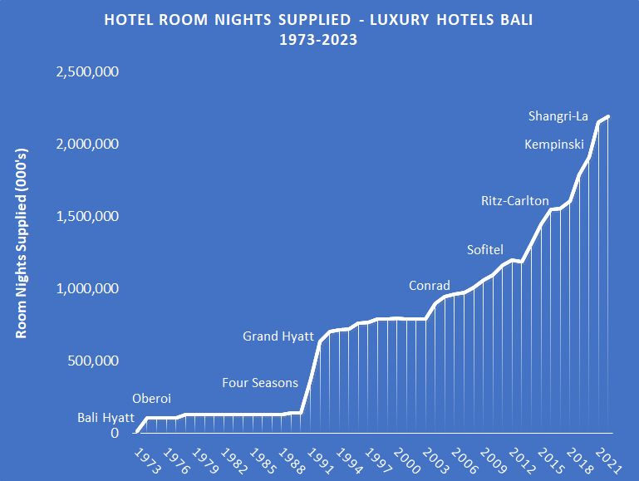Figure 03: Growth of Luxury Hotel Rooms in Bali (1973-2022) (Woods, 2024).
The macroeconomic factors emphasized the overall economic conditions, rate of economic growth, inflation, exchange rate, and consumer expenditure patterns. The economy of Bali is dependent mostly on tourism, which makes it vulnerable to fluctuations in the world economic scene (Adi Saputra et al., 2022). The fact that slower economic growth or recession in the large markets is the source of the demand could cause a fall in travel and spending on non-essential items that hurt the revenue of hotels (Vickers, 2011). Further, exchange rate volatility could be a factor that becomes a determinant of international tourists’ purchasing power and affordability to travel which in turn will impact their decision to visit Bali and stay at luxurious hotels that include the Ritz-Carlton (Law et al., 2016).
Social Factors: Social factors grasp the social tendencies, cultural values, lifestyle choices, and societal attitudes that shape consumer behaviour and demand (Astuti, Chariri and Rohman, 2019). For a hotel in Bali, social factors such as the growing middle class in emerging markets, increasing desire for experiential travel, and the new surged interest in sustainable tourism could present opportunities (Astawa et al., 2022). Customer choice fluctuation, travel patterns change and various cultures may require the hotel to be flexible about its offerings and services, which will be done to fit all the potential guest segments.
Technological Factors: The technological factors cover the development of technology, digitalization, and innovation which can affect the way the hospitality industry operates and also the kind of experience that the guests get (Sugiyanto, Husin and Wahyudi, 2019). The Ritz-Carlton, Bali, can make use of technology to improve guest interaction, simplify tasks, and personalize the services. To illustrate these, mobile check-in/check-out services, guest-facing mobile apps and data analytics for personalized marketing can be implemented for operational efficiency and guest satisfaction. The fast-moving technology necessitates continuous spending on the replacement of infrastructure and training of staff to retain a competitive position in the market (Permatasari and Mahyuni, 2022).
Environmental Factors: Environmental factors such as ecological sustainability, climate change, environmental regulations, and green initiatives are the ones that lead to the hotel's environmental footprint and corporate social responsibility initiatives (Japutra and Situmorang, 2021). In addition to being a luxurious hotel, The Ritz-Carlton, Bali has the responsibility of decreasing its ecological footprint and promoting eco-friendly behaviour. Embracing eco-friendly measures like energy conservation and waste reduction and community engagement will increase the hotel's reputation, attract conscious travelers and promote sustainable tourism development in Bali. Consequently, complying with environmental regulations and certifications (for instance LEED certification) will be proof of the hotel's environmental responsibility.
Legal Factors: The legal dimension includes laws, regulations, and the legal environment that regulates hospitality operations including labour laws, health and safety standards, and licenses. Compliance with the local rules and regulations and the requirements of the industry is a must for The Ritz-Carlton, Bali to maintain the integrity of its operations and the safety of the guests. Changes in labour laws, taxation policies, or licensing regulations might require the hotel to make adjustments in its business operations and the way its employees work. A proactive legal compliance and risk management strategy plays a vital role in preventing the occurrence of any legal risks and liabilities (Ketut Astawa, Ketut Budarma and Widhari, 2021).
Overall Impact and Implications
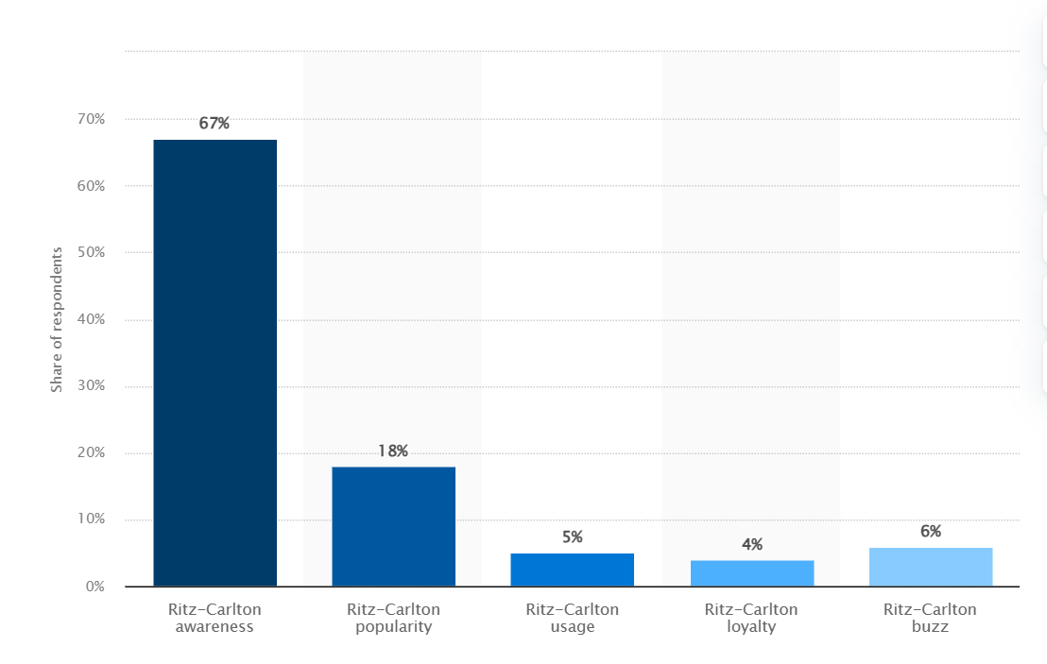
Figure 04: Ritz-Carlton brand awareness, usage, popularity, loyalty, and buzz among hotel customers in the United States in 2022 (Statista, 2022).
PESTLE analysis indicates that the external forces are the interconnected factors that have the potential to impact both business operations and the success of The Ritz-Carlton, Bali. At first glance, some of the angles may look like a way for development and self-improvement, but the other ones can clearly show the risks that should be addressed cautiously and strategically. The hotel can neutralize the uncertainty and get the advantage of the opportunities and therefore, stabilize its success in the market of the hospitality industry, by the means of understanding the changing external environment and adaptation to it (N. W. B. P. Dewi et al., 2022). This research is a rich source of data on the factors that determine the operating environment of The Ritz-Carlton, Bali. Consequently, the hotel can make its decisions on its competitive strategies much easier and maintain a leading position in the market.

SWOT Analysis
A SWOT analysis analyses the inner strengths and weaknesses of the hotel and external opportunities and threats. It formulates strategic recommendations that will be used to improve the hotel's competitiveness (Bunting, 2015).
Strengths | Weaknesses
Luxurious amenities | Ineffective feedback management
Exceptional service | Reputation vulnerabilities
Brand reputation | Revenue volatility
Prime location | Limited scope of offerings

Opportunities | Threats
Market expansion | Intense competition
Diversification of offerings | Economic downturns
Technological advancements | Negative publicity
Sustainability initiatives | External crises
By means of a thorough SWOT analysis, The Ritz-Carlton, Bali is able to identify the most important strategic priorities, to stand out with strengths, to deal with weaknesses, to take advantage of opportunities and to defend itself from threats, bringing the luxury hospitality market a competitive advantage that will allow it to achieve long-term success.

TOWS Analysis
A TOWS analysis combines the findings of the SWOT analysis to formulate strategic directions:
Strengths (S) | Weaknesses (W) | Opportunities (O) | Threats (T)
S1: Leveraging brand reputation to enhance reputation management strategies | W1: Implementing robust feedback management systems and training programs | O1: Expanding market presence through strategic partnerships and targeted marketing campaigns | T1: Mitigating revenue volatility through diversification of revenue streams
S2: Enhancing service excellence through staff training and empowerment | W2: Addressing reputation vulnerabilities through proactive communication and crisis management protocols | O2: Differentiating offerings through innovative guest experiences and sustainability initiatives | T2: Anticipating and preparing for potential external crises through comprehensive contingency planning
S3: Capitalizing on prime location to attract high-end clientele | W3: Increasing scope of offerings to meet evolving guest preferences and market trends | O3: Embracing technological advancements to enhance guest experiences and operational efficiency | T3: Monitoring and managing competitive threats through continuous market analysis and adaptation
By using a TOWS strategy, The Ritz-Carlton, Bali, can identify implementable tactics to take advantage of its strengths, handle weak points, make the best of opportunities, and neutralize threats. In this way, the hotel will be able to foster sustainability and improve guest satisfaction. This extensive analysis offers an understanding of the problems and solutions facing Ritz-Carlton, Bali and it becomes the platform from where strategy development can be based to deal with these matters effectively and achieve continuous improvement in guest satisfaction and operational performance.

Recommendations and Change Management
To increase The Ritz-Carlton Bali guests' enjoyment in a fabulous five-star resort located in the beautiful Nusa Dua area, the consultant suggests a total strategy that includes personalization, staff training, technology integration, facility enhancements, and continuous improvement. This will make the hotel a first choice for guests seeking a luxury destination and setting a benchmark for the elite hospitality in the island of Bali.
1.Personalization and Customization
a. Creating an advanced guest profile system that stores information regarding guest’s preferences, interests and stay history details. This information should be available to all guest-facing staff, thus, staff would be able to personalize the services and amenities that are suited for every individual guest depending on his/her unique requirements and preferences. By way of illustration, if a guest has a favorite pillow or favorite drink, this information should be stored to provide guests with a smooth and personalized experience all the way.
b. Developing a pre-arrival communication mechanism where guests can submit their needs and specific preferences beforehand. This could be anything from food preferences, room amenities, activity preferences, any special request etc. This way, the hotel can collect the information in advance and be ready for every guest. This will allow the hotel to prepare and anticipate the guest’s needs and therefore, create a smooth and personalized experience from the moment the guest enters the hotel.
2. Staff Training and Development
a. Improve the present training for staff to attend to guests' every need and anticipate what they need before they ask. This should encompass extensive training on cultural awareness, efficient communication skills, problem-solving techniques, and the sensitivity to read and respond to the subtleties that guests may be signalling (Malek et al., 2018). Through staff development, Ritz-Carlton Bali can always provide friendly customer service and ensure that every guest's concern is addressed with proficiency, empathy and much care.

b. Have regular coaching sessions with the employees as well as give them feedback so that they can adapt to a culture of ever-improving. As such, these sessions should be designed to offer staff the chance to get professional evaluations, discuss their issues, and highlight the regions of their professional development. Through the development and training of its staff, the hotel will ensure that its highest level of service quality is serviced.
3. Technology Integration
a. Invest in a mobile application that can help guests view hotel services, make reservations, and communicate directly with hotel staff using their devices (Shin et al., 2019). This feature may include food ordering in the room, spa appointment booking, and real-time display of the events or activities in the hotel. With the introduction of mobile technology, The Ritz-Carlton, Bali, can come up with means of serving to the sophisticated traveler by proving the convenience and effectiveness in accessing the services.
b. The smart room controls, high-speed wi-fi, and integrated entertainment systems should be part of the room upgrading process. The additions facilitate guests to engage in seamless connectivity by using their devices, control their room environment to their preference, and enjoy the entertainment of their choice during their stay. With the use of state-of-the-art technology, this hotel can serve as a perfect example for the new generation of travelers who prefer high-tech amenities.
4. Facilities and Amenities Enhancements
a. Through a thorough assessment of the hotel's spaces and services, spot out those areas that need further improvement or even development after paying close attention to the guests' comments as well as to the recent trends in the hotel industry and the market situation. This review should be inclusive of a room check, a check on public areas, dining outlets, recreational amenities, and wellness offerings. The Ritz-Carlton, Bali can keep its place as one of the world's leading luxury hotels by always measuring and improving its facilities. This will help the hotel to preserve the level of comfort and delight its guests with the services they are used to.
b. Exploring the possibility of providing brand-new amenities or some experiences that are customized to the ever-changing craving of luxury travelers, i.e. curated wellness programs, selected culinary experiences, or off-site exclusive excursions. These special types of offerings could be the differentiator of the hotel from its competitors that are offering mundane experiences that don't satisfy the guest's interests and values.
5. Guest Feedback and Continuous Improvement
a. Strengthen the existing guest feedback system by inviting real-time feedback both during and after their stay, through surveys, comment cards, or direct communication channels like dedicated hotlines or email addresses. Giving a chance to the guests to express their feedback can be an excellent source of information for the hotel to understand their standard levels, improvement factors, and upcoming trends or preferences.
b. Establish a full-scale system for evaluating and responding to guest feedback that will involve cross-department teams to discover recurrent themes, prioritize issues, and execute corrective actions expeditiously. Such a prevention strategy to feedback management will help the hotel to be always responsive to guests' needs and continuously upgrade their services and offerings.
Change Management Strategies
With the suggestions listed, they will be needed to develop change management strategies for the transition to be in the direction and to mitigate any operation disruption.
- Communication and Stakeholder Engagement: Forming a complete communication strategy that will enlighten all the stakeholders such as employees, management, guests, and external partners about the upcoming changes as well as the reasons for them. Transparent and understandable communication is the core element of involving all parties in the understanding, support, and buy-in. Organizing town hall meetings or focus group sessions often to solicit views and answer questions from employees. Such events should offer a setting where workers, managers, and owners can openly discuss any concerns and hesitations, as well as initiate a sense of belonging and acceptance among the workforce (Astawa et al., 2019).
- Training and Development: Designing a robust training program to help employees acquire the necessary competencies and knowledge on the new processes, technologies or services. Such training programs should take into account the specific requirements of each department and job position, thus, ensuring that the staff is well-equipped to go through the transition and achieve the desired results. Selecting the change leaders from each department who will champion for the changes within their department and provide their colleagues with assistance during the transition (Baron and Armstrong, 2007). They must be recognized and allowed to lead their peers, as role models and ambassadors of the change that is coming.
- Phased Implementation: Applying a gradual approach to change implementation, prioritizing vital areas, and granting time for running tests and corrections before full-scale implementation. This gradual approach will have a minimal effect on the ongoing work and allow for the incorporation of the feedback and the lessons learned from the experience (Song and Lee, 2020). Running pilot programs or soft launches for the novel initiatives, obtaining feedback from staff and guests, and making the needed adjustments to the full-scale implementation. These pilot programs can help to reveal potential problems or areas of improvement, thus the transition will be much easier, and further risks related to the large-scale changes will be less likely to happen. regularly communicating milestones will keep the momentum knowing the stakeholders updated throughout the transition.
- Performance Monitoring and Continuous Improvement: Setting performance standards (KPIs) and measures to assess the effectiveness of the implemented changes, for instance, guest satisfaction scores, revenue growth, operational efficiency, and environmental impact reduction. These metrics should be in line with the goals and objectives of the proposed changes, which will help determine the result of the implementation in a quantifiable and unambiguous way (Whittington, 2020). Tracking and evaluating system performance, identifying the areas that need more emphasis or problems that need to be solved. These routine monitoring and evaluation activities will help the change to remain effective and continue to bring the desired results in the future. Building a culture of continuous improvement through the constant acceptance of the staff’s suggestions to enhance guest experience and operational methods (Al-Ababneh, 2021). Create communication channels for the employees to express their thoughts and experience, and ensure their ideas are considered and used in the next improvement initiatives.
- Reward and Recognition: Developing an awarding scheme for staff that would appreciate and promote the change, acknowledging their efforts and commitment. Such recognition may happen in different forms through public acknowledgment, performance-based incentives, or special privileges and rewards. Establishing performance appraisals and incentives that are linked to the successful implementation of the initiatives, thus, making the employees feel that they are stakeholders. Aligning their work to the open outcomes and rewards will let the staff to be motivated and get fully absorbed in the change process. Celebrating milestones and successes along the change process and recognizing the positive outcomes that come with them while encouraging staff to maintain the momentum. Celebrations can be team events, social gatherings, or public recognition ceremonies which make the entire team feel great and accomplished.
The Ritz-Carlton, Bali can achieve guest experience excellence, remain a top luxury destination and foster a culture of continuous improvement and world-class service delivery by implementing all the recommendations and adopting effective change management strategies.
Potential Benefits and Costs
The successful implementation of these recommendations is expected to yield substantial benefits for The Ritz-Carlton, Bali, including:
1. Increased guest satisfaction and loyalty: Personalized experiences, exceptional service, and advanced facilities will allow the hotel to build a passionate fan base and create positive word-of-mouth communication which will result in repeat business and bringing in new guests (Al-Hyari et al., 2023).
2. Revenue growth: An increase in the customer base, stable ancillary revenue streams from on-site facilities and services, and the ability to set higher room rates can positively affect the overall revenue of the hotel (Saleh et al., 2023).
3. Operational efficiency: The amalgamation of technology and smoothening of processes will be the driving force towards the improvement of operational workflows that will eventually result in cost reduction and high overall efficiency in different sections of the business (Kaligis et al., 2023).
4. Competitive advantage: Through being in front of the industry trends and always getting better its facilities and services, The Ritz-Carlton, Bali, can stand out from other competitors and stay on the top position as a leader of luxury hospitality (Anggraeni et al., 2023).
5. Talent attraction and retention: A pledge to train and empower employees as well as recognition of their efforts can lead to increased levels of job satisfaction and improve the quality of the workplace culture. This in turn helps in creating a competitive advantage in the hospitality industry, by attracting and retaining the best talent (Garavan et al., 2023).
6. Sustainability and environmental stewardship: By adopting eco-friendly measures and encouraging sustainable conduct, the hotel can give a hand to the conservation of the Bali natural marvels and cultural heritage, as well as attracting environmentally inclined travelers (Bianco et al., 2023).
Potential costs to consider may include
1. Technology upgrades: Developing a mobile app, improving in-room technology, and integrating digital concierge services needs considerable investments in hardware, software, and regular routine maintenance and support (Ngari and Mwangi, 2023).
2. Facility enhancements: Renovations, additions, or expansions to the existing facilities and amenities often are capital-intensive meaning that they cannot be done without careful budgeting and project management (APPIAH et al., 2023).
3. Staff training and development: Designing and delivering up-to-date training programs, coaching sessions, and cross-training initiatives will necessitate significant resources, such as trainers, materials, and staff participation time (Moreno Brito et al., 2023).
4. Marketing and promotion: Communicating and promoting the upgraded guest experience as well as the new offerings may simply not only marketing efforts but also advertising and promotional campaigns (Dimitrios et al., 2023).
5. Operational costs: Adding new processes, services, or amenities may incur additional operational costs, like hiring workers, purchasing materials, and outsourcing other services (Zhang et al., 2023).
6. Sustainability initiatives: The implementation of green processes and technologies could potentially involve initial capital outlay, but this cost is normally compensated by long-term savings and enhanced productivity (Bianco et al., 2023).
What The Ritz-Carlton, Bali needs to do is a careful analysis of the costs against the benefits and develop a detailed financial plan for the long-term viability and profitability of the above-mentioned initiatives. The hotel can successfully execute these suggestions by achieving a balance between the investment and the return. Hence, it will be the ultimate luxury destination in Bali.

Action Plan
Number | Problem | Solution | Desired Outcome | Time Scale | Completion Date | Planned Budget
1 | Inadequate Technology Integration | Invest in technology upgrades and integration of guest-centric solutions | Seamless guest experiences, improved operational efficiency | 6 months | July 31, 2024 | $50,000
2 | Limited Community Engagement | Strengthen partnerships with local communities and organizations | Enriched guest experiences, support for sustainable tourism | Ongoing | - | $10,000
3 | Marketing and Branding Challenges | Develop a comprehensive marketing strategy and branding initiatives | Increased brand awareness, expanded market reach | 12 months | December 31, 2024 | $100,000
4 | Staff Training and Development | Implement training programs focused on service excellence and innovation | Enhanced guest satisfaction, empowered workforce | Ongoing | - | $20,000
5 | Continuous Evaluation and Adaptation | Establish a framework for ongoing evaluation and adaptation of strategies | Sustained effectiveness of implemented initiatives | Continuous | - | $5,000 per annum

Conclusion
The consultancy report for The Ritz-Carlton, Bali has been concluded, and it consists of an in-depth study and strategic recommendations designed to improve the guest experience and to deal with the operational challenges. The review of the factors, both internal and external, including technology integration, community engagement, staff training, and marketing strategies, has led to the identification of actionable insights that the hotel can use in order to achieve sustainable growth and the best service delivery. The analysis outcomes prove that the existing difficulties have to be solved and the opportunities be used to preserve the position of The Ritz-Carlton, Bali as a world-class luxury resort. One of the most important barriers highlighted is the need for increased technology integration to simplify business processes and improve guest experiences. With the technology upgrade and the client-focused implementation of the solution, the hotel can optimize efficiency and enhance service quality. This will be the cause of guest satisfaction and loyalty, eventually. Thus, the analysis established the imperativeness of the continuation of the relationship with the local communities and organizations, as well as the other stakeholders that are engaged in the green tourism activities. By participation in eco-friendly practices and engaging local communities, the Ritz-Carlton Bali can offer unique travel experiences to visitors and assist the social and environmental wellbeing of the destination at the same time. The report recommended that the staff training and development should be a continuous process in order to enhance the competence of the workforce and bringing out their motivation to give an outstanding service. The hotel can achieve this goal by initiating and fully utilizing the integrated training programs which emphasize the service excellence and innovation, thus prompting the staff to overachieve guests’ expectations and leading to positive word-of-mouth referrals. The marketing and branding strategy, according to the analysis, should focus on the accumulation of consistent strategies that will be used to increase the brands’ recognition and expansion of the market (Gigilo et al., 2020). By using a structured marketing strategy that is directed towards the digital platforms, partnerships and target marketing campaigns, the hotel will be more visible and will bring in more of its extremely analytical customers.
The next step is to ensure the development and implementation of the recommended strategies to achieve the set objectives and to maintain the hotel's competitiveness. The hotel should not only be committed to the effective use of available resources but also keep track of progress and modify operations by market dynamics, in order to achieve the targeted results.
In the end, we are honored to be part of The Ritz-Carlton project and thanks for the opportunity to work with you. To me, the hotel's management team and their stakeholders who entrusted me with the responsibility to work with them to strategize on ways of improving the guest services and also the organizational success is an honor. The consultancy team will stay dedicated to the realization of The Ritz-Carlton, Bali's strategic goals and objectives. The team is also very happy to prospect for future partnerships.

References
- “The concensual interaction between a traditional village and hotel investors” (2018) International journal of applied sciences in tourism and events, 2(2). doi: 10.31940/ijaste.v2i2.1179.
- Adi Saputra, K. W. et al. (2022) “Crisis management strategy in Bali hotel industry during the COVID-19,” South Asian Journal of Social Studies and Economics, pp. 21–29. doi: 10.9734/sajsse/2022/v13i230352.
- Aeberhard, M., Conrady, R., Grandy, S., Illes, T.P., Parken, A., Pokorny, N., Vogler, R., Wenske, M., Wohltorf, J., Aeberhard, M. and Grandy, S., 2020. Luxury and the tourism offer. In Luxury Tourism: Market Trends, Changing Paradigms, and Best Practices (pp. 157-211). Cham: Springer International Publishing.
- Al-Ababneh, M., 2021. The implementation of Total Quality Management (TQM) in the hotel industry. International Journal of Tourism and Hospitality, 1(1), pp.25-34.
- Altman, J. (2021) People strategy: How to invest in people and make culture your competitive advantage. Nashville, TN: John Wiley & Sons.
- Andriany, D. et al. (2022) “5-star luxury hotels’ Instagram performance as a digital marketing strategy during the travelling restriction,” International Journal of Glocal Tourism, 3(2), pp. 100–110. doi: 10.58982/injogt.v3i2.210.
- Anggraeni, R.D., Ismail, T., Lestari, T. and Ramdhani, D., 2023. The Relationship between Strategic Leadership, Competitive Advantage and Intellectual Capital: Evidence from Hotel in Tangerang Indonesia. Britain International of Humanities and Social Sciences (BIoHS) Journal, 5(2), pp.100-112.
- APPIAH, P.A., ADONGO, R. and Abdul-Rafiw, S.A.F.O., 2023. Sustainable Energy Systems and Green Hotel Practices in Hotels in Tamale Metropolis, Ghana. Journal of Environmental Management and Tourism, 14(7), pp.2915-2934.
- Astawa, I. K. et al. (2019) “The practice of green hospitality at the operational level (a case of 5-star hotel in Bali),” in Proceedings of the International Conference on Social Science 2019 (ICSS 2019). Paris, France: Atlantis Press.
- Astawa, I. K. et al. (2022) “Green hotel promotion strategy in Bali: A study using SWOT analysis,” in Proceedings of the International Conference on Applied Science and Technology on Social Science 2021 (iCAST-SS 2021). Paris, France: Atlantis Press.
- Astuti, P. D., Chariri, A. and Rohman, A. (2019) “Association between intellectual capital and competitive advantage: A case study on the hotel industry in Bali Province, Indonesia,” Humanities & social sciences reviews, 7(4), pp. 440–449. doi: 10.18510/hssr.2019.7460.
- Baron, A. and Armstrong, M. (2007) Human Capital Management. London: Kogan Page.
- Bianco, S., Bernard, S. and Singal, M., 2023. The impact of sustainability certifications on performance and competitive action in hotels. International Journal of Hospitality Management, 108, p.103379.
- Bianco, S., Bernard, S. and Singal, M., 2023. The impact of sustainability certifications on performance and competitive action in hotels. International Journal of Hospitality Management, 108, p.103379.
- Bouzid, A. (2020) The PESTLE model & the 7S framework the PESTLE model & the 7S framework: Business analysis tools:: To learn & apply to your business. Independently Published.
- Brierley, E. (2006) Talent on tap: getting the best from freelancers, interims and consultants. London: Chartered Institute of Personnel and Development.
- Bunting, D. (2015) The art of swot analysis. North Charleston, SC: Createspace Independent Publishing Platform.
- Buttrick, R. (2018) The project workout: The ultimate guide to directing and managing business-led projects. London, England: Routledge.
- Dev, C.S., 2024. Hotel Brand Overload: The Coming Shakeout.
- Dewi, K. I. E. et al. (2022) “Implementation of eco-friendly behavior by front office employees to support green hotel at The Ritz-Carlton Bali,” International Journal of Green Tourism Research and Applications, 4(2), pp. 68–85. doi: 10.31940/ijogtra.v4i2.68-85.
- Dewi, N. W. B. P. et al. (2022) “Tri Hita Karana-Based CSR: How Hotel Relates to Community during the Covid-19 Pandemic,” International Journal of Glocal Tourism, 3(2), pp. 121–130. doi: 10.58982/injogt.v3i2.213.
- Dimitrios, B., Ioannis, R., Angelos, N. and Nikolaos, T., 2023. Digital marketing: The case of digital marketing strategies on luxurious hotels. Procedia Computer Science, 219, pp.688-696.
- Florent, V. (2024) The influence of training on employee performance; the mediating factor of teamwork at The Ritz-Carlton, Bali. Universitas Pelita Harapan.
- Garavan, T.N., Sheerin, C., Koukpaki, S., O'Brien, F., Chami-Malaeb, R., MacKenzie, C. and Buckley, J., 2023. Strategic talent management in hotels during COVID-19: upper echelons and dynamic attention-based perspectives. International Journal of Contemporary Hospitality Management, 35(8), pp.2728-2754.
- Giglio, S., Pantano, E., Bilotta, E. and Melewar, T.C., 2020. Branding luxury hotels: Evidence from the analysis of consumers’“big” visual data on TripAdvisor. Journal of business research, 119, pp.495-501.
- Japutra, A. and Situmorang, R. (2021) “The repercussions and challenges of COVID-19 in the hotel industry: Potential strategies from a case study of Indonesia,” International journal of hospitality management, 95(102890), p. 102890. doi: 10.1016/j.ijhm.2021.102890.
- John-Mariadoss, B., 2023. 11.5 Designing Products, Services, and Processes with Customers in Mind. Core Principles of Strategic Marketing.
- Kaligis, J.N., Tumbelaka, S.S.X. and Goni, D., 2023. Organizational Culture, Work Motivation, and Work Effectiveness (Case Study on Hotels in Tomohon and Tondano). International Journal of Applied Business and International Management (IJABIM), 8(1), pp.89-100.
- Ketut Astawa, I., Ketut Budarma, I. and Widhari, C. I. S. (2021) “Green hotel practice Di Bali Dan respons perilaku Tamu,” Prosiding Seminar Nasional Terapan Riset Inovatif (SENTRINOV), 7(2), pp. 1–8. Available at: https://proceeding.isas.or.id/index.php/sentrinov/article/view/1025 (Accessed: May 3, 2024).
- Kevin, K. (2019) Maximizing service quality of guest service center at ritz-carlton, bali. Universitas Pelita Harapan.
- Krismasari, M. A. et al. (2020) “Commission of online travel agent to increase room occupancy at The-Ritz-Carlton, Bali,” International Journal of Green Tourism Research and Applications, 2(2), pp. 96–103. doi: 10.31940/ijogtra.v2i2.1991.
- Law, A. et al. (2016) “Transitioning to a green economy: the case of tourism in Bali, Indonesia,” Journal of cleaner production, 111, pp. 295–305. doi: 10.1016/j.jclepro.2014.12.070.
- Legrand, W., Chen, J. S. and Laeis, G. C. M. (2022) Sustainability in the hospitality industry: Principles of sustainable operations. 4th ed. London, England: Routledge. doi: 10.4324/9781003081128.
- Malek, K., Kline, S.F. and DiPietro, R., 2018. The impact of manager training on employee turnover intentions. Journal of Hospitality and Tourism Insights, 1(3), pp.203-219.
- Margaretha, F., Wirawan, S.E. and Wowor, W., 2022. The influence of service quality toward customer loyalty at five-star hotel in Bali. International Journal of Social and Management Studies, 3(2), pp.175-186.
- Mavridopoulou, I. and O’Mahoney, J. (2020) “Elitism in strategy consulting: How institutional prestige influences recruitment,” Management Consulting Journal, 3(1), pp. 12–22. doi: 10.2478/mcj-2020-0003.
- Moreno Brito, Y.L., Ban, H.J. and Kim, H.S., 2023. Ecological hotels' customer satisfaction through text mining of online reviews: a case of Ecuador hotels. Journal of Hospitality and Tourism Insights.
- Moscardó Zaforteza, M.D.C., 2023. Innovación y estrategia empresarial.
- Ngari, J.M. and Mwangi, Z.M., 2023. Technology orientation and sustained competitive advantage in star rated hotels in Kenya. The University Journal, pp.131-142.
- Noordzife, G. (2014) Project Management of Hotel Opening Processes: Exploring Better Ways to Manage New Hotel Openings, CreateSpace.
- Omahoney, J. (2021) “How Small Consultancies Grow: Challenging Problem-Based Theorising,” Management Consulting Journal, 4(1), pp. 5–20.
- ORCID (2024) Orcid.org. Available at: http://orcid.org/0000-0003-3782-4989 (Accessed: May 3, 2024).
- Paramita, P.W.P., Astawa, I.P., Mataram, I.G.A.B. and Sudira, I.P., 2022. Implementation of Offline Travel Agent Promotion Model to Increase Room Occupancy. International Journal of Travel, Hospitality and Events, 1(1), pp.7-14.
- Permatasari, M. G. and Mahyuni, L. P. (2022) “Crisis management practices during the COVID-19 pandemic: The case of a newly-opened hotel in Bali,” Journal of general management, 47(3), pp. 180–190. doi: 10.1177/03063070211063717.
- Rhou, Y. and Singal, M. (2020) “A review of the business case for CSR in the hospitality industry,” International journal of hospitality management, 84(102330), p. 102330. doi: 10.1016/j.ijhm.2019.102330.
- Saleh, M.M.A., Jawabreh, O. and Abu-Eker, E.F.M., 2023. Factors of applying creative accounting and its impact on the quality of financial statements in Jordanian hotels, sustainable practices. Journal of Sustainable Finance & Investment, 13(1), pp.499-515.
- Shin, H., Perdue, R.R. and Kang, J., 2019. Front desk technology innovation in hotels: A managerial perspective. Tourism Management, 74, pp.310-318.
- Song, S. and Lee, S. (2020) “Motivation of internationalization and a moderating role of environmental conditions in the hospitality industry,” Tourism management, 78(104050), p. 104050. doi: 10.1016/j.tourman.2019.104050.
- Statista (2022) Ritz-Carlton brand profile in the United States 2022, Statista. Available at: https://www.statista.com/forecasts/1335782/ritz-carlton-hotels-brand-profile-in-the-united-states (Accessed: May 3, 2024).
- Sugiyanto, L. B., Husin, Z. and Wahyudi, A. S. (2019) “The mediated role of absorptive capacity in the relationship between technology, learning, entrepreneurial orientation and performance of hotel industry in Bali, Indonesia,” The International Journal of Business & Management, 7(7). doi: 10.24940/theijbm/2019/v7/i7/bm1907-072.
- Sun, S., Lee, P.C., Law, R. and Zhong, L., 2020. The impact of cultural values on the acceptance of hotel technology adoption from the perspective of hotel employees. Journal of Hospitality and Tourism Management, 44, pp.61-69.
- The Ritz-Carlton Bali (2024) The Luxe Voyager: Luxury Travel | Luxury Vacations & Holidays. Available at: https://www.theluxevoyager.com/luxe-hotels/indonesia/the-ritz-carlton-bali/ (Accessed: May 3, 2024).
- Tripadvisor (2024) The Ritz-carlton, Bali, Tripadvisor.com. Available at: https://www.tripadvisor.com/Hotel_Review-g297698-d6820858-Reviews-The_Ritz_carlton_Bali-Nusa_Dua_Benoa_South_Kuta_Bali.html (Accessed: May 3, 2024).
- Vickers, A. (2011) “Bali rebuilds its tourist industry,” Bijdragen tot de taal-, land- en volkenkunde, 167(4), pp. 459–481. doi: 10.1163/22134379-90003580.
- Wangchuk, D. and Wetprasit, P., 2019. Assessment of current training program and its effectiveness in hotels of Bhutan. Journal of Quality Assurance in Hospitality & Tourism, 20(4), pp.405-423.
- Whittington, R. (2020) Exploring Strategy. Harlow: Pearson Education Limited.
- Whittington, R. and Molloy, E. (2005) HR’s role in organisation: shaping change. London.
- Woods, R. (2024) The growth of luxury hotels in Bali, Linkedin.com. Available at: https://www.linkedin.com/posts/ross-m-woods_growth-of-luxury-hotels-in-bali-1973-activity-7127651854963900416-f64C (Accessed: May 3, 2024).
- Yasa, M.D.M., Sadguna, I. and Putra, I., 2022. Prosedur Penanganan Barang Bawaan Tamu Grup di The Ritz-Carlton, Bali (Doctoral dissertation, Politeknik Negeri Bali).
- Zhang, D., Fang, C., Gao, Z., Wang, X., Shen, C. and Li, H., 2023. Energy, environmental and economic assessment of wastewater heat recovery systems in hotel buildings. Applied Thermal Engineering, 222, p.119949.

