Joseph Omar
Analysis and Simulation of a Centrifugal Clutch

Table of Contents
1. Introduction 2
2. Main Body 3
2.1. Task A 3
2.2. Task B 9
Bibliography 13

Introduction
This assignment analyses and simulates the operation of centrifugal clutch to meet the aims of the brief and the modules learning outcomes the main body of this report will comprise of two distinct tasks.
The first task mainly focuses on research into the topic of centrifugal clutches, and it will achieve this aim by investigating key points:
- The development of centrifugal friction clutches
- Materials used in the construction of these devices.
- Functions in which these devices can be used.
- Conditions in which these devices operate best under
The final part of this first task will be to explore how electromagnetic clutches are used to automate the modern manufacturing process.

The second task is more mathematical in nature and will calculate and explore various exponents of a specific centrifugal clutch (the specifics are for which are provided in the assignment brief). To complete this task several questions must be answered, and computer software must be used (Microsoft excel).

Main Body
This section of the assignment will be divided into two tasks as provided in the brief.

Task A
• How a centrifugal clutch works
A centrifugal clutch operates on the basis on the principle centrifugal force, the central rotating shaft in the clutch connects with the crankshaft of the engine this is connected to the outer casing.
As the rotations per minute increase in the engine so to does the rotation of the shaft increase, this causes the shoes which are located on the inner side of the device to reach the outer wall of the drum. The shoes and the surface of the drum are comprised of materials which create high leaves of friction. A disadvantage of this is that high temperatures are generated when the clutch is engaged and disengaged frequently.
(Toulas, 2018)
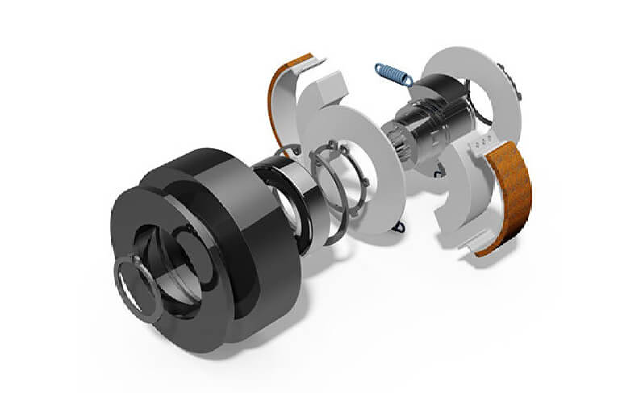

• The development of centrifugal friction clutches
Centrifugal clutches were used as early as 1850s for steam locomotives, A patent of 1898 proposes use of a centrifugal clutch on an electrical automobile.

(Crowdus, 1898)
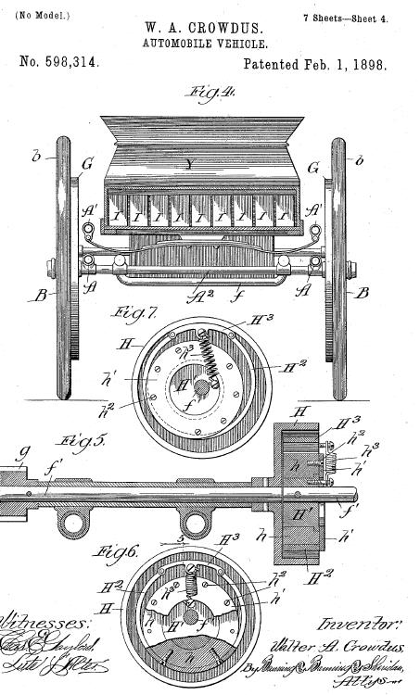
A centrifugal clutch was integrated into an Armstrong Siddeley 17 horsepower in 1934.
(Donald, 2004)
Centrifugal clutches have been largely supplanted in modern cars being largely replaced with fluid mechanical clutches, centrifugal clutches are still widely used in go-karts, scooters and mopeds and a range of other devices which are not associated with transportation and will be examined later in the report.
(Crowdus, 1898)
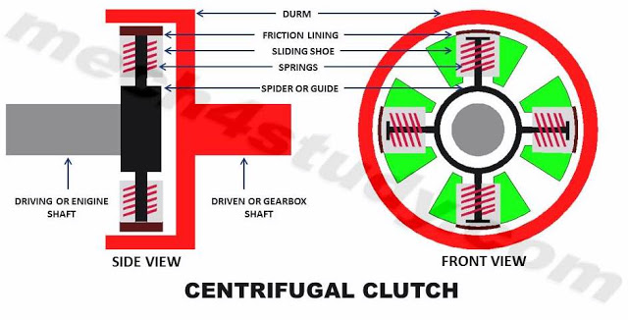

Guide:
The guide connects to the drive shaft of an engine drive shaft (the reason this component is named the guide is owing to the method it has of holding the shoes and guiding their movement). In the first instance the position of the shoe is governed by the spring.
Shoe:
A major component of the centrifugal clutch is the shoe, during the operation of the device the shoe clumps to the drum thus making a temporary connection between the guide and the drum. As the drive shaft rotates (along with the attached guide) so to do the shoes which under centrifugal action are forced to move outwards to connect to the drum.

Drum:
The drum works the same as the centrifugal clutch as the pressure plate does in a simple clutch mechanism. The drum is not connected directly to either the drum or the shoe and rotates in proportion to the driven elements.

Springs:
This type of clutch is largely controlled by springs with each shoe requiring a spring which provides connection with the guide. The shoes are held in their initial resting position until the required speed is reached by the guide for centrifugal force to overcome the force of the springs. Use of different springs within the clutch assembly would allow for this action to occur at different time for a different speed.

Friction Lining:
The shoe is coated with a lining which produces high friction when in contact with the drum. These linings are used to avoid direct contact between shoe and drum and the ware that would be associated with such contact. This lining functions in the same way as a friction plate in a simple clutch.
(Mech4study, 2017)

• Materials used in the construction of these devices.
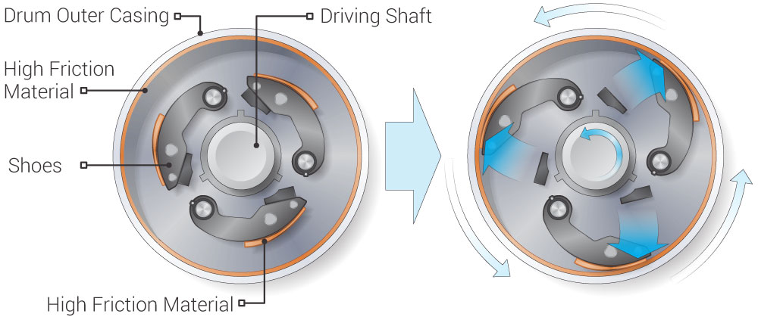

Most of the materials used to construct the centrifugal clutch are primarily steel, however the surface of the shoes and the inner lining of the drum require a high friction material (as previously discussed)
- Organic
Clutch discs of the organic variety are comprised of a mixture of natural high friction materials. Some of the more common material which fall into this category include –
  - phenolic resins
  - metallic powders
  - compounded rubber
These can either be moulded or woven.
Where clutch discs are woven this may involve the weaving of fiberglass into the discs to increase their durability. Moulded discs have a tendency to be cheaper in production but inferior in terms of longevity and durability.
- Heavy-Duty Organic
These materials are largely comprised of same components as those discussed in the previous point (organic) the only major difference being that the combination of fundamental materials will be weighted more towards the metallic components. The impact of using a mixture that is heavier in metallic composition is that the resultant materials will be more durable when exposed to high temperatures (the friction caused within a clutch as seen later in this report). Some heavy-duty organic materials can withstand temperatures up to 700 degrees Fahrenheit (371.1 Celsius)

- Ceramic
The use of the word ceramic is a misnomer to a certain extent when discussing clutch plates as ceramic examples are largely composed copper, iron, bronze, silicon, and graphite. The reason that the ceramics are more weighted towards their more metallic elements is because this allows the resulting ceramics to withstand high level of heat and friction. This is particularly useful in instances whereby the clutch needs to be engaged and disengaged frequently and at high speeds e.g., race cars etc.
A downfall of this kind of clutch is that engaging and disengaging of the clutch will not be as smooth when compared to clutches utilising other materials.
- Kevlar
Clutches of this type are possibly the most favourable option in terms of smoothness and precision and can last up to 3 times longer than clutches that employ organic materials, Kevlar is an incredibly durable and resilient material and clutches of this type are known to engage smoothly.
- Feramic
Materials of this type are an evolution of the materials discussed in the ceramic section with Feramic materials basically being a heavy-duty form of ceramics (in the case of clutch discs) materials of this type can produce extremely high friction and are comprised of similar component materials as ceramics (steel, silicon, and graphite). These are widely used in vehicles such as race cars and heavy-duty trucks. A child class of Feramic discs would be carbonic clutch discs which are common placed in trucks and are known the have a high level of heat resistance and smooth engagement.
(Kor-Pak, 2018)
• Functions in which these devices can be used.

Centrifugal Clutch Applications
Many pieces of equipment that are driven by engines employ a centrifugal clutch. Centrifugal clutches are frequently a component of equipment containing engines and rotating parts. Some devices that make use of a centrifugal clutch are listed below.
- Trowel and concrete finishers
- road cleaners
- Compressor/vacuum/fan drives
- Transport refrigeration units
- water pumps
- Woodchippers/stump grinders/milling cutters
- mixers in chemical industries,
- Vibratory plate compactors and rollers
- industrial applications like machinery, mining, military, manufacturing purposes.
- lawn movers, chain saw.
- scooters, go-karts, and mopeds.

(Lancereal, 2019)
Some advantages of the centrifugal clutch include the fact that this is a cost effective means which Is simple to operate. The device does not require separate control mechanisms. The centrifugal clutch offers a means of controlling the engage speed by simply altering the spring configuration and this device requires less maintenance than the alternatives.
There are however several draw backs to choosing a centrifugal clutch such as the fact that there is a limitation to power transmission because of slippage. Clutches of this nature cannot tolerate high levels of torque and there can be issues caused by generated heat which is biproduct of the friction generated within the device.
(Mech4study, 2017)
Industrial electromagnetic clutches are used in many types of machinery which utilise high speeds or high cycle rates. Machinery that falls into this category can be quite diverse including devices such as packaging machines, food processing equipment and industrial mixers.
(Process industry informer, 2020)
Electromagnetic clutches are particularly useful for monitoring and controlling assembly lines or devices remotely for example modern technologies incorporating the internet of things (IoT).
“Without going into too much detail, such clutches can deliver soft starts or over-excitation functions. Here, the clutch can either engage slowly or accept a voltage spike to engage quickly,” said Flemming.
In the event of an electric clutch is disengaged or engaged the control system can monitor the activity in the form of an electric signal. This is since the act of clutching or breaking produces energy (in the case of clutching this would be speed or inertia) which can be monitored instantly and remotely. Through use of the cloud this means that technologies making use of these devices can be managed either directly or remotely making them superior to their alternatives. In terms of manufacturing on an industrial scale this means that machinery can operate efficiently with a minimal amount of supervision or human intervention.
(Eitel, 2016)

Task B
Question 1
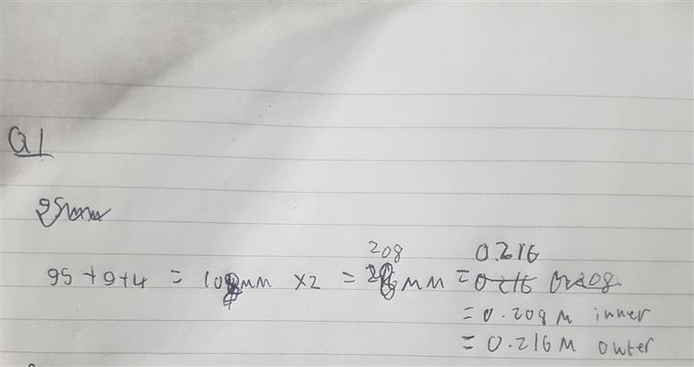
Question 2
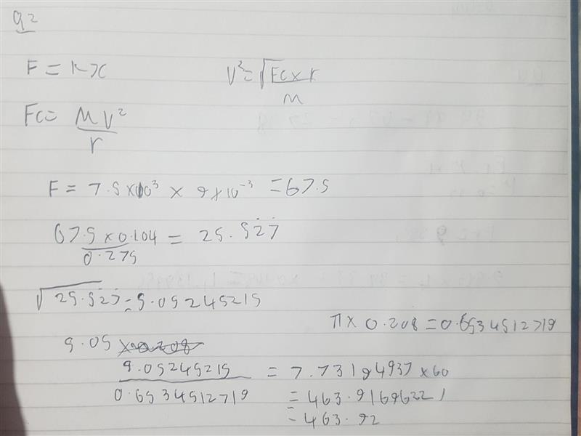

Question 3+4
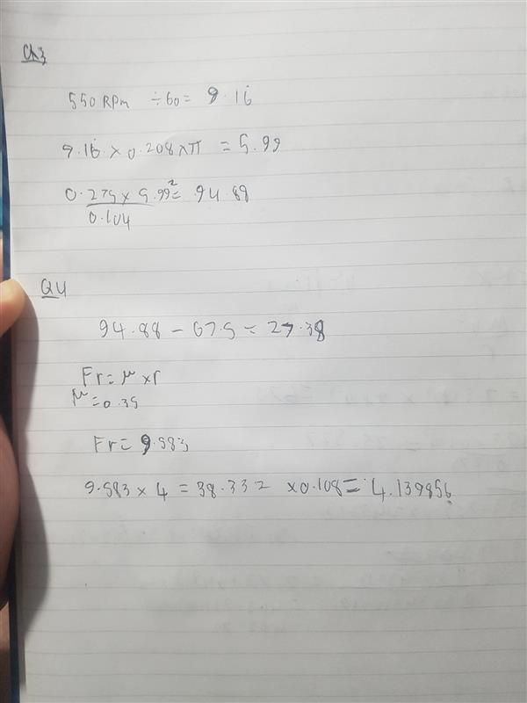

Question 5
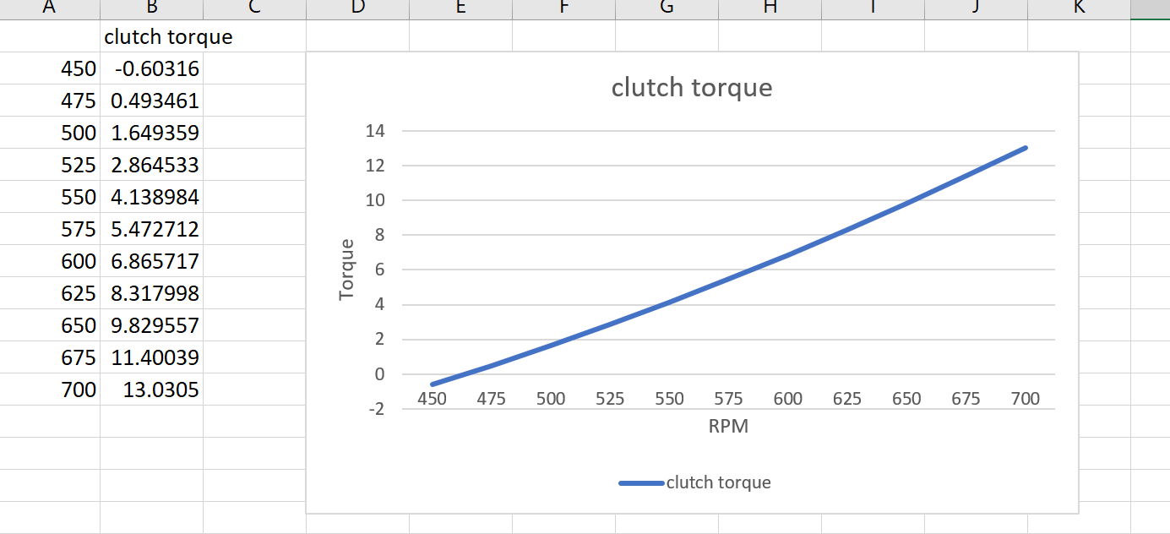
Question 6
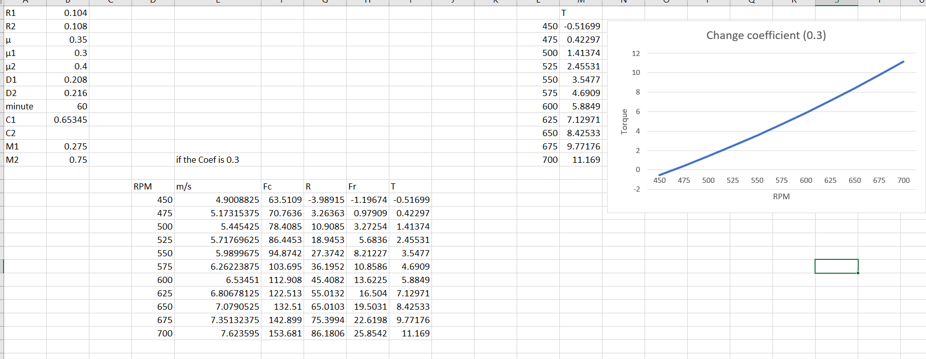

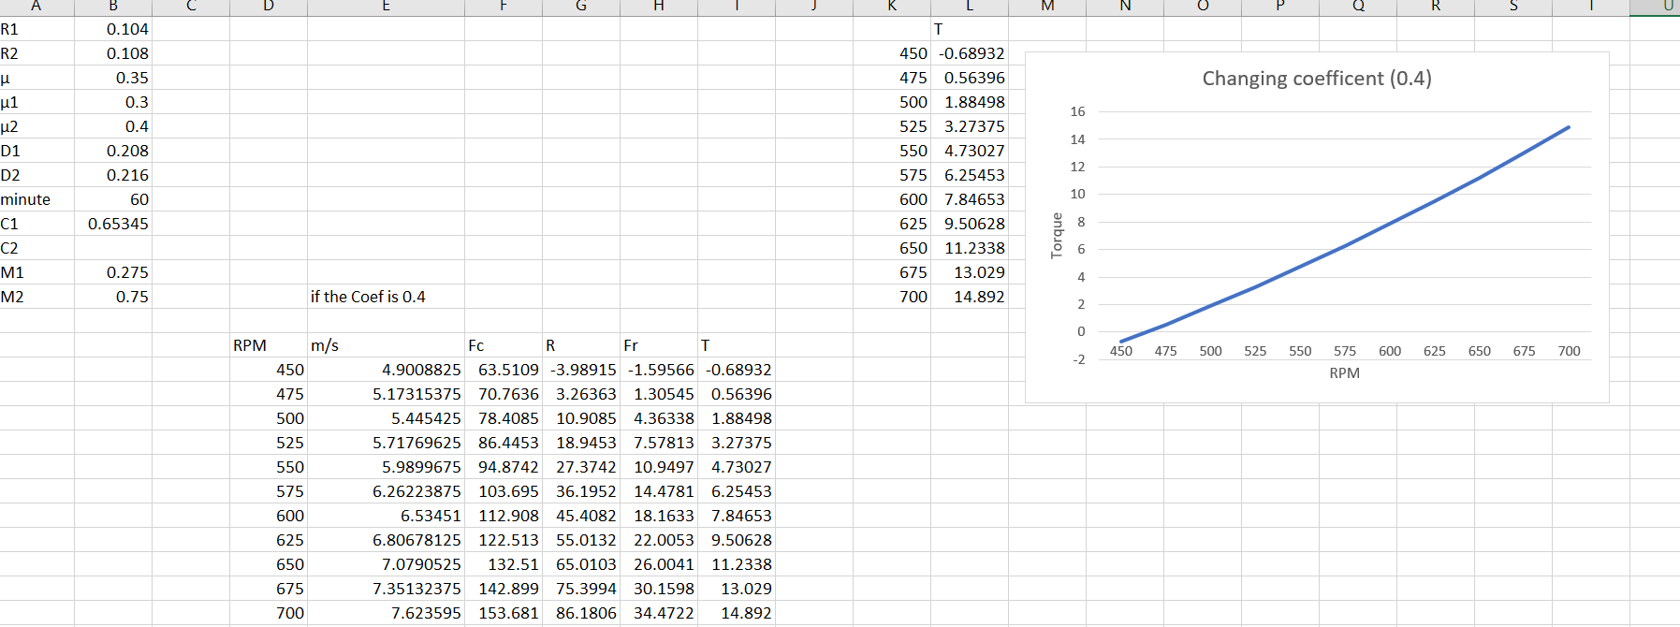
Question 7
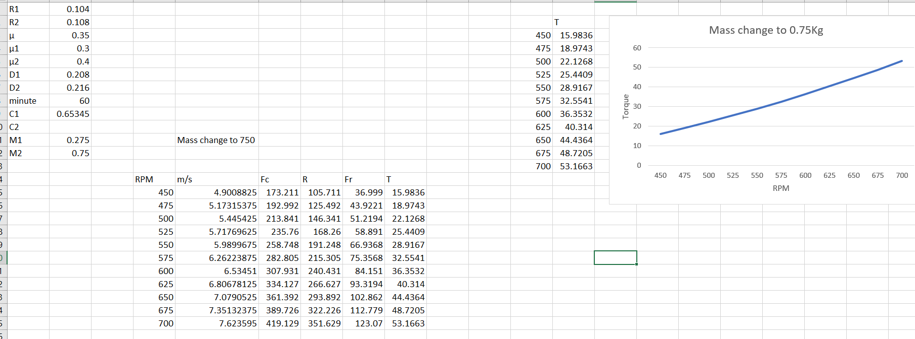
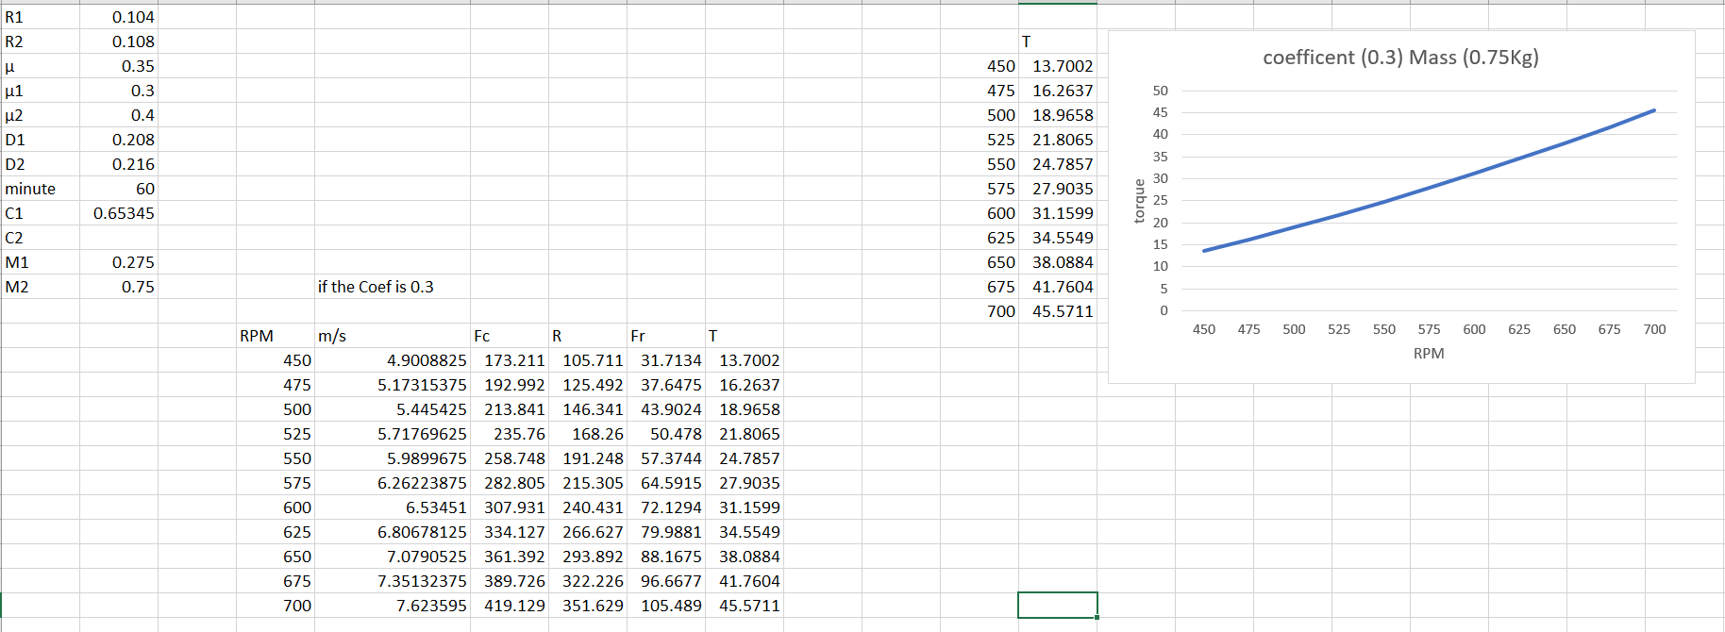
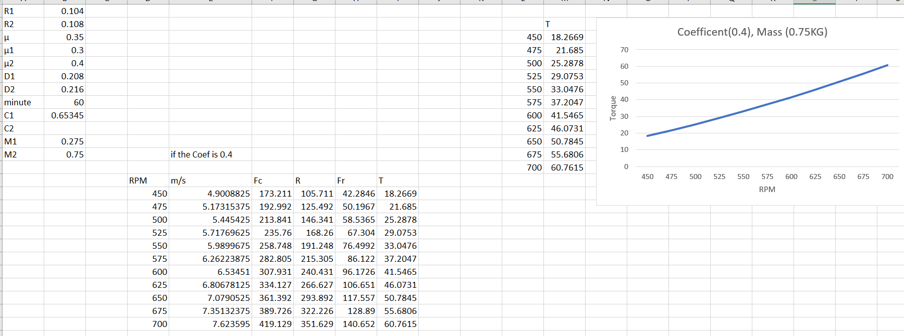

Bibliography
Crowdus, W., 1898. Automobile vehicle. USA , Patent No. 598314.
Donald, M., 2004. ARMSTRONG SIDDELEY 17 hp. [Online]
Available at: https://web.archive.org/web/20040216181745/http://siddeley.com/info_17hp.html
[Accessed 18 April 2021].
Eitel, L., 2016. Trends in clutches and brakes leverage software and customization. [Online]
Available at: https://www.designworldonline.com/trends-in-clutches-and-brakes-leverage-software-and-customization/
[Accessed 18 April 2021].
Kor-Pak, 2018. What is the Best Clutch Material for Friction?. [Online]
Available at: https://kor-pak.com/best-clutch-material-friction/
[Accessed 18 April 2021].
Lancereal, 2019. Centrifugal Clutch Explained – An Engineer’s Guide to a Centrifugal Clutch. [Online]
Available at: https://www.lancereal.com/centrifugal-clutch-explained/
[Accessed 20 April 2021].
Mech4study, 2017. Centrifugal Clutch: Principle, Construction, Working, Advantages and Disadvantages with Application. [Online]
Available at: https://www.mech4study.com/2017/11/centrifugal-clutch-principle-parts-construction-working-advantages-disadvantages-and-application.html
[Accessed 15 April 2021].
Process industry informer, 2020. Electromagnetic Clutches For Harsh Environments. [Online]
Available at: https://www.processindustryinformer.com/electromagnetic-clutches-for-harsh-environments
[Accessed 18 April 2021].
Toulas, B., 2018. How does a Centrifugal Clutch work? What are the pros and cons?. [Online]
Available at: https://www.engineeringclicks.com/centrifugal-clutch/
[Accessed 18 April 2021].

