

BA BUSINESS MANAGEMENT
Assignment 1

Module: Global Business Environment
Code: LCBB4005
Lecturer: Dr Rexon Nting
Name: Lorian-Alexandru Georgescu
Student ID: 2213950

SUBMITTED ON 5 December 2022

Global Business Environment Assessment 1

Contents
Introduction 4
Introduction of Romania as the Selected Country 5
Theories of Business Environment 6
PESTLE ANALYSIS 6
PORTER’S FIVE FORCES: 9
Opportunities and challenges for foreign businesses in Romania 11
Different difficulties faced by foreign companies in Romania 12
Recommendations 13
Conclusion 13
Reference List 14

Introduction

Production, sales, and other commercial operations that are constrained by geographic or national boundaries are referred to as an international business.
The company gains the ability to expand its operations to other nations.
Companies now have the chance to share the goods and services they make with other nations because of globalisation.
They don't need the money of any one nation to transact.
All businesses nowadays anticipate expanding their operations.
When businesses experience success and growth in one nation, they attempt to profit from other markets by making smart investments and entering those nations.

This report will be focusing on Sony Corporation, a significant consumer electronics manufacturer in Japan. Tokyo Telecommunications Engineering Corp. was established in 1946 by Ibuka Masaru and Morita Akio. In 1958, the company changed its name to its current one. Voltmeters, sound generators, and other similar devices were produced at first. The audio tape recorder was its first significant consumer product, which was unveiled in 1950. Since then, it has led the way in developing innovative technologies for consumer goods that are sold globally, such as the first transistor radio that fits in a pocket.
Having achieved success at a global level, this company intends to expand its operations furthermore. During this expansion, they will be required to analyse a variety of factors that need to be considered in advance of entry. As a result, the author of this report will analyse the external factors affecting the business in the market. Moreover, opportunities and challenges will be discussed to gain a competitive advantage in this market.

Introduction of Romania as the Selected Country

Romania is a fascinating land, full of enthralling tales, unusual places, stunning vistas, and remarkable people.
The nation is bursting with natural, architectural, and artistic marvels, from the best-preserved delta in all of Europe to the greatest outdoor museum.

Romania is the third largest state in Central Europe after Germany, with a surface area of 238,391 km2 and a population of 21,584,365 as of July 1, 2007. The country is located between two combat zones: the former Yugoslavia and the former Soviet Union.
Within this geostrategic environment, Romania is a stable country with a broad political readiness for European and Euro-Atlantic cooperation structures, engaging in potential crisis circumstances by EU and NATO requirements.
Romanian is the official language. With 87% Eastern Orthodox, 5% Protestant, and 5% Roman Catholic adherents, Christianity is the predominant religion in the country. The robust economy of Romania, with a long history of commerce and business, is the key attraction for foreign investors. Another important factor is the technological advancement of Romania. The president and the government both carry out executive duties.
The Chamber of Deputies and the Senate make up the bicameral Romanian parliament.

Theories of Business Environment

However, several external elements together referred to as the business climate will determine if this development is a success.
As a result, before investing, these aspects must be evaluated.

The business environment in Romania will be assessed using a variety of models and frameworks in the sections below.

PESTLE ANALYSIS
Political, economic, social, technical, legal, and environmental issues make up the PESTLE study. This is how these variables will be assessed:

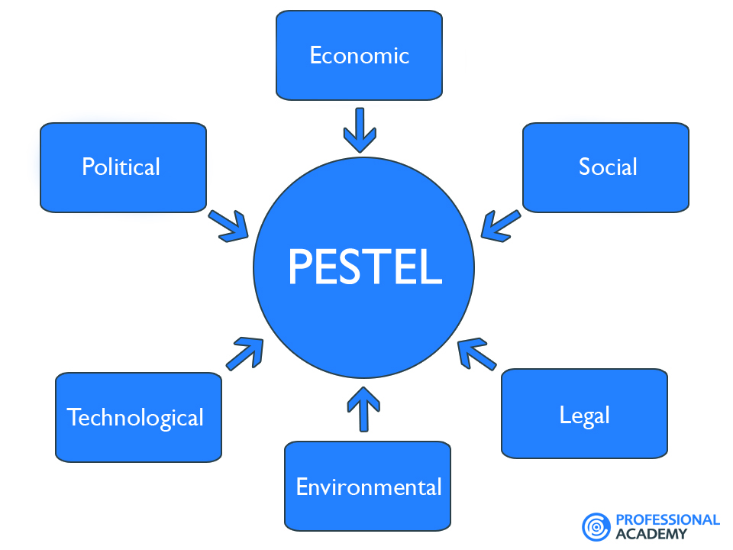

POLITICAL FACTORS: With judicial, executive, and legislative departments of power, Romania is an autonomous parliamentary republic. The president of Romania is its head of state. The prime minister of the country is in charge of it. With the approval of the Parliament, the president picks the prime minister. The country's capital, Bucharest, serves as the location of the government. Every company, Sony included, is impacted by political and governmental forces. Economic stability is linked to political integrity. And if the economy is failing, it's not unreasonable to think that rules and regulations are also in turmoil. Because SONY is a worldwide brand that works in several nations, the political conditions in each area have a direct impact on SONY's business.
ECONOMIC FACTORS: Economic factors include the taxation system, inflation, economic conditions, exchange rate etc. There aren't many, if any, internationally competitive industries that are connected to the Romanian brand. This is somewhat contradictory because, in the age of technical developments, knowledge and technology transfers occur more readily and quickly, enabling developing nations to skip growth stages and catch up to developed nations. The rising amount of disposable income globally should be taken into account. This outside factor gives Sony choices to boost its revenue. For instance, the company can market the PlayStation more aggressively if it anticipates that customers would be more able to afford the products (MBA Skool Team, 2022).

SOCIAL FACTORS: 18 official ethnic minorities in Romania have the legal right to speak in their mother tongue when interacting with the government or administration in places where they make up more than a fifth of the population. In contrast, a 2008 Freedom House Report emphasises that this right is frequently not honoured, remaining simply a legal one. The same survey demonstrates that discrimination against the Roma minority still exists when it comes to getting a job, housing, or social assistance.
Increased leisure-time accessibility could boost Sony's sales.
This external component highlights the need of marketing gaming and entertainment products to satisfy the leisure needs of target clients.
This aspect indicates how Sony's remote or macroenvironment sociocultural variables influence its big growth chances.

TECHNOLOGICAL FACTORS: Innovation, the supply chain, customer service, and other company operations are significantly impacted by technological elements. The most significant traditional industries or clusters in Romania, as we have previously noted, are those of wood and textiles. Compared to other nations, the percentage of GDP spent on research & development is rather low. It is also well recognised that Romania has favourable ecological and climatic conditions, but the lack of adequate infrastructure makes it difficult for tourists to take use of these benefits. SONY is mostly a technology firm. They incorporate technology into each and every one of their goods. For instance, gaming consoles consist of a collection of devices that send visual information to TV screens. Romania being such a lower cost option and for Sony to produce their gaming consoles wouldn’t sound that bad for the company. Sony has the potential to expand its businesses in electronics, gaming, entertainment, and financial services. As an illustration, the business can leverage its R&D expenditures to create a competitive advantage to promote the differentiation generic strategy (Roberta Greenspan, 2017).
ENVIRONMENTAL FACTORS: The mentality of the people and the business has changed over the past ten years as well. Sustainability, carbon footprint, environmental laws and regulations, and climate change have all gained significant relevance in business. Numerous companies are figuring out how to go green. It's more to please customers than it is out of the goodness of their hearts. To protect the environment, many customers are attempting to lower their carbon footprints. As well as SONY being expected to assist. Before joining the European Union, the legal climate of Romania was not very inviting for prospective customers, foreign investors, or multinational corporations, albeit since 2007 easing measures have been put in place. SONY has planned for a carbon-neutral future and is already making investments to further reduce its environmental effect. SONY's website states that “Sony has continued to promote environmental activities based on our “Road to Zero” environmental plan, which aims for a zero environmental footprint. To accelerate our environmental activities, we have now established our “Green Management 2020” environmental targets (achievement year: FY2020). As we move toward these targets, the entire Group, including the field of entertainment in addition to electronics, will make the best use of its strengths in performing these activities” (Abhijeet Pratap, 2017).
LEGAL FACTORS: The legal environment has an impact on business in Romania. Foreigners are allowed to conduct business without interference in the nation because there are no limits on foreign investment. Before 2005's Accession Treaty, foreign nationals were prohibited from investing in Romanian agriculture by purchasing agricultural land. Numerous laws and policies have been implemented in Romania to entice foreign capital to the nation. The nation has implemented regulations that give foreign investors equal access to resources including national money. The policies of the nation let international businesses purchase agricultural properties just like local businesses. Due to their equal treatment with local enterprises, these policies enable international businesses to operate at high profitability levels. The laws of the nations where Sony conducts business have a significant impact on how the company operates. Every nation establishes its legislative restrictions that any business wishing to conduct business there must abide by. For instance, Sony must abide by the recently established age discrimination rule in the UK. If a company is involved in a legal dispute, it could end up paying millions of dollars or losing a significant amount of money.

In this situation, the law can be quite difficult. Even when businesses make every effort to stay out of legal trouble, issues can still occur. It can be challenging for any business to wait months for the required regulatory permits in some nations. For major corporations like SONY, local legal and regulatory restrictions, such as labour laws and collective bargaining agreements, can make things difficult.

PORTER’S FIVE FORCES:

Five competing forces are analysed in this framework to explain the industry's strengths and shortcomings.
1. RIVALRY AMONG EXISTING COMPETITORS: The two forces with the highest intensities in Sony's instance are competition and customer bargaining power. These two factors are the most important ones that Sony takes into account when making business judgments about the industrial environment. It is advised that the business take steps to improve its competitiveness. For instance, the quick invention can make gaming consoles more competitive. By making products more appealing, this suggestion also addresses the bargaining power of consumers. The strong intensity of the force of competition against Sony is caused by the outside sources listed below: a high level of firm aggression, a low cost of switching, and a modest number of businesses.
2. BUYER’S BARGAINING POWER: Customers or buyers control a product's market share and profitability. The following external elements, which amplify the customers' significant intensity of negotiating power, must be taken into consideration by Sony in this situation: exceptional information, moderate buying frequency and low switching costs.
3. SUPPLIER’S BARGAINING POWER: The business of Sony Corporation is supported by its suppliers.
The modest size of Sony's suppliers is consistent with their modest and restrained influence on the market. For instance, a strategic shift in one supplier would have a limited and mild effect on the business. The availability of the materials that Sony needs is also moderately and minimally impacted by the general moderate supply. The modest degree of forward integration is another external element that supports Sony's suppliers' low bargaining leverage.
4. THREAT OF NEW ENTRANTS: The potential rise of new competitors must be addressed by Sony Corporation. This section of the Five Forces analysis looks at how new competitors affect the company's market share in the financial services, gaming, entertainment, and electronics sectors. Because of the cheap switching costs, new entrants can readily steal clients from well-known companies like Sony. However, the enormous expense of brand building poses a significant barrier to new entrants. For instance, to build and sustain a good brand, new businesses must budget amounts comparable to what big, established businesses spend. The impact of new competitors on Sony's industry environment is constrained by this external element.
5. THREAT OF SUBSTITUTES: Customers are encouraged to move away from products made by well-known companies like Sony and toward readily available alternatives of cheap switching costs. The industry environment of the company is strongly influenced by this external element. This force is nevertheless restrained by the modest range of replacements. Customers discover, for instance, that there are far more gaming alternatives available through Sony PlayStation than there are with more conventional, offline games.

Opportunities and challenges for foreign businesses in Romania

Over the past 20 years, Romania has experienced amazing growth and prosperity. The COVID-19 pandemic and the Ukraine conflict, however, have exposed basic weaknesses in the economy. These include structural rigidities in the labour and product markets, flaws in fiscal policy, and significant institutional constraints impeding the effective use of resources. They also include persistent poverty and differences in economic opportunity between regions and between urban and rural areas.
Being a multinational corporation, Sony must contend with the market's diverse cultures and tastes. The following are the difficulties Sony has encountered in marketing its goods in various regions:
-Since Sony is a multinational corporation and must promote its products internationally, it must deal with regional linguistic variations.
-Sony used many National languages of various nations to bridge the linguistic divides.
-Sony had to keep its staff diverse across all geographies.
-To meet customer needs, Sony must implement client-based after-sales services.
The business must also ensure that it has a strong business plan that will enable it to succeed in the Romanian market.
The corporate governance landscape changed in Romania, as it did in other transitional economies, less as a direct result of focused reform initiatives than as an unintended side effect of more comprehensive reforms meant to reshape the entire economic system. Corporate governance has only recently become a stand-alone matter of policy. The foundation for the private enterprise was created through enterprise reform, which was motivated by the breakdown of the administrative controls in place under the communist state. For the first time in many years, equities trading was made possible by reforms to the capital markets. In addition to transferring state assets to the private sector, privatisation produced tens of thousands of publicly traded shareholder-owned businesses.

Different difficulties faced by foreign companies in Romania

According to a study carried out for TMF Group Romania and released on Monday, the three main challenges faced by foreign companies operating on the Romanian market are the frequent changes in legislation, obtaining the proper level of support from the authorities, and the implementation of legal requirements. Finding the correct talent was a challenge for one-third of the managers who took part in the poll in 2014. Most enterprises, however, are prepared to meet these obstacles as they gain from Romania's robust economic recovery and an incentive for progress in recent years, which also translates into a wealth of lucrative chances (Anca Bernovici, 2016).
Because Romania is not a part of the "Euro Zone," payments must be made in the native currency, the New Romanian Lei (RON). However, many businesses and households have debt in euros, and most big-ticket consumer items (such as real estate, vehicles, and major appliances) are priced in euros. Due to greater transaction costs and fluctuating exchange rates, this causes trade inefficiencies.

Recommendations

Although the company already sells gaming gadgets, it is advised to use aggressive marketing and improve these items more to assist the business to develop. These moves are noteworthy, especially considering the market's huge profit potential for gaming gadgets on a global scale.
A suggestion is that the business implements continuous improvement to keep such security abreast of cutting-edge technologies. This suggestion also addresses the risk of cyberattacks. To grow the business, it is also advised that Sony execute quick innovation in addition to new product creation. For instance, quick innovation can boost a company's market share and potential revenues in the market for mobile devices.

Conclusion

The study's major objective has been to analyse the Romanian market to help the Japanese company expand successfully. It has been discovered that there are many business-related factors to consider when a firm is growing in the global market. It has been discovered that external factors significantly influence how successfully a corporation expands worldwide.

Reference List

https://www.worldbank.org/en/country/romania/overview

https://www.romaniajournal.ro/business/foreign-companies-in-romania-complain-of-frequent-change-of-legislation-find-out-the-other-most-pressing-challenges/
https://www.mbaskool.com/pestle-analysis/companies/18253-sony.html

