York Museums Trust Public Programme Proposal Form
Please email to exhibitions@ymt.org.uk once completed

What is the title of your  proposal? | Life and death: The Myth of Osiris
Date proposal submitted | 8th of November 2022
Please provide your name  and contact details | McKenzie Rowney  email: 2105411@student.uwtsd.ac.uk
Is it an idea for:  Event Exhibition  Subject / anniversary Communications campaign Research and Development Don’t know yet | This is an idea for a moderately sized exhibition.
Elevator pitch: in no more  than three sentences summarise your proposal | This exhibition tells the myth of Osiris from his dismemberment to his reconstruction. Because of his role as a god of fertility, but immediate connection to death, the exhibition focuses on the Egyptian journey of life, death, and the afterlife through a lens focusing on him and his family.

Who are the target  audience?  Reference Audience Spectrum segments if known.  If not known, who do you think this would this appeal to? | This exhibition aims to have something for all ages but does have a bit more of a focus towards older crowds due to the material the myth encapsulates (i.e., death and fertility). It will most likely appeal towards those who actively strive to learn about other cultures, but don’t necessarily have access to the finances or time to be able to travel to the places of the cultures. This audience does not fall cleanly into any one box provided by the audience agency. Particularly because this exhibition is focused moreover on accessibility for all than a specific audience.
What is the budget? | The current working budget is £5000.
Are there any fundraising  opportunities? | Yes, there are fundraising opportunities, for example an artistic showcase or a child-focused event. The showcase could feature things such as interpretive dance, paintings, music, and more. The event for children could go through the myth in a way that is easy to understand while being age appropriate. activities for such an event would include mould and amulet making, scavenger hunts, and lessons on the Nile (fertility). Though not an exhaustive list of opportunities both are educational and draw in a crowd different to those who would primarily be viewing the exhibition (i.e., those who are more art focused, etc.).
Are there any partnership  opportunities? | This exhibition would be a collaboration with Cyfarthfa Castle Museum for display of the amulet mould currently housed at the University of Wales Trinity Saint David (see figure 1). This exhibition would also have other objects on loan from other museums
Are there any other similar  shows / events happening regionally or nationally? | No similar events at a regional or national level at this given moment.
Does it draw on any of  YMT’s collections, or is inspired by them? | Yes, there are two bronze Osiris figurines in the archaeology collection (object numbers YORYM : 2010.743 and YORYM : 2010.738) , as well as figurines of Horus (object numbers YORYM : 2010.739 and YORYM : 2012.791). Drawing on these to expand the understanding of the wider mythology of Osiris and his family. The exhibition is, however, inspired by the amulet mould kept at UWTSD (figure 1) and it being something connected to Osiris while not featuring him directly. Isis being the focus of said mould is very reminiscent of the focus on Isis in the myth itself. Her being the one to piece him painstakingly back together and birth baby Horus, who is featured suckling in the mould.
Proposed location / gallery  for your idea. | I propose the Yorkshire Museum to be the location for this exhibition.
Who have you consulted  with at YMT or externally? | Yes, within YMT I have spoken with Senior Curator Andrew Woods, as well as other members of the team, in particular chief executive Reyahn King and head of finance Paul Lambert. Externally, I have spoken with the team at Cyfarthfa Castle Museum on being loaned the amulet mould.

How is this project unique  for YMT? | This project is unique for YMT because the York Museum Trust’s collection has Egyptian artefacts while not having an exhibition currently focusing on them. This is a myth that is approachable for most people as it doesn’t require too much prior knowledge. This will help diversify YMT’s focus which tends to be around the evolution of Yorkshire.
When would this project be  delivered? Does it link to any critical dates? | This project can be delivered at earliest convenience. There are no critical dates linked to this exhibition.
Please add relevant images | 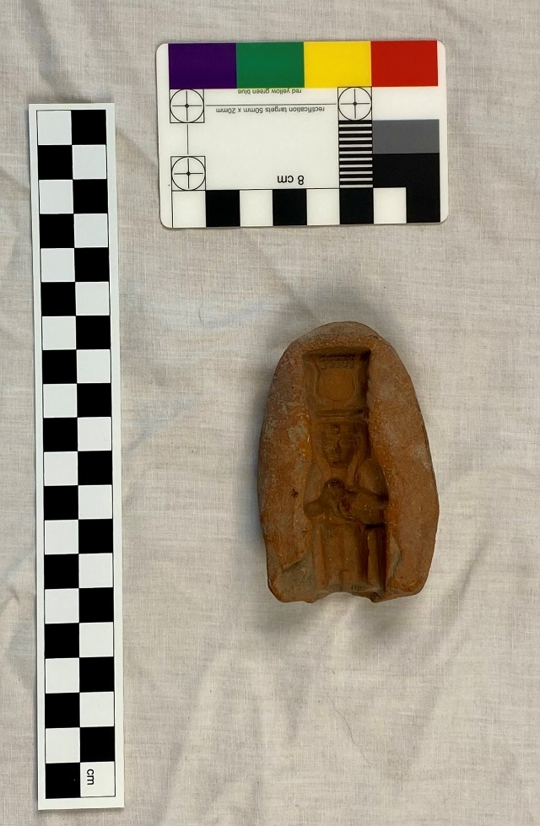  Figure 1 photo of amulet mould featuring Osiris's wife Isis and son Horus  (Photo taken by me)

When you have completed your proposal please email to: exhibitions@ymt.org.uk
Many thanks for submitting your proposal. We will be in touch once the proposal has been reviewed.

