Application Functionality Report – Welsh Hospital Pharmacy Stock Management System (WHPSMS)

Name: James Goddard
Student Number: 2111623
Word Count for Core Document Between Contents List and Reference: 5445

Contents

Introduction 3
Methods 7
The FITT Framework 8
System Usability Scale – SUS 9
Results 11
Fit between individuals and technology 13
Fit between task and technology 14
Fit between Individuals and task 14
Fit with other systems 15
Limitations 15
Discussion 17
Lessons Learned during Implementation 18
Interventions 19
Interventions regarding task 19
Interventions regarding user 19
Interventions regarding technology 19
Appropriateness of FITT and other approaches 20
Comparisons 21
Seamless Care 22
Conclusion 23
References 24
Appendix 1 – Usability and Scoping Questionnaire 26

Introduction
Pharmacy services are an essential part of any hospital whether public or private. It is estimated that in a typical NHS district general hospital around 7000 doses of medicines are administered daily (Audit Commission, 2001). With medicines being one of the most frequent therapy interventions it is important that they are professionally managed, stocks controlled, and the dispensing done accurately.
The system for managing hospital pharmacy stocks, which is used in six out of the seven Health Boards, has been in place for over thirty years and utilises old “green screen” technology. It has not been replaced before, but has been upgraded more than once, with no new functionality, simply to remain operational. Having had its software support withdrawn, and not integrating well within NHS Wales digital architecture it was becoming increasingly risky and more difficult to sustain. It has been deemed no longer fit for purpose. The old system had many different configurations (at least one per health board in Wales), which contained many different ways of describing medicinal products in different hospitals, some even utilising different configurations within the same health board. These configurations were jointly developed over the years by NHS Wales Informatics Service (now DHCW) and pharmacy users, in response to local operating procedures and service needs. This led to variation in functionality across hospital sites.
Between November 2020 and December 2021, a project to replace the legacy system with a new centrally hosted system took place. This is referred to as the Welsh Hospital Pharmacy Stock Management Service (WHPSMS). This system was procured from a supplier with a large market share in hospital pharmacy systems and has since changed its parent company and name three times, although its core product remains the same, hence it is referred to as WHPSMS.
Replacing the WHPSMS was seen as an enabler for delivering against a number of key Welsh policies and strategies, because of its functionality and rich source of consistent secondary data. For example the Informed Health and Care – a Digital Health and Social Care Strategy for Wales (NHS Wales, 2015), emphasised and prioritised electronic medicines management, care-planning tools and decision support to underpin workflow and patient safety in delivery plans.

In the Lord Carter Report (Lord Carter, 2016), it was suggested that there is as much as 20% variation in the costs of medicines used for treatment and that having a system to manage efficient stockholding could save in the region of £50mil in NHS England per year. The new system is intended to replace inconsistency with consistency and standardisation; and achieve more resilience and cross-site transparency.

Another aspect that is seen as an important benefit of a modern pharmacy stock management system, would be to enable integration with hospital electronic prescribing and medicines administration (HEPMA), when HEPMA is delivered in the future. The integration aspect of functionality will not be explored in this evaluation, as HEPMA is not implemented across Wales, yet, however, the use of a single consistent national medicines file takes steps towards this ambition and is reflected in the overall notions of the evaluation.

The purpose of the WHPSMS (otherwise known as JAC, WellSky or its latest name; CareFlow Medicines Management) is to allow medicines to be procured, receipted, dispensed, or booked out safely, accurately and efficiently, and allowing accounts to be settled. A detailed set of requirements was used to procure software and it was recognised that standardisation and consistency across health boards would also enable a more efficient approach to medicines stock control and usage.
Hospital Pharmacy systems have a significant role to play in medicines management and safety. They allow reporting on the medications that have been used within a hospital, health board and wider context. They will not necessarily contain an accurate record of everything a patient has been prescribed, as many routine medications are issued as stock supply to wards, but all medication stock is administered, ordered and “booked-out” to cost centres that can be monitored.
Whilst the hospital pharmacy system is concerned with the supply of medication to patients this can still contribute to medication error. Errors can occur in the ordering process, both ordering from the pharmacy and ordering medications into the pharmacy stock and in dispensing. Bates et al. (1995) notes the following rates of errors at each of these medicines process stages:
- Ordering (56%) – ordering the correct medication from pharmacy;
- transcribing (6%) – re-writing the medicines from the prescription to an order sheet, or re-writing a prescription to a new medicine chart;
- dispensing (4%) – the issuing of medication from pharmacy or similar, and
- medicines administration (34%) – the giving of the correct medication to the correct patient, at the correct time and dose.
Therefore, it is important to manage these processes effectively.
Currently the process for ordering and transcribing is a paper process, especially without electronic prescribing and medicines administration systems (ePMA). To order medication for ward-based patients, known as inpatients, either a medicine chart will need to be taken to the pharmacy department, risking being lost, or an order will be transcribed from it, either to paper or to a third-party system, where the order is printed out. During the course of a day a vast number of orders are sent to pharmacy and transcribed to the pharmacy system. It is quite possible that because of the many orders that arrive in a pharmacy department that delays can occur meaning patients could go without vital medicines and the medicine may be misinterpreted or misread during transcribing due to illegible handwriting.
When a medication is dispensed, in order to correctly maintain stock balances and book out correctly, the correct patient and details about where the supply is going in the hospital need to be entered into the WHPSMS and the stock booked out. Booking out stock is usually intertwined as part of the dispensing and/or issuing process and is vital to ensure the system supports prompt procurement and prevents stock shortages, which could also lead to harm. The dispenser must first find the correct patient, then find the correct medication on the system, then, where relevant, enter the correct dosage instructions and supply the correct amount. A label is then produced, and the stock booked out. The medication is then prepared and packed, checked and stored for transportation. At each of these steps there is a potential for error, such as incorrect patient, incorrect medication, incorrect dose, quantity and inadequate labelling, which could include the wrong label being put on the wrong drug. Therefore, it is important that the business process around dispensing and supply is a well-supported with systems that can help with each of these stages and reduce deviation from the process.
It is apparent that a well configured and usable pharmacy system should be able to help prevent and/or reduce product selection and dispensing errors and become an enabler to reduce transcription.
The new implementation of WHPSMS is a client-based application graphical user interface, although later developments will be towards introducing a web-based user interface. Figure 1. shows a screen shot of the graphical user interface and initial screen seen when launching the WHPSMS system in Windows.

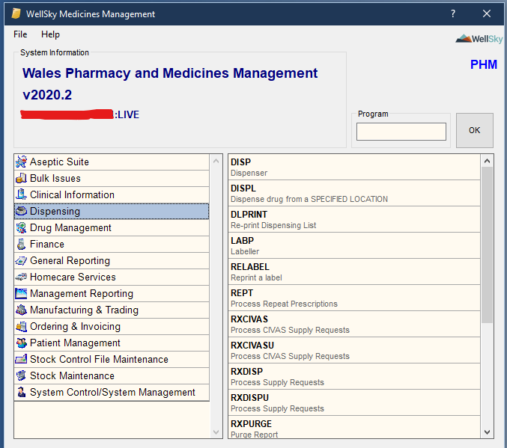
Figure 1 - WHPSMS (here seen as WellSky) - GUI (initial user screen)
It is important that the evaluation of the national approach to the WHPSMS is undertaken, especially to understand the effectiveness of the technology and to consider how well it fits the expectations of both users and tasks. There were many local configurations and nuances before the new system and undoubtedly users will have been very familiar with the older systems and the tasks nuanced to it.

Methods

The methodology of evaluation for the WHPSMS consisted of a mixed method approach to undertake a FITT evaluation (Ammenwerth et al., 2006), examining usability as an aspect to support this. The approach used a web-based questionnaire aimed at hospital pharmacy users of all roles combined with analysis of experiences and lessons learned from implementation. Part of the questionnaire included a section that allowed the user to identify their role and for what they use the system for. The questionnaire included both a Likert style system usability scale (SUS) survey (Brooke, 1996), a validated tool, with further questions orientated around the validated FITT framework (Ammenwerth et al., 2006) (Appendix 1). The intention to understand and identify key themes and issues. The FITT related questions included some high-level questions examining users’ perceptions of how well they felt the technology “fitted.” It was also the intention that this approach could enable and inform future study, such as semi-structure interviews with themes informed from the responses in the questionnaire. However due to time constraints it was not possible to take this next step in evaluation.
Initially the questionnaire was tested with colleagues within NHS Digital Health and Care Wales, before being disseminated to pharmacy health board WHPSMS users across NHS Wales.
To supplement the evaluation and gain better understanding and perspective it was considered useful to understand the pharmacy workflows. These help to visualise the work processes and steps involved, helping to inform further evaluation methodology and gives context to user responses. The business process model shown in Figure 2, helps to demonstrate the dispensing process, one of the core business functions of WHPSMS.

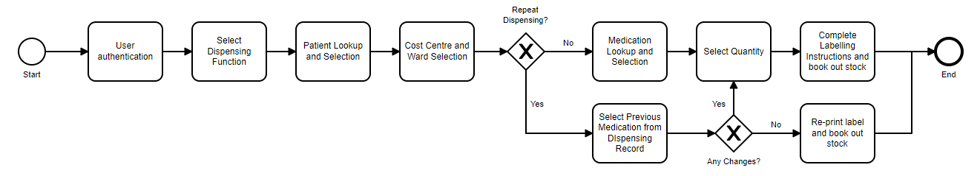
Figure 2 - Business Process Diagram of the "Happy" Dispensing path within WHPSMS

Hand in hand with the survey an analysis was undertaken from documented experiences and lessons learned from each implementation from across NHS Wales (DHCW, 2022). This also helps to identify interventions that were made or that still need to be made to support the optimal fit.

The FITT Framework
The FITT framework developed by Ammenwerth et al. (2006), considers the interaction (fit) between users, task and technology (Figure 3), and contemplates the socio-organisational factors that have an impact on Health Information Technology (HIT) adoption. A user or individual could be representing a group or a particular role. Technology may represent more than one solution or tools that are used to complete a given task and “task” represent the entirety of the jobs and processes that need to be done by the user, supported by the HIT.
Within the clinical setting the FITT framework recognises the notion that adoption of HIT depends on the fit between the traits of the individual using the HIT (such as their level of desire or motivation to use technology (or not) and whether IT related anxieties or fears exist), the traits of the HIT (such as the ability of the technology to do what is expected of it, it’s usability, performance), and the traits of the clinical processes and tasks (e.g. level of difficulty or complexity involved).

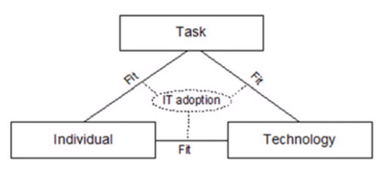
Figure 3 – FITT Framework – Fit between Individuals, Tasks and Technology (Ammenwerth et al., 2006)
It should be noted that the organisational considerations of an HIT evaluation are reflected in the individual aspect, which would include groups or roles within a workplace, or these are reflected upon in the task aspect as these are often defined and organised in a set way.
The quality of fit depends on the traits, described by Ammenwerth et al. (2006) as attributes, of the related objects for Task, Individual and Technology (Table 1).

Table 1- FITT Attribute objects of Individual, Task and Technology level (Ammenwerth et al., 2006)
Individual Attributes | Task Attributes | Technology Attributes
IT Knowledge | Organisation of the tasks to be completed | Stability and usability of a software of hardware tool
Motivation and interest in the task to be completed | Activities and their interdependence | Costs of a tool
Flexibility and openness to new ways of working | Complexity of tasks | Functionality
Team Culture |  | Available Technical Infrastructure
Organisational Context |  | Integration of tools
Cooperation within a team |  | Availability of tools in a certain clinical situation.
Politics within an organisation

In considering the above an objective of successful HIT implementation would be to attain an optimal fit between technology, user and task (Ammenwerth et al., 2006). It is important to consider these aspects and seek to understand the adequacy of knowledge and motivation that users must have to undertake the tasks expected, the adequacy of the performance and functionality the technology should have to support the expected tasks and the level of training of the user to use the technology sufficiently. The authors of the FITT framework suggest that an imbalance between these will probably lead to problems and appropriate interventions may influence the relevant fits, e.g., an intervention such as user training sessions at the individual level.

System Usability Scale – SUS
To help inform a FITT evaluation on task and the fit between individual and technology and how effectively the WHPSMS can perform it’s expected functionality, it is considered useful to gauge the level of the solutions effectiveness. Therefore a system usability scale study was undertaken (included in the questionnaire) which follows the principles defined by Brooke (1996) which has been previously applied in evaluation of usability of electronic health records by Bloom et al. (2021). The usability questions include ten questions which are scored between 1-5. Questions 1,3,5,7,9 have a positive slant e.g. “I feel very confident using the system” and questions 2,4,6,8,10 have a negative slant e.g. “I find the system very cumbersome to use.” SUS is a well-used industry standard for usability research and Sauro (2011) determines that 20 responses are a suitable threshold to produce reliable and valid results, the scale ranging from 0 (worst) to 100 (best) with the threshold of acceptable usability considered to be 68. An example of the SUS scale can be seen in Figure 4.
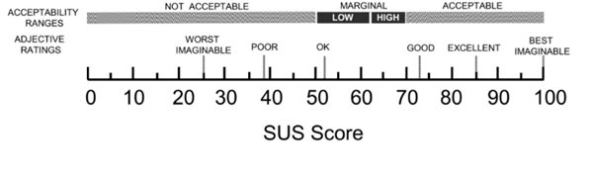
Figure 4 - Adjective Ratings and Acceptability Scores (Adapted from Bloom et al. (2021)

Both the FITT evaluation framework and the SUS scoring are validated tools that have been used within healthcare application assessments. The SUS helps to understand and validate responses in terms of links between usability and fit. It also allows a validated industrial standard of comparison to be made in terms of the final score when and if comparing against other systems.

Results
There were 37 responses to the questionnaire, representing users from hospital pharmacies across NHS Wales. Responses included individual system usability scale (SUS) scoring and qualitative FITT related questions. The qualitative answers were analysed to determine themes and categories to explore the systems fit between individual roles, tasks and technology.
The SUS scores were calculated, the mean score was 55.6, and the median usability score was 57.5 (IQR 45-70, the interquartile range, or spread of the middle 50% of the values). This is considered a marginal score or somewhere between “OK” to “Good”. A rate of more than 20 responses can be viewed as reliable and valid (Sauro, 2011).
The median and mean results of the individual questions can be seen in Table 2 and Figure 5 below visualises where the SUS score sits in the acceptability scale.

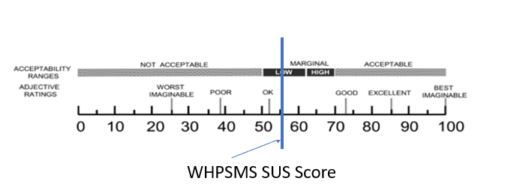
Figure 5 - WHPSMS Mean SUS Score

Table 2 - Individual Usability Scale Responses
No. | Question | Median (IQR) | Mean (SD)
1. | I like using the system | 4 (3-4) | 3.3 (1.2)
2. | I find the system unnecessarily complex | 3 (2-4) | 2.9 (1.4)
3. | I think the system is easy to use | 3 (2-4) | 3.3 (1.2)
4. | I need the support of a technical person to use the system | 2 (1-3 | 2.1 (1.2)
5. | I find the various functions in the system are well integrated | 3 (2-4) | 2.7 (1.2)
6. | I think there is too much inconsistency in the system | 3 (2-4) | 2.8 (1.3)
7. | I learned to use the system very quickly | 4 (3-4) | 3.6 (1.1)
8. | I find the system very cumbersome to use | 3 (2-4) | 3.1 (1.4)
9. | I feel very confident using the system | 3 (3-4) | 3.3(1.2)
10. | I needed to learn a lot of things before I could get going with this system | 3 (2-4) | 2.9 (1.3)

It can be seen from the responses to the questionnaire that one of the key features that the WHPSMS system is designed for is in fact where most of the activity is orientated, dispensing and stock issues (Figure 6).

Figure 6 - The core business process (System uses) reported.

Fit between individuals and technology
The majority of respondents (65%) felt that the system allowed them to do the tasks required of their role (question 13) (Figure 7).


Figure 7 – I Feel that the WHPSMS system allows me to do the tasks required of my role (question 13).

Fit between task and technology
70% of the respondents indicated that they felt that the WHPSMS technology was suitable to undertake the tasks that were required of it (Figure 8).



Figure 8 - I Feel that the WHPSMS system technology/design is suitable to undertake the tasks required of it (question 15).

Fit between Individuals and task
75% of the respondents indicated that they felt that the tasks required of them were suitable (Figure 9).


Figure 9 - I Feel that the tasks required of me that are part of the processes around the use of WHPSMS are suitable (question 17)

In general, the responses indicated that the system allowed users to undertake the usual tasks that would be required of their role, especially dispensing and there was a good fit here. There were comments about the number of steps required to undertake some tasks, such as procurement, which would impact on the way that a role is done, and therefore there was less of a good fit here where intervention may be required.
Whilst most responses reported that they believed the technology was able to undertake the tasks required of it (Figure 8), there were concerns raised about the number of steps or number of screens involved to undertake some processes. One comment ended with “you get there in the end.” This clearly demonstrates that more work is needed by the software supplier in collaboration with users to understand the tasks required of it, considering contextual awareness, and limiting the number of steps required to complete a task.

There were three comments that referred to it being “clunky” to undertake some processes but in addition to other comments there was recognition that this may be due to not having the correct level of training, or “not knowing what they do not know”. In addition, many of the users reported the technology being cumbersome or not being intuitive to use.
On further examination of frequency of words in questionnaire responses, one of the most consistently used words in comments was “report” or “reporting,” mentioned 22 times, 5 of these comments highlighted the benefits of consistent reporting, and 2 of them stated that with more training they were able to run more advanced reports, with one person stating that they would like to understand more. The remaining comments stated that they found the system did not allow them to run the reports that they needed. Taking all the comments, relating to reporting, into consideration, caution needs to be used when drawing conclusions in terms of available functionality, however in some cases additional training could make a difference. Additional training was seen as beneficial during implementation.

Fit with other systems
Whilst slightly beyond the scope of the initial evaluation, it was also highlighted that there were inconsistencies between the ways of doing similar things in one system compared to the WHPSMS system. One example mentioned at least twice was a system called MTeD – Medicines Transcription and electronic Discharge. This is a Welsh NHS developed clinical system used in secondary care in Wales to produce electronic discharges. In this system medicines are searched and selected and then discharge information produced. The search mechanism and the medicines file used in MTeD differs from that in WHPSMS and the process and short codes used to create dosing (labelling) instructions are different from those in WHPSMS. It is the same users who use both the WHPSMS system and the MTeD system who are therefore required to learn and use two different methods to do similar functions. This introduces inefficiencies and risks errors and confusion between the two systems. An intervention would be recommended here.

Limitations
The analysis could have delved deeper into the appropriate “fit” of each business process and role, however part of this initial scoping analysis was to understand the individual business contexts and functions and learn what they were from the user perspective. The questionnaire has enabled identification of these individual areas described in Figure 6 and themes picked up in the unstructured responses. It would be the intention that these would then be explored in further detail if time and resources permitted.
No statistical significance or correlation coefficient testing was undertaken at this stage, this was primarily as there was no comparison between systems and the level of response was deemed sufficient for valid usability scoring.
The FITT questions did allow the responder to further expand on initial “yes” or “no” responses in related follow up questions but there is a limited degree of measurability on the analysis of these, that the SU scale affords. On reflection from some of the responses given to question 17, five people indicated that they did not understand the question, so to improve, it could be further refined and re-worded. This was not picked up during the testing of the questionnaire. To improve on this the language used in the questionnaire could have been explained in more simplistic terms and/or come with an explanation.
One major drawback of the supporting mixed methodology used for this FITT evaluation, was that it was unable to closely explore and examine the users approach to workflow described by Deutsch (2017), despite producing an “ideal” or imagined workflow that helped with general understanding. Comparing work as imagined against work as done and other facets of work process would be a useful addition for further evaluation.
The evaluation did not assess any outcomes data related to the business processes and rates of errors. This would be a useful addition to the evaluation.

Discussion

The system usability scale findings in combination with a FITT framework analysis presents the WHPSMS system as marginal and adequate. When further exploring the differences and commonalities between individual SUS scale answers and insights given from the same users in the FITT answers the results suggest that those who felt that the system did not help them do their role also reflected comparable results in the usability scoring. There are conversely similar views from those who felt the system met the needs of their role and those tasks required of the system and their individual SUS scores.

From the 65% (Figure 10) of respondents that felt the WHPSMS system allowed them to do the tasks required in their role (question 13), when comparing these responses against the usability scores (SUS), 82% of the these strongly disagreed that they needed support of a technical person to use the system (SUS question 4.) (Figure 10)
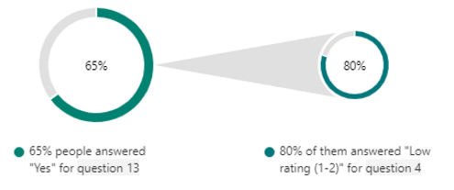
Figure 10 - Comparing response between those who felt WHPSMS allowed them to do the tasks (question 13) and how many of these disagreed that they did not need the support of a technical person to use the system (question 4.).

In contrast it was interesting to see possible correlation between those not feeling that the WHPSMS system allowed them to do the tasks required of their role (33%), of which 91% answered a low rating (1-2) to the SUS question, strongly disagreeing that “I find the various functions in the system are well integrated”, suggesting the technology itself and integration of the functions themselves was a factor in not allowing this cohort to undertake their role (Figure 11).
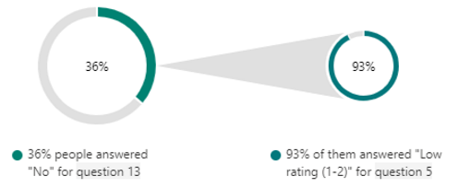
Figure 11 - Comparing response between those who felt WHPSMS did not allow them to do the tasks required of them (question 13) and how many of these disagreed that they found the various functions of the system well integrated (question 5).

SUS alone only allows comparisons to be made between one system and another however when combined with an FITT framework type evaluation useful insights can be gained around why a particular individual might have given a particular score. Although combining SUS with a FITT type evaluation is relatively novel, it is not uncommon for SUS to be used in combination with other questions as part of an evaluation, such as demonstrated by Hägglund and Scandurra (2021), in their evaluation of a health record from a patient perspective.

When considering other applications of SUS it would be useful to compare the individual solutions within a system of systems such as described in Bloom, et al (2001) study of multiple electronic health record systems. There was no intentional comparison of the WHPSMS system against others in this study and no comparisons between different instances. Making comparisons would be useful further study.

Lessons Learned during Implementation

From the lessons learned documentation obtained from the project team (DHCW, 2022) there were a number of similar themes that arose that concur with these results. A number of interventions have or are being made as a result.
Reporting required the creation of a specific reporting workstream and a national solution to extract and utilise the pool of data from the system.
A change facilitator was brought on board to work with Health Boards during implementation. This helped in terms of turning the software suppliers training into material that was meaningful to how the system fitted with current ways of working, helping to translate what this meant before, in the old system, to how it should be done in the new system.

Interventions
Following the initial evaluation, interventions to increase fit between individual, task and technology and subsequent acceptance, are required (Figure 12).
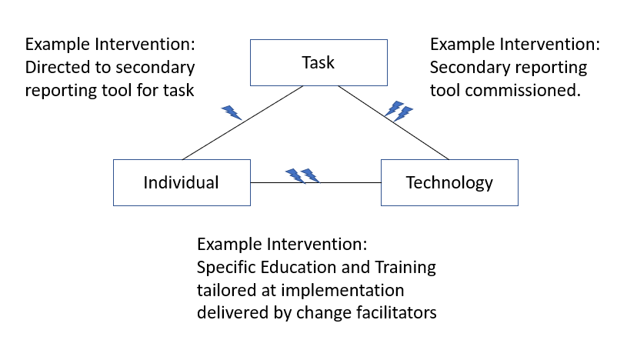
Figure 12 - FITT Diagram showing where interventions could be made on WHPSMS implementation with actual examples.

Interventions regarding task
Users needed to undertake extra steps in some areas and learn new dispensing and labelling codes. Therefore, an intervention to try and standardise the short codes for dosage instructions is required whilst considering similar processes in other systems like MTeD. In addition, further intervention should follow an analysis of the activities required in procurement aimed at attempting to reduce the extra steps seen in this task and the process of making an order. It is possible that motivation could also be increased in this area by highlighting and contrasting the benefits and increasing user knowledge.

Interventions regarding user
During the implementation it was identified that training was given too early for some hospitals in relation to the implementation. Therefore, further support and training was delivered closer to the implementation dates and during implementation.

Interventions regarding technology
A secondary reporting tool needed to be developed to allow users to run the reports the needed in a more intuitive way.

Appropriateness of FITT and other approaches
Ammenwerth et al. (2006) developed and proposed the FITT framework from building on and utilising considerations from other models such as the Technology Acceptance Model (TAM) (Holden and Karsh, 2010) and the Task Technology Fit model (TTF) (Goodhue and Thompson, 1995). It utilises the concepts from TAM such as the interactions between users and technology and the TFF concepts of those between task and technology. The FITT framework, developed specifically for healthcare, takes this a step further by introducing the additional element of the interaction between users and task. FITT is a validated approach to healthcare technology evaluation (Ammenwerth et al., 2006).
A paper by Prgomet et al. (2019) describes the use of FITT in an evaluation of Health Information Technologies, set in an Australian hospital. It used a mixed method approach to gather data on task, technology, users, and other factors that might hinder the use of the technology. Importantly they found that even though a satisfactory ‘fit’ might occur between users, task and technology there were still extra elements connected to the environment that had a substantial impact on use. Such factors included physical space limitations for storing and using equipment, the relationship between the timings of ward activities, ward rounds, and use of infection control cubicles. Therefore, they proposed an extension to FITT that more closely examines the environmental factors in which task, technology and users operate, something that Ammenwerth does consider but loosely addresses in the “individual” element of FITT. Although this paper reinforces and demonstrates the usefulness of FITT evaluations and undertaking mixed method investigations to achieve them, it also highlights the importance of considering factors outside of this framework.
Adopting the suggestions of Prgomet et al. (2019) would help when reflecting on the concerns raised with regards to inconsistencies between two systems, the FITT on its own is more limited to certain perspectives and does not specifically consider the environment that the organisation is in neither systems that might be used and assessed across different healthcare settings, organisations, or locations.
When considering making use of documentation and learning produced prior to the evaluation, one example of a case study by Tsiknakis and Kouroubali (2008) used the FITT framework retrospectively to demonstrate its usefulness in helping to explain observed successes and failures in terms of implementation and identifying factors that influence wider adoption of technology in healthcare. Thus, in a similar fashion, utilising analysis of the lessons learned during the WHPSMS implementation, can be seen as a valid enhancement to the FITT evaluation.
Interestingly the FITT framework has also been used to evaluate patient experiences, challenges and opportunities related to medicines (Cho et al., 2019) and self-management (Kujala et al., 2020). This type of approach is out of scope for the WHPSMS evaluation.

Comparisons
A paper by Mahalli et al. (2016) describes an assessment of a pharmacy information system performance in three hospitals in Saudi Arabia, looking at assessing the use of the system and it’s availability, considering this at each of six levels in the patient medication process, namely:
- Prescribing
- Transcribing
- Dispensing
- Administration
- Monitoring
- Patient Education
Interestingly they found adoption rates of the different functionalities were low. The WHPSMS does not really compare to these functionalities, apart from dispensing and monitoring. With monitoring only really being around reporting on general medicines usage rather than the health outcomes of that medication. Therefore, although the model proposed in this study does suggest some further categories that further research might incorporate, it was less relevant to evaluating WHPSMS. However, Mahalli et al. (2016) did draw some conclusions that are probably relevant to health care systems in general:
“1. Involve healthcare professionals in the process of system choice and implementation.
2. Provide effective training for users on the use of the system.
3. Ensure availability of system administrators or a help desk for help at any time.
4. Allow time for use of the system (i.e., do not make usage of the system an added burden for the users).
5. Have a system administrator track the usage level of different functionalities and communicate this information with users.
6. Study problem areas experienced by users and fix them.
7. Customize the PIS functionalities according to users’ needs; for example, add computerized ADE monitoring using the EHR system to monitor ADEs in all study settings, and add a computerized system for patient education about drugs’ usage and precautions at DCH.
8. To measure the extent of PIS adoption over time, repeat the survey nationally at regular intervals (every two years, three years, etc.).”
(Mahalli et al., 2016)

When considering user evaluations Goodhue (1995) reflects that we should consider user evaluations as a measurement technique rather than a single theoretical construct and that due to there being multiple underlying constructs around lots of varied “somethings” about the system, which could include usability, ease of use etc, it is most likely not possible to design a single general theoretical basis for user evaluations. Goodhue (1995) postulates a number of perspectives to consider as target constructs for evaluations depending very much on the context being evaluated e.g., usefulness of the system. He then brings the additional perspective of task-technology fit (TTF) which should be linked in a manner that is understandable to characteristics of the core systems which should be linked to user performance. TFF is adopted into the FITT framework.

Seamless Care
Pharmacy information Systems have the potential to be allow integration with hospital electronic prescribing and medicine administration (HEPMA) systems. This functionality would be seen as an improvement to the current business process and workflow. Currently medicines are routinely transcribed to an order from a paper system, to a paper system and then checked and transcribed into the WHPSMS system for correct medication selection and dispensing (or issuing). Each time a medicine is transcribed it takes an amount of time and there is a risk of error which could cause patient harm. Integration with an HEPMA system would allow the medication order to flow digitally from the prescribing system to the pharmacy system without transcription. Thus, increasing safety and efficiency. The green dashed line in Figure 13 highlights where the WHPSMS sits in terms of seamless care.
Ideally the HEPMA system medication names and identification codes would match those on the WHPSMS, and this could allow automatic stock selection and dispensing. However, even without this level of automation – digital presentation of the transcription/order alone, alongside logical choices, would save efficiency and increase safety. Therefore, to support this pending functionality it is important that users are accustomed and familiar with the system and the standardised terms associated with it.

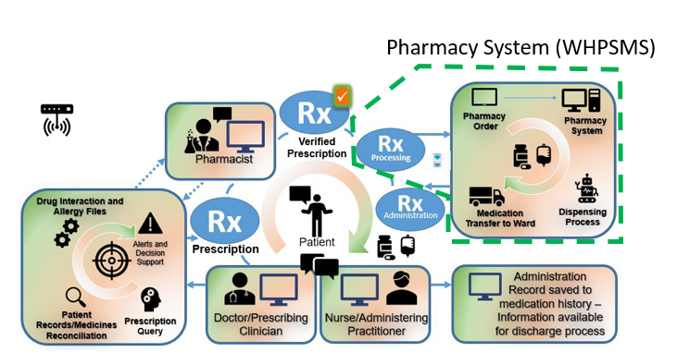
Figure 13 - Hospital Medicines Management Process (Green Dashed Line highlights where WHPSMS sits in process)
Some of the other values added from the WHPSMS product in terms of seamless care include:
- Allows the same nomenclature and standardisation to be used across hospitals in NHS Wales
- Improves interoperability through product mapping to the NHS dictionary of medicines and devices (dm+d) (Spiers et al., 2017).
- Allows transparency of stock levels and management between hospitals making it more efficient to locate stock then “ringing around.” Therefore, freeing up time.
- Allows visualization

Conclusion
If there is at least one process that the WHPSMS system does seem to do well it is the dispensing process, which is the core functionality of the system as seen in Figure 6. However, there are many supporting processes that underpin this function that responses to the questionnaire suggest are cumbersome. These are key areas where further work is needed and collaboration with the supplier needs to take place. Consideration also needs to factor how the WHPSMS fits with other systems in terms of consistency of processes.

References

Ammenwerth, E., Iller, C. and Mahler, C. (2006), 'IT-adoption and the interaction of task, technology and individuals: a fit framework and a case study', BMC Medical Informatics and Decision Making, Vol. 6 No. 1.10.1186/1472-6947-6-3,Available at:https://dx.doi.org/10.1186/1472-6947-6-3
Audit Commission, L. (2001), A spoonful of sugar medicines management in NHS hospitals.
Bates, D. W., Cullen, D. J., Laird, N., Petersen, L. A., Small, S. D., Servi, D., Laffel, G., Sweitzer, B. J., Shea, B. F. and Hallisey, R. (1995), 'Incidence of adverse drug events and potential adverse drug events: implications for prevention', Jama, Vol. 274 No. 1, pp. 29-34
Bloom, B. M., Pott, J., Thomas, S., Gaunt, D. R. and Hughes, T. C. (2021), 'Usability of electronic health record systems in UK EDs', Emergency Medicine Journal, Vol. 38 No. 6, pp. 410-415.10.1136/emermed-2020-210401,Available at:https://dx.doi.org/10.1136/emermed-2020-210401
Brooke, J. (1996), 'SUS-A quick and dirty usability scale', Usability evaluation in industry, Vol. 189 No. 194, pp. 4-7at:https://hell.meiert.org/core/pdf/sus.pdf
Cho, H., Flynn, G., Saylor, M., Gradilla, M. and Schnall, R. (2019), 'Use of the FITT framework to understand patients’ experiences using a real-time medication monitoring pill bottle linked to a mobile-based HIV self-management app: A qualitative study', International journal of medical informatics (Shannon, Ireland), Vol. 131, pp. 103949-103949.10.1016/j.ijmedinf.2019.08.009,Available
Deutsch, E. S. (2017), 'Bridging the gap between work-as-imagined and work-as-done', Pennsylvania Patient Safety Advisory, Vol. 14 No. 2, pp. 80-83
DHCW (2022), 'WHPSMS Implementation Lessons Learned', Project Documentation.
Goodhue, D. L. (1995), 'Understanding user evaluations of information systems', Management science, Vol. 41 No. 12, pp. 1827-1844
Goodhue, D. L. and Thompson, R. L. (1995), 'Task-Technology Fit and Individual Performance', MIS Quarterly, Vol. 19 No. 2, p. 213.10.2307/249689,Available at:https://dx.doi.org/10.2307/249689
Hägglund, M. and Scandurra, I. (2021), 'User Evaluation of the Swedish Patient Accessible Electronic Health Record: System Usability Scale', JMIR Human Factors, Vol. 8 No. 3, p. e24927.10.2196/24927,Available at:https://dx.doi.org/10.2196/24927
Holden, R. J. and Karsh, B.-T. (2010), 'The Technology Acceptance Model: Its past and its future in health care', Journal of Biomedical Informatics, Vol. 43 No. 1, pp. 159-172.10.1016/j.jbi.2009.07.002,Available at:https://dx.doi.org/10.1016/j.jbi.2009.07.002
Kujala, S., Ammenwerth, E., Kolanen, H. and Ervast, M. (2020), 'Applying and Extending the FITT Framework to Identify the Challenges and Opportunities of Successful eHealth Services for Patient Self-Management: Qualitative Interview Study', Journal of Medical Internet Research, Vol. 22 No. 8, p. e17696.10.2196/17696,Available at:https://dx.doi.org/10.2196/17696
Lord Carter, o. C. (2016), 'Operational productivity and performance in English NHS acute hospitals: Unwarranted variations', An independent report for the Department of Health.
Mahalli, A. E., Sahar, H. and Yamani, W. (2016), 'Assessment of pharmacy information system performance in three hospitals in Eastern Province, Saudi Arabia', Perspectives in health information management, Vol. 13 No. Winter,
NHS Wales (2015), 'Informed health and care: a digital health and social care strategy for Wales', Cardiff: Welsh Government, Welsh Government.
Prgomet, M., Georgiou, A., Callen, J. and Westbrook, J. (2019), 'Fit between individuals, tasks, technology, and environment (FITTE) framework: A proposed extension of FITT to evaluate and optimise health information technology use', MEDINFO 2019: Health and Wellbeing e-Networks for All, IOS Press, pp. 744-748.
Sauro, J. (2011), A practical guide to the system usability scale: Background, benchmarks & best practices, Measuring Usability LLC.
Spiers, I., Goulding, J. and Arrowsmith, I. (2017), 'Clinical terminologies in the NHS: SNOMED CT and dm+ d', British Journal of Pharmacy, Vol. 2 No. 1, pp. 80-87
Tsiknakis, M. and Kouroubali, A. (2008), 'Organizational factors affecting successful adoption of innovative eHealth services: A case study employing the FITT framework', International journal of medical informatics (Shannon, Ireland), Vol. 78 No. 1, pp. 39-52.10.1016/j.ijmedinf.2008.07.001,Available

Appendix 1 – Usability and Scoping Questionnaire


