Module: Learning in the Digital Era
Student Name: Shamsa Naser
Student ID: 2524811
Module Code: ACCA4025
Lecturer: Mohammed Ben Farah
Assignment title: Professional Development Plan (PDP)

Table of Contents
Task 1 – Self-evaluation. 3
Task 2 – PDP. 4
Presentation link: 4
Screenshots of PDP 4
Task 3 – Unit 4 topic summary. 6
Task 4 – Video presentation. 7
YouTube link 7
Google Drive link of presentation: 7

Task 1 – Self-evaluation.
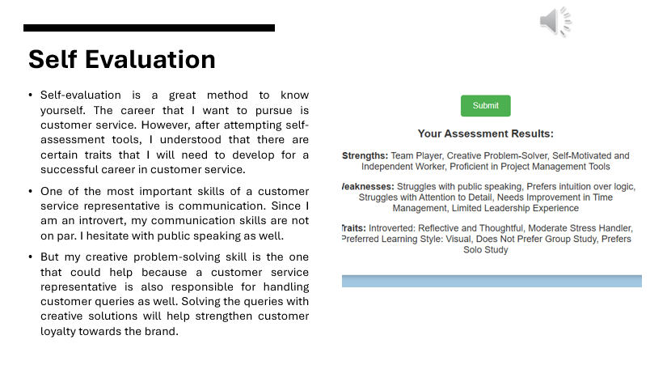

Task 2 – PDP.
Presentation link: https://docs.google.com/presentation/d/1W_ZsVHRG4TcexYce3OQWjU0h73ovHDFq/edit?usp=sharing&ouid=111915559305360396070&rtpof=true&sd=true
Screenshots of PDP
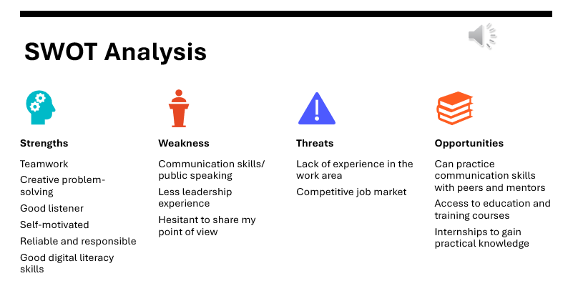
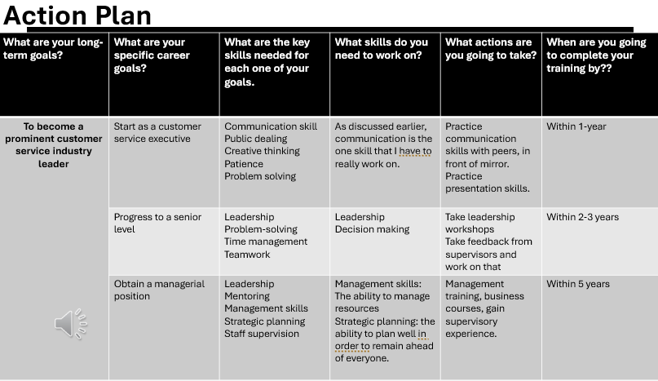

Task 3 – Unit 4 topic summary.
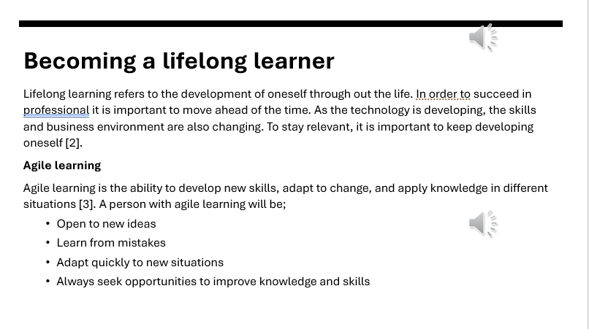
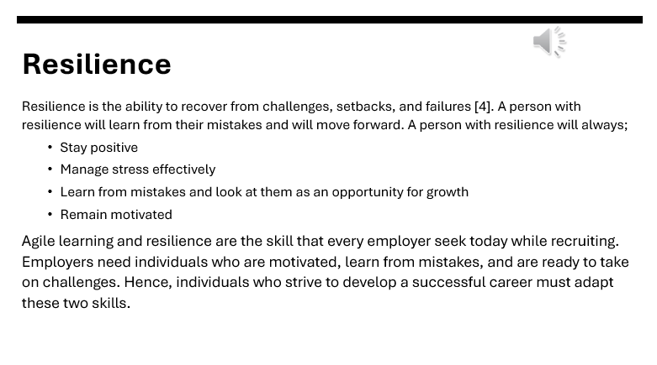

Task 4 – Video presentation.

YouTube link
https://youtu.be/eVyZhrJeiMw
Screenshot of the Video in its cloud platform (e.g., YouTube).
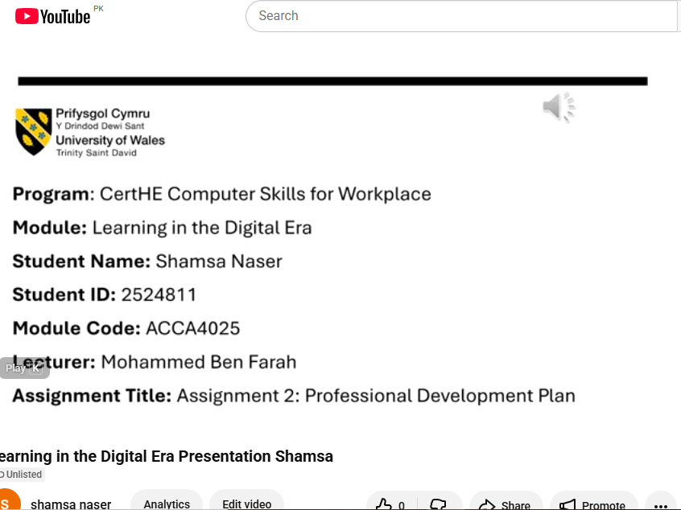

Google Drive link of presentation: https://docs.google.com/presentation/d/1pQmtxS-WyNtFKreqPXw34Hj19n2m5nNe/edit?usp=sharing&ouid=111915559305360396070&rtpof=true&sd=true

