EVIDENCE OF LEARNING
E PORTFOLIO

Learning in the Digital Era – BMPL4007 & BMPS4009

Student Name:Emine Bayir
Student ID: 2238708
Lecturer: Sadie France
Internal Verifier: Zita Draper
Submission Deadline: 7th July,23:59 pm.

Table of content
- Overview regarding Higher Education
- Mind map of “Becoming a Digital Learner”
- Youtube Link regarding Personal Identity
- Reflection summary using Gibbs reflective tool
- Personal Development Plan (PDP)
- Harvard References List


Source: Google

1.Overview of Higher Education

In the academic work, the concept of learner involvement and commitment in higher education are widely recognised, proving several benefits for aspiring police officers as students. Such ideas have continued to be at the forefront of discussions in education over the years how to better engage students, in turn, enhance their educational experiences. On the other hand, it is equally important to comprehend the situations in which we sometimes fail of achieving these goals. It is commonly accepted that students tend to achieve higher learning results when they are actively involved in the learning process, enjoy what the task they are doing, and acquire appreciate from it (Kahu 2013).
In addition to broadening, one’s intellect and developing abilities, which vary for everyone in the same or various surroundings, it is crucial for students to grasp the function of higher education. For example, in their studies students are using different combinations of approaches as (Meyer,2007) some of them may find a better connection with their learning if they are in a white, soundproof room with no distractions. On the other hand, there are students that are efficient on their studies in noisy places, dark coloured rooms, or even while eating. As Postareff (2015) stated that the learning environment it is a challenge for many of the students.
Motivation is another approach, for example, a good team improves cooperation and creativity results in increased learning experience for the students and the peers (Parpala,2010). Also, the use of technology is a great tool in which they can achieve their best learning, performance being enhanced by clearly defined objectives and interactive strategies. The technology use is a E-learning process, and the project outcomes are influenced by all the ideas listed above. Below it is a diagram which shows exactly how simple is E-learning in achieving better learning skills (Khaled,2020).
Teaching Methods
Education Content
Technology used
Practical
Experience
Active Thinking
Support
Communication Skills
Better Thinker
Reflective Essay
Collaboration
Self-Peer Content Design
Creativity
Presentations
Communication



TEACHERR
STUDENTS

Quality
Online Education
https://mm.tt/app/map/2808289955?t=MeKG7j4dzs
2.Brain Map of “Becoming a Digital Learner”

https://mm.tt/app/map/2808289955?t=MeKG7j4dzs
3.PowerPoint Presentation About Personal Identity

https://mm.tt/app/map/2808289955?t=MeKG7j4dzs

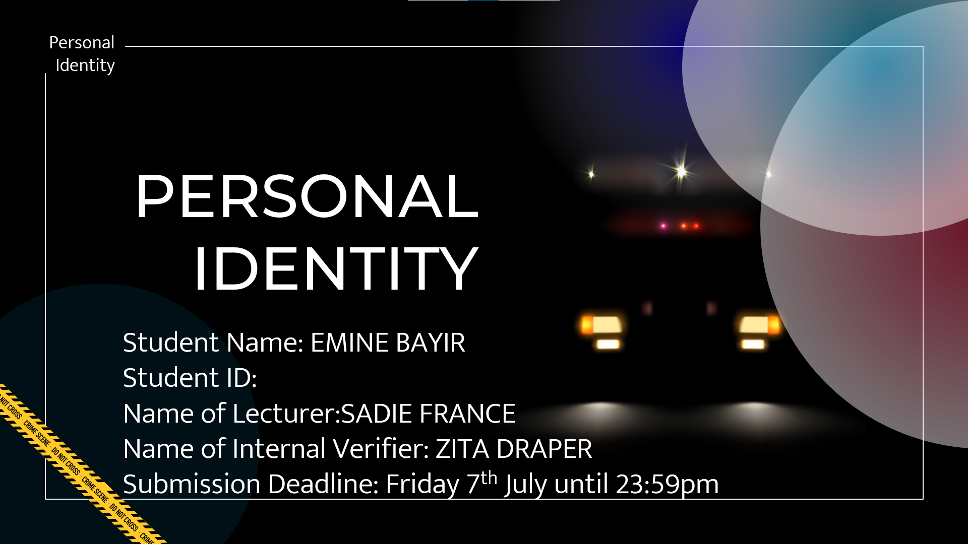
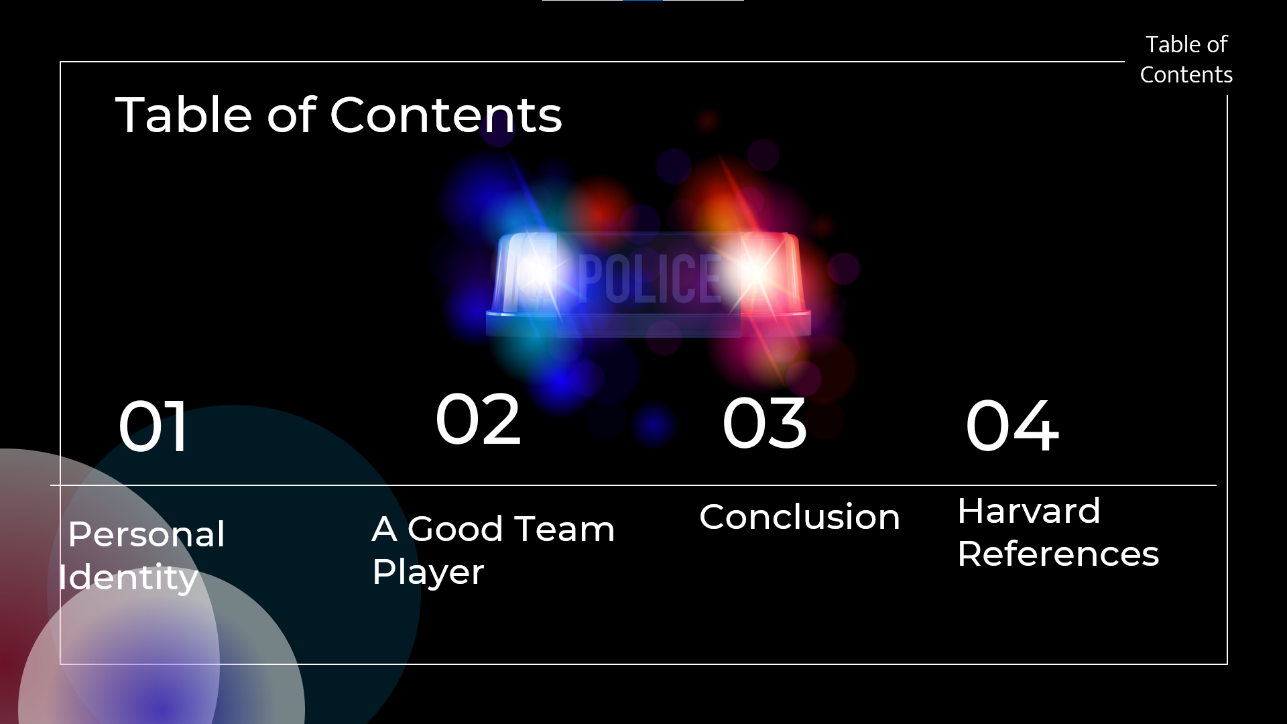
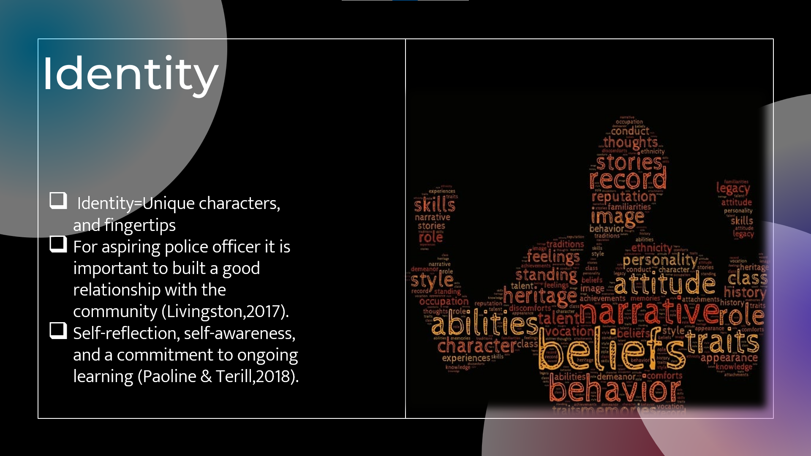
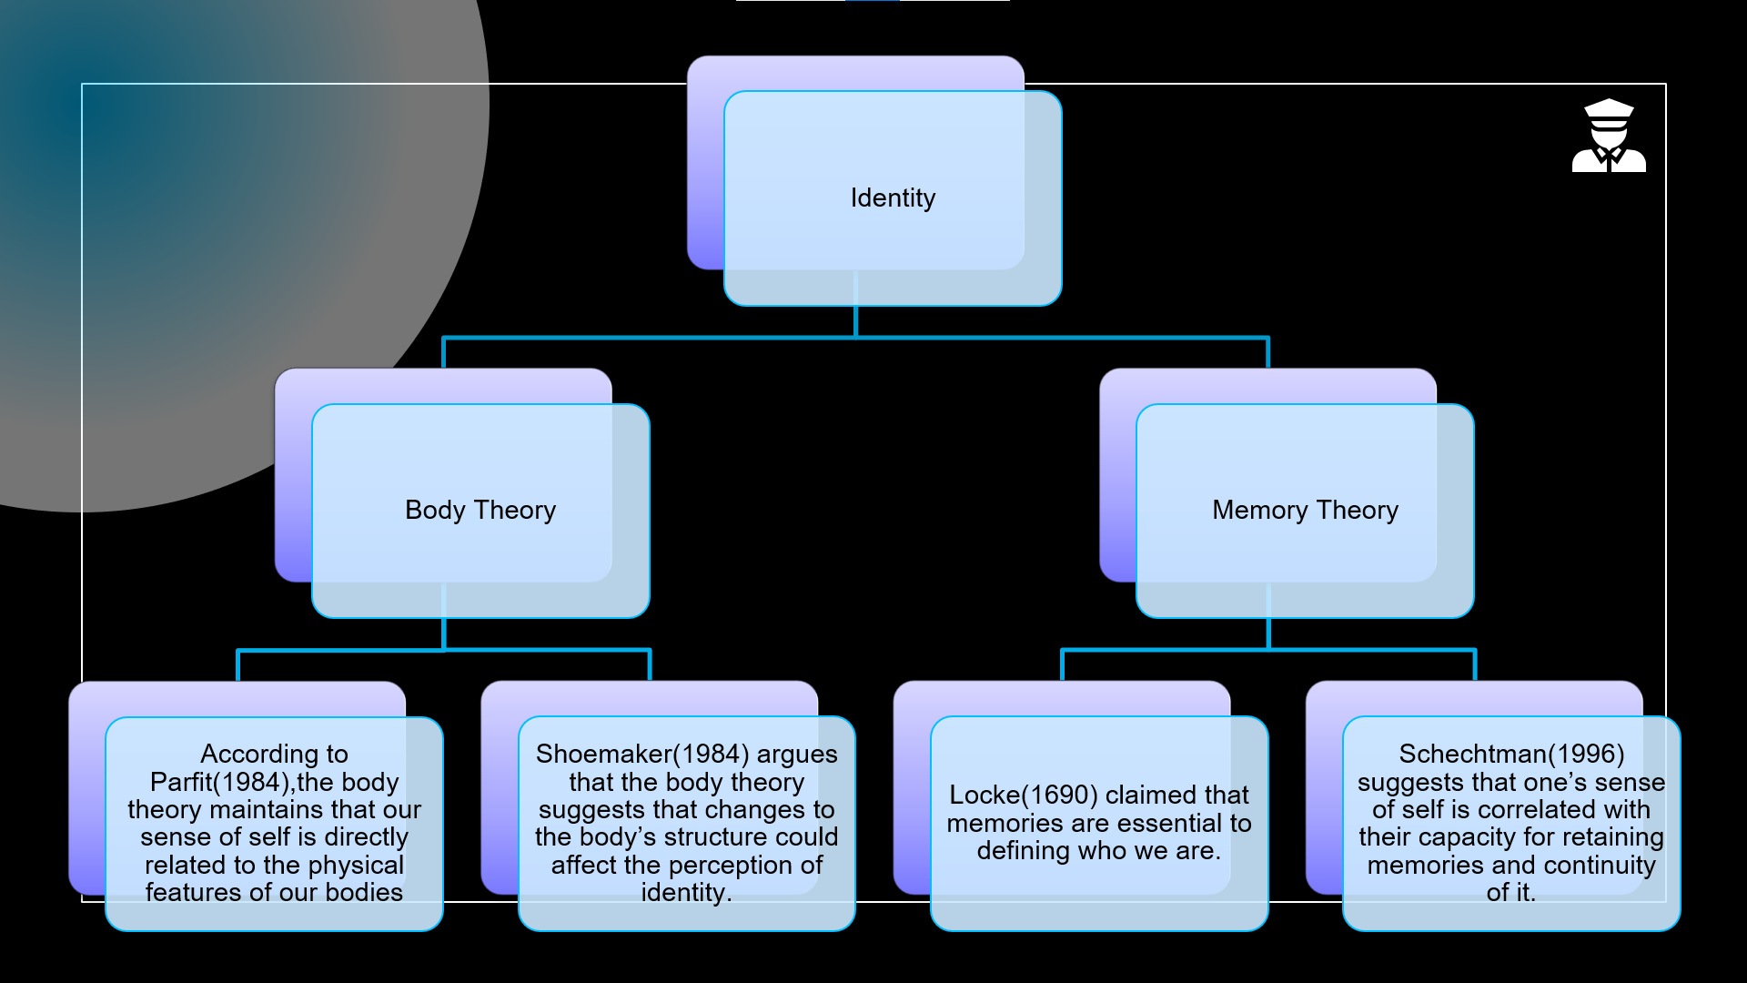
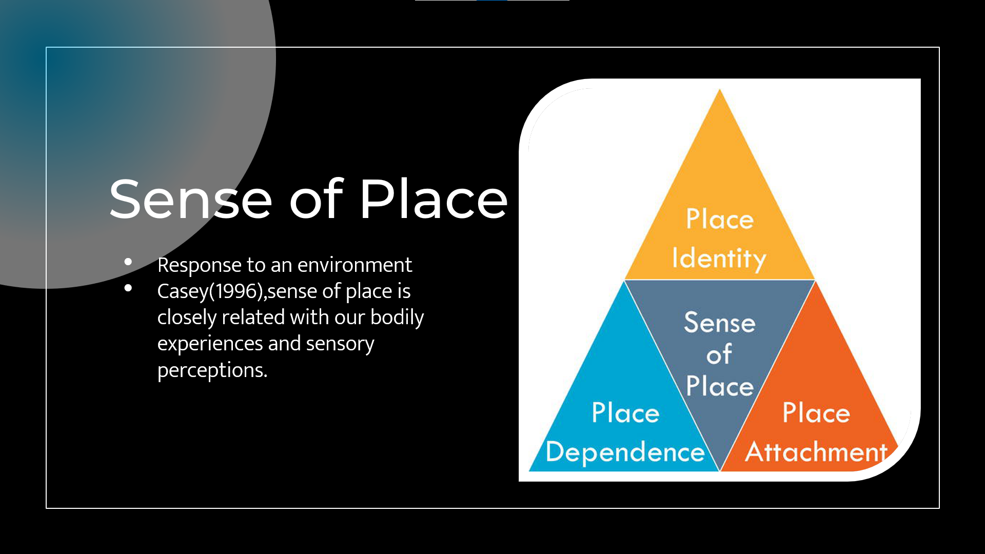

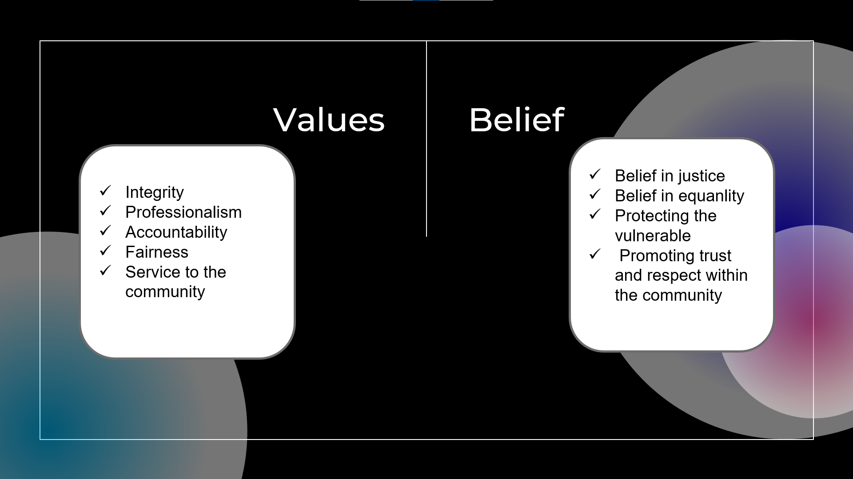

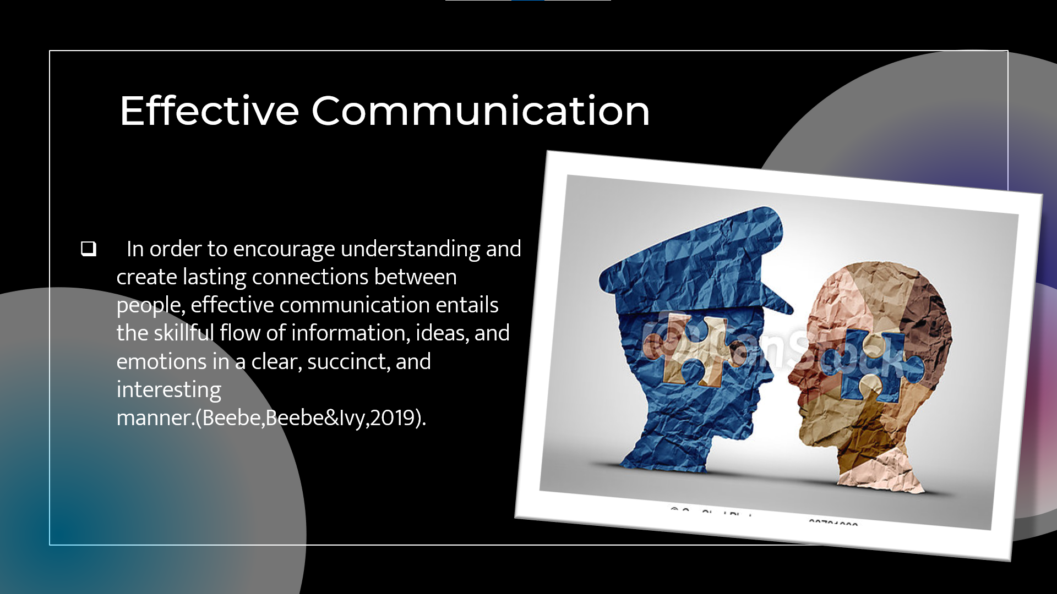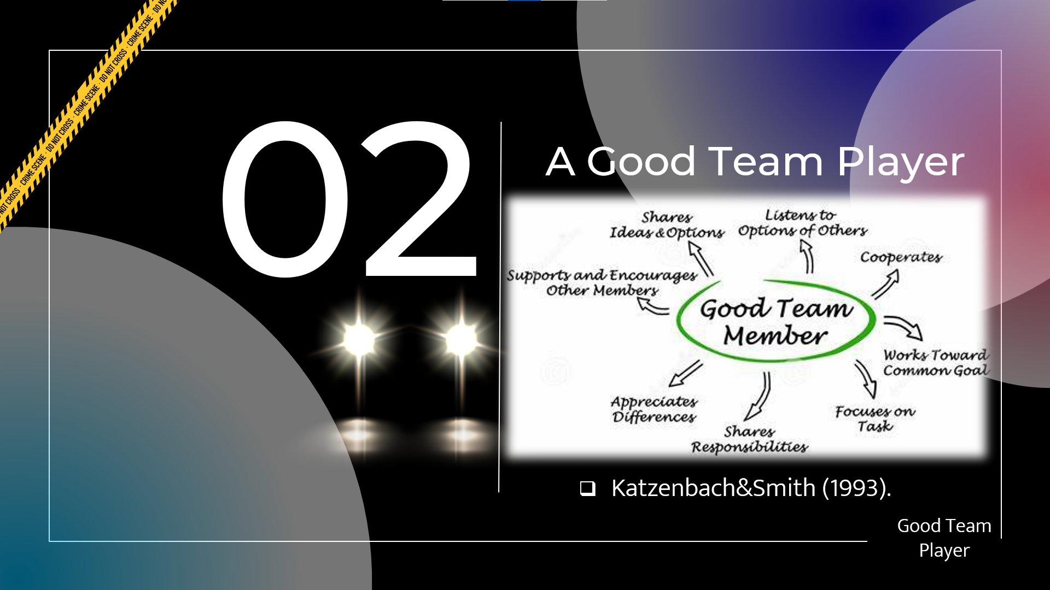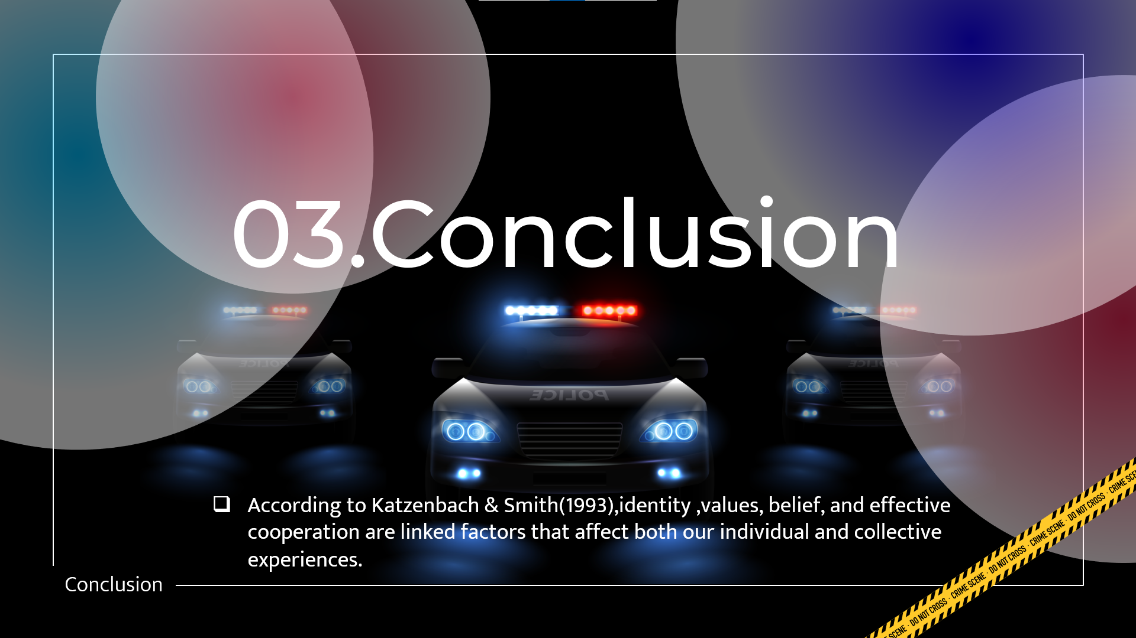

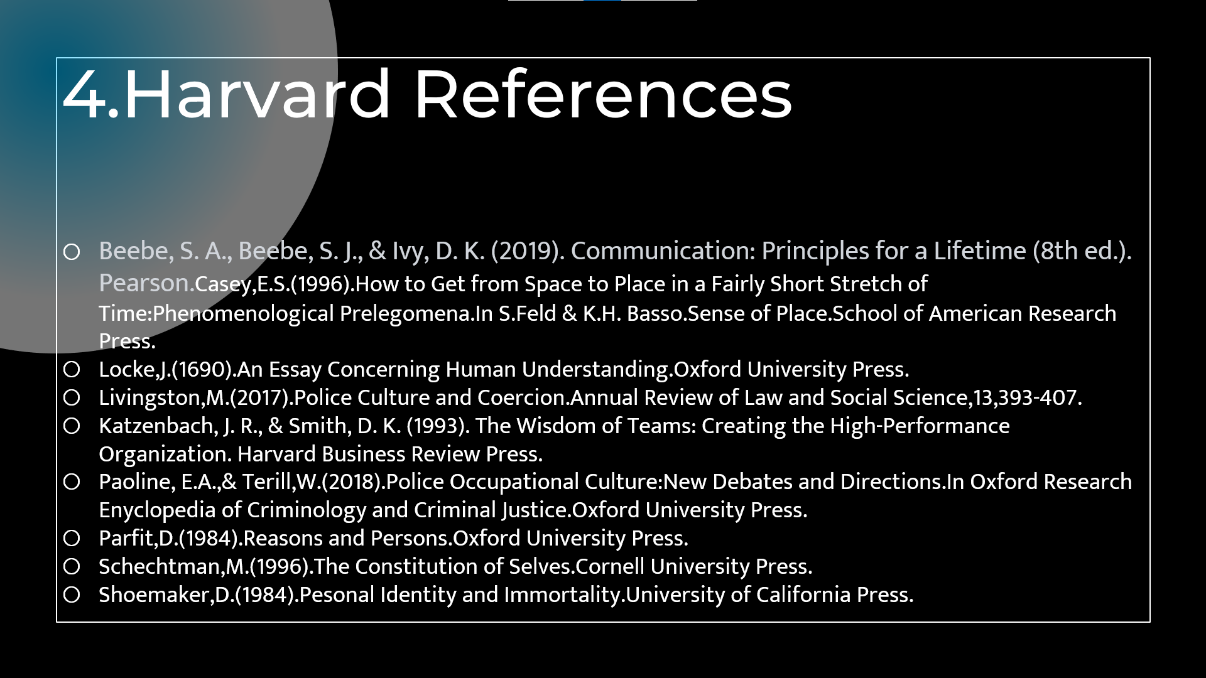



3.Gibbs Model
As an undergraduate, the University of Wales Trinity David provided the chance to comprehend the aim of reflection, which is to examine closely a specific subject and look in on it with a view to learning from an individual’s experience, concepts, or feelings. It involves an active interaction with the experiences, a critical assessment of them and major findings, and learnings that can be used in any current action and in future behaviour (Gibbs,1988).

Gibb’s Reflective Cycle (1998)

Description
As a single mother with an autistic child, I have encountered numerous circumstances that require comprehension, tolerance, and adaptability. It requires a balance of my parental responsibilities, being in charge for the child’s care, as well as making sure that the requirements connected to autism are met and ensuring his overall wellbeing. Being a parent of a child with special needs requires a lot of time and effort, where numerous difficulties are associated including sensory sensitivity, communication and behavioural issues. On the other hand, the desire to protect and serve my community, is what motivates me to pursue a career in law enforcement. One day, my child had a breakdown when we were in public, in our neighbourhood park. This experience made me understand that with my knowledge and the skills developed throughout this fight with autism, I can be a big help in my community. I am aware of the requirements and duties that go along with being a police officer. It necessitates being mentally alert, physically fit, and willing to work irregular hours and to respond to emergencies.

Feelings
During this incident, I experienced a mixture of feelings, including the concern for my child’s safety, and frustration because I had several situations where I was down just because people were pointing fingers at me, just because of the fact that I am a single mom with a child that has autism. But that only made me stronger and eager to learn more about this neurological disorder. This is the main reason why I participated at this course, and I will not give up until I finish all the years of education aiming to become a police officer, as I am sure that I can bring my skills in this job and get even better.
According to LeDoux and Pine (2016) anxiety is a complicated emotional and physiological reaction ,which everyone is suffering, meaning that I am not the only one that can get low at times .I really feel that it is more than a dream, more than just a way to show others that I can do this, honestly it is more like fulfilling what my heart and my mind keep telling me for a long time, and now I have the best opportunity.
I also feel that I have to be aware about the demanding training and unexpected nature of police job that can make it more difficult for me to balance my parental responsibilities (Smith,2018), but something tells me that I can handle it by acting carefully and responsible.

Evaluation
Regarding the incident with my child, I recognized that my first response was instinctive, concentrating mainly on controlling my child’s behaviour, and ensuring his and other individuals’ safety. However, I realised that my lack of planning and knowledge on how to manage such circumstances in public areas contributed to a higher stress level for me and my child. I experienced the pressure to respond appropriately to those circumstances while remaining composed and understanding (Smith,2018). As an aspiring police student at University of Wales Trinity David, I recognised the importance of creating a safe environment that promotes inclusivity and supports individuals, no matter by their nationality, skin colour or special needs. Also, I will reflect on any modifications or enhancement I need to make to better manage my multiple responsibilities as a single mom of an autistic child, and an aspiring police office. Determining my areas of strength and improvement so I can succeed in both.
Analysis
The analysis stage offers the chance to learn more about the situation and look at the elements that affected my reaction. I knowledge that the intensity of the circumstance was increased by my lack of planning in anticipating the difficulties of a crowded and overwhelming atmosphere leading to frustration. It became clear that I could handle similar scenarios more effectively if I increased my understanding of methods in calming autistic children’s and creating ways to prepare for sensory overload also working more on my abilities to be a leader in the community could help me more in those types of situations.
According to Smith (2019) it is important to consider solutions to manage the balance of a single parental role and the job goals, analysing the difficulties faced by exploring accessible resources, methods for time management, including communities of support.

Conclusion
Reflecting on this particular incident as a single parent of a child with autism and aspiring police officer has entailed my understanding of the challenges and the task associated with these roles. It has reaffirmed how crucial empathy, clear communication, and continual education are in helping autistic people and families. I hope to advance a more kind and welcoming community that recognises and answers to the various needs of people with autism by combining my experience as a parent and an aspirant police officer.

Action Plan
There will be similar situations like the one that I experienced, and this is the reason why I have created the following action plan in order to successfully integrate the knowledge and abilities I have acquired in my dual responsibilities as a single parent of an autistic child and a future police officer. Firstly, to improve my capacity to manage situations involving autistic people, I will register in specialised training courses on autism awareness intervention methods, and calming down strategies (Smith,2018). Secondly, I will continuously search for chances to work with autistic organisations, such as taking part in neighbourhood projects and events that attempt to raise public knowledge and understanding of autism (Johnson,2021). Thirdly, developing coping strategies where being a mom and a police officer can both be hard, so it is important to learn appropriate coping techniques to handle stress and keeping my wellbeing. Finding activities or practises that allow me to unwind and charge, alike exercise, meditation, or a hobby. Regularly practising self-care in making sure that I have the mental and physical stamina necessary to fulfil the responsibilities effectively.

5.Personal Development Plan
Student Name |  | Student Number |  | Module |  | Code
Emine Bayir |  | 2238708 |  | Learning in the Digital Era |  | BMPL4007  BMPS4009
What goals do I want to achieve? | How will I measure my progress? |  | What resources or support will I need? |  | How is the objective relevant to my personal aspirations? | What is the timeframe for the achievement of my goals?
Specific | Measurable |  | Achievable |  | Relevant | Timebound
1.Improve leadership abilities in order to inspire and motivate team members. | The progress can be measured by gaining improvements from coworkers and receiving good feedback from them serve as indicators of leadership milestones (Smith,2018). |  | I currently participate in workshops, downloading programmes on android, for example Leadership Skill Training, and tracking leadership development opportunities within the police department in order to help me achieve this goal (Brown,2020). |  | It is relevant as the effective leadership is important for creating a positive work atmosphere, and a strong team dynamic. It is in accordance with leadership and management responsibilities of an aspiring police officer (Johnson&Jones,2019).  As well according to College of Policing (2022),a competent leadership is a key component of police work, which ensure ethical and effective operation of law enforcement organisations. | I intend to achieve this goal in a specific timeframe,  (Smith &Johnson,  2017), such as withing the next six years or within the next year, I will finish leadership development programmes.
2.Establish coping strategies to handle frustration with the aim of maintaining composure in difficult situation at work as well with my autistic child. | I will determine the amount and degree of irritability experience in challenging situations as an aspiring police officer and as a mother of an autistic child. I will be able to do this by maintaining control and applying various coping strategies (Jones,2022). |  | With the intention of coming with efficient coping strategies, I will seek advice from therapists in autism and emotional management approaches. Also using techniques used by people to try and control the negative emotions brought on by stressful circumstances  (Austenfeld&Stanton,2004). Participating in different training sessions and workshops on stress management and emotional stability (Anderson,2021) |  | Coping strategies are crucial for controlling frustration, having a good composure, and developing positive interactions both at work and when raising my autistic child (Brown & Wilson, 2020). | I aim to implement and use those coping strategies over a predetermined period of time, such as the following three to six months as I waill have more knowledge about how to put them in application.  I will consistently assess my progress and make the necessary changes in order to achieve this goal (Thompson & Davis,2019).
3.Improving my knowledge about controlling the behaviour of the people that have special needs in the community as an aspiring police officer | Attend training sessions, workshops and, and seminar related on autism and other special needs. Through performance reviews in my police training programme and continuous applications of developed strategies in daily interactions with my autistic child, I can track my personal growth and progress (National Autistic Soctiety,2022). |  | Creating helpful surroundings using evidence-based techniques that I am learning at the university. Joining support groups for single parents of autistic children, seeking advice from specialists, and taking an active part in relevant social media forums and communities. Also engaging in training, debriefing sessions with peer reviews, policy and CPD-continuing professional development on working with diverse groups and dealing with emergencies (College of Policing,2021). |  | Enhancing my skills as an aspiring police officer to help to interact effectively with people from autism spectrum and to contribute to the creation of a safe environment, so it is a crucial goal for providing the best support and care, for me, my family, and community (Jones&Smith,2020). | I allocated time for each week to read, participate to lessons and workshops, go to training classes, and practise techniques. It is more like a long-term goal for improving knowledge and developing skills in this area. Regularly evaluate my progress and get guidance from my training supervisor and autism specialists (Thomspon,2019).
4.Utilise time management strategies that work to dedicate time to important duties and prevent procrastination. | I will keep a daily journal to keep track on how every day is spend, including the amount of time and the type of the various activities. |  | In order to increase concentration and productivity, I will acquire and apply a variety strategy according time management, such as Time Blocking & Time Boxing Method, Eat that Frog Technique and 52/17 rule (Gridfiti,2022). I also take in consideration to attend classes about it and to seek advice from professionals, for example from real police officers. |  | Effective time control manage create a balance between my personal and professional duties, which enhance my overall wellbeing(Adams,2020). This improves productivity while also lowering stress levels and boosting my job as an aspiring police officer (Tracy,2018). Moreover, leading to promotions, progression, and additional duties (Robbins, 2017). | I will set specific deatline for completimg activities and create a daily,weekly, and monthly calendar, which will take over a few months to be able to fulfil this goal. Also, at every 6 months I will review and modify the calendar as needed to account for changing priorities (Allen,2015).

6.Harvard References List

Adams,S.(2020). Time Management and Work-Life Balance:Strategies for Succes.Journal of Applied Pshycology,45(3),256-270.
Allen,D.(2015).Getting Things Done: The Art of Stress-Free Productivity. New York,NY:Penguin Books.
Alcock,M.Chakrabarti,R.,&Kendall,T.(2021).Technology in Mental Health:Developing Digital Mental Health Literacy.BJPsyck Advances,27(2),99-107.
Anderson,K.(2021).Coping strategies for parents of children with autism: A qualitative study. Journal of Autism and Development Disorders,25(3).89-105.
Austenfeld, J.,Stanton,A.(2004).Coping through emotional approach: A new look at emotion,coping, and health-related outcomes.Journal of Personality,72,pp.1335-1364.
Beebe, S. A., Beebe, S. J., & Ivy, D. K. (2019). Communication: Principles for a Lifetime (8th ed.). Pearson.Casey,E.S.(1996).How to Get from Space to Place in a Fairly Short Stretch of Time:Phenomenological Prelegomena.In S.Feld & K.H. Basso.Sense of Place.School of American Research Press.
Boulos,M.N.,Skrygiannis,H.,&Jacobson,J.(2020).Leveraging Google Workspace for telemedicine,telehealth and tele-educaation in the era of COVID-19 and beyond.International Journal of Health Geographics.
Brown,A.,& Wilson,S.(2020). Managing frustration in the workplace: Strategies for maintaining composure, Journal of Occupational Psychology,32(2),123-140.
Brown,A.,(2020).Leadeship development programs in law enforcemeny. Journal of Police Studies, 17(3),pp.89-105.
Carliner,S.(2020).E-Learning.In The Wiley International Handbook of Educational Technology,pp321-341.Wiley.
Chen,Y.L.,HUANG,H.M.,&Wu,W.H.(2019).Effects of Different Web 2.0 Activities on Students Learning Performance:A Structural Equation Modeling Approach.Interactive Learning Envrironments,27(8),1050-1063
College of Policing.(2021).Professional development.https://www.college.police.uk/guidance/vulnerability-related-risks/professional-development#982906ac-ecce-4eb4-807b-ea6ec43bc4ba.
College of Policing.(2022).Performance and improvement http://www.college.police.uk/guidance/leadership-expectations/performance-and-improvement .
Dormann,C.,Nell,K.,&Forerster,A.(2019).Mobile apps in the context of law enforcement:A user-centered design approach.Computers in Human Behavious,95,pp12-23.
Gibbs G. (1988). Learning by Doing: a guide to teaching and learning methods. Oxford: Oxford Polytechnic.
Grifiti,2022. 9 Study Techniques Like Pomodoro: The Best Alternatives to Use.
http://gridfiti.com/study-techniques-like-pomodoro/
Kahu, E. R. (2013). Framing student engagement in higher education. Studies in Higher Education,38(1), pp.758-773.
Khaled,H., Abid Amori. (2020). E- Learning and Digital Education in the Twenty -First Century. Available at: http://www.intechopen.com/chapters74314 .(Accessed :07 June 2023).
Katzenbach, J. R., & Smith, D. K. (1993). The Wisdom of Teams: Creating the High-Performance Organization. Harvard Business Review Press.
Ifenthaler,D.(2020).Learning Analytics.From Measurement to Impact.Springer.
Johnson,C.A.,(2011).The Information Diet: A Case for Conscious Consumption.O`Reilly Media.
Johnson,M.(2018).Virtual Learning for Law Enforcement: A Path Forward.Policing: A Journal of Policy and Practice,12(1),78-88
Johnson,M.A.,&Anderson,L.(2021). Effective Communication Strategies for Working with Individuals with Autism.Journal of Autism Studies,15(2),pp.73-90.
Johnson,P.,Jones,M.(2019).The role of leadership in law enforcement: A literature review: Police Quarterly,24(2),pp.67-83.

Jones,R.(2022). Coping strategies for maintaining composure at work. Journal of Workplace Health and Well-being,28(2),167-183.
Jones,R.,&Smith,L.( 2020).Building Inclusive Communities:The Role of Police Officers in Supporting Individuals with Autism Spectrum Disorders.Journal of Policing and Community Safety,15(2),123-140.
LeDoux,J.E.,&Pine,D.S(2016).Using neuroscience to help fear and anxiety.A two-system framework.American Journal of Psyhiatry,173(11),pp.1083-1093
Lee,S.H.,Park,J.H.,Cheon,J.H.(2007).Analyzing Learners Interaction.Journal of Education Reaseqach,45(3),123-145.
Livingston,M.(2017).Police Culture and Coercion.Annual Review of Law and Social Science,13,393-407.
Locke,J.(1690).An Essay Concerning Human Understanding.Oxford University Press.
Meyer,J.W.,Ramirez F.O., Frank David J., Schofer Evan.2007.Higher Education as an institution.Johns Hopkins University Press.
National Autistic Society. (2022).Understanding. https://www.autism.org.uk/what-we-do/professional-development/training-and-conferences/understanding-autism.
Paoline, E.A.,& Terill,W.(2018).Police Occupational Culture:New Debates and Directions.In Oxford Research Enyclopedia of Criminology and Criminal Justice.Oxford University Press.
Parfit,D.(1984).Reasons and Persons.Oxford University Press.
Parker,K.R.(2020).Self-paced learning.In The SAGE Encyclopedia of Human Communication Sciences and Disorders,pp.1589-1591. Sage Oyblications
Parpala A, Lindblom-Ylanne S, Komulainen E, et al. (2010). Students’ approaches to learning and their experiences of the teaching-learning environment in different disciplines. British Journal of Educational Psychology ,80(2), pp.269-282.
Postareff L, Parpala A, Lindblom-Ylanne S. (2015). Factors contributing to changes in a deep approach to learning in different learning environments. Learning Environments Research, 18(3), pp. 315-333.
Ritzhaupt,A.D.,&Kumar,S.(2019).Essential EdTech:Transforming Police Education with Digital Technology.Springer.
Robbins,T.(2017).The Power of Time Management: Strategies for Success, New York,NY:Free press.
Rosenberg,M.J.(2019).Beyond E-Learning: Approaches and Technoligues to Enhance Organizational Knowledge,Learning and Performance.Pfeiffer.
Schechtman,M.(1996).The Constitution of Selves.Cornell University Press.
Sharples,M.,Taylor,J.,&Vavoula,G.(2019).A Theoory of Learning for the Mobile Age. In Mobile Learning:The Next Generation,pp.1-8.Routledge
Shoemaker,D.(1984).Personal Identity and Immortality.University of California Press.
Smith(2018).Assessing team performance in law enforcement. A practical guide. Police Practice and guide.Police Practice and Research,25(1),123-140.
Smith,J.(2019).Managing Multiple Roles: The Challenges and Strategies of Single Parents. Journal of Family Issues, 40(7), pp.967-989.
Smith,L.,&Johnson,R.(2017). Leadership skills for law enforcement officers: A comprehensive framework.Journal of Criminal Justina, 32(3),167-183.
Smith, R. (2018).Autism Awareness in Law Enforcement.New York, NY:ABC Publishing
Smith,R.(2018). The Experiences of Single Parents in the Police Service:Balancing Work and Family Life. Police Practice and Research,19(1),pp.45-59.
Thomson,L.(2019).Effective Communication Strategies for Parents of Children with Autism,25(3),89-105.
Thompson,L.& Davis,M.(2019).Emotional regulation techniques for parents of children with autism. Journal of Applied Developmental Psychology,18(1),45-62.
Tracy,B.(2018).Eat That Frog:21 Great Ways To Stop Procrastinating and Get More Done in Less Time,San Francisco,CA:Berett-Koehler Publishers.

