Martin Dunn (1705105)

Website Design
Assignment Report

Contents
Abstract Page 3

Requirements Page 3

Implementation Page 4

Accessibility Evaluation Page 7

General Evaluation Page 8

Conclusion Page 8

Appendix Page 9
Abstract
This report will cover various aspects of the creation of a five-page website that is an Eminem fan page. It will assess different areas of the webpage such as, accessibility validation, functionality and content. The page has been created using HTML5 and CSS3 using notepad++. This is a beginner website that has been created with only and entry level knowledge of HTML5 and CSS3, this will lead to imperfections in certain areas of the page and certain aspects not being carried out in the most efficient way compared to and experienced web developer. The website features 5 separate pages; Home, Gallery, Albums, Awards and Merchandise. Each page was created using a separate HTML file in the source folder, but they all utilise the same CSS style sheet.

Requirements
The website that has been created is a five-page Fan made, Fan page. Made by fans, for fans. It is based entirely around the Hip-Hop artist Eminem and his fans from all around the world, of any age, gender or race.
The purpose of this page is to provide information about the record braking artist to fans who want to look at different pieces of information about him, or even for die hard fans who just like to see content about their favourite artist.
As stated above there is no specific target audience other then being an Eminem fan, but even this is not necessity as any person could look to seek information on a topic without being a fan of said topic. This website is only a small portion of what it could be if all the information found around Eminem was provided from his 20+ year spanning career and personal life.

Implementation
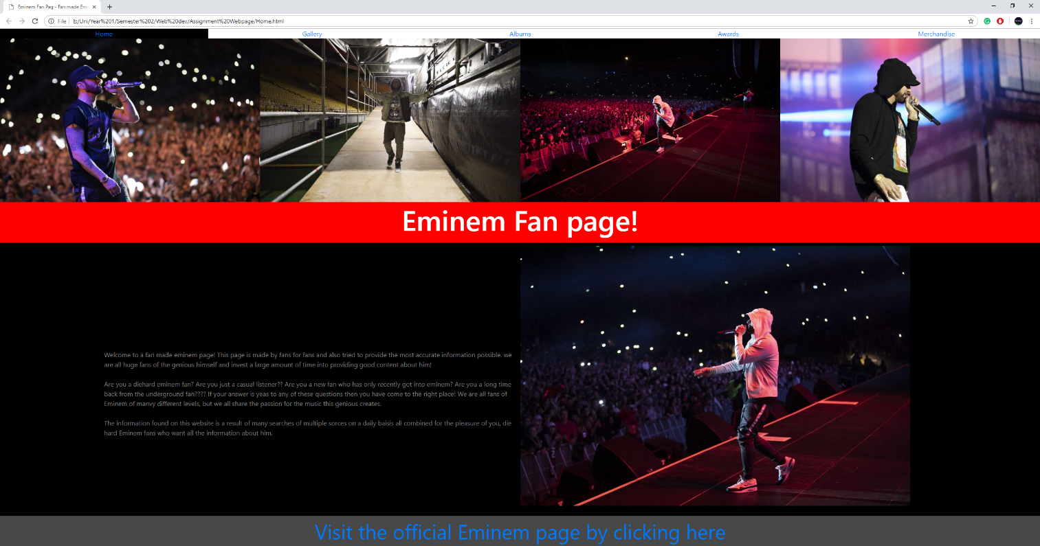
Fig 1. Home Page
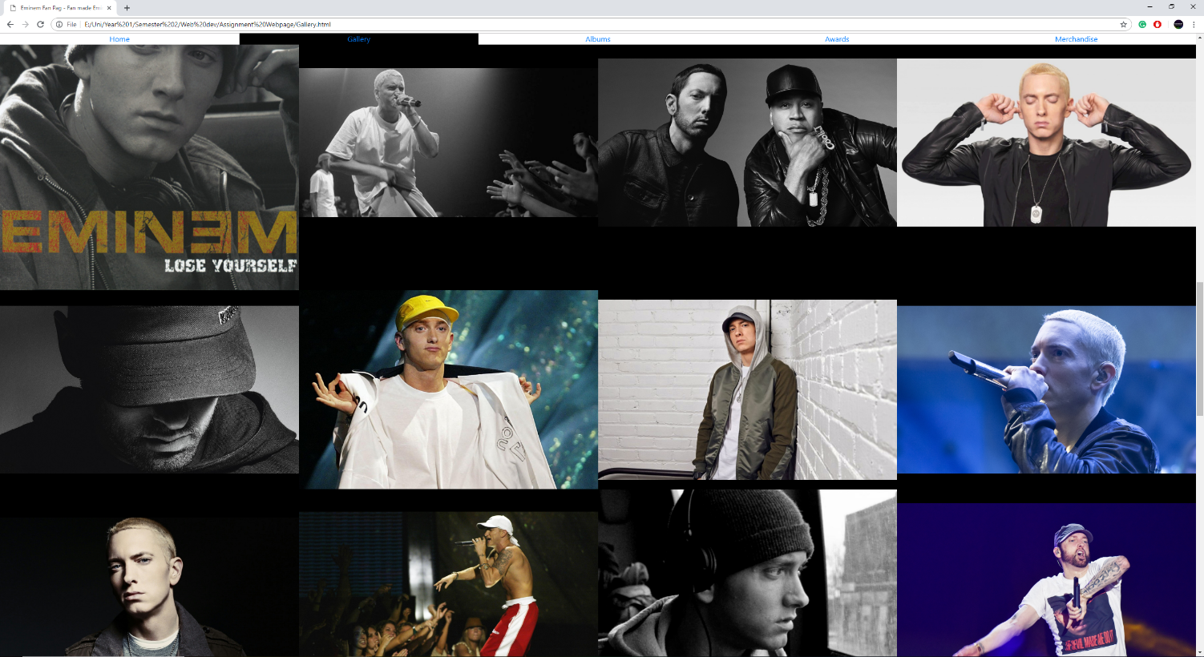
Fig 2. Gallery

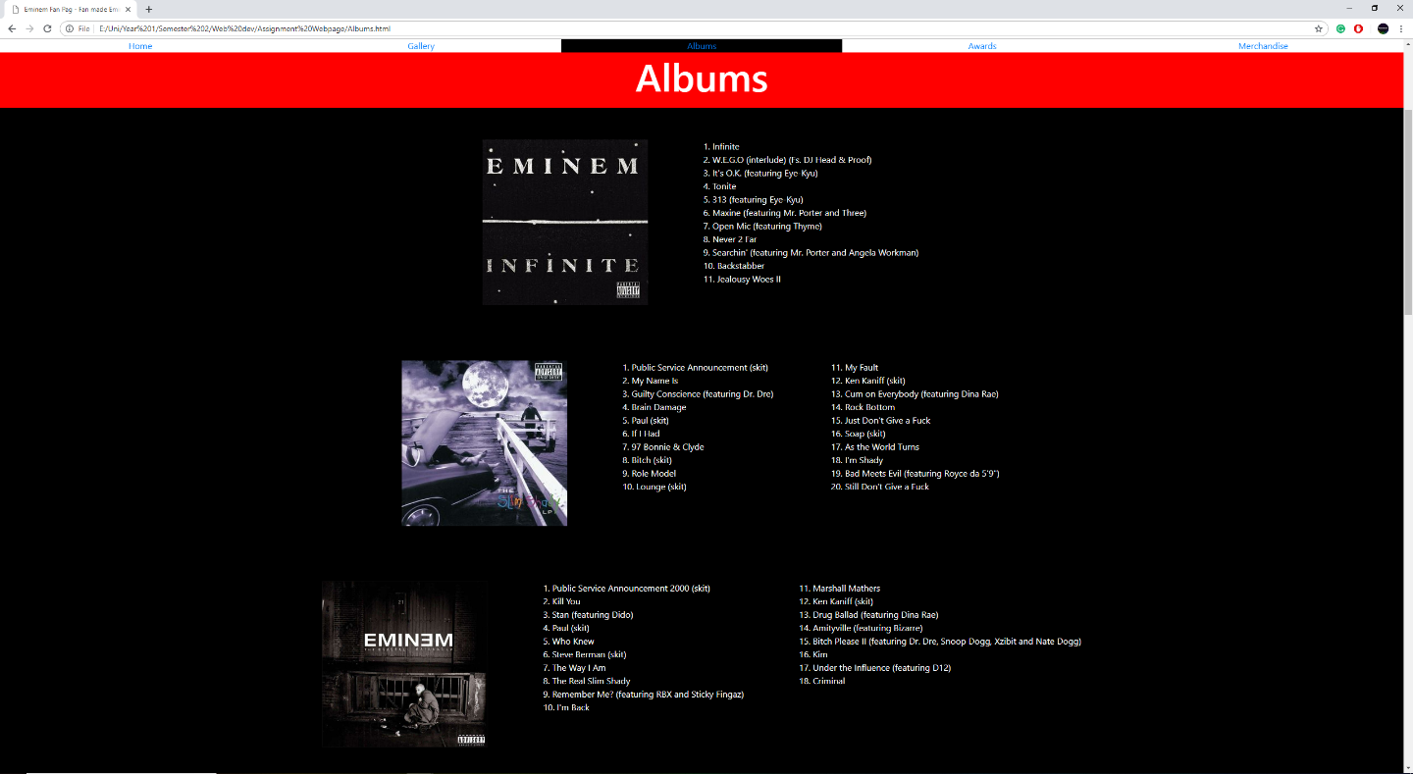
Fig 3. Albums

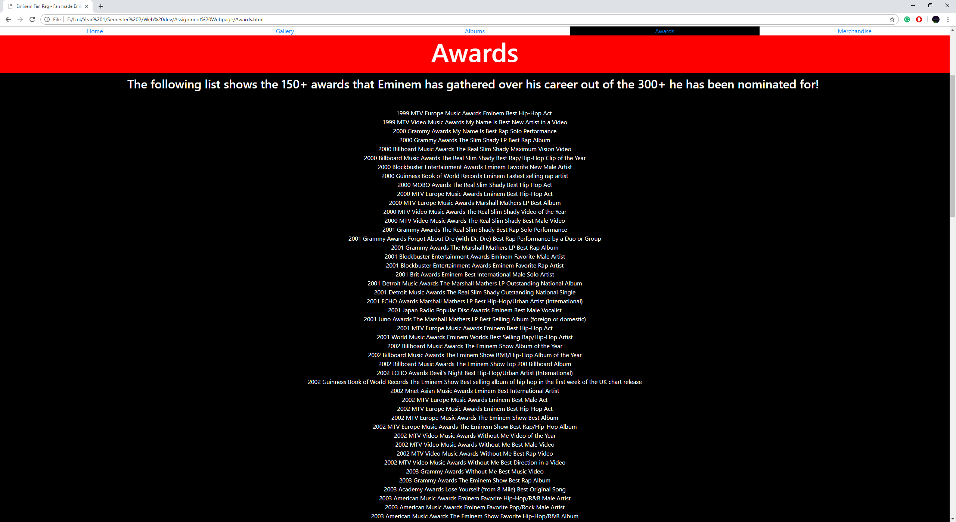

Fig 4. Awards

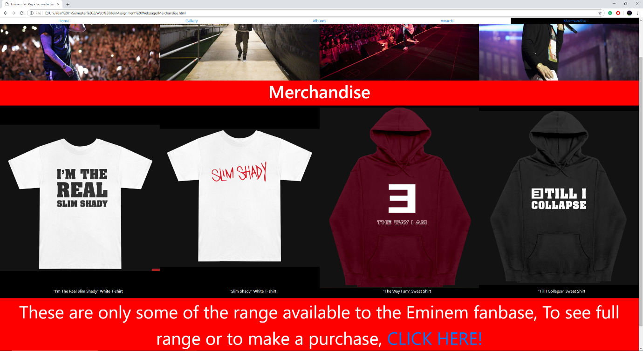
Fig 5. Merchandise

The images Provided above Show the content and design of the web page that has been created about Eminem covering come brief information about his career.

The HTML and CSS code for the Home page has been validated using an online validator. This validator has confirmed that there are no errors in the coding of the website, see fig 6-7.
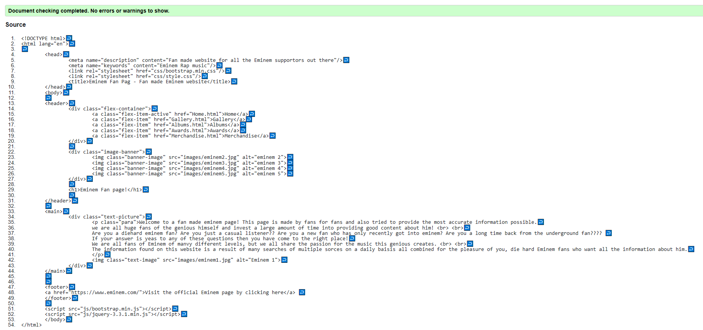

Fig 6. HTML Validation

Fig 7. CSS Validation

Accessibility Evaluation
The author of the website has attempted to adhere to the four main principles of accessibility during development. There are some areas that could be largely improved but have been left in the way that they are as it can be used to improve on in the future and not fall into the same problems that have happened in this site.
The Perceivable aspect of the website is believed to be to an acceptable standard as all the content that is provided on each page is very easily seen and understood by the user. The colours have been chosen to stand out in areas that should be seen by all users to do things such as, provide them with what page they are on, or show and external link on the page that may be useful for more information or making a purchase. Also, the text elements of the page are chosen to be an opposite of the background colour as to stand out and be seen by all users, also not hard to find or hidden in any way. The navigation bar that has also been created has many good perceivable attributes, such as an effect to change colour when hovering over a different button, or a different colour for the background when that page is selected. Also, it is also in a fixed position on the top of the page to prevent the user from having to always return to the top to navigate to another section of the website. Finally, there are always text alternatives provided for any non-text content that is included in any of the pages, this is so the user can know what they should be seeing if for some unknown reason the content is unavailable to be displayed at this point.
The Operable principle is also believed to be at an acceptable standard for the crated website. There are very minimal ways that the user can use this site as there are only buttons on the page that can be interacted with, all of which are clearly displayed as to show to the user clearly where they are located if they are needed. It is also believed to be possible to use this website using only a keyboard.
The third principle of accessibility is Understandable. The HTML code for this site breaks the sections up using tags such as ‘<header>’ or ‘<main>’ tags to split the content into different areas and be displayed correctly. This also helps the content become easily understandable to both use and creator and the operation of the page is almost predictable to the user, so they do not have to search for content. Lastly, any text content that appears is also in clear colour to stand out from the set background colour.
Although the 3 principles already covered seem to be followed to an acceptable standard, from the authors judgment, it falls short when it come to the final principle, Robust. The page is not believed to be very robust in a few areas. The first of these being support across all device, it is uncertain weather the page that has been created is mobile/tablet friendly, this would be a problem in the current world as almost every person has a smartphone or smart device that can browse the web and access all the information they need. Also, it is not developed to be used with assistive technologies.
It has been attempted to use a few different things to access the accessibility of the website, such as chrome extensions, but due to technical difficulty is has not been possible to carry this out.

General Evaluation
The design of the created website is believed to be to an acceptable standard, but in no way exceeding in any areas. It shows that the creator does not have a large amount of experience in this field. It is believed to be okay for an entry level developer who is still learning the basics and would need to be improved upon in many ways to bring it to a professional level. The functionality of this website is all in working order, all buttons and links perform as intended by the author, this is a good example of good usability for the website. Although, if this website was to be used on a device that it has not been optimised for, such as a smartphone or tablet, the usability whilst still being the same, may be a lot harder to figure out and the layout could be wrong.
The content is as accurate as possible on the given subject as the author is a huge fan and already does a lot of research and has a lot of knowledge online. There are no specific points of reference for researching the subject but there are many sources that will be provided that were used to confirm the content that has been given. See appendix.

Conclusion
In conclusion, the author feels that the website that has been created meets most of the required standards that are needed to be able to make a successful website that is easy to use and easy to understand by the target audience and any other users who may happen to stumble across the website. It has been pointed out through this report that there are many areas that could be improved on that would naturally come with experience and time of a professional developer. As development and design work is continued to be attempted more and more skills naturally build along the way, and this can normally be seen through the work that people make over time from beginning to professional level. Overall, the author id happy with the final product and feels that it was completed to the best of their abilities.

Appendix

Reading List
There were several sources that were used to research about this report, although none of them were directly cited, they all have provided backup and reinforcement of the content and the code that had been provided.
[1] https://www.w3schools.com/
[2] HTML and CSS: Design and Build Websites, 2011, Jon Duckett
[3] Get Coding! Learn HTML, CSS, and JavaScript and Build a Website, App, and Game, 2016, Young Rewired State

