Presentation Slides
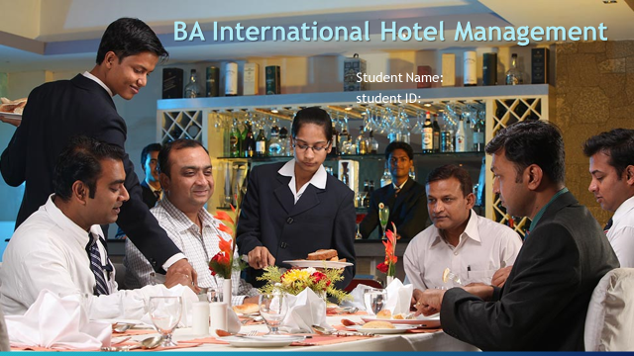
Recording-20231026_193503.webm

Ana Maria Bosuioc
2126864

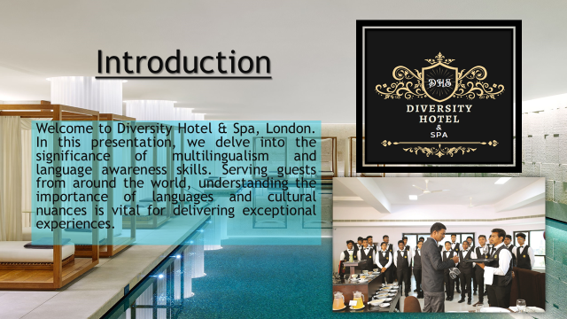

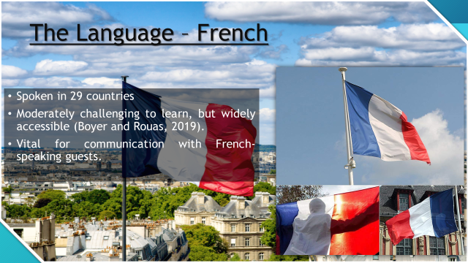





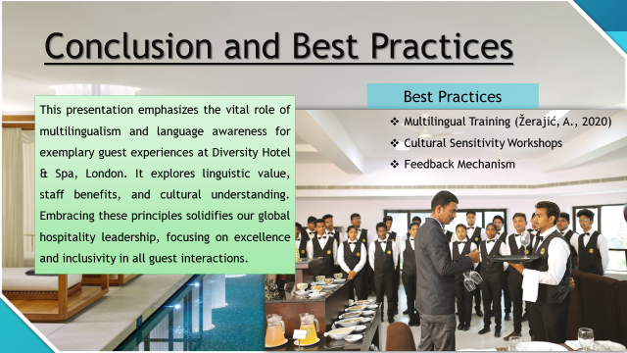

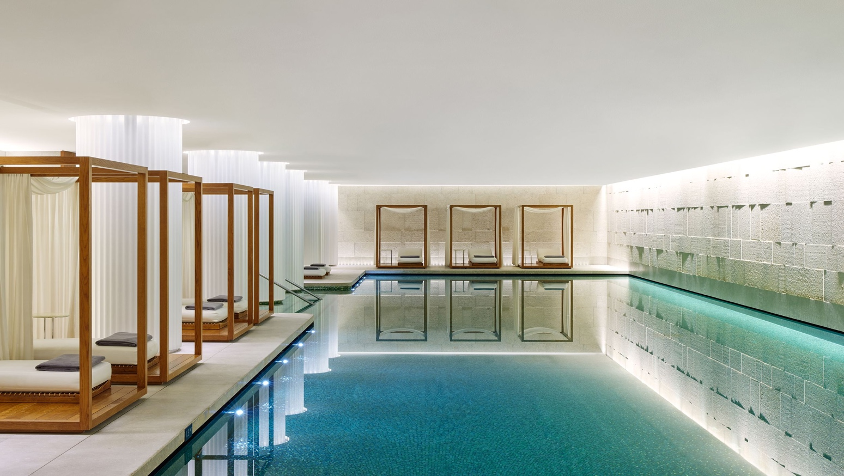
- Boyer, F. and Rouas, J.L., (2019). ‘End-to-end speech recognition: A review for the french language’. Available at: https://doi.org/10.48550/arXiv.1910.08502 .
- Kim, W.G., Li, J., Han, J.S. and Kim, Y., (2017). ‘The influence of recent hotel amenities and green practices on guests’ price premium and revisit intention’, Tourism economics, 23(3), pp.577-593. Available at: https://doi.org/10.5367/te.2015.0531 .
- Kirwan, D., (2019). ‘Multilingual environments: Benefits for early language learning’, TEANGA, the Journal of the Irish Association for Applied Linguistics, 10, pp.38-57. Available at: https://doi.org/10.35903/teanga.v10i0.69 .
- Koller, V., (2018). ‘Language awareness and language workers’, Language Awareness, 27(1-2), pp.4-20. Available at: https://doi.org/10.1080//09658416.2017.1406491 .
- Žerajić, A., (2020), ‘Multilingualism in tourism’, Tourism International Scientific Conference Vrnjačka Banja-TISC, 5(1), pp. 518-535.
References

