

Module Name: Academic Skills in the Digital Era
Module Code:BMSW4013
Assessment 1: E-Portfolio
Student Name: Luma Aal-khamees Aga
Student Number: 2438571
Lecturer: Scott James
Deadline: Friday 21st November 23:59PM

Contents

Component 1: Research and Planning | 4
Source Exploration  Key Challenge for Students  Key Opportunity for Students  Planning the Report | 4  4  4  5
Component 2: Answering the Question | 6
Introduction  Challenges: Why They Matter  Opportunities: Why Do They Matter  How Students Can Thrive  Conclusion | 6  6  7  8  9
Component 3: Reflection  Slide 1 Introduction  Slide 2 Research  Slide 2 Planning and writing  Slide 3 What I found challenging in my research  Slide 3 Success  Slide 4 How to overcome the challenges  Slide 4 Looking forward  Slide 5 Thank you/ Any questions?  Slise 6 References | 10  11  11  12  12  13  13  14  14  15
Reference List | 16
Appendix 1: CRAAP Test | 19

AI Acknowledgement
I confirm that I have not presented any AI generated text as my own work.
I confirm that I have copies of my drafts, notes, and other resources I used, which I may be asked to provide in evidence.

Component 1: Research and Planning

- Source Exploration
Zou et al. published their article titled “Digital learning in the 21st century: trends, challenges, and innovations in technology integration”, in 2025.
The main point of the article is that using digital technologies such as online platforms, virtual reality (VR) or Artificial Intelligence (AI) in education has the potential to make learning more accessible, flexible, engaging and personalised. However, barriers remain and need to be addressed, such as accessibility issues for students with specific learning needs or disability.
This article was chosen because it is relevant and accurate for my topic. It was very recently published, and the website is trusted by educators. The CRAAP test (Refer to Appendix 1) was used to check that the source is current, relevant to student learning and comes from a reliable source.
- Key Challenge for Students
Availability of content and platforms that cater to a diverse range of learning needs is an ongoing challenge for many students who have special education needs. Many digital platforms and tools are not adequately equipped to support these learners, which can further worsen educational inequalities (Timotheou et al, 2022). AI models must be designed to avoid reinforcing bias and exclusion (Burt, 2023).
As a dyslexic person with poor working memory, I won’t understand why I can’t remember and everyone else can. Therefore, with AI, I can sometimes feel overwhelming, the volume of information that language-based apps generate can at times be difficult to process.
- Key opportunity for Students
AI is becoming an important tool in education. It can help create smart tutoring personalised learning programs. For example, AI can study how students learn, find out what they struggle with, and adjust lessons to fit each student’s needs. This personalized approach gives students the right support at the right time, which makes learning more interesting and effective (Zizikova, 2021).
Virtual reality (VR) and augmented reality (AR) are becoming more popular in education because they offer learning experiences that feel very real and engaging. VR lets students explore subjects like biology or history in an interactive way (Bower et al., 2020). For example, students can take virtual trips to historical sites or look inside the human body in 3D, helping them understand the topics much better.
My experience with some AI Apps such as Caption Ed, note taking and flashcards has helped me in taking notes in the classroom. These advanced tools can help some students with short memory to take notes in lectures; and can help them to organize the information on cards for learning. This integration of technology in education not only contributes towards ensuring equitable access to educational content; in addition, it supports learners with disabilities in developing greater independence self-determination, and social integration (Han, 2025).
- Planning the report:
My report will focus on the positive and negative impacts of using AI for students with learning disabilities.

Timeline to complete Component 2
Task | Date / Deadline
Finish research | 26th October 2025
Draft first section | 7th November 2025
Complete first draft | 14th November 2025
Final editing | 20th November

Answering the Question Component 2:
Introduction
The use of digital learning and accessibility tools in higher education has gradually increased over the past 20 years, but their adoption increased significantly during the Covid-19 pandemic (Casey, 2023). These digital tools offer students new opportunities for students. However, important challenges remain. Ignoring these challenges can leave students unsupported or even excluded in the classroom.
This report examines both the opportunities and the challenges associated with using AI-based digital tools for students with learning differences. On one hand, AI can offer significant benefits: students with conditions such as dyslexia or dysgraphia may experience improved reading efficiency and comprehension through personalised support and generative AI has the potential to help students with disabilities develop key skills, including communication and social interaction. On the other hand, important challenges remain. Many AI tools still overlook accessibility needs and limited or unequal access to digital technologies continues to be a critical obstacle (McMurtrie, 2023). This report therefore explores how AI can support students with diverse learning needs, while also addressing the barriers that may prevent these tools from being fully effective.

Challenges: Why They Matter
There are several challenges that affect students of all abilities in the classroom, but these issues can be particularly significant for students with disabilities. For example, some learners with visual impairments find it difficult to interact effectively with text-based chatbots. Similarly, the volume or complex language produced by digital tools can overwhelm students with learning disabilities, increasing their cognitive load and stress rather than reducing it (Tlili et al., 2023).
Another obstacle is that many tools are not designed with disabled students in mind. This can lead to frustration, exclusion, and widening accessibility gaps. For instance, early versions of ChatGPT relied only on text-based interaction, which may have made it more challenging for students with dyslexia to process and interpret (Botchu et al., 2023).
These challenges support the argument that simply providing access to digital technologies does not automatically create equal educational opportunities. Digital inclusion is always shaped by a learner’s broader offline circumstances, such as their environment, resources, and support networks (Cranmer, 2019). Therefore, it is essential to ensure that digital tools are not only available, but also genuinely usable, accessible, and beneficial for every student with diverse learning need.
Digital Apps as IA often overwhelmed me as a dyslexic postgraduate student with dense material, where I feel like information overload, especially when dyslexia make processing large volumes of language more difficult. That’s such an important point that Al developers need to pay attention to it as this can creates barriers rather than opportunities for some students.
Opportunities: Why Do They Matter
AI tools have the potential to support students with disabilities by helping them develop their interpersonal and communication skills. Students with learning disabilities may sometimes struggle to express themselves or interpret others’ speech and actions during conversations, which can contribute to social isolation. AI-based systems that provide guided communication practice, real-time feedback, or simulated social interactions can therefore help these students participate more confidently and collaborate more effectively with their peers, promoting greater interaction within the learning environment (Brewer et al., 2020).
Another important opportunity lies in AI-powered platforms designed to support students with dyslexia. Digital tools such as Caption Ed and flashcard applications help dyslexic learners engage with meaning beyond text, demonstrating inclusive design in action. Features such as speech-to-text, which converts spoken words into written text, and text-to-speech (TTS), which reads written content aloud as seen in tools like Microsoft Immersive Reader provide multiple ways for students to access information. Generative AI can potentially benefit these students by helping clarify writing instructions, establish writing goals, and create structured writing plans (Onufer, 2024).
Personalisation is another key advantage of digital education. Through learning analytics, AI, and adaptive learning systems, it is now possible to create tailored learning experiences that respond to each student’s needs, preferences, and learning styles (Johnson et al., 2020). When used effectively, these technologies offer students a flexible digital environment and the freedom to access knowledge in ways that best support their individual learning requirements.
My experience with learning tools such as mindview90 was beneficial as it instead of doing the task one long block of work, I can pause after each section; and I can be in control of the flow of my writing and reading. This will keep students motivated as smaller steps feel achievable, so progress is visible and encouraging.
How students can thrive
By understanding the issues with the digital tools, the disadvantage students can adopt specific measures to overcome these barriers and focus more on how to succeed. Let’s break this down step by step:
- Student with learning difficulties need to be committed to learning in the way that works best for them by managing overload while studying. Such as:
- Break responses into smaller sections or bullet points. this way, they can process one idea at a time instead of forced through long paragraphs.
- Summaries first: you can request a “headline-style summary” before diving into details.
- Highlighting key points: can bold or emphasize the most important words.
This facilitates easier comprehension of core concepts in reading, thereby enhancing students' engagement with learning materials (Zhao 2025)
- Used digital tools to improve social life and communication, as This will help students to collaborate more effectively with their peers and foster a greater sense of engagement in the learning environment. Certain generative AI-based tools can simulate real-life communication scenarios, allowing students to practice and develop the skills needed to better understand others and communicate more effectively (Almufareh, 2024).
- Asking for support and help:
Accessing support services not only builds technical skills but also empowers students to solve problems quickly and feel more independent when using new tools.
By implementing these strategies, Students with special needs can turning barriers with AI tools into opportunities for independence and inclusion in learning.

Conclusion
In summary, while technology‑assisted learning tools, for example AI, introduce new challenges for students with learning difficulties such as feeling overwhelmed and stressed, it also creates pathways to independence in learning, confidence, and inclusion. It can open doors for students with learning difficulties such as dyslexic students, by transforming how they access, process, and express knowledge. Students should be aware of these points, which will encourage them to use these digital tools effectively. Also, they need to know these tools are designed inclusively, and set to make learning smoother, more engaging, and more equitable for learners.

Component 3: Reflection

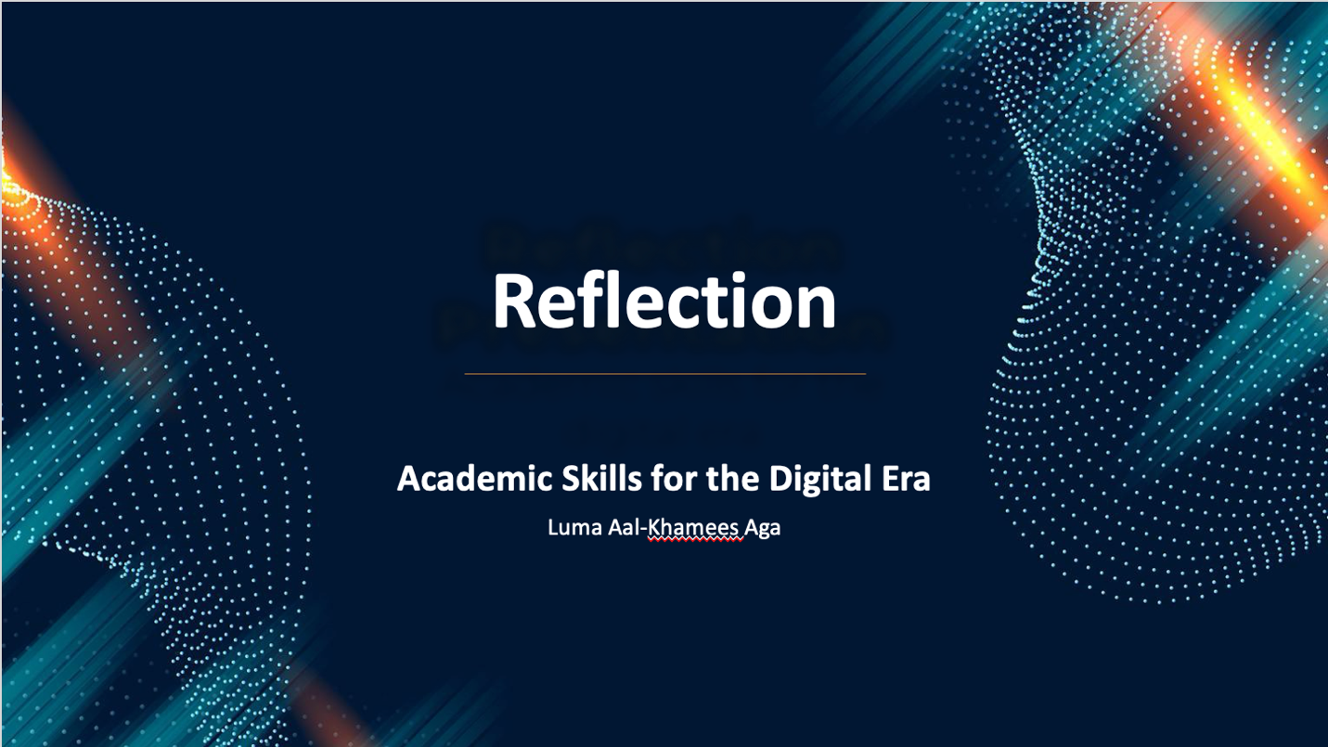
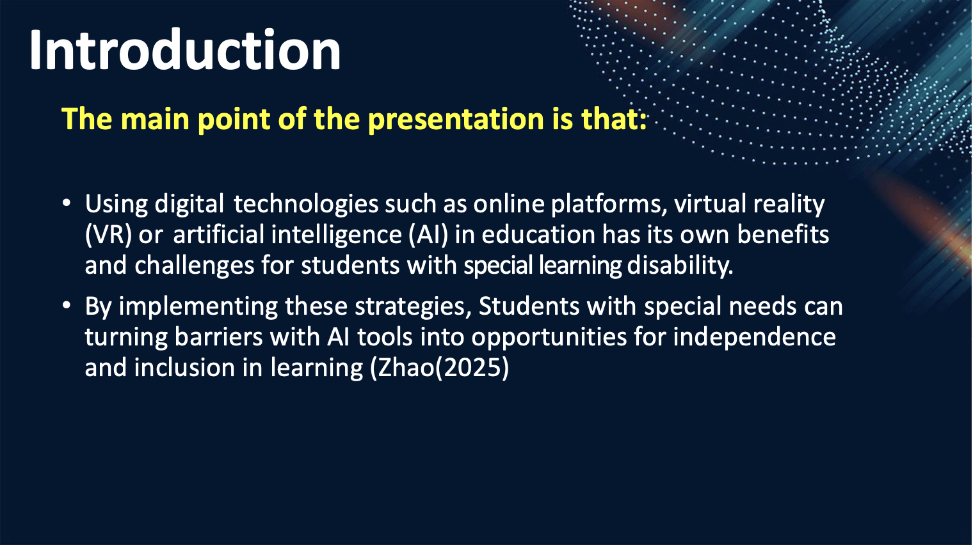
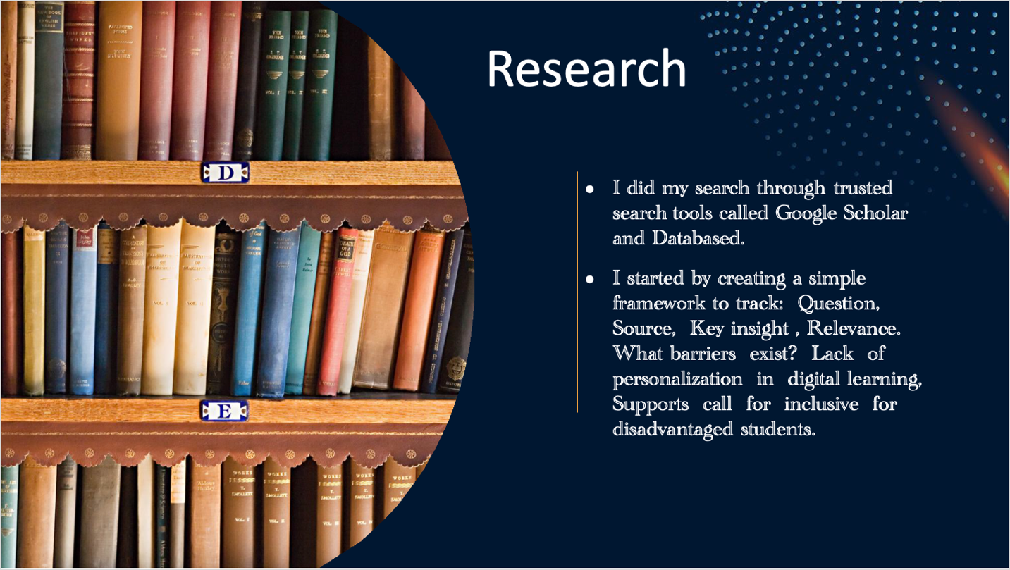
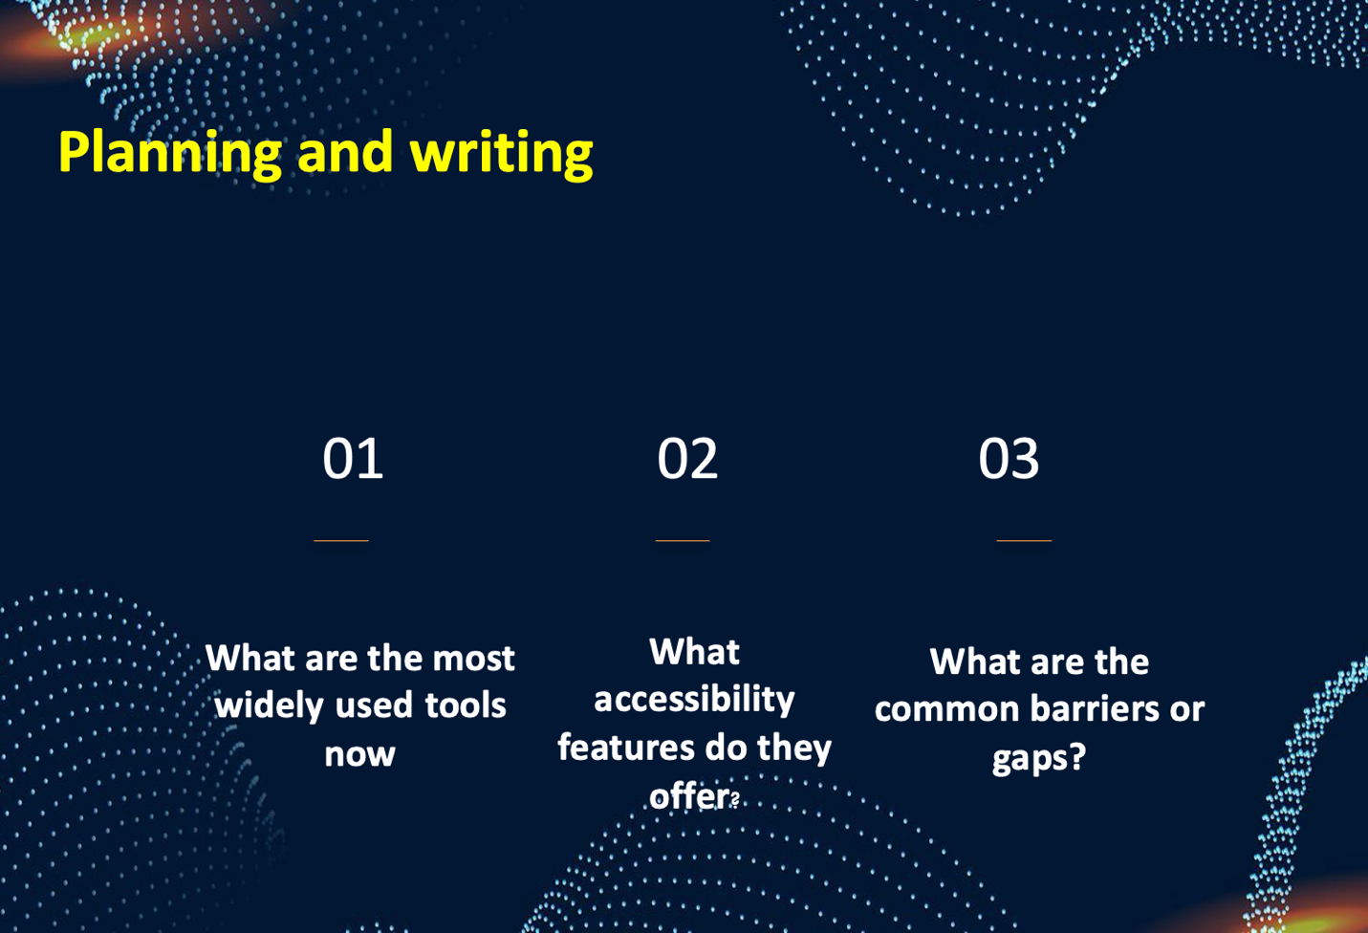

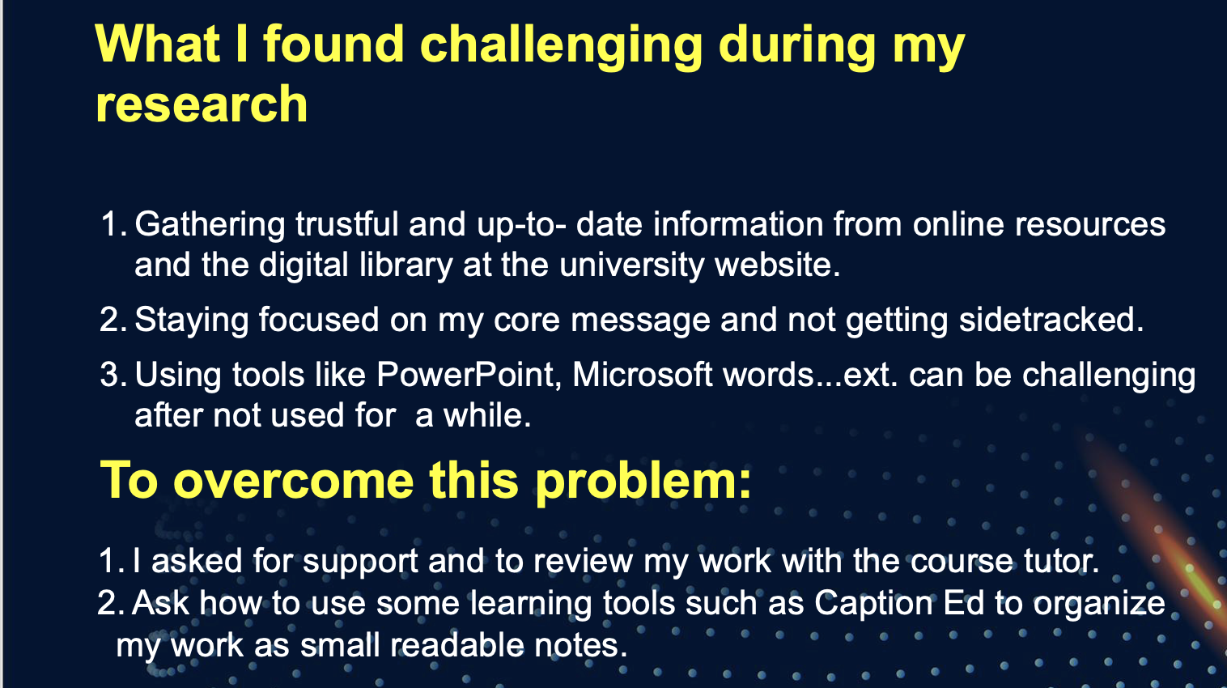
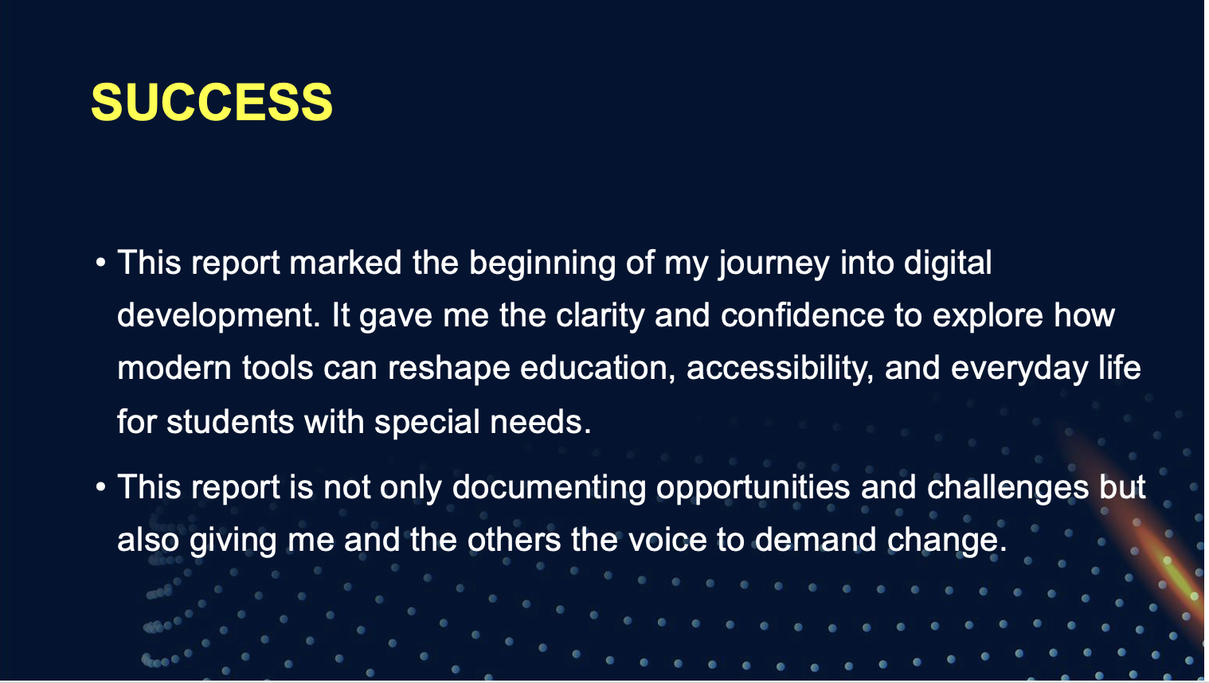





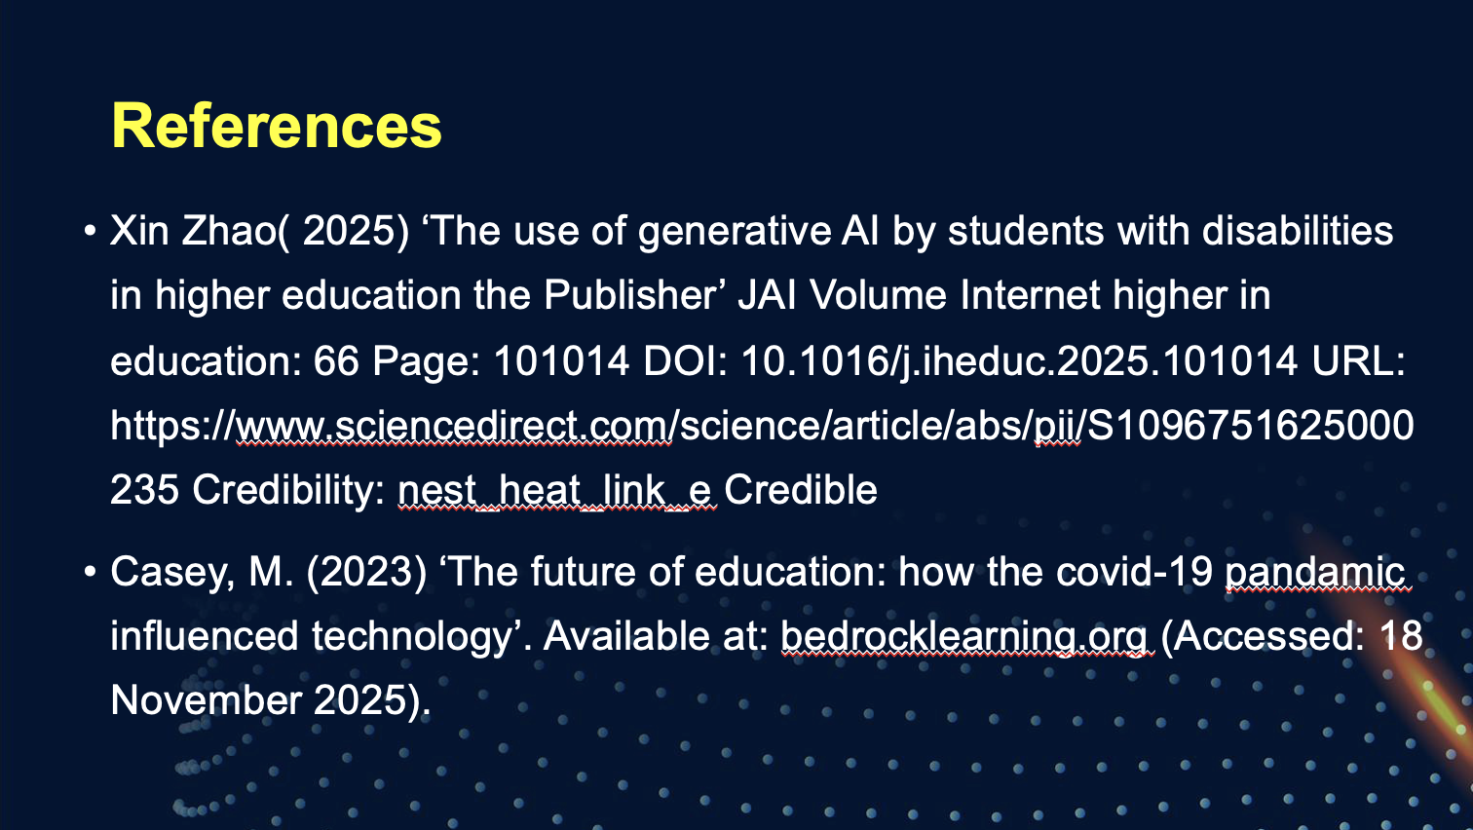

References

Almufarej, A. (2024) Cited in Zhao, X., Cox, A. and Chen, X. (2025) 'The use of generative AI by students with disabilities in higher education', The Internet and Higher Education. 66, 101014.

Botchu, R., Baal, J.D. and Beaman, F.D. (2023) 'ChatGPT: ‘A disruptive innovation or a disruptive invention?', Annals of Biomedical Engineering. 51(6), pp. 1125-1126.

Bower, M., DeWitt, D. and Lai, J.W.M. (2020) 'Reasons associated with preservice teachers’ intention to use immersive virtual reality in education', British Journal of Educational Technology. 51(6), pp. 2214-2232.

Burt, A. (2023) ‘AI’s Trust Problem’. Harvard Business Review. Available at: https://hbr.org/2023/03/ais-trust-problem (Accessed: 18 November 2025).

Casey, M. (2023) ‘The future of education: how the covid-19 pandemic influenced technology’. Available at: https://bedrocklearning.org (Accessed: 18 November 2025).

Cranmer, S. (2019) 'Disabled children’s evolving digital use practices to support formal learning, a missed opportunity for inclusion', British Journal of Educational Technology. 51(2), pp. 315-330.

Haleem, A., Javaid, M., Qadri, M.A. and Suman, R. (2022) 'Understanding the role of digital technologies in education: A review', Sustainable Operations and Computers. 3, pp. 275-285.

Han, H. (2025) ‘Embracing Technological Innovation’: UNESCO advances SDGs through inclusive education for learners with disabilities. Paris: UNESCO. Available at: https://www.unesco.org/en/articles/embracing-technological-innovation-unesco-advances-sdgs-through-inclusive-education-learners (Accessed: 20 November 2025). Johnson, L., Smith, R., Willis, H., Levine, A. and Haywood, K. (2020) The 2020 Horizon Report: Teaching and Learning Edition. EDUCAUSE. Available at: https://library.educause.edu/resources/2020/3/2020-educause-horizon-report-teaching-and-learning-edition (Accessed: 18 November 2025).

McMurtrie, B. (2023) 'How AI Could Save or Sink the Accessibility Movement', The Chronicle of Higher Education, 26 April. Available at: https://www.chronicle.com/article/how-ai-could-save-or-sink-the-accessibility-movement (Accessed: 18 November 2025).

Onufer, L. (2024) 'Teaching at Pitt: Using generative AI to create more accessible student learning experiences', University Times. 56(1). Available at: https://www.utimes.pitt.edu/news/teaching-pitt-using (Accessed: 12 November 2025).

Timotheou, S., Miliou, O., Dimitriadis, Y., Sobrino, S.V., Giannoutsou, N., Cachia, R., Monés, A.M. and Ioannou, A. (2022) 'Impacts of digital technologies on education and factors influencing schools’ digital capacity and transformation: A literature review', Education and Information Technologies. 28(28), pp. 6695-6726.

Tlili, A., Shehata, B., Adarkwah, M.A., Bozkurt, A., Hickey, D.T., Huang, R. and Agyemang, B. (2023) 'What if the devil is my guardian angel: ChatGPT as a case study of using chatbots in education', Smart Learning Environments. 10(1), p.15.

Zhao, X., Cox, A. and Chen, X. (2025) 'The use of generative AI by students with disabilities in higher education', The Internet and Higher Education. 66, 101014.

Zizikova, S.I. (2021) 'Transformation of education in the context of digitalization', in Ashmarina, S.I., Mantulenko, V.V., Inozemtsev, M.I. and Sidorenko, E.L. (eds.) Proceedings of Global Challenges and Prospects of The Modern Economic Development. Samara: European Publisher, pp. 1074-1081.

Zou, Y., Kuek, F., Feng, W. and Cheng, X. (2025) 'Digital learning in the 21st century: Trends, challenges, and innovations in technology integration', Frontiers in Education. 10, 1562391.

Appendix 1: CRAAP Test

- Currency: The article was published in 2021, so it is quite recent and up-to-date. This is important because technology and digital learning tools change quickly.
- ⁠Relevance: The article directly discusses how technology affects student learning, which is exactly what the assignment asks for. It is written for educators and students, making it relevant and useful.
- ⁠Authority: Youki Terada is a recognised education writer who frequently contributes to Edutopia, a well-respected website supported by The George Lucas Educational Foundation. This adds credibility to the source.
- ⁠Accuracy: The article provides clear examples and references research studies to support its points. Edutopia is known for fact-checking and providing reliable educational information.
- Purpose: The purpose of the article is to inform and help educators and students understand the benefits and challenges of using technology in learning. It is not trying to sell a product or promote a specific company, so the information is likely unbiased and trustworthy.

