LCMB7004- Entrepreneurship Assessment 50%
Submitted By- Suraj kumar

Student Name- Suraj kumar
Student ID- 2126818
Module: - Entrepreneurship Assessment 50%
Lecturer Name:- Isaiah oino
Course Name:- Masters of Business Administration General
Submission Date:- 9th January2023
Pages:-17

Table of Contents
INTRODUCTION 3
MAIN BODY 3
Traits of Entrepreneur 3
Characteristics of Entrepreneur 5
Attributes of Entrepreneur 7
Motivations of Entrepreneur 8
Entrepreneur Values and Beliefs small for-profit organizations 10
Entrepreneur Values and Beliefs for small non-profit organizations 11
CONCLUSION 12
REFERENCES 13

INTRODUCTION
An entrepreneur can be referred to as an individual who consists of an idea to create a product or service that will help to attract potential customers in the marketplace. An entrepreneur is a person who takes a risk and starts a new business in the market by providing innovative products and services to customers. In regards to this report, there will be a discussion about the various concepts and knowledge about entrepreneurship that how entrepreneurs carry out operational activities at the workplace. Along with that, there will be an analysis of the traits and characteristics of the entrepreneurs. After that, it will be analyzed how they motivate their employees at the workplace so that they can produce their efficiency. At the end of the report, there will be a discussion about the entrepreneur's value and belief for the profit organization and non-profit organizations.

Figure 1: Entrepreneur

MAIN BODY

Traits of Entrepreneur
Entrepreneur consists of various trades that help them to carry out operational activities at the workplace. Some of the major trades of the entrepreneur are described below:
Strong Leadership Quality: - It is one of the major traits that entrepreneurs consist of, and these qualities are inherited by them from the start. Leaders can be referred to as the essential person of the organization who values the goals and targets of the organization, and just like the leader, an entrepreneur works for the organization through which they focus on achieving the goal. Entrepreneurs generally focus on getting the trust of each person at the workplace so that everybody can give their full potential towards the organizational goal. They act as a good leader because they maintain relationships with every person, such as investors, employees, etc. They consist of the ability to lead others which makes them the best leader.
Highly Self-Motivated: -Entrepreneurs are highly self-motivated and confident towards their business which they are introducing in the marketplace. They have to take various types of risks while introducing new products and services into the market, and therefore, they have to be very confident and motivated towards their decision which has them become successful entrepreneurs in the market. Their decisions play an important role in developing their business, and this is only done because they are self-motivated and confident in their decision-making power.
Innovators: - It is one of the main traits of the entrepreneur because they believe that innovation is essential in the business through which they can maintain engagement with the customers. Entrepreneurs in the business keep on developing new ideas and enhancing the existing process of production through which they can provide more efficient products and services to the marketplace. One of the main reasons for the success of the entrepreneur is that they keep on introducing change in the market through which they fulfill the needs of the customers of the current time (Presenza et al., 2020).
Competitive Spirit: -Entrepreneurs generally have the mind sent to compete in the market with full competition because they love to take challenges and through which they focus on enlarging their business on a big scale. They keep on introducing new products and services to the customers, and therefore they also have to face tough competition in the market, which has become as their one of their traits.
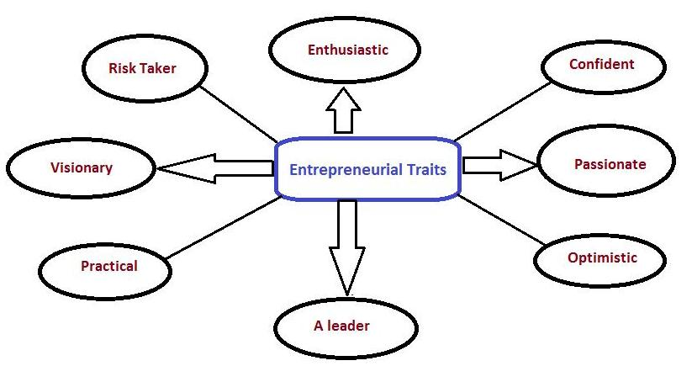
Figure 2: Entrepreneurial Traits

Characteristics of Entrepreneur
When an entrepreneur starts a business, they offer innovative products and services to the customers, and therefore, they consist of various types of characteristics through which they become successful in their field. Some important characteristics of the entrepreneur which they consist of to carry out the operational activities are mentioned below:
Vision: - It is one of the main characteristics of the entrepreneur because when a venture is started in the market, it has a particular vision of what it wants to achieve shortly. Entrepreneurs have a great mindset and strong vision that they want to build their businesses in the marketplace by offering new products and services to customers. They can build a vision for their business organization, and accordingly, they set up the goals by undertaking the SMART objectives. These characteristics of themselves help them to build their brand in the market (Laguía and Morianoand Gorgievski, 2019).
Risk-Taking:- It is another main characteristic of the entrepreneur that they consist of. The risk-taking ability is not common in every person, but entrepreneurs consist of this quality as they keep on introducing new products and services into the market, which involves so much cost and time. This can only be done with the help of risk-taking quality, and they prepare themselves to meet unwanted happenings such as losses, and they have a pre-planned approach to deal with challenges. Entrepreneurs only become successful in their particular field because they consist of the quality and ability to take risks in challenging times, which helps them to earn a sufficient amount of revenue and profit.
Curiosity: -It is another main characteristic of the successful entrepreneur because they have a curiosity to do new things in the business, and they have a different mindset from other business owners, which helps them to seek new opportunities in the marketplace through which they offer effective products and services to the customers. It is one of the essential features of the entrepreneur because, without curiosity, entrepreneurship can't work, and entrepreneurs cannot achieve the goals and targets that they have set for themselves. This feature of the entrepreneurs always forced them to discover new opportunities and to take challenges to become more successful in the market. These features always help them to ask more questions to the customers so that they can provide their desired wants related to the products and services.
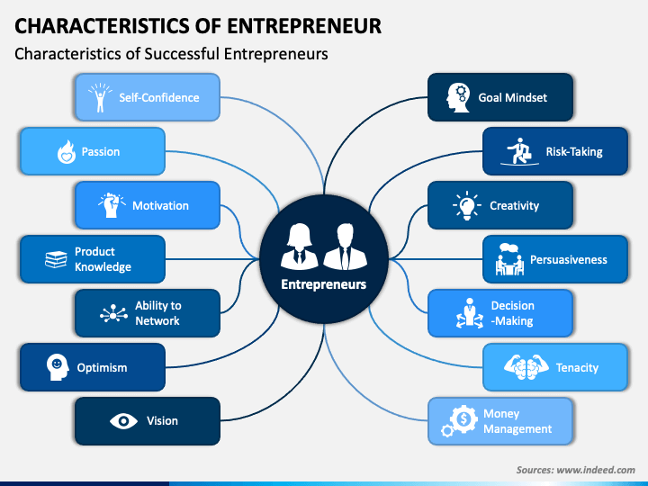
Figure 3: Characteristics of Entrepreneur

Attributes of Entrepreneur
There are various kinds of attributes that entrepreneurs consist of, which facilitates them to take their business to great heights. There are some of the main attributes of entrepreneurs are explained below:
Willing To Work Hard: - When an individual starts their business in the marketplace, it depends upon them how they carry out the operational activities. The success ratio of the organization is also dependent upon that particular person. There is a need for hard work in the initial stages of the business because it takes so much effort and challenges to establish the business in the marketplace and to make connections with the customers. Entrepreneurs generally possess these attributes that they are willing to work hard across the cycle of the business and not only in the initial stages of the organization but at every stage of the organization as then only they become successful in their field (SHIMOLI, CAI, MUHAMMAD HASNAIN, and LANG, 2020). They always work hard to achieve the goal and targets that they have set for themselves. Entrepreneurs love their businesses and the products that they offer to the customers, and therefore, they are always willing to work hard to achieve their goals achieved.
They Aren't Afraid To Take A Chance:- Starting a completely new business or venture in the market with so much competition already present is a great risk that entrepreneurs take. It is the main attribute that they consist of because there is always a possibility that the organization or the new business may fail in the market place and there is no such guarantee that it will show profits in the initial stages. Entrepreneurs generally don't take back steps to take a chance, and they make tough decisions such as investing capital in their organization and business so that they can become able to grow their business and become successful entrepreneurs.
They Know How To Manage Money And People: - An individual can consist of the best Idea to build the brand in the marketplace. But it requires that the individual should know how to make that Idea profitable and how to carry out the business activities. Entrepreneurship consists of this attribute because they know how to manage the money and people at the workplace through which they can set a budget and make a business plan. They always motivate their employees at the workplace so that they can give their important contribution to achieving the targets.
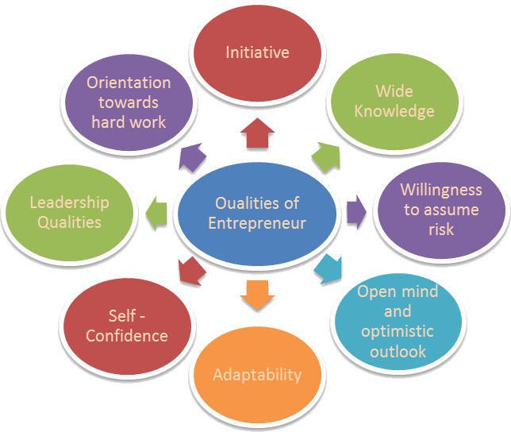
Figure 4: Qualities of Entrepreneur

Motivations of Entrepreneur
There are differences in the decision-making power of individuals on certain matters. Apart from that, entrepreneurs are the ones who become successful while making various decisions at different times. These are the people who set up objectives and goals for themselves and undertake the struggle process through which they earn success. When entrepreneurs find out the course of action, they face so much conflict, and out of those, they try to capture the opportunities. Hence it can be stated that the source of motivation for entrepreneurs can be determined when they launch a new product or service into the marketplace (Staniewski, and Awruk, 2019).
There are very steps and circumstances under which entrepreneurs take out their business activities to the great height of success. One of the main elements to get success for the entrepreneur is the environment in which they carry out the operational activities, and one of the most crucial aspects of the environment is the political factors and the economic condition. But since, the inspiration to become big helps entrepreneurs to do to their full potential and even carry out the work in unfavorable conditions. Can only become successful when they are highly motivated and when they overcome the conditions that challenge them.
While an entrepreneur makes various decision at the workplace, different concept, such as the vision of the entrepreneur and experience in the particular field, also plays a major role in making further decision for the business. Every individual in the workplace wanted to take advantage of the environment. Entrepreneurs, on the other hand, always focus on finding out opportunities in this environment, and successful entrepreneurs such as the CEO of Apple always engage their customers by developing new designs for the phone. Hence it is a very competitive market, and yet they can maintain environmental control. Along with that, it can be stated that the level of motivation of the entrepreneurs is one of the main sources of vision that they carry out to make their business more successful.
There are various types of entrepreneurs present in the marketplace, and their growth and success rate are dependent on their entrepreneurial endeavors. Motivation plays a key role in business owners becoming able to achieve the goals and targets they have set for themselves, and in addition to the goals, they are also concerned about environmental factors. This helps the entrepreneur to generate effective outcomes from their operations in a successful manner. When they get results from the operations, they get more motivated, and through this, they part to grab new opportunities in the market.

Figure 5: Motivation

Entrepreneur Values and Beliefs small for-profit organizations
Entrepreneurs consist of various values and beliefs when they carry out their operations for small-profit organizations. Some of the important values they consider in the market are mentioned below:
- Honesty: It is the core value of the profit organization, which is an entrepreneur's belief. Without honest operations, small organizations cannot earn a profit, and entrepreneurs focus on this belief very well (Abdelfattah, Al Halbusi, and Al-Brwani, 2022). This value helps the small-scale organization to stay in the market for a longer period.

- Accountability: It is the second main value and belief that entrepreneurs consider while leading the operations for small organizations. They are accountable to the customers to whom they are dealing and selling the particular products and services because they believe that customers are the blood of the business, and four, they believe that accountability should be there.
- Trust: It is the other value that they inherit because they show trust in the employees who carry out the work. Without showing trust and faith in the employees, organizations cannot perform well, and entrepreneurs mainly consider these beliefs because they know it is the main way to motivate the employees.
- Respect: Entrepreneurs have the mindset that they respect every person at the workplace, and therefore they consider these values at the workplace. They always focus that by giving respect, everyone stays motivated towards the functioning of the company.
- Continue Experimentation: It is another main belief of the entrepreneur that they always carry out experimentation with the products and services. They are never satisfied until they achieve their target, and this helps them to generate enough profits from the market for small-scale organizations.
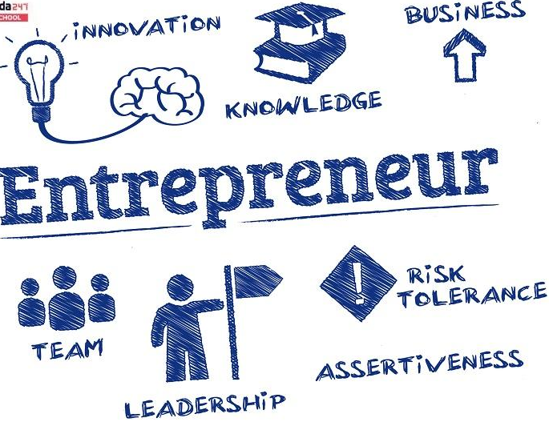
Figure 6: Entrepreneur meaning

Entrepreneur Values and Beliefs for small non-profit organizations
As compared to the value and beliefs of small-profit organizations, small non-profit organizations consist of different values and beliefs regarding entrepreneurial thinking. Some of the major values and beliefs are described below for the non for small profit organization:
Collaborative: It is the main value and belief that entrepreneurs consider for small non-profit organizations. They always believe in collaboration with different organizations so that they can do the welfare of the larger section of society. It is the main belief that they put into their work. Non-profit small organizations and entrepreneurs have different thought processes, and therefore they allow collaborations with different agencies so that community welfare can be done on a large scale.
Diversity: Entrepreneurs believe that people from different backgrounds and cultures should be allowed at the workplace to carry out the work for non-profit organizations. It is one of the main beliefs of the entrepreneur because people from different backgrounds show unity and integrity in society and the community.
Equality: This is the core value of the entrepreneur for the small non-profit organization as they believe in giving equal opportunities to every employee at the workplace. Equality helps the organization to do well in the market, and for the non-profit organization, equality helps in providing welfare to each section of society.
Transparency: It is one of the main values of the entrepreneur because every work carried out in the organization is transparent, and anyone can see the records. Transparency facilitates the non-profit organization to value the code of conduct that has been made for the functioning of the organization (Hervieux and Voltan, 2018).

CONCLUSION
From the above report, it can be evaluated that entrepreneurs are essential person in the business who takes a potential risk to generate more profits for the organization. It has been seen that they consist of various characteristics through which they carry out the business. From the various studies, it also has been evaluated that they keep on introducing new products and services into the marketplace through which they can maintain engagement. In the above report, various characteristics, attributes, and ways of motivating entrepreneurs have been undertaken. At last, there has been the valuation of the entrepreneur values and beliefs for the organizations which carry out their activities for profit and the organizations which carry out their operation for non-profit activities.

REFERENCES
Abdelfattah, F., Al Halbusi, H. and Al-Brwani, R.M., 2022. Influence of self-perceived creativity and social media use in predicting E-entrepreneurial intention. International Journal of Innovation Studies, 6(3), pp.119-127. https://doi.org/10.1016/j.ijis.2022.04.003
Hervieux, C. and Voltan, A., 2018. Framing social problems in social entrepreneurship. Journal of Business Ethics, 151(2), pp.279-293. https://doi.org/10.1007/s10551-016-3252-1
Laguía, A., Moriano, J.A. and Gorgievski, M.J., 2019. A psychosocial study of self-perceived creativity and entrepreneurial intentions in a sample of university students. Thinking Skills and Creativity, 31, pp.44-57. https://doi.org/10.1016/j.tsc.2018.11.004
Presenza, A., Abbate, T., Meleddu, M. and Sheehan, L., 2020. Start-up entrepreneurs' personality traits. An exploratory analysis of the Italian tourism industry. Current Issues in Tourism, 23(17), pp.2146-2164. https://doi.org/10.1080/13683500.2019.1677572
SHIMOLI, S.M., CAI, W., MUHAMMAD HASNAIN, A.N. and LANG, Q., 2020. Entrepreneurship success traits. Do Kenyans possess the desired entrepreneur personality traits for enhanced E-entrepreneurship? Case study of Kenyan students in the people's republic of China. Cogent Business & Management, 7(1). https://doi-org.ezproxy.uwtsd.ac.uk/10.1080/23311975.2020.1847863
Staniewski, M.W. and Awruk, K., 2019. Entrepreneurial success and achievement motivation–A preliminary report on a validation study of the questionnaire of entrepreneurial success. Journal of Business Research, 101, pp.433-440. https://doi.org/10.1016/j.jbusres.2019.01.073

