Introduction
This paper aims to critically reflect on the positive contribution the ‘Business Class’ initiative had on the concept of sustainable leadership. It will detail why ‘Business Class’ is a good example of sustainable leadership, its impact on both internal and external stakeholders and society in general and evaluate what went well, what could be improved and recommendations for repeating the initiative in the future.
To ensure learning from the first roll-out of ‘Business Class’ is captured and reflected on, this paper will use the six stages of Gibbs' Reflective Cycle (Gibbs,1988):
- Description
- Feelings
- Evaluation
- Analysis
- Conclusion
- Action plan

This approach has been taken because it is hoped, ‘Business Class’ can become a repeatable initiative that can be delivered on all major projects and Gibbs originally advocated its use in repeated situations.

Description
In 2017, Griffiths, a Wales-based civil engineering contractor, created a formal partnership with Greenfield Academy School as part of the Business in the Community’s Business Class initiative.
Business Class
Business Class is a strategic partnership between a business and a school. It enables responsible businesses to develop meaningful, sustainable relationships with schools within the communities it works and engage with a future workforce.
The drivers for Griffiths to start a Business Class partnership are multifaceted:
- Griffiths has identified the current construction skills gap (UCL, 2017) as a risk to the business;
- Business Class could provide an opportunity to address the lack of diversity in the construction workforce (Threlfall, 2019);
- Contributions to education (Welsh Government, 2014) and developing a skilled and well-educated population (Department for Natural Resources, 2015) are priority objectives for key clients, such as Welsh Government and local authorities;
- Recruitment of apprentices is a priority for Griffiths to tackle an ageing workforce and presents the opportunity to address the gap between employer requirements and the skills and aspirations of young pupils;
- Business Class offers Griffiths the opportunity to differentiate itself from competitors and become an industry-leading contractor in relation to school engagement and apprentices.
- Increase staff engagement levels through employee volunteering programme and participation and develop employees as mentors as they share their career paths and experience with pupils.
Business Class benefits the school, pupils, teachers and local communities by helping to prevent a child's social background from predicting their success at school and beyond. Pupils benefit through increased engagement with employers. Teachers and parents benefit by learning about career opportunities in industries that they may not have considered. This is particularly relevant in the construction industry, with 35% of teachers saying careers in construction are ‘unattractive’ (Mair, 2014). And, local communities benefit through increased skills and qualifications in the local workforce, resulting in reduced unemployment and more people in good quality work.
The Partnership
Griffiths, represented by their Pre-construction Director, Sustainability Manager and members of the Community Engagement Team, met with Business in the Community (BitC) and Careers Wales to assess schools within the company’s operational area who were looking to form a Business Class Partnership. The aim here was to identify a school with similar values and objectives as Griffiths. Three schools were proposed by Careers Wales and Griffiths assessed each school before making a decision.
Greenfield Academy, a special educational needs and disabilities school in Merthyr Tydfil, was selected due to the synergies with Griffiths and the ability to support and deliver against the drivers for Business Class.
An introductory meeting was hosted by the school and a scoping workshop was held to identify the priorities of the school and Griffiths. From these priorities, an action plan for the following 12 months would be developed and ensure consistent and regular engagement is held throughout the year.
Engagement and Activities
From the beginning of the partnership in 2017, numerous collaborative engagement activities have been delivered over the course of three years.
- Griffiths visits the school every six months and delivers educational classes to 3 – 7 year-olds through the Sally Safe Steps and Bridges to Schools activities.
- Three Construction Industry Days have been held and introduced 16-19-year-old pupils to the various range of careers available in construction – not just the typical site-based roles.
- Griffiths has provided the school with support and materials to develop a school garden which is used to grow vegetables for the school canteen.
- A school ecology group has been established.
- Griffiths delivered Mental Health Awareness training to teachers.
- Safety improvements have been made to the school playground.
- An ongoing Business Project was proposed but unfortunately did not happen. This project would have seen a group of pupils develop a new catering business which would provide hot drinks and healthy snacks to our site-based staff at one of our canteens.

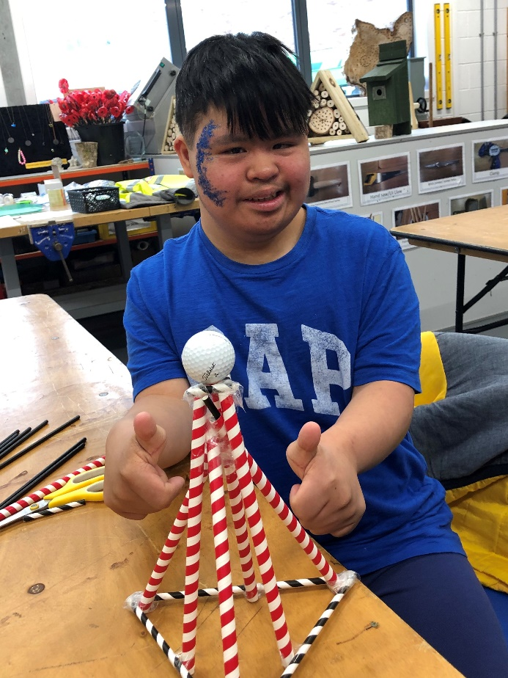
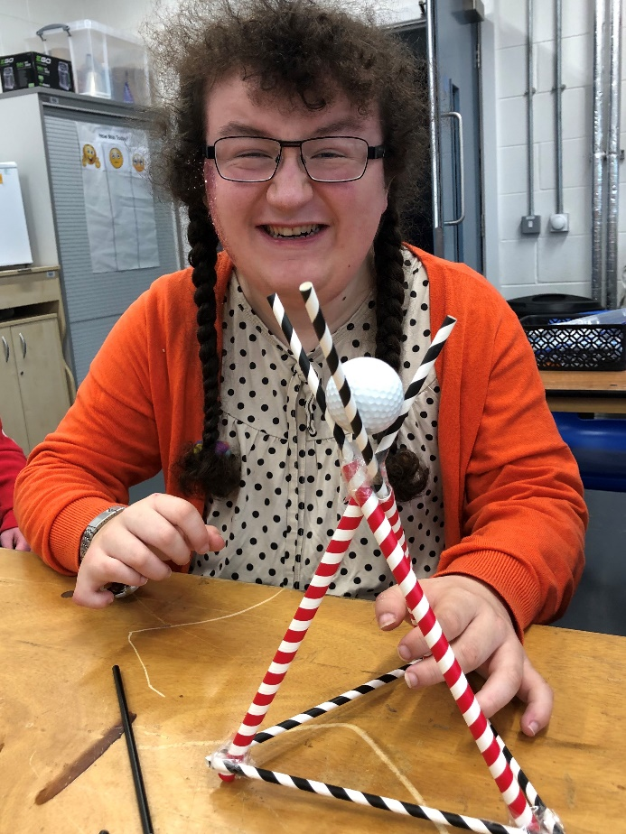
Figure 1: Pupils participating in Science, Technology, Engineering and Maths (STEM) Challenges
Outcomes
The Business Class partnership between Griffiths and Greenfield Academy can be considered a success. If nothing else, the pupils have benefited through increased engagement with a local employer. They know more about the construction industry and the diverse range of careers available to them. Teachers now also have a better understanding of the Griffiths business and that not all jobs are site-based, manually labour roles.
As a business, Griffiths has also benefited. The school has helped to update the Equality, Diversity and Inclusion Policy, a pool of previously untapped talent has been discovered and a longstanding relationship with a school in a targeted business-growth area has been developed. The educational engagement activities which were undertaken in collaboration with Greenfield, BitC and Careers Wales provided significant evidence of past performance in our successful A465: section 5 and 6 Dowlais Top to Hirwaun tender – potentially leading to over £80m of work.
However, due to a lack of sustainability leadership, numerous mutual benefits have either been missed, not realised, captured or measured. These will be discussed in the Evaluation and Analysis sections of this paper.

Feelings
Joining Business Class and finding a partner school was initially seen as an opportunity to develop a relationship with a school in an area where Griffiths was targeting work.
However, following initial discussions with the Pre-construction Director, it became clear there were additional opportunities that would support the delivery of our corporate sustainability strategy and many of our social sustainability objectives and targets.
I was excited about the prospect and felt this was an opportunity to demonstrate how our sustainability strategy could have a direct impact on work winning. I also knew we had a good team with the skills and experience to make Business Class a success. It also became clear from the outset that we had the support of two senior directors – Pre-construction and Major Projects – both working on the linked A465 tender.
I thought the selected partner school, Greenfield Academy, was an excellent choice and would provide a two-way partnership. I thought the school would help Griffiths just as much as Griffiths would help the school.
From our initial meeting, it was clear the school were very proactive and wanted to maximise the benefits of the partnership. However, it was also clear that we had not allowed sufficient time to plan. This sort of initiative was new to both Griffiths and Greenfield and would require the buy-in from school teachers and parents, colleagues from across Griffiths and external support from BitC and Careers Wales.
I was pleased that our initial scoping meeting resulted in a 12-month action plan. Although, the plan was a loose set of outcomes with little time for planning, preparation and delivery.
We held quarterly meetings throughout the three-year partnership and, following each meeting, the relationship between the school and Griffiths grew stronger. The school seemed happy with the support we were providing, but, I did feel we were missing opportunities to think more long-term and really maximise benefits. I also think my thoughts were mirrored by the Griffiths Community Engagement Manager.
We should have had clearly defined targets – such as the number of weeks of work experience provided, and aspirational objectives – such as the number of pupils offered full-time employment.
Despite the numerous quick or short-term successes we had, I cannot help but feel that with adequate planning and aspirational thinking, we may have delivered higher impact outcomes. I was disappointed that the Business Project for pupils to develop their own catering business didn’t go ahead. Looking back, I think earlier engagement with the necessary departments, such as Health & Safety and Human Resource, we could have made the project happen.
Overall, I feel our first Business Class partnership has been a success…..but could have been even more impactful with better planning and wider internal and external engagement.

Evaluation and Analysis
The Griffiths/Greenfield Business Class partnership has been a success. Despite Welsh Government funding of Business Class ceasing in 2020, Griffiths and Greenfield have agreed to continue their relationship indefinitely. This suggests both parties have benefited from the partnership.
What could be improved
It could be said that all school engagement activities provided by Griffiths were delivered by the Sustainability Manager and Community Engagement Team. Very little support was provided from other departments across the business. This was because Business Class has not communicated appropriately, teams and individuals were not involved in the initiative until their input or support was required. If you were to visit the Griffiths construction site nearest to Greenfield Academy School and ask: “who is the company’s partner school?”, I’m not sure you would get the correct answer.
Although Business Class would not have required largescale organisational change (NHS England, 2021), I believe the selection of an appropriate change management model, such as McKinsey 7-S Change Management Model, Kotter’s Change Management Model, Kübler-Ross Five Stage Change Management Model (Sharma, 2019) or maybe a hybrid model which would draw on the strengths of all tried and tested models. As identified by Prosci, even small changes or adjustments to how the business operates requires a successful change management strategy to be implemented.
The table below evaluates and analyses the actions taken during our preparation for Business Class against the three steps (Prosci, 2021) that should have been taken in developing a change management strategy:
Prosci Steps | What happened | What should have happened
- Identify Change Characteristics | Little to no thought was given to the scope of change, who and how many people would be impacted or timescales.  Failing to engage others resulted in a reluctance to support the bigger initiatives and activities. This could be why more short-term/low impact outcomes were delivered than long-term, high impact ones. | By taking time to understand the scale of change and those impacted, we could have developed a stronger team from the outset. This would have drawn on the experience and expertise of other departments and may have resulted in the pupil’s Business Project going ahead unhindered.
- Assess the Organization | Griffiths have a supportive culture of school engagement activities. The company has received external recognition for inspiring future generations and people development. However, this supportive culture was not harnessed at the develomnet stage and, therefore, did not materialise during delivery.  If communicated properly – will support tendering for a major local project, will support future recruitment, will help build diversity, etc, employees would have engaged and supported. Without this communication, employees saw Business Class as something the Community Engagement Team delivers and their input was not required. | Identifying groups/departments within the business who would be impacted by Business Class would have been advantageous and resulted in more support.  By identifying these groups during the planning stage would have allowed us to develop specific and customised plans later in the change management process and resulted in other groups feeling a part of the initiative rather than just called upon when we needed support.
- Create a Change Management Strategy | Although we had good support from two Directors, no project sponsor was named or communicated. Looking back, this was a missed opportunity. We should also have identified a project team (the community engagement team) and a change management team (responsible for making the necessary organisational changes and supporting the project team).  We didn’t develop a team structure and responsibility for Business Class remained with just two team members throughout. | Appointing the Major Projects Director as Business Class sponsor would have clearly demonstrated why we were delivering the initiative – i.e. to win a major new contract.  The change management team could have helped with communicating the message internally and increasing the level of inter-departmental support. This would have left more time for the project team to develop and plan on longer-term, higher impact outcomes – rather than just delivering quick/easy wins.

No matter what the scale of change, 70% of organisational transformations fail (McKinsey, 2019). This could be down to reasons such as a weak culture which is not aligned with the mission, a lack of employee participation and buy-in, under-communicating a powerful vision, over-communicating a poor vision, not enough training or resources, etc (Gleeson, 2017). All of which apply to our Business Class initiative:
- Griffiths has a strong culture of supporting school engagement. However, school engagement is not aligned with the company mission, vision or values. This could have been overcome by communicating a Business Class-specific mission – to develop and attract the brightest and best young people, to build diversity into the workforce and create an inclusive working environment. Alternatively, the skills gap risk needs to be communicated with Business Class framed as one of our responses.
- We had a lack of employee participation because the workforce was not engaged until their support was required. This resulted in employees seeing volunteering at the school as additional work. This was a missed opportunity to increase staff engagement levels as it has been found workers supported by their employers to volunteer in schools and colleges were more motivated, more productive and had a greater sense of wellbeing (Percy & Rogers, 2021).
- We did not under-communicate a powerful vision or over-communicate a poor vision……we simply did not have a vision. A clear and concise vision “To support young people, irrespective of circumstance or personal background, into employment” could have had a big impact and helped communicate the need for Business Class.
- No training or resources were allocated to Business Class. I see this as one of the biggest missed opportunities. As a company committed to apprentices and training, Business Class could have been used to develop a team of Construction/STEM Ambassadors from our existing apprentices and trainees. These young people would then be tasked with visiting schools and helping to inspire younger generations through the sharing of their journey’s and career paths something already being adopted by many competitors (Wilmott Dixon, 2017).
What went well
Despite a clear lack of planning, the Sustainability Manager and Community Engagement Team can be proud of their achievements. As mentioned above, the fact the school is keen to continue the relationship rather than choose a new business is a clear indication of success.
Due to her past experience as a Careers Advisor, Community Engagement Coordinator Gail Jones did a fantastic job engaging with the school and collating and acting upon any requests received. Gail should continue to lead Business Class initiatives and begin to share her work with the wider business, particularly as more major projects are required to establish formal partnerships with local schools.
The involvement of the Sustainability Manager ensured shared value was achieved. For example, some materials from local projects were heading for landfill, but liaison with the school resulted in asphalt plannings being re-used as sub-base for a playground extension, topsoil being re-used for the school allotment and old water-filled barriers being used for safety measures at school events. These donations resulted in cost savings to Griffiths, saved the school buying in materials/equipment and resulted in waste being diverted from landfill.
The school were also extremely receptive to the offer of mental health awareness training for teachers. Griffiths provided our Mental Health First Aiders to deliver 45-minute sessions and this could be incorporated into all future school engagement activities.
By engaging with regional Business Class Collaborative Networks (Camarinha-Matos & Boucher, 2010), Griffiths has also benefited by accessing cross-sector best practice. Griffiths’ Sustainability Manager and Community Engagement Coordinator attend the quarterly Heads of the Valleys Business Class Cluster Network meetings and collaborate with other business involved in Business Class, such as Tesco, Welsh Water, EE and United Utilities. This collaborative network was instrumental in organising a multi-disciplinary careers event at one of the local high schools and resulted in two local students joining Griffiths for work experience.

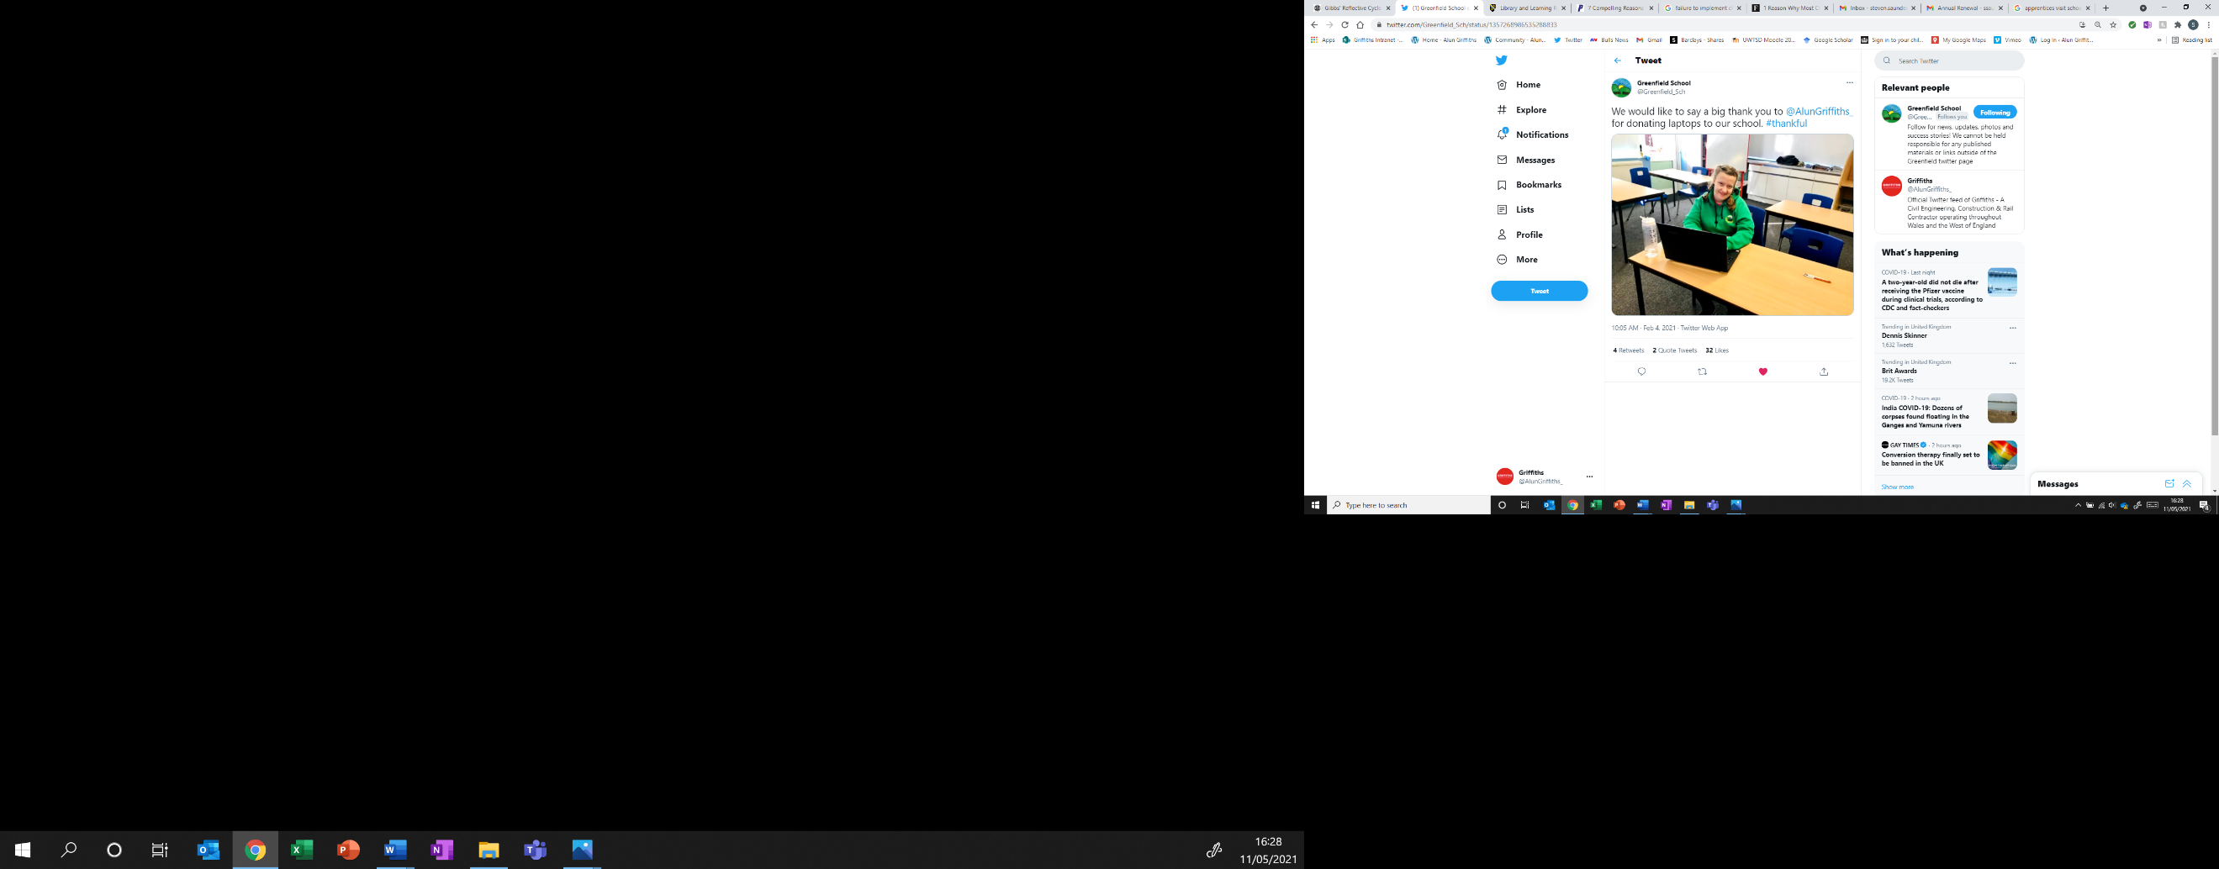
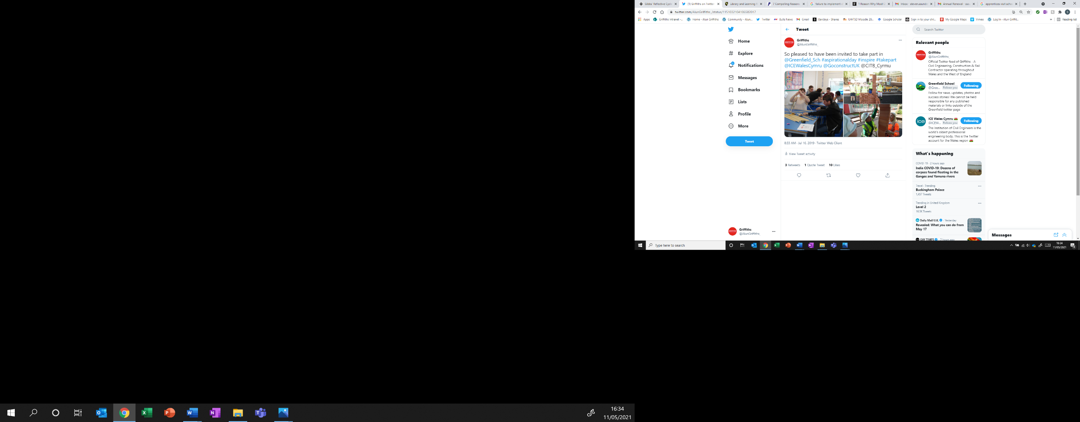
Social media, an integral part of any sustainability strategy or sustainability change initiative (De Leo et al, 2016), was also embraced by both Griffiths and Greenfield Academy. Despite, no prior planning or forewarning, the Griffiths Business Class Team engaged well with the Communications Department to promote and communicate educational engagement activities delivered at the school. This resulted in high levels of engagement with both employees and external stakeholders, such as clients, members of the public, Careers Wales, Construction Industry Training Board, other schools, the Institution of Civil Engineers and Civil Engineering Contractors Association. Any future Business Class initiatives should include a Social Media Communications Plan as part of the planning process.
Figure 2: Collaborative use of social media resulted in high levels of stakeholder engagement

Finally, and possibly most rewarding and beneficial, was the feedback sessions with pupils, parents and teachers. Feedback sessions were arranged after most engagement activities so that we could learn what had gone well, what the pupils had enjoyed and what would they like to do more. It was highly rewarding to hear from the parents of some of the special educational needs pupils who had benefited from our engagement activities. Parents reported that their children had returned home with boosted confidence and new ideas on career paths they had previously not considered or thought would not be achievable to them. This was highly rewarding and, in future, feedback sessions should include more members of the project/delivery team.
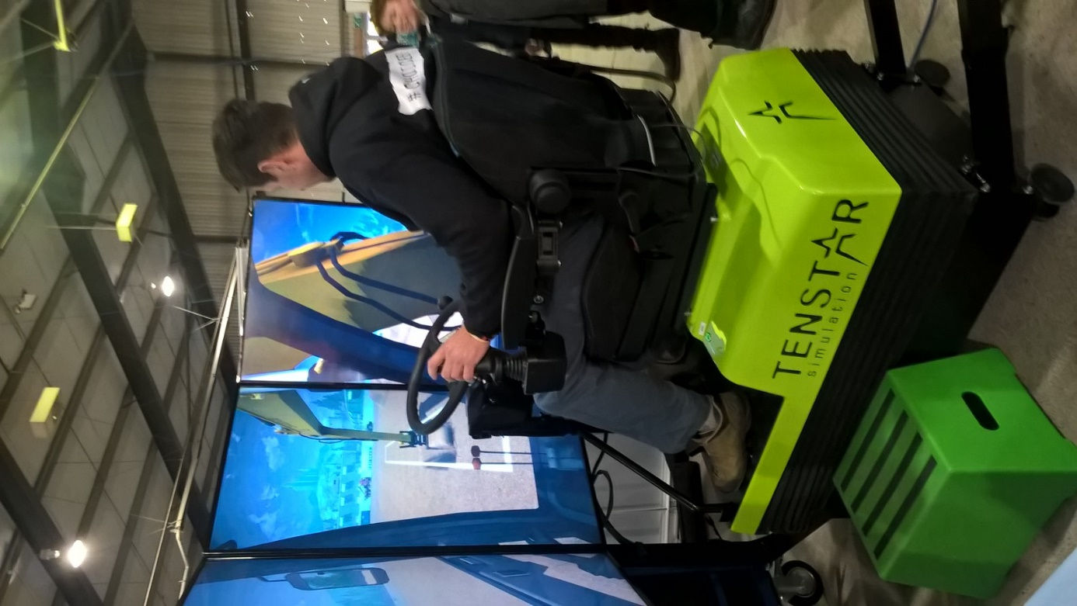
Figure 3: Our excavator simulator inspired many of the pupils to want to become Plant Operators.

Conclusion
In conclusion, Griffiths’ first Business Class partnership can be considered a success. Both Griffiths and Greenfield Academy have benefited over the course of the three-year initiative and it has been agreed that the partnership will be extended.
Griffiths utilised many of the school engagement activities as evidence in the A465 tender submission and have now been awarded this multi-million pound contract – which was one of the main drivers for starting Business Class.
However, opportunities to embed wider, long-term and mutually beneficial sustainability outcomes were missed due to a lack of change management planning and engagement with the workforce.
Implementing a change management strategy
Despite Business Class requiring minimal organisational change, I feel a bottom-up change management strategy, such as ADKAR (Caredda, 2020), would focus efforts on the individuals needed to make the initiative a success. The model would upskill employees by ensuring they achieve the five goals of Awareness, Desire, Knowledge, Ability, and Reinforcement.
For instance, at the Awareness stage, we could have communicated why we were developing a partnership with a local school. This would have enabled the team to communicate the wider sustainability benefits – rather than just work-winning. Increasing our skilled and qualified workforce, reducing the average age of employees, succession planning, increasing equality, diversity and inclusion, increasing volunteering opportunities and improving staff engagement are just a few examples of how Business Class could have been framed as a benefit to our employees.
The Desire stage would be used to recruit additional resource for the project team, with highly engaged employees recruited and trained as Business Class Ambassadors. Additionally, during the Knowledge stage, existing apprentices would undertake training to become Construction/STEM Ambassadors and begin to visit partner schools.
The Ability and Reinforcement stages should be used to upskill employees across the business and extend Business Class across all major projects – this would mean each project worth £25m+ would form a partnership with a local school.
A hybrid model
However, as discussed in our Week 5, Activity 2 Forum having reviewed the Choosing Strategies for Change article by Kotter and Schlesinger, it was pointed out that most change management models focus entirely on internal stakeholders (Gladstone, 2021). Therefore, a hybrid change management strategy should be developed to include engagement with external stakeholders. This should include school teachers, parents and governors – maybe even pupil representation via a pupil-led network? The Construction Industry Training Board, Careers Wales and Heads of the Valleys Business Class Cluster (schools and businesses) should be engaged. This would result in more collaborative activities, sharing of best practise and increased societal impact.

Action Plan
Moving forward, the Business Class partnership with Greenfield Academy will continue for, at least the next three years. In preparation, a hybrid change management model (which was missed last time) should be developed and implemented.
The chosen change management model should be simplistic and easily replicated on other major projects as they begin to establish partnerships with local schools in their communities. A bottom-up, people-focused model, such as ADKAR, could be combined with a simplified version of Kotter’s Theory, which does a great job of building enthusiasm and understanding for the change initiative. Additional stages should be added to include both employee feedback and external stakeholder engagement which are neglected in the unadapted models (Sharma, 2019).
A clear Business Class Change Management Plan should developed with ‘gates’ that cannot be passed until the previous stage is completed. This will prevent the Sustainability Manager and Community Engagement Team progressing alone with out the required support of the wider business. It will also ensure all wider benefits and aspirational targets – such as pupils recruited at the end of the programme – are included and data captured.

3,613 Words

References
Caredda, S. 2020. Models: the ADKAR Change Management Model. Accessed online 12/05/2021:https://sergiocaredda.eu/organisation/tools/models-the-adkar-change-management-mode/
Camarinha-Matos, L & Boucher, X. 2010. The Role of Collaborative Networks in Sustainability. Accessed online 14/05/2021: https://www.researchgate.net/publication/261215764_The_Role_of_Collaborative_Networks_in_Sustainability
De Leo, F. Gravili, G. Miglietta, P. 2016. Social Media and Environmental Sustainability: An Overview of European Countries. Accessed online 14/05/2021: https://moodle.uwtsd.ac.uk/pluginfile.php/328193/mod_resource/content/1/IJBM58098-212032-1-PB.pdf
Department for Natural Resources, 2015. Well-being of Future Generations (Wales) Act 2015 – The Essentials. Accessed online 11/05/2021: https://gov.wales/sites/default/files/publications/2019-08/well-being-of-future-generations-wales-act-2015-the-essentials.pdf
Gibbs, G. 1988. Learning by Doing: A guide to teaching and learning methods. Further Education Unit. Oxford Polytechnic: Oxford. Accessed online 14/05/2021: https://www.ed.ac.uk/reflection/reflectors-toolkit/reflecting-on-experience/gibbs-reflective-cycle
Gladstone, E. 2021: Leading Sustainability Change (BMSP7004D), Week 5, Activity 1 Discussion Forum. Accessed online 13/05/2021: https://moodle.uwtsd.ac.uk/mod/forum/discuss.php?d=64825
Gleeson, B. 2017. Forbes: 1 Reason Why Most Change Management Efforts Fail. Accessed online 14/05/2021: https://www.forbes.com/sites/brentgleeson/2017/07/25/1-reason-why-most-change-management-efforts-fail/?sh=3c405166546b
Mair, L. 2014. Construction News: 35% of teachers say careers in construction are ‘unattractive’. Accessed online 11/05/2021: https://www.constructionnews.co.uk/news/knowledge-news/35-of-teachers-say-careers-in-construction-are-unattractive-24-02-2014/
McKinsey & Company, 2019. Why do most transformations fail? A conversation with Harry Robinson. Accessed online 13/05/2021: https://www.mckinsey.com/business-functions/transformation/our-insights/why-do-most-transformations-fail-a-conversation-with-harry-robinson#
NHS Engalnd, 2021. Sustainable Improvement Team and the Horizons Team: Leading Large Scale Change: A guide to leading large scale change through complex health and social care environments - A practical guide. Accessed online 11/05/2021: https://www.england.nhs.uk/wp-content/uploads/2017/09/practical-guide-large-scale-change-april-2018-smll.pdf
Percy, C & Rogers, M. 2021. Educationa nd Employers: The Value of Volunteering: Volunteering in Education and Productivity at Work. Accessed online 14/05/2021: https://www.educationandemployers.org/wp-content/uploads/2020/12/The-Value-of-Volunteering-final-8th-Jan-2021-1.pdf
Prosci. 2021. Prosci: Why You Need A Change Management Strategy. Accessed online 13/05/2021: https://www.prosci.com/resources/articles/change-management-strategy
Sharma, K. 2019. Whatfix: 10 Proven Change Management Models. Accessed online 13/05/2021: https://whatfix.com/blog/10-change-management-models/
Threlfall, R. 2019. Building: Construction must admit it has a problem with diversity. Accessed online 11/05/2021: https://www.building.co.uk/comment/construction-must-admit-it-has-a-problem-with-diversity/5098743.article
UCL, 2017. The Bartlett School of Sustainable Construction: Skills Shortage in Construction - building the future post-Brexit. Accessed online 11/05/2021: https://www.ucl.ac.uk/bartlett/construction/news/2017/may/skills-shortage-construction-building-future-post-brexit-5-october-2017
Welsh Government, 2014. Community Benefits: Delivering Maximum Value for the Welsh Pound. Accessed online 11/05/2021: https://gov.wales/sites/default/files/publications/2019-09/community-benefits-delivering-maximum-value-for-the-welsh-pound-2014.pdf
Wilmott Dixon. 2017. ConnectWM: Apprentices inspire school pupils in Wolverhampton. Accessed online 14/05/2021: http://connectwm.com/article/apprentices-inspire-school-pupils-in-wolverhampton.html

