Output: Presentation to line-managers that will enhance their knowledge and understanding of managing and improving performance, covering the following points:

- High Performance Working

1.1 What is High Performance Working?

High Performance Working (HPW) can be described as a collection of human resource policies and practices that, when complementary, support an organisation to achieve improved performance. These policies and practices are often referred to as a ‘bundle’ (Taylor, 2016, p199).

The purpose of HPW is to promote a culture of trust, honesty and openness; one in which employees feel engaged, inspired and valued, leading to improved performance (Caruso, 2020).

There has been much debate around what the component parts of an ideal ‘bundle’ should be. Through their research, Marchington et al (2016, pp56 - 70) summarise the key elements as:

- Job security and development opportunities in recognition of employee’s contribution commitment;
- Robust recruitment and selection processes – using best practice techniques that are appropriate for determining who is the right person for the role;
- Investment in professional and personal training and development activities to stay ahead in a competitive market;
- Effective communication and employee engagement to build trust and support decision-making;
- Teamworking to encourage innovative thinking and empowering staff to make decisions;
- A fair and equal pay system that rewards performance and exceeds that offered by competitors;
- A performance management system that aligns individual performance to organisational performance and that supports development opportunities;
- Standardised terms and conditions that promotes the fair treatment of all, regardless of position or status, and;
- The offer of a better work-life balance for all employees.

Taylor (2016, p199) also suggests through his research that other factors include internal promotion, a just grievance process, one without fear of reprisal, and flexible working opportunities.

1.2 The link between HPW and organisational performance

Much research as been undertaken to demonstrate a link between HPW and organisational performance. In his research undertaken in the 1990’s, Pfeffer (1998) concluded that an organisation’s performance was linked to the existence of a suite of complementary policies aligned to the ‘bundle’.

Huselid’s (1995) large-scale research involving almost 1,000 organisations, undertaken around the same time, concluded that good HPW practices positively impacted on turnover, market value and profits. This high profile research was the first to demonstrate the added-value of human resources in terms of financial gain.

Purcell et al (2003) went further in their ‘black box studies’, working with 12 organisations across different sectors, already using or developing advanced HR practices, to understand why HPW impacts positively on performance. The results of this research were:

- HPW ‘bundles’ have a positive impact in what Purcell et al describe as ‘discretionary effort’; that is, motivated and committed employees are likely to go above and beyond the requirements of their role;
- High performing organisations have a clear mission, described by Purcell et al, as a ‘Big Idea’, and values that are embedded through the organisation’s policies and practices, and;
- Line managers and leaders have a critical role in ‘bringing to life’ HR policies and practices and ensuring that they are implemented fairly and consistently across the organisation.

Purcell et al suggest that as well as the ‘bundle’, ‘AMO’ (Taylor, 2016, p202) conditions must be met to ensure high levels of performance; that is, employees must have the ability, motivation and opportunity to perform well.

Harter et al’s research (2002), conducted over a 30 year period involving nearly 8,000 organisations, sought to explain the link between HPW and organisational performance. Their conclusions aligned closely with Purcell et al’s work; that is, that sophisticated HR policies and practices led to increased levels of motivation amongst staff and higher performance. Harter et al refer to this extra effort as ‘employee engagement’.

Not all commentators are convinced of the link between HPW and high performance. Fleetwood and Hesketh (2010) argue that existing research focuses too heavily on HR practices and fails to consider how employees contribute to positive business outcomes and sustained organisational performance.

1.3 The link between HPW and employee well-being

The value of HPW in terms of organisational performance has been much debated. Beer (2015, p419) suggest that this research fails to consider the impact of HPW on employee well-being.

The CIPD (2021) advocate health and well-being as being critical to engagement and performance and identify a number of domains of well-being that should be reflected in HPW practices. Furthermore, they suggest that fostering a strategy of well-being can help to ‘prevent stress and create positive working environments where individuals and organisations can thrive’. In their research, Boxall and Macky (2014, pp977-978) also conclude that HPW can benefit employees’ well-being, as long as they feel empowered and exposure to stress is manageable.

Haddon (2018) considered how employee physical and mental well-being, impacted on performance. She found that an individual’s mental health could be a significant factor in determining performance both for the individual but also the wider team and that the well-being of staff should be at the centre of an organisation’s culture.

Organisations can reap many benefits from high levels of employee well-being, such as job satisfaction, improved morale, lower absence rates and better productivity (Perkbox, 2021)

- Performance Management
2.1 The main stages of the performance management cycle and key performance management activities

Whilst the performance management approach adopted by an organisation will depend on organisational structure and culture, the key activities that make up a continuous performance management cycle should be embedded into an overarching framework that aims to:
- Set individual and team objectives that align to the organisation’s mission and strategy and that are understood by the workforce;
- Improve individual, team and organisational performance; and
- Hold people to account for their performance.
(CIPD, 2020)

Hutchinson (2013, p17) describes performance management as a variety of management activities that are designed to improve performance and ‘to make performance more manageable’. Hutchinson (p72) defines these as being both informal and formal activities that are delivered through organisational policy and processes including induction, performance appraisal, training and development, career development, competency frameworks and reward.

Armstrong (2006, p17) defines continuous performance management in terms of a process of ‘plan, act, monitor and review’.
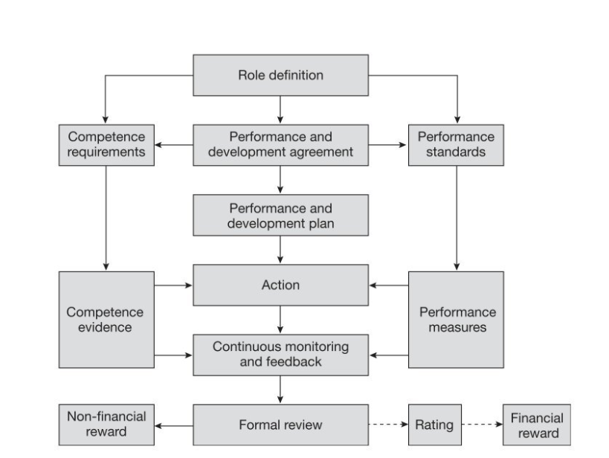

Armstrong, M (2006, p17)

Armstrong identifies the key steps in the cycle as:
- Role definition – agreeing the individuals key result areas and competency levels.
- Performance agreement – defines expectations set out in agreed objectives and how these will be measured.
- Performance improvement – sets out required improvements and timelines. This may include training and development needs.
- Performance development – the steps required to develop and improve competencies, including the undertaking of any learning and development requirements.
- Managing performance – continuous cycle of feedback, informal progress reviews, updated objectives and addressing performance issues as they arise.
- Performance review – formal evaluation, which may lead to financial or non-financial reward, and which sets the foundation for the next performance management period.

In terms of the performance agreement steps above, the CIPD (2020) suggest that ‘SMART’ (Specific, Measurable, Achievable (but challenging), Relevant, and Time-bound) objectives can be successful in some contexts but not all, such as when working in more complex environments where behavioural or learning objectives may be more effective.

This traditional approach to performance management can generate anomalies for individuals in terms of both forming part of the formal processes for evaluation and personal development (Taylor, 2016, p206). Whilst performance management activities can support development opportunities, individuals many not be completely open about their development needs if they feel that the performance management process will inform decisions regarding pay, promotion or the potential of redundancy.

More recently, authors such as Adams advocate a more informal and much more regular approach to performance management, one that moves away from the annual appraisal process and focuses on an individual and customised approach. (Adams, 2017, pp113-114). Some of the key aspects of this approach are to set team objectives rather than individual objectives, to regularly review and update objectives, to give staff ownership of their performance and rather than having annual reviews, hold regular and continuous performance conversations with staff.

2.2 How performance management can contribute to employee capability and commitment and recognising and rewarding talent

As previously described, performance management is a process defined by management activities. However, individuals will have different thoughts, feelings and values which will impact on their reaction and behaviour to performance processes. Factors such as motivation, commitment and engagement need to be considered in order to enhance performance (Rees and Tymon, 2016, p268). Rees and Tymon suggest that pay is not always a positive factor in terms of performance and that performance-related pay may not be right for all organisations. They suggest that other interventions may impact on individual and ultimately organisational performance, including learning and development, coaching and mentoring, team-building, reward schemes (not necessarily financial), culture and management style.

Armstrong (2018, p179) suggests that performance management is more than just about financial rewards and that in fact there are several other elements that can make up a performance management ‘total reward system’. Armstrong sees the importance of non-financial rewards including recognition, development opportunities and career planning in gaining engagement and commitment from employees.

In a 2017 survey (PM Insight), organisations were asked how they measured performance and how it impacted on the way they managed people. Just under three-quarters of respondents felt that they had a detailed understanding of what drives their workforce. Whilst salary was deemed a motivator, it was no more significant than other factors, with ‘feeling valued’ coming out top.

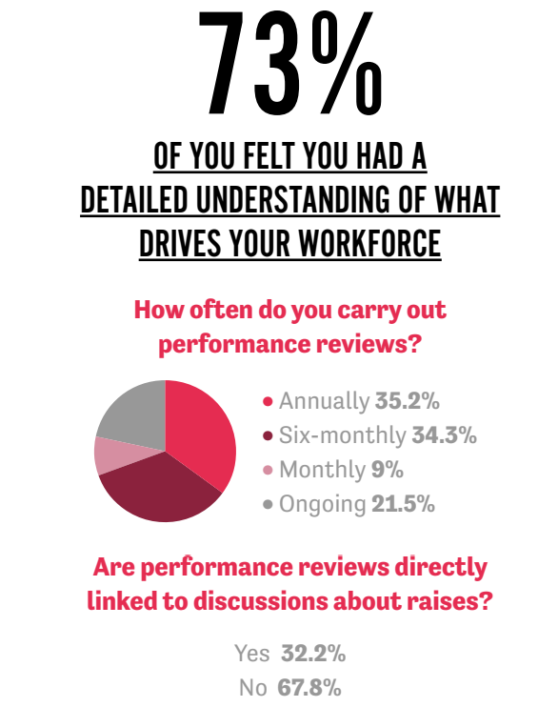


PM Insight (2017) Infographic: How effective is your performance management system?

In a 10-year study, Bloom et al (cited in Taylor, 2016, p205) found that organisations were more successful when incentives including praise, recognition, pay and development opportunities were offered to employees.

Furthermore, a study by HR Magazine (2014) found that financial reward had little impact on performance, with only 13% of staff citing money as a motivating factor and 60% of staff claiming that job satisfaction was the biggest motivator. This study highlights the importance of feedback from managers in determining the added-value from employees.

In their review of research on goal setting and performance appraisals, the CIPD (2016, p3) concluded that goal setting is fundamental to improved performance in terms of supporting the process for monitoring progress and providing feedback. They argue the importance of perceived fairness in determining how employees react to performance appraisals and the impact of this in terms of their usefulness.

Lang (2018) argues that employees are more likely to be motivated when the appraisal process incorporates constructive feedback and praise and the support to agree and deliver on objectives that are challenging but achievable.

3.1 The role of line managers in performance management processes
The day to day performance management of employees is generally the responsibility of the line manager (Taylor, 2016, p211). Marchington (2008, p277) agrees and suggests that this is the most appropriate approach in cases where performance determines reward and where the process aims to control behaviours and outcomes.

Hutchinson (2013, p123) suggests that the role of line managers has changed significantly over recent years with key areas of responsibility relating to performance management as
Including:
- setting individual and team objectives;
- measuring performance;
- providing feedback;
- recognising and acting on training and development needs;
- coaching and mentoring;
- determining reward, and;
- managing under-performance.

Hutchinson also refers to the important role that line managers play in terms of displaying leadership behaviours that ‘motivate employees and encourage them to put in extra effort to ‘go the extra mile’ for the organisation’.

The line manager also has a key role in communicating the organisation’s mission and strategy and ensuring that these are embedded into individual and team objectives (CIPD, 2020).

Given their responsibility for performance management, it is essential that line managers have both the right attitude and see the process as one that is valuable (Juneja, n.d.). Harris (cited by Murphy, 2018) agrees, saying that problems will occur where line managers do not believe in the value or aims of the performance management process. Juneja suggests that to ensure success line managers must be made aware of the importance of performance management in delivering positive outcomes for the organisation and that they should be engaged in the design of performance management processes.

3.2 How HR and line managers can work together in performance management processes

Performance management does not solely sit with line managers; it also requires a joint responsibility and commitment across the whole organisation to embrace a continuous improvement approach (CIPD, 2020).

HR’s role in performance management is one of a central co-ordination function encompassing the whole process (Mayhew, 2019).

To support the delivery of the organisation’s objectives, HR has a critical role to ensure that HR policies and practices, including those for performance management, align with the business and HR strategy (Taylor and Woodhams, 2016, pp141-172). Furthermore, the performance management process must complement and enhance other HR practices including reward, talent management and training and development (HRM Handbook, 2021).

HR has a role in the efficient administration of the performance management process, particularly in terms of providing the expertise to support training and advice to line managers (SHRM, n.d.). HR needs to ensure that, through its policies and practices, employees and managers understand the performance management process, including the setting of both quantitative and qualitative goals (Smythe, 2020).

HR specialists have a role in supporting line managers to deliver effective performance management through the development and provision of standardised documentation and appraisal training (Taylor, 2016, p211).

Standardised documentation
Research on best practice undertaken by commentators including Beaumont and Fletcher (cited in Taylor, 2016, p211) suggests that the provision of standardised documentation offers a consistent framework for both employees and managers in the self-appraisal part of the process. Standardised forms will often include feedback sections for both appraisee and appraiser to complete, along with sections for the recording of objectives, training and development needs and scoring.

Training
Taylor (2016, p212) suggests that those delivering performance appraisals should be appropriately trained to do so. The impact of a poor appraisal experience can be significant in terms of motivation, job satisfaction and trust. Taylor advocates skills training which includes the:
- importance of being consistent and objective;
- avoidance of personal views about an individual that bears no consequence on their performance at work;
- value of preparation;
- need to provide examples to justify negative feedback and providing feedback in a constructive manner;
- fostering a relaxed and open environment;
- significance of providing positive feedback, and;
- concluding the appraisal in a positive manner.

