
MODULE CODE: Digital Skills for Personal Development and Business Growth BMSW4008

ASSESSMENT COMPONENT: PORTFOLIO

STUDENT NAME: Tanisha Thomas

STUDENT NUMBER: 2515604

LECTURER: Philippa Fitzgerald

DATE: 27 November 2025

Contents
Task 1 2
Assessment of Digital Skills 2
Introduction 3
Summary of Jisc Discovery Capability Results 3
Strengths and Areas for Improvement 4
SMART Goals for Digital Skill Development 5
References 6
Task 2 7
LinkedIn Learning Certificates for Office365 7
Task 3 11
The Importance and Relevance of Excel in professional and personal life. 11
Introduction 11
The use of Excel in Personal Organisation and Finances 11
The use of Excel as a Professional 12
Conclusion 13
References 13
Task 4 15
7 Minute Reflective Presentation 15

AI Acknowledgement

I confirm that I have not presented any AI generated materials as my own work.
I confirm that I have copies of my drafts, notes, and other resources I used, which I may be asked to provide in evidence.

Task 1

Assessment of Digital Skills

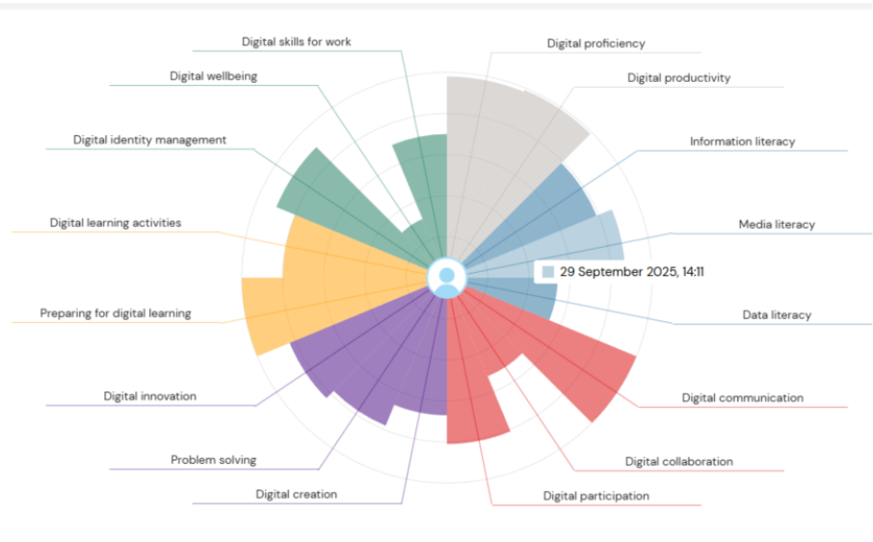Jisc (2025)

Introduction

Digital skills are important because technology is constantly changing. To keep up with technology both inside and outside the classroom, we should continually develop new digital skills. Good use of these skills allows us to thrive in our new tech focused world and opens the door to better jobs and opportunities. “Digital literacy is relevant to higher education, further education, schools, children and the workplace. At its heart it is a citizenship & inclusion issue, necessary for the full participation and achievement of potential of all in society” (Reedy and Parker, 2018, p.xxiii).

Summary of Jisc Discovery Capability Results

The Jisc Digital Capability assessment shows 16 key digital skills and rates your confidence levels as “Developing”, “Capable” or “Proficient” (Jisc, 2025). The table below shows my confidence level for each skill.

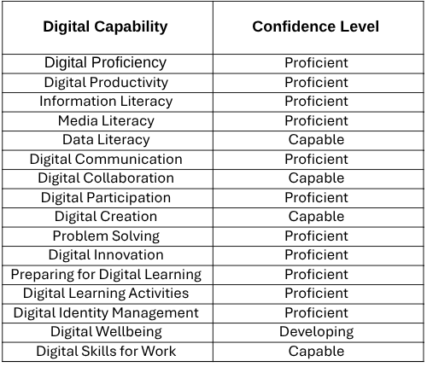

The results of the table show that I am confident in most skills. For example, Digital Communication and Digital innovation, were all rated as proficient. I also have a good understanding of skills such as Digital Proficiency and Digital Skills for Work. These were rated as capable, showing I can perform effectively but could improve my skills further. Areas for improvement included Digital Wellbeing, which was rated as developing. Focusing on improving these digital skills will help me become a better learner because “essential digital skills are a step towards learning lots of other new things” (OpenLearn, 2022).

Strengths and Areas for Improvement

One of my main strengths is digital communication, which was rated as proficient. This shows I can use digital tools to communicate clearly. For instance, I use the class WhatsApp group to ask and answer questions, which helps me stay engaged and support others on the course.

Another key strength of mine is problem solving. “Digital problem-solving is the disciplined process of framing a challenge, gathering relevant data, and applying digital tools, methods, and thinking to reach a solution” (Jacobs and Castek, 2018). This shows I can use different digital tools to find the right solutions when I face challenges. For example, if I am unsure about how to complete a task on Moodle or fix a technical issue, I will look for guides, watch short tutorials or explore help pages until I figure it out. This allows me to work independently and feel confident when using new apps and when facing unexpected digital challenges.

My main weakness is digital wellbeing, which was rated as developing. This was my lowest score in the assessment. I struggle to manage my screen time and keep a healthy balance between being online and switching off. For instance, I often stay on my phone for longer than planned, especially when using social media. I also find it difficult to take regular breaks when working on assignments. Improving my digital wellbeing will help me manage my time better and stay focused when working online. It will also improve my mental health and give me more time for other activities, like going to the gym or meeting up with friends.

Another area I find challenging is digital creation, this was rated as capable. Although I feel confident designing documents and presentations, I find it difficult to record, edit and combine audio/video clips without following step by step instructions. Improving these skills will help me feel more confident when using creative digital tools.

SMART Goals for Digital Skill Development

Improve Digital Wellbeing

Specific: I want to reduce my screen time and build a consistent routine for taking regular study breaks.
Measurable: I will reduce my daily screen time by one hour and use the Pomodoro Technique by studying for 25 minutes followed by a five-minute break.
Achievable: I will use tools such as, the screen time feature on my phone and the Pomodoro timer on my computer to support this routine.
Relevant: Improving my digital wellbeing will help me succeed at university by helping me stay focused, keep a healthier study routine and prevent burnout.
Time-bound: I will follow this routine for four weeks to see if my concentration and time management has improved. I will review my progress each week to keep myself on track.

Strengthen Digital Creation Skills

Specific: I want to improve my confidence in recording and editing audio and video material.
Measurable: I will complete two practice tasks, such as recording a one-minute video and editing it by adding transitions, text, and audio.
Achievable: I will use tools like, Canva, Adobe Creative Cloud and iMovie. I will follow one LinkedIn Learning tutorial per week.
Relevant: These skills will help me create stronger digital assignments and prepare me for any future editing and recording tasks.
Time-bound: I aim to complete the two practice tasks within three weeks. I will reflect on my progress after each task.

References

Reedy, K. & Parker, J. (eds.) (2018) Digital Literacy Unpacked. Facet Publishing.

Jisc (2025) Digital Capability Personal Results. Available at: https://uwtsd.potential.ly/pub/jisc/digital-capability/pages/students (Accessed: 29 September 2025).

OpenLearn (2022) Hybrid working: skills for digital transformation. Available at: https://www.open.edu/openlearn/digital-computing/hybrid-working-skills-digital-transformation/content-section-1 (Accessed: 28 November 2025)

Jacobs, G. and Castek, J. (2018) ‘Digital problem solving: The literacies of navigating life in the digital age’, Journal of Adolescent and Adult Literacy, 61(6), pp. 681–685.

Digital Buzz at UoE (2024) What do we mean by ‘digital communication’?. Available at: https://sites.exeter.ac.uk/digitalbuzzuoe/what-do-we-mean-by-digital-communication/ (Accessed: 28 November 2025)

Task 2

LinkedIn Learning Certificates for Office365

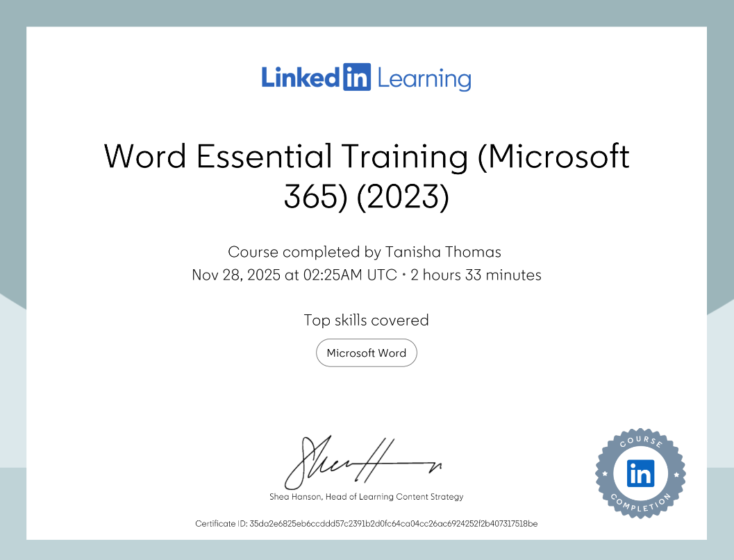

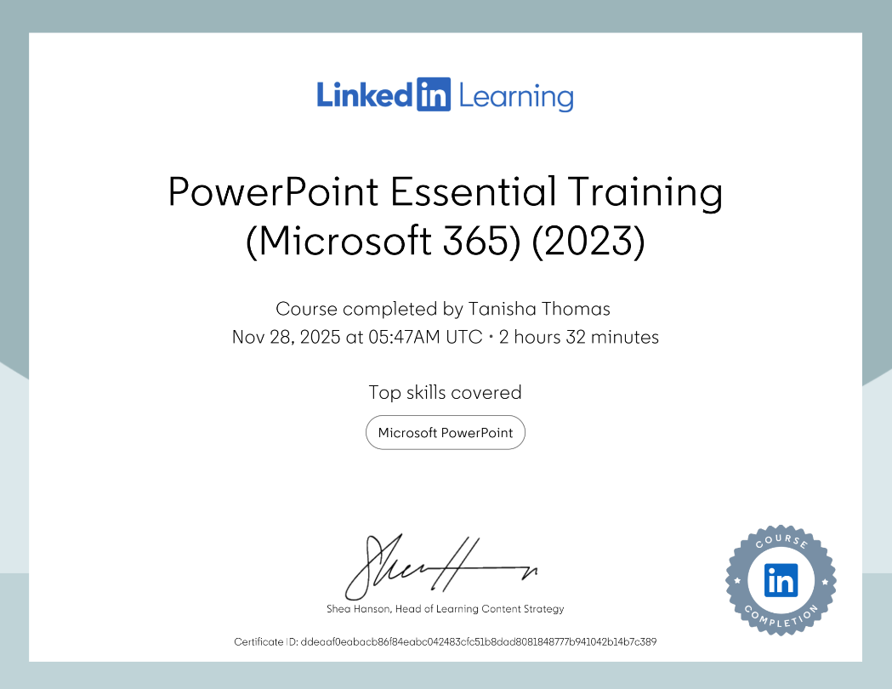

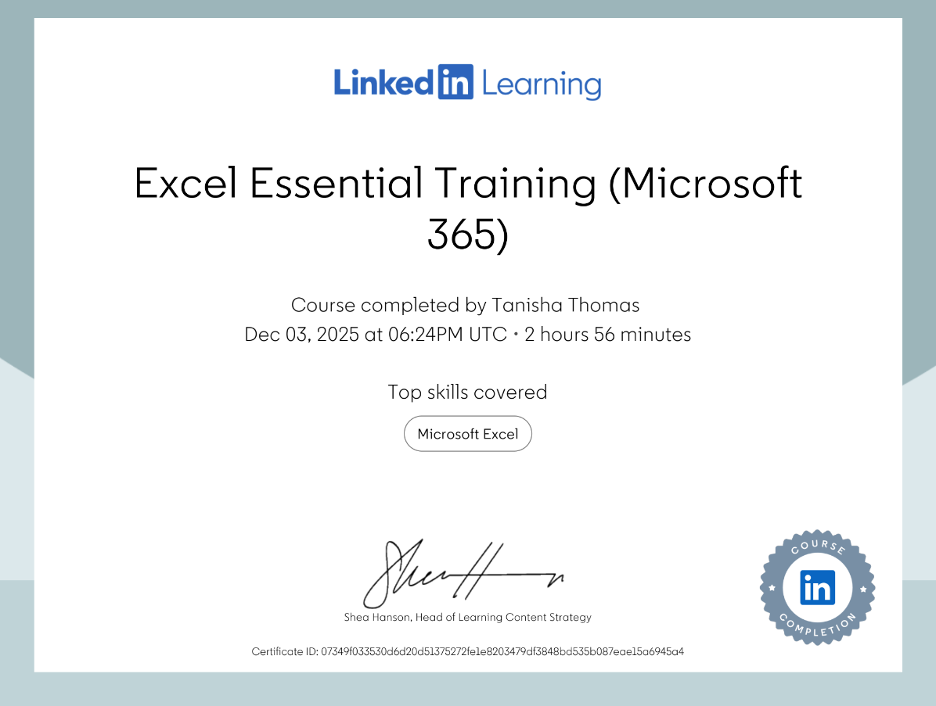

Task 3

The Importance and Relevance of Excel in Professional and Personal Life

Introduction

Microsoft Excel is a tool used for managing finances, organising information, performing calculations and handling data. “Excel is one of the most popular and widely used spreadsheet software applications worldwide” (ExcelDelta, 2025). It is used at home, in studies and at the workplace. It is valuable in everyday life for tasks such as, budgeting, planning schedules and keeping track of information, while in a professional setting it is mostly used for creating reports, analysing data and organising large amounts of information. In addition, there are different ways tools such as Excel can help save you time. Examples within Excel include formulae, macros, and keyboard shortcuts. It also helps keep information in a clear and organised format. Microsoft has worked hard over many years to make these tools as accessible as possible to as wide an audience as possible. “Excel is an incredibly powerful tool for getting meaning out of vast amounts of data. But it also works well for simple calculations and tracking almost any kind of information”. (Microsoft, n.d). This essay will explain why Excel is so important and how it can be used both professionally and personally.

The use of Excel in Personal Organisation and Finances

Excel is very helpful for managing personal and household finances because it allows you to track income, expenses and savings in a clear and organised way. You can use simple formulas such as SUM to add up total income or spending and basic subtraction to work out how much money is left over at the end of the month. For example, a family can create a monthly budget to see how much money comes in from wages and how much is spent on rent, bills and shopping. As Scottish business news states “The core issue with budgeting is that it’s hard to master. Effective planning of your financial resources requires solid financial literacy, as well as good math skills” (Scottish Business News, 2023), using Excel to manage personal and household finances can make it easier to plan, save and avoid overspending.

In addition, Excel is also useful for organising schedules and keeping track of information. For everyday personal life, StatAnalytica explains that Excel offers easy computation of calculations, options for formatting and data organisation, and the ability to keep “all data in one place,” which makes it useful for budgeting, expense tracking, or organising personal information (StatAnalytica, 2025). For instance, you can create a weekly timetable to plan study hours, work shifts and appointments. This makes it easier to stay organised and manage your time better. You can also use Excel to keep track of things like shopping lists, wardrobe inventory and household tasks. Having the information laid out in a spreadsheet can help with planning and make everyday tasks easier to manage because everything is in one place.

For students, Excel can also support study tasks. It can be used to track assignment deadlines, plan revision timetables and store research notes. By using Excel this way, students can break tasks into smaller steps, calculate study hours and stay organised throughout the year. This helps reduce stress and improve time management.

The use of Excel as a Professional

Excel is also very important in professional settings because many organisations rely on it to manage information, analyse data and support decision making. From small businesses to Fortune 500 companies, Excel has become a cornerstone of workplace productivity (GeeksforGeeks, 2025). In places such as offices, schools, hospitals and businesses, Excel is used to create reports, track progress and organise large amounts of data. According to Lee, Kerler and Ivancevich (2018), Excel remains “the most frequently utilized software/tool” among accounting professionals and is considered the most important application for new hires. For example, a manager might use Excel to record staff attendance, plan budgets or keep track of project deadlines.

In addition, the ability to use formulas and filters help makes information easier to understand and saves time when working with large amounts of data. For example, formulas can calculate profit, find averages or identify the highest and lowest values in a data set. Filters make it easier to find specific information quickly, which is helpful when dealing with a long list of numbers or names. ExcelDelta notes that “its grid-like layout with rows and columns allows users to input, store, and manipulate data efficiently.” (ExcelDelta, 2025). Excel is also useful for creating charts, which help present information clearly during meetings or presentations. A simple bar chart or pie chart can show trends, compare results or highlight areas that need improvement. AceProject also highlights that Excel is effective for managing projects because it is easy to use, cost-efficient and works well for both small and large teams (AceProject, 2024). These points show that Excel is a tool that can support many different kinds of work. This makes Excel a valuable tool in many jobs because it helps improve accuracy, organisation and communication.

Conclusion

In conclusion, Excel is important in both personal and professional life because it helps people stay organised, manage information and make tasks easier. In everyday life, it can be used to keep track of money, plan schedules and store important information all in one place. This helps people save time and stay in control of their responsibilities. Excel is also useful for students because it can help with planning revision, tracking assignments and staying organised throughout the year.
Excel is just as valuable in the workplace. It can be used to create reports, analyse data, manage projects and support decision-making. XlInExcel explains that Excel is useful not only for simple tasks but also for more advanced jobs like data analysis, automation and working with other software (XlInExcel, 2025). This shows why many businesses expect employees to know how to use it.
Overall, Excel is a helpful and reliable tool that makes organising information easier in daily life, studies and professional settings. Learning how to use Excel well can improve productivity, save time and help people work more accurately, in both their personal and professional lives, which is why it continues to be such an important and highly sought after skill.

References

10XSheets (2024) The Importance of Excel in Business (+ Examples). Available at: https://www.10xsheets.com/blog/importance-excel-business/ (Accessed: 9 December 2025).

AceProject (2024) 10 Advantages of Managing Your Projects with Excel. Available at: https://www.aceproject.com/blog/10-pros-advantages-of-managing-your-projects-with-excel-9387815/ (Accessed: 10 December 2025).

ExcelDelta (2025) Why Use Excel: The Benefits and Advantages. Available at: https://www.exceldelta.com/tutorials/why-use-excel-the-benefits-and-advantages (Accessed: 9 December 2025).

GeeksforGeeks (2025) Importance of Microsoft Excel in the Workplace (With Real-World Examples). Available at: https://www.geeksforgeeks.org/excel/importance-of-microsoft-excel-in-workplace/ (Accessed: 9 December 2025).

Lee, L., Kerler, W. & Ivancevich, D. (2018) Beyond Excel: Software Tools and the Accounting Curriculum. AIS Educator Journal, 13(1), pp. 44–61. Available at: https://aisej.kglmeridian.com/view/journals/aise/13/1/article-p44.xml?utm_source=chatgpt.com (Accessed: 10 December 2025).

Microsoft (n.d.) Basic tasks in Excel. Available at: https://support.microsoft.com/en-gb/office/basic-tasks-in-excel-dc775dd1-fa52-430f-9c3c-d998d1735fca (Accessed: 29 November 2025).

Scottish Business News (2023) 6 Ways Students Can Use Excel in Life and Studies. Available at: https://scottishbusinessnews.net/6-ways-students-can-use-excel-in-life-and-studies/ (Accessed: 8 December 2025).

StatAnalytica (2025) What Are The Uses of Excel in Our Daily Life? Available at: https://statanalytica.com/blog/uses-of-excel/ (Accessed: 9 December 2025).

XlInExcel (2025) Why Learning Microsoft Excel is Important? Available at: https://xlinexcel.com/why-learning-microsoft-excel-is-important/ (Accessed: 10 December 2025).

Task 4

7 Minute Reflective Presentation



