Digital skills and research methodology
BMSW4003
Assessment 2

Table of Contents
1 Introduction 3
1.1 Objectives of the study 4
2 Literature review 4
3 Methodology 4
4 Findings 5
4.1 Figure 1 5
4.2 Figure 2 6
4.3 Figure 3 6
4.4 Figure 4 7
4.5 Figure 5 7
4.6 Figure 6 8
4.7 Figure 7 8
5 Discussion 9
6 Conclusion 9
7 Recommendations 10

Introduction
The virtual learning environment or VLE is considered to as a design space which is used by the teachers as well as it is being used by students as well for the sake of the development of the learning. According to Torres et al. (2021), the term Virtual conjures up an artificial world which has the involvement in replacing real life, via incorporation of the technology. However, the Virtual learning environments do not have the involvement in the replacing classroom not in the replacing the existing educational practices, even though the virtual enhances the learning practices for teachers as well as students. According to Lacka, E., Wong, T.C. and Haddoud, (2021) some examples have been noted that might elaborate on virtual learning including online or computer-based systems, distance learning degree programs, and professional certification courses as well as the instructional videos. In addition to this, it has been noted that a good learning environment might be led to a good attribute for the sake of success in the online courses. Similarly, Chui et al. (2020) have mentioned that having a good environment is not only about creating a positive atmosphere in class for the students in order to feel engaged as well as to feel motivated. Considering this, an ideal course setting ought to encourage the conception between the instructor as well as the learner and represent a positive sense of communication as well as support. During the COVID-19 when the all the physical activities were banned and particularly the education practices have dealt with a number of issues and declared the temporary closure, for ensuring the safety of the students thus it has been noted that in order to save the time of the student and to make sure that their learning activities keep running. Teachers have focused on the online teaching practices and the course was covered through the using the online software which includes ZOOM., Google meeting, the private online platform of the university as well as other local websites have been implemented on respectively.
On the other hand, some of the different perspectives have been observed from the side of the students, some of the students have taken it as an opportunity and found a way which is being used for deal with the identified issue while staying home and safe, so they can continue study safely. On a comparative note, some of the students have thought that due to the technology some of the barriers can be created the boundaries in order to be facilitated from these platforms. Since the era of the pandemic, it has been noted the pandemic is due to the lack of knowledge of technology, some of the students have found it problematic to deal with the virtual learning platforms.
According to Yang et al. (2018), the educational institutions have created the VLEs while using some of the various open-source sites, for instance, Moodle and Google Classroom. Moodle has the involvement in offering an inclusive management system of learning, sequences and development of the training as well as to get high marks. In addition to this, Moodle leads a student to find out a path for their study. Moodle-based learning enhances understudies; opportunities for growth, regardless of whether they have recently been associated with schooling (Annansingh et al., 2019). The accompanying examination has specially planned to the personality the effect of the VLE in the middle between UWTSD understudies. This exploration centres around the adequacy of Moodle and its acknowledgement among the understudies of UWTSD.

Objectives of the study
The objectives of the study have been represented below:
- To explore the role of the VLE learning in the development of students’ skills
- To identify the impact of the VLE’s Moodle on the UWTSD students
- To find out the contribution of the VLE Moodle to the exploration of UWTSD student’s study
- To give the recommendations for the goodwill of the VLE with respect to the university’s student

Literature review
As shown by Hamutoglu et al. (2020) informatisation of the educational cooperation at a particular stage prompts the ascent of another idiosyncrasy; a virtual learning environment as a lot of progressions, enlightening and information resources, and data structures that structure essentially complete system planned to give all possible kinds of client development (teacher and student) in the developing experience. This environment is the carrier of Meta development and definitive sorts of enlightening communication. Completing the guidelines of insight, development, and independence in learning is one of the major tasks of modernizing the educational system (Pletz, and Zinn, 2020). Its response is worked with by the accumulated ability of present-day information and correspondence progressions.
Rungrangtanapol and Khlaisang (2021) highlighted that the e-learning model has been proposed to cultivate electronic educational systems. Researchers acknowledge that the association is at risk of making informational foundations more viable to adjust to the creating number of students and online courses and that clients expect genuinely refined organizations.
Plus, according to Hamidet al. (2018), execution and plan of a VU Web-Based System are critical to the continuous learning structure. In this assessment article, the author portrays the North China University of Technology's online virtual school lifestyle. This system helps better with getting a handle on the life and relationship of the school (Lacka, and Wong, 2021). They thought about a Life System structure that integrates the tasks of the leaders, internal hailing, Computer support, player meandering, and database organization, from that point, anything is possible.

Methodology
The research methodology is considered to as one of the significant parts of the research since it allowed the researcher to identify the techniques as well as tools to explore the research issue in an effective as well as in the required manner. In line with this to identify the role of the VLE’s Moodle on the student of the UWTSD the researcher has elected the quantitative research design and to ensure that this research has incorporated the quantitative data. According to Melissa Lee Yen, (2020) quantitative data involves all the numeric data instead of the theories as well as phenomenal concepts. The key reason for the selection of the quantitative research is that it would allow the researcher to identify the impact of the VLEs of students of UWTSD in a quantitative manner where the numerical data will be as per the perceptive of the students of the selected university. In addition to this, for the collection of the quantitative data the researcher has used the primary data as well as for the sake of the collection of the primary data the researcher has used the particular instrument named a questionnaire. In addition to this, it has been encouraged that the implementation of the questionnaire research instrument has been implemented under a specific participant. For that study, the sample was 12 and all those 12 have been asked the asked questions related to VLE.
The researcher has implemented the close-ended questionnaire and due to the increment of the pandemic the face-to-face interaction has been avoided and an online survey the been used. In addition to this, the sampling strategy of this survey was to non-probability and the participants have responded. In addition to this, since the researcher has conducted the primary data thus, all the ethical measurement has been ensured in this survey and all the participants were aware of the aim as well as the objectives of the research, additionally, the safety of the participants have been ensured in this research survey. Since this research was based on the exploration of the issues related to the university and the student of the university have been taken as well as the participants were already informed from this project.
The collected data has been analysed through specific techniques which include frequency analysis, as well as content analysis. The frequency analysis has helped the researcher to find out the research issue with respect to the frequency of the student’s collected perception. In addition to this along with the help of the content analysis via the incorporation of existing literature review, the researcher has explored the main findings.

Findings

Figure 1
In the case of the identified response related to the use of the VLE Moodle, whether it is effective or not it has been noted that all the 12 respondents have marked it yes. Thus, in the survey, 100 Percent results have indicated that the VLE is beneficial for the development of student learning. Since the explored data it has been empowered that within the university the use of the Moodle VLE is useful.

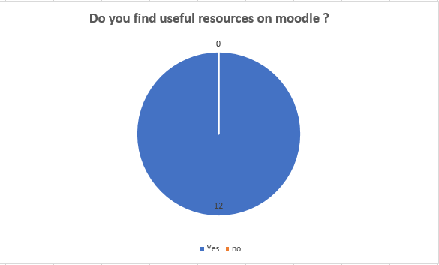
Figure 1 Useful Resources on Moodle

Figure 2
According to the survey another question was related to the exploration of the fact that either the students have found these sources hard to use or not. In these cases, 5 students have stated that they have found these hard to use. Meanwhile, 7 students have said that it is easy to use, thus for the 60 % of the participants the VLE’s Moodle is easy to use and the rest of the students are still finding complementation to be facilitated from these platforms.
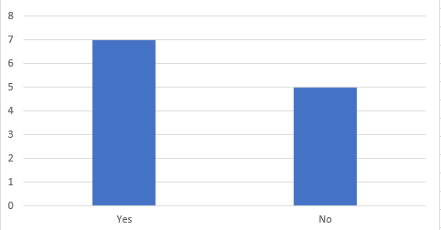
Figure 2 did you find these resources hard to use

Figure 3
Moreover, the students were asked that do you agree with the statement that the provided information in the Moodle is useful or not whether it is helpful for the execution of the course or not, of which 7 students have marked to agree while 2 remained neutral. But none of them has marked the disagreed.
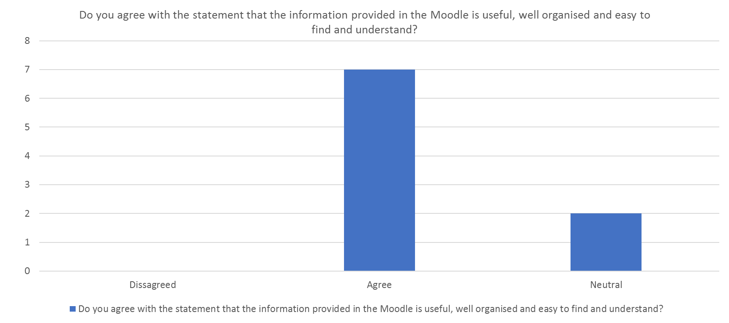
Figure 3 is the provided information is significant

Figure 4
Another question of this survey was to identify that either the provided tool that is Moodle is interesting or not. In which the findings have mentioned that all the participants have indicated it as the interesting.
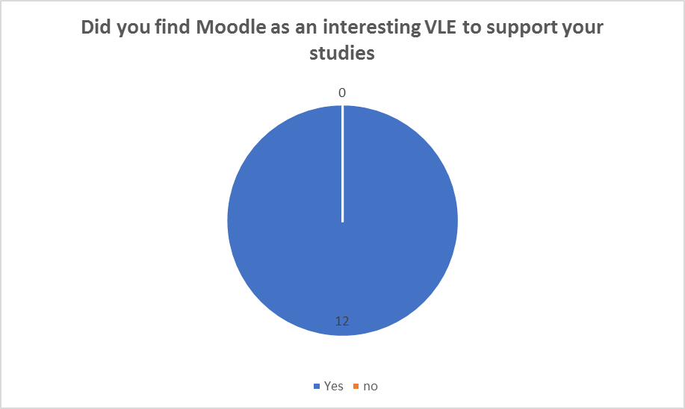
Figure 4 is Moodle interesting

Figure 5
According to the conducted survey, another question was related to the experience of the students whether it is significant for the student or not and they have been proved with a scale and asked to the rate from 1 to 5. And in the 5 students have rated their experience at 5, 3 students have rated their experience on a scale of 4. In addition to this, the rest of the 4 students rated their experience on a scale of 3. Thus, the overall experience has been marked as excellent and the student is amazed to use it.
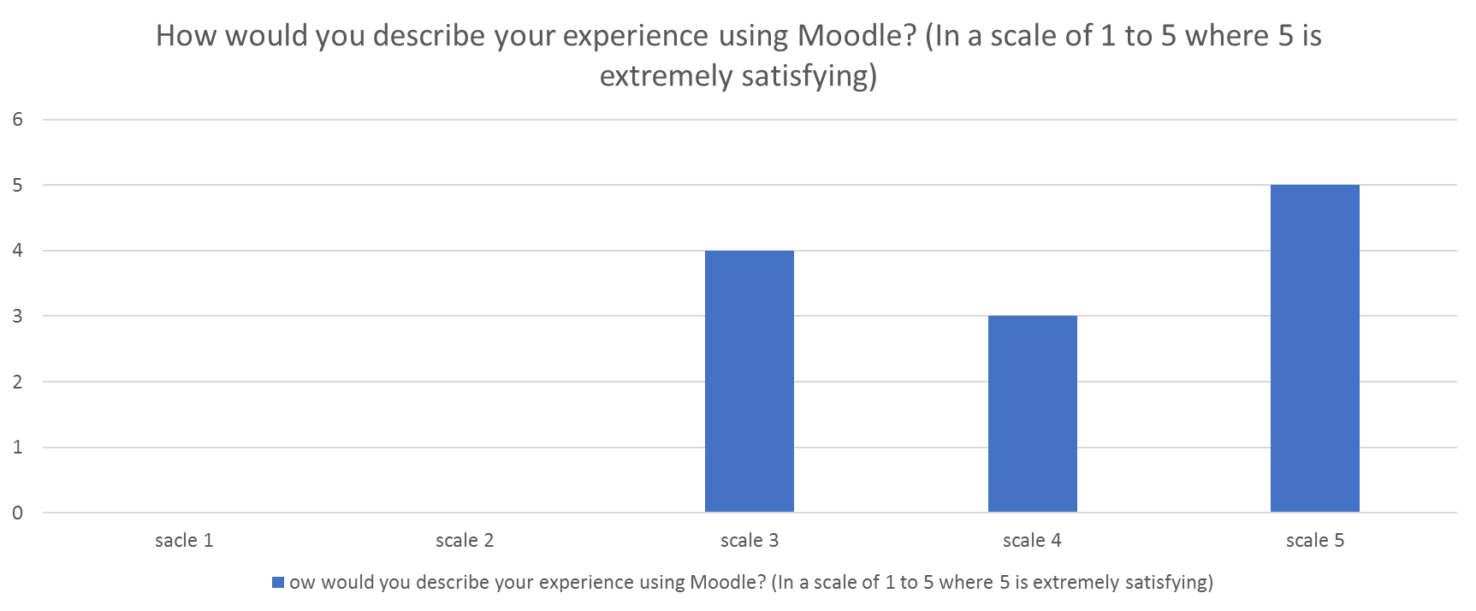
Figure 5 experience of using Moodle

Figure 6
In addition, the next thing which was asked to the students was related to rating for the recommendation of the Moodle to others, in which it has been noted that the 5 students have marked as a 5, where 4 and 3 students have marked their vote as scale 3 and 4 respectively.
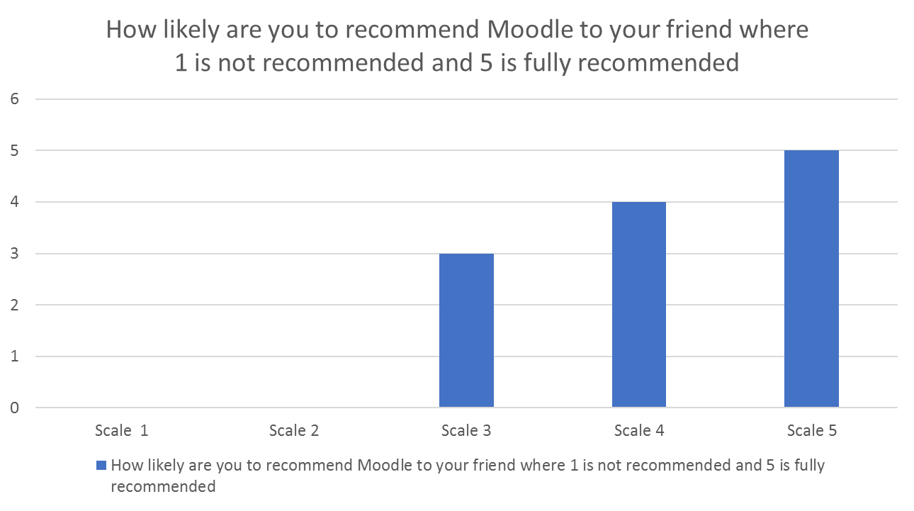
Figure 6 Recommendation of the Moodle

Figure 7
Another question was related to satisfaction of the students whether they are satisfied while using Moodle or not, and they were given the options the somewhat satisfied, neither satisfied nor the dissatisfied as well as the very satisfied. In line with the marking have mentioned that the 6 were very satisfied with the use of the Moodle and the 3, 3 were somewhat satisfied and neither satisfied nor dissatisfied.
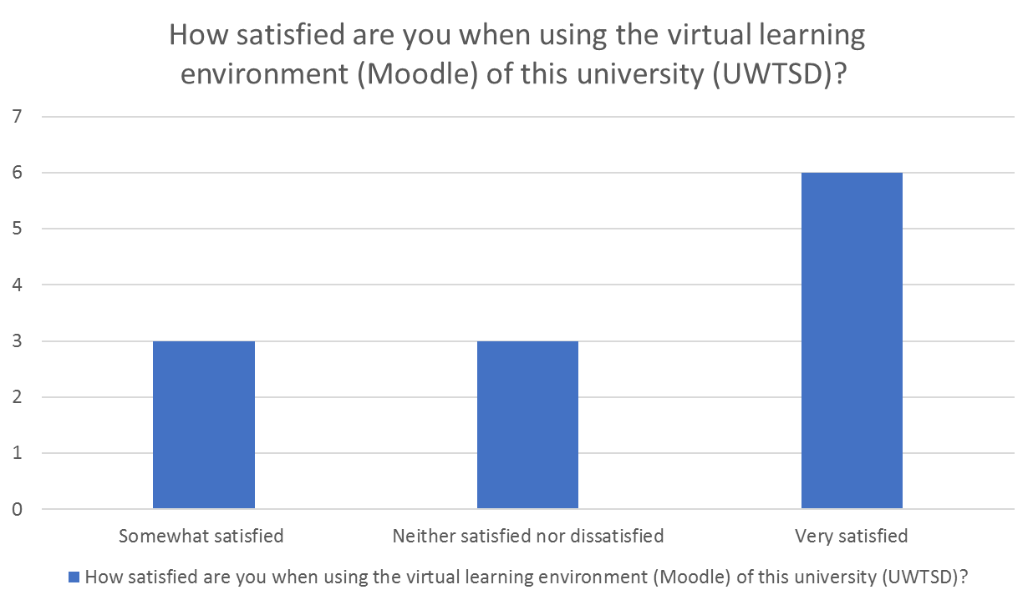
Figure 7 satisfaction of Moodle

Discussion
The findings of this research through the use of the questionnaire instrument it has been noted that the more all the aspects have indicated that students of the selected university have found the use of Moodle is significant and it has helped to make their study easy and to contribute in enhancing the students’ skills. This investigation focused on the perspectives of the virtual learning environment among UWTSD students. It was seen that VLE accepts a key part in guidance today. Moodle is for the most part invited and positively impacted by UWTSD students. In the continuous pandemic, Moodle expects a pressing part in the concentrate on corridors and a movement of tests. Our results are consistent with the revelations of Skalka et al. (2019), which underline that the arrangement and execution of a Virtual University Web-Based System are vital for the continuous learning structure. In any case, headway is the most effective way to beat the hindrances to using VLE-Moodle. The foundations ought to consider all devices online for some time in the future, for instance, giving survey materials and manuals through VLE. A couple of students acknowledge that the library is the most obliging portion; addresses are by and largely available and can get to email, library, and organization workspace through Moodle. Most of the students were presumably going to endorse Moodle to buddies and associates.

Conclusion
The creation of a VLE in academic foundations is a strong mechanical assembly to handle the understudy’s capable development and planning. According to this investigation, Moodle gives significant web-based organizations to the students, which are helpful for their investigation and studies. Shrewd models of a close-by investigation nature (model examination community stands) and demonstrate constructors continue the illustrative and showing series, but add to the headway of thinking, opportunity, research capacities, and the plan of model data. While working with models (as an improvement to the exploration place practice), students do in a trade mode such sorts of development as discernment, assessment, theory, assurance, assessment of results, search for conditions for the execution of the task, advancement of conditions and systems. This is especially huge free of charge, self-awakened students who track down it routine yet significant to work with test frameworks.

Recommendations
After the accomplishment of the study the following recommendations have been made:
- Moodle needs to access for all the students
- Moodle ought to be industrialised for facilitating the students
- Imaginative innovations, like all virtual projects for understudies with incapacities, can beat Moodle boundaries for understudies with inabilities.

References
Annansingh, F., 2019. Mind the gap: Cognitive active learning in virtual learning environment perception of instructors and students. Education and Information Technologies, 24(6), pp.3669-3688.
Chui, K.T., Fung, D.C.L., Lytras, M.D. and Lam, T.M., 2020. Predicting at-risk university students in a virtual learning environment via a machine learning algorithm. Computers in Human Behavior, 107, p.105584.
Hamid, Z., Peng, C.F., Shaharom, M.S.N., Ter, T.C. and Raman, K., 2018. The concept and use of the virtual learning environment in teaching: a literature review. International journal of academic research in business and social sciences, 8(6), pp.1293-1301.
Hamutoglu, N.B., Gemikonakli, O., Duman, I., Kirksekiz, A. and Kiyici, M., 2020. Evaluating students experiences using a virtual learning environment: satisfaction and preferences. Educational Technology Research and Development, 68(1), pp.437-462.
Lacka, E. and Wong, T.C., 2021. Examining the impact of digital technologies on students’ higher education outcomes: the case of the virtual learning environment and social media. Studies in Higher Education, 46(8), pp.1621-1634.
Lacka, E., Wong, T.C. and Haddoud, M.Y., 2021. Can digital technologies improve students' efficiency? Exploring the role of Virtual Learning Environment and Social Media use in Higher Education. Computers & Education, 163, p.104099.
Melissa Ng Lee Yen, A., 2020. The influence of self-regulation processes on metacognition in a virtual learning environment. Educational Studies, 46(1), pp.1-17.
Pletz, C. and Zinn, B., 2020. Evaluation of an immersive virtual learning environment for operator training in mechanical and plant engineering using video analysis. British Journal of Educational Technology, 51(6), pp.2159-2179.
Skalka, J., Drlík, M. and Obonya, J., 2019, April. Automated assessment in learning and teaching programming languages using virtual learning environment. In 2019 IEEE Global Engineering Education Conference (EDUCON) (pp. 689-697). IEEE.
Torres Martín, C., Acal, C., El Honrani, M. and Mingorance Estrada, Á.C., 2021. Impact on the virtual learning environment due to COVID-19. Sustainability, 13(2), p.582.
Yang, D., Alsadoon, A., Prasad, P.C., Singh, A.K. and Elchouemi, A., 2018. An emotion recognition model based on facial recognition in virtual learning environment. Procedia Computer Science, 125, pp.2-10.

