e-Portfolio
Tariq Ahmed
2323389
University of Wales Trinity St David
ACCA 4025
Learning in the Digital Era
17/01/2024

Table of Contents
e-Portfolio 3
1.1 Link: https://tariq2436.wixsite.com/learning-in-the-digi 3
1.2 Screenshot: 3
3
Task 1: Academic and Employment Skills 3
Part A: Summary of Essential Skills for Academic and Career Success 3
1.3 Screenshot: 5
Part B: Reflection on Turnitin Similarity Score 5
Task 2: Collaborative Teamwork and Academic Poster 6
Task 3: Automatic Referencing Tool 7
Virtual Collaboration: Key Points and Challenges 7
1.4 Screenshot: 8
Task 4: E-Portfolio Creation and Review 9
Tools and Approach 9
1.5 Screenshot: 9
References 11

e-Portfolio

Link: https://tariq2436.wixsite.com/learning-in-the-digi

Screenshot:


Task 1: Academic and Employment Skills

Part A: Summary of Essential Skills for Academic and Career Success
Like any other profession, the foundation of getting a good job and climbing the ladder involves modifying a number of critical skills that include interpersonal skills, teamwork, flexibility, organisational skills and critical thinking in the job market place. These skills for any profession fit in the modern world’s work market and afford continuity.
Effective communication is effective in development and presentation of ideas and concepts and helps in developing good interpersonal relationships. Stake argues that not only must accurate communication promote just learning outcomes, but it also guarantees satisfactory work results and effective interaction between teams [1]. For instance, real estate or sales personnel in their line of duty need to relay messages in ways that are unique to meet the needs of their clients [2].
Teamwork has been highlighted as important to fostering the achievement of group objectives. Research has shown that action within group cooperation allows a person to use the experience of many people when making decisions [3]. According to Tannenbaum, Weimer & Kennedy (2012) working in teams involves trust, accountability, and desired goals and objectives in any field including construction, health, technological fields [4].
Adaptability is equally important, especially in growing fields where change is constantly on the move. As Diaba Nuhoho has pointed out it is business flexibility that can cope with unforeseen circumstances hence strengthening career advancement [5]. For example, workers in progressive industries like construction or retail need to adapt to certain technology advancement or market situational analysis.
Time management is one of the most important success factors in reaching targets effectively. In several cases, research shows that professionals who know how to manage time well, he/she will always work on high priorities and complete project on time especially when he/she has many responsibilities at the same time [6].
Lastly, problem-solving is very crucial in solving multifaceted problems effectively and efficiently. The skill helps professionals do well in positions that demand fast decision making and problem solving [7]. This capacity is useful when new problems must be solved as soon as possible, for instance, in a crisis or when working with clients.
Such skills are compatible with valued types of work that require professionals to achieve high levels of accurate and coordinated performance and professional leadership levels.

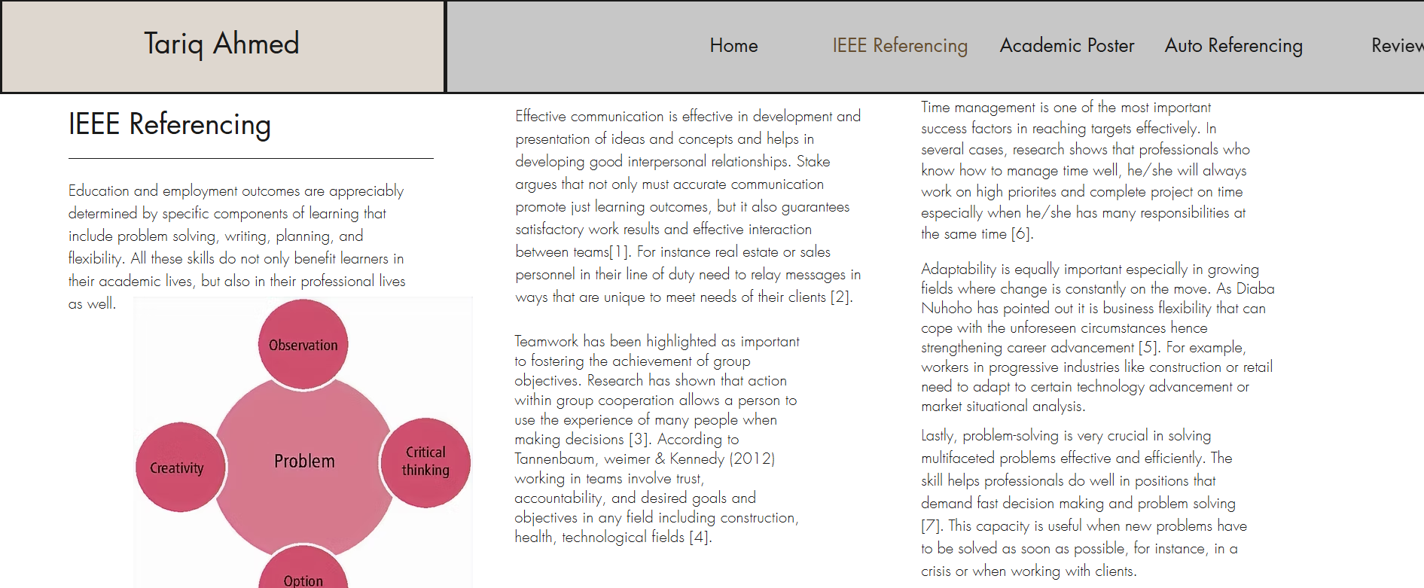
Screenshot:

Part B: Reflection on Turnitin Similarity Score
Subsequently, running the submission through the Turnitin checker the similarity index returned an acceptable number to show that adequate paraphrasing and referencing of valid sources had been done. For further improvement, the use of a diverse number of academic research materials and reduction of clichéd expressions will be adopted in the subsequent writing. By the Generic Assessment Criteria, I would assess this work at 85% in terms of if its structure separating ideas and concepts is clear, organisation, and compliance with the academic principles governing the work.

Task 2: Collaborative Teamwork and Academic Poster
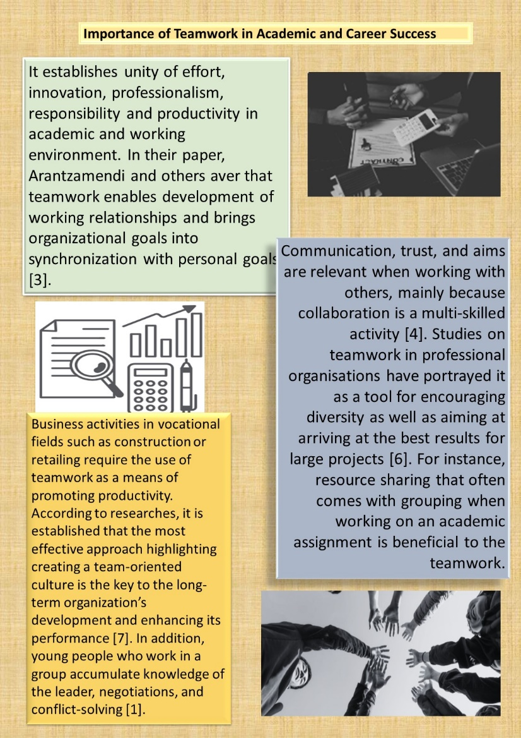

Task 3: Automatic Referencing Tool

Virtual Collaboration: Key Points and Challenges
But virtual collaboration has now become a key feature of contemporary work landscapes. It enables people to work together regardless of their location and also helps to overcome geographical barriers between organisations and their personnel. As stated by recent research, using contemporary instruments like Microsoft Teams, Slack, and Zoom stepped up communication up to a certain level as it defines interaction of various teams [5].
But there are also difficulties when it comes to virtual collaboration. Reviews reveal that lack of physical communication and technical challenges such as low connectivity result to misunderstandings, which affect productivity [7]. Finally, one should bear in mind that when working cross culturally, people might have different communication patterns and are most likely to reside in different time zones [4].
Key elements of successful virtual collaboration include:
- Effective use of technology: Knowledge of collaboration tools helps to avoid disruptions of the work process. Studies prove that the utilisation of common platforms, including Google Drive, increases transparency and accountability in the context of virtual teams [1].
- Structured communication: Proper communication reduces complexity since the information is well understood. Research indicates that specific communication standards improve clarity and achieve team goals [3].
- Time management: Cross time zone cooperation implies that scheduling has to be well done. It has been established that managing the work hours of global teams is effective in creating equality and eradicating inconvenience [6].
For easy management of the references used in this section, I used RefWorks, which is an auto generating tool for references. RefWorks simplifies the process of citation by enabling students to select citation styles and meet its guidelines perfectly. Steps included:
- On importing journal articles and other sources from online sources into RefWorks.
- The practical use of tags for a thematic division of references.
- To address this problem, we must devise a way of creating the IEEE citation style directly for use in the text.
Documents of the RefWorks show how references were gathered and formatted correctly to meet IEEE requirement as shown in the screenshots below.

Screenshot:
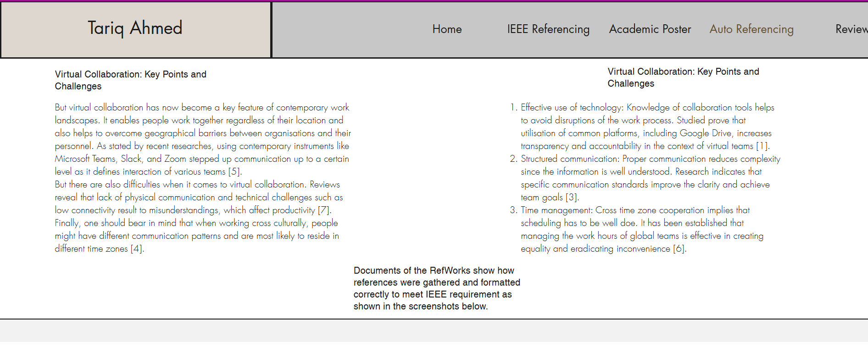

Task 4: E-Portfolio Creation and Review

Tools and Approach
While constructing the e-portfolio Wix was employed because it rendered flexibility in design, easy to use and supports adding of multimedia features. Due to integration with Google Drive, it was possible to link to other resources and make them available to tutors.
The e-portfolio includes four pages:
- Academic and Employment Skills & Academic Skills Self-Assessment Employment].
- Collaborative Teamwork and Academic Poster
- The last discovered benefits of virtual collaboration include automatic referencing.
- Illustrative Review and Conclusion
Both are intended to present research and its applications, with illustrations and references on each page. Pictures of every page prove visual organisation to be coherent and professional, reflecting the subject of the portfolio.

Screenshot:
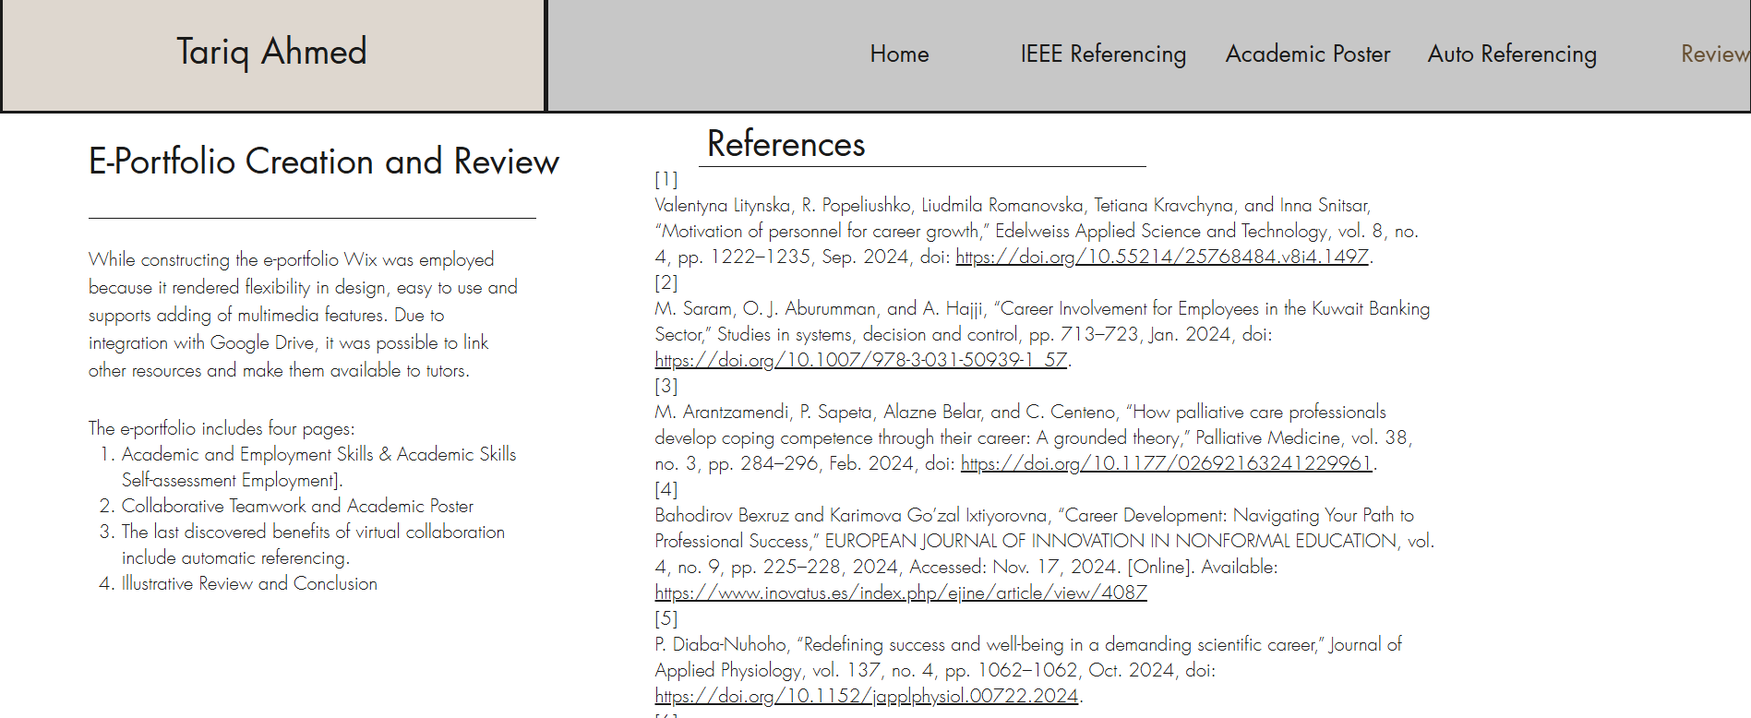

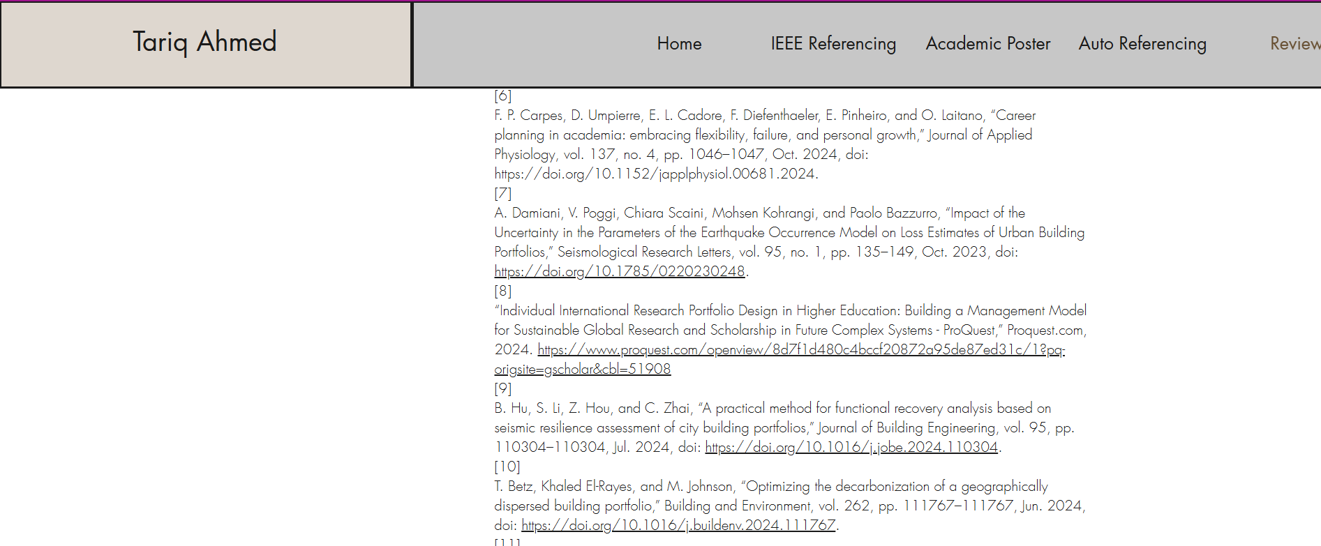

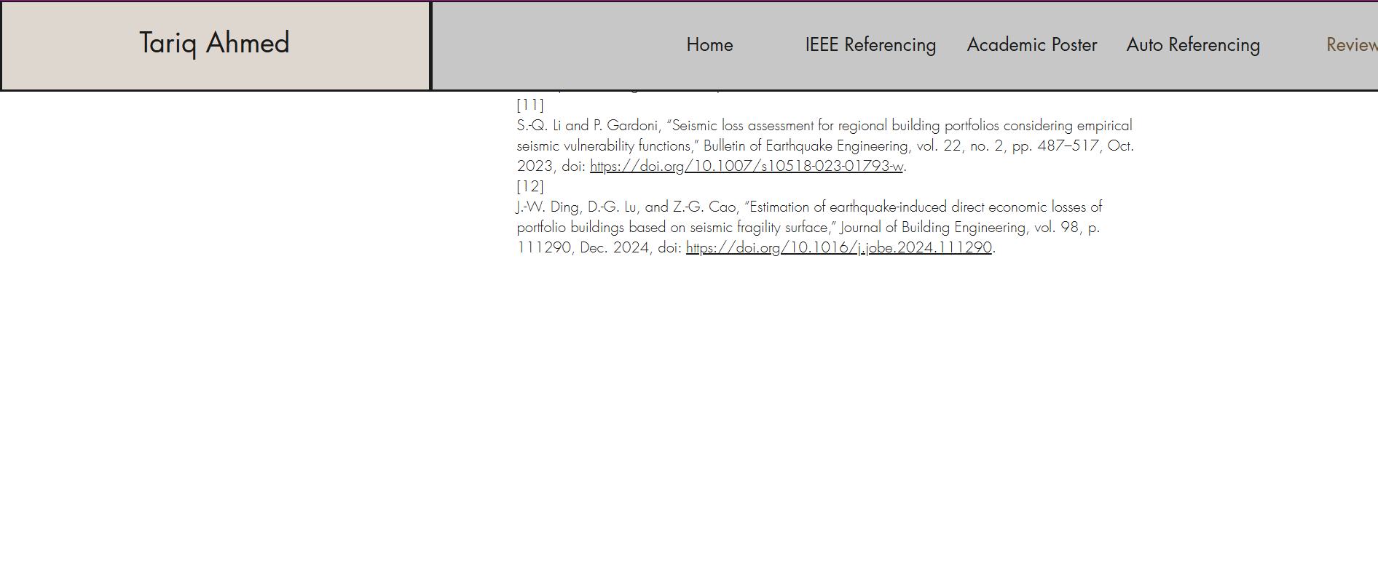

References
[1]
Valentyna Litynska, R. Popeliushko, Liudmila Romanovska, Tetiana Kravchyna, and Inna Snitsar, “Motivation of personnel for career growth,” Edelweiss Applied Science and Technology, vol. 8, no. 4, pp. 1222–1235, Sep. 2024, doi: https://doi.org/10.55214/25768484.v8i4.1497.
[2]
M. Saram, O. J. Aburumman, and A. Hajji, “Career Involvement for Employees in the Kuwait Banking Sector,” Studies in systems, decision and control, pp. 713–723, Jan. 2024, doi: https://doi.org/10.1007/978-3-031-50939-1_57.
[3]
M. Arantzamendi, P. Sapeta, Alazne Belar, and C. Centeno, “How palliative care professionals develop coping competence through their career: A grounded theory,” Palliative Medicine, vol. 38, no. 3, pp. 284–296, Feb. 2024, doi: https://doi.org/10.1177/02692163241229961.
[4]
Bahodirov Bexruz and Karimova Go’zal Ixtiyorovna, “Career Development: Navigating Your Path to Professional Success,” EUROPEAN JOURNAL OF INNOVATION IN NONFORMAL EDUCATION, vol. 4, no. 9, pp. 225–228, 2024, Accessed: Nov. 17, 2024. [Online]. Available: https://www.inovatus.es/index.php/ejine/article/view/4087
[5]
P. Diaba-Nuhoho, “Redefining success and well-being in a demanding scientific career,” Journal of Applied Physiology, vol. 137, no. 4, pp. 1062–1062, Oct. 2024, doi: https://doi.org/10.1152/japplphysiol.00722.2024.
[6]
F. P. Carpes, D. Umpierre, E. L. Cadore, F. Diefenthaeler, E. Pinheiro, and O. Laitano, “Career planning in academia: embracing flexibility, failure, and personal growth,” Journal of Applied Physiology, vol. 137, no. 4, pp. 1046–1047, Oct. 2024, doi: https://doi.org/10.1152/japplphysiol.00681.2024.
[7]
A. Damiani, V. Poggi, Chiara Scaini, Mohsen Kohrangi, and Paolo Bazzurro, “Impact of the Uncertainty in the Parameters of the Earthquake Occurrence Model on Loss Estimates of Urban Building Portfolios,” Seismological Research Letters, vol. 95, no. 1, pp. 135–149, Oct. 2023, doi: https://doi.org/10.1785/0220230248.
[8]
“Individual International Research Portfolio Design in Higher Education: Building a Management Model for Sustainable Global Research and Scholarship in Future Complex Systems - ProQuest,” Proquest.com, 2024. https://www.proquest.com/openview/8d7f1d480c4bccf20872a95de87ed31c/1?pq-origsite=gscholar&cbl=51908
[9]
B. Hu, S. Li, Z. Hou, and C. Zhai, “A practical method for functional recovery analysis based on seismic resilience assessment of city building portfolios,” Journal of Building Engineering, vol. 95, pp. 110304–110304, Jul. 2024, doi: https://doi.org/10.1016/j.jobe.2024.110304.
[10]
T. Betz, Khaled El-Rayes, and M. Johnson, “Optimizing the decarbonization of a geographically dispersed building portfolio,” Building and Environment, vol. 262, pp. 111767–111767, Jun. 2024, doi: https://doi.org/10.1016/j.buildenv.2024.111767.
[11]
S.-Q. Li and P. Gardoni, “Seismic loss assessment for regional building portfolios considering empirical seismic vulnerability functions,” Bulletin of Earthquake Engineering, vol. 22, no. 2, pp. 487–517, Oct. 2023, doi: https://doi.org/10.1007/s10518-023-01793-w.
[12]
J.-W. Ding, D.-G. Lu, and Z.-G. Cao, “Estimation of earthquake-induced direct economic losses of portfolio buildings based on seismic fragility surface,” Journal of Building Engineering, vol. 98, p. 111290, Dec. 2024, doi: https://doi.org/10.1016/j.jobe.2024.111290.

