Student name: Safeena Bi Ali
Student ID:1715941
Tutor: Mumtaz Goolam
Introduction to Physiology
(BMHP5003BIRM)
Assignment: Skeletal system

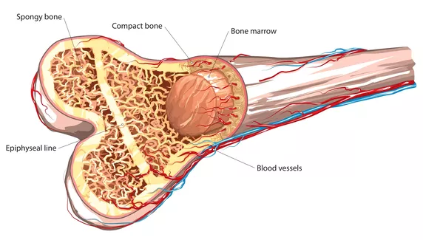
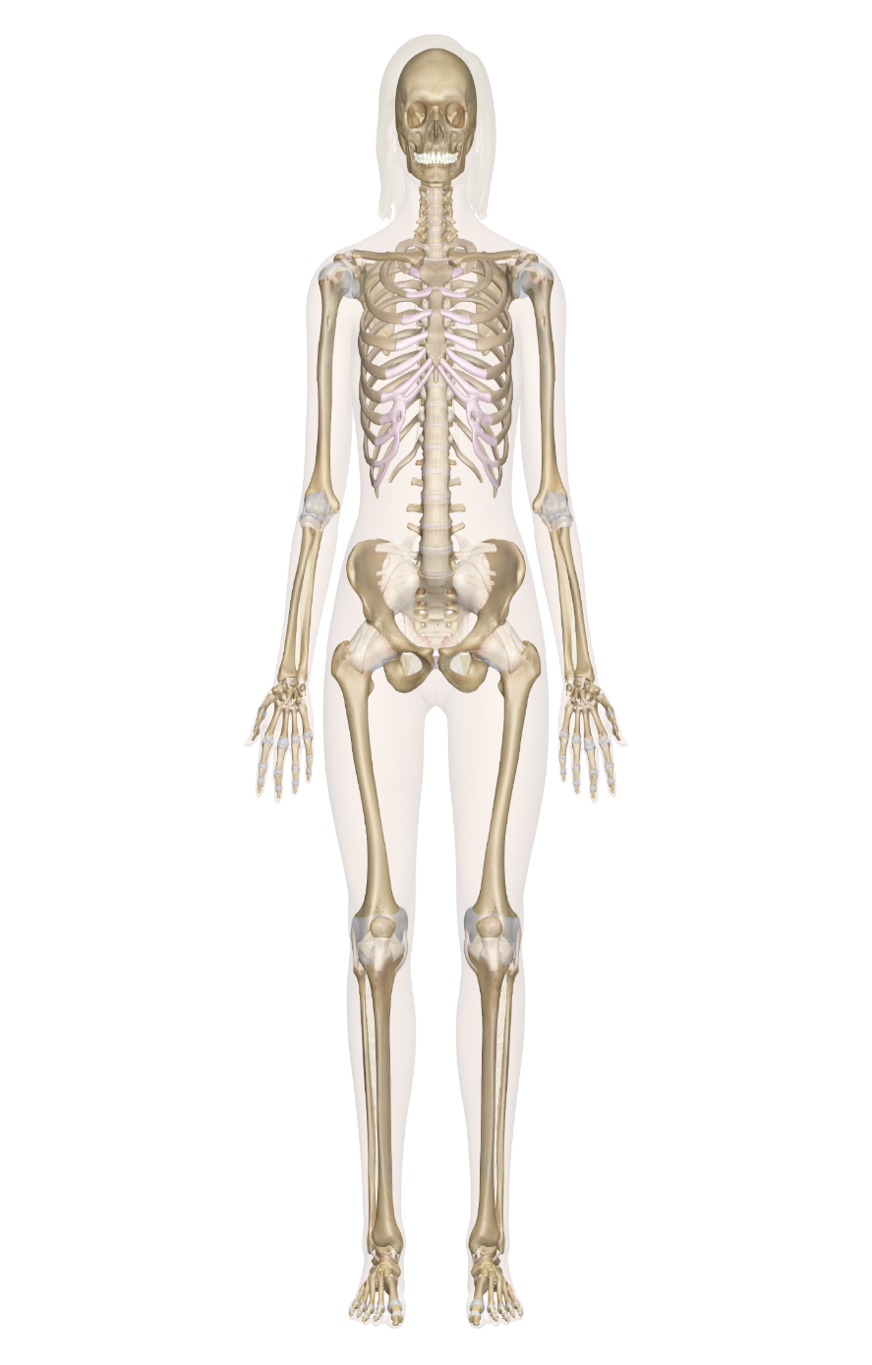
Bone Marrow
There are four main types of bones in the body. Each bone has a unique function and purpose in the body:
1. Flat Bones: Main function is to protect internal organs and provide attachment points. For example, ilium
2. Short Bones: Main function is to support and maintain stability with little to no movement; these are cube shaped. For example, Tarsals
3. Sesamoid Bones: The main function is to reinforce tendons and characterized by being embedded within a tendon. i.e. Patella.
4. Irregular Bones: Main function is widely varying, as their complex shapes do not fit the normal four categories for example
Vertebrae.
Phalanges/Foot
Tarsals/ Short
Long Bone
Ilium/ Pelvic
Spine
The purpose of the skull (Cranium) is to protect your brain. The human skull has a three‐layered sandwich structure, where the middle layer (not equally thick everywhere) consists of soft (spongy) bone, whereas the outer layers consist of hard (compact) bone.
(Dannheaur, 2011)

SKELETON STYSTEM
The long Bones are composed of a hollow shaft, or diaphysis; flared, cone-shaped metaphysis below the growth plates (Clarke, 2008). Long bones are found in the arm and legs as well as in the fingers and toes, these are long bones that act as levers they help to move when muscles contract. These bones are vital to support the human weight and help in movement these bones are called Femur.

Ribs
Patella/ Knee
The Spine is part of the axial skeleton and is composed of five regions: the cervical, thoracic, lumbar, sacral, and coccygeal spines. (Muscolino, 2014)

Phalanges/fingers
Source: innerbody.com: https://www.innerbody.com/image/skelfov.html

Tibia
Fibula
Source: Foundation for Biomedical research: https://www.fbresearch.org
The bone marrow is found in the bones throughout the body and plays an integral part in the body. The Bone Marrow is the spongy viscous tissue that fills the inside of your bones.
The red bone marrow helps red blood cells to produce the yellow marrow is important for the storage of fat. There are many functions of the bone marrow such as: Red blood cells. “These are the cells that work to carry oxygen-rich blood to the cells of the body. Old red blood cells can also be broken down in red bone marrow, but this task is mostly performed in the liver and spleen. Platelets. Platelets help your blood clot. This prevents uncontrolled bleeding. White blood cells. There are several types of white blood cells. They all work to help your body fight off infections”.
(Seladi-Schulman, 2018)

.
The skeletal structure of the foot is strong as it bears more weight, “There are five metatarsal bones in each foot. Similar to the bones of the hand, these nearly parallel bones create the body of the foot”, (Healthline 2018). The foot also contains numerous pieces of cartilage, a connective tissue that pads bones and joints. This cartilage can be damaged with excessive use or injury. Cartilage damage can cause joint pain.
Parts of the skull have specific and different functions, protection of delicate structures including the brain, eyes and inner ears.
(Ross & Wilson 2014)

The human skull or cranium as it is known in the medical world is a bone structure of the head that is very important part of the body it helps to protect the brain and also contain and hold the features of the face. “Skeletal framework of the head of vertebrates composed of bones and cartilage that protect the brain and some sense organs, (Encyclopaedia Britannia, 2020).

Function of the Bone
Disease of the Bone
The bones are very important to produce vital blood cells and platelets, according to an article Bones have many functions: These are to support the body structurally, protect our vital organs, and allow us to move., they also provide “an environment for bone marrow, where the blood cells are created, and they act as a storage area for minerals, particularly calcium”.
(Newman, 2018).

The bones support the body to maintain movement, the bones act as levers, and help protect internal organs for example the heart and ribs. The spinal cord is protected by the vertebral column.

The Functions of bone include:
Providing the body framework
Giving attachment to muscles and tendons
Allowing movement of the body
Forming boundaries of the cranial thoracic and pelvic cavities.
Protecting organs and haemopoiesis production in bone marrow, (Ross & Wilson 2014).

CKD is a Chronic Kidney Disease this occurs when the Kidneys are not working properly this illness can be seen in older people or black people. CKD can be caused by other conditions that prevent the kidneys from functioning properly.
This is a long term illness that can cause the kidneys to stop working altogether. People suffering with this disease may have following symptoms, tiredness, swollen ankles feet or hands, shortness of breath feeling sick or blood in your urine, (NHS 2020).

Chronic kidney disease is associated with bone disorders especially in the aging population a report suggests, “CKD contributes to the large burden of cardiovascular and bone disease”,
(Covic, 2017).
Red blood cells are made by the bone marrow therefore to get the marrow to make red blood cells the kidneys need to make a particular hormone. The kidney produces hormones called erythropoietin or EPO, this helps the bone marrow to create red blood cells. According to an article “Anemia may arise as a complication of several chronic diseases, and chronic kidney disease (CKD) in particular”,
(Colbert, 2020).

Bone marrow adiposity tissue may be affected by chronic Kidney disease “CKD is among the conditions associated with greater marrow adiposity in humans”, (Woods, 2018).

Reference list
Clarke .B (2008), Normal Bone Anatomy and Physiology Available at: https://www.ncbi.nlm.nih.gov/ {accessed: 15/10/2020}
Colbert. G, (2020) “Anemia of chronic disease and Kidney failure”, Medscape available at: https://emedicine.medscape.com accessed {03/11/2020}.
Covic. A, Massy. Z, Vervloet. M, and Torres. P (2017), “Bone and mineral disorders in chronic Kidney disease.”. available at: researchgate.net, accessed: {4th November 2020}.
Dannheaur. M, Lanfer. B, Wolters. C, Knocshe .T (2011) Modelling of the human skull in EEG source analysis available at: https://onlinelibrary.wiley.com accessed: {15/10/2020}
Encyclopaedia Britannica 2020, Skull anatomy, available at: https://www.britannica.com accessed {12/10/2020}.
Healthline 2018 “Bones” ,available at: https://www.healthline.com accessed: {14/10/2020}
Muscolino. J (2014) Kinesiology, The Skeletal system and Muscle function available at: https://books.google.co.uk/books accessed: {13/10/2020}
Newman. T (2018) “Bones: All you need to know, available at: https://www.medicalnewstoday.com accessed: {12/10/2020}
NHS, Available at:www.nhs.uk accessed:{ 5th November 2020}
Seladi-Schulman (2018), “What is Bone marrow and what does it do?” available at: https://www.healthline.com accessed: {01/11/2020}
Ross & Wilson, (2014) Anatomy and Physiology in Health and Illness, 12th edition. Accessed: {03/11/2020}
Woods. G, Ewing. S et.al (2018) “Chronic Kidney disease associated with greater Bone Marrow Adiposity”, vol 33, issue 12. Available at: mr.onlinelibrary.wiley.com accessed: {4th November 2020}

