Student name: Emmanuel Kumi Agyabeng
Student ID: 2430040
Module name: Introduction to physiology
Module code: BMHP5023_LON
Lecturer name: Dr Soban Sadiq
Assessment: Assignment 1 Case Study 2

a. Definition of asthma
The National Asthma Education and Prevention Program Expert Panel Report 3 (NAEPPR3) characterises asthma as “a chronic inflammatory disorder of the airways wherein various cells and cellular components are involved specifically, mast cells, eosinophils, neutrophils, T lymphocytes, macrophages, and epithelial cells” (Litonjua, 2020). In predisposed individuals, this inflammation leads to recurrent episodes of coughing (especially at night or in the early morning), wheezing, dyspnoea, and sensations of chest tightness. These episodes are typically characterised by widespread yet variable airflow obstruction, which is often reversible either spontaneously or through therapeutic intervention.

ai. Vitamin D
In the past ten years, there has been a growing interest in the association between vitamin D and asthma. Numerous studies have indicated that a deficiency in vitamin D may contribute to the severity of asthmatic symptoms. Vitamin D, along with the activation of its receptor, has demonstrated immunomodulatory and anti-inflammatory effects. It has been posited that vitamin D can mitigate the effects of both innate and adaptive immune responses via its interaction with dendritic cells, macrophages, and T and B lymphocytes (Litonjua, 2020).
A multitude of investigations has identified a relationship between vitamin D deficiency and adverse outcomes in asthma, including diminished lung function, exacerbated symptoms, and an increased frequency of asthma attacks. Moreover, low levels of vitamin D in maternal blood during pregnancy have been correlated with a heightened occurrence of wheezing in children. Research involving animal models has indicated that vitamin D is significant in foetal lung development. In one study, maternal dietary restriction of vitamin D during gestation and lactation in rats resulted in offspring exhibiting alterations in airway contractility and signalling pathways. Furthermore, vitamin D supplementation in pregnant rodents with deficiencies has been shown to rectify some pulmonary abnormalities in their offspring.

aii. Gastrointestinal and respiratory microbiome
In recent years, the relationship between the microbiome and a variety of disease conditions, including asthma and allergic disorders, has been increasingly investigated. It is well established that children in Europe who have early exposure to farm environments exhibit lower instances of asthma, likely due to greater exposure to a diverse array of microorganisms (Ionescu, 2023). Inhalation has been suggested as the primary means of exposure; however, oral exposure may also contribute to a varied microbiome, as evidenced by a reduced risk of atopic diseases in children consuming unpasteurized milk. Nonetheless, other research has demonstrated that early exposures in non-farming populations can also confer protective effects against the onset of atopic diseases.

aiii. Tobacco smoke exposure
It is well recognized that maternal smoking during both pregnancy and childhood elevates the likelihood of wheezing episodes and the development of asthma in children. More recent research has likewise indicated that paternal smoking during pregnancy may adversely impact foetal lung development, thereby increasing the risk of asthma in their offspring (Ionescu, 2023). A study that focused on children whose parents smoked while pregnant found that the risk of asthma was heightened if one or both parents engaged in smoking.
Secondhand and thirdhand tobacco smoke exposure during childhood has been found to elevate the likelihood of developing asthma, with one study estimating an increase of approximately 20% in risk. Similar to in utero exposure, post-natal exposure to tobacco smoke may skew pulmonary immune responses towards certain pathways, resulting in enhanced inflammation, an increased likelihood of allergic diseases, and heightened vulnerability to infections, all of which collectively exacerbate the risk of asthma onset (Sharma et al, 2023).

c. The process of gas exchange occurs within the network of airways in the lungs, culminating in microscopic structures known as alveoli. These alveoli are encased by a dense network of capillaries. The efficient diffusion of gases is facilitated by the thin walls of both the capillaries and the alveoli, which serve to maximize the surface area available for exchange (Glenny et al, 2023). During inhalation, oxygen diffuses into the alveoli due to variations in oxygen concentration and subsequently enters the deoxygenated blood within the capillaries. The majority of this oxygen binds to haemoglobin in red blood cells for transportation. Concurrently, carbon dioxide from the blood infiltrates the alveoli and is expelled. Factors such as surface area, membrane thickness, ventilation, and blood flow can influence the effectiveness of gas exchange (Glenny et al, 2023).

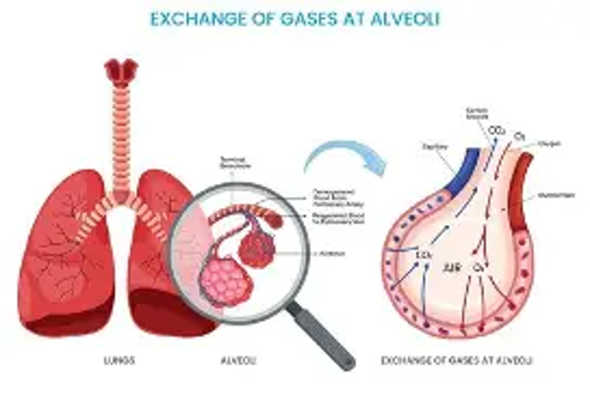

di. Respiratory inflammation is an adaptive response that occurs in the airways and lungs of the body. It encompasses the immune system's response to harmful stimuli, with the objective of eliminating irritants or pathogens and fostering healing (Valenca et al, 2023). This intrinsic defense mechanism can considerably affect both respiratory health and overall quality of life. When harmful agents like viruses or allergens invade the respiratory system, the body triggers an inflammatory response. Immune cells secrete chemical signals that promote the dilation of blood vessels. This augmented blood flow results in swelling and redness, facilitating the recruitment of immune cells to extinguish the threat (Valenca et al, 2023). This response assists in the entrapment and elimination of foreign invaders or damaged cells. Acute inflammation, characterized by its transient nature, is beneficial for recovery. Nonetheless, if irritants endure or if the immune response is perpetually activated, chronic inflammation can inflict damage on healthy tissues, modify lung architecture, and compromise respiratory function, leading to enduring complications (Kallawicha et al, 2024).
Some common causes are infections such as influenza, allergens such as dust mites, and underlying health conditions such gastroesophageal reflux disease.

dii. Impact on respiration
Asthma
Asthma is classified as a chronic condition characterized by persistent inflammation of the airways, resulting in heightened sensitivity to various triggers. This heightened sensitivity induces airway narrowing, increases mucus production, and leads to recurrent episodes of wheezing and difficulty in breathing.
Bronchitis
The bronchial tubes experience inflammation during instances of bronchitis. Acute bronchitis typically follows a viral infection and resolves in a short time frame. In contrast, chronic bronchitis denotes a prolonged state of inflammation accompanied by increased mucus production, frequently triggered by irritants such as cigarette smoke that affect the airways.
Chronic Obstructive Pulmonary Disease (COPD)
Both emphysema and chronic bronchitis are classified as types of COPD, and each of these disorders is associated with persistent inflammatory responses. The underlying inflammation is often instigated by harmful particulates or gases, such as tobacco smoke, which impedes airflow.

e. Although peak flow meter systems have been developed for the assessment of asthma patients, there is an identified need for remote monitoring solutions to support them in all circumstances. This study introduces a mobile health device designed to monitor the whereabouts of individuals with asthma in various situations. The system's architecture comprises a power pack system, an MPX5010DP pressure sensor, and a nodeMCU microcontroller (Owodolu et al, 2023). The system utilizes Wi-Fi, GPS, Google Maps, and SMS to transmit signals and messages between the user's device and components associated with the system. During emergencies, the system facilitates tracking and monitoring of asthmatic patients for emergency responders and their designated family members.

The mobile application associated with the system was created using the Dart programming language, whereas the code for the microcontroller was written in C programming language. The efficacy of the system was assessed through the measurement of the expiratory flow rate. The system was successfully developed and tested via a prototype (Owodolu et al , 2023). The system operates as intended, with each component responding appropriately to the signals received. This methodology can be applied to monitor individuals with asthma, particularly in scenarios of health crises.
Recently, the integration of inertial measurement unit (IMU) sensors has facilitated the monitoring of respiratory micro-movements (Vavrinsky et al. , 2024). The application of techniques such as seismocardiography and ballistography has gained traction. The primary benefit of these sensors is their cost efficiency and easy incorporation into contemporary hardware designs. Over time, these sensors have evolved from being externally attached to the human body to becoming essential elements in everyday products that individuals use, including smart textiles, bedding, seating, and mattresses. Additionally, optical fibre-based sensors are frequently integrated into these objects. With the development of modern bio amplifiers, it has also become feasible to derive respiratory parameters from variations in chest impedance. Remote techniques include the analysis of chest movements derived from visual signals using high-precision cameras or the use of Doppler radars.
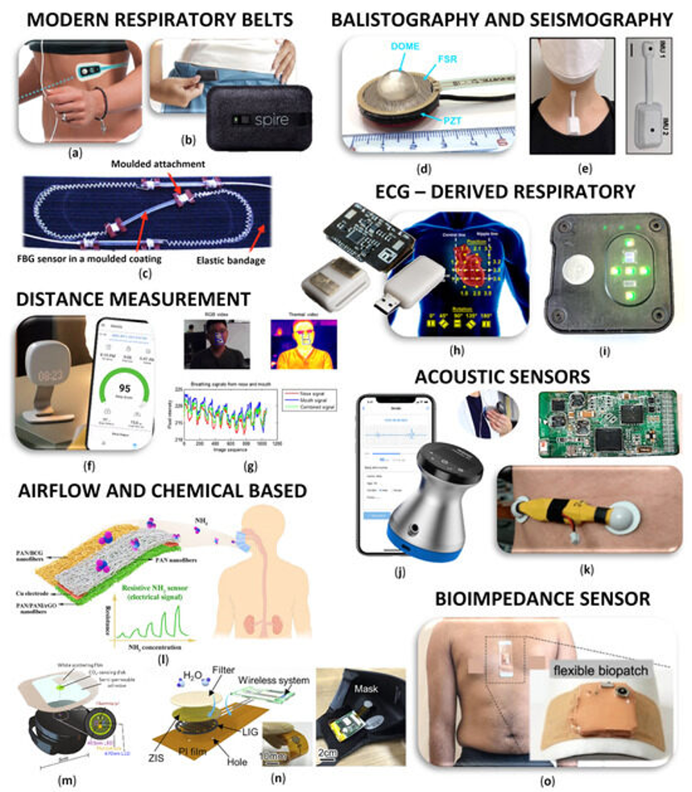

f. Consuming a substantial quantity of fruits, vegetables, and whole grains may provide benefits for overall health and potentially assist in the management of asthma. Antioxidants, such as vitamins C and E present in these foods, may play a role in mitigating inflammation within the airways. A systematic review conducted in 2023 indicated that increased consumption of fruits and vegetables is associated with enhanced lung function among adults suffering from asthma (Smith et al. , 2023). In contrast, multiple studies have indicated that a high intake of processed foods, saturated fats, and sugars may exacerbate inflammation and intensify asthma symptoms. Consequently, it is generally advisable to modify one's dietary habits to adopt a Mediterranean-style diet that emphasizes plant-based foods, lean proteins, and healthy fats. Furthermore, obtaining adequate omega-3 fatty acids, which are abundant in fatty fish such as salmon and mackerel, has demonstrated anti-inflammatory properties that may be advantageous for individuals with asthma. A study published in 2022 indicated that omega-3 supplementation might assist in decreasing the reliance on rescue medication in paediatric asthma patients (Jones and Davies, 2022). However, prior to implementing significant dietary changes or initiating any supplements, it is advisable for individuals to consult with a healthcare professional or a registered dietitian.

Conclusion
Asthma is a complex chronic respiratory condition that necessitates a comprehensive understanding of its aetiology, pathophysiology, and therapeutic approaches. Various factors, ranging from the intricate physiology of the respiratory system and the mechanics of respiration to the vital gas exchange occurring in the alveoli, influence an individual's ability to breathe effectively. It is crucial to acknowledge that individuals diagnosed with asthma possess airways that are significantly hyperresponsive, with inflammatory reactions precipitated by irritants leading to airway inflammation and obstruction, which profoundly affects respiratory function. Consistent monitoring utilizing devices such as peak flow meters enables individuals to maintain their health, detect early indicators of deterioration, and collaborate effectively with healthcare providers. Through the integration of fundamental lifestyle interventions such as avoiding triggers, managing body weight, engaging in regular physical activity, and implementing stress-reduction strategies individuals with asthma can markedly improve their quality of life, alleviate the burden of their symptoms, and prevent debilitating exacerbations. By embracing this multifaceted approach, the challenges posed by asthma can be effectively mitigated, leading to healthier and more fulfilling lives.
References
Akbar, K.A., Chao, H.J., Thanvisitthpon, N., Wongsasuluk, P. and Kallawicha, K., 2024. Respiratory diseases caused by air pollutants. In Diseases and health consequences of air pollution (pp. 27-53). Academic Press. [Accessed 30/07/2026]
Bezerra, F.S., Lanzetti, M., Nesi, R.T., Nagato, A.C., Silva, C.P.E., Kennedy-Feitosa, E., Melo, A.C., Cattani-Cavalieri, I., Porto, L.C. and Valenca, S.S., 2023. Oxidative stress and inflammation in acute and chronic lung injuries. Antioxidants, 12(3), p.548. [Accessed 30/07/2026]
Brinkman , J.E. , Toro , F. , and Sharma , S. ( 2023 ). Physiology, Respiratory Drive . Treasure Island, FL: StatPearls Publishing https://www.ncbi.nlm.nih.gov/books/NBK482414 [Accessed 30/07/2026]
Ionescu, C.M., 2023. The human respiratory system. In The Human Respiratory System: An Analysis of the Interplay between Anatomy, Structure, Breathing and Fractal Dynamics (pp. 13-22). London: Springer London[Accessed 30/07/2026]
Ogunniyi, J.O., Elesemoyo, I.O., Oyewole, O.T., Olowu, A.J. and Owodolu, O., 2023. Development of a Peak Flow Meter to Remotely Monitor Asthmatic Patients in Emergency Cases [Accessed 30/07/2026]
Petersson, J. and Glenny, R.W., 2023, October. Gas exchange in the lung. In Seminars in Respiratory and Critical Care Medicine (Vol. 44, No. 05, pp. 555-568). Thieme Medical Publishers, Inc.[Accessed 30/07/2026]
Sandra O Ansong & Dependable C Amaechi & Emmanuel C Amaechi & Lordsfavour I Anukam & Ijeoma D Elendu & Mary C Joseph & Tochi C Elendu & Chiamaka O Oguoma & Abolore Aminat Ajakaye & Chukwuka Elendu & Varun Tyagi, 2025. Guideline-driven and dependable management of asthma: an evidence-based systematic review - PMC. pmc.ncbi.nlm.nih.gov. Available at: https://pmc.ncbi.nlm.nih.gov/articles/PMC12333720/ [Accessed 04 Aug 2026]
Stern, J., Pier, J. and Litonjua, A.A., 2020, February. Asthma epidemiology and risk factors. In Seminars in immunopathology (Vol. 42, No. 1, pp. 5-15). Berlin/Heidelberg: Springer Berlin Heidelberg [Accessed 30/07/2026]
Vitazkova, D., Foltan, E., Kosnacova, H., Micjan, M., Donoval, M., Kuzma, A., Kopani, M. and Vavrinsky, E., 2024. Advances in respiratory monitoring: A comprehensive review of wearable and remote technologies. Biosensors, 14(2), p.90. [Accessed 30/07/2026]

