In this piece of work, I will be exploring and identifying how media images/identity are often portrayed and how they can be (mis)interpreted within society. (mis)interpreted within society can mean various things in different contexts such as people being (mis)interpreted within a social setting, someone, or something in society being interpreted differently (Wilkson,2002; Morgan & ‎Ltanley, 1993). There is a significant link between social exclusion, and those who are marginalised within society due to the way in which they are portrayed (Macdonald, 2006; Cartwright, 2012). I will be exploring one group such as Mental Health from three different representations within society. I will be exploring theoretical models and exploring the effect of power and control within society, whilst critically exploring theory, policy, and legislation.

Furthermore, when referring to (mis) interpretation within society, it is significantly important to focus on the term social representation. Moloney & Walker (2007) claim;
‘Social Representation can be hard to define, and it cannot be proven that representations occur, we can therefore only establish the power of this concept, through the interoperations we can offer of social phenomenon’ (Moonley & Walker.p.1,2007).

In comparison Duveen & Lloyd (1990) argue that social representations are a system of values, beliefs, ideas and establishes social order through communities. Often social representations within society, start with social issues, thus involving, power, identity, and social class(Mannarini, ‎Veltri, ‎Salvatore, 2020; Flick, 1998). Obhi & Cross (2016) argue social representations, can sometimes be considered as thoughts in movement, which can be developed through communication. Individuals can also contribute to the formation and development in social representations between social structure and individuals, these representations contribute each time to the global vision of a society to establish itself(Marková, 2003).
Höijer (2011) highlights the social representation theory first developed by Serge Moscovici, suggest there is a clear link between Durkheim’s model “collective representations” which refers to concepts, and beliefs that do not belong to isolated individuals, but refer to the product of social collectively (Höijer, 2011 cited in Moscovici, 2000) argues that social representations involve different types of thoughts, and beliefs of societies or groups of people, they are always linked to social or cultural objectives(Madsen, 2015; Gulland, 2019). Moreover, Janowitz (1975) suggests often in society, and communities there are elements of power and control that can sometimes impact an individuals life and can sometime influence the behaviour (Blomberg & Cohen, 2003). Within the origins of sociology ‘social control’ refers to the main concept, for both understanding sociology and the ability to analyse the functioning of society (Deflem, 2010; Deflem, 2019). Sociologists such as Karl Marx, and Max Webber, have highlighted and researched some of the significant issues facing society when referring to social control(Giddens & Sutton, 2017; Chriss, 2007). Furthermore social control can cause exclusion, and conflict within society (Janowitz, 1975 cited in Parkand & Burgess, 1921) claim that;
‘Social control and the mutual relegation of individuals to the community have their own origin within conflict, assume, definite, organized forms within the process of accommodation and are combined and fixed in assimilation’ (Park & Burgess, p.8. 1921).
Ember & Ember (2003) elaborate further, on the three forms of social control, such as Informal Control, Medical Control and Legal Control. Informal control refers to the reactions of groups that can undertake conformity to ‘norms’ this can sometimes be impacted by friends and family and can be as a result to peer pressure(Scott, 2014; Gochman, 1997). Medical control refers to the way in which medication functions, the social control is undertaken to secure particular by using medical means, or power to minimise and reduce deviant behaviour(Scambler, 2005; Green, Meagher, Millon, 2012). Legal control within society refers to the behaviour that should be underpinned by members of society, which are conducted through legal norms through the criminal justice system by suggesting society needs to be ‘fixed’. Whereas in comparison (Chriss & Deflem, 2010 cited in Black,1983) who argues social control can be defined more as any process where individuals respond to deviant behaviour, further suggestions (Chriss & Deflem, 2010 cited in Gibs,1994) who argues, he developed a theory of social control without invoking ‘norms’ such as objectives of control, the ability to control inanimate objects, thus suggesting social control is simply one form of control for all(Chriss, 2007; Deflem, 2019). Which can be demonstrated in the social vs medical model. Thus, the medical model refers to any disability as the individual being the problem, and therefore the disability is also the issue within society(Riva & Eck, 2016; Shakespeare, 1998). Whereas, in comparison the social model refers to the issue existing with society and then excluding them, treating them unequal, rather including them in society, and providing support(Huda, 2019; Bolton, ‎& Gillett, 2019; Heller & Harris, 2012).Power and control have been defined in many different ways according to Alsop (2004) claims that on the World Banks website there are over 900 entries for reports within the subject of ‘power’. Suggesting power is the ability to have an effect (Alsop,2004 cited in Sen,1995) who asserts the standpoint that individuals are not free, when they do not have power to make choices about their life(Njoh, 2007; Stark & Bainbridge, 2013).

Individuals with mental health problems, can sometimes be excluded within society and can sometimes feel powerless. The Mental Health Foundation (2016) highlights that mental health problems are a developing health concern. Suggestions made in 2013 depression due to mental health issues in 26 countries was the main disability. A significant 17% of individuals over the age of 16 experienced mental health problems, The World Health Organisation (WHO) suggests mental health problems, often cause depression and anxiety due to social circumstances, thus being caused by the distribution of power and control within society (The Mental Health Foundation,2016 cited in ONS, 2015) who claim that stigma, misrepresentation, and bullying are strongly liked with mental health problems, between 2011 and 2012 12% of children aged 10-15 were being bulled at school due to these issues(MIND,2021; Scheid & Brown, 2010).
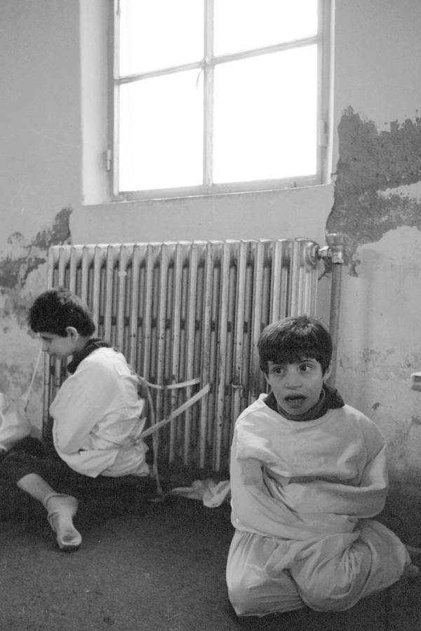
(Getty Images, 2017).

As seen above, this is a photograph of children tied to a radiator inside the psychiatric hospital at Deir el Qamar, Lebanon pictured (1982). During this time, if you had a mental health illness you were excluded from society and considered ‘ill’ or ‘crazy’. Suggestions highlighted by Young (2015) claim mental institutions were developed in order to keep those with mental illness inside, and away from society to ensure there was no threat to humans, they believed mental illness through their lens was seen as a disease, which violated the ‘norms’ within society(Riva & Eck, 2016). Confinement within a mental asylum was the only way in which they thought they could treat the disease, and therefore change the behaviour, as people were referred to as lunatics, psycho and crazy(Rimmerman, 2013). Some of the procedures that were undertaken within these asylums were trephination, where a small part of the skull would be removed, this procedure would often be believed to relieve demonic possession (Selin,1997; Arnott, Finger, ‎ Smith, 2005).

There are significant implications for Equality and Fairness, which results in those with mental health problems being stigmatised against, and treated unequal to other people in society. Layte et al (2010) suggests a majority of European citizens feel socially excluded in society due to the mental health problems, there is a significant links to those who experience mental health problems and being socially excluded within communities and society, social exclusion often happens due to individuals not being classed as demonstrating behaviour of ‘norms’ within society (Spaaij, Magee, Jeanes, 2014). Social exclusion can have implications upon health, due to lack of social support resulting in alienation effecting every aspect of their life, such as the ability to work and socialise and seek help if needed as supported by McKenzie & Harpham (2006). Moreover, higher levels of those with mental health that experience social exclusion and unequal access, result in a greater risk of depression, disability, chronic diseases.(Boardman, ‎ Currie, ‎ Killaspy, 2010; Treviño , 2018).

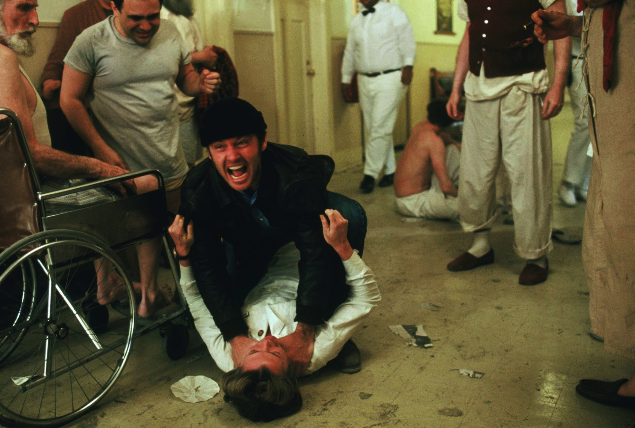
(Warner Bros, 1975).

The photo above is an image from the film One Flew Over The Cuckoo's Nest in (1975) which was played by Jack Nicholson who had a criminal past and had gotten himself into trouble being sentenced by the court, in order to not to go prison he claimed insanity, and was admitted to a mental institution where he rebels against the oppressive behaviour from nurses on the ward who demonstrated a significant amount of power over him(Kesey, 2011). Due to this film there was a significant amount of stigma attached to mental health and as demonstrated in the above photograph, the individual is attacking the nurse which can link to mental illness being linked with aggression, and violence (Lindert & Levav, 2015). Richter & Whittington (2006) claim there are a lot of misconceptions on those with a mental illness, especially when watching this film. Unfortunately, these misconceptions have impacted the way people have been treated, associating a mental health illness in similarity to the film (Arboleda-Flórez & Sartorius, 2008). In the film, the individuals were untitled, and lacked the basic rights a human being, resulting in being manipulated by the nurses(Karp , 2017). Those who were considered as difficult, would be forced to undertake various treatments to try and stop the behaviour(Szasz, 2011). Further claims highlighted by Ash (2019) claim the illness was portrayed as a split personality and violent, which created a lot of stigmatization when people would think about mental health problems, they would automatically be associated with the representation demonstrated within the film which would develop unequal treatment, stigmatization, lack of access to opportunities, alienation and many more difficulties(Gilman , 2019). Suggestions highlight this film was significantly damaging to those with mental health problems, and caused a significant impact to those who were labelled and misrepresented within society due to the effect of media( Elder, Evans, Nizette,2011).


(Hello Magazine, 2018).

The photo demonstrated above, is a photograph of Price Harry pictured in Hello Magazine, Prince harry is the Duke of Sussex, and a member of the royal family. Demonstrated in this photo you see a wealthy Prince, who has been privileged within society, (Krajnik, 2019). Claims suggested by Droby (2020) that Price Harry has been struggling with Mental Health Issues since the passing of his Mother and is now working with various projects in order to reduce the stigma of Mental Health. The unfair treatment is demonstrated in this photograph due to his positioning within society and social class, due to the power he holds he was not stigmatized against due to his battle with mental health issues, he was provided with support and understanding. David Melzer, Jenkins & Fryers (2004) claim individuals who are in higher social classes, are being less stigmatised against when demonstrating health inequalities, in comparison to individuals from a poorer, socio-economic background. Social Inequalities are established structures within society, with clear evidence of stigmatization from those who do not hold a high social positioning or hierarchy(Artorius, Gaebel, Rössler, 2017).

In conclusion, it is evident that from the images used within this piece of work, there are individuals who have been (mis)interpreted within society partially focusing upon those with mental health problems. There are significant challenges demonstrated in all three images for those with mental health problems such as stigmatization and social exclusion which is still present within a 21st century, and as a result many individuals experience depression, and anxiety (Durbano, 2015). The Welsh Government have been developing ways in which they can overcome stigma and provide individuals with the adequate support they need in order to manage any difficulties they are experiencing. The Welsh Government (2016) suggest that Together for Mental Health Delivery Plan is a 10-year strategy to improve the mental health and overall well-being for individuals in order to ensure people access the correct support. They include the Well-being of Future Generations (Wales) Act (2015) to reduce mental health problems as this act aims to work with communities, in a joint up approach to reduce problems, ensuring they consider the long-term impact and create a more suitable Wales. The Mental Health Act (1983) was also implemented by the Welsh Government, which underpinned certain values that should be followed. One of the points from the act was to ensure individuals were treated with dignity, and their opinions and views were listened too and protected. The code of conduct, is there to be followed and promote good practice amongst all those providing mental health services(Welsh Government, 2016). Further suggestions on how mental health is being promoted within society can be identified by MIND (2021) as they have been involved in the Heads Together Mental Health charity which is led by the Duke, and Duchess of Cambridge and Prince Harry which has encouraged many individuals to have important discussions around the issues facing mental health, the charity provides a £2 million fund which is in place to create digital tools and online programmes, to support people online and in the community. Although, the government are working towards tackling barriers of mental health, claims suggest mental health awareness should be raised through education in order for individuals to fully understand the implications, and support available to them(Hymer, ‎ Lockney, Ewens, 2018).

Reference List:
Alsop, R., 2004. Power, Rights, and Poverty: Concepts and Connections. [online] A working meeting sponsored by DFID and the World Bank March 23–24, 2004. Available at: <https://moodle.uwtsd.ac.uk/pluginfile.php/438223/mod_resource/content/0/ECED7002%20Session%202%20power%20rights%20and%20poverty%20cocepts%20and%20connections.pdf> [Accessed 5th March, 2021].

Arboleda-Flórez, J. and Sartorius, N., 2008. Understanding the Stigma of Mental Illness Theory and Interventions. 1st ed. Great Britain: Wiley & Sons.

Arnott, R., Finger, S. and Smith, C., 2005. Trepanation. 1st ed. The Netherlands: Taylor & Francis.

Ash, P., 2019. From Courtroom to Clinic Legal Cases that Changed Mental Health Treatment. 1st ed. Cambridge: Cambridge University Press.

Blomberg, T. and Cohen, S., 2003. Punishment and Social Control. 2nd ed. New York: Aldine Publishers.

Bolton, D. and Gillett, G., 2019. The Biopsychosocial Model of Health and Disease New Philosophical and Scientific Developments. 1st ed. London: Springer International Publishing.

Cartwright, J., 2012. Misrepresentation, Mistake and Non-disclosure. 3rd ed. Maxwell: Great Britain.

Chriss, J. and Deflem, M., 2010. Social Control Informal, Legal and Medical. 1st ed. UK: Emerald Group Publishing Limited.

Chriss, J., 2007. Social Control An Introduction. 1st ed. USA: Polity Press.

Cross, E. and Obhi, S., 2016. Shared Representations Sensorimotor Foundations of Social Life. 1st ed. Cambridge: Cambridge University Press.

Deflem, M., 2010. Popular Culture, Crime and Social Control. 1st ed. UK: Emerald Group Publishing Limited.

Deflem, M., 2019. The Handbook of Social Control. 1st ed. UK: Wiley & Sons ltd.

Droby, R., 2020. With the Wind and the Waves A Guide to Mental Health Practices in Alaska Native Communities. 1st ed. Alaska: University of Alaska Press.
Ember, C. and Ember, M., 2004. Encyclopedia of Medical Anthropology Health and Illness in the World's Cultures Topics. 1st ed. New York: Springer.

Evans, K., Create, N. and Elder, R., 2011. Psychiatric & Mental Health Nursing. 2nd ed. New Zealand: lsevier Health Sciences.

Fryers, T., Melzer, D. and Jenkins, R., 2004. Social Inequalities and the Distribution of the Common Mental Disorders. 1st ed. New York: Taylor & Francis.

Gaebel, W., Rössler, W. and Sartorius, N., 2017. The Stigma of Mental Illness - End of the Story?. 1st ed. London: Springer.

Getty Images, 2017. Child patients sit bound and tied to a radiator inside the psychiatric hospital at Deir el Qamar, Lebanon in 1982.. [image] Available at: <https://allthatsinteresting.com/mental-asylums#3> [Accessed 26th March, 2021].

Giddens, A. and Sutton, P., 2017. Essential Concepts in Sociology. 2nd ed. USA: Polity Press.

Gilman, S., 1988. Disease and Representation Images of Illness from Madness to Aids. 1st ed. New York: Cornell University Press.

Gochman, D., 1997. Handbook of Health Behavior Research I Personal and Social Determinants. 1st ed. New York & London: Springer.

Gov.wales. 2016. Mental Health Act 1983 Code of Practice for Wales Review. [online] Available at: <https://gov.wales/sites/default/files/publications/2019-03/mental-health-act-1983-code-of-practice-mental-health-act-1983-for-wales-review-revised-2016.pdf> [Accessed 17th March, 2021].

Gov.wales. 2016. Together for Mental Health Delivery Plan: 2016-19. [online] Available at: <https://gov.wales/sites/default/files/publications/2018-12/mental-health-delivery-plan-2016-to-2019.pdf> [Accessed 4th March, 2021].

Green, C. and Meagher, R., 2012. Handbook of Clinical Health Psychology. 1st ed. New York: Springer.

Gulland, J., 2019. Gender, Work and Social Control A Century of Disability Benefits. 1st ed. UK: Palgrave Macmillan.

Heller, T. and Harris, S., 2012. Disability Through the Life Course. 1st ed. London: SAGE Publications.

Hello Magazine, 2018. Why Prince Harry will keep his beard for the royal wedding. [image] Available at: <https://www.hellomagazine.com/royalty/2018051148524/prince-harry-keep-beard-royal-wedding/> [Accessed 2nd March, 2021].

Höijer, B., 2011. Social Representations Theory A New Theory for Media Research. [online] Core.ac.uk. Available at: <https://core.ac.uk/download/pdf/43557448.pdf> [Accessed 1 March 2021].

Huda, A., 2019. The Medical Model in Mental Health An Explanation and Evaluation. 1st ed. United Kingdom: Oxford University Press.

Hymer, B., Howard, C., Glazzard, J., Ewens, T. and Lockney, K., 2018. Themes and Issues in Primary Education. 1st ed. Great Britain: Critical Publishing.

Janowitz, M., 1975. Sociological Theory and Social Control. Chicago Journals, [online] Vol. 81(No. 1). Available at: <https://moodle.uwtsd.ac.uk/pluginfile.php/438232/mod_resource/content/0/ECED7002%20Session%203%20Sociological%20Theory%20and%20Social%20Control.pdf> [Accessed 2nd March, 2021].
Karp, D., 2017. Speaking of Sadness Depression, Disconnection, and the Meanings of Illness. 1st ed. UK: Oxford University Press.

Kesey, K., 2011. One Flew Over the Cuckoo's Nest. 1st ed. UK: Penguin Books Limited.

Killaspy, H., Boardman, J., Gillian, G. and Currie, A., 2010. Social Inclusion and Mental Health. 1st ed. London: Royal College of Psychiatrists.

Krajnik, E., 2019. Prince Harry Royal Rule-Breaker. 1st ed. New York: Greenhaven Publishing.

Layte, R. and Maître, B., 2010. econd European Quality of Life Survey Living conditions, social exclusion and mental well-being. [online] Mentalhealthpromotion.net. Available at: <http://www.mentalhealthpromotion.net/resources/living-conditions-social-exclusion-and-mental-wellbeing.pdf> [Accessed 2nd March, 2021].

Levav, I. and Lindert, J., 2015. Violence and Mental Health Its Manifold Faces. 1st ed. USA: Springer.

Lloyd, B., 1990. Social Representations and the Development of Knowledge. 1st ed. Australia: Cambridge University Press.

Macdonald, R., 2006. Youth, The 'Underclass' and Social Exclusion. 1st ed. London: Taylor & Francis.

Madsen, O., 2015. Optimizing the Self Social Representations of Self-help. 1st ed. New York: Taylor & Francis.

Markova, I., 2003. Dialogicality and Social Representations The Dynamics of Mind. 1st ed. Cambridge: Cambridge University Press.

McKenzie, K. and Harpham, T., 2006. Social Capital and Mental Health. 1st ed. USA: Jessica Kingsley Publishers.

Mentalhealth.org. 2021. Mental health statistics: poverty. [online] Available at: <https://www.mentalhealth.org.uk/statistics/mental-health-statistics-poverty> [Accessed 17th March, 2021].

Mind.org.uk. 2021. Heads Together. [online] Available at: <https://www.mind.org.uk/news-campaigns/campaigns/heads-together/> [Accessed 2 March 2021].

Mind.org.uk. 2021. What are mental health problems?. [online] Available at: <https://www.mind.org.uk/information-support/types-of-mental-health-problems/mental-health-problems-introduction/about-mental-health-problems/> [Accessed 2nd March, 2021].

Njoh, A., 2006. Planning Power Town Planning and Social Control. 1st ed. USA: Taylor & Francis.
Richter, D. and Whittington, R., 2006. Violence in Mental Health Settings Causes, Consequences, Management. 1st ed. England: Springer New York.

Rimmerman, A., 2013. Social Inclusion of People with Disabilities National and International Perspectives. 1st ed. Cambridge: Cambridge University Press.

Riva, P. and Eck, J., 2016. Social Exclusion Psychological Approaches to Understanding and Reducing Its Impact. 1st ed. London: Springer.

Riva, P. and Eck, J., 2016. Social Exclusion Psychological Approaches to Understanding and Reducing Its Impact. 1st ed. Switzerland: Springer.

Salvatore, S., Mannarini, T. and Veltri, G., 2020. Media and Social Representations of Otherness Psycho-Social-Cultural Implications. 1st ed. Italy: Springer.
Scambler, G., 2005. Medical Sociology Major Themes in Health and Social Welfare. 1st ed. London & New York: Routledge.

Scheid, T. and Brown, T., 2021. A Handbook for the Study of Mental Health Social Contexts, Theories, and Systems. 1st ed. Cambridge: Cambridge University Press.

Scott, J., 2014. A Dictionary of Sociology. 1st ed. UK: Oxford University Press.

Selin, H., 1997. Encyclopaedia of the History of Science, Technology, and Medicine. 1st ed. USA: Kluwer Academic Publishers.

Shakespeare, T., 1998. Disability Reader Social Science Perspectives. 1st ed. London: Bloomsbury Academic.

Spaaij, R., Jeanes, R. and Magee, J., 2014. Sport and Social Exclusion in Global Society. 1st ed. New York: Taylor & Francis.

Stanley, L., 1993. Debates in Sociology. 1st ed. Manchester: Manchester University Press.

Stark, R. and Bainbridge, S., 2013. Religion, Deviance, and Social Control. 1st ed. New York: Taylor & Francis.

Szasz, T., 2011. The Myth of Mental Illness Foundations of a Theory of Personal Conduct. 1st ed. London: Harper Collins e-books.

Treviño, A., 2018. The Cambridge Handbook of Social Problems. 1st ed. Cambridge: Cambridge University Press.

Walker, I., 2007. Social Representations and Identity Content, Process, and Power. 1st ed. England: Palgrave Macmillan.

Warner Bros, 1975. One Flew Over the Cuckoo's Nest (1975). [image] Available at: <https://www.imdb.com/title/tt0073486/mediaindex> [Accessed 2nd March, 2021].

Wilkinson, R., 2001. Unhealthy Societies The Afflictions of Inequality. 1st ed. London and New York: Taylor & Francis.

Young, M., 2015. Encyclopedia of Asylum Therapeutics, 1750-1950s. 1st ed. London: McFarland, Incorporated, Publishers.

