

Critical Literature Review for Doctoral Research

Assignment

LCDB7009

Module Lead: Dr Emma Roberts

Submitted by: Zhanyu Gou

July 2022

Part I-Critically Explore the Purpose, Content and Format of a Critical Literature Review for Doctoral Research.

Critical Literature Review
Literature review is a process of critical analysis and synthesis of exsiting research that provides the key concepts, assumptions, beliefs, and theories that serve as the conceptual foundation of a research (Maxwell, 2005; Creswell, 2007, Efron and Ravid, 2018). Literature reviews are conducted for a variety of purposes and are formatted differently depending on the intended audience. For doctoral researchers, the practice of reviewing literature is perceived as engaging in the research discourse and recognizing the unique integration of theories and past work in an academic field. The literature review is a vital part of the development of conceptual, critical, and creative work due to its interaction with theoretical perspectives, theory, and a diversity of recent work in the subject area (Wisker ,2015). A researcher benefits from the literature review in various aspects as Maxwell (2005) describes “These valuables include new terminology, including keywords to use in searches; references to other publications and researchers; ways of framing research questions, describing the research, or presenting theory, results, or conclusions; and identification of validity issues and ways of dealing with these” (p65) .
Instead of a descriptive list of the literatures, a high-quality critical literature review provides the reader a comprehensive and unbiased evaluation of the most relevant pieces of work. Moreover, through critical synthesis and integration, the researcher contributes novel finding of trends, themes, and research gaps in the research issue area (Torraco, 2016; Efron and Ravid, 2018). Therefore, the doctoral level researchers must demonstrate not only information seeking ability, but also critical thinking skills to evaluate and interpret information, to reveal the unresolved debates, inconsistencies, tensions, and questions in the research filed, and then to formulate well-designed research questions (Torraco, 2016; Cottrell, 2017).
The process of developing a critical literature review is iterative. To analyze and contextualize the work, as each layer of inquiry is added, there is a return to a deeper, and more selective comprehension of past reading and newly discovered significant literature (Templier and Paré, 2015). Through constructing, returning to, and completing the literature review, the researcher develops an ongoing constructive dialogue between the previous knowledge on the specific research question. This iterative process empowers the researcher to become a part of the research field with the appreciation for their engagement and contribution to knowledge (Templier and Paré, 2015; Wisker ,2015).
Purpose of Critical literature Review
A critical literature review serves multilevel of purposes. It assists the researcher in comprehending the study background, previously investigated regions and methods, and research gaps to be filled. (Templier and Paré, 2015). These objectives are classified into three major categories (Efron and Ravid, 2018): to provide the research context, to inform the research design and methodology, and to highlight areas for improving scholarship in the discipline.
To Provide the Research context
A critical literature review presents the historical background and a contemporary context of the research area for a research topic to situate within. Through recognizing the influential researchers and seminal studies, contrasting perspectives, ideas, and approaches, a literature review constructs a theoretical framework to guide the entire research process. Furthermore, a literature review discusses current debates, controversies, and questions to identify relationships between ideas and theories and their practical implications (Efron and Ravid, 2018). A good understanding of the research context helps the researcher to modify and refine the initial research problem to make it feasible in the iterative process (Templier and Paré, 2015).
To Inform the Research Design and Methodology
A critical literature review identifies and evaluates the methodological assumptions and research procedures utilized in prior studies. These findings aid the researchers in developing the research design, methodological stance, data collection and analysis strategy. By reviewing the existing research approaches, the method-based gap may be found, and a new research methodology or design will be adopted. (Efron and Ravid, 2018). Moreover, researchers can defend their research methods, tools, questions, and procedures with the review information on methodology and research design (Templier and Paré, 2015).
To Identify Areas for Advancing the Scholarship in the Field
A critical literature review identifies research gaps, establishes research priorities, and outlines research significance (Efron and Ravid, 2018; Nyanchoka, L. et al. 2019). Synthesis of existing research may identify new viewpoints or interpretations, furthermore, gaps in knowledge, methodology, and theory may emerged which empower the researchers extend the academic exploration in this area. A literature review demonstrates the significance of the topic it addresses, so that, the researcher can justify the significance of the study.
Content of Critical Literature Review
Scholars summarize the major steps in developing and conducting a literature review (See Table1). A literature review designs the protocol which follows these steps will generates the contents including a broad academic overview of the study field, identifying key researchers and theorists, key concepts and definitions, identifying research gap, and ending with formulating research question (Efron and Ravid, 2018).
Table1: Literature Review Developing and Conducting Steps
Efron and Ravid, 2018. CLAS-WE | Templier and Paré, 2015
1. choosing a literature review topic | (1) formulating the problem
2. locating literature review sources | (2) searching the literature
3. analyzing and evaluating the literature review sources | (3) screening for inclusion
4. synthesizing the literature | (4) assessing quality,
5. writing the literature review, | (5) extracting data,
6. editing and refining the literature review | (6)analyzing and synthesizing data
Resources: Efron and Ravid, 2018;Templier and Paré, 2015.

Format of Critical Literature Review
A literature review may serve either as the foundation for research or as a meaningful stand-alone piece of work. Both types are exhaustive and emphasize the cumulative and evolutionary nature of knowledge development. There are various sorts of literature reviews, ranging from systematic to traditional–narrative to hermeneutic–phenomenological, depending on the researcher’s methodological perspective (Efron and Ravid, 2018). Cooper (1984, cited in Creswell, 2016) categorized the literature review into three forms which are integrative review, theoretical review and methodological review. For doctoral level study, an integrative review is the most adopted form.
Although there are a variety of literature review approaches, a systematical designing and conducting process ensures to identify a comprehensive body of studies on the research topic, additionally, to reduce the possibility of bias (Booth, 2016). It is essential that a critical literature review be guided by research questions; alternatively, the design of the literature review is defined by the nature of the research question, the underlying theoretical inquiry, and the research objective. (Booth, Sutton and Papaioannou, 2016).
Summary of Critical Literature Review
In sum, a critical literature review is a systematic, explicit, and reproducible approach for recognizing, analyzing, and synthesizing the existing body of knowledge in a research area. A critical literature review serves to identify existing knowledge and research gaps relevant to the research and its context. In addition, it provides the basis for the formulation of appropriate research questions. The purpose of a critical literature review can be summed up as follows: to set the context for a study, to inform the research design and methodology, and to identify areas for advancing. A critical literature review is expected to cover the broad academic field of the research topic, a focused critical analysis on the key concepts and theories, a novel navigation of research gap, and a well-constructed research question. For the researchers, the production of a good literature review enlarges their knowledge and understanding in the research area, empowers them with confidence and contribution in their field.

Reference
Booth, A., Sutton, A. and Papaioannou, D. (2016) 'Systematic approaches to a successful literature review'. Second edition edn. Los Angeles: Sage, pp. 326.
Cooper HM (1988). Organizing knowledge synthesis: a taxonomy of literature reviews. Knowl. Soc. 1(1):104-126. DOI: 10.1007/BF003177550
Cunliffe, A.L. (2004) 'On Becoming a Critically Reflexive Practitioner', Journal of Management Education, 28(4), pp. 407-426. doi: 10.1177/1052562904264440.
Efron, S.E. and Ravid, R. (2018) 'Writing the Literature Review: A Practical Guide' New York, UNITED STATES: Guilford Publications.
Maxwell, J.A., Boote, D.N. and Beile, P. (2006) 'Literature Reviews of, and for, Educational Research: A Commentary on Boote and Beile's "Scholars Before Researchers"/On "Literature Reviews of, and for, Educational Research": A Response to the Critique by Joseph Maxwell', Educational Researcher, 35(9), pp. 28-35.
Nyanchoka, L. et al. (2019) ‘A scoping review describes methods used to identify, prioritize and display gaps in health research’, Journal of Clinical Epidemiology, 109, pp. 99–110. Available at: https://doi.org/10.1016/j.jclinepi.2019.01.005.

Paré, G. and Kitsiou, S. (2017) 'Chapter 9 Methods for Literature Reviews' University of Victoria.
Templier, M., Paré, G., 2015. A Framework for Guiding and Evaluating Literature Reviews. CAIS 37. https://doi.org/10.17705/1CAIS.03706
Terry Rowlands, Neal Waddell & Bernard McKenna (2016) Are We There Yet? A Technique to Determine Theoretical Saturation, Journal of Computer Information Systems, 56:1, 40-47, DOI: 10.1080/08874417.2015.11645799
Torraco, R.J. (2016) ‘Writing Integrative Literature Reviews: Using the Past and Present to Explore the Future’, Human Resource Development Review, 15(4), pp. 404–428. Available at: https://doi.org/10.1177/1534484316671606.

Wisker, G. (2015) 'Developing doctoral authors: engaging with theoretical perspectives through the literature review', Innovations in Education and Teaching International, 52(1), pp. 64-74. doi: 10.1080/14703297.2014.981841.
Xu, W. and Stahl, G. (2021) 'Reflexivity and cross-cultural education: a Foucauldian framework for becoming an ethical teacher-researcher', Asia Pacific Education Review, . doi: 10.1007/s12564-021-09723-8.

Part II
In the first section, I will describe this literature review's design in relation to the research topic and justify the literature review design in a grounded theory approach. The second section demonstrates how I designed and conducted the literature review, including the plan and organization of the literature review's purpose, the review questions, the search strategy, literature selection criteria and procedures, data extraction strategy, and synthesis of the extracted evidence.
Research Topic and Literature Review Design
Research Topic
In the initial stage, this study proposes the research topic as enterprise social media’s impact on knowledge hiding behaviour in the knowledge creation and transfer process. Accordingly, the tentative research question is: How does enterprise social media influence the knowledge hiding behaviour in the knowledge creation and knowledge transfer process? This study aims to investigate and identify the impact of enterprise social media on knowledge hiding behavior in the knowledge creation and transfer process, and to build an explanatory theory to explain this impact.
Literature Review Design in Grounded Theory Approach
In most studies, the literature review is undertaken prior to the data collecting and analysis stages to contextualise the research, its design, and identify the existing theoretical or practical gaps (Creswell, 2012). However, the nature of the research question is to investigate and interpret a social phenomenon, the theoretical inquiry underneath the research question is to understand the relationship between the technological tool and human behaviour within an organization. To align with the nature of the research question, the theoretical inquiry underneath the research question, and the research purpose, this study adopts grounded theory as the research methodology, because it is consistent with the research purpose of investigating and interpreting the little-known technology and human interaction process.
In grounded theory research approach, a literature study prior to data collection and analysis was perceived as a restrictive activity (Strauss and Corbin, 1998). Researchers in grounded theory take different stances on whether a literature review prior to data collection affect the reliability and validity (Strauss and Corbin, 1998; Glaser and Strauss, 2010). This study holds the viewpoint that with the purpose to identify the research gap, justify the rationale for research, a preliminary literature review in an early stage is acceptable (Charmaz, 2005). Nevertheless, a comprehensive literature review will be conducted until after the data analysis process.
Literature Review Design and Conduct of This Study
A literature review design consists of the plan and organization of the purpose of the literature review, the review questions, the search strategy, literature selection criteria and procedures, data extraction strategy, synthesis of the extracted evidence, and a time schedule (Booth, Sutton and Papaioannou, 2016).
Literature Review Purpose
A literature review consists of multilevel of purposes, including a broad academic overview of the study field, identifying key researchers and theorists, key concepts and definitions, identifying research gap, and ending with formulating research question (Efron and Ravid, 2018）. Accordingly, this literature review set the purpose as:
- To review and analyze the theoretical development of knowledge hiding behaviour in the knowledge management field.
- To review and analyze the current research on enterprise social media’s relationship with the knowledge management, including knowledge creation and knowledge transfer process.
- To review and analyze the current research on enterprise social media’s relationship with knowledge sharing and knowledge hiding behaviour.
- to identify and evaluate the research methods adopted in knowledge management field, and different theoretical perspectives underneath.
- To identify the research gap existed in the field of enterprise social media’s impact on knowledge hiding.
Literature Review Question
- What is theoretical development path of research on knowledge hiding in the knowledge management field?
- What are the key researchers, the seminal works, the key journals in the field of knowledge hiding behaviour study?
- What is theoretical development path of research on the relationship of enterprise social media and knowledge hiding topic?
- What are the key researchers, the seminal works, the key journals on the relationship of enterprise social media and knowledge hiding topic?
- What are the theories, concepts, arguments on the relationship of enterprise social media and knowledge hiding topic?
- What research methodology and methods have been adopted in the existed study? And what the limitations and future research recommendations?
- What are the practical challenges for business to manage the usage of enterprise social media in the knowledge management process?
These review questions are structured to achieve the purpose of the literature review. Through finding answers to the review question, the researcher will develop the understanding of the field, to identify what has been examined and what the gaps for further study.
Literature Review Search Strategy
The purpose of review search is to find high quality up-to-date literature to answer the review questions. The search started from a skim scan for review type of paper in the subject of “knowledge management, knowledge-hiding, knowledge-sharing, social media AND knowledge management” in database as ProQuest, Jstor for English peered-reviewed papers published from year 2017 to 2022. Moreover, with the help of AI filtering programs as Connected Papers (See Screenshot1), Open Knowledge Map (See Screenshot2), the research located the most relevant papers within the recent five years for further analysis and synthesis.

Screenshot1
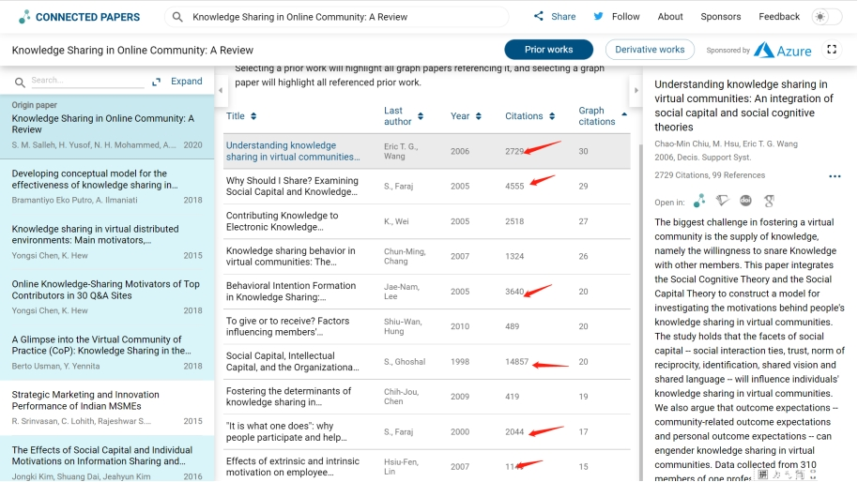

Screenshot2
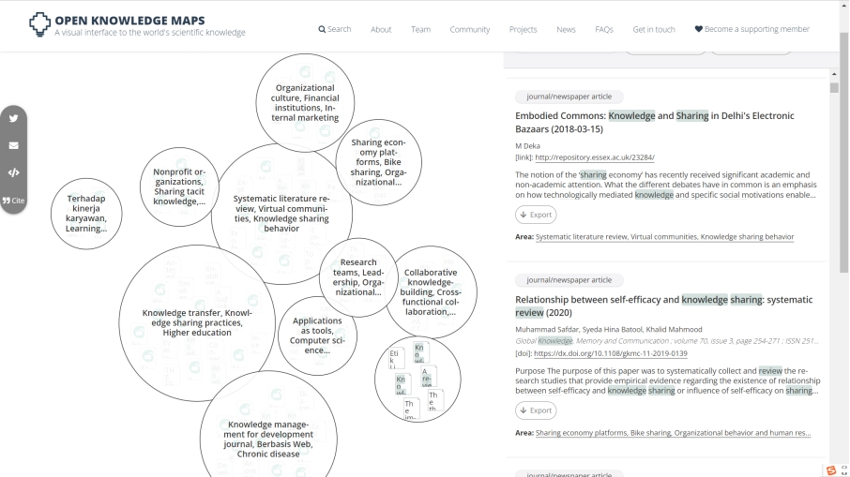
The reading started from the secondary sources which are mainly review papers conducted with methods of systematic review, meta-analysis, bibliometric, and morphological analysis. Based on the reviews paper published within three years (2019-2022), keywords were identified including: knowledge management, knowledge creation, knowledge sharing, knowledge hiding, hidden knowledge, knowledge sharing barriers, withholding inputs or knowledge, knowledge transfer, social media, enterprise/corporate social media (Di Vaio et al., 2021; He et al., 2021; Garg, K., Ganguly, 2022; Bernatović, 2022). Additionally, seminal works, key authors, key journals were identified (see Table1).
Table1
2012 | Knowledge hiding in organizations  2012 | Catherine E. Connelly, David Zweig, Jane Webster, John P. Trougakos | Journal of Organizational Behavior
2016 | Understanding counterproductive knowledge behavior: antecedents and consequences of intra-organizational knowledge hiding  2016 | Serenko, A. and Bontis, N. | Journal of Knowledge Management
2013 | Why and when do people hide knowledge?  2013 | Peng, H. | Journal of Knowledge Management
2020 | Why should I share knowledge with others? A review-based framework on events leading to knowledge hiding  2020 | Anand, A., Centobelli, P. and Cerchione, R. | Journal of Organizational Change Management
2015 | How perpetrators and targets construe knowledge hiding in organizations  2015 | Connelly, C.E. and Zweig, D. | European Journal of Work and Organizational Psychology
2022 | Knowledge Sharing and Sustainable Development  2022 | Russ, M. | Sustainability
2021 | Knowledge sharing and innovation: A systematic review  2021
 | What is not hidden about knowledge hiding: Deciphering the future research directions through a morphological analysis  2021 | Issac, A.C., Baral, R. and Bednall, T.C. | Knowledge and Process Management
2020 | Enterprise social media usage and knowledge hiding: a motivation theory perspective  2020 | Ma, L., Zhang, X. and Ding, X. | Journal of Knowledge Management
2021 | Knowledge hiding and knowledge hoarding: A systematic literature review  202 | Oliveira, M., Curado, C. and de Garcia, P.S. | Knowledge and Process Management
2013 | Enterprise Social Media-Definition, History, and Prospects for the study of social technologies in Organizations  2013 | Leonardi, P.M., Huysman, M. and Steinfield, C | Journal of Computer-Mediated Communication
2020 | Social media in knowledge management: A holistic knowledge funnel based on a retrospective 10‐year study in top‐tier journals  2020 | Narazaki, | Knowledge and Process Management
1996 | Knowledge and the firm: Overview  1996 | Spender, J.-C. and Grant, R.M. | Strategic Management Journal
2016 | What factors influence knowledge sharing in organizations? A social dilemma perspective of social media communication  2016 | Razmerita, Kirchner and Nielsen | Journal of Knowledge Management
2019 | The impact of enterprise social media platforms on knowledge sharing: An affordance lens perspective.  201 | Sun et al. | Journal of Enterprise Information Management

The second stage of reading focused on the primary sources which were mainly the key papers. More detailed understanding of theories, relationships among concepts and constructs, arguments, different research approaches/methods were developed.
Literature Selection Criteria and Procedures
Selection among the literature were followed the eight criteria (Bruce, 2001) which are topicality, comprehensiveness, breadth, relevance, currency, exclusion, authority, and availability. Among more than 100 papers in a basic database, 15 papers in knowledge hiding, 12 in knowledge management, 26 in knowledge sharing, and 8 in knowledge-based theory were selected respectively for further reading (See screenshot 3) and bibliographic notes were taken (See screenshot 4).
Screenshot 3


Screenshot 4
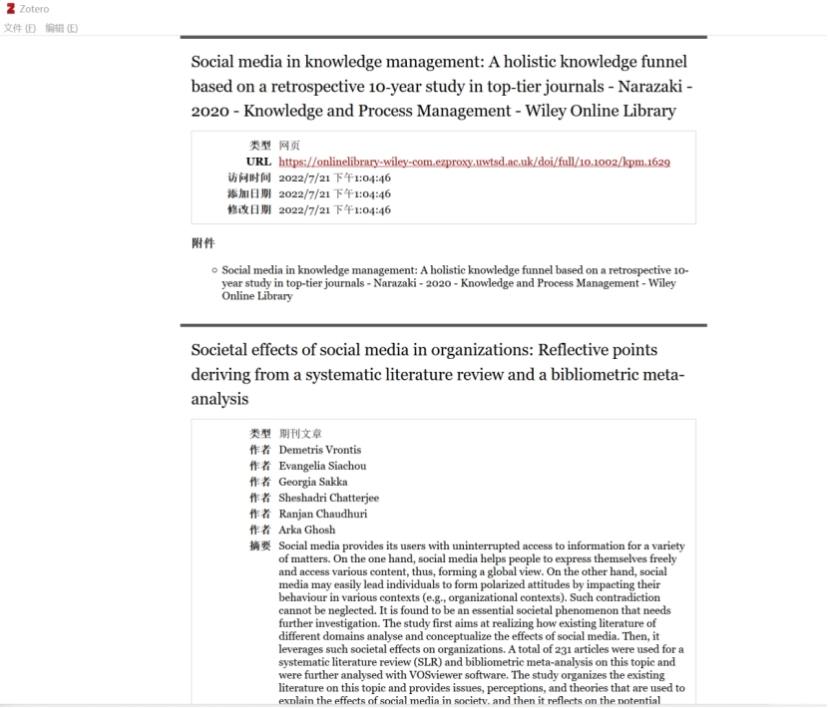
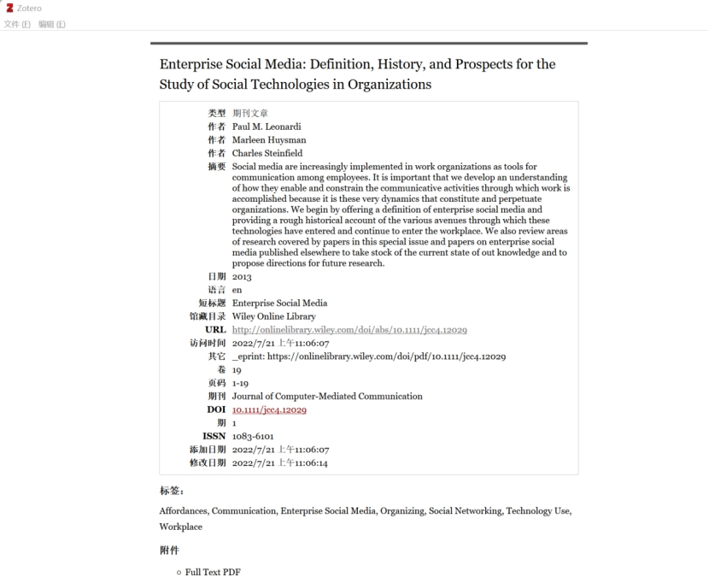
Synthesis of the extracted evidence
Literature synthesis in qualitative research focuses on identifying the theme or pattern that emerged from the data (Booth, et.al., 2016). Table2 displays a portion of the iterative nature of the synthesis process.
Table2 Synthesis of Literature
Author | Research Design Methodology  Research Approach | Relevance to my research | Research Purpose (RP), Research Objectives (RO), Research Questions (RQ) | Findings
Catherine E. Connelly, David Zweig, Jane Webster, John P. Trougakos | study 1. an experience sampling methodology (ESM) to uncover knowledge transfer events, then qualitative interviews to understand the dimensionality of the construct.  Study 2. quantatitive-survey. dimensionality of the knowledge hiding items-playing dumb, evasive hiding, and rationalized hiding are identified.  study3: quantatitive-survey. distrust and Kh. | seminal work, construct of Kh.  a multidimensional measure of this construct. Theoretical antecedents and consequences of knowledge hiding in organizations | this paper develops and investigates a novel construct, knowledge hiding. We establish that knowledge hiding exists, we distinguish knowledge hiding from related concepts (knowledge hoarding and knowledge sharing), and we develop a multidimensional measure of this construct. We also identify several predictors of knowledge hiding in organizations. . | The results of three studies, using different methods, suggest that knowledge hiding is comprised of three related factors: evasive hiding, rationalized hiding, and playing dumb. Each of these hiding behaviors is predicted by distrust, yet each also has a different set of interpersonal and organizational predictors.
Author | Research Design Methodology  Research Approach | Relevance to my research | Research Purpose (RP), Research Objectives (RO), Research Questions (RQ) | Findings
Peng, H. | Quantitative | the link between knowledge-based psychological  ownership and knowledge hiding. | that knowledge-based psychological ownership positively affects  knowledge hiding.  Moreover, organization-based psychological ownership moderates | the positive link between territoriality and knowledge hiding. Specifically, territoriality will mediate the  indirect effect of knowledge-based psychological ownership on knowledge hiding when  organization-based psychological ownership is low, but not when it is high
Serenko, A. and Bontis, N. | quantitative | sample: knowledge workers from 15 North American credit unions.  Findings: antecedents and consequences of KH. | The availability of knowledge management systems and knowledge policies has no impact on intra-organizational knowledge hiding.  The existence of a positive organizational knowledge culture has a negative effect on intra-organizational knowledge hiding.  In contrast, job insecurity motivates knowledge hiding. Employees may reciprocate negative knowledge behavior | 1. Knowledge hiding and knowledge sharing belong to unique yet possibly overlapping constructs.  2. Individual employees believe that they engage in knowledge hiding to a lesser degree than their co-workers.
Author | Research Design Methodology  Research Approach | Relevance to my research | Research Purpose (RP), Research Objectives (RO), Research Questions (RQ) | Findings
Ma, L., Zhang, X. and Ding, X. | Quantitative  Based on the intrinsic and extrinsic motivation model using a structural equation modeling analysis of 288 employees’ data.  a seven-point Likert scale open-ended questionaire | highly relevant research topic: whether the use of enterprise social media affects knowledge hiding or not.  The research model developed through the research; | Purpose, to examine whether the use of enterprise social media inhibits or promotes knowledge hiding is still unclear. contributes to knowledge-hiding literature by revealing a boundary condition, namely, job engagement. | work-related public social media usage has an inhibiting effect on employees’ knowledge hiding, whereas the effect of work-related private social media usage on employees’ knowledge hiding is not significant;  socially related public social media and private social media usage has a promoting effect on employees’ knowledge hiding; and job engagement acts in a positive moderating role between socially related private and public social media usage
Author | Research Design Methodology  Research Approach | Relevance to my research | Research Purpose (RP), Research Objectives (RO), Research Questions (RQ) | Findings
Narazaki, | a systematic literature review comprising articles published over the last 10 years, in top-tier KM journals. | The holistic knowledge funnel model and the six dimensions could be used for developing theoretical perspectives; | To investigate the dynamic relationship between social media and knowledge management | six dimensions or roles of SM in KM: (a) ideological and technological foundations, (b) effort, (c) KM process, (d) infrastructure, (e) systematization, and (f) SM application.  Also a holistic knowledge funnel, which is a three-dimensional knowledge funnel that presents integrative knowledge with organizational structure, technological infrastructure, people, and knowledge flow.

Reference
Bruce, C. (2001) ‘Interpreting the scope of their literature reviews: Significant differences in research students’ concerns’, New library world, 102(4/5), p. 158–. doi:10.1108/03074800110390653.

Booth, A., Sutton, A. and Papaioannou, D. (2016) Systematic approaches to a successful literature review. Second edition. Los Angeles: Sage.

Colbert, A.E., Yee, N. and George, G. (2016) 'The Digital Workforce and the Workplace of the Future', Academy of Management Journal, 59(3), pp. 731-739. doi: 10.5465/amj.2016.4003.

Creswell, J.W. and Creswell, J.W. (1966) 'Research Design: Qualitative, Quantitative, and Mixed Methods Approaches', .

Creswell, J.W., Hanson, W.E., Clark Plano, V.L. and Morales, A. (2007) 'Qualitative Research Designs: Selection and Implementation', The Counseling Psychologist, 35(2), pp. 236-264. doi: 10.1177/0011000006287390.

Crotty, M., Crotty, M. and Crotty, M. (1998) 'The Foundations of Social Research: Meaning and Perspective in the Research Process', .

Part III A preliminary literature review of the proposed research on Enterprise Social Media’s Impact on Knowledge Hiding Behaviour

1 Introduction
Research Background
In the era of the digital economy, knowledge has become a significant intangible asset and a competitive force. Therefore, the proper management of knowledge has become one of the most essential tools for businesses to increase their competitive advantage. (Di Vaio et al., 2021; He et al., 2021; Garg, K., Ganguly, 2022; Bernatović, 2022). Knowledge management is traditionally defined as a process which consists of knowledge creation/construction, knowledge storage/ embodiment, knowledge transfer/dissemination and knowledge use / exploitation ( Bernatović, Gomezel,and Černe,2021; Ferreira, Mueller and Papa, 2018).
Digital transformation is changing the business managerial environment including the knowledge management operations (Colbert, Yee and George, 2016). As enterprise social media (ESM hereafter) are widely utilised in the workplace, it is crucial to gain an understanding of how this technological platform facilitates and limits the communication activities through the process of knowledge management, especially in knowledge hiding which has been diagnosed as a counterproductive behaviour (Ma, Zhang and Ding, 2020). However, limited amount of research on the relationship between enterprise social media and the knowledge hiding behaviour has been conducted ((Di Vaio et al., 2021; He et al., 2021; Garg, K., Ganguly, 2022; Bernatović, 2022). Existing works are primarily focused on reason-oriented or result-oriented analysis but lack a greater understanding of the events and interactions that occur during the knowledge transfer process, consequently, scholars underline the necessity for more qualitative research to assess knowledge transmission from a process-oriented standpoint. (Bernatović, Gomezel,and Černe,2021).
Literature Review Purpose and Questions
Therefore, this research topic is to explore how the usage of enterprise social media impact the knowledge hiding behaviour. The research aims to investigate and interpret the relationship between enterprise social media usage and the knowledge hiding behaviour. To align with the research topic, the purpose of the literature review is to critically explore the research area of social media and knowledge manageemnt. Key concepts and theories will be identified and evaluated. Additionally, a conceptual framework will be constructed based on the findings in the literature to demonstrate the rational and the theoretical approach of the proposed study.
The purpose of the literature review set as:
1. To review and analyze the theoretical development of knowledge hiding behaviour in the knowledge management field.
2. To review and analyze the current research on enterprise social media’s relationship with the knowledge management, including knowledge creation and knowledge transfer process.
3. To review and analyze the current research on enterprise social media’s relationship with knowledge sharing and knowledge hiding behaviour.
4. To identify the research gap existed in the field of enterprise social media’s impact on knowledge hiding.
5. to identify the research methods adopted in knowledge management field, and different theoretical perspectives underneath.
To achieve the goal of the literature review, the following review questions are formulated accordingly:
1. What is the theoretical development path of research on knowledge hiding in the knowledge management field?
2. What are the key researchers, the seminal works, the key journals in the field of knowledge hiding behaviour study?
3. What is theoretical development path of research on the relationship of enterprise social media and knowledge hiding topic?
4. What are the key researchers, the seminal works, the key journals on the relationship of enterprise social media and knowledge hiding topic?
5. What are the theories, concepts, arguments on the relationship of enterprise social media and knowledge hiding topic?
6. What research methodology and methods have been adopted in the existed study? And what the limitations and future research recommendations?
7. What are the practical challenges for business to manage the usage of enterprise social media in the knowledge management process?
By answering the review question, the researcher will have a better grasp of the topic and identify research gaps.
2 Literature Review
The literature review firstly examines the concepts of knowledge management, knowledge hiding, and enterprise social media, which are fundamental themes and ideas related to the research question. A theoretical framework on knowledge-based theory is presented and supported by a review of relevant theories, which will the whole research design and conduct. Three types of research gap are identified which are knowledge-based, theory-based, and method-based. Research questions and purpose are clarified based on the research gaps. Lastly, a conceptual model is provided to demonstrate the rational and the theoretical approach of the proposed study with the concepts and theories identified through the literature review.
Knowledge Management
Knowledge management traditionally is defined as a process which consists of several activities, such as knowledge creation/construction, knowledge storage/embodiment, knowledge transfer/dissemination and knowledge exploitation/use (Ma, Zhang and Ding, 2020). The literature in knowledge management field shows that two paradigms dominate this area--the information techonology paradigm with an emphasis on technology, systems, and applications; and the Humanist Paradigm emphasising people and process (Gloet and Berrell, 2003). Similarly, the IBM team also discussed the the scientific perspective and the social perspective on KM theory (2003). Two important considerations have been arising in practice: collaboration and facilitating leadership (Ferreira, Mueller and Papa, 2018;Tzortzaki and Mihiotis, 2014).
Knowledge management research has been developed in dual paradigms, one is information technology centered, and the other is organization centered or human centered (Gloet and Berrell, 2003). Consistent with this point of view, later scholars distinguished knowledge management theory based on the epistemological perspectives on knowledge. As a result, knowledge management theory is categorized into four streams: the positivistic stream, the interpretive with a resource-based focus, the interpretive with a knowledge-based focus, and the organic/dynamic stream (Tzortzaki and Mihiotis 2014).
Knowledge Hiding
In their pioneer study, Connelly et al. (2012) defined the knowledge hiding behaviour as “an intentional attempt by an individual to withhold or conceal knowledge that has been requested by another person” (Connelly et al., 2012, p. 65). In the new construct, the scholars categorized knowledge hiding behaviour into three types: evasive hiding, rationalized hiding, and playing dumb (Connelly et al., 2012). With a comprehensive analysis on the knowledge hiding (Kh)behaviour through multiple theoretical perspectives, including social exchange, norms of secrecy, and territorial behaviors, Kh has been identified as a challenging counterproductive behaviour that hinders the knowledge transfer and flow, consequently, affect the organizational performance (Connelly et al., 2012; Colbert, Yee and George, 2016). Existed Kh studies have covered the dimensions including knowledge, knowledge management, mechanism, individual, team, organization (Di Vaio et al., 2021; He et al., 2021; Garg, K., Ganguly, 2022; Bernatović, 2022.).
Enterprise Social Media
Enterprise social media is defined as Web-based platforms that allow workers to (1) communicate messages with specific coworkers or broadcast messages to the entire organization; (2) explicitly indicate or implicitly reveal particular coworkers as communication partners; (3) post, edit, and sort text and files linked to themselves or others; and (4) view the messages, connections, text, and files communicated, posted, edited, and sorted by anyone else ( Leonardi, Huysman and Steinfield, 2013). Unlike prior business communication tools that served as channels, enterprise social media permeate the organization's operations as a platform. It is commonly accepted that social media have transformed and will continue to revolutionize communication, collaboration, and networking. Social media facilitates new methods of knowledge creation, search, sharing, and application (Faraj, S. et al., 2016; Ahmed, et al., 2019; Castaneda and Cuellar, 2020).
Even though social media offers businesses innovative opportunities, it also inevitably complicates knowledge process. From a corporate operations standpoint, enterprise social media has the potential to boost knowledge productivity, or conversely, it may decrease productivity if employees participate in virtual idleness (Global Institute of McKinsey, 2012; Ma, Zhang and Ding, 2020).
Although social media promises novel possibilities for organisations, it is still a poorly understood phenomenon (Di Vaio et al., 2021; He et al., 2021; Garg, K., Ganguly, 2022; Bernatović, 2022.). Particularly, this is the case in the KM context (Ma, Zhang and Ding, 2020) Therefore, this study argues the need to explore how enterprise social media work towards each part of knowledge management process, and interpret the impact in order to adapt the knowledge management performance.
Theoretical Framework
Theoretical framework is a fundamental guidance and foundation for the “philosophically, epistemologically, methodologically, and analytically approach” in a research design and conduct (Maxwell, 2005; Creswell, 2013; Osanloo and Grant, 2016). Theoretical framework is developed from a generally accepted theory which has been tested and validated in the academic literature. Based on the theory, the researcher justifies the rational of the study, choose appropriate methods, develops relevant research questions, evaluate and refine research aims, and identify the potential challenges to validity (Maxwell, 2005; Creswell, 2013). Theoretical framework provides a researcher a common worldview or lens to understand, analyze and investigate a research problem, consequently, has a fundamental impact on the whole process and every aspect of a research (Imenda, 2014).
Knowledge-based Theory as Theoretical Framework
Researchers in knowledge-based view field mostly employ managerial and social psychological theories to investigate and interprate the research questions (He, et al., 2021, Issac, et al., 2021). The key concepts are categorized as “exchange, resources, learning, cognition, ownership, goal orientation, personal traits, job characteristics”, represented by social exchange theory, adaptive cost theory, self-efficacy theory, psychological ownership, territorial theory, social identity theory, and justice theory (Connelly and Zweig, 2015; Serenko and Bontis, 2016; Anand et al., 2020; Di Vaio et al., 2021; He et al., 2021; Garg, Kumar and Ganguly, 2022).
Knowledge-based theory （KbT）argues that the primary function of an organization is to establish the specific management mechanism to integrate the explicit and tacit knowledge resident in individuals (Grant, 1996). KbT indicates that organization knowledge is created, stored, and utilized by individuals, and four mechanisms, including “rules and directives”, “sequencing”, “routines”, and “group problem solving and decision making”, affect the effectiveness of knowledge transfer, and consequently the organizational operation (Grant, 1996). Moreover, KbT argues that the four mechanisms’ performance depends on “common knowledge” which contains language, communication (data, IT programs), shared expertise, and shared meanings. Information systems can be used to synthesis, improve, and expedite large-scale intra- and inter-firm knowledge management, hence playing an essential role in the knowledge-based vision of the organization (Alavi and Leidner 2001). Enterprise social media becomes an emerging information communication technology, and a new element of “common knowledge” (Kogut and Zander, 1992; Grant, 1996; Alavi and Leidner, 2001; Hakanson, 2010). How EMS affect the four mechanisms, and consequently affect the knowledge transfer process, deserves a further study (Hernaus et al., 2018; Wang et al., 2018; Gagne et al., 2019; Sun et al., 2019)。
The Rational of Adopting Knowledge-based Theory as Theoretical Framework
This research adopts the knowledge-based theory as a theoretical framework to guide this study. The research purpose, the nature of the research question, and the theoretical inquiry underneath the research question all correspond to the knowledge-based theoretical framework. Firstly, this research aims to explore and interpret the enterprise social media usage’s impact on knowledge workers’ knowledge hiding behaviour. To answer this question requires theoretical understanding from the knowledge management field. Secondly, the research question-How does an emerging communication technology (namely ESM) influence the knowledge management process with a focus on knowledge hiding- related closely to the territory of knowledge-based theory. As an interpretive human-oriented theory, the knowledge-based theory argues that the primary function of an organization is to establish a specific management mechanism to integrate the explicit and tacit knowledge resident in individuals (Grant, 1996; Nonaka, 1994; Kogut, B., & Zander, 1992, 2003; Miles, 2012). Thirdly, the theoretical inquiry underneath the research question is to understand the interaction between technological tool and human behaviour within an organization, which corresponds to the knowledge-based theoretical frame which empowers researchers to understand and analyze the interactions in the context-specific, experience-based, organization structure, and human behaviour related questions (Tzortzaki and Mihiotis, 2014; Ferreira, Mueller, and Papa, 2018). Figure 2.1 demonstrates the interpretive epistemological position of the knowledge-based theory in the knowledge management field and the theoretical frame which guides the whole research design and conduct.
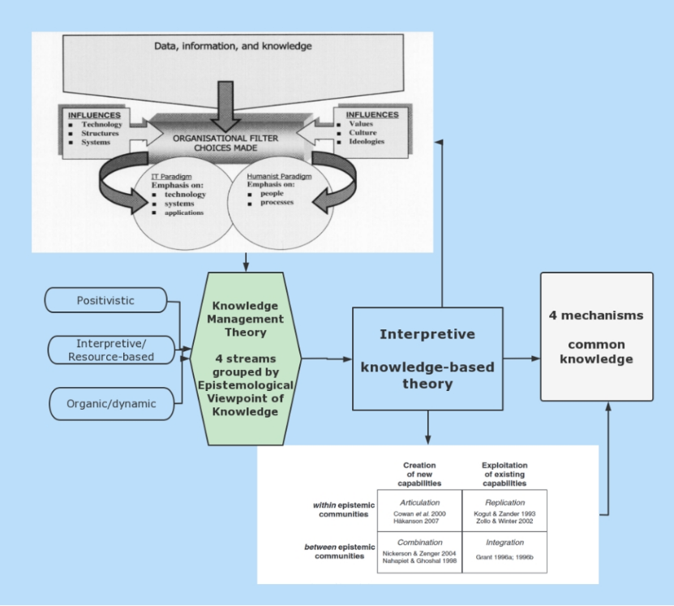
Figure 2.1 Theoretical Framework of Knowledge-Based Theory. Source: Extended and Developed from Ferreira, Mueller and Papa, (2018),Tzortzaki and Mihiotis (2014), Gloet and Berrell, (2003), Hakanson, (2010), Grant, (1996).

Research Gap
Knowledge-based gap
Literature review shows a growing interest in understanding the enterprise social media’s influence on knowledge hiding. However, most works are primarily focused on reason-oriented or result-oriented analysis, but lack a greater understanding of the events and interactions that occur during the knowledge transfer process (Bernatović, Gomezel,and Černe,2021). Moreover, literature review suggests that further study should integrate multidiscipline theories, extend the focus from the antecedents of knowledge hiding to the generating mechanisms, across multilateral levels, and in more diverse sectors (He, et al., 2021). Therefore, this study will conduct from a process-oriented standpoint to explore and investigate how the enterprise social media affect knowledge hiding in the knowledge creation and transfer process.
Theory-based gap
According to the literature review, few theories exist to describe the dynamic relationship between enterprise social media usage and knowledge production and transfer (Di Vaio et al., 2021; He et al., 2021; Bernatović, Gomezel,and Černe,2021;Garg, K., Ganguly, 2022).
Method-based gap
Due to the necessity to generate new theory, the grounded theory method is an appropriate choice for this research. The constructivist's approach of grounded theory enables researchers to construct their own theory through engagement and interaction with people, perspectives, and research practices (Creswell, 2014). Furthermore, as a form of qualitative method, grounded theory is a suitable strategy for understanding social issues when researchers are confronted with complex settings for which no acceptable theory exists (Creswell, 2014). Additionally, the majority of present research in this area adopts quantitative research method, hence, scholars emphasize the necessity for more qualitative research (Di Vaio et al., 2021; He et al., 2021; Bernatović, Gomezel,and Černe,2021;Garg, K., Ganguly, 2022).
Hence, this study will adopt the grounded theory to develop an explanatory theory to interpret the impact of enterprise social media on knowledge hiding behaviour.
Research Question
Based on the research gap identified through the literature review, the research question is defined as: How does the usage of enterprise social media influence the knowledge hiding in the knowledge creation and transfer process?
Research Purpose
The purpose of this study is set as to investigate and identify the impact of ESM on the knowledge hiding behavior in the knowledge creation and transfer process, and to build an explanatory theory to interpret this impact.
Research Objectives
1. To develop a theory to investigate and interpret the little-known process of the enterprise social media’s interaction with the knowledge creation and transfer process, and the influential mechanism with knowledge hiding.
2. To explore and identify how ESM react on knowledge creation, knowledge transfer process.
3. To apply the theory derived from the research to improve the performance of both individuals and organizations by facilitating the flow of knowledge and optimizing the knowledge management process.

Theoretical and Practical Contribution
Theoretical contribution
The theory emerged from the grounded theory research approach will interpret the impact of ESM on Kh behavior, therefore contributing a new theory to the field of knowledge management. In addition, the grounded theory approach will expand the methodological options in the field of knowledge management. Consequently, a fresh perspective will be available for application in future research.
Practical contribution
In practice, the research-derived theory will assist managers to understand how ESM enhance or inhibit the flow of knowledge. Based on this comprehension, managers might adjust practice or policy to maximize the relevant knowledge management process, consequently improving individual, group, and organizational performance.
A conceptual framework
A conceptual framework illustrates “the concepts, assumptions, expectations, beliefs, and theories” that underpin and guides research in a visual graphical or written form (Maxwell, 2005, p39). The purpose of a conceptual framework is to demonstrate the rational and the theoretical approach of the proposed study with the existed concepts, findings, theories (Maxwell, 2005; Creswell, 2013; Efron and Ravid, 2018).
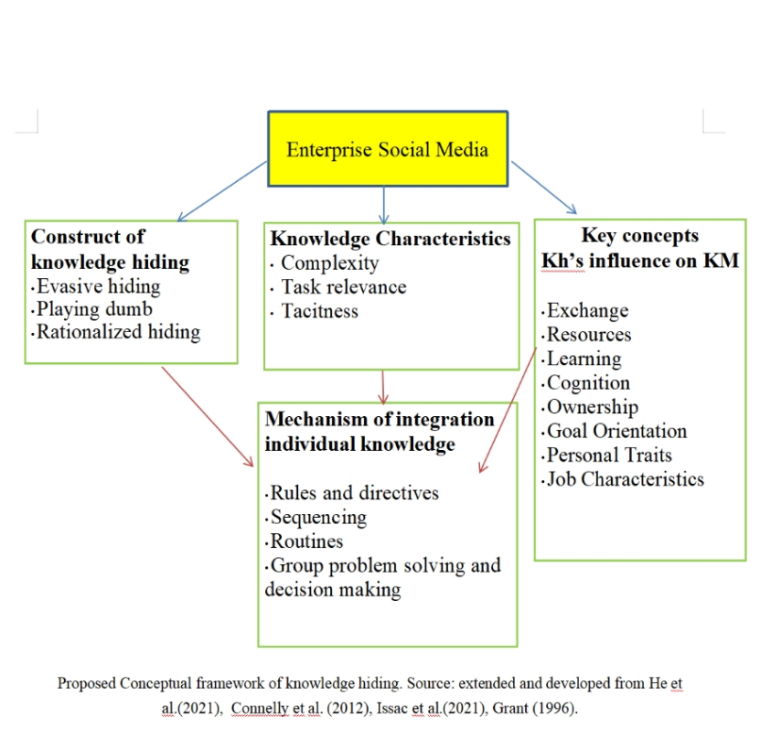
This proposed conceptual framework is a visual demonstration of the research plan, key concepts, theories, and the assumed influential relationships to be investigated and identified.
Literature Review Summary
This literature review covers the broad academic field of the research topic, identified key theories and scholars in this area, critical analysis the key concepts and definitions. Based on the understanding of the knowledge management area from the literature review, this research adopts the knowledge-based theory as a theoretical framework to empower the researcher to explore and analyze the knowledge management process. Based on the synthesis of reviewed literature, the research gap is identified as knowledge-based, theory-based, and methods based. The research purpose is clarified as to investigate and identify the impact of enterprise social media on on knowledge hiding behavior in the knowledge creation and transfer process, and to construct an explanatory theory to explain this impact. A conceptual framework is built to demonstrate the research plan, key concepts, theories, and the assumed influential relationships to be investigated and identified.

Reference
Research methodology
Creswell, J. W. (2014). Research design: Qualitative, Quantitative and Mixed Method Approaches (4th ed.). Thousand Oaks, CA: Sage.

Crotty, M. (1998). The Foundations of Social Research: Meaning and Perspective in the Research Process. London: SAGE Publications Ltd.

Denscombe, M. (2008). Communities of practice: A research paradigm for the mixed methods approach. Journal of mixed methods research, 2(3), pp. 270-283.

Maxwell, J.A. (2005), Qualitative research design: An interactive approach, 2nd ed, Thousand Oaks, CA: Sage.
Charmaz, K. (2014). Constructing grounded theory. 2nd ed. Thousand Oaks, CA: Sage.

Glaser, B.G. and Strauss, A.L. (2010) The discovery of grounded theory: strategies for qualitative research. 5. paperback print. New Brunswick: Aldine Transaction.

Strauss, A., & Corbin, J. (1998). Basics of qualitative research: Techniques and procedures for developing grounded theory. Thousand Oaks, CA: Sage.
Ferreira, J., Mueller, J. and Papa, A. (2018) ‘Strategic knowledge management: theory, practice and future challenges’, Journal of Knowledge Management, 24(2), pp. 121–126. doi:10.1108/JKM-07-2018-0461.

Knowledge-based theory
Grant, R.M. (1996) ‘Toward a knowledge-based theory of the firm’, Strategic Management Journal, 17(S2), pp. 109–122. doi:10.1002/smj.4250171110.

Hakanson, L. (2010) ‘The firm as an epistemic community: the knowledge-based view revisited’, Industrial and Corporate Change, 19(6), pp. 1801–1828. doi:10.1093/icc/dtq052.

IBM Business Consulting Services. 2003. Study on market prospect S, business needs and technological trends for business knowledge management. Pre-final report – Part 1, Nov 30th 2003.

Kogut, B. and Zander, U. (1992) ‘Knowledge of the Firm, Combinative Capabilities, and the Replication of Technology’, Organization Science, 3, pp. 383–397. doi:10.1287/ORSC.3.3.383.

Spender, J.-C. and Grant, R.M. (1996) ‘Knowledge and the firm: Overview’, Strategic Management Journal, 17(S2), pp. 5–9. doi:10.1002/smj.4250171103.

Tzortzaki, A.M. and Mihiotis, A. (2014) ‘A Review of Knowledge Management Theory and Future Directions’, Knowledge and Process Management, 21(1), pp. 29–41. doi:10.1002/kpm.1429.

Social media
Alavi, M., and Leidner, D.E. (2001) “Review: Knowledge Management and Knowledge Management Systems,” MIS Quarterly (25:1), pp. 107-136.

Gagne, M., Tian, A.W., Soo, C., Zhang, B., Ho, K.S.B. and Hosszu, K. (2019), “Different motivations for knowledge sharing and hiding: the role of motivating work design”, Journal of Organizational Behavior, Vol. 40 No. 7, pp. 783-799. doi:10.1002/job.2364.

Hernaus, T., Cerne, M., Connelly, C., Vokic, N.P. and Sˇ kerlavaj, M. (2019), “Evasive knowledge hiding in academia: when competitive individuals are asked to collaborate”, Journal of Knowledge Management, Vol. 23 No. 4, pp. 597-618.

Jalonen, H. (2014) ‘A framwork for dealing with fundamental knowledge problems through social media’, The International Journal of Management Science and Information Technology (IJMSIT), Issu. 14, pp. 27-38

Ma, L., Zhang, X. and Ding, X. (2020) ‘Enterprise social media usage and knowledge hiding: a motivation theory perspective’, Journal of Knowledge Management, 24(9), pp. 2149–2169. doi:http://dx.doi.org.ezproxy.uwtsd.ac.uk/10.1108/JKM-03-2020-0234
Sun, Y., Zhou, X., Jeyaraj, A., Shang, R.-A. and Hu, . (2019), “The impact of enterprise social media platforms on knowledge sharing: an affordance lens perspective”, Journal of Enterprise Information Management, Vol. 32 No. 2, pp. 233-250. doi:10.1108/JEIM-10-2018-0232.

Wang, Y. et al. (2018) ‘The double-edged effects of perceived knowledge hiding: empirical evidence from the sales context’, Journal of Knowledge Management, 23. doi:10.1108/JKM-04-2018-0245.

Knowledge sharing in social media/knowledge intensive org context
Faraj, S. et al. (2016) ‘Special Section Introduction—Online Community as Space for Knowledge Flows’, Information systems research, 27(4), pp. 668–684. doi:10.1287/isre.2016.0682.

Ahmed, Y.A. et al. (2019) ‘Social media for knowledge-sharing: A systematic literature review’, Telematics and Informatics, 37, pp. 72–112. doi:10.1016/j.tele.2018.01.015.
Castaneda, D.I. and Cuellar, S. (2020) ‘Knowledge sharing and innovation: A systematic review’, Knowledge and Process Management, 27(3), pp. 159–173. doi:10.1002/kpm.1637.

Chatterjee, S., Rana, N.P. and Dwivedi, Y.K. (2020) ‘Social media as a tool of knowledge sharing in academia: an empirical study using valance, instrumentality and expectancy (VIE) approach’, Journal of Knowledge Management, 24(10), pp. 2531–2552. doi:http://dx.doi.org.ezproxy.uwtsd.ac.uk/10.1108/JKM-04-2020-0252.

Sol Pereira Oliveira, M.J. (2020) ‘Sharing Tacit Knowledge in an Organizational Context - Different Profiles, Different Strategies’, Scholars Journal of Economics, Business and Management, 7(12), pp. 431–442. doi:10.36347/sjebm.2020.v07i12.002.

Knowledge Management
Castaneda, D. and Cuellar, S. (2020) ‘Knowledge sharing and innovation: A systematic review’, Knowledge and Process Management, 27. doi:10.1002/kpm.1637.

Cohen, W.M. and Levinthal, D.A. (1990) ‘ABSORPTIVE CAPACITY: A NEW PERSPECTIVE ON LEARNING AND INNOVATION’, Administrative Science Quarterly, 35, pp. 128–152. doi:10.2307/2393553.

Gloet, M. and Berrell, M. (2003) ‘The dual paradigm nature of knowledge management: implications for achieving quality outcomes in human resource management’, Journal of Knowledge Management, 7(1), pp. 78–89. doi:10.1108/13673270310463635.

Kogut, B. and Zander, U. (1992) ‘Knowledge of the Firm, Combinative Capabilities, and the Replication of Technology’, Organization Science, 3, pp. 383–397. doi:10.1287/ORSC.3.3.383.

Leonardi, P.M., Huysman, M. and Steinfield, C. (2013) ‘Enterprise Social Media: Definition, History, and Prospects for the Study of Social Technologies in Organizations’, Journal of Computer-Mediated Communication, 19(1), pp. 1–19. doi:10.1111/jcc4.12029.

Nonaka, I. (1994) ‘A Dynamic Theory of Organizational Knowledge Creation’, Organization Science, 5, pp. 14–37. doi:10.1287/ORSC.5.1.14.
Nonaka, I. and Takeuchi, H. (1995) ‘The Knowledge-Creating Company: How’. doi:10.1016/b978-0-7506-7009-8.50016-1.

Russ, M. (2022) ‘Knowledge Sharing and Sustainable Development’, Sustainability, 14, p. 3078. doi:10.3390/su14053078.

Knowledge Hiding
Anand, A., Centobelli, P. and Cerchione, R. (2020) ‘Why should I share knowledge with others? A review-based framework on events leading to knowledge hiding’, Journal of Organizational Change Management, 33, pp. 379–399.

Černe, M. et al. (2014) ‘What Goes Around Comes Around: Knowledge Hiding, Perceived Motivational Climate, and Creativity’, Academy of Management Journal, 57, pp. 172–192. doi:10.5465/AMJ.2012.0122.

Connelly, C.E. and Zweig, D. (2015) ‘How perpetrators and targets construe knowledge hiding in organizations’, European Journal of Work and Organizational Psychology, 24, pp. 479–489.

Skerlavaj, M., Connelly, C.E., Cerne, M. and Dysvik, A. (2018), “Tell me if you can: time pressure, prosocial motivation, perspective taking, and knowledge hiding”, Journal of Knowledge Management, Vol. 22 No. 7, pp. 1489-1509.

Di Vaio, A. et al. (2021) ‘Understanding knowledge hiding in business organizations: A bibliometric analysis of research trends, 1988–2020’, Journal of Business Research, 134, pp. 560–573. doi:10.1016/j.jbusres.2021.05.040.

Garg, N., Kumar, C. and Ganguly, A. (2022) ‘Knowledge hiding in organization: A comprehensive literature review and future research agenda’, Knowledge and Process Management, 29(1), pp. 31–52. doi:10.1002/kpm.1695.

He, P. et al. (2021) ‘Knowledge Hiding: Current Research Status and Future Research Directions’, undefined [Preprint]. Available at: https://www.semanticscholar.org/paper/Knowledge-Hiding%3A-Current-Research-Status-and-He-Jiang/44950bd55ca02a6b914c15e26723306fd50b10bc (Accessed: 24 March 2022).

Ivija Bernatović, Alenka Slavec Gomezel & Matej Černe (2021): Mapping the knowledge-hiding field and its future prospects: a bibliometric co-citation, co-word, and coupling analysis, Knowledge Management Research & Practice, DOI: 10.1080/14778238.2021.1945963

‘What is not hidden about knowledge hiding: Deciphering the future research directions through a morphological analysis’ (2022). doi:10.1002/kpm.1657.

Bari, M.W. et al. (2019) ‘Knowledge Hiding Behaviors and Team Creativity: The Contingent Role of Perceived Mastery Motivational Climate’, SAGE Open, 9(3), p. 2158244019876297. doi:10.1177/2158244019876297.

Connelly, C.E. et al. (2012) ‘Knowledge hiding in organizations’, Journal of Organizational Behavior, 33(1), pp. 64–88. doi:10.1002/job.737.

Issac, A.C., Baral, R. and Bednall, T.C. (2021) ‘What is not hidden about knowledge hiding: Deciphering the future research directions through a morphological analysis’, Knowledge and Process Management, 28(1), pp. 40–55. doi:10.1002/kpm.1657.

Ma, L., Zhang, X. and Ding, X. (2020) ‘Enterprise social media usage and knowledge hiding: a motivation theory perspective’, Journal of Knowledge Management, 24(9), pp. 2149–2169. doi:http://dx.doi.org.ezproxy.uwtsd.ac.uk/10.1108/JKM-03-2020-0234.

Oliveira, M., Curado, C. and de Garcia, P.S. (2021) ‘Knowledge hiding and knowledge hoarding: A systematic literature review’, Knowledge and Process Management, 28(3), pp. 277–294. doi:10.1002/kpm.1671.

