Nerys Craig P148404
Nerys Craig

Abstract
A report on the understanding of Brexit on the Tourism Industry, detailing statistics on travel to and from the EU. Legislation which is currently in place and recommendations for politicians and travel planners to mitigate the effects for the economy and tourists.
Brexit No Deal Recommendations

Strategic Travel and Tourism Management
Contents:
Page 2 >> Introduction
Page 3 & 4 >> Background
Page 5 & 6 >> UK / EU Visitor Numbers and Spend
Page 7 >> Employment of EU / UK Nationals
Page 8,9,10,11 >> UK Economy, Current Legislation
Page 12,13,14,15,16,17 >> Brexit Impacts
Page 18 & 19 >> Recommendations
Page 21,22,23 >> Bibliography
Page 24 >> Appendix

Introduction:

This report aims to give initially a background oversight of the significance of the tourism industry globally and here in the UK. Further analysis into defining the complex nature of tourism intertwined with the EU. Examining visitor numbers and spend, the report will delve deeper into EU legislation particularly focusing on air and sea travel. This discussion will lead to the impacts of Brexit No Deal scenario, and evidently highlight the effects of those impacts. The report will continue with recommendations to politicians and transport planners on how to mitigate the negative impacts on the Brexit No Deal eventuality.

Background on Global / UK Tourism:
To understand the magnitude of tourism here in the UK, EU and globally the nature of the expanse of the industry needs to be outlined. The Tourism Sector is a broad term to include many industries, the OECD (2002) has defined tourism ‘as the activities of persons travelling to and staying in places outside their usual environment for not more than one consecutive year for leisure’ the definition reveals the inclusion of many services and products that are utilized when an individual is pursuing their travelling activities. All these services and products with their associated profits can be calculated under the realm of Tourism, for example accommodation, restaurants, attractions, hospitality, transport and travel services as outlined in the Tourism Sector Report for the House of Commons Committee on Exiting the European Union. (2017) According to Deloitte the travel and tourism sector accounts for 10% of Global GDP (2018). Within the UK in 2015 direct tourism was worth 62.4 billion pounds. (DCMS.2017)
According to the Tourism Alliance (2015) their figures reveal that in 2013 the value of tourism was at 9%, with a further break down of the revenue areas.
Appendices A
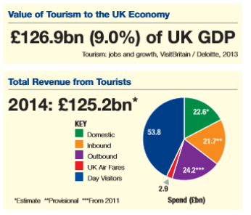
To understand the magnitude and importance of the growth of the tourism sector, the statistics provided by Office National Statistics stating that the tourism industry grew by 34% between 2010 and 2016, comparatively only 23% in the same period for the rest of the economy.
To further the extent of the understanding of UK tourism on a global setting is set out by ABTA, with their figures demonstrating 29.3 million visits in 2011 making the UK the seventh top global destination to visit.
Appendices B:
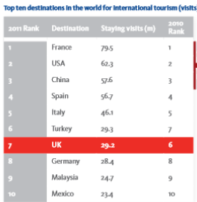
Its also crucial to include the volume of domestic tourism, as it is a major contributor to the industry. A document report in the House of Commons Library (2016) stated that in 2015 one hundred and twenty-four million overnight visits were made by British residents to other destinations within the UK, the term ‘Staycations’ has been created to identify this market.

UK / EU Visitor Numbers and Spend:
The report extends its research to provide the evidence into the volume of visitors and spend between the UK and EU, revealing the prolific amount of movement and trade exchanged. This corroborating the vital contribution to both economies.
A paper produced by the HM Government documents the vast numbers of travelers to and from UK and EU twenty-seven countries. It states in 2017 one hundred and sixty-four million passengers travelled by air between the two, going on to stipulate that one hundred and eighty-five airports have the minimum of one weekly service to a UK airport.
Appendices C:
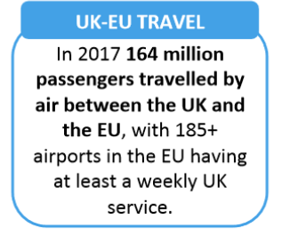
(HM Government 2018)

Deeper analysis into the EU and UK travel market using the ONS statistics for the period January to August 2017 show a 4% increase on the same period of the previous year of visits from the twenty-seven EU nations, accounting for 65% of all visits to the UK from overseas. The figure being at 17.6 million.
The government instructed a committee called Exiting the European Union committee produced a Tourism Report which gives evidence on the spend in the economies associated between the both sides of the UK and EU. It gives detail analysis and evidence stating that ‘UK trips to the EU generate more than €15 billion in GVA for EU member state economies, and more than €37 billion in aggregate or indirect impacts. Over half of all GVA from tourism in the EU goes directly to employees through wages’
Comparatively the volume of outbound tourists from the UK visiting the EU is at 75% of all outbound journeys, 53 Million tourists left the UK for bound for EU nations. Therefore, accounted for 58% of the total outbound spend totaling 25.4 billion pounds.

Employment of EU / UK Nationals:
This section of the report gives the reflection of employment statistics here in the UK, particular focus on the level of EU workers within the tourism industry. A HM report ‘Tourism and Brexit’ (2017) outlines in 2015 4.5% of all jobs in the UK were directly related to Tourism setting the figure at 1.5 million jobs. The paper gives continued insight into employment associated with tourism the ‘wider’ tourism economy at 3.1 million. This volume of jobs spread out across the UK.
All areas of research confirm the deep association of business and employees from the EU, this relationship has become a characteristic of modern day living for both UK and EU nationals. The evidence compiled by the Tourism Alliance reiterates the figure of 1.5 million jobs, which observes that this employment ‘at all entry levels across the UK’. The Tourism Alliance also goes on to include a valuable summary of the tourism sector has a higher number than average of EU workers and being one of the largest employers of EU citizens throughout the UK. It concludes with their research form ONS that in 2016 EU nationals accounted for 10% of the tourism industry workforce.

UK Economy, Current Legislation:
Currently here in the UK there has been a long-standing agreement established in 1922, pre-EU regulations, this is The Common Travel Area covering Republic of Ireland, Isle of Man and Channels Islands. This agreement sets at special travel zone allowing nationals of the CTA to travel freely a Parliament UK Research Briefing states ‘This special status affects Irish nationals’ rights across a number of areas, including eligibility for British citizenship, eligibility to vote and stand for election, and eligibility for certain welfare benefits. It is thought that, as a result, Irish nationals have more rights than other EU/ EEA Nationals resident in the UK’ (2017)
At this present time and over the past decade citizens of EEA member states have prevailing rights to work and live in the UK according to EU Free Movement Law. The Directive of 2004/38/EC of the European Parliament sets out ‘Citizenship of the Union confers on every citizen of the Union a primary and individual right to move and reside freely within the territory of the Member States…constitutes one of the fundamental freedoms of the internal market, which comprises an area without internal frontiers’
The UK economic position at the moment is being part of both the EU Customs Union and Single Market. Being apart both allows for free trade and movement of people between UK and EU however, restricts nations involved not to have trade deals with third countries outside the agreement explained by The Economist (2016).
The Tourism Alliance has produced very clear data to explain how the UK charges VAT within the tourism industry and compares to other countries:

Appendices D:
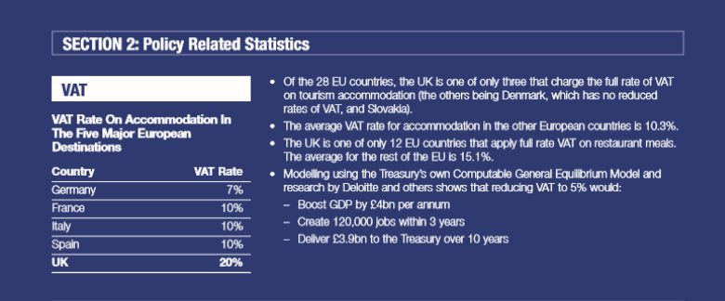

The data also continues to give a clear analysis of the financial impacts of Air Passenger Duty and cost of visa’s for nationals outside the EU and need a visa to visit the UK.

Appendices E:
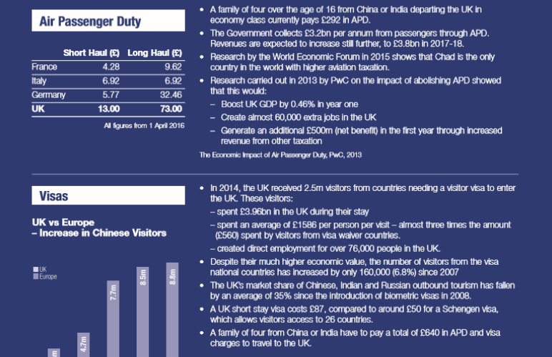
Appendices F:
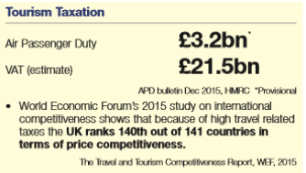

Aviation and the European Common Aviation Area (ECAA) was formed along with the Single Market which allowed freedom of airlines to fly within EU nations, it has the advantage of centralized legislation. The ECAA has a bilateral agreement with the USA ‘Open Skies’ for example where aviation deal is in place for trade and tourism. (House of Commons. 2018)
Appendices G:

(ABTA)

Seaborne trade between the UK and the EU is estimated at £511 billion according to Southampton University research it also goes on to state that ‘UK flag ranks nineteenth internationally per share of dead-weight tonnage24 and the UK flag is currently open to EU/EEA physical and legal persons.
The regulation of the shipping industry is primarily overseen by the International Maritime Organisation which implements global maritime safety regulations, however there are regulations which originate from both UK and EU legislation. Here in the UK the Department for Transport agency called the Maritime and Coastguard Agency implement safety policies with national and international partners ensuring the safety of ships and their construction. (Gov.uk 2012)

Brexit Impacts:
On the 29th of March 2017 the UK Government triggered Article 50 of the Treaty of the Functioning of the European Union. This treaty was agreed to allow member stated the right to withdraw from the EU, with this process to occur over a two-year time period. (The Telegraph 2018).
The government actioned this after the Brexit Referendum ‘The referendum was set to take place on Thursday, June 23, 2016. On this date, all Britons aged eighteen and over would have the chance to vote for one of two options: ‘leave’ for an independent UK, or ‘remain’ to stay as a member of the European Union.’ (Statista).
The result clearly demonstrated by The BBC:
Appendices H:
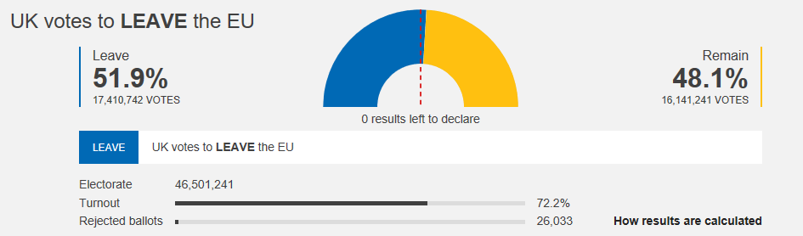
This shock vote to leave set shock waves around the globe, affecting the value of the pound. The Value of the pound dropped dramatically:
Appendices I:
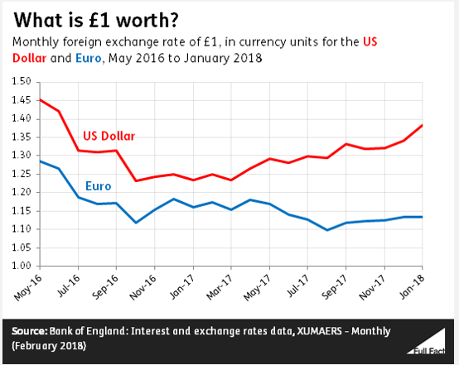
(Full Fact. 2018)
This drop in the bound has had a contrasting effect in the travel sector, as the UK became appealing for foreign visitors as more affordable destination and for domestic tourism where the pound was weakened position made it less financially attractive to go abroad. Reuters observed that. ’Tourism has been a winner from the 2016 Brexit vote which pushed down the value of the pound, making Britain a more attractive holiday destination for foreign tourists and encouraging British holiday makers to stay at home’ (2018)
This is also confirmed by the BBC stating, ‘Prices in the UK have become relatively cheaper for overseas visitors due to the pound's 11% fall’ (2017). Across all research the effect of the bound has made a positive impact for UK Tourism, the impact clearly expressed in a Parliament paper ‘Exchange rates are important in the tourism industry. A weaker pound is effectively a price cut for foreign visitors to the UK – their money is worth more in the UK than it was previously. Conversely, for UK residents going abroad, a weaker pound means that the value of their money falls and their foreign holidays become more expensive.’ (Parliament UK 2016). Interestingly the Lonely Planet Travel Guide listed the UK as the seventh value destination. (2017)
At the start of this year Visit Britain declared that hotels and restaurants were braced for a record year with inbound tourism to increase to 42 million visits bringing with it 27 billion pounds in spend, it summarizes the influence for this being the weak pound against both Euro and Dollar and minimize the predicted post Brexit economic slowdown. (Guardian 2017)
As the above reflects the impacts of Brexit having its positive affect on UK tourism it has adverse effects in the sense of the UK being a welcoming nation especially based on the nature of the content of the Leave Campaign. Qualitative research by Visit Britain revealing ‘French, German and Italian tourists are turning their backs on Britain after the vote to leave the EU…found an increasingly negative view of the UK among visitors from Europe, nearly half of visitors from China said they had a more positive opinion of the country. (The times 2018)
Considering Brexit impacts in the tourism sector leads us to the work force. As the Mayor of London Sadiq Khan has been quoted saying ‘up to 27,000 jobs in the creative industries could be lost if the UK does not reach a deal with the European Union over Brexit.’ (The stage 2018).
Organisations and businesses across the UK are concerned of the shortfall in the labour market post UK exit from the EU. The expansion of the industry is reliant on an accessible labour force. Industry professional who is the Chief Executive of UK Hospitality voices her concerns that consumers will feel the brunt with higher costs and closures. (UK Hospitality 2018). Like wise Travel Weekly quoted an ETOA survey of ‘replace this volume would be almost impossible. (Travel Weekly 2018).
The discussion on Brexit employment impacts isn’t solely for the EU national working within the UK, but for UK nationals too. The UK outbound travel sector has many individuals working for package holidays which rely on the Posted Workers Directive to allow them to move around the EU without the need for separate contracts. (Tourism Sector Report)
The National Audit has given summary of their Key facts focusing on custom duties at ports across the UK ‘No Deal’ Brexit is presenting a chaotic scenario with lack of human resource and IT systems to cope with the increased work load:

Appendices J:
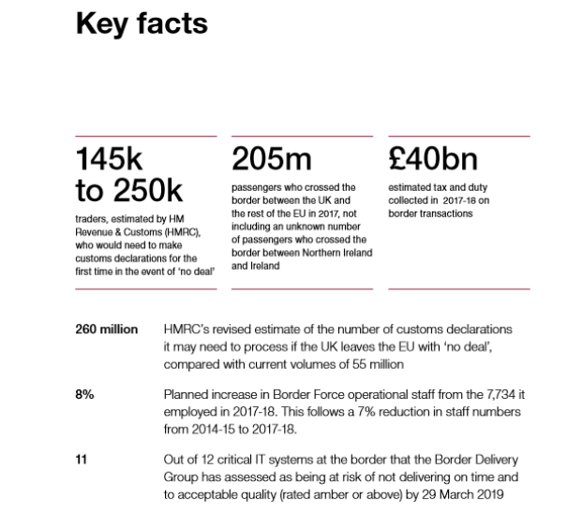
(National Audit Office 2018)
The ‘No Deal Brexit’ implications are far out reaching several are listed below can be listed below:
- Ireland threatens to destabilize the long-standing Common Travel Area.
- Duty free.
- EU Health card.
- Mobile phone roaming charges within EU.
- Driving license and vehicle checks legalities
- The Package Travel Directive:
- Compensation rights.
- The Tour Operators Margin Scheme (TOMS): The TOMS VAT scheme.
- Immediate loss of EU Funding such as European Structural and Investment Funds (ESIF), inc. Skills Funding Agency funding for skills; European Regional Development Fund (ERDF) (EU. 2015)

The Bank of England draw their forecast for the No Brexit deal with harsh yet precise analysis ‘The level of preparedness of businesses and infrastructure (such as ports, excise and customs systems and transport operations) will be important in determining how the economy adjusts to new barriers. The extent of any disruption at the border and to transport and financial services will depend on preparations made by firms, the authorities and on policy decisions yet to be taken by both sides. It is likely that the corporate sector is in general not yet well equipped to cope with a ‘no deal’ Brexit.’ (Bank of England 2018)

Recommendations:
- The consideration of all the background evidence, current UK legislation, the Impacts of Brexit since the referendum are compiled into the considerations on making recommendations for a No Deal Brexit to politicians and transport planners.
- The improvement of internal travel once reaching UK ports, namely bus and rail. To encourage incentives to be developed with airlines and ferries to have an ‘onward travel’ deal for travelers once in the UK. To ensure coordinated timings and financial savings.
- To amend regulations to allow B & B’s and Guest Houses to collect their guests from ports.
- An inter UK-EU travel ticket, to appeal to international visitors to include UK if on Europe wide travel itinerary.
- To disperse the flow of both cargo and non-cargo ferries to use other UK ports such as hull to avoid congestion.
- Establish a UK – EU hire car contract to enable travelers to have multiple use and drop off locations.
- Visa for EU nationals for tourism, no visa restriction for three months. International Visa purchased at more competitive rate to the EU Schengen Visa deal.
- Air Passenger Duty to be lowered to make tickets more affordable, also incentive for bilateral deals with international countries.
- Existing EU nationals in Tourism Industry to be granted contract of work to stay within the UK. Future workers to incorporate languages as skills for issuing work visas.
- Maximize on Visit Britain Action Plan, to support the healing of the reputation of the UK as pleasant welcoming place to visit. Displaying multicultural society through the medium of the arts.
- Trade deals with USA, China, Japan etc. large economies to secure existing and new business investment.
- Establish a similar Open Skies Agreement for the UK to both EU and USA.
- Negotiate talks with CTA to stabalise the long-standing agreement.
- Business incentive for mobile phone networks to offer UK nationals roaming benefits to EU and deals with new free sky nations.
- Support talks and seal agreement for tour operators and package holiday companies for the security of passengers and the work force to continue their trade.
- Have cruise ship onboard visa and custom checks to enable the passengers to disembark at destination with ease.
- To set up business support across the tourism sector focusing on small business to mitigate the impacts of no deal Brexit on the running of their business’.
- Finalise the Brexit situation to restore stability in the economy and perception of the global markets.
The above recommendations aim to mitigate the impacts for politicians and transport planners on their mammoth task of leading the UK through this historical political landscape. The challenge to keep the travel industry strong and prosperous, minimizing disruption and damaged connections to UK – EU nations and their citizens.

Bibliography:
- ABTA Making a success of Brexit for travel and tourism Accessed 29.10.18 file:///C:/Users/User/AppData/Local/Packages/Microsoft.MicrosoftEdge_8wekyb3d8bbwe/TempState/Downloads/ABTA%202%20Making%20a%20success%20of%20Brexit%20for%20travel%20and%20tourism%20(3).pdf
- Bank Of England (2018) EU withdrawal scenarios and monetary and financial stability Accessed 22.11.18
file:///C:/Users/User/AppData/Local/Packages/Microsoft.MicrosoftEdge_8wekyb3d8bbwe/TempState/Downloads/eu-withdrawal-scenarios-and-monetary-and-financial-stability%20(1).pdf
- BBC Results Accessed 29.10.18 https://www.bbc.co.uk/news/politics/eu_referendum/results
- BBC. (2017) Lonely Planet tells the world to visit cheap Britain Accessed 28.101.18
https://www.bbc.co.uk/news/business-41736420
- DCMS Accessed 15.11.18 https://www.gov.uk/government/publications/tourism-action-plan
- Deloitte. (2018) Accessed 12.11.18 https://www2.deloitte.com/insights/us/en/industry/dcom/travel-hospitality-industry-outlook.html
- DIRECTIVE 2004/38/EC OF THE EUROPEAN PARLIAMENT AND OF THE COUNCIL of 29 April 2004 Accessed 21.11.18
https://eurlex.europa.eu/LexUriServ/LexUriServ.do?uri=OJ:L:2004:158:0077:0123:EN:PDF
- EU. (2015) Guide on EU funding for the tourism sector - updated version Accessed 21.11.18 http://ec.europa.eu/growth/content/guide-eu-funding-tourism-sector-updated-version-0_en
- Full Fact Accessed 2.12.18 https://fullfact.org/economy/pound-fallen-since-brexit/
- Gov.UK (2012) Shipping industry regulation https://www.gov.uk/guidance/shipping-industry-regulation
- House of Commons Library. (2018) Effect on the aviation sector of the UK leaving the EU. Accessed file:///C:/Users/User/AppData/Local/Packages/Microsoft.MicrosoftEdge_8wekyb3d8bbwe/TempState/Downloads/Aviation%20report%20Commons%20briefing%20(1).pdf
- House of Commons Library Potential effect of the UK leaving the EU on UK tourism Accessed 23.11.18 research briefings.files.parliament.uk/documents/CDP-2016-0169/CDP-2016-0169.pdf
- HM Government (2018) Framework for the UK-­‐EU Partnership Transport Accessed 14.11.18
file:///C:/Users/User/AppData/Local/Packages/Microsoft.MicrosoftEdge_8wekyb3d8bbwe/TempState/Downloads/Framework_for_the_UK-EU_partnership_Transport%20(1).pdf
- H M Tourism and Brexit (2017)
file:///C:/Users/User/AppData/Local/Packages/Microsoft.MicrosoftEdge_8wekyb3d8bbwe/TempState/Downloads/Brexit%20impact%20on%20tourism%20(3).pdf
- National Audit Office (2018) The UK border: preparedness for EU exit Accessed file:///C:/Users/User/AppData/Local/Packages/Microsoft.MicrosoftEdge_8wekyb3d8bbwe/TempState/Downloads/The-UK-border-preparedness-for-EU-exit%20(1).pdf
- OECD. (2002) Accessed 28.11.18 https://stats.oecd.org/glossary/detail.asp?ID=2725
- Office for National Statistics. (2014) Accessed on 27.11.18. https://www.ons.gov.uk/peoplepopulationandcommunity/leisureandtourism/articles/tourismemploymentsummaries/characteristicsoftourismindustries2014
- ONS (2017) https://www.ons.gov.uk/economy/grossdomesticproductgdp/bulletins/quarterlynationalaccounts/octobertodecember2017
- Parliament UK Research Briefing (2017) The Common Travel Area and the special status of Irish nationals in UK lawhttps://researchbriefings.parliament.uk/ResearchBriefing/Summary/CBP-7661
- Parliament UK Potential effect of the UK leaving the EU on UK tourism Accessed 28.11.18https://researchbriefings.parliament.uk/ResearchBriefing/Summary/CDP-2016-0169#fullreport
- Reuters (2018) https://uk.reuters.com/article/uk-britain-economy-tourism/uks-post-brexit-vote-tourism-boom-fades-idUKKBN1F717B
- Statista https://www.statista.com/topics/2971/eu-referendum/
- The Economist (2016) The difference between the customs Union and single market https://www.economist.com/the-economist-explains/2016/10/07/the-difference-between-europes-customs-union-and-single-market
- The Guardian https://www.theguardian.com/travel/2017/dec/26/uk-braced-for-record-number-of-tourists-in-2018
- The Stage (2018) https://www.thestage.co.uk/news/2018/sadiq-khan-brexit-cost-britains-creative-industries-27000-jobs/
- The Telegraph (2018) What is Article 50? The only explanation you need to read. https://www.telegraph.co.uk/politics/0/what-is-article-50-the-only-explanation-you-need-to-read/
- The Times (2018) https://www.thetimes.co.uk/article/more-chinese-tourists-visiting-britain-but-brexit-deters-french-germans-and-italians-j2xvlxmww
- http://www.tourismalliance.com/downloads/TA_390_415.pdf
- Travel Weekly http://www.travelweekly.co.uk/articles/297574/brexit-damaging-uk-travel-industry
- UK Hospitality https://www.ukhospitality.org.uk/news/428506/
- University of Southampton The UK maritime sectors beyond Brexit https://cdn.southampton.ac.uk/assets/imported/transforms/content-block/UsefulDownloads_Download/BAFDE6DB1EFF4DBFA1AFC900CEFCDD6D/Final%20Report%20Brexit.pdf#_ga=2.133887502.1259284084.1543778018-2074440331.1543778018

Appendix:

Appendices A: Tourism Alliance Accessed 19.11.18 http://www.tourismalliance.com/downloads/TA_390_415.pdf

Appendices B : ABTA Accessed 23.11.18 file:///C:/Users/User/AppData/Local/Packages/Microsoft.MicrosoftEdge_8wekyb3d8bbwe/TempState/Downloads/ABTA%20Brexit%20Briefing%20(1).pdf

Appendices C: HM Government (2018) Framework for the UK-EU partnership Transport Accessed 22.11.18
file:///C:/Users/User/AppData/Local/Packages/Microsoft.MicrosoftEdge_8wekyb3d8bbwe/TempState/Downloads/Framework_for_the_UK-EU_partnership_Transport%20(1).pdf

Appendices D, E & F: Tourism Alliance Accessed 19.11.18 http://www.tourismalliance.com/downloads/TA_390_415.pdf

Appendices G: ABTA Making a success of Brexit for travel and tourism file:///C:/Users/User/AppData/Local/Packages/Microsoft.MicrosoftEdge_8wekyb3d8bbwe/TempState/Downloads/ABTA%202%20Making%20a%20success%20of%20Brexit%20for%20travel%20and%20tourism%20(3).pdf

Appendices H: BBC Results https://www.bbc.co.uk/news/politics/eu_referendum/results

Appendices I: Full Fact
https://fullfact.org/economy/pound-fallen-since-brexit/

Appendices J: National Audit Office (2018) The UK border: preparedness for EU exit Accessed 22.10.18 file:///C:/Users/User/AppData/Local/Packages/Microsoft.MicrosoftEdge_8wekyb3d8bbwe/TempState/Downloads/The-UK-border-preparedness-for-EU-exit%20(1).pdf

