Component 2 - Research Report
Student Name: Amreen Akhtar
Student Number: 2214675
Lecturer Name: Olu Adegbite
LCHS4002 BIRM
Digital Skills and Research Methods

Contents
1. Introduction 3
2. Research design 3
2.1. Research Question 3
2.2. Method 3
2.3. Ethical Considerations 3
3. Results 3
4. Discussion 3
5. Conclusion 3
6. Reference List 3
7. Appendix A – A blank copy questionnaire. 3

Introduction
Digital literacy refers to the capacity to utilise computers to gather, analyse, produce, display, and exchange data as well as to communicate and take part in online collaborative networks. The ability to utilise gadgets like computers, tablets, or mobile phones for basic personal and professional purposes is one of the most important digital skills. using the internet to research information original content production, network and information security, digital marketing on social media, and data analysis are some examples of digital talents in the workplace. transferring information safely and responsibly while communicating online. Identify information, find it, access it, get it, shop it, and organise it. to employ digital talents to execute tasks using media and technology. You can advance in higher education with the support of digital abilities and having strong IT skills. The ability to use computers for communication, collaboration, data collection, analysis, production, display, and exchange is referred to as digital literacy. One of the most crucial digital skills is the ability to use devices like computers, tablets, or mobile phones for fundamental personal and business needs. using the internet to do information research Digital talents in the workplace include things like data analysis, original content creation, network and information security, social media marketing, and digital marketing. Online communication involves the secure and responsible flow of information. Information can be identified, located, accessed, obtained, purchased, and organised. to use digital skills to carry out activities involving media and technology. With the assistance, you can progress in your further education.

Research design
Participants in research must first provide their consent and be fully informed of the implications of participating. For students, research digital techniques and abilities are crucial. The participant must have a basic understanding of the research and what they are consenting to for their consent to be considered informed. The research design is the overall approach you select to combine the various elements of the study in a logical and coherent manner, so ensuring you will successfully answer the research challenge. An explanation of the type of research—experimental, survey, correlational, semi-experimental review—and its subtypes of study—data collection, measurement, and analysis—is provided by the creation of a research topic.
An enquiry that a study or research effort seeks to answer is known as a research question. This question frequently refers to a concern or issue that is addressed in the study's conclusion after data analysis and interpretation. Basic research questions or hypotheses fall into three categories. A hypothesis is a statement that predicts how two or more variables will relate to one another. Although they take the form of questions, research questions are comparable to hypotheses. The fundamentals of research methods are planning and organisation, Adaptability and flexibility, Problem solving, Initiative and written communication. 2

Method
The research techniques employed, such as the questions and the way you chose your subjects. Employers use a variety of approaches to evaluate candidates' knowledge, abilities, and capacity for research-based work. utilising the library, social networking, data input, word processing, and emails For learning, doing and sharing research, as well as for creating a profile, a variety of digital tools are available. Effective literature research, data management, and communication are all aspects of digital study skills. Students may employ online classes, Google searches, online video viewing, and the usage of digital technologies as methods. Technology is also assisting people in gaining digital skills and strategies for using the internet on a laptop, smartphone, tablet, or PC. Use social media and email to communicate online. working from a remote or at home. using internet resources like Skype and Zoom. Facetime and teams for communication. To access information, find trustworthy online sources and information, and act safely and lawfully online, create an online account. The body of research on work-integrated learning has grown significantly.
When used to respond to inquiries and issues raised by multiple models. This special issue aims to provide examples of the numerous research methods that are available. A mixed methods methodology was employed to examine risk to first deepen understanding of the topic due to a deficiency in the literature.

In this article, justifies qualitative phase of study using data from both methods, the use of triangulation strengthens the overall research of findings which is a key advantage of mixed methods approach2.

Ethical Considerations
A collection of concepts known as ethical considerations in research include voluntary participation, informed consent, anonymity, secrecy, the possibility of harm, and the transmission of results. Respect should be shown towards research subjects, who should never be harmed in any way. Prioritizing respect for the research participants' dignity is important. Prior to the study, complete consent from the subjects should be obtained. Participants in study must have their privacy protected. Colleagues who were also students were asked for permission before being given the questions and the option to participate in answering them. They were guaranteed utmost anonymity and that no names would be mentioned. We decided on the questions and why we thought they were significant as a team. The significance of digital competence and why it's for pupils. We need to learn how to use keyboarding efficiently, comprehend computer basics, apply technology and productivity tools, comprehend spreadsheets and databases, use word processing, produce presentations, and be able to generate efficient multimedia, therefore digital skills are crucial. The capacity to find, assess, use, exchange, and create content on digital devices like computers and smartphones is known as having digital skills.

- Results
Outcomes of those who took part in the poll as respondents. You can use it to analyse the values of other sentiments and learn how the respondents are doing. to complete a survey, fill out a questionnaire, express an opinion, and review a report of respondents' views. The responses from the respondents only show how crucial and beneficial digital skills are for learning and how much they boost employability. To enhance learning, evaluate the level of abilities in your organisation using technology. Determine how comfortable you are using digital tools and platforms. Recognize any obstacles to applying digital skills and determine learning preferences to create efficient digital support and training. Inquire on the users' progress with digital tools. The responses' responses to each question consider utilising Microsoft Teams to be crucial. Do you believe that the most crucial digital skill is the ability to send emails. Arrange phrases in the order that best represents how you feel about your level of digital proficiency. These programmes are ranked based on how frequently you have used them as a worker or student. The most crucial digital talent to possess, in my opinion, is the ability to use social media tools effectively.

Figure 1: Q.1 Consent to take part to this research.

Figure 2: Q.2 Do you think that using Ms Teams is an important digital skill?

Figure 4: Q.3: Do you think being able to send emails is the most important digital skill?
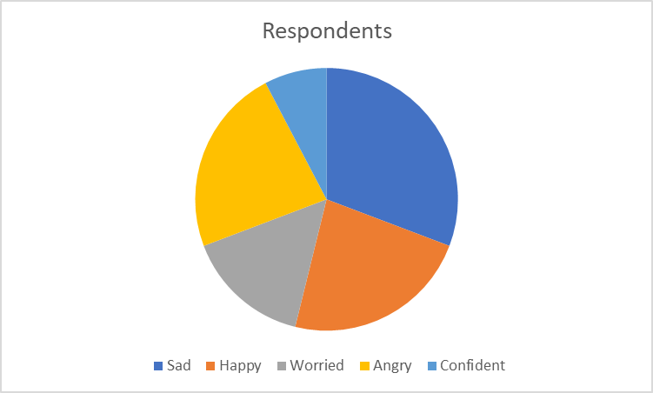
Figure 4: Q.4 Rank these words in order of according to how you feel about your level of digital skill.

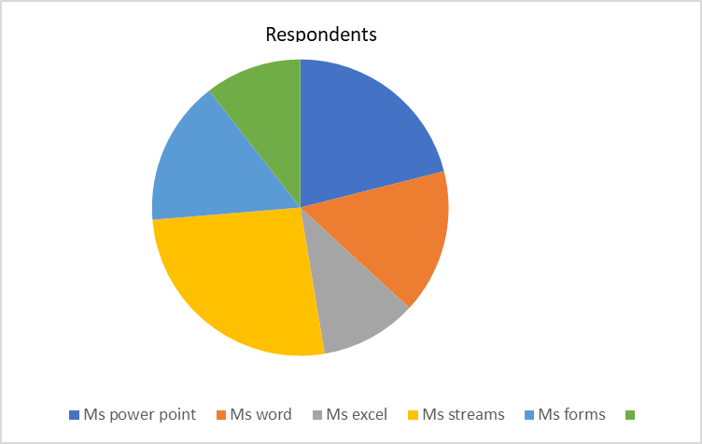
Figure 5: Q. 5 Rank these applications to how often you have used them as a student or worker.
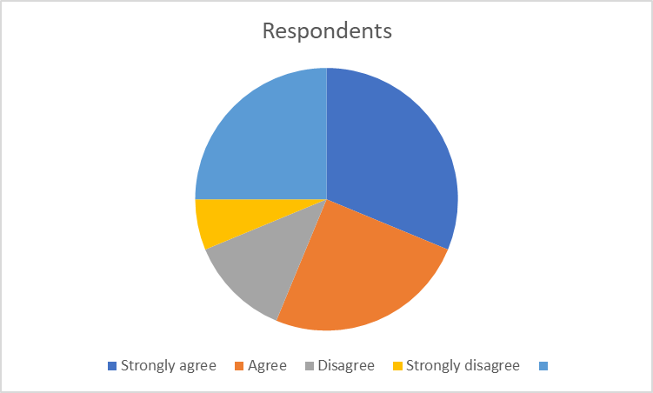
Figure 6: Q.6 I feel that using social media tools successfully is the most important digital skill to have.

Discussion

An eight-question survey was developed for this study to collect data for a quantitative analysis. Consent was the subject of the first query since it is crucial to obtain the participant's consent before proceeding. Microsoft Team is a collaboration tool that organises your team, promotes communication, and arranges meetings to complete tasks quickly and effectively. It is a productivity tool that promotes teamwork in businesses. Better on the inside, particularly for remote working arrangements in this new normal. Because it allows users to communicate information in letter format and potentially take the place of traditional mail methods, email is crucial for communication. Emails have the potential to improve communication. since they frequently contain text, documents, and multimedia, such as pictures and videos. With our digital skills, we may construct, and you communicate, exchange content, and schedule posts on social media with the aid of these tools.

The tools are more crucial for your business the more platforms you have. Join forces instantly and globally. Yet, it is important to keep in mind that these abilities vary greatly, even though they can be data- and goal-focused. These also include fundamental abilities like communication and problem-solving. The need for digital abilities in the workplace has never been higher, and learning these skills can significantly improve your life in our increasingly digital world. Being proficient in a wide range of these abilities is essential for your career because an increasing number of individuals work remotely and many professions in the UK (United Kingdom) mention digital skills as a criterion. There are typically three different types of social media tools. Together, listening platforms, publication platforms, and competitive analysis platforms attack social media from many perspectives. They may aid your brand in achieving all your commercial and social media objectives.
Teams zoom while holding a group discussion over a video conversation. Facebook is being used as an online debate forum. using Google Forms to carry out online surveys. Utilizing the internet as a data source and analysing blogs, websites, and publications on a certain subject. For the workplace, digital literacy is crucial. The advantages of having digital skills include the ability to interact with one another, cooperate, learn about new and important concerns, and be empowered to innovate in ways that were previously unthinkable. Today, every part of our lives is impacted by technological innovation. Companies demand that their employees possess the abilities necessary to function well in today's digital culture. To prepare for work, digital literacy is crucial. Yet it's critical to comprehend So, learning technical skills is important to achieve IT proficiency. Being computer savvy is now a necessary life skill. Collaboration is crucial for a team's success because it requires strong interpersonal and teamwork abilities. Being creative means being able to evaluate opportunities in an entrepreneurial approach and pose the appropriate questions to spark original thought. being able to analyse data and arguments, spot trends and connections, and create knowledge that is both practical and valuable. being able to communicate successfully with a diversity of audiences through a few tools and ways.

- Conclusion.
Digital skills are the capabilities to use digital devices to gather, analyse, share, and create content. The secret to maximising all affordances and reducing all restrictions that digital technology provides to students and their education, whether it be knowledge-based or practice-based, is striking a balance between that technology and social contact. it brings digital learning to a close.

When we conduct research and draw judgements about what other individuals believe and feel. To determine how we can improve things, it is crucial to understand and assess those facts and findings. knowing how to understand the thoughts and feelings of others. Learning is everything, as demonstrated by the fact that I have picked up a staggering amount of new knowledge and skills in the area of digital technology. Students of today frequently use web applications in daily life. In order to improve their learning, students must use internet technologies in the classroom. The study sought to identify the digital platform used by students the most frequently.

- Reference List:

- Appendix A – A Blank copy questionnaire.
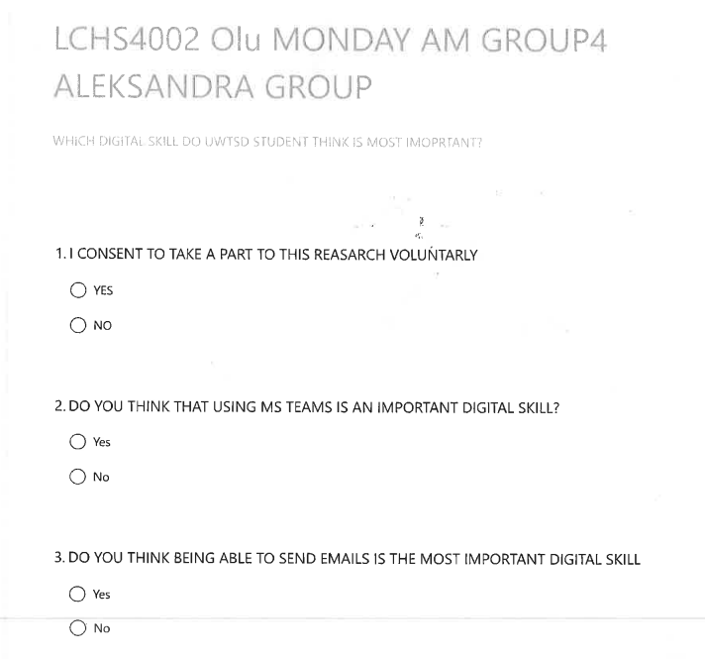
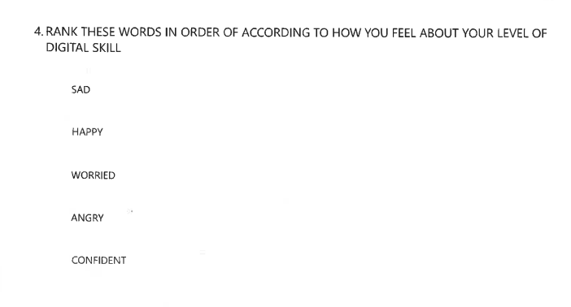

Solis B ‘’ What do digital skills involve’’www.sales.forc3.com/news/stories/what-are-digtial-skills/?accessed March 25, 2023 2 ‘’Digital Skills Insights 2020’’>www.acacdemy.itu.int/itud/research-publications/digtal-skills-insights/insights > accessed March 25, 2023
Bhandari P, ‘’ Ethical Considerations in Research’’www.research-methods/ethical-considerations accessed March 25, 2023
‘’ Digital Skills: with its benefit’’www.ihifix.com/digital-skills-shaping-the-future-with-its-benefit/ accessed March 25, 2023

