
Skills for the Workplace
Module Assignment Submission
Student Name: | Laura Williams
Student Number: | 1815022
Module No: | BMSK6003
Module Title: | Leading and Implementing Change in the Workplace

Statement of Confirmation of Authenticity
By the act of making this submission, the student declares that this is the work of the student named above. The work has not, in whole or in part, been knowingly presented elsewhere for assessment, or where assessment has been built on a previous assessment, this has been identified. Where materials have been used from other sources it has been properly acknowledged. If this statement is untrue, the student acknowledges that an assessment offence has been committed.
Attention is drawn to the plagiarism and unfair practice policies of both the University and of ILM.
Permission for ILM to use this script
ILM uses learners’ submissions – on an anonymous basis – for assessment standardisation. By submitting, both the centre and the learner agree that ILM may use this script on condition that identifying information is removed. However, if you are unwilling to allow ILM use this script, please refuse by ticking the box: □
Table of Contents
1. INTRODUCTION 2
2. UNDERSTANDING ORGANISATIONAL CHANGE 2
2.1.1. MACRO FORCES FOR CHANGE OUTSIDE THE ORGANISATION 4
2.1.2. PESTLE ANALYSIS 5
2.2. PORTERS 5 FORCES 7
2.3.1. MICRO FORCES FOR CHANGE IN THE ORGANISATION 9
2.3.2. SWOT ANALYSIS 11
2.4. EMOTIONS AND ORGANIZATIONAL CHANGE 13
2.5. STAKHOLDER ANALYSIS 15
3. LEADING STAKEHOLDERS THROUGH AN ORGANIZATIONAL CHANGE 17
3.1 CREATING A SENSE OF URGENCY 17
3.2. CREATING A GUIDING COALITION 17
3.3. DEVELOP AND FORM A STRATEGIC VISION 18
3.4. COMMUNICATING THE CHANGE VISION TO THE STAKEHOLDERS 18
3.5. EMPOWERING BROAD-BASED ACTION 19
3.6. GENERATING SHORT TERM WINS 19
3.7. CONSOLIDATING GAINS AND PRODUCING MORE CHANGE 20
3.8. INITIATION OF NEW CHANGE. 20
4. CONCLUSION 21
REFERENCES 22
APPENDIX A 28
APPENDIX B 29
APPENDIX C 35
APPENDIX D 36
APPENDIX E 37
APPENDIX F 38
APPENDIX G 39
APPENDIX H 48
APPENDIX I 49

1. INTRODUCTION

This report will start with Change. to see how the management of change is crucial to implement a change in an organisational successfully, by using various examples of how the recent pandemic, has forced organisations to react in the way they operate, and investigate case studies to determine how effective they dealt with the management of change. The report will focus on the student’s workplace Alcumus and evaluate what they did well or didn’t do well enough when managing a complex change during the way they operated in the pandemic.
Section 2 will start with the insights of change and the environmental forces that impact changes in the workplace. Looking deeper into the external forces can impact an organisation to conceptualise a complex change in response to an environmental change such as the recent pandemic. Using the PESTLE (Political, Economic, Sociological, Technological, Legal and Environmental) analysis tool will be performed based on external factors that can force organisations to change and used to identify macro forces that impacted a complex change within Alcumus. It will then investigate micro forces that need to be considered when implementing a change in an organisation and conducting a SWOT (Strengths, Weaknesses, Opportunities and Threats) analysis for Alcumus will help to identify strategic decision making when implementing changes.
Data reports will be used to research how the pandemic causing an increase in working from home and adopting a hybrid approach when restrictions were lifted. The section will finish with a stakeholder analysis for Alcumus, that will be conducted to identify opponents to understand how to effectively communicate change, as the attitude of stakeholders can have a significant impact on the management of change.
Section 3 will evaluate how stakeholders can be led through a complex change looking at Alcumus to see how their management of change compares to Kotter’s eight step change model.
Finally, section 4 will discuss and summarise its findings.

2. UNDERSTANDING ORGANISATIONAL CHANGE

“Transformation, development, metamorphosis, transmutation, evolution, regeneration, innovation, revolution and transition”
(Stickland 2002, P.14)
In an increasingly complex and dynamic business environment, organizations are continually striving to change and adapt their operations to circumstances as they evolve. Research seems to suggest change is a continuous process that organisations need to be prepared for, to stay ahead of the competition. However, change may take many forms. According to Burke (2013), organisational change is either discontinuous, which he explained to be revolutionary or transformational, or continuous, which he described to be evolutionary or transactional. Understanding the distinction between both, can help to identify the nature of an organisational change and what action needs to be taken.
Errida, Lotfi (2021) stated that organisations must prepare to make significant investments to implement various changes to adapt to changing circumstances. Beer (1980) and Senior (2002) conceptualization is that any type of organisational change can be defined as a constant process related with the structure, strategy, processes, and people within an organisation.
According to Mintzberg et al. (1998) organisations must frequently manage change to manage strategy, which could be responding to changes in macro environments such as technological advances, competition, and economic changes, whether this be strategically planned, reactive or emerging change. Jacobs et al. (2013) argue that the management of change is a complex process and can be a risky venture. According to By (2005), it may be argued that for an organisation to succeed in the highly competitive and fast evolving business environment, the successful management of continuous change in an organisation is crucial.
The research conducted by Vigoda-Gadot (2007) and Neves, Caetano (2009) concluded leadership is a critical element for managing change in an organisation. Also stated by Albion, Gagliardi (2007), the successful management of change, largely depends on the quality of leadership during change. As believed by Pastor, Mayo (2008), leadership styles can either reduce or increase the value of workforce when responding to change. In a later study, Northouse (2016) believes that leadership is central factor for implementing change in organisations, because it increases psychological support for members. As change is a continuous process, organisations may come under pressure if the workforce are not led through change effectively. As stated by Hassan et al. (2018), the success or failure of organisational change deeply depends on organisational adoption of a predominant leadership style.
One of the most critical factors for change to be implemented successfully, is stakeholders getting led through a change process with effective leadership. The research conducting for this report suggests that change can affect people in various ways. This is discussed further in section 2.1.
Research suggests that for an organisation to keep up with continuous changes impacted from environmental forces, an organisation must adopt a learning culture within their organisation to help the workforce adapt to change effectively. As stressed by Garvin et al. (2008) being a learning organisation means being open for changes when needed.
This relates to the investigation of the leadership styles in Alcumus, as it seems that transformational and democratic leadership styles are used and adopted into a learning, creative, innovative, and collaborative leadership culture. Being ‘Brave’ is communicated as one of their core values (See Appendix A), seeking employees who are creative, innovative take a chance and try new ideas, to improve their products and services, to stay ahead of the competition and meet the organisational objectives. This type of leadership vision could also reflect transformational and democratic leadership styles, demonstrating trust in the organisation to take responsibility for their role and be brave to try new processes. Northouse (2017) stated followers under democratic leadership are more likely to participate and be more committed to group decisions. This would suggest that this will also help employees to be prepared for change and adapt to it more effectively. This will be discussed further in section 3 using evidence, based on a complex workplace change caused from the environmental forces.
The next section will look at environmental forces both macro and micro, that need to be addressed when deciding to make a change, where it be transformational or transactional, in an organisation. and analyse the environmental factors that forces organisational change.

2.1.1. MACRO FORCES FOR CHANGE OUTSIDE THE ORGANISATION

The macro environment looks at the key external and uncontrollable factors that can impact an organization’s strategy, performance and decision making according to Claessens (2022). A study conducted by Saebi et al. (2017) found that organizations are more likely to adapt their business model to identified threats rather than opportunities. However, in a more recent study, Trzcielinski (2020) states that agile organizations tend to focus on exploiting opportunities rather than defending against threats and survival. As expressed by Stowell (2017) it is important to embrace the forces of change whether they are perceived as good or bad, planning and developing a strategy from the identified forces, prepares for either outcome.
It seems imperative to have a clear and recent understanding of the environment an organization will operate in. According to Odey (2021) this understanding will help determine the viability of the organization and Claessens (2022) explained that the macro environment can be a key influence on the way an organization can operate.
Another tool used widely by organizations to monitor the environmental forces that may impact the organization is a PESTEL analysis, which we move to conduct and compare with the macro forces that caused a complex workplace change in Alcumus, in the next section.

2.1.2. PESTLE ANALYSIS
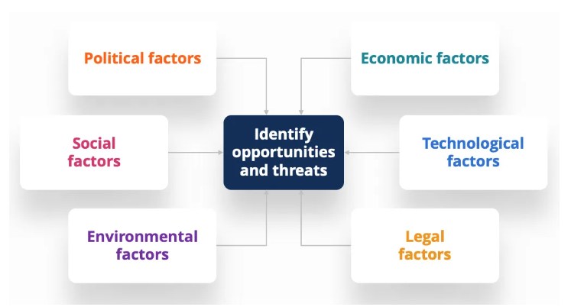

Source (Peterdy 2022)
A PESTEL analysis is a framework for an organisation to assess Political, Economic, Social, Technological, Environmental and Legal factors. According to Rastogi, Travedi (2016) this is a well-known framework for organisations, used for helping organisations have a better understanding of their environment, prepare for future challenges, and promote strategic thinking to counter such challenges. In a later study, Odey (2021) comments that the PESTLE model, considers external factors that may affect the stakeholders in an organisation rather than focussing on the organisation. As stated by CIPD (2021) a PESTLE analysis can be used in various situations to help strategic decision making in an organisation. Meaning that this framework could be referenced when looking for possible threats or opportunities that may arise, and base strategic planning from the findings, whether it be for a transformational, complex change, or a smaller change within the organisation such as technological advances to enhance their processes, to keep ahead of the market. An example of how Alcumus monitor near future vulnerabilities including natural disasters, they subscribe to the Met Office and US-CERT to provide immediate updates that would require change (See Appendix B, Pg.17) Sociocultural factors effected by the pandemic has provided an opportunity for remote work to shine as expressed by Bush (2020)
According to Rastogi, Trivedi (2016), a PESTLE Analysis used to coincide with a SWOT Analysis, helps to identify internal risks associated with the change project. In a recent study, Peterdy (2022) strengthens this argument by describing that findings from a PESTEL analysis can be incorporated into other frameworks in the organisations such as SWOT analysis, see section 2.3.2 and Porter’s 5 Forces, see section 2.2.

The following PESTLE analysis displays key factors of macro forces that Alcumus must consider, before making strategic decisions based on internal information collated by key stakeholders (See Appendix B).
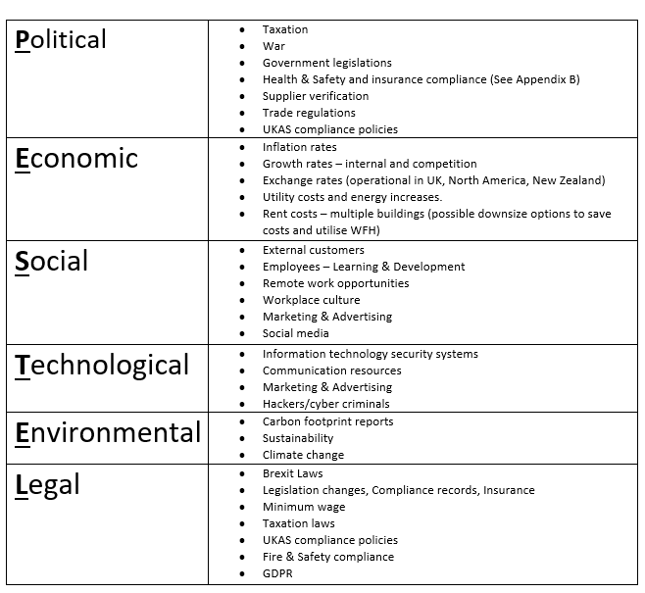

Another model for external forces outside the organisation to stay ahead of the competition, is Porters Five forces. This concentrates on industry forces to base decisions on new strategies and changes that need to be made to survive and succeed, this will be discussed further, in the next section.

2.2. PORTERS 5 FORCES

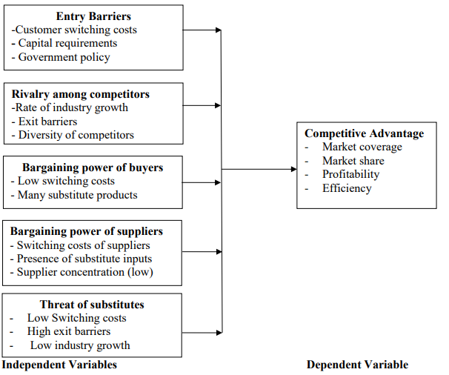
Source (Mugo 2020 Pg. 37)

The impact of the pandemic, limited economy activity in Small and Medium Enterprises (SME), by reducing the amount of demand according to a recent study by Nengsih et al. (2021), who also stated that in the service sector, the pandemic had an impact that encouraged SME’s to take advantage of possible opportunities, to become more creative and innovative, to provide better services, and with the use of technology, as well as for other types of SME’s that are required to be able to develop more effective strategies and create innovative products, to maintain business continuity.
To achieve a sustainable competitive advantage, an organisation must have the capabilities to adapt to macro and micro forces, and according to Jimmy, Mustamu (2015) they must also have effective planning, implementation and evaluation of each strategy used. An organisation needs to understand how they differentiate from their competitors, according to Farooq (2019) by analysing what tactics are used by competitors when responding to market change will help them come up with more effective planning strategies to these changes.
Michael Porter created the Porters 5 Forces model in 1970 as a tool to help organisations achieve a competitive advantage in the industry that they are in. The five forces are made up of factors that could influence the position of the organisation in their industry.
The five main forces that can impact the competitiveness of Alcumus are considered below:
- Competitive Rivalry: Alcumus was the fifth founding members of the 25 registered members within the SSiP Scheme which started in 2009 (See Appendix C). Alcumus SafeContractor is the largest SSiP Scheme to hold UKAS Accreditation as stated by Clements (2022). This suggests Alcumus currently hold a unique selling point over their rivals
- Supplier Power: This looks at the ability of suppliers, to drive up the prices of the organisation’s inputs and materials.
- Buyer Power: This investigates the strength the customers have, that drive down an organisation’s prices.
- Threat of Substitution: This concentrates on the extent of different products and services that can be used. Evidence suggests there are currently 25 members of the SSiP scheme who would be Alcumus substitutes for customers.
- Threat of New Entry: This investigates which new competitors can enter the market (and potentially drive down the organisation’s prices). The last member joined in December 2021 (See Appendix C). This could suggest a threat as the competitors’ objectives and status is unknown.
According to Mindtools (2019) this model is an important tool to use, to understand the main competitive forces in an industry to help pinpoint areas where an organisation can amend their strategy to improve profitability. Goyal (2020) the relative importance of a threat varies from industry to industry. In contrast to this, Beattie (2018) criticizes that this model only provides a snapshot of the wider industry in the past and may only be useful to develop short-term strategy, and Isoraite (2018) stated a disadvantage of this model, is that the forces that are considered fails to identify where different cultures in organisations may be responsible for the market control opposed to Porters Five Forces. Whereas in the current modern-day dynamism and continuous changes he believes the model doesn’t benefit an organisations advantage. In a recent study that conflict with this, Mugo (2020) stated that many organisations performed poorly in a competitive environment, by failing to analyse and make strategic decisions based on the Porter’s Five Forces. However, the research conducted in this report seems to suggest that Porters Five forces model is beneficial, if used alongside other models and theories, whether it be analysing the macro or micro forces, that require organisational change, to maintain their place in the market. Hence, as stated by Benjamin (2018) it is vital to establish strategies to deal with these forces and to do this successfully, organizations need to understand their capabilities and how the forces affect their organization in that situation. It would be logical to suggest that organisations must consider each force, and by identifying its strength and direction, using this model means you can quickly assess your competitive position and make strategic decisions to remain competitive and survive.
The report will now discuss micro forces in an organization to identify factors based on the macro forces that require change.

2.3.1. MICRO FORCES FOR CHANGE IN THE ORGANISATION

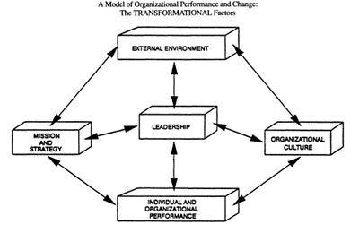
(Burke, Lithwin 1992 p.530)
Research suggests that implementing a change in the workplace requires good leadership for it to be successful.
The micro-environment consists of stakeholders linked to the organisations. Examples of micro environmental factors that affect organisations include customers, competitors, employees, suppliers, and shareholders.
Employees are strongly linked to an organisation and research suggests how they react to change needs to be considered to enable them to be led through a change effectively. This will be discussed in section 2.4. According to Burke, Lithwin (1992), employees can potentially have a negative influence on an organisations environment to minimize certain changes. An example of this would be forming or being part of trade associations and coalitions. Their model of organisational performance and change is to reflect this kind of influence from employees and as leadership is central to their model. This would suggest that the leadership styles used to manage employees, and to get them on board with the change and address any negative behaviour early on.
External factors that organisations cannot control, such as the recent pandemic, has undeniably affected how organisations must operate internally. Remote working or a hybrid approach has increasingly become the ‘new normal’ for many organisations. According to Hartmans (2020), well-known organisations, including Amazon, Apple, Facebook, Google, Microsoft, and Twitter are inclined to adopt homeworking into their business model since the pandemic. However, not all organisations have the capability to adopt ‘working from home ‘into their business model. As stated by Dingel, Neiman (2020), organisations that require face-to-face involvement such as hospitality are unable to adopt home working. This would suggest an organisation adopting the ‘new normal’ working from home or a hybrid approach will depend on the nature of the organisation as not all objectives can be accomplished from home.
Working from home enables a more flexible way of working according to Murray (2020) who suggested this can increase trust between the workforce which can increase well-being and a feeling of belonging. According to Hillberth et al. (2020) adopting a hybrid work model, allows organisations to recruit talent more effectively, achieve innovation and create value. Further to this, as stated by Beno, Hvorecky (2021) evidence suggests that commuting to work less and including hybrid working in an organisations business model increases individual productivity. Strengthening this argument, a report conducted by Office for National Statistics (2022) reported the most common reason for organisations planning to use homeworking in their permanent business model, 60% reported improved well-being, reduced overheads by 43% and increased productivity by 41% (See Appendix D). The same report also states more than half of the organisations in the Information and Communication industry (54%) intend to use increased homeworking as part of their permanent business model in April 2022, opposed to business is the accommodation and food services industry (3%) and business in the construction industry (5%) which are less adaptable to work from home (See Appendix E). As stated by Nolan et al. (2022) homeworking has more than doubled based on data between October to December 2019 compared to January to March 2022 (See Appendix F).
Alcumus have adopted hybrid working into their business model. They recognise that hybrid working has increased employee’s productivity and well-being. The students team members in Alcumus were given a short survey to complete, to see how satisfied they are with the flexible hybrid working approach and the leadership team (See Appendix G). The sales team consists of 10 employees, 7 of which are male and 3 are female in the age range of 22-45 years old. 70% reported they were very satisfied with their current hybrid working arrangement, 20% employees reported to be somewhat satisfied and 10% remained neutral. 80% of employees were satisfied with working in the office on their last visit. It is acknowledged to get a better understanding of employee satisfaction with the hybrid working model in Alcumus, with a deeper analysis of employee satisfaction to include all employees within the organisation to strengthen the validity of these results.
It would be logical to suggest that organisations who include homeworking or hybrid working, which has become the new normal way of working, into their business model, should explore ways to increase employee satisfaction and productivity for future success and be open and accept continuous change is essential to succeed. The next part of the report will conduct a SWOT analysis on Alcumus to determine their capabilities and opportunities to effectively lead the stakeholders through an organisational change.

2.3.2. SWOT ANALYSIS

The Strengths, Weaknesses, Opportunities and Threats (SWOT) framework is an analytical tool that can be used to categorize both internal and external environmental factors to the organization. Gibis et al. (2001) described the SWOT analysis as a framework used for strategic planning performed by experts in the organisation to assess the business from a critical perspective. As suggested by Perera (2017) the SWOT analysis considers the key aspects in the external forces to help form conclusions, of their market potential and industry attractiveness, to predict industry key success or market trends for future growth opportunities. However, Pickton, Wright (1998) argues if used simplistically, the SWOT activity can lead to damaging consequences. This would suggest using this framework effectively, a more detailed analysis would be required to help with strategic planning. Stacey (1993) stated the decisions led by change, should match strengths with opportunities, repel threats and look to overcome weakness.
Strengths and weaknesses relate to micro forces where Opportunities and Threats relate more to macro forces. Below is an example of Alcumus SWOT analysis conducted by the student based on the evidence provided in this report.
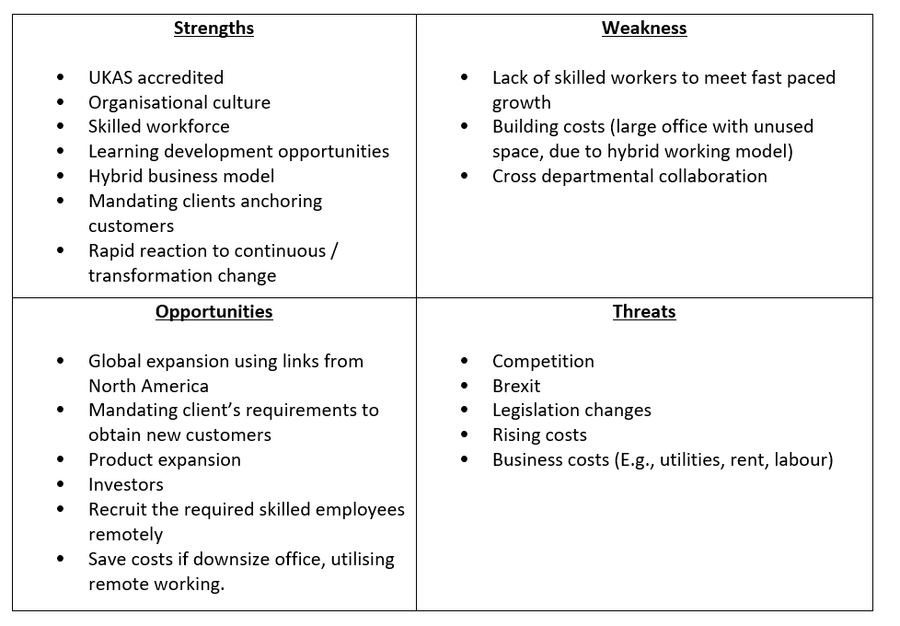

According to Taylor (2018) communication in the organization on how change is managed, and the reactions of the stakeholders to change, are key factors that can influence the successful implementation of change. According to Hart et al. (1996) undergoing change in an organization can cause distress in employees and reduced morale which can impact job satisfaction. The next section will discuss stakeholders’ reactions and emotions when dealing with change using, he Kubler-Ross Change Curve model as a framework.

2.4. EMOTIONS AND ORGANIZATIONAL CHANGE

When making strategic decisions to implement a change, research suggests it is important to understand that resistance stakeholders pose can be linked to their emotional reaction to change and how they are managed. To understand an individual’s emotional stages in the process of grief, Elizabeth Kubler-Ross provided a framework that provided a framework consisting of Five stages (Denial, Anger, Bargain, Depression, Acceptance). According to Mayo Clinic (2016) peoples experiences of grief can vary and are influences by the nature of loss. Hence, Tahir, Umar (2019) stated this model is a useful framework to implement when going through a change as it is easy to understand and can be applied to any situation as they believe emotions are the same whether it is about personal loss or changes in an organisation. According to Castillo et al. (2018) the importance of this model resides in the concept that emotions are an important factor to the way a person perceives their social environment. Further to this, Connelly (2020), all change involve loss at some level and describes this model as a framework that conveys levels of emotions experienced by individuals as they deal with change in their life. Therefore, it would suggest this model provides the appropriate framework to identify how individuals’ perceptions to change, whether positive or negative situation within their organisation.
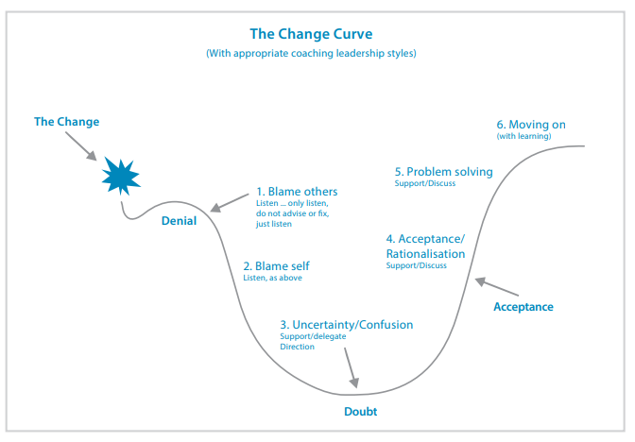
Source (Gentry 2017 Pg.1)
As stated by Gentry (2014) this is a powerful model used as it helps to predict how individuals will react to change so you can make sure they have the help and support they need to help them make their own personal transitions. He believes organizations will reap the benefits of change only when the people involved in the change process have made their own personal transition. This suggests coaching methods are beneficial to help employees transition through the stage. Individuals who resist change and remain in stages 1 and 2 can prevent the change from being successful.
In her book, Shapiro (2003) identifies four main types of reactions to change. Apathetic individuals tend not to care about change as it makes no difference to them, Incubators tend to think about it first, if they think positively towards the change, resistance is minimized, in contrast, if they think negatively to the change, this could cause problems. Advocates are individuals who welcome change and are enthusiastic and resistors who are actively against change. This can relate to the change curve aligning incubators and resistors into stages 1 and 2. Therefore, it is important to be patient with these individuals and listen and let them vent so they can make their own transition to adapt. Shapiro’s idea is to create the right conditions for positive enthusiasm and commitment to change, to acceptance that becomes contagious, and more people get on board.
According to Taylor (2018) communication in the organization, how change is managed and the behaviors of employees to change are key factors that can influence the successful implementation of change. According to Hart et al. (1996) undergoing change in an organization can cause distress in employees and reduced morale which can impact job satisfaction.
When facing a change, resistance is a natural reaction as change creates uncertainty and tension that can affect an employee’s perception of the situation of the change according to Loo et al. (2017).
If resistance to change is not managed effectively it can potentially undermine the success of the change. As stated by Florea (2013), dismissing a certain stakeholder category could have detrimental effects for the organisation such as losing shareholders’ support or losing employees who usually perform well. In a recent study Kotter, Cohen (2012) stated that fear, anxiety, and other negative thoughts are the reason behind most resistance to change and they believe ‘cultivating a realistic attitude that everything cannot be done at once’ and rewarding new types of behaviors and attitudes towards change, will help to counteract the resistance to change.
The report will now discuss a stakeholder analysis to identify who needs what communication and when to effectively move through change.

2.5. STAKHOLDER ANALYSIS

“Stakeholders are the persons, institutions, organizations, formal and non-formal groups which are interested or can be affected, or which could influence the company decisions or actions”
(Florea, 2013 Pg. 130)
Understanding stakeholders in an organisation and their needs and interests in projects or change processes, is a crucial analysis that needs to be done, to help overcome barriers and implement a change effectively to meet the organisations objectives. As stated by Hoory (2022), it is important to understand each stakeholder and their expectations to identify if their needs and expectations collide with the core requirements of the change. This would suggest that understanding the stakeholders and how and when to communicate with them to keep them satisfied, will effectively recognise if the organisation is capable to implement the change successfully.
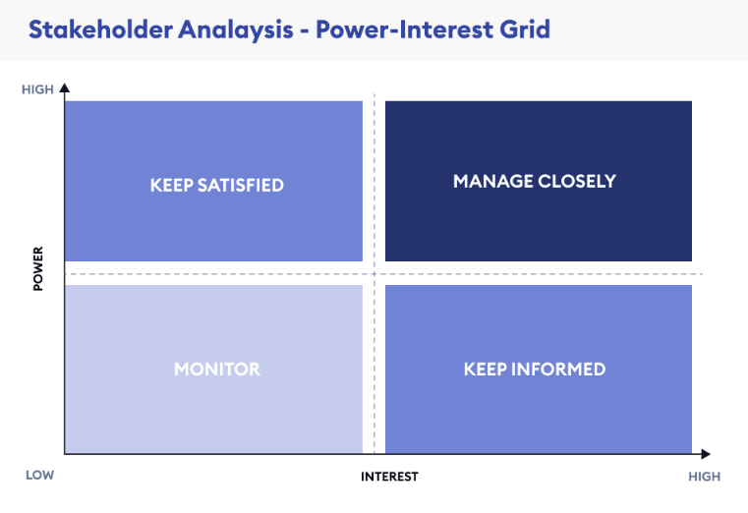
Source (Hoory, 2022)
A Stakeholder analysis is an operating procedure that can assist the management team to understand the variety of stakeholders, that have an interest or influence in the change process. It also helps to identify the risks and possible resistance to change.
Stakeholders in the high power – high interest quadrant would need to be managed closely, leaders would fully engage with them and prioritise their satisfaction. According to Florea (2013), if stakeholders in this quadrant are negative, they become powerful opponents to the organisations objectives and could make if difficult for the project / change to succeed.
For those in the high power – low interest quadrant, stakeholders would not need to be managed closely however leaders would prioritise their satisfaction.
Those in the low power- high interest quadrant, would need to be kept regularly informed of updates and progress of the change to keep them motivate to achieve the organisations goals.
Stakeholders in the low power – low interest quadrant requires minimum involvement but as suggested by Project-Managemnt.com (2022), leaders should monitor the stakeholders in this quadrant to ensure they do not move position on the matrix.
According to Smith (2000), understanding the level of influence that the stakeholder may impose, can be a great asset to the management of change. In a recent article, Kier, Huemann (2022) stated that stakeholders can influence the outcome of a project and have a major impact on the project success.
This suggests the difference of the management of change being a success or failure, may be having the knowledge of the advocates and the opposition, understanding their levels of influence and needs, and aligning them to manage the change effectively.
Knowing the importance of understanding stakeholders and their position in Alcumus stakeholders (See Appendix H) are identified and will now be placed into a matrix to understand their level of influence and importance to communicate. How Alcumus recognize their stakeholders’ needs and expectations in the current objectives are displayed in more detail (See Appendix B). It is recognized that stakeholders experiencing different states of emotion during the change can have an impact of where they fall in the matrix. Therefore, it would seem for this framework to be successful, it would need to be revisited frequently throughout the change.
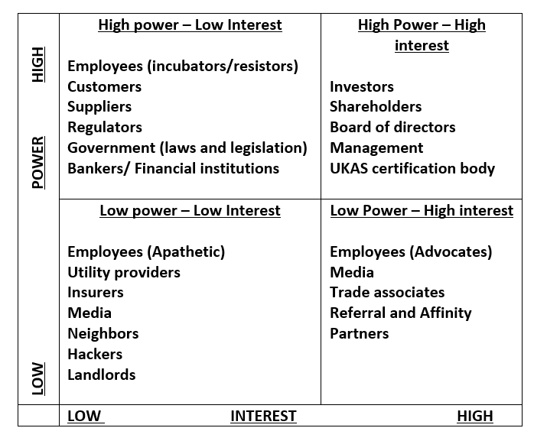

Having looked at both macro and micro forces and gaining an understanding of the stakeholders and why it is important to understand their needs, we will now evaluate how stakeholders can be led through a complex change. In doing this we will be looking at Alcumus and how they manage change in their workplace and see how their processes compare to Kotter’s eight step change.

3. LEADING STAKEHOLDERS THROUGH AN ORGANIZATIONAL CHANGE

According to Galli (2018), Kotter’s eight step change model broadens Lewins original change theory as he believed that ‘Leadership must create and sustain the kind of changes needed for successful organizations. Kotter’s theory consists of eight steps to ensure change is a successful process. Compared to Lewins model, Kotter’s theory provides a more detailed direction on how to implement change and incorporates the stakeholders side of change. Galli (2018) argues the Kotter’s model, in comparison to Lewin’s model, provides greater direction on how to implement change. It further incorporates the people side of change. This suggests that unlike Lewin, Kotter gives advice on which point in the process to communicate with employees in the model. The following sections will discuss each step in more detail.

3.1 CREATING A SENSE OF URGENCY

Once the organization recognizes the need for change, the first step is to create a sense of urgency. This is a critical step to increase the organizations awareness for strategic adjustments to be made according to Kotter (2012). Alcumus ensures immediate meetings are set for the high-interest- high-power stakeholders who participate in the strategic planning from the offset. Stakeholders in other quadrants would be notified immediately of the change to ensure Alcumus creates transparency in the organization’s objectives early on depending on how much the change would affect them, this suggests Alcumus considers creating a sense of urgency by iterating the ‘why’ in their vision statement, empowering stakeholders to get on board to drive the change. This would also relate to Lewins model at the unfreeze stage, as Lewin (1951) believes allowing organizations time to reflect on the change and involving all parties of interest is crucial. Therefore, understanding the change requires an in-depth analysis for what is and is not working.

3.2. CREATING A GUIDING COALITION

According to Senior et al. (2020) poor leadership and slow reactions to competitors are typical management problems that are linked to the failure of change. Kotter (1996) notes that for effective change to happen, effective leaders need to develop into a coalition to build on the urgency need for the change and people need to know change is necessary. The culture of Alcumus helps to understand this step is taken seriously as they believe in the development of a leadership team, so employees adapt to change effectively. Opportunities are available from all stakeholders, to discuss any concerns or ideas to ensure obstacles are overcome early on. This would suggest that Alcumus adhere to step 2. Involving stakeholders at this stage will help to identify any restrictions or potential barriers that may arise and including frameworks, such as Klien (1999) thinking environment which would allow for the leaders to encourage the stakeholders to have their say and be heard, creating opportunities empower employees to get on board and to build enthusiasm and generate creative ideas for the success of the change that is needed.

3.3. DEVELOP AND FORM A STRATEGIC VISION

Stakeholders must understand why the change is needed in order to support the organizational objectives. As stated by Galli (2018) strong and well directed visions can help change management and believes the knowledge and expertise to effectively deliver the vision is necessary.
Alcumus are transparent with their organisation’s values and mission (See Appendix G). It would seem the approach to empowering their workforce, to be part of a team to ‘achieve continued success’ and ‘create better workplace’ is promoted from the start of a career journey, to encourage employees to get on board with their workplace culture from the offset and throughout the journey working at Alcumus. Alongside other models and theories that Alcumus use in their business model, for example in this step they share the vision of ‘creating a better workplace’ which could create an expectancy of a change culture.

3.4. COMMUNICATING THE CHANGE VISION TO THE STAKEHOLDERS

This report has discussed how stakeholders are key components for change to be successful. Understanding individuals’ emotions by assessing their feelings and behaviors using the Change Curve model, would be a necessity in this step for the vision to be shared effectively. When employees hear about a transformational change in an organization, their initial feelings could create resistance. It would be logical to assume that using a leader who has high emotional intelligence, and expertise in the change models, would be a key factor to bring a positive outcome of achieving objectives. Miller (2016) expressed a leader that relates to adaptive or situational leadership styles can adapt their communication methods to encourage innovation, creativity and overcome resistance to change. Therefore, good leadership is crucial to take the time to make sure members of the organization feel heard and supported during the process of organisational change. In a study by Watson (2022) he revealed employees need a platform to allow them to cultivate openness and transparency to become a more collaborative organization. He believes technology has the power to strengthen communication between employees in the way of effective ideas and knowledge sharing techniques.
Alcumus communicates openly and honestly with their stakeholders to maintain their trust and respect of the employees. The advanced technological factors, and the preparation of remote working, provides opportunities to Alcumus to collaborate with their workforce to achieve other organizational objectives to promote autonomous and creative effectiveness in their roles. As hybrid working is in their business model, Alcumus can utilize the office space to hold face to face meetings with shareholders when needing to communicate the change vision. Historically, when any type of complex change arises, Alan the CEO of Alcumus communicates a personal video log 24 hours after the change is communicated, this could be done face to face calling everyone into the office and teams meeting could be made compulsory for home workers at short notice, to ensure all stakeholders receive the vision and mission at the same time and is shown a road map of how to get there to help the stakeholders see the urgent need for the change. This relates to Kotter’s step 4 framework. Further evidence would be required at this stage to monitor the stakeholders closely to ensure they are on board with the vision and find ways to overcome resistance when it arises. Hence, Galli (2018) believes this step is crucial as there could be fundamental resistance from employees and people may feel left out if not managed properly.

3.5. EMPOWERING BROAD-BASED ACTION

Allowing employees to try new ideas and approaches is to empower them according to Galli (2018) communication alone is not sufficient. According to Derman (2019) A successful leader guides their followers effectively to meet the organisations objectives while reassuring and motivating them to share the organisational goals. Alcumus believe in ‘work your way’ policy which means they show they trust you to meet your role objectives in the hopes to empower new creatives ways of doing things to improve the culture and service that is provided.

3.6. GENERATING SHORT TERM WINS

This step sees that any changes and progress that are made with significant outcomes are celebrated. Alcumus hold meetings which automatically invite you to be a part of, on the last Friday of every month to share the progress reports at month end and have special mentions to reward employees for their work to encourage all employees to be brave and try latest ideas. Alcumus also generates an email and copies in all employees, to celebrate any other business success as soon as it happens to ensure all stakeholders are part of the mission and celebrations.

3.7. CONSOLIDATING GAINS AND PRODUCING MORE CHANGE

Avoiding complacency and continuous progress is the key objective in this step. It requires the organization to consolidate gains and create more change. According to Galli (2018) a change proves can fail if the employees revert to their previous habits. This would suggest the employee may have reverted to stages 1 & 2 of the change curve and other factors may not have been considered or it could assume that the organization lacked the capability to overcome the resistance to change.
The innovative culture of Alcumus welcomes change and celebrates the wins. This would suggest they take step 7 into account in their business model, adopting an open innovative environment which allows creativity and collaboration. Reverting to strategic scanning on a regular basis for a change process would be useful to monitor the change and adapt the management of change accordingly.

3.8. INITIATION OF NEW CHANGE.

In line with the final stage in Lewin’s model (freeze), this stage requires continuous reinforcement to maintain the new normal, finding opportunities to continually adapt and improve products and services.
According to Kanter (2003) the final stage of Kotter’s theory focuses on institutionalizing change and embedding it into the organizational culture. In the organizational culture of Alcumus, the vision and missions of the organizational objectives are communicated on a regular basis using various methods of communication and visuals. Change is expected in an organization such as Alcumus and it seems the Kotter’s Eight step change model is a suitable match.
There are many theories and frameworks available to research to guide management and leaders on effective change processes. It is evident that change management models can prepare organizations for resistance to change and lead stakeholders towards a successful change implantation.

4. CONCLUSION

The evidence in this report would assume that organisations who have capability and flexibility in their structure and operations, can develop creative ways to add value and to deliver on organisational outcomes to help them effectively maintain their place in the market.
Therefore, this report concludes in agreeance with Burns, Jackson (2011) that the use of one model or just a few models may not be enough to cover various change situations for an organisation to implement a change successfully. The evidence in this report suggests that for changes in an organisation, there are many useful models and theories that can be used as frameworks to implement a change successfully and that the importance of great leadership, seems to be the crucial factor for the theories and models to be effective in implementing a change in an organisation.
Although, based on the research conducted in this report, it would be logical to suggest that as homeworking or hybrid working in organisations have more than doubled since 2019, organisations who include this way of working into their business model, would benefit from incorporating Kotter’s eight step model into their change process, to ensure the management of change, is effective. It can be arguable that other models such as Lewin freeze unfreeze freeze may not be suitable for a fast transition, according to Sharma (2022) the Lewin’s model usually involves the change process taking place over a longer time, to manage resistance and provide the appropriate training. Therefore, it would be a logical assumption that if an organisation, where change is a continuous and expected, has the capability, and adopt an innovative culture, such as Alcumus, Kotter’s eight step change seems a more appropriate framework that relates to their change process. Research suggests that involving other models for organisational change is not solely based on the framework of a change theory, but it involves other important factors as transformational or adaptive leadership.

REFERENCES

Albion, M. J., & Gagliardi, R. E. (2007). A study of transformational leadership, organisational change, and job satisfaction. Australian Psychological Society. https://eprints.usq.edu.au/3098/1/Albion_Gagliardi.pdf
Beer, M. (1980). Organisation change and development: A systems view. Goodyear.
Benjamin, S. (2018). Exploration to Exploitation: An industry analysis of suborbital space tourism. New Space,6(1), 87-98.
Beno, M., Hvorecky, J., & Caganova, D. (2021). An Optimal e-working Environment: Online Survey Results. International Journal of Business and Applied Social Science, 7(2), 10.
Burke, W. W., & Litwin, G. H. (1992). A causal model of organizational performance and change. Journal of management, 18(3), 523-545.
Burke, W. W. (2013). Conceptual Models for Understanding Organisational Change. 4th Ed. Sage. ‘In’ Maund, A. (2018) BA in Leadership and Management, skills for the workplace Student Yearbook, Final year. Sage
Bush, T. (2020). PEST Analysis of Coronavirus. PESTLE Analysis. https://pestleanalysis.com/coronavirus-pest-analysis/
By, R. T. (2005). Organisational change management: A critical review. Journal of change management, 5(4), 369-380.
Castillo, C., Fernandez, V. and Sallan, J.M. (2018), "The six emotional stages of organizational change", Journal of Organizational Change Management, Vol. 31 No. 3, pp. 468-493. https://doi.org/10.1108/JOCM-05-2016-0084
CIPD. (2021). PESTLE Analysis. CIPD. https://www.cipd.co.uk/knowledge/strategy/organisational-development/pestle-analysis-factsheet#gref
Claessens, M. (2022). The Macro Environment in Marketing – Why is it important and how to work with it? Marketing-Insider. https://marketing-insider.eu/macro-environment-in-marketing/#:~:text=As%20you%20can%20imagine%2C%20the%20macro%20environment%20is
Clements, R. (2022). Alcumus SafeContractor awarded UKAS accreditation by UKAS, the National Accreditation Body. SSIP - Safety Schemes in Procurement. https://ssip.org.uk/alcumus-safecontractor-awarded-ukas-accreditation-by-ukas-the-national-accreditation-body/
Farooq, U. (2019). StackPath. Marketingtutor.net. https://www.marketingtutor.net/micro-environment-definition-factors-example/
Florea, R., & Florea, R. (2013). Stakeholders’ interests analyse and harmonization-starting point of strategic approach. Economy Transdisciplinarity Cognition, 16(1), 130.https://www.researchgate.net/profile/Ramona-Florea/publication/315768552_Stakeholders_Interests_Analyse_and_Harmonization_-_Starting_Point_of_Strategic_Approach/links/58e368a0aca2722505d2159a/Stakeholders-Interests-Analyse-and-Harmonization-Starting-Point-of-Strategic-Approach.pdf

Galli, B. J. (2018). Change management models: A comparative analysis and concerns. IEEE Engineering Management Review, 46(3), 124-132. https://ieeexplore.ieee.org/stamp/stamp.jsp?arnumber=8486843&casa_token=hNwdlAayEuEAAAAA:m_HpdI6ukX3QClpMv-l1YCssjqiXj4G72CYJOEzNnzvrdyXSpIaNWxQ8ynNlVL78GOxzHj702Qk&tag=1

Garvin, D.A. Edmondson, A.C. Gino, F. (2008), “Is yours a learning organization?”, Harvard Business Review, Vol. 86 No. 3, pp. 109-116.
Gentry, B. (2019). Coaching people through the Change Curve. Insights.com. https://www.insights.com/media/1086/coaching-people-through-the-change-curve.pdf

Goyal, A. (2020). A critical analysis of Porter’s 5 forces model of competitive advantage.
Hartmans, A. (2020). Google just delayed its office reopening until September 2021. Here’s how other major Silicon Valley companies are thinking about the future of work. Online. https://www.businessinsider.com/silicon-valley-future-of-work-port-coronavirus-apple-amazon-facebook-2020-10?r=US&IR=T.
Hassan, S., Prussia, G., Mahsud, R. & Yukl, G. (2018), How leader networking, external monitoring, and representing are relevant for effective leadership’, Leadership & Organization Development Journal, 39 (4): 454-467.
Hilberath, C., Kilmann, J., Lovich, D., Tzanetti, T., Bailey, A., Beck, S., Kaufman, E., Khandelwal, B., Schuler, F., & Woolsey, K. (2020). Hybrid Work Is the New Remote Work. https://web-assets.bcg.com/c6/fe/e4f521174360a21f280425a04613/bcg-hybrid-work-is-the-new-remote-work-sep-2020.pdf
Isoraite, M. (2018). The competitive advantages theoretical aspects. Ecoforum Journal,7(1).
Jimmy, P. & Mustamu, R. H. (2015) “Analisis Strategi Pada Perusahaan Plastik Dengan Porter
Five Forces,” Agora, vol. 3, no. 1, pp. 736–741.

Kanter, R. M. (2003). Challenge of organizational change: How companies
experience it and leaders guide it. Free Press.

Kotter, J.P. (1995) Leading change: why transformation efforts fail. Harv Bus Rev; 59–67.
Kotter, J. P. & Cohen, D. S. (2012). The heart of change: Real-life stories of how people change their organizations. Harvard Business Press.
Lewin K. (1947) Field theory in social science. Harper & Row.
Loo, J. T. K. Lee, P. H. & Low, A. L. (2017). Impact of Transformational Leadership and the Mediating Effect of Employees' Perception of Organizational Change on Affective, Normative and Continuance Commitment. Journal of Business and Social Review in Emerging Economies, 3(2), 185-198.
https://publishing.globalcsrc.org/ojs/index.php/jbsee/article/view/99/324
Miller, A. (2016). What is adaptive leadership. Online http://www.andrewemiller.com/2016/01/08/what-is-adaptive-leadership/
Mindtools. (2019). Porter’s Five Forces Understanding Competitive Forces to Maximize Profitability. Mindtools. https://www.mindtools.com/pages/article/newTMC_08.htm
Mugo, P. (2020). Porter’s five forces influence on competitive advantage in telecommunication industry in Kenya. European Journal of Business and Strategic Management, 5(2), 30-49.https://www.iprjb.org/journals/index.php/EJBSM/article/view/1140/1255
Murray, M. (2020) The Lockdown has Shown Employers There are Benefits to Remote Working. Available at: https://www.irishtimes.com/special-reports/new-future-of-work/the-lockdown-has-sho wn-employers-there-are-benefits-to-remote-working-1.4279631
Nengsih, M. K. Gayatri, I. A. M. E. M. Wagini, K. C. S. & Indriasari, N. (2021). Strategy of Developing: Five Competitive Force Model Case Study: SMEs Fajarwonk. ‘In’ BISIC 2020: Proceedings of the 3rd Beehive International Social Innovation Conference, BISIC 2020, 3-4 October 2020, Bengkulu, Indonesia (p. 180). European Alliance for Innovation.
Neves, P., & Caetano, A. (2009) Commitment to Change: Contributions to Trust in the Supervisor and Work Outcomes, Group and Organisation Management, 34, 623-644.
Nolan, O., Probert, J., Chapman, N., Hendry, C., & Knight, A. (2022). Homeworking in the UK – regional patterns - Office for National Statistics. Www.ons.gov.uk. https://www.ons.gov.uk/employmentandlabourmarket/peopleinwork/employmentandemployeetypes/datasets/homeworkingintheukregionalpatterns
Northouse, P.G (2016). Leadership: Theory and practice, 7th Ed, Thousand Oaks CA: Sage.
Northouse, P. G. (2017). Understanding Philosophy and Styles. Sage, Ch. 4. Pg 77-98. ‘In’ Maund, A. (2018) BA in Leadership and Management, skills for the workplace Student Yearbook, Final year. Sage
Odey, L. D. (2021). An Evaluation of Challenges Affecting New Technology Startups in the United Kingdom Today: A Pest Analysis. https://www.researchgate.net/profile/Lehiowo-Odey/publication/349009288_An_Evaluation_of_Challenges_Affecting_New_Technology_Startups_in_the_United_Kingdom_Today_A_Pest_Analysis/links/601b3fa8299bf1cc269ffefe/An-Evaluation-of-Challenges-Affecting-New-Technology-Startups-in-the-United-Kingdom-Today-A-Pest-Analysis.pdf
Office for National Statistics. (2022). Is hybrid working here to stay? - Office for National Statistics. Www.ons.gov.uk. https://www.ons.gov.uk/employmentandlabourmarket/peopleinwork/employmentandemployeetypes/articles/ishybridworkingheretostay/2022-05-23
Pastor, J.C. & Mayo, M. (2008) Transformational leadership among Spanish upper echelons: The role of managerial values and goal orientation’, Leadership & Organisation Development Journal, 29 (4): 340-58.
Perera, R. (2017). The PESTLE analysis. Nerdynaut.
Peterdy, K. (2022). PESTEL Analysis. Corporate Finance Institute. https://corporatefinanceinstitute.com/resources/knowledge/strategy/pestel-analysis/
Pickton, D. W., & Wright, S. (1998). What's swot in strategic analysis?. Strategic change, 7(2), 101-109. What's swot in strategic analysis? - Pickton - 1998 - Strategic Change - Wiley Online Library
Project-Management.com. (2022, July 14). What is Stakeholder Analysis? Project-Management.com. https://project-management.com/what-is-stakeholder-analysis/
Rastogi, N. I. T. A. N. K., & Trivedi, M. K. (2016). PESTLE technique–a tool to identify external risks in construction projects. International Research Journal of Engineering and Technology (IRJET), 3(1), 384-388.
Saebi, T., Lien, L. and Foss, N.J. (2017) 'What Drives Business Model Adaptation? The Impact of Opportunities, Threats, and Strategic Orientation', Long Range Planning, 50(5), pp. 567-581.
Senior B., 2002, Organisational change, 2nd ed., Prentice Hall, London.
Senior, B. Swailes, S. Carnall, C. (2020). Organizational change. Pearson Education Limited
http://ebookcentral.proquest.com/lib/trinity/detail.action?docID=6130627.
Shapiro, A. (2003) Contagious Commitment at Work: Applying the Tipping Point to Organizational Change. Strategy perspective.
Sharma, K. (2019). 10 Proven Change Management Models. Whatfix Digital Adoption Blog | Insights, News, Tips, Trends - Whatfix Blog. https://whatfix.com/blog/10-change-management-models/
Stacey, R. (1993). Strategic Management and Organisational Dynamics, Pitman. Pg 52.
Stowell, C. (2017). The Driving Forces of Change [Internal & External]. CMOE; CMOE. https://cmoe.com/blog/the-forces-of-change-and-informal-strategic-leadership/
Smith, L. W. (2000). Stakeholder analysis: a pivotal practice of successful projects. Project Management Institute.
https://www.pmi.org/learning/library/stakeholder-analysis-pivotal-practice-projects-8905
Tahir, Umar, (2019), Kubler-Ross Change Curve Model. Change Management Insight. Online https://changemanagementinsight.com/kubler-ross-change-curve-model/
Taylor, S. (2018). (PDF) Organisational Behaviour, Leadership and Change. ResearchGate. https://www.researchgate.net/publication/324501008_Organisational_Behaviour_Leadership_and_Change
Trzcielinski, S. (2020) Advances in Manufacturing, Production Management and Process Control. Springer International Publishing.
Vigoda-Gadot, E (2007) Leadership style, organizational politics, and employees’ performance: An empirical examination of two competing models, Personnel Review 36 (5): 661-683.
Watson, A. (2022), "How organisations can remove barriers to increase workforce collaboration", Strategic HR Review, Vol. 21 No. 1, pp. 31-33. https://doi.org/10.1108/SHR-11-2021-0057

APPENDIX A

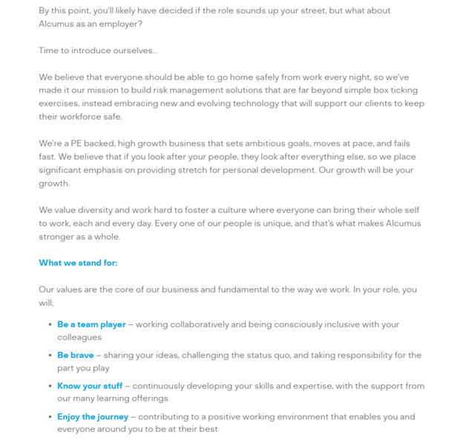
Source https://alcumus.pinpointhq.com/en/jobs/55956

APPENDIX B

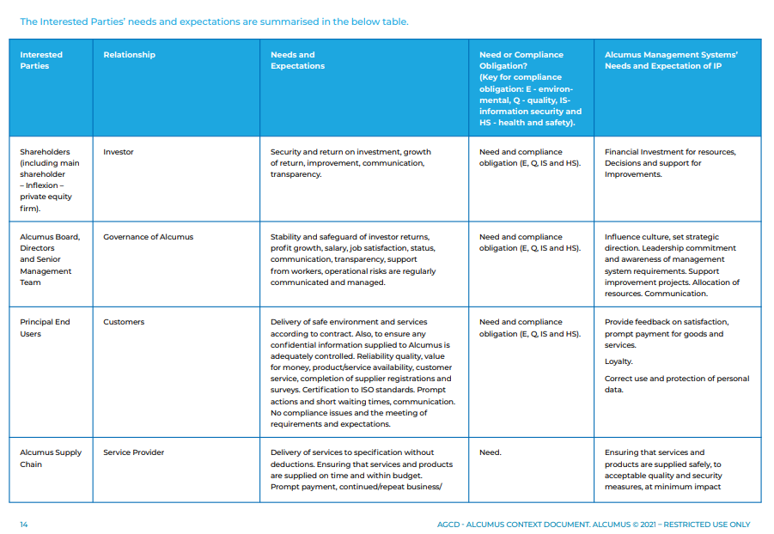
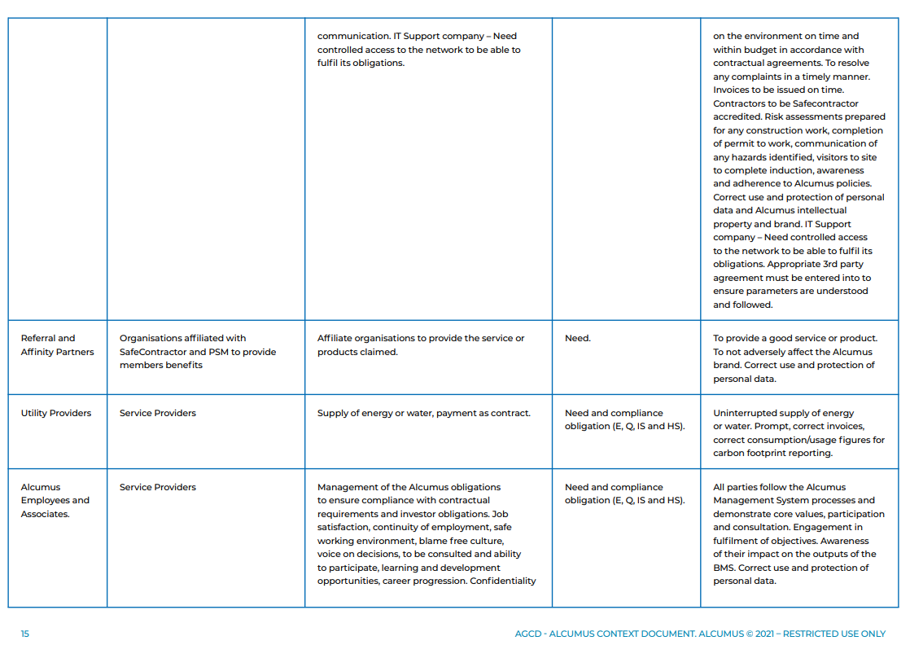
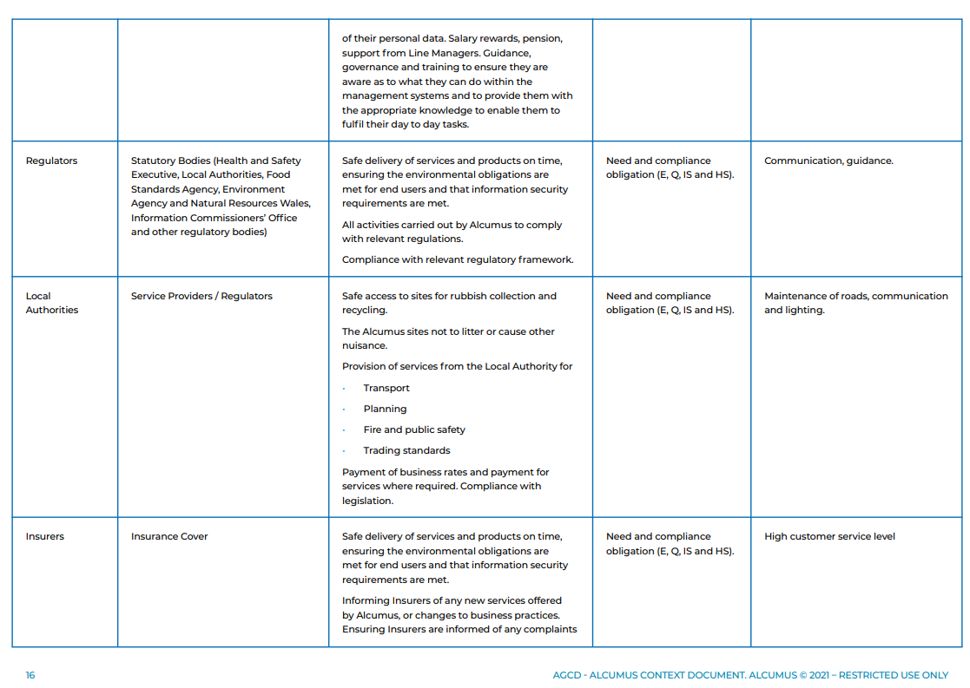
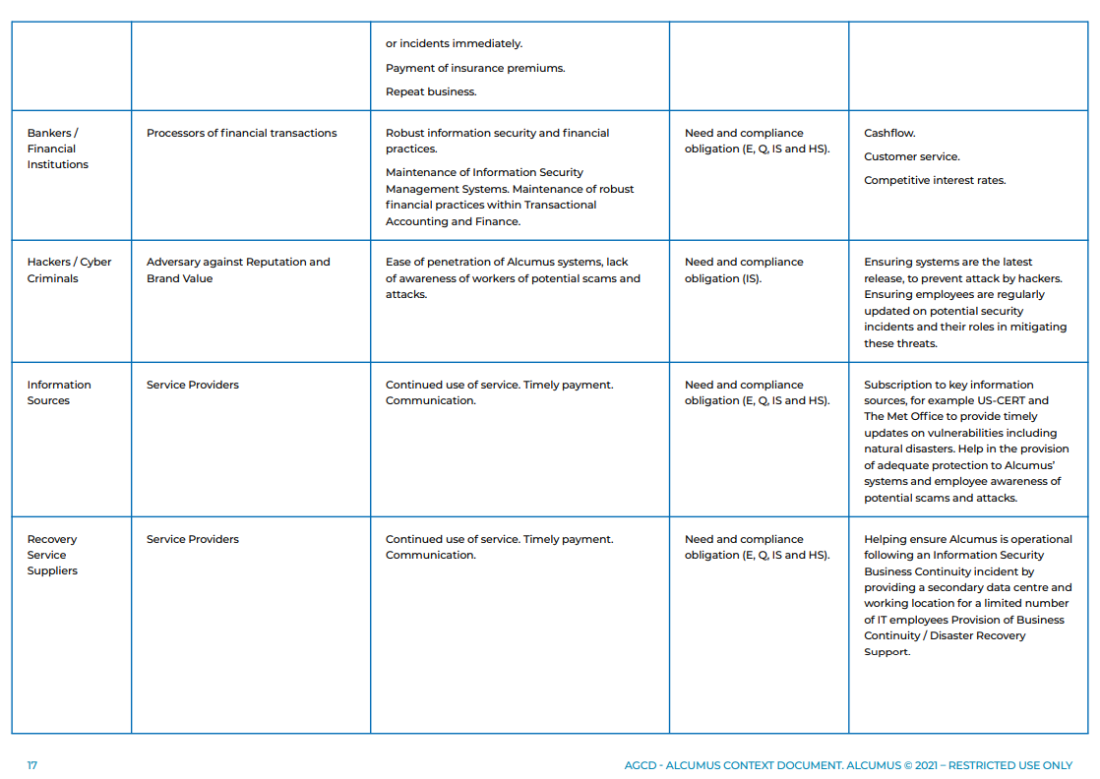
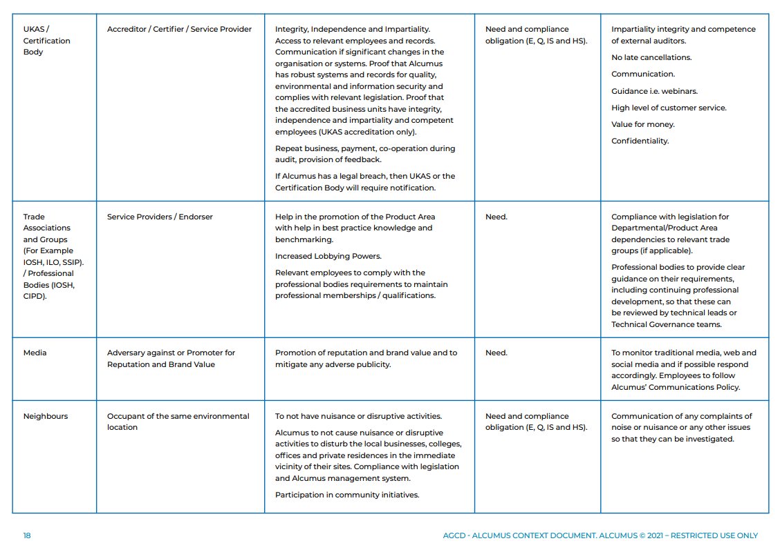
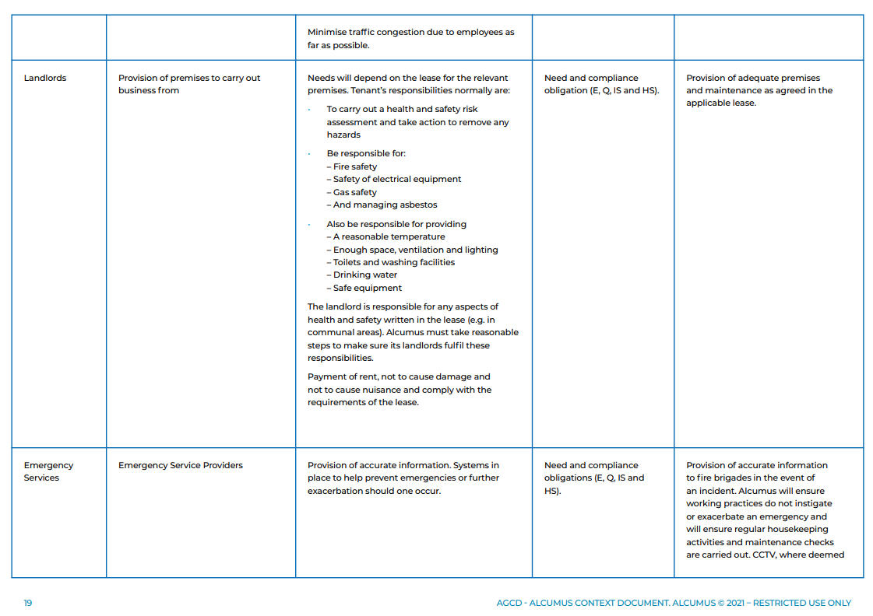
Source (Alcumus internal use 2022)

APPENDIX C

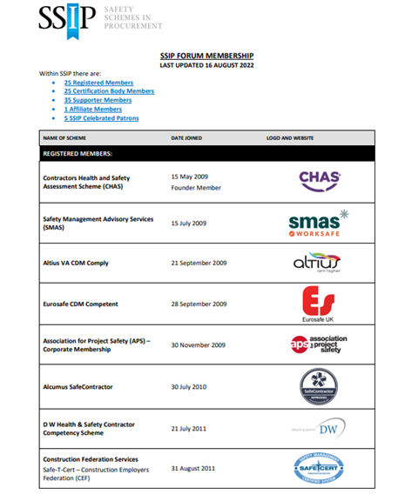
Source SSiP.Org.Uk (2022) https://ssip.org.uk/wp-content/uploads/2022/08/SSIP-Forum-Members-16.08.2022-1.pdf

APPENDIX D

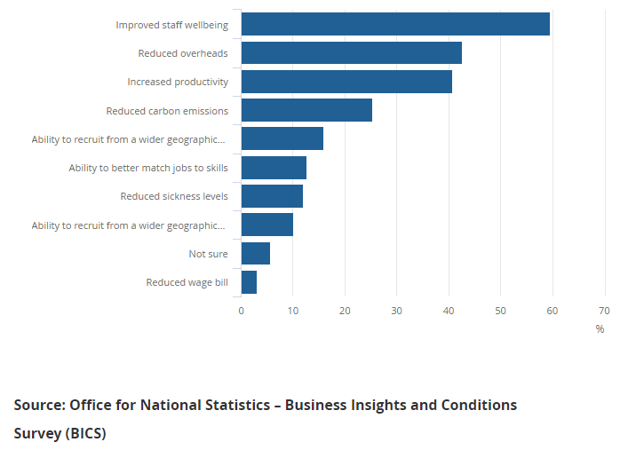

APPENDIX E
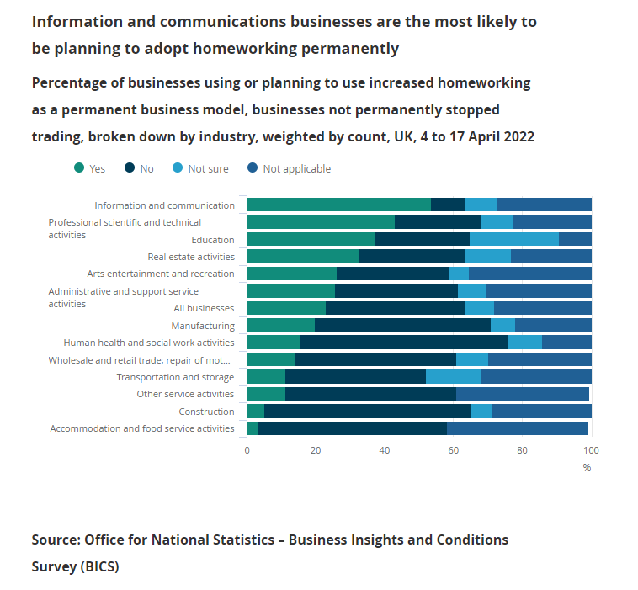

APPENDIX F

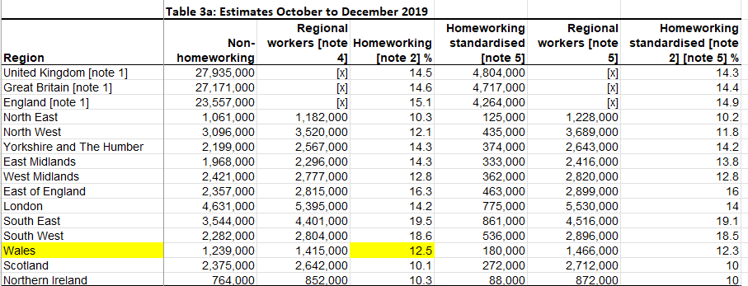
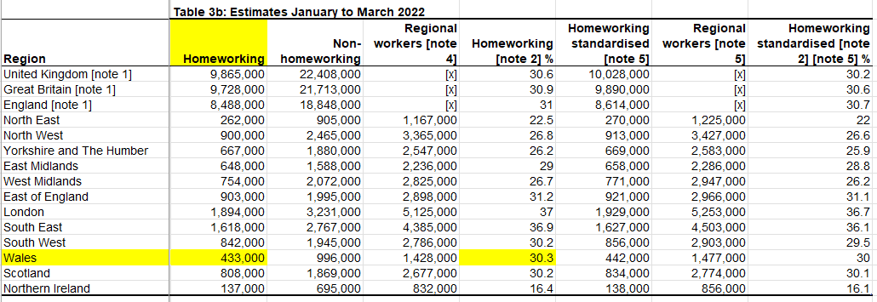
Source (Nolan et al. 2022)

APPENDIX G

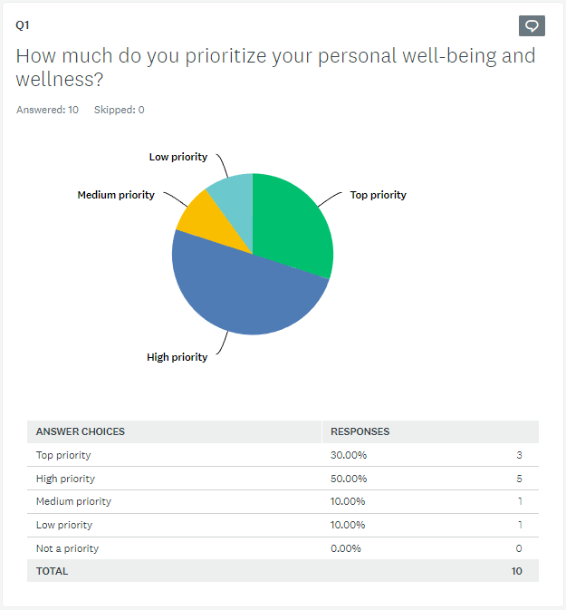
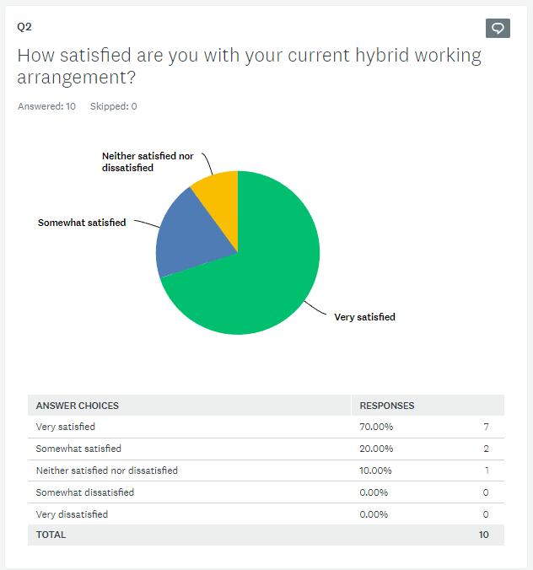
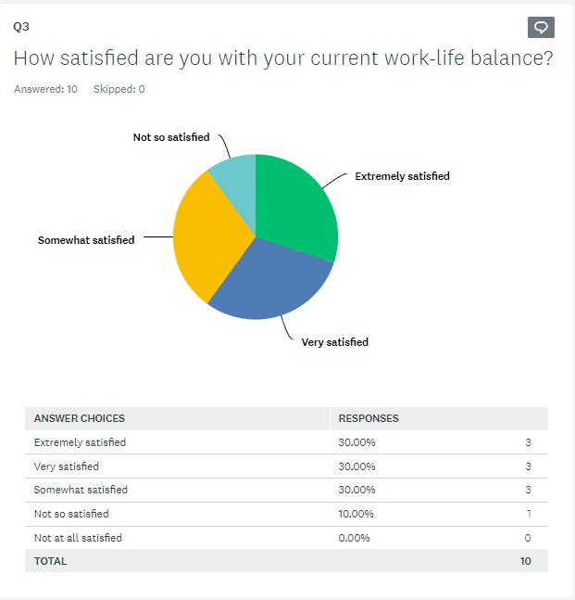
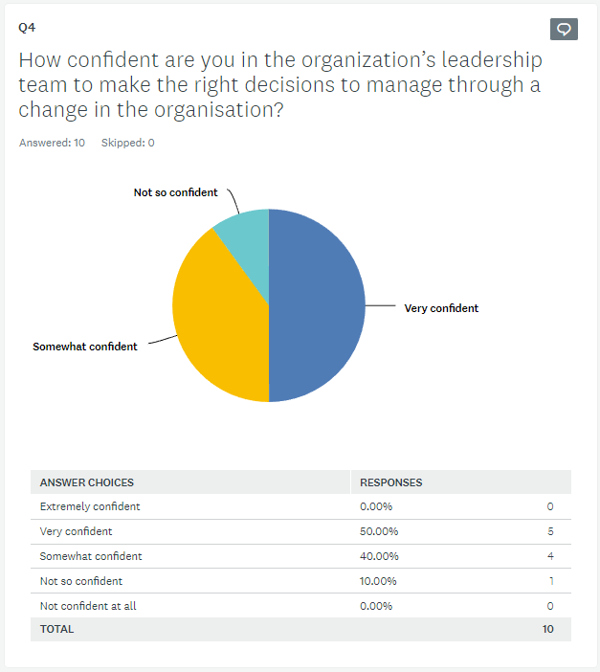
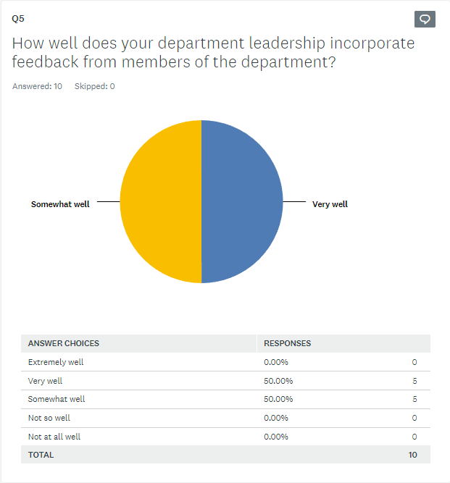
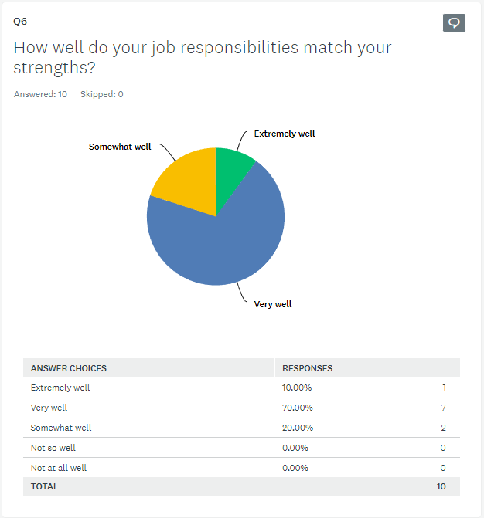
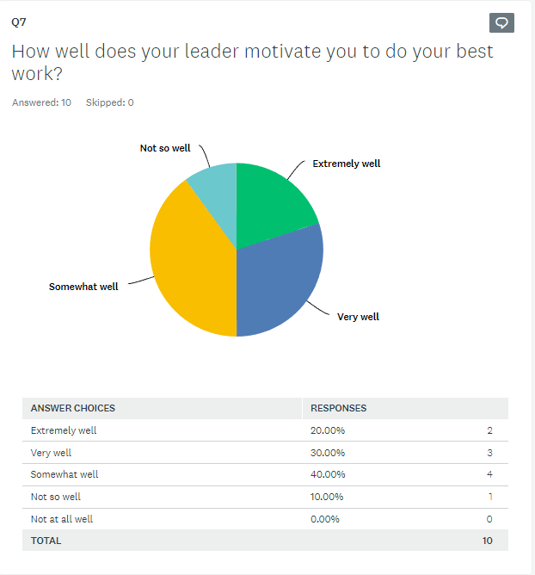
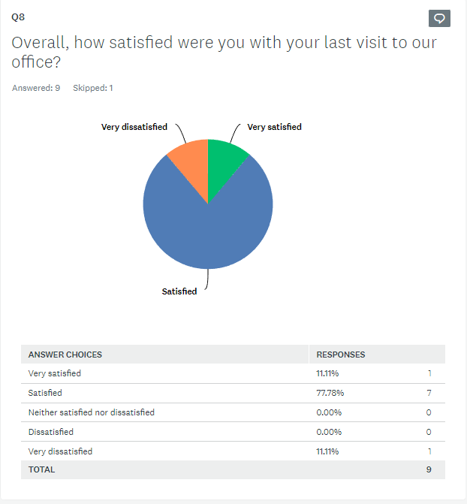
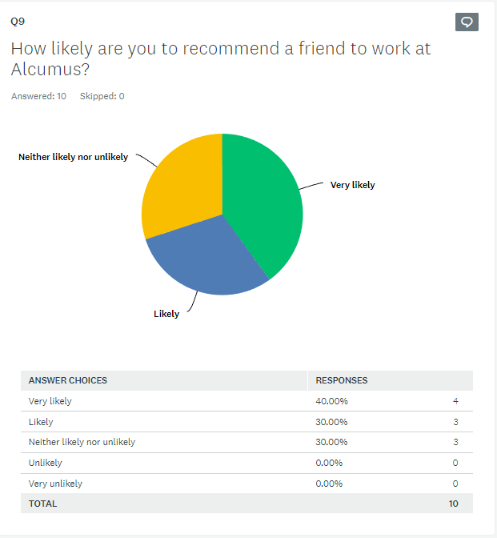
Source (https://www.surveymonkey.com/results/SM-e05U8BUd3hgkNTJi9uN5nQ_3D_3D/)

APPENDIX H

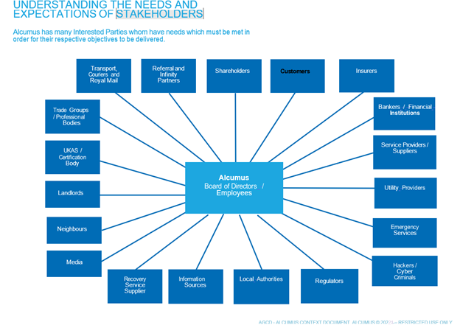
Source (Alcumus internal use only 2022)

APPENDIX I

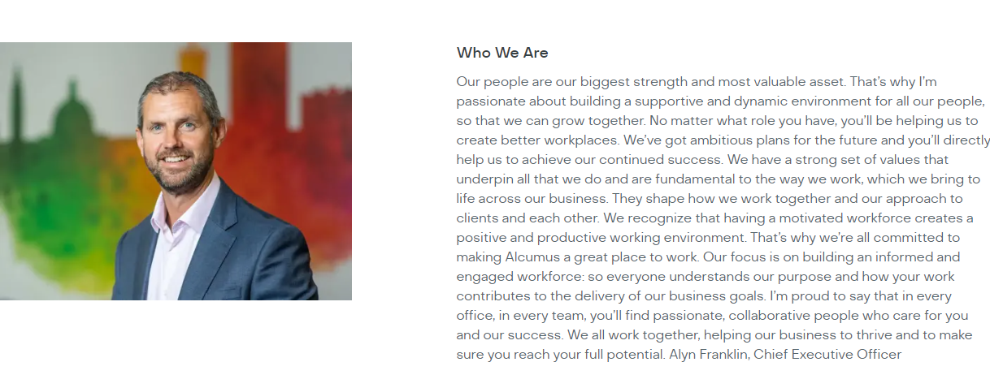
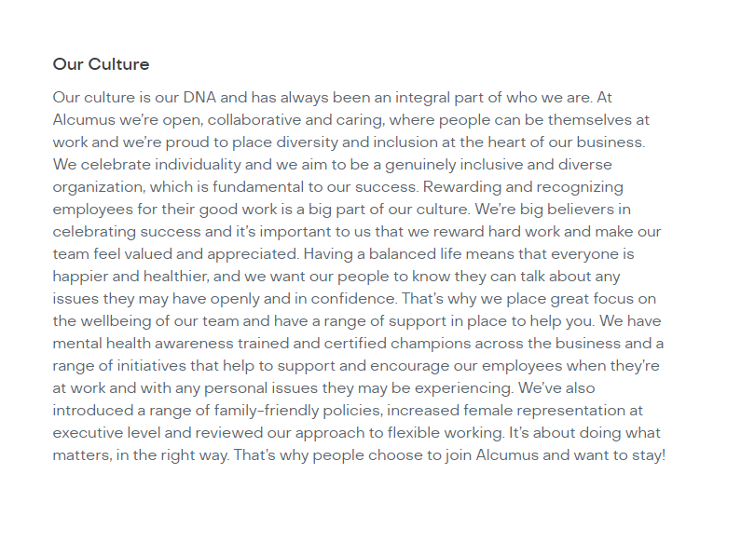
Source (https://alcumus.pinpointhq.com/)

